Software Requirements Specification (SRS)
Vehicle Parking System
Project: Vehicle Parking System
Version: 1.0
Date: 06-09-2026
Status: Draft — For Review

Revision history
Version | Date | Author | Change summary
1.0 | 06-09-2026 | Project Team | Initial SRS draft with diagrams

Table of Contents
1. Introduction
2. Overall description
3. External interface requirements
4. System features (detailed)
5. Non-functional requirements (detailed)
6. Quality attributes & Acceptance tests
7. System models and diagrams (UML Use-Case Diagrams)
8. Requirements Traceability Matrix (RTM)

1. Introduction

1.1 Purpose
This document is a Software Requirements Specification (SRS) for a Vehicle Parking System (VPS). It defines the functional and non-functional requirements, external interfaces, and verification criteria for a system that manages parking slot allocation, vehicle entry/exit, and vehicle tracking across one or more parking facilities.

1.2 Scope
The system covers driver-facing functions (registration, slot search, online reservation, payment, ticketing) and staff-facing functions (lot configuration, occupancy monitoring, attendant management, reporting) for a single or multi-facility parking operator. It excludes physical construction/civil work of parking structures and the internal implementation of third-party payment gateways beyond their published APIs.

1.3 Audience
Developers, QA Engineers, System Integrators, Parking Facility Operators, and Assessment Evaluators.

1.4 Definitions
List of acronyms: VPS (Vehicle Parking System), ANPR (Automatic Number Plate Recognition), QR (Quick Response code), API (Application Programming Interface), UI (User Interface), RFID (Radio-Frequency Identification), JWT (JSON Web Token), TLS (Transport Layer Security), RTO (Recovery Time Objective), RPO (Recovery Point Objective).

2. Overall description

2.1 Product perspective
The Vehicle Parking System is a web-based platform (built on the MERN stack, with a Python/Flask or Django variant as an alternative backend) that coordinates parking slot inventory, reservations, entry/exit gate events, and payments. It interacts with drivers via a web/mobile-responsive interface, with facility hardware (gate barriers, ANPR cameras or RFID/QR scanners) via a hardware-abstraction API, and with external payment gateways for transaction processing.

2.2 Major product functions (detailed)
- Driver registration, authentication, and profile/vehicle management
- Real-time search and display of available parking slots by facility/zone
- Online slot reservation and pre-booking with time-window locking
- Vehicle entry logging (manual, QR, or ANPR-based) and automatic slot assignment
- Vehicle exit processing with duration- and rate-based fee calculation
- Online and at-gate payment processing with receipt/ticket generation
- Parking lot, zone, and slot configuration and pricing management (admin)
- Real-time occupancy monitoring dashboard and analytics/reporting
- Attendant account management and shift-based access control
- Manual gate override and exception handling for hardware failures

2.3 User roles and characteristics (expanded)
- Driver / Vehicle Owner: general public, expects a fast booking flow and clear fee breakdown; may have limited technical proficiency.
- Parking Attendant: on-site staff, needs a simple interface for manual entry/exit overrides and real-time occupancy views.
- Admin / Facility Operator: manages lot configuration, pricing rules, staff accounts, and reviews analytics/reports.

2.4 Operating environment
Cloud-hosted backend (Node.js/Express with MongoDB, or Python Flask/Django with a relational database) served over HTTPS; a responsive web front end (React for the MERN variant); on-premise gate controllers and sensors connected over a local network or the internet; mobile data/Wi-Fi connectivity for driver-facing apps.

2.5 Constraints
- Must integrate with at least one third-party payment gateway (e.g., Razorpay/Stripe sandbox) via published REST APIs.
- Must support concurrent slot booking without double-allocation (atomic slot-locking required).
- Must comply with applicable data-protection norms for storage of personal and vehicle data.
- Hardware interface layer must tolerate intermittent connectivity to gate controllers.
[Note: This SRS defines at least 15 functional requirements, 5 non-functional requirements, 2 security objectives, and 5 security requirements, as required for the assignment.]

3. External interface requirements

3.1 User interfaces
Primary UI: responsive web interface (desktop and mobile browser) with a clear menu structure for search, booking, and payment. A simplified kiosk-style UI is provided at physical entry/exit points for attendants. Accessibility: legible high-contrast text and screen-reader-friendly labels on key actions.

3.2 Hardware interfaces
- Boom barrier / gate controller (relay or serial/network interface)
- ANPR camera or QR/RFID scanner at entry and exit lanes
- Slot-level occupancy sensors (ultrasonic/IR) — optional, for real-time slot status
- Receipt/ticket printer or digital ticket display
- Status indicator (LED/display) showing full/available lots

3.3 Software interfaces
- Payment Gateway API (HTTPS/JSON) for processing online and at-gate payments and refunds
- SMS/Email notification API for booking confirmations and receipts
- Mapping/geolocation API (optional) for showing nearby facilities
- Internal REST API between front end, backend, and the hardware-abstraction service

3.4 Communications
- TLS 1.2+ enforced for all client-server and server-to-gateway communication
- Retry/backoff strategy for gate-controller commands with local queuing during network loss
- Webhook-based asynchronous confirmation from the payment gateway, with signature verification

4.System features (detailed)
Each requirement below includes acceptance criteria and a reference test case. IDs follow VPS-F-###.

4.1 Vehicle Entry & Slot Allocation
Description: Log vehicle entry at the gate (manual, QR, or ANPR) and automatically allocate the nearest available slot matching the vehicle type.
Req ID | Requirement | Type | Priority | Source/Stakeholder | Acceptance criteria / Test case ref | Comments / Dependencies
VPS-F-001 | The system shall capture vehicle entry via ANPR, QR ticket, or manual attendant input and create a session record. | Functional | High | Facility Operations | AC-VPS-F-001: Entry event creates a session with timestamp and vehicle ID. Test: TC-Entry-01 | Requires camera/scanner integration
VPS-F-002 | The system shall automatically allocate the nearest available slot matching the vehicle's size/type and reserve it against the session. | Functional | High | Business | AC-VPS-F-002: Allocated slot status changes to Occupied and is not offered to another vehicle. Test: TC-Entry-02 | Requires slot-locking logic
VPS-F-003 | The system shall reject entry and display a 'Facility Full' message when no matching slot is available. | Functional | High | Operations | AC-VPS-F-003: Barrier remains closed and message is shown when occupancy = capacity. Test: TC-Entry-03 | Depends on real-time occupancy count
VPS-F-004 | The system shall print or issue a digital entry ticket (QR code) containing session ID, entry time, and slot number. | Functional | Medium | Customer Experience | AC-VPS-F-004: Ticket contains all required fields and scans correctly at exit. Test: TC-Entry-04 | Requires printer/QR generation

4.2 Vehicle Exit & Fee Calculation
Description: Process vehicle exit, calculate the parking fee based on duration and rate rules, and confirm payment before releasing the barrier.
Req ID | Requirement | Type | Priority | Source/Stakeholder | Acceptance criteria / Test case ref | Comments / Dependencies
VPS-F-010 | The system shall calculate the parking fee based on duration parked and the applicable rate card for the vehicle type and zone. | Functional | High | Business | AC-VPS-F-010: Fee matches duration x rate within rounding rules. Test: TC-Exit-01 | Depends on pricing configuration
VPS-F-011 | The system shall verify payment completion (online pre-payment or at-gate payment) before releasing the exit barrier. | Functional | High | Security/Business | AC-VPS-F-011: Barrier opens only after payment status = Confirmed. Test: TC-Exit-02 | Requires Payment Gateway API
VPS-F-012 | The system shall release the allocated slot back to the available pool immediately upon confirmed exit. | Functional | High | Operations | AC-VPS-F-012: Slot status changes to Available within 2 seconds of exit confirmation. Test: TC-Exit-03 | Updates real-time occupancy dashboard
VPS-F-013 | The system shall generate a digital/printed receipt showing entry time, exit time, duration, and amount charged. | Functional | Medium | Customer Experience | AC-VPS-F-013: Receipt fields match session record. Test: TC-Exit-04 | Requires printer/email service

4.3 Slot Reservation / Online Pre-booking
Requirements: Allow registered drivers to search available slots by facility/zone/date-time and reserve a slot in advance, with the reservation held for a configurable grace period. Reject bookings that exceed facility capacity or fall outside operating hours. IDs: VPS-F-020..VPS-F-023.

4.4 Payment Processing
Requirements: Support online payment for reservations and at-gate payment for walk-in exits via an integrated payment gateway; support refunds for cancelled reservations within policy; log all transactions with gateway reference IDs. IDs: VPS-F-030..VPS-F-032.

4.5 Admin, Attendant & Reporting
Requirements: Provide an admin console for configuring parking lots, zones, slots, and pricing rules; provide attendant accounts with manual entry/exit override capability; provide occupancy, revenue, and usage reports exportable in common formats. IDs: VPS-F-040..VPS-F-043.

5. Non-functional requirements (detailed)
NFRs below are measurable and tied to test plans. IDs VPS-NF-###.
Req ID | Requirement | Category | Priority | Acceptance criteria / Measurement
VPS-NF-001 | End-to-end entry/exit transaction (barrier command to confirmation) shall complete within 3 seconds for 90% of transactions under normal load. | Performance | High | 90th percentile <= 3s in load test. Test: TC-Perf-01
VPS-NF-002 | The system shall provide 99.5% monthly availability for the reservation and payment services; scheduled maintenance windows excluded. | Reliability | High | Uptime reports show >=99.5% per month. Test: Ops reports
VPS-NF-003 | All payment and personal data must be transmitted and stored in compliance with applicable data-protection requirements; card data must never be stored in plaintext. | Security/Compliance | High | Security review checklist pass. Test: TC-Sec-01
VPS-NF-004 | The system shall retain transaction and access logs for at least 1 year for audit and dispute-resolution purposes. | Audit/Data Retention | Medium | Automated archival and retrieval verified. Test: TC-OPS-01
VPS-NF-005 | The system shall support horizontal scaling to accommodate at least 10x the baseline concurrent users without code changes. | Scalability/Maintainability | Medium | Load test at 10x baseline passes without errors. Test: TC-Perf-02

5.1 Security

5.1.1 Security Objectives
- Protect driver personal data, vehicle information, and payment details from unauthorized access or disclosure.
- Ensure the integrity of parking transaction records (tickets, sessions, payments) to prevent tampering or fraudulent fee manipulation.
- Ensure availability of the entry/exit gate control and reservation services against disruption, including graceful degradation during network loss.

5.1.2 Security Requirements
Req ID | Requirement (shall...) | Type | Priority | Acceptance criteria / Test case ref
VPS-SR-001 | TLS 1.2+ shall be mandatory for all network connections between client, server, and payment gateway. | Security | High | TLS scan confirms no connections below 1.2. Test: TC-Sec-02
VPS-SR-002 | The system shall hash and salt all stored user passwords using a industry-standard algorithm (e.g., bcrypt/argon2). | Security | High | Password DB review confirms no plaintext passwords. Test: TC-Sec-03
VPS-SR-003 | The system shall enforce role-based access control (RBAC) so attendants and admins can only access functions permitted for their role. | Security | High | Access-control test matrix passes for all roles. Test: TC-Sec-04
VPS-SR-004 | The system shall never store full payment card numbers; only tokenized references from the payment gateway shall be persisted. | Security | High | Database review confirms only tokens present. Test: TC-Sec-05
VPS-SR-005 | The system shall log and alert on repeated failed login attempts and lock the account after 5 consecutive failures. | Security | Medium | Account locks after 5 failed attempts; alert generated. Test: TC-Sec-06

6. Quality attributes & Acceptance tests
- Exit criteria for acceptance: All high-priority functional requirements implemented and verified, no critical NFR failures, and the RTM shows all test cases passed.
- Acceptance test suites: Registration/Authentication, Entry & Slot Allocation, Exit & Fee Calculation, Reservation, Payment, Reporting, Performance, Security, and Accessibility tests.

7. System models and diagrams

7.1 UML Use-Case Diagram 1 — Driver / Vehicle Owner
This diagram shows the primary interactions of a driver with the Vehicle Parking System, from registration through slot search, reservation, payment, and ticket issuance. The Payment Gateway is modelled as an external actor.
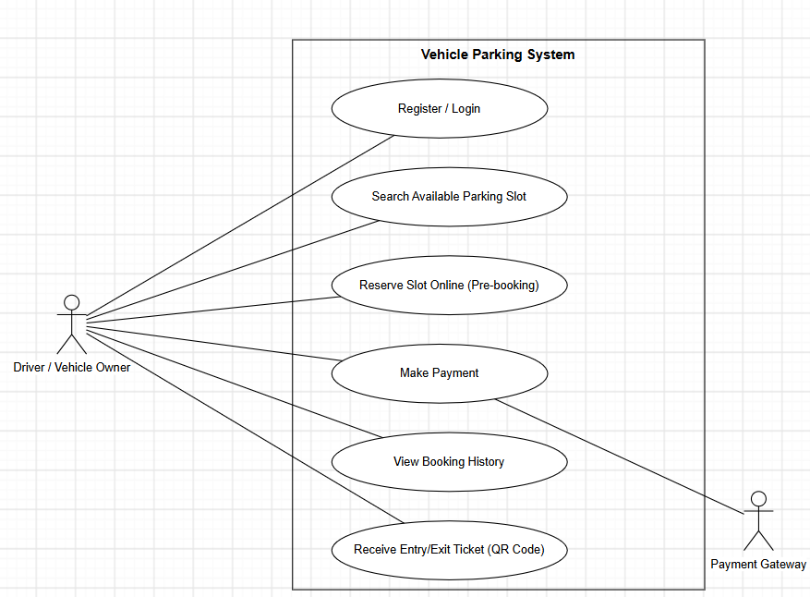

7.2 UML Use-Case Diagram 2 — Admin / Parking Attendant
This diagram shows the management-side interactions: the Admin configures lots, pricing, and staff accounts and reviews reports; the Parking Attendant monitors occupancy and can manually override the gate; the Gate Controller is modelled as an external actor triggered by the manual override use case.
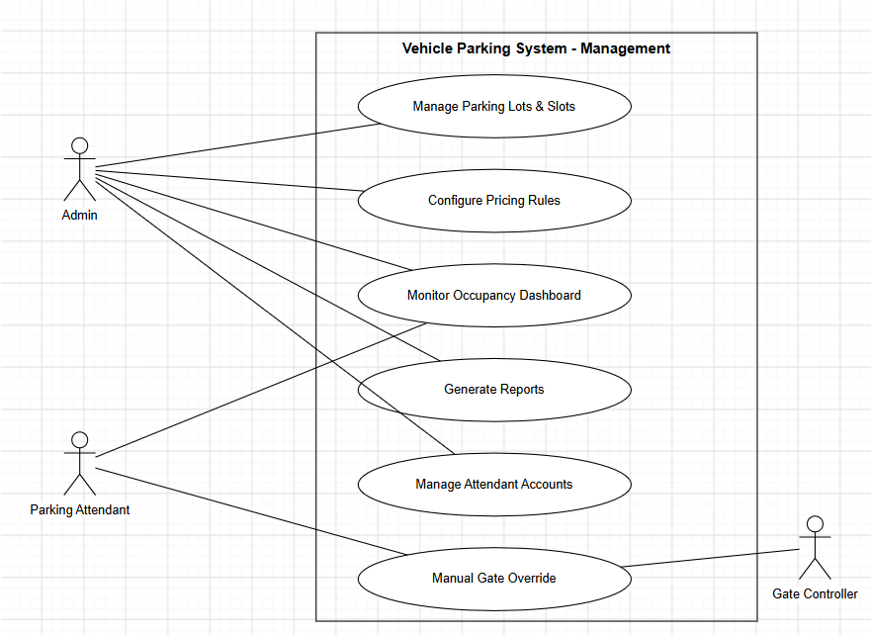

8. Requirements Traceability Matrix (RTM)
Req ID | Requirement short | Section ref / Design Spec | Module | Test case(s) | Status (N/P/A) | Comments
VPS-F-001 | Capture vehicle entry | 4.1 / DS-Entry-01 | EntryModule | TC-Entry-01 | N
VPS-F-002 | Auto slot allocation | 4.1 / DS-Entry-02 | AllocationModule | TC-Entry-02 | N
VPS-F-010 | Calculate parking fee | 4.2 / DS-Exit-01 | BillingModule | TC-Exit-01 | N
VPS-F-011 | Verify payment before exit | 4.2 / DS-Exit-02 | PaymentModule | TC-Exit-02 | N
VPS-F-020 | Online slot reservation | 4.3 / DS-Res-01 | ReservationModule | TC-Res-01 | N
VPS-NF-001 | Transaction response time | 5 / DS-Perf-01 | WebUI / API | TC-Perf-01 | N
VPS-SR-001 | TLS 1.2+ enforcement | 5.1.2 / DS-Sec-01 | All Modules | TC-Sec-02 | N

