Vehicle Rental Management System
SB Car Rental


Item | Details
Course | Software Engineering
Instructor | Dr. Haya Samaaneh
Prepared by | Bana Sarhan & Shaimaa Ghanem
Team | SE-37

1. Executive Summary
The Vehicle Rental Management System is a Java desktop application developed for SB Car Rental. It helps a manager perform the main rental operations: login, view vehicles, rent a vehicle, return a vehicle, calculate billing, review vehicle types, and send rental reminders. The application uses a clean Swing graphical interface and follows a layered structure to keep presentation, service, domain, repository, billing, notification, and validation responsibilities separated.
The final version includes a consistent visual identity, SB Car Rental branding, manual GUI verification, unit testing for business logic, Mockito-based testing for notification behavior, Maven build support, and GitHub collaboration evidence.

2. Introduction and Problem Statement
Vehicle rental work can become difficult when availability, rental status, late penalties, and reminders are handled manually. Manual processing may cause double booking, incorrect billing, missing return records, or forgotten reminders.
This project provides a structured solution that allows a manager to control the rental workflow through one desktop system. The project was implemented as a software engineering application with focus on maintainability, object-oriented design, testing, and clear user interaction.

3. Project Objectives
- Provide a complete manager workflow for vehicle rental operations.
- Display vehicles and vehicle types in an organized interface.
- Validate rental input and prevent invalid rental operations.
- Calculate rental cost, late penalty, and total cost using a billing service.
- Separate responsibilities using layered architecture and service classes.
- Apply design patterns where they improve flexibility and maintainability.
- Use JUnit, Mockito, JaCoCo, Git, and GitHub to support quality and collaboration.

4. Scope and Main Features
Feature | Description
Manager Login | Authenticates the manager before accessing the dashboard.
View Vehicles | Displays available vehicles and vehicle details.
Rent Vehicle | Allows selecting a vehicle and entering a valid rental duration.
Return Vehicle | Returns an active rental and makes the vehicle available again.
Billing | Calculates rental cost, late penalty, and total amount.
Vehicle Types | Lists vehicles by categories such as Car, Van, Truck, Motorcycle, and Electric Vehicle.
Rental Reminder | Uses the notification service to send rental reminder messages.
Testing | Uses unit tests, mocking, coverage measurement, and manual GUI testing.

5. Technology Stack and Tools
Tool / Technology | Usage
Java | Main programming language.
Swing | Desktop graphical user interface.
Maven | Build lifecycle and dependency management.
JUnit 5 | Unit testing for business logic.
Mockito | Mocking notification behavior in tests.
JaCoCo | Measuring test coverage.
Git and GitHub | Version control and team collaboration.
IntelliJ IDEA | Development and project execution environment.
Draw.io | UML diagram design.

6. Sprint Implementation Summary
Sprint | Main Goal | Implemented Work
Sprint 1 | Login and view vehicles | Manager login, dashboard access, and vehicle display.
Sprint 2 | Rent vehicle | Rental service, repository usage, and rental duration validation.
Sprint 3 | Reminder and mocking | Notification service and Mockito-based verification.
Sprint 4 | Return and billing | Vehicle return flow, billing calculation, and late penalty handling.
Sprint 5 | Vehicle types | Vehicle categories and type-related validation structure.

7. System Architecture
The system follows layered architecture. Each package has a clear role, which makes the project easier to understand, test, and extend. The GUI screens do not contain the main business rules; instead, they call service classes. Repositories manage stored data, and domain classes represent the main business objects.
Layer / Package | Responsibility
Presentation | Swing frames such as LoginFrame, DashboardFrame, RentVehicleFrame, ReturnVehicleFrame, BillingFrame, VehicleTypesFrame, and RentalReminderFrame.
Service | Business operations such as login, vehicle retrieval, rental processing, return processing, and reminders.
Domain | Core objects such as Vehicle, Rental, and Manager.
Repository | In-memory storage for vehicles, rentals, and manager data.
Billing | Rental cost, late penalty, and total cost calculations.
Notification / Observer | Reminder notification behavior and observer-based message handling.
Strategy / Vehicle Type | Vehicle-specific type behavior and extendable validation structure.

8. UML Class Diagram
The UML class diagram shows the main classes, inheritance relationships, service dependencies, repositories, Strategy Pattern, Observer Pattern, and notification structure. It gives a high-level view of how the project components work together.
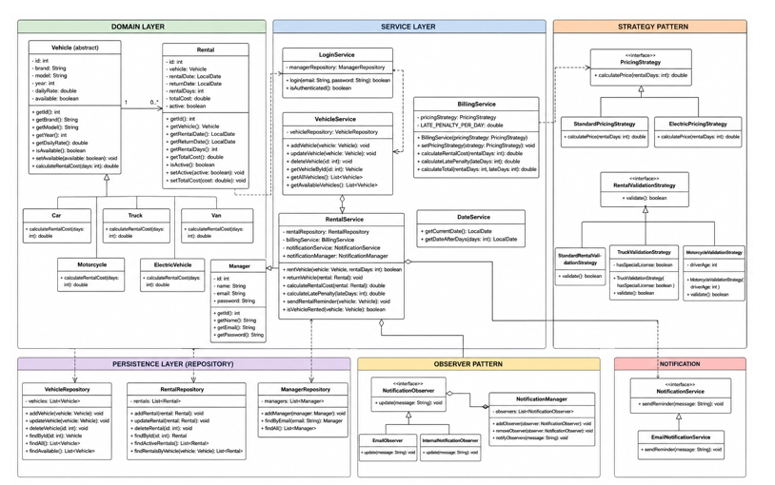

9. Detailed Feature Description
Screen / Feature | Description
Splash Screen | Shows SB Car Rental branding and a loading progress bar before opening the login screen.
Login Screen | Validates username and password and opens the dashboard after successful login.
Dashboard | Central navigation screen for all main system functions.
View Vehicles | Displays vehicle information in a table.
Rent Vehicle | Allows selecting a vehicle and entering valid rental days.
Return Vehicle | Allows returning an active rental.
Billing | Calculates rental cost, late penalty, and total amount.
Vehicle Types | Displays vehicles grouped by category.
Rental Reminder | Sends a reminder message through the notification service.

10. Design Patterns
Pattern | How it is used | Benefit
Strategy Pattern | Separates vehicle-related validation or pricing behavior into interchangeable strategy classes. | Supports Open/Closed Principle and reduces hardcoded rules.
Observer Pattern | Separates notification observers from the reminder trigger logic. | Allows adding new notification channels without changing rental logic.
Repository Pattern | VehicleRepository, RentalRepository, and ManagerRepository isolate data access. | Keeps storage logic separate from services and GUI classes.

The project also applies separation of concerns. For example, BillingFrame calls BillingService instead of calculating prices inside the GUI, and reminder screens call service/notification classes instead of directly handling message logic.

11. User Interface Design
The final GUI design uses a consistent soft blue and navy palette, white rounded cards, clear form fields, and professional spacing. The redesign improves readability and makes all screens feel like part of the same system.
UI Element | Design Decision
Primary color | Deep navy blue for branding and headers.
Secondary color | Medium blue for main action buttons.
Background | Soft light blue/gray background for comfort and readability.
Cards | White rounded cards with subtle shadows.
Buttons | Consistent button size, colors, and hover effects.
Logo | SB Car Rental logo with vehicle illustrations and matching colors.

12. Testing and Quality Assurance
Testing focused on service logic, billing behavior, authentication behavior, rental operations, and notification handling. Mockito was used to verify reminder behavior without depending on a real email server. GUI screens were verified manually because desktop interface behavior is better validated through user interaction scenarios.
QA Activity | Purpose
Unit testing | Tests service logic such as rental, billing, login, and repository behavior.
Mocking | Uses Mockito to verify notification calls without sending real emails.
Coverage | JaCoCo report confirms tested code percentage. GUI screens were excluded from unit-test coverage and tested manually.
Manual testing | All screens were checked with valid and invalid inputs.
Build verification | Maven build and IntelliJ rebuild were used to confirm project compilation.

The final JaCoCo report after excluding GUI presentation classes shows 78% instruction coverage and 75% branch coverage. The presentation screens are documented as manually tested because they are Swing UI classes.
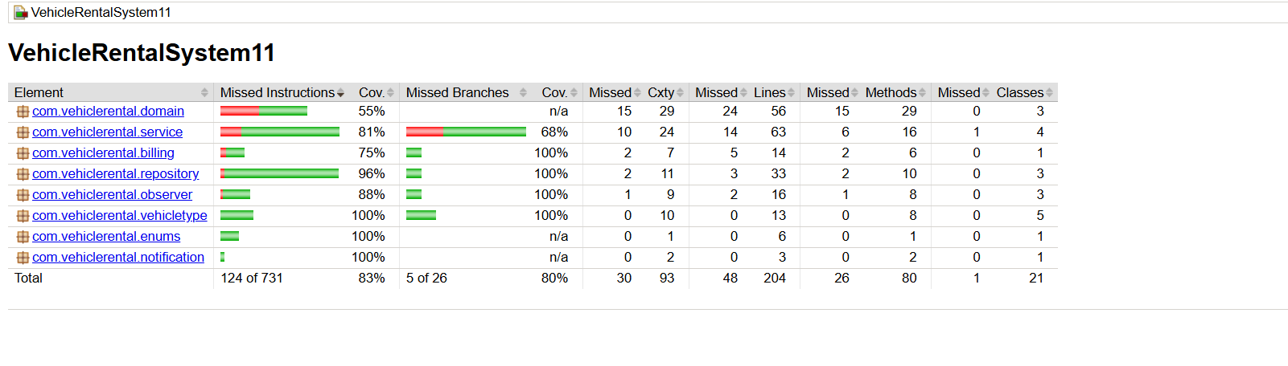

12.1 Manual Test Cases
Test Case | Steps | Expected Result | Status
Login with empty fields | Leave username/password empty and click Login. | Error message appears. | Pass
Login with valid account | Enter valid credentials and click Login. | Dashboard opens. | Pass
View vehicles | Open View Vehicles from dashboard. | Vehicle table is displayed. | Pass
Rent with invalid days | Enter 0, negative number, or text. | Validation message appears. | Pass
Rent with valid days | Select vehicle and enter valid days. | Rental success message appears. | Pass
Return vehicle | Select an active rental and return it. | Vehicle returned successfully. | Pass
Billing calculation | Enter rental days and late days. | Costs are calculated and displayed. | Pass
Rental reminder | Select vehicle and send reminder. | Reminder success message appears. | Pass

13. Conclusion
The Vehicle Rental Management System successfully demonstrates a complete Java desktop application for managing rental operations. It includes manager authentication, vehicle browsing, rent and return workflows, billing, reminders, multiple vehicle types, and a redesigned professional interface.
The final system is organized and extendable. Its layered architecture, design patterns, testing approach, and GitHub collaboration make it a strong foundation for a larger rental management platform with persistent storage, customer accounts, and automated reporting.

