ML-Based Automated HR Expense Claim Intelligence: Two-Stage Bill Classification, OCR Field Extraction and Tax-Document Recognition for Indian Employee Claims
Tejvir Singh (24BAI1040)
Chitwan Singh (24BAI1629)
Dasari Durga Naga Sri Surya Vignesh (24BAI1589)
[Guide name, department, institute]

Abstract—Employee expense claims reach human resources (HR) teams as photographs, scans and PDF files of very different bills, and the staff sort and key them in by hand. This work proposes a two-stage pipeline that reads each bill with optical character recognition (OCR), classifies it into one of 16 expense categories with a calibrated fusion of a term frequency-inverse document frequency (TF-IDF) text model, an image model and a layout-aware transformer, extracts up to 34 fields, and passes any bill the first model cannot place to a second document-type classifier for rent receipts, salary slips, insurance premiums, school fees and other tax-evidence documents that were previously rejected as non-expense. The approach matters because tax-saving documents would otherwise be lost, and because a confidence-gated hand-off to HR keeps automation safe. On held-out real documents the first stage reaches 0.907 accuracy and 0.839 macro-F1, with 93.0% of bills processed automatically at 94.4% precision, and the field extractor reaches 0.663 micro-F1; the second stage scores 1.000 on synthetic held-out layouts, a saturated result that reflects the synthetic generator and shows only that the integration works, not that it will be accurate on real documents. Against the project's own baselines, the fusion is only slightly better than the best single model (the difference is not statistically established), the hybrid extractor improves micro-F1 over the rule baseline by 0.219, and a controlled comparison with recurrent, attention, summarisation-based and transformer text classifiers is reported on identical OCR text. A final multi-seed study of the transformer XLM-RoBERTa (XLM-R) against TF-IDF found a mean macro-F1 of 0.883 versus 0.831 (difference +0.052, 95% interval -0.005 to +0.127), i.e. an advantage that the test set cannot establish (inconclusive, not equivalence), at 45 times the central processing unit (CPU) latency and 25 times the model size. A ten-seed analysis, two unseen test sets and a TF-IDF-first hybrid did not change this verdict. Published scores are not compared directly because datasets differ.
Index Terms—expense claim automation, document classification, OCR, LayoutLMv3, information extraction, confidence calibration, two-stage classifier, Indian tax documents.
SUMMARY
This project builds a working prototype that reads the bills submitted by Indian employees and prepares them for human resources review. Each bill is read by optical character recognition and classified into one of 16 expense categories by a calibrated fusion of three models, and up to 34 fields are extracted from it. A bill that the first model cannot place is passed to a second classifier for twelve tax-evidence document types, such as rent receipts and salary slips. On held-out real documents the first stage reaches 0.907 accuracy and 0.839 macro-F1, with 93.0% of the bills handled automatically at 94.4% precision, and the field extractor reaches 0.663 micro-F1. The second stage was trained on synthetic documents only, so its perfect synthetic scores show that it is integrated correctly but say nothing about its accuracy on real documents.
The report also examines whether the large transformer XLM-R should replace the simple TF-IDF text classifier. Over 5 training seeds XLM-R reached a macro-F1 of 0.883 against 0.831 for TF-IDF (a difference of +0.052), but the interval includes zero, so the advantage is not established on the 386-document real test set (95% interval -0.005 to +0.127). Ten training seeds, two unseen test sets (one synthetic and one small real set) and a hybrid that sends only uncertain documents to XLM-R did not change this conclusion. XLM-R also needs 25 times the storage and 45 times the processor time per document, so the measured gain does not justify its cost.
TF-IDF with logistic regression therefore remains the recommended text classifier for production. The conclusions are limited by the small number of real test documents in several classes, by the 256-token input limit of XLM-R, and by the absence of real documents for the second stage; the most useful next step is a larger, labelled set of real documents from unseen templates, which would also decide whether XLM-R or the cheaper hybrid is worth deploying.
1. INTRODUCTION
Reimbursement and tax-declaration workflows in Indian organisations depend on employees uploading bills: electricity and gas statements, restaurant and fuel receipts, train and flight tickets, hotel folios, and, at year end, rent receipts, insurance premium receipts, school-fee receipts and loan-interest certificates. HR staff must decide what each document is, read its amount, date and vendor, and file it under the right head. The work is repetitive, error-prone and slow, and the documents are visually diverse: phone photographs with perspective and noise, screenshots, scanned PDFs, regional-language headings and many vendor layouts.
Automating it needs three capabilities: reading the page (OCR), deciding what kind of document it is, and extracting structured fields. Recent document-AI models such as LayoutLMv3 jointly use text, layout and image and set strong results on form and receipt understanding benchmarks [1], but benchmark scores are usually reported on clean, English, largely non-Indian data, and a deployed claim system also needs calibrated confidence so that uncertain bills are routed to a person instead of being silently mis-filed.
This project builds such a system as a working prototype. Task A classifies a bill into one of 16 expense categories using a calibrated fusion of a TF-IDF text model, a ConvNeXt-Tiny image model and a LayoutLMv3 model. Task B extracts up to 34 fields with a per-field hybrid of rules, a gradient-boosted candidate ranker and LayoutLMv3. A rule layer proposes income-tax sections as suggestions only; eligibility is left to HR. A Streamlit application and an e-mail ingestion worker expose the pipeline.
A limitation of the first version motivates the present work: its 16 labels describe what money was spent on, so tax-evidence documents (rent receipt, Form 16, salary slip, insurance premium, school fee, loan certificate, investment proof, meal-voucher statement, electric vehicle (EV) document, bank statement) fell into the 'non_expense' class. We therefore add a second-stage document-type classifier that is consulted whenever the first model finds no expense category, and the application no longer reports 'non_expense' unless the second model also cannot place the document. No public labelled dataset exists for these Indian document types, so the second stage is trained on synthetic data only; this report states plainly what that does and does not prove.
2. LITERATURE SURVEY
TABLE I. Related work reviewed: existing method, advantage, disadvantage and how this work addresses it.
Table I reviews recent work on document understanding, information extraction, document classification and confidence calibration. Journal papers published in 2021-2025 are [4], [5], [8], [16]-[27]; conference papers and preprints ([1]-[3], [6], [7], [9]-[15]) are included because they describe models and datasets used in this work. For each paper the table gives the existing work, its advantage, its disadvantage and how this project addresses it.
Ref | Existing work | Advantage | Disadvantage | How this work overcomes it
[1] Huang et al., 2022 | LayoutLMv3: unified text and image masking, word-patch alignment pre-training for Document AI. | State of the art on form, receipt, visual question answering (VQA), classification and layout tasks with one architecture. | Needs fine-tuning data; weights are CC-BY-NC-SA (non-commercial); benchmarks are not Indian bills. | Fine-tuned on our bills and used inside a calibrated fusion and a hybrid extractor, with real-only evaluation.
[2] Xu et al., 2021 | LayoutLMv2: multi-modal pre-training with spatial-aware attention for visually-rich documents. | Adds visual and 2-D relative-position cues to text; strong on FUNSD, CORD, SROIE. | Heavier visual backbone; still needs OCR and in-domain labels. | We use OCR once and share it among all models; cheaper TF-IDF model is part of the fusion.
[3] Li et al., 2022 | DiT: self-supervised pre-training of a document image transformer. | Strong image-only document classification (RVL-CDIP) without OCR. | Document-type labels are generic (letter, memo...), not tax-evidence types; zero-shot DiT could not separate our types. | We trained an OCR-text document-type model for the missing Indian types.
[4] Yeghiazaryan et al., 2022 (IEEE Access) | TokenGrid: graph convolutional network (GCN) over text segments plus bidirectional long short-term memory (BiLSTM)-CRF for key information extraction from unstructured documents. | Uses text, visual and spatial cues together; efficient. | Needs annotated field data per layout; limited public Indian data. | Hybrid extractor picks the best system per field on validation; fields without evidence are left empty, not guessed.
[5] Yan et al., 2025 (Information Processing & Management) | DocExtractNet: LayoutLMv3-based framework for receipts with an ImageEnhance step for low-quality images and a PrecisionHints strategy that supplements missing key-value pairs. | Reports F1 of 97.38% on CORD (96.56% for the LayoutLMv3 baseline). | Evaluated on CORD, FUNSD and a finance-receipt set, not on Indian bills; extraction accuracy is the focus, not routing of uncertain cases. | We evaluate on real Indian bills and add calibrated abstention and an HR-review route.
[6] Larson, Lim and Leach, 2023 (EACL) | Critical evaluation of RVL-CDIP: estimated 8.1% label noise, ambiguous documents, train-test overlap and personal data. | Shows reported accuracies may be inflated. | Diagnoses the problem but supplies no new data. | Group-aware splits, near-duplicate audit, real-only headline metrics; synthetic scores reported separately.
[7] Cui et al., 2021 | Survey 'Document AI: Benchmarks, Models and Applications'. | Maps tasks, datasets and pre-training approaches. | Survey only; no deployment guidance. | Used to select the model families (text, image, layout) combined here.
[8] Rombach and Fettke, 2025 (ACM Computing Surveys) | Systematic literature review of deep-learning key information extraction from business documents, covering 130 approaches published 2017-2024. | Compares approaches and datasets across the field. | A survey: it does not supply labelled Indian tax-document data. | Dataset audit with provenance and licence register; synthetic data clearly separated from real.
[9] Wang et al., 2025 (arXiv 2510.13366) | Survey 'Document Intelligence in the Era of Large Language Models'. | Covers large language model (LLM)-based document understanding. | LLM output can be wrong or ungrounded. | Optional local LLM may only confirm values found in the OCR text and never overwrites the extractor.
[10] Wang et al., 2022 (LiLT) | Language-independent layout transformer for structured document understanding. | Transfers across languages by decoupling layout from text. | Needs per-language fine-tuning for best results. | Indian bills with Hindi headings are handled by the TF-IDF and image branches as well.
[11] Appalaraju et al., 2021 (DocFormer) | Multi-modal transformer with shared spatial features for document understanding. | Strong on RVL-CDIP and entity tasks. | Large pre-training cost. | Smaller fine-tuned models on a 6 GB graphics processing unit (GPU).
[12] Kim et al., 2022 (Donut) | OCR-free document understanding transformer. | Avoids OCR error propagation. | Heavy; weaker on small noisy photos with little data. | We keep OCR but fall back to the image model when OCR is empty.
[13] Liu et al., 2022 (ConvNeXt) | Modernised pure-ConvNet image backbone. | Efficient, accurate image features. | Image-only; weak at reading amounts or titles. | Used as the image branch of the fusion.
[14] Guo et al., 2017 | Temperature scaling for calibrating neural network confidence. | Simple, effective, one parameter. | Calibration alone does not decide when to defer. | Per-model temperatures plus a validation-chosen routing threshold tau = 0.61.
[15] Huang et al., 2019 | ICDAR 2019 SROIE: scanned receipt OCR and information extraction competition and dataset of 1,000 receipt images. | Standard receipt benchmark. | Not Indian bills and limited to a few key fields. | Used as one real source among several, never as the only evidence.
[16] Mifsud et al., 2025 (Machine Learning and Knowledge Extraction) | Receipt information extraction with a joint multi-modal transformer and a rule-based model, on a dataset of real and synthetic receipts (DocTR for OCR). | Reports overall F1 of 0.98 on classifying receipt text, including line items; shows that a rule layer can add to the transformer. | Receipt extraction only; no document-type or tax-evidence classification. | We also combine learned models with a rule layer (document profile and tax suggestions) and add a second-stage document-type model.
[17] Liu et al., 2021 (Neurocomputing) | Survey 'Document image classification: Progress over two decades': textual, structural, visual and hybrid methods on public benchmarks. | Organises classification methods and open issues. | Survey; benchmark document types are generic, not tax-evidence types. | Hybrid text + image + layout fusion for Task A and a text model for the new tax-document types.
[18] Gawlikowski et al., 2023 (Artificial Intelligence Review) | A survey of uncertainty in deep neural networks. | Reviews ways to estimate and use model uncertainty. | General; not specific to bills or documents. | Calibrated confidence plus a validation-chosen routing threshold sends uncertain bills to HR.
[19] Ha and Horak, 2022 (Signal Processing: Image Communication) | OCRMiner: extracts indexing metadata from scanned invoices by combining text analysis with layout features on top of standard OCR output. | Works from possibly erroneous OCR output; the authors report recovering invoice data in 90% of English and 88% of Czech invoices with an open-source OCR. | Targets (semi-)structured invoices and metadata extraction; it does not decide an expense category or hand uncertain documents to a person. | We also read OCR output with layout cues (LayoutLMv3 branch) but add expense classification, a second document-type stage and a confidence-gated HR route.
[20] Baviskar et al., 2021 (IEEE Access) | A high-quality multi-layout unstructured invoice dataset, assessed with a statistical data-validation technique and evaluated with several feature-extraction approaches for key-field extraction. | Diverse invoice layouts and a documented validation process address the shortage of annotated invoice data. | Covers invoice documents for field extraction; it does not provide expense-category or tax-evidence labels. | We keep a provenance and licence register, split by template group and report real and synthetic scores separately.
[21] Saifullah et al., 2024 (IEEE Access) | Studies nine explainability methods on ten document-classification models using RVL-CDIP and Tobacco3482; most methods give poor explanations, and only Occlusion and DeepSHAP are relatively faithful. | Shows that high benchmark accuracy does not mean a model relies on meaningful evidence. | An analysis study: it does not offer a deployable classifier or a routing rule. | Our main text classifier is an inspectable linear model, and every model is judged on real-only metrics with calibrated confidence.
[22] Omurca et al., 2023 (Applied Intelligence) | Classifies twelve types of university student documents uploaded as PDF using (i) OCR with traditional machine learning, (ii) deep learning and (iii) an entropy-based fusion of deep models; the best F-score is 94.45% (EfficientNetB3 with ExtraTree). | Shows that combining text-based and image-based models improves document classification. | One institution and twelve document types; no calibrated abstention or tax-evidence types. | Calibrated fusion of text, image and layout models with a validation-chosen threshold, plus a second stage for tax documents.
[23] Gbada et al., 2024 (Neurocomputing) | Models a visually rich document as a weighted graph whose nodes carry visual, textual and spatial features and classifies nodes with a graph convolutional network; evaluated on invoices and receipts. | Uses relations between neighbouring text regions; reported to match or exceed strong baselines. | Needs node-level field annotations; benchmark documents are not Indian bills. | A per-field choice between rules, a candidate ranker and LayoutLMv3 is made on validation data; fields without evidence are left empty.
[24] Gbada et al., 2024 (International Journal on Document Analysis and Recognition) | Survey of deep-learning approaches for information extraction from visually rich documents: datasets, challenges and methods. | Organises methods, datasets and open problems in one place. | A survey; it supplies no labelled Indian tax-document data. | Used to choose the model families and to document dataset gaps.
[25] Balanya et al., 2024 (Neural Computing and Applications) | Studies post-hoc confidence scaling that generalises temperature scaling; shows that complex calibrators fail when data are limited and proposes entropy-based temperature scaling that is robust to data scarcity. | Guidance on calibrating when only a small validation set exists. | Evaluated on standard classification benchmarks, not on documents. | We fit one temperature per model on the validation set only, which suits our small validation sets.
[26] Fernando and Tsokos, 2022 (IEEE Transactions on Neural Networks and Learning Systems) | A dynamically weighted balanced loss for class-imbalanced learning that is classification-calibrated, tested on cyber-intrusion and medical-imaging data. | Addresses minority-class errors and confidence calibration together. | Not tested on document classification. | Our models use balanced class weights and we report macro-F1 and per-class scores so that minority-class errors are visible.
[27] Luxemburk and Cejka, 2023 (Computer Networks) | Releases a dataset with almost 200 fine-grained service labels and a neural network with a reject option; it reports 97.04% accuracy and detection of 91.94% of unknown services at a 5% false-positive rate. | Demonstrates that a classifier can refuse inputs of classes it has not seen. | Applied to encrypted network traffic, not to documents. | The second stage accepts a label only at probability 0.60 or higher and otherwise leaves the document as non_expense for HR review.

Summary: published work shows that multimodal transformers are accurate on benchmark documents, that benchmark labels can be noisy [6], and that confidence calibration is needed for deployment [14]. None of the surveyed work provides a classifier for Indian tax-evidence document types or an end-to-end claim workflow with a human-review route; this project fills that gap with the limits stated in Section 4.
3. PROPOSED WORK
The system accepts a bill image or PDF (or an e-mail attachment), validates it, renders pages and runs RapidOCR on the GPU once. Stage 1 (Task A) fuses three classifiers - TF-IDF + logistic regression on OCR text, ConvNeXt-Tiny on the image and LayoutLMv3 on text, layout and image - after per-model temperature scaling, with weights 0.5 / 0.3 / 0.2 selected on validation only. A bill whose fused confidence is below tau = 0.61 is flagged for HR review. In parallel, Task B extracts 34 fields (merchant, invoice number and date, totals, goods and services tax identification number (GSTIN), central goods and services tax (CGST)/state goods and services tax (SGST)/integrated goods and services tax (IGST), travel and hotel fields and so on) with a per-field choice between a rule baseline, a gradient-boosted candidate ranker and a LayoutLMv3 token classifier.
Stage 2 (new) is a document-type classifier for the categories Stage 1 has no label for: rent_receipt, rental_agreement, insurance_premium_receipt, school_fee_receipt, loan_interest_certificate, loan_statement, investment_certificate, meal_voucher_statement, ev_document, form_16, salary_slip and bank_statement (cheque has no approved data and is not covered). It is a TF-IDF (character 2-5 grams + word 1-2 grams) logistic-regression model on OCR text, trained only on synthetic documents generated by the project (11 types, 110 documents each) plus a synthetic bank-statement set, with whole layouts held out for validation and test. It is invoked only when Stage 1 returns 'non_expense', fails, or is below the routing threshold, and its answer is accepted only at probability >= 0.60. When accepted for a 'non_expense' bill, the new type replaces the label everywhere in the application and the bill is filed under it; otherwise the bill stays non_expense. The result is always marked for HR review because the model has never seen a real document of these types.
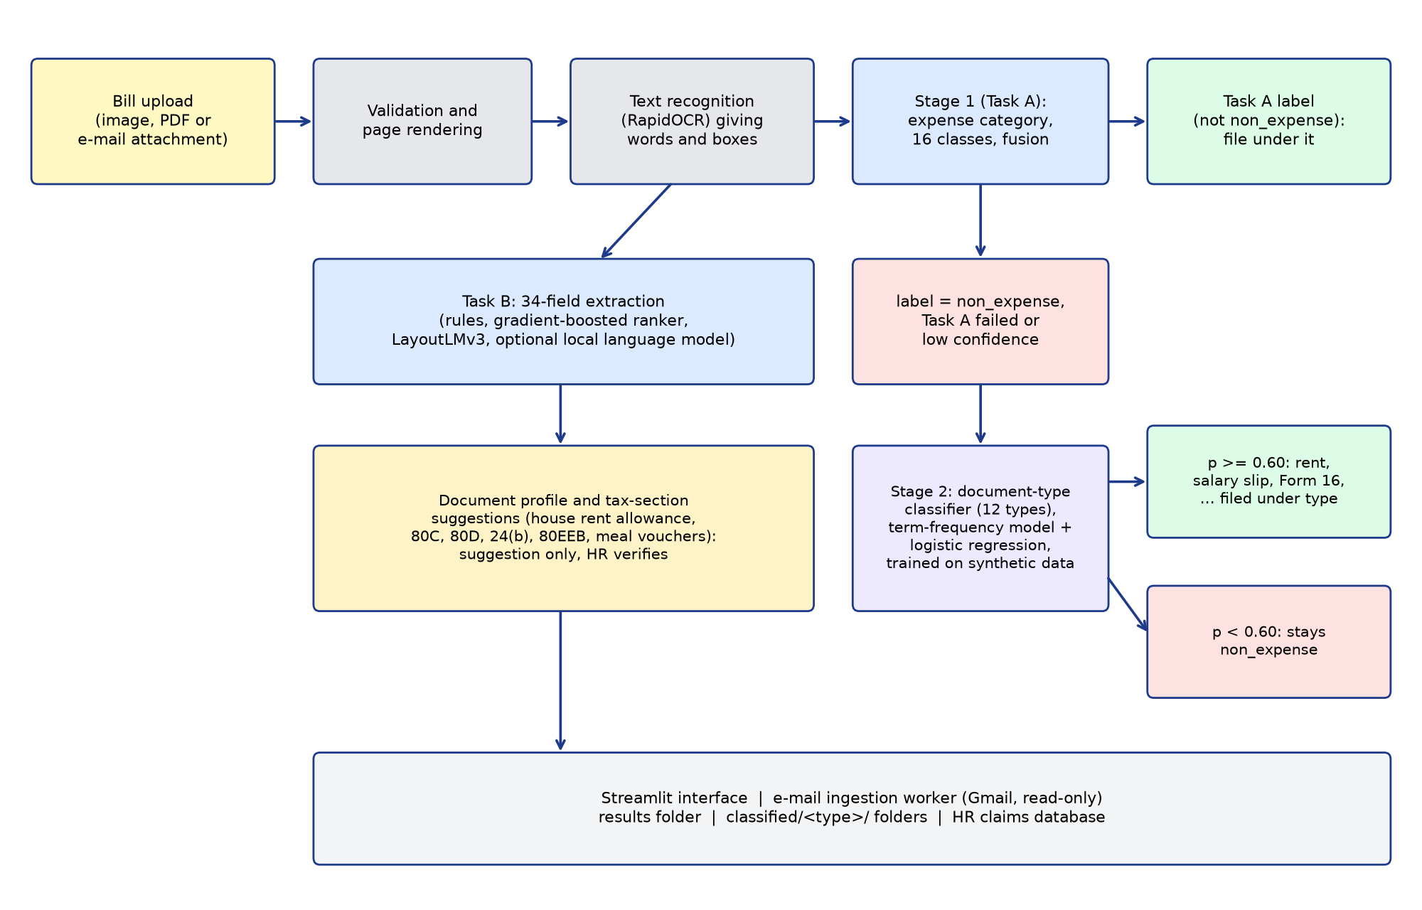
Fig. 1. Architecture and flow of the two-stage bill classification and extraction pipeline.
Implementation notes: Python, PyTorch, scikit-learn, RapidOCR (ONNX), Streamlit; the e-mail worker polls a Gmail mailbox read-only and processes only registered senders. The second stage lives in app/second_classifier.py and is wired in app/service.py; the training script is scripts/doc_type_new/train_new_classes.py.
4. PERFORMANCE ANALYSIS
4.1 Parameters, data and testing
Data. The expense dataset has 7,924 documents (5,494 real, 2,430 synthetic Indian). Splits are by document group (template, merchant, near-duplicate family) with an independent audit finding no validation or test image within perceptual-hash distance 4 of training. Task A: train 4,848 (2,904 real), validation 634 (391 real), test 629 (386 real). Task B: 6,442 documents (2,932 real, 3,510 synthetic), split 5,160 / 646 / 636. All hyper-parameters, fusion weights, temperatures and thresholds were chosen on validation data; the test set was evaluated once per model.
Metrics. Real-document accuracy and macro-F1 are the headline numbers because templated synthetic bills score about 1.0 for every model. Confidence intervals are bootstrap over document groups. Expected calibration error measures how well confidence matches correctness; auto-coverage and auto-precision describe the HR routing rule. Task B uses per-field precision, recall and F1 and the micro-F1 over fields.
Second-stage test design. The 12 new classes were trained on two layouts, validated on a third and tested on an unseen layout (layout D; held-out templates for bank statements): 357 validation and 274 test documents. To choose the acceptance threshold, we measured the maximum second-stage probability on 600 synthetic test bills of the existing types: median 0.18, 99th percentile 0.47, while correct new-type documents scored at least 0.93 at the 1st percentile; the threshold was therefore set to 0.60.
4.2 Results obtained
TABLE II. Task A (expense category) on the held-out test set, real documents.
Model | Real acc. | Real macro-F1 (95% confidence interval) | Real-Indian acc. | expected calibration error
TF-IDF + logistic regression (OCR text) | 0.883 | 0.831 (0.75-0.87) | 0.936 | 0.026
ConvNeXt-Tiny (image) | 0.800 | 0.627 (0.54-0.67) | 0.836 | 0.068
LayoutLMv3-base | 0.863 | 0.704 (0.62-0.77) | 0.909 | 0.045
Calibrated fusion (final) | 0.907 | 0.839 (0.75-0.89) | 0.955 | 0.020

Routing: with tau = 0.61 the test result is 93.0% auto-coverage at 0.944 auto-precision (27 of 386 real documents sent to HR). Group 5-fold cross-validation of the text model gives 0.857 real accuracy / 0.838 macro-F1.
TABLE III. Task B (field extraction), real test documents.
System | Real micro-F1 (95% confidence interval) | Real macro-F1 | Indian-real micro-F1
Rule baseline | 0.444 (0.414-0.480) | 0.358 | 0.467
gradient-boosted decision tree (GBDT) candidate ranker | 0.546 (0.501-0.588) | 0.451 | 0.449
LayoutLMv3 | 0.646 (0.606-0.685) | 0.549 | 0.534
Hybrid (final) | 0.663 (0.621-0.697) | 0.578 | 0.599

Per-field real F1 of the hybrid: total_amount 0.820, tax_total 0.821, merchant_address 0.829, subtotal 0.765, invoice_date 0.750, merchant_name 0.543, invoice_number 0.422. Merchant name and invoice number remain weak and should be verified by a person.
TABLE IV. Second-stage classifier (synthetic data only; 12 classes). The perfect scores are a property of the synthetic generator, not an estimate of real-world accuracy.
Evaluation | Documents | Accuracy | Macro-F1 | Notes
Validation (held-out layout) | 357 | 1.000 | 1.000 | no confusions
Test (unseen layout / templates) | 274 | 1.000 | 1.000 | refit on train+val for the saved model
Test, class-name keywords removed | 274 | 1.000 | - | diagnostic: model unchanged
Test, half of the words dropped at random | 274 | 1.000 | - | mean of 5 random draws
Test, keywords removed and half of the words dropped | 274 | 1.000 | - | mean of 5 random draws

Why the accuracy is 1.000. The held-out 'layout' differs in page design, but every document of a type is produced by the same generator, so documents of one type share the same field labels, number formats and phrasing, and the types differ from one another in many words, not only in their titles. The classifier is a linear model on word and character n-grams, which separates such classes trivially. Removing the class-name keywords, or dropping half of the words at random, leaves the accuracy at 1.000 (Table IV), which shows that the score does not depend on a few title words and that the task is saturated. Bank statements, taken from a different source, are also 100 of the 274 test documents. A real rent receipt, salary slip or insurance receipt varies in wording, language, layout and print quality far more than this generator does, and the accuracy on real documents is unknown and expected to be much lower. For this reason the second stage keeps the 0.60 acceptance threshold, marks every accepted result for HR review, and no real-world accuracy is claimed for it.
End-to-end checks in the application: all 12 new document types were uploaded through the Streamlit interface; the second stage accepted and filed each under its type (confidence 0.93-0.99). A confident expense bill (food) never reached the second stage, and text the model cannot place (a generic thank-you line, empty text) stays non_expense. The application's self-test passes 32 of 32 checks, including the second-stage cases. Thirteen real bills from the held-out test split (one per expense category, e.g. electricity, gas, water, parking, train, hotel) were re-run through the full pipeline and all were classified correctly with confidence 0.989-1.000. Runtime: models load in about 7-8 s; OCR runs at roughly 170 images per minute on an RTX 4050 (6 GB); a bill takes on the order of ten seconds from upload to result in the interface.
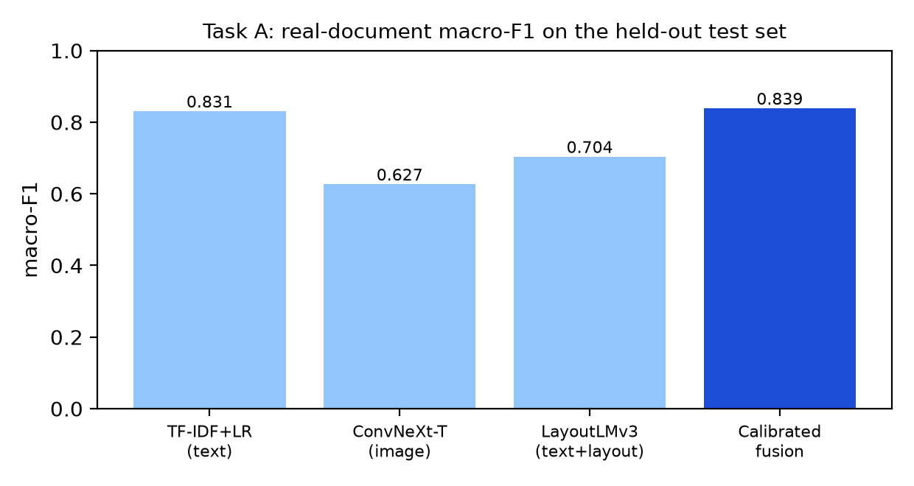
Fig. 2. Task A real macro-F1 per model: the calibrated fusion is the best.
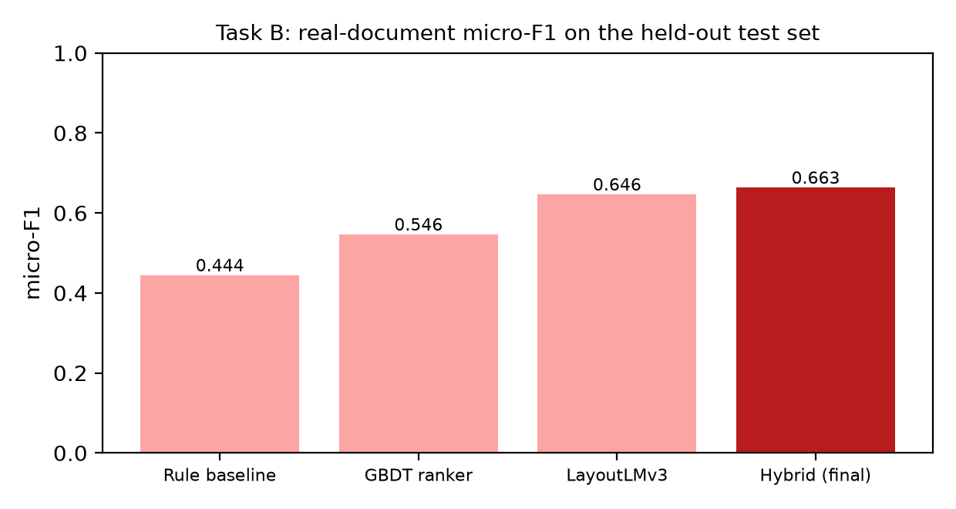
Fig. 3. Task B real micro-F1 per system: the hybrid is the best.
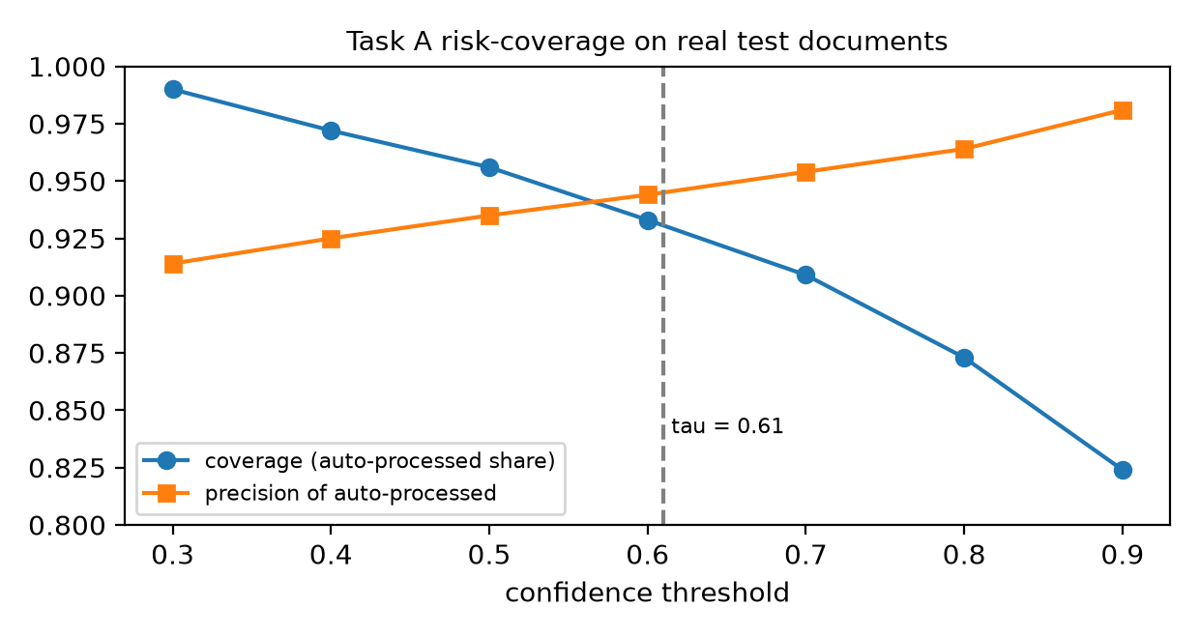
Fig. 4. Task A risk-coverage on real test documents; the dashed line is the chosen threshold.
4.3 Comparative analysis
The comparison above is against this project's own baselines (single models; rule, ranker and LayoutLMv3 extractors), all evaluated on the same held-out real documents: fusion scores slightly higher than the best single model (macro-F1 0.839 vs 0.831; accuracy 0.907 vs 0.883), but a paired bootstrap (Section 4.4) finds the difference from TF-IDF alone not statistically established, and its expected calibration error (0.020) is only modestly lower than TF-IDF's (0.026) without an interval; the hybrid extractor the hybrid extractor beats the rule baseline by 0.219 micro-F1 with a paired bootstrap interval of [0.192, 0.247]. A numeric comparison with figures published in the surveyed papers (for example RVL-CDIP accuracies in the mid-to-high 90s, or SROIE/CORD field F1) would be misleading: those use different datasets, label sets and splits, and [6] shows that even the benchmark labels carry noise. Qualitatively, our system adds what the surveyed models do not: calibrated abstention, an HR route, Indian document types and a complete claim workflow.
4.4 Comparative Evaluation of OCR and Text Classification Approaches
4.4.1 Objective
A reviewer asked why TF-IDF is used and why recurrent neural networks (RNNs), LexRank, attention or Transformer models are not. Two different questions are hidden in this. (A) OCR text recognition turns pixels into characters; TF-IDF plays no role there. (B) OCR text classification takes the text that OCR has already produced and assigns one of the 16 expense categories; this is where TF-IDF is used. We therefore measured both separately, on the project's existing splits, with the project's own ground truth, and report failures as well as successes. LexRank is an extractive summariser: it cannot read an image and cannot classify, so it is evaluated only as a summarise-then-classify pipeline and has no OCR row.
4.4.2 Methodology
Data and splits. Text classification uses the unchanged Task A splits (train 4,848 / validation 634 / test 629 documents; 16 categories). The headline numbers are on the REAL test documents (n = 386), as in the rest of this report; results on all 629 test documents (incl. synthetic) are in the CSV files. Every text model receives the same OCR text of the same documents (the stored RapidOCR output). Hyper-parameters, epochs and early stopping use validation data only; the test set was never used to choose hyper-parameters, epochs or seeds (for transparency the three seeds of each BiLSTM and the four LexRank settings were all scored on it; the reported seed was chosen by validation macro-F1 and the 50% LexRank setting was fixed in advance). One temperature per model is fitted on validation logits and applied to test (the same recipe as the production fusion), so expected calibration error, negative log-likelihood and Brier are reported raw and temperature-scaled; expected calibration error uses 10 equal-width confidence bins.
Models. (1) TF-IDF + logistic regression: the production configuration, re-fitted and verified to reproduce the production probabilities exactly (word 1-2 + character 2-5 grams, C = 10, class-balanced). (2) BiLSTM: 128-d embeddings trained from scratch, 1 bidirectional LSTM layer with 128 hidden units, dropout 0.4, 256 tokens. (3) BiLSTM + additive attention pooling: identical except for the pooling. Both: AdamW, learning rate 2e-3, batch 64, up to 30 epochs, early stopping on validation macro-F1, class-balanced loss, three seeds (the seed with the best VALIDATION macro-F1 is reported). (4) LexRank summarisation + the same TF-IDF/logistic regression: OCR lines are the units, LexRank (similarity threshold 0.10, damping 0.85) keeps the most central 75 / 50 / 25 percent of the lines; the 50% setting was fixed as the headline before the results were seen. (5) XLM-RoBERTa-base, a pretrained multilingual Transformer (the data contains English, German, Portuguese, Indonesian and Japanese), fine-tuned (all encoder layers and the classification head; the 192M-parameter word-embedding matrix was frozen so that training fits in 6 GB): 256 tokens, learning rate 3e-5, batch 16, bf16, up to 6 epochs, early stopping, one seed in this section (the original run; Section 4.5 repeats it over five seeds), no hyper-parameter search. (6) LayoutLMv3-base and the production fusion, taken read-only from the production checkpoints as reference rows; unlike the other models they also use the page image and layout.
Statistics. Differences from TF-IDF use a paired group bootstrap (2,000 resamples of whole templates/merchants; the same resampled documents for every model) with 95% intervals. Several models are compared with the same test set, so an isolated 'significant' interval can arise by chance; we call a difference established only when its interval excludes zero, and treat borderline cases as unresolved.
Environment: NVIDIA GeForce RTX 4050 Laptop GPU, 6 GB; Python 3.12.3, PyTorch 2.9.1+cu128, scikit-learn 1.9.1, transformers 5.18.0; seed 42. Latency is the median per-document time at batch size 1 after warm-up (GPU timings synchronised), classifier only (OCR excluded); CPU numbers use 4 threads. Timings were taken on a shared machine while other jobs ran, so differences of a few milliseconds are not meaningful.
4.4.3 OCR recognition comparison
Ground truth: the project's SROIE (receipt lines) and FUNSD (form words) transcriptions, test-split documents only (11 + 18 documents, 2,862 cropped lines/words). Each recogniser reads the same ground-truth crops (no detector, so layout errors do not mix into character error rate/word error rate). Strict character error rate/word error rate compare the text exactly; the SROIE ground truth is upper-case and keeps spaces, whereas the production recogniser drops spaces and keeps the printed case, so the case/space-insensitive character error rate is the fairer accuracy measure. The convolutional recurrent neural network (CRNN) was trained here from scratch on the training-split crops and is a small experiment, not a replacement candidate.
TABLE V. OCR recognition on test-split ground-truth crops (norm. = case- and space-insensitive).
OCR model | Architecture | character error rate strict | character error rate norm. | character error rate norm. SROIE / FUNSD | word error rate strict | word error rate case-ins. | Latency (ms/page) | Pages/s | Size (MB) | Status
RapidOCR PP-OCRv4 recogniser (production) | PP-OCRv4 text recognizer (ONNX, connectionist temporal classification (CTC) decoding) | 0.135 | 0.036 | 0.012 / 0.046 | 0.302 | 0.216 | 482.2 | 2.0 | 10.4 | completed
CRNN (convolutional neural network (CNN) + BiLSTM + CTC), trained here | CRNN: 6-conv VGG-style CNN (height 32) + 2-layer BiLSTM(256) + CTC, gr | 0.056 | 0.050 | 0.032 / 0.058 | 0.188 | 0.174 | 128.9 | 7.0 | 31.4 | completed
TrOCR-small-printed (Transformer) | TrOCR-small-printed: ViT-style image encoder + Transformer text decode | 0.304 | 0.035 | 0.002 / 0.049 | 0.392 | 0.152 | 1084.5 | 0.8 | 234 | completed (SROIE possibly seen in pre-training)

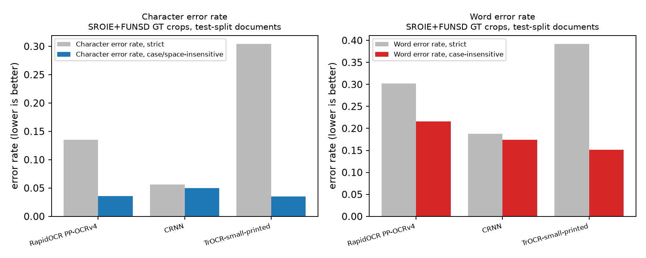
Fig. 5. Character and word error rates of the OCR recognisers on the same ground-truth crops.
4.4.4 Text-classification comparison
TABLE VI. Expense-category classification on the REAL test documents (n = 386). Same OCR text, same split; temperature fitted on validation. Latency excludes OCR; the fusion latency is the sum of its branches and was not re-measured.
Model | Layout / image? | Acc. | Macro-P | Macro-R | Macro-F1 (95% confidence interval) | Weighted-F1 | expected calibration error raw / T-scaled | negative log-likelihood (T) | Latency CPU / GPU (ms) | Size (MB)
TF-IDF + Logistic Regression | no | 0.883 | 0.910 | 0.796 | 0.831 (0.75-0.88) | 0.880 | 0.124 / 0.026 | 0.362 | 2.05 / N/A | 48.4
BiLSTM | no | 0.712 | 0.656 | 0.587 | 0.598 (0.51-0.66) | 0.696 | 0.168 / 0.057 | 1.020 | 4.70 / 1.74 | 7.9
BiLSTM + attention | no | 0.777 | 0.789 | 0.659 | 0.683 (0.59-0.74) | 0.772 | 0.159 / 0.046 | 0.883 | 4.93 / 1.92 | 8.0
LexRank 50% summary + TF-IDF/logistic regression | no | 0.852 | 0.908 | 0.765 | 0.807 (0.72-0.86) | 0.845 | 0.130 / 0.024 | 0.474 | 2.17 / N/A | N/A
XLM-RoBERTa-base (original single run, checkpoint not saved) | no | 0.899 | 0.900 | 0.881 | 0.884 (0.82-0.92) | 0.900 | 0.076 / 0.041 | 0.395 | 75.6 / 5.85 | 1064
LayoutLMv3-base (production) | yes | 0.863 | 0.772 | 0.712 | 0.704 (0.62-0.77) | 0.857 | 0.050 / 0.045 | 0.561 | N/A / 53.4 | 480
Calibrated fusion (production, 3 models) | yes | 0.907 | 0.915 | 0.814 | 0.839 (0.75-0.89) | 0.903 | 0.025 / 0.020 | 0.299 | N/A / N/A | N/A

The XLM-R row is the ORIGINAL single run (seed 0); its fine-tuned weights were not saved, so it cannot be reloaded. Section 4.5 repeats the fine-tuning over five seeds with saved checkpoints and supersedes this single-run evidence for the XLM-R conclusions.
TABLE VII. Training and inference resources. Peak memory is the GPU memory allocated during training (N/A for CPU models); LayoutLMv3's training time is taken from its original training log.
Model | Training time (s) | Device | Peak memory (MB) | CPU / GPU latency (ms) | Model size (MB) | Completed
TF-IDF + Logistic Regression | 55 | CPU | N/A | 2.05 / N/A | 48.4 | yes
BiLSTM | 45 | GPU | 439 | 4.70 / 1.74 | 7.9 | yes
BiLSTM + attention | 72 | GPU | 423 | 4.93 / 1.92 | 8.0 | yes
LexRank 50% summary + TF-IDF/logistic regression | 41 | CPU | N/A | 2.17 / N/A | N/A | yes
XLM-RoBERTa-base (original single run, checkpoint not saved) | 405 | GPU | 3568 | 75.6 / 5.85 | 1064 | yes
LayoutLMv3-base (production) | 3310 | GPU | 827 | N/A / 53.4 | 480 | yes
Calibrated fusion (production, 3 models) | N/A | GPU | N/A | N/A / N/A | N/A | yes

TABLE VIII. Per-class F1 on categories with at least 8 real test documents (precision, recall and the small categories are in table_D_per_class.csv).
Category (real test support) | TF-IDF+logistic regression | BiLSTM | BiLSTM+attn | LexRank+TF-IDF | XLM-R | LayoutLMv3
bus (n=13) | 0.750 | 0.643 | 0.593 | 0.750 | 0.727 | 0.595
electricity (n=12) | 0.917 | 0.692 | 0.800 | 0.880 | 0.923 | 0.880
flight (n=13) | 0.960 | 0.348 | 0.783 | 0.960 | 0.846 | 0.813
food (n=109) | 0.924 | 0.811 | 0.861 | 0.882 | 0.936 | 0.967
fuel (n=13) | 0.880 | 0.786 | 0.815 | 0.846 | 0.880 | 0.733
hotel (n=23) | 0.818 | 0.651 | 0.718 | 0.864 | 0.933 | 0.936
miscellaneous (n=50) | 0.909 | 0.722 | 0.804 | 0.869 | 0.857 | 0.920
non_expense (n=80) | 0.912 | 0.789 | 0.835 | 0.885 | 0.945 | 0.970
parking (n=8) | 0.800 | 0.308 | 0.625 | 0.857 | 0.941 | 0.769
train (n=28) | 0.783 | 0.389 | 0.634 | 0.634 | 0.816 | 0.585
transport (n=14) | 0.828 | 0.710 | 0.558 | 0.815 | 0.800 | 0.714

TABLE IX. LexRank summarisation + the same TF-IDF/logistic regression classifier, with random-line and first-line controls of similar length (real test documents).
Configuration | Words/doc | Text reduction | Accuracy | Macro-F1 | Summarise (ms) | Classify (ms)
Full OCR text (Model 1, flat text) | 109.7 | 0.0% | 0.883 | 0.831 | 0.00 | 2.05
All OCR lines re-joined (LexRank 100%) | 109.7 | 0.0% | 0.886 | 0.834 | 0.00 | 1.80
LexRank 75% of lines | 88.0 | 19.8% | 0.865 | 0.811 | 0.81 | 2.15
LexRank 50% of lines | 63.1 | 42.5% | 0.852 | 0.807 | 0.71 | 1.47
LexRank 25% of lines | 35.0 | 68.1% | 0.790 | 0.697 | 0.71 | 1.15
CONTROL: random 50% of lines (mean of 3 seeds) | 54.5 | 50.3% | 0.845 | 0.770 | - | -
CONTROL: first lines 50% of lines (mean of 1 seed) | 48.2 | 56.0% | 0.858 | 0.798 | - | -
CONTROL: random 25% of lines (mean of 3 seeds) | 27.2 | 75.2% | 0.782 | 0.687 | - | -
CONTROL: first lines 25% of lines (mean of 1 seed) | 23.1 | 79.0% | 0.816 | 0.747 | - | -

4.4.5 Graphical analysis
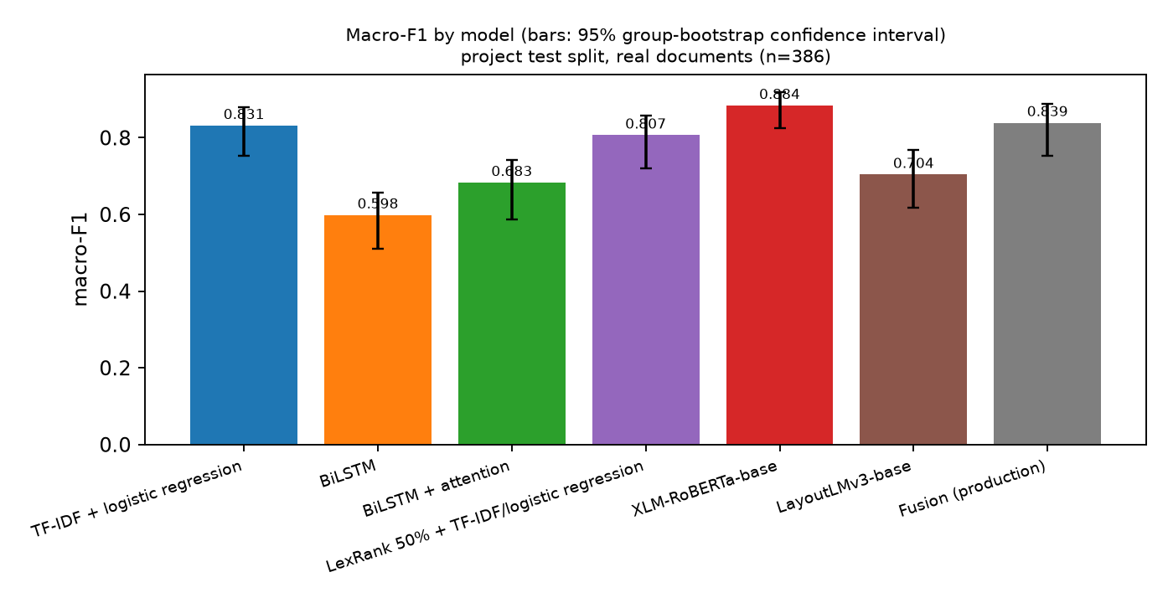
Fig. 6. Macro-F1 by model with 95% group-bootstrap intervals (real test documents; XLM-R = the original single run, see Section 4.5 for five seeds).
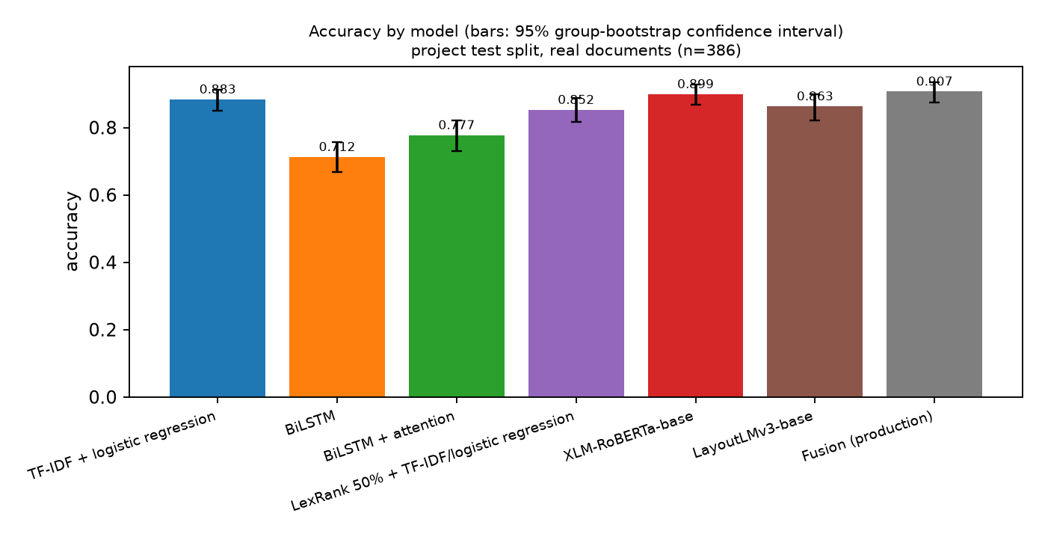
Fig. 7. Accuracy by model with 95% group-bootstrap intervals (XLM-R = the original single run).
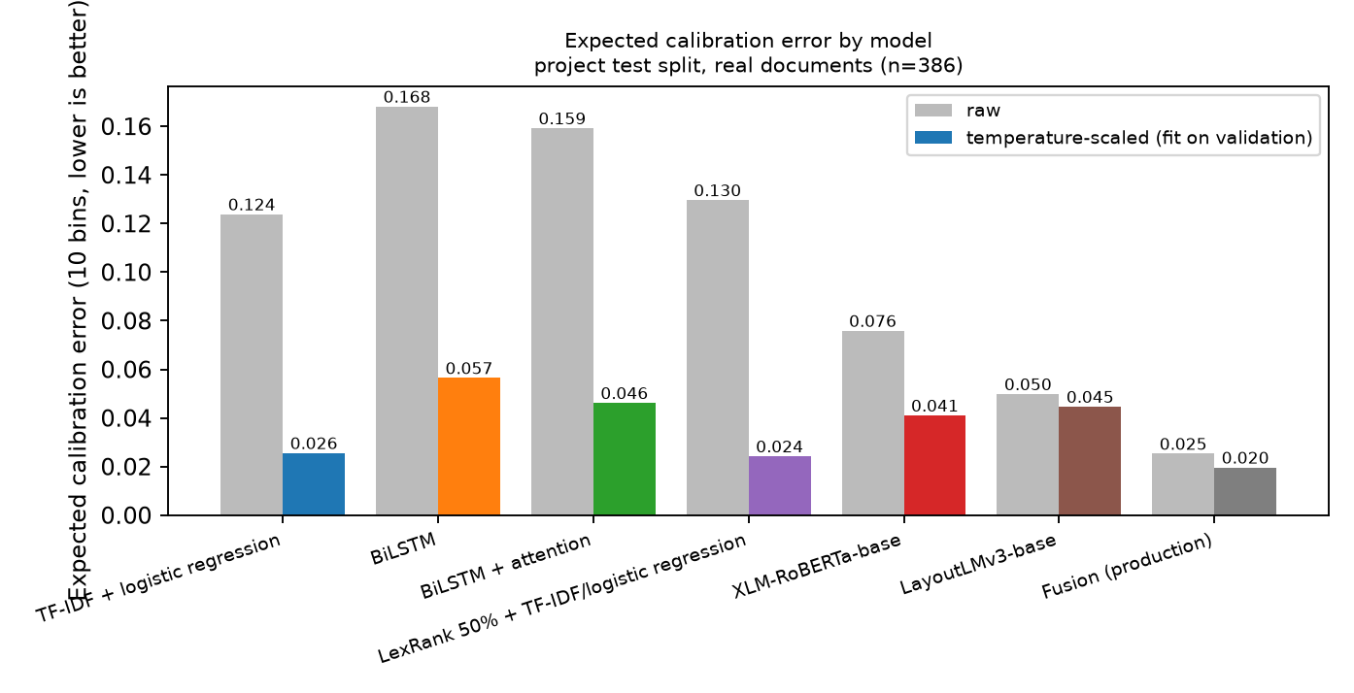
Fig. 8. Expected calibration error before and after temperature scaling.
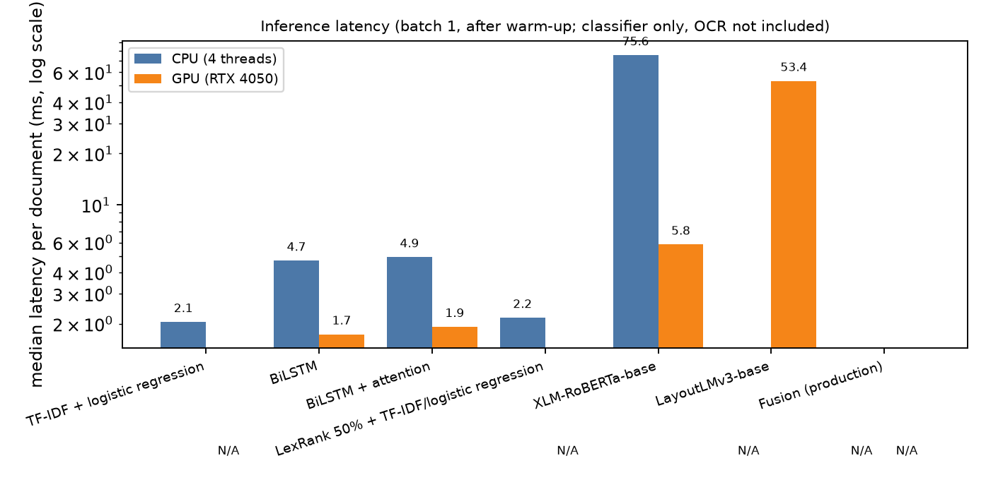
Fig. 9. Inference latency (log scale).
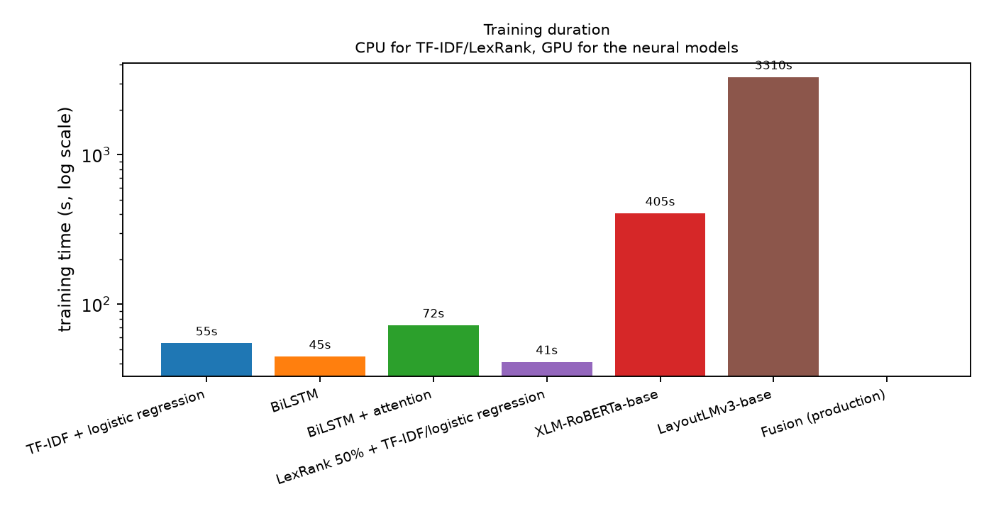
Fig. 10. Training duration (log scale).
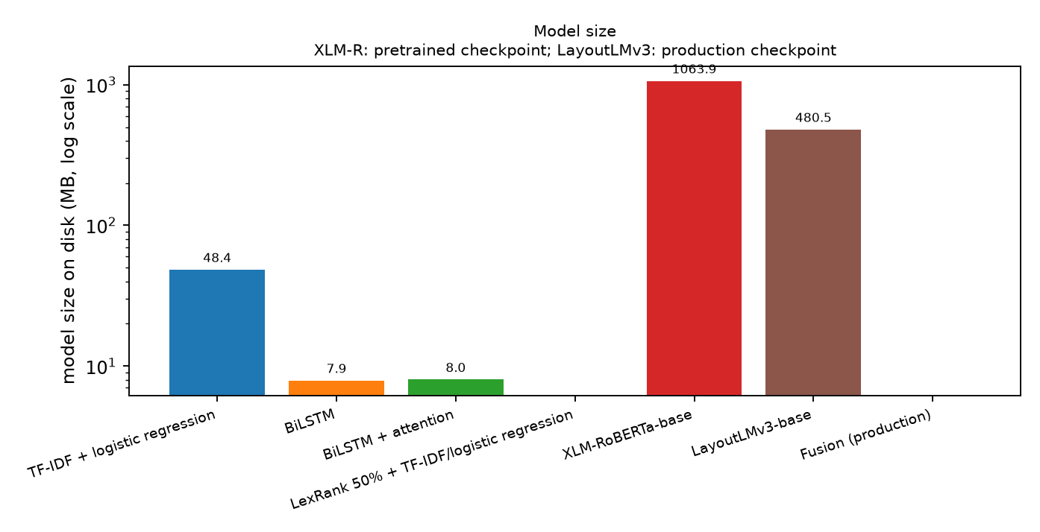
Fig. 11. Model size on disk (log scale).
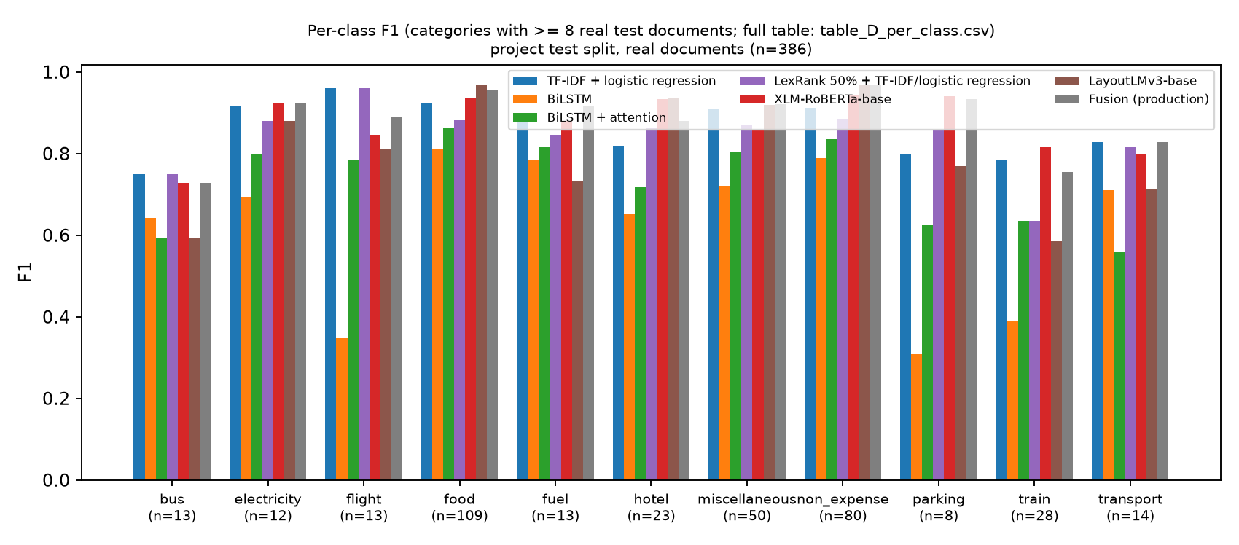
Fig. 12. Per-class F1 on categories with at least 8 real test documents (XLM-R = the original single run).
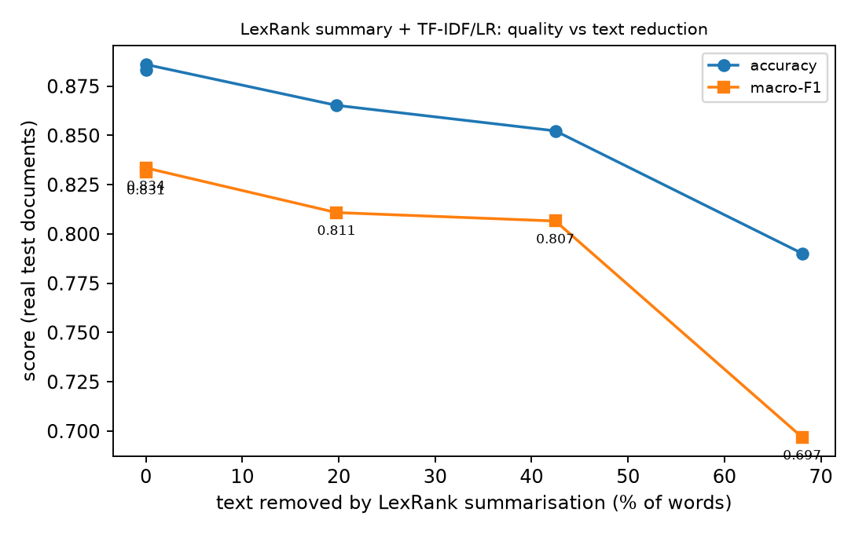
Fig. 13. LexRank summarisation: accuracy and macro-F1 against the share of text removed.
4.4.6 Interpretation
Best text-only model by macro-F1: XLM-RoBERTa-base (original single run, checkpoint not saved) (0.884); by accuracy: XLM-RoBERTa-base (original single run, checkpoint not saved) (0.899). The production fusion, which also uses the image and layout, reaches macro-F1 0.839 / accuracy 0.907. Best calibrated (temperature-scaled expected calibration error, lowest): LexRank 50% summary + TF-IDF/logistic regression (0.024); lowest negative log-likelihood: TF-IDF + Logistic Regression (0.362). Before temperature scaling every model is over- or under-confident; the scaling uses validation data only. Fastest on CPU: TF-IDF + Logistic Regression (2.1 ms/document); smallest on disk: BiLSTM (7.9 MB). A BiLSTM trained from scratch vs TF-IDF/logistic regression: macro-F1 -0.233 (95% confidence interval -0.318 to -0.154), accuracy -0.171 (-0.217 to -0.128) -> worse, established by the paired bootstrap. A BiLSTM with attention pooling vs TF-IDF/logistic regression: macro-F1 -0.149 (95% confidence interval -0.224 to -0.078), accuracy -0.106 (-0.149 to -0.065) -> worse, established by the paired bootstrap. The original single XLM-RoBERTa run vs TF-IDF/logistic regression: macro-F1 +0.052 (95% confidence interval -0.004 to +0.124), accuracy +0.016 (-0.016 to +0.047) -> not distinguishable from TF-IDF on this test set (the interval includes zero). LexRank summarisation before the same classifier vs TF-IDF/logistic regression: macro-F1 -0.025 (95% confidence interval -0.061 to +0.001), accuracy -0.031 (-0.052 to -0.010) -> not distinguishable from TF-IDF on this test set (the interval includes zero).
LexRank keeps 58% of the words and loses -0.025 macro-F1 relative to the full text. Controls with similar reduction give random 50% of lines: macro-F1 0.770 (accuracy 0.845); first lines 50% of lines: macro-F1 0.798 (accuracy 0.858), versus 0.807 for LexRank. Summarisation therefore saves classifier input but does not improve accuracy, and selecting lines by centrality is not shown to beat simply truncating or sampling lines: on bills the useful signal (merchant name, a few key words) is spread over short lines, not concentrated in 'central' sentences.
Attention vs the plain BiLSTM (same data, same split): macro-F1 +0.085 (95% confidence interval +0.003 to +0.174 from 2,000 resamples); an independent re-computation with 10,000 resamples gives -0.004 to +0.174 -> borderline: the lower end of the interval sits at zero, so the improvement is suggestive but not established (and it does not survive a correction for the seven comparisons made). Seed-to-seed variation is also large (see results.json: nn_seed_variation), so a gain of this size from one selected seed must not be read as a property of attention.
Cost versus benefit. TF-IDF/logistic regression is a 48 MB model that trains on a CPU in about 55 s and answers in about 2.1 ms per document. The fine-tuned Transformer needs a GPU for training and is about 22 times larger on disk. The BiLSTMs are cheap but clearly less accurate, so they are not a good trade. Whether the Transformer's extra cost is justified depends on whether its higher macro-F1 survives a larger test set; here it is suggestive, not established.
4.4.7 Limitations of this comparison
The real test set has 386 documents and several categories have fewer than 10 (gas 4, internet 6, medical 6, water 7); per-class numbers and small macro-F1 differences are therefore noisy, and the paired intervals above are wide. Many models are compared on one test set, which raises the chance that one looks better by luck; we only call differences established when the interval excludes zero. The neural text models are small-data baselines: the BiLSTMs learn their embeddings from about 4,800 training documents (no pretrained embeddings), use a word tokenizer although the OCR engine often drops spaces (words run together, e.g. 'GSTID:000433614848'), and were not tuned beyond the documented configuration. In this section the Transformer is a single run (one seed, no hyper-parameter search, 256 tokens, frozen word-embedding matrix); Section 4.5 repeats it over five seeds with the same recipe. A better-tuned or larger model could do better; this experiment does not rule that out. TF-IDF and LayoutLMv3 come from the original, independent training runs; the other models were trained here with a similar but not identical protocol. LayoutLMv3 also uses the page image and layout, so it is not a like-for-like text comparison. The OCR comparison uses only 29 test-split documents with ground-truth boxes (SROIE receipts and FUNSD forms), recognises ground-truth crops rather than whole pages (detector excluded), and the ground-truth conventions (upper case, spaces, masked '***' regions) penalise the production recogniser under strict character error rate. The CRNN was trained on about 40,000 crops from the training split and is not a drop-in replacement; the TrOCR checkpoint may have seen SROIE during its own fine-tuning, so its SROIE score is not clean. Timings were measured on a shared 6 GB laptop GPU/CPU with other jobs running; they show orders of magnitude, not precise ratios. The results concern one dataset, mostly English with some German, Portuguese, Indonesian and Japanese, and do not show that any method is universally better. Unequal input length: TF-IDF/logistic regression reads the whole OCR text, but XLM-R sees only the first 256 sub-word tokens and the BiLSTMs the first 256 word tokens. 47% of the real test documents exceed 256 XLM-R tokens (34% exceed 256 word tokens), so the neural models never saw the end of those bills (totals, tax lines), while the LexRank pipeline deliberately drops lines. Longer inputs or chunking could change the neural results; Section 4.5.5 tests 512-token and chunked inputs on single seeds.
4.4.8 Conclusion of the comparison
No neural text model was established to beat TF-IDF + logistic regression in this single-run comparison: the original XLM-R run scored higher (macro-F1 0.884 vs 0.831, accuracy 0.899 vs 0.883) but the paired interval for the macro-F1 difference (-0.004 to +0.124) includes zero; the two BiLSTMs were clearly worse. LexRank is a valid summarisation method but neither an OCR engine nor a classifier; as a pre-processing step it did not improve classification and its line choice was not shown to be better than a random or first-lines cut. The attention BiLSTM scored higher than the plain BiLSTM, but that gain was not firmly established (its interval is borderline), and both trailed TF-IDF clearly. The best-performing system overall is the production fusion (image and layout added), whose edge over TF-IDF alone is also not established statistically. Follow-up (Section 4.5): repeated over five training seeds, XLM-R's mean macro-F1 is 0.883 against 0.831; the pre-registered decision is 'C: inconclusive'. The cost-benefit discussion and the final recommendation are in Sections 4.5.8 and 4.5.12.
4.5 XLM-RoBERTa versus TF-IDF: Final Multi-Seed Study
This section settles the two questions left open in 4.4: is a fine-tuned XLM-RoBERTa demonstrably better than TF-IDF + logistic regression, and is any gain worth its cost? The design, the primary metric (macro-F1 on the 386 real test documents), the five training seeds, the decision rule and the 0.02 practical threshold were written down before any new training (experiments/xlmr_vs_tfidf_final/PREREGISTRATION.md); checkpoints were selected on validation data only.
4.5.1 Reconciled classification metrics
TABLE X. Reconciliation of the provisional comparison (original single XLM-R run).
Metric (real test, n = 386) | TF-IDF + logistic regression | XLM-R original single run | Source artifact
Accuracy | 0.8834 | 0.8990 | stored logits recomputed (max abs. diff vs stored metrics < 1e-7)
Macro precision | 0.9101 | 0.9003 | stored logits recomputed (max abs. diff vs stored metrics < 1e-7)
Macro recall | 0.7957 | 0.8813 | stored logits recomputed (max abs. diff vs stored metrics < 1e-7)
Macro-F1 | 0.8314 | 0.8838 | stored logits recomputed (max abs. diff vs stored metrics < 1e-7)
Weighted-F1 | 0.8799 | 0.8995 | stored logits recomputed (max abs. diff vs stored metrics < 1e-7)
expected calibration error (10 bins, temperature-scaled) | 0.0256 | 0.0411 | stored logits recomputed (max abs. diff vs stored metrics < 1e-7)
negative log-likelihood | 0.3620 | 0.3953 | stored logits recomputed (max abs. diff vs stored metrics < 1e-7)
Brier | 0.1590 | 0.1551 | stored logits recomputed (max abs. diff vs stored metrics < 1e-7)
Model size | 48.4 MB | 1063.9 MB (pretrained checkpoint; fine-tuned weights not saved) | outputs/m1_tfidf.json, m5_xlmr.json
CPU latency, historical | 2.1 ms | 75.6 ms | same files (historical; re-measured in 4.5.7)

The macro-F1 difference is 0.0523 (displayed as 0.884 - 0.831 = 0.053 after rounding each score). The earlier +0.057 was the mean of the macro-F1 differences over 2,000 bootstrap resamples, which is biased because macro-F1 is non-linear: the mean over resamples is below each point estimate (XLM-R -0.0055, TF-IDF -0.0096), more so for TF-IDF, so the difference of means (0.056) is about 0.004 larger. The same prediction files, the same 386 documents and the same class-inclusion rule were used in both; the point estimate is the effect size reported from here on. The discrepancy did not change the conclusion of the earlier study.
4.5.2 Experimental protocol and fairness
Same documents and labels. Both classifiers use the project's Task A split files (train 4,848 / validation 634 / test 629) and the same label mapping; no document identifier or template group appears in more than one split (checked), and the identical stored OCR text is the input of both (no additional normalisation). TF-IDF baseline: re-fitted with its documented configuration and verified against the production model (maximum probability difference 5.8e-14, identical predictions); not retuned. Fit time 38 s on one CPU thread. XLM-R: FacebookAI/xlm-roberta-base, trainable parameters 86,054,416 of 278,055,952 (the 250k-token word-embedding matrix is frozen, so this is not a full fine-tune), maximum length 256 tokens including the two special tokens, learning rate 3e-5, batch 16, bf16, at most 6 epochs, class-balanced loss. The epoch is chosen by validation macro-F1; the test set is scored once, after selection. 5 seeds (0, 1, 2, 3, 4); each run's trainable weights (fp16), predictions, logs and configuration are stored under experiments/xlmr_vs_tfidf_final/runs/. Software: Python 3.12, PyTorch 2.9.1 (CUDA 12.8), transformers 5.18.0, scikit-learn 1.9.1; hardware: laptop NVIDIA RTX 4050 (6 GB), 16 CPU threads; exact commands and versions are saved in each run's config.json.
4.5.3 Multi-seed XLM-R results
TABLE XI. XLM-R (256 tokens, original recipe), one run per seed, real test documents; Delta = XLM-R minus TF-IDF. The original single run is shown for reference only; its fine-tuned model was not saved and it is not part of the statistical test.
Run | Epoch | Val macro-F1 | Test acc. | Test macro-F1 | Delta macro-F1 | McNemar p (acc.) | Train time | Peak GPU (MB)
seed 0 | 5 | 0.877 | 0.917 | 0.906 | +0.075 | 0.047 | 6.8 min | 3568
seed 1 | 5 | 0.890 | 0.891 | 0.855 | +0.023 | 0.743 | 6.7 min | 3568
seed 2 | 6 | 0.886 | 0.909 | 0.891 | +0.060 | 0.110 | 6.7 min | 3576
seed 3 | 5 | 0.895 | 0.907 | 0.889 | +0.057 | 0.175 | 6.7 min | 3568
seed 4 | 6 | 0.883 | 0.896 | 0.875 | +0.044 | 0.522 | 6.7 min | 3568
mean (sd) | - | - | 0.904 (0.010) | 0.883 (0.019) | +0.052 | - | - | -
min - max | - | - | 0.891 - 0.917 | 0.855 - 0.906 | - | - | - | -
TF-IDF + logistic regression | - | - | 0.883 | 0.831 | - | - | 38 s (CPU) | -
XLM-R original run (not reloadable) | 6 | 0.873 | 0.899 | 0.884 | +0.052 | 0.42 | 405 s | 3,568

Training stability: macro-F1 across seeds has mean 0.883, standard deviation 0.019, range 0.855 to 0.906; 5 of 5 seeds scored above TF-IDF and 5 of 5 by more than 0.02. The original run (macro-F1 0.884) is inside that range. The seeds are real repeated trainings; the bootstrap resamples below are not.
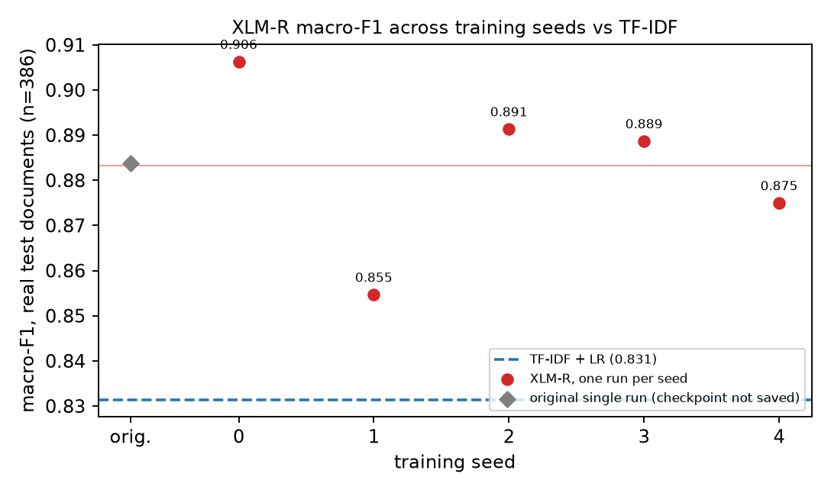
Fig. 14. XLM-R macro-F1 for each training seed against TF-IDF (real test documents).
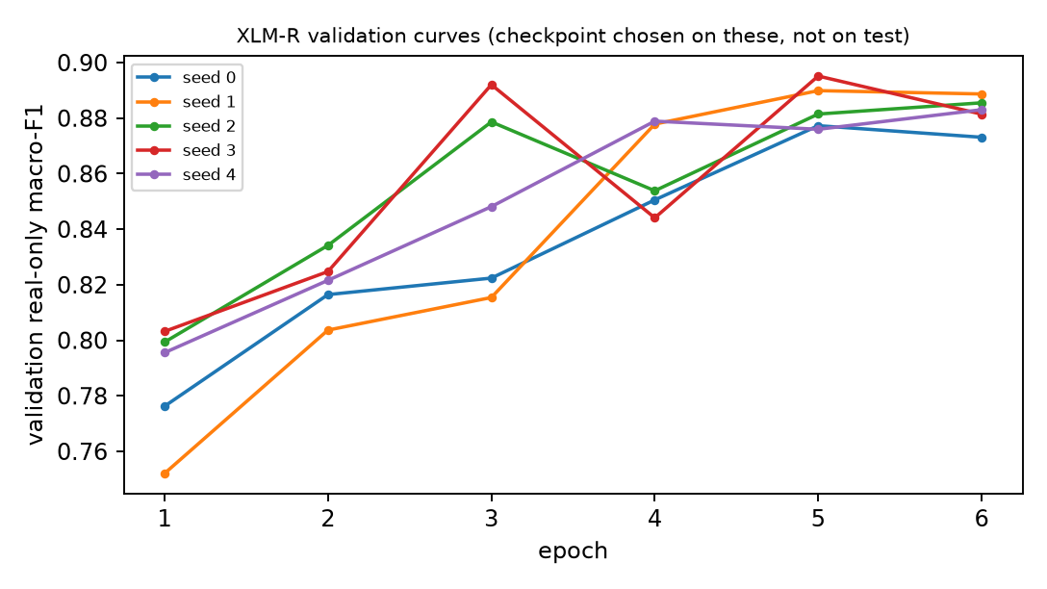
Fig. 15. Validation macro-F1 per epoch for each seed; checkpoints were chosen on these curves.
4.5.4 Statistical comparison with TF-IDF
TABLE XII. Primary comparison (pre-registered): macro-F1, XLM-R (256 tokens, 5 seeds) vs TF-IDF + logistic regression.
Quantity | Value
Absolute macro-F1 improvement (mean over seeds of per-seed differences) | +0.052
Relative macro-F1 improvement (absolute / TF-IDF macro-F1) | +6.2%
95% interval, hierarchical bootstrap (test groups AND seeds resampled, 10,000 replicates) | -0.005 to +0.127
95% interval, test documents only (observed seeds fixed) | -0.001 to +0.125
95% t-interval over the seed-level differences (seed variability only) | +0.028 to +0.076
Absolute accuracy improvement (mean over seeds) | +0.021
95% hierarchical interval for the accuracy difference | -0.007 to +0.049
Seed-ensemble (secondary; mean probability of all seeds) | accuracy 0.917, macro-F1 0.903
Pre-registered decision | C: inconclusive

McNemar's exact test (per seed, Table XI) compares the number of documents only XLM-R classifies correctly against those only TF-IDF classifies correctly; it tests differences in paired correctness (accuracy), not macro-F1, and is shown only as a secondary check. The hierarchical bootstrap resamples whole template/merchant groups of the test set (the unit of dependence) and the training seeds together, so the interval reflects both finite-test-set and training-seed uncertainty; with only five seeds the seed component is itself roughly estimated.
Reading the intervals together: the seed-only t-interval (+0.028 to +0.076) excludes zero and every seed scored above TF-IDF, so the advantage is repeatable across training runs of this recipe; the intervals that also account for the finite test set (-0.005 to +0.127 hierarchical, -0.001 to +0.125 documents only) include zero, so the test set cannot rule out that the average advantage is a feature of these 386 documents. Per seed, only 1 of 5 McNemar tests reached p < 0.05. This is why the pre-registered verdict is 'inconclusive'; it is not evidence that the models are equivalent.
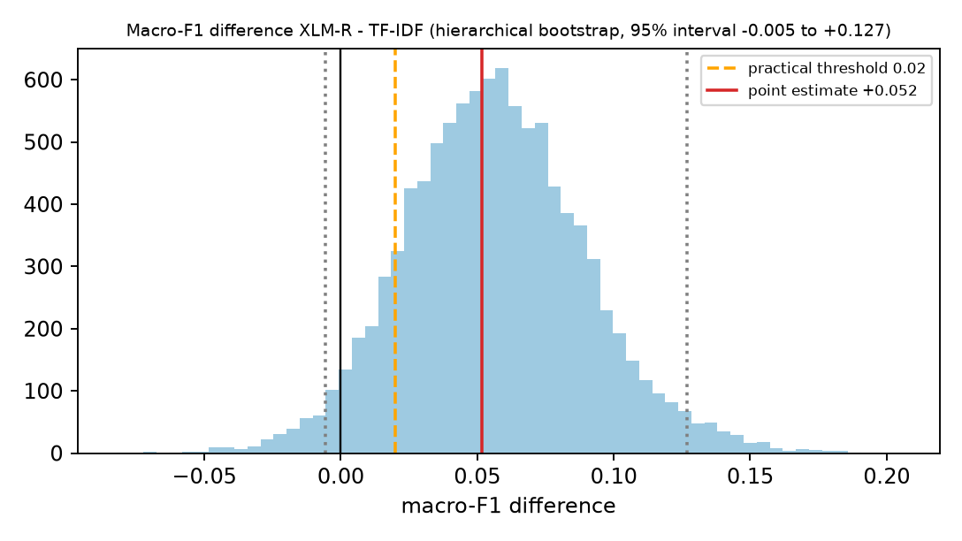
Fig. 16. Distribution of the macro-F1 difference (XLM-R - TF-IDF) over the hierarchical bootstrap; vertical lines mark zero, the 0.02 threshold and the interval.
TABLE XIII. Exploratory input-length / training variants (not part of the primary decision; interpret with the multiple-comparison correction).
Exploratory variant | Seeds | Val macro-F1 (seed 0) | Test macro-F1 mean | Delta vs TF-IDF | 95% confidence interval (documents/seeds) | Bonferroni confidence interval (k=3) | Status
512 tokens | 1 | 0.889 | 0.885 | +0.054 | single seed | N/A | not selected
256-token overlapping chunks (mean logit) | 1 | 0.864 | 0.835 | +0.004 | single seed | N/A | not selected
10 epochs (256 tokens) | 5 | 0.914 | 0.858 | +0.026 | -0.038 to +0.103 | -0.056 to +0.121 | selected on validation

The 10-epoch variant won the validation comparison on seed 0 (validation macro-F1 0.914 best seed) but did not generalise across seeds: mean test macro-F1 0.858 (sd 0.036) against 0.883 for the primary recipe, and seed 4 stopped early at epoch 2 with macro-F1 0.794, significantly worse than TF-IDF on accuracy (McNemar p = 0.007). Choosing the variant from one seed's validation score overstated its merit (a winner's-curse effect); it was kept out of the primary comparison, as pre-registered.
4.5.5 Input-truncation investigation
Mechanics: the 256-token limit includes the two special tokens (<s>, </s>), so 254 content tokens remain; truncation keeps the START of the text (right-side cut) and discards the end. At 512 tokens 510 content tokens remain. Prevalence (token count including special tokens): 47.4% of real test documents exceed 256 tokens (29.1% of all test documents) and 22.5% exceed 512; for training documents 57.4% (real) exceed 256. The earlier figures (47.4% and 33.7% for the BiLSTM's word limit) were reproduced. What is lost: among the 183 truncated real test documents the cut removes on average 44% of the tokens; the discarded text mentions total/tax words in 55% of them (the retained part in 66%). Does the tail carry class information? The production TF-IDF model scores 89.6% on those documents with the full text and 89.6% with only the first 256 tokens, and 71.0% from the discarded tail alone: the tail is informative but largely redundant with the head for TF-IDF. Same-policy diagnostic (TF-IDF re-fitted on text cut at the same token limit): at 256 tokens macro-F1 0.814 / accuracy 0.873; at 512 tokens 0.834 / 0.883; full text 0.831 / 0.883. TF-IDF therefore loses 0.017 macro-F1 when it too is limited to 256 tokens: truncation costs something, but little compared with the difference between the models.
Does longer or chunked input help XLM-R? 512 tokens: validation macro-F1 0.889, test macro-F1 0.885 (1 seed); 256-token overlapping chunks (mean logit): validation macro-F1 0.864, test macro-F1 0.835 (1 seed); 10 epochs (256 tokens): validation macro-F1 0.914, test macro-F1 0.858 (5 seeds). For comparison the 256-token recipe with the same seed (0) scored validation 0.877 and test macro-F1 0.906 (five-seed mean 0.883). The 512-token run's test macro-F1 (0.885) is not higher than the same-seed 256-token run, and it needed 12.4 min to train against 6.8 min. Truncation is therefore not shown to be the cause of any gap: longer or chunked input did not raise the test score in these single-seed exploratory runs, and TF-IDF itself loses only about 0.017 macro-F1 at 256 tokens.
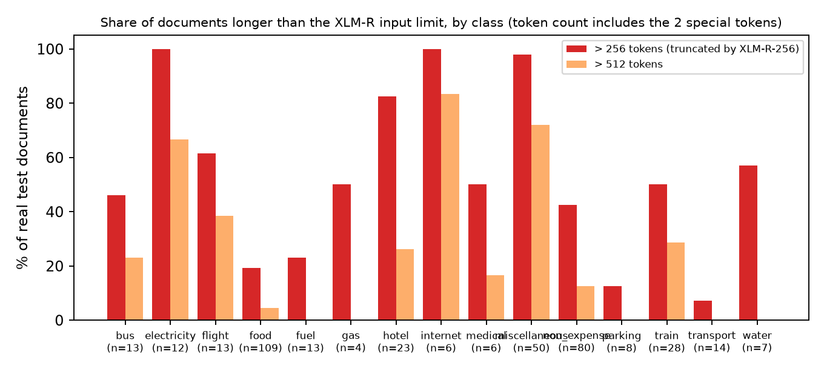
Fig. 17. Share of real test documents longer than the 256-token (and 512-token) limit, by class; electricity, internet and miscellaneous are almost always truncated, so the neural model sees only their first part.
4.5.6 Per-class performance
TABLE XIV. Per-class F1 on the real test documents (macro-F1 averages these 15 values; classes with n < 15 are noisy).
Category | Test n | TF-IDF F1 | XLM-R F1 mean (min-max) | Delta mean | Seeds above TF-IDF
bus | 13 | 0.750 | 0.712 (0.63-0.80) | -0.038 | 2/5
electricity | 12 | 0.917 | 0.925 (0.88-0.96) | +0.008 | 2/5
flight | 13 | 0.960 | 0.947 (0.89-1.00) | -0.013 | 2/5
food | 109 | 0.924 | 0.943 (0.93-0.95) | +0.019 | 5/5
fuel | 13 | 0.880 | 0.911 (0.83-1.00) | +0.031 | 2/5
gas | 4 | 0.857 | 0.978 (0.89-1.00) | +0.121 | 5/5
hotel | 23 | 0.818 | 0.928 (0.88-0.98) | +0.109 | 5/5
internet | 6 | 0.800 | 0.894 (0.83-0.91) | +0.094 | 5/5
medical | 6 | 0.500 | 0.894 (0.83-0.91) | +0.394 | 5/5
miscellaneous | 50 | 0.909 | 0.879 (0.85-0.92) | -0.030 | 1/5
non_expense | 80 | 0.912 | 0.942 (0.93-0.95) | +0.029 | 5/5
parking | 8 | 0.800 | 0.841 (0.75-1.00) | +0.041 | 2/5
train | 28 | 0.783 | 0.825 (0.78-0.86) | +0.043 | 4/5
transport | 14 | 0.828 | 0.822 (0.80-0.86) | -0.005 | 1/5
water | 7 | 0.833 | 0.808 (0.77-0.83) | -0.026 | 0/5

Largest mean gains: medical (+0.394, n=6), gas (+0.121, n=4), hotel (+0.109, n=23); largest mean losses: water (-0.026, n=7), miscellaneous (-0.030, n=50), bus (-0.038, n=13). Classes with fewer than 15 test documents account for +0.040 of the +0.052 macro-F1 difference (78% of it). The single class 'medical' (6 test documents) contributes +0.026 on its own (51% of the total): the macro-F1 advantage is driven substantially by classes with very few test documents, whereas on the large classes (food, non_expense, miscellaneous) the differences are small and not consistently in XLM-R's favour.
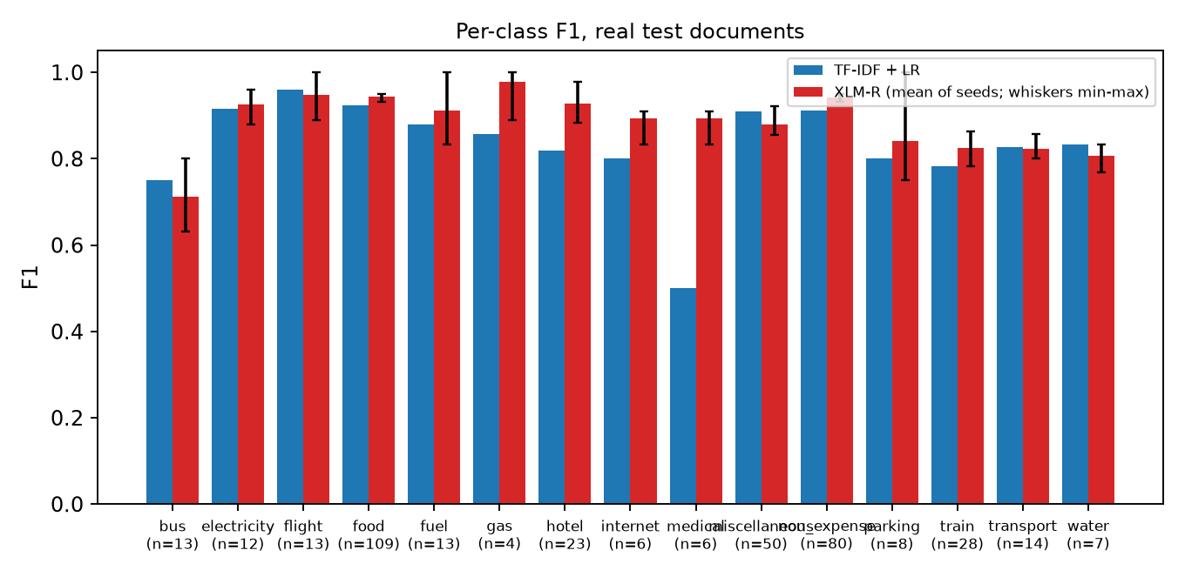
Fig. 18. Per-class F1: TF-IDF versus XLM-R (mean of seeds, whiskers min-max).
4.5.7 Resource and latency comparison
TABLE XV. Measured resource use (same machine, 4 CPU threads, first 100 real test documents; end-to-end = tokenisation/vectorisation + forward + softmax, OCR excluded; GPU Transformers in bf16; training times for BiLSTM/LayoutLMv3 are historical).
Model | Artifact (MB) | CPU end-to-end (ms) | CPU model-only (ms) | GPU end-to-end (ms) | Throughput CPU bs32 (doc/s) | Peak resident memory (MB) | Peak GPU bs32 (MB) | Training
TF-IDF + logistic regression | 48.4 | 1.55 | 0.09 | N/A | 1012.5 | 847 | N/A | 38 s
XLM-RoBERTa-base | 1228 | 70.6 | 74.8 | 5.72 | 7.7 | 2474 | 1436 | 6.7 min
BiLSTM | 7.9 | 4.14 | 3.99 | 1.75 | 764.8 | 1076 | 70 | 45 s (hist.)
BiLSTM + attention | 8.0 | 4.25 | 4.09 | 1.82 | 687.0 | 1160 | 70 | 72 s (hist.)
LayoutLMv3-base | 480 | 832.9 | 815.1 | 50.5 | 1.2 | 6478 | 3236 | 55.2 min (hist.)

Deployment dependencies: TF-IDF needs scikit-learn/numpy only and a 48 MB file; XLM-R needs PyTorch, transformers, tokenizers/sentencepiece and safetensors, the 1.06 GB pretrained base weights plus the 172 MB fine-tuned delta, and a model-loading step (see the load times and resident memory in the saved benchmark JSON); LayoutLMv3 additionally needs the page image and OCR word boxes at inference. These are measured file sizes and package versions, not estimates.
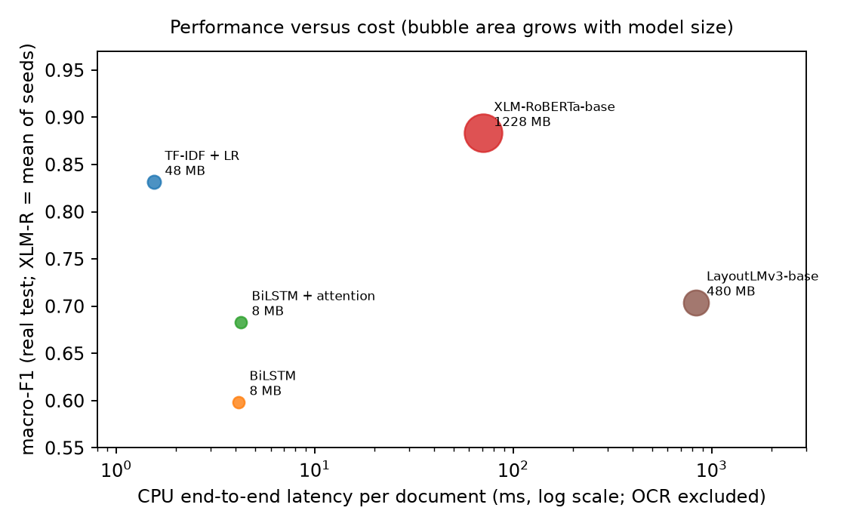
Fig. 19. Macro-F1 against CPU end-to-end latency (log scale); bubble area grows with model size.
4.5.8 Classification Performance Versus Computational Cost: Is XLM-RoBERTa Worth It?
A. How much does XLM-R gain?
Absolute macro-F1 +0.052 (relative +6.2%), interval -0.005 to +0.127; accuracy +0.021 (interval -0.007 to +0.049). 5 of 5 seeds beat TF-IDF; seed-to-seed macro-F1 sd 0.019. The gain is concentrated in classes with few test documents (Table XIV). Statistical status: C: inconclusive.
B. What does it cost?
TABLE XVI. Measured cost of XLM-R relative to TF-IDF. XLM-R artifact = 1064 MB pretrained base weights + 164 MB fine-tuned delta as stored; one merged fp32 file would be about 1061 MB (22x).
Cost measure | TF-IDF | XLM-R | Ratio (XLM-R / TF-IDF)
Model artifact | 48.4 MB | 1228 MB | 25.4x
CPU latency, model-only (ms/doc) | 0.09 | 74.8 | 801x
CPU latency, end-to-end (ms/doc) | 1.55 | 70.6 | 45x
GPU latency, end-to-end (ms/doc) | not applicable (CPU model) | 5.72 | 3.7x vs TF-IDF on CPU
Throughput at batch 32, CPU (docs/s) | 1012.5 | 7.7 | 132x slower
Throughput at batch 32, GPU (docs/s) | - | 297.8 | -
Peak CPU resident memory (MB) | 847 | 2474 | 2.9x
Peak GPU memory, inference batch 32 (MB) | none | 1436 | -
Training time | 38 s | 6.7 min per seed (GPU) | 10x

C. Is the gain worth the cost?
TABLE XVII. ESTIMATED classification time (number of documents x measured median latency / throughput; OCR, model loading and queueing excluded).
Documents | TF-IDF, CPU (batch 1) | XLM-R, CPU (batch 1) | XLM-R, GPU (batch 1) | XLM-R, GPU (batch 32)
1,000 | 2 s | 71 s | 6 s | 3 s
10,000 | 16 s | 11.8 min | 57 s | 34 s
100,000 | 2.6 min | 117.6 min | 9.5 min | 5.6 min

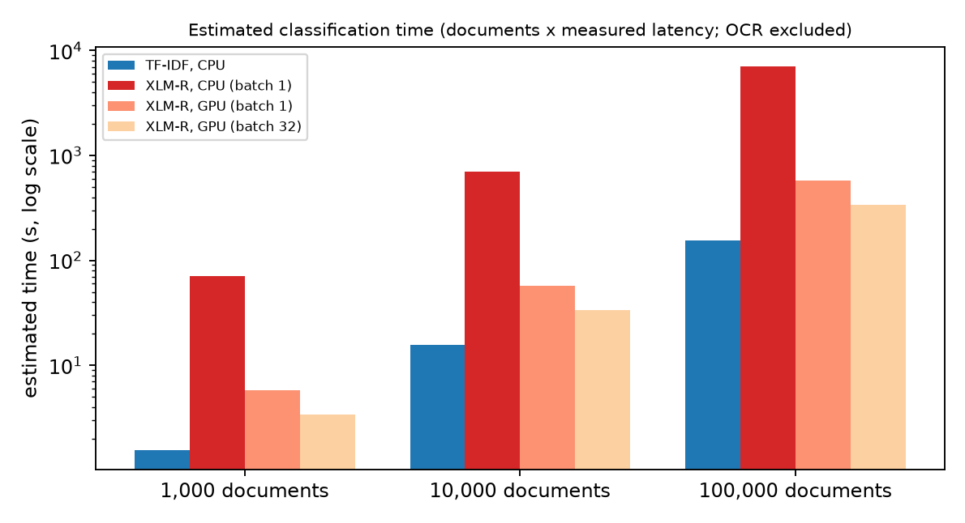
Fig. 20. Estimated time to classify 1,000 / 10,000 / 100,000 documents (log scale).
For 100,000 documents the estimate is 2.6 min for TF-IDF on a CPU against 117.6 min for XLM-R on a CPU (batch 1) or 5.6 min on this GPU at batch 32. Whether these times are acceptable depends on an application requirement that was not specified for this project and is therefore not assumed. The measurements show that XLM-R needs the GPU to be practical at volume, and that even then it is 3.7 times slower per document (batch 1) and delivers 298 documents/s at batch 32 against 1012 for TF-IDF on the CPU.
TABLE XVIII. Decision matrix.
Criterion | TF-IDF | XLM-RoBERTa | Evidence-based assessment
Classification quality | macro-F1 0.831, acc 0.883 | macro-F1 0.883 (sd 0.019), acc 0.904 | XLM-R higher on average
Statistical certainty | - | interval -0.005 to +0.127 | inconclusive: interval includes zero
CPU latency (end-to-end) | 1.55 ms | 70.6 ms | XLM-R 45x slower
GPU requirements | none | training 3570 MB; inference batch 32 1436 MB | GPU needed for training; strongly advisable for inference
Model size | 48.4 MB | 1228 MB | 25x larger
Peak memory (CPU resident memory) | 847 MB | 2474 MB | 2.9x
Training cost | 38 s (CPU) | 6.7 min per run (GPU) | 10x; XLM-R needs several seeds
Calibration (temperature-scaled) | expected calibration error 0.026, negative log-likelihood 0.362 | expected calibration error 0.042, negative log-likelihood 0.408 | TF-IDF better calibrated
Deployment complexity | one small file, scikit-learn | PyTorch + transformers + 1.2 GB of weights, tokeniser, GPU for speed | XLM-R clearly higher
Overall feasibility | feasible on any CPU | feasible on CPU for low volumes, GPU for high volumes | XLM-R: promising but not yet proven superior

D. Four different statements.
1. XLM-R achieved a higher observed score: yes (macro-F1 0.883 vs 0.831; accuracy 0.904 vs 0.883). 2. XLM-R demonstrated statistically supported superiority: no (interval -0.005 to +0.127). 3. XLM-R demonstrated a practically meaningful improvement (lower bound above 0.02): no. 4. XLM-R provides a better overall production trade-off: not demonstrated.
4.5.9 Why the other models scored lower
For each model the observed shortfall, the facts that were measured, the explanations that remain unverified and the experiment that would be needed to establish a cause are kept apart. None of this shows that RNNs, attention or layout-aware Transformers are inherently inferior: these were small-data baselines trained once under limited budgets.
BiLSTM: (1) Observed: macro-F1 0.598, -0.233 relative to TF-IDF. (2) Measured: 2,066,704 parameters, embeddings learned from scratch on 4,848 documents; epochs run per seed [18, 17, 25] (best epochs [12, 11, 19], maximum 30); test accuracy across seeds 0.681, 0.689, 0.712; 22% of alphabetic test tokens are outside the vocabulary; 34% of real test documents exceed the 256-word limit. (3) Unverified explanations: (a) Too little labelled text (about 4,800 documents) to learn word embeddings and recurrence from scratch, whereas a linear model over n-gram counts needs far fewer examples. (b) The word tokeniser meets merged words because OCR drops spaces (e.g. 'GSTID:000433614848'), which become unknown tokens; character n-grams in TF-IDF are insensitive to this. (c) Early stopping on a small validation set (391 real documents) and the large seed-to-seed variation mean that the selected seed is partly luck. (4) Experiments needed: (a) Pretrained embeddings or a character/sub-word tokeniser with the same architecture (isolates the tokeniser/out-of-vocabulary (OOV) effect). (b) More seeds and a learning-curve experiment (accuracy vs number of training documents) to test the data-size explanation. (c) Same model on whitespace-repaired OCR text.
BiLSTM + attention: (1) Observed: macro-F1 0.683, -0.149 relative to TF-IDF. (2) Measured: 2,099,728 parameters, embeddings learned from scratch on 4,848 documents; epochs run per seed [13, 30, 12] (best epochs [7, 25, 6], maximum 30); test accuracy across seeds 0.754, 0.777, 0.736; 22% of alphabetic test tokens are outside the vocabulary; 34% of real test documents exceed the 256-word limit. (3) Unverified explanations: (a) Too little labelled text (about 4,800 documents) to learn word embeddings and recurrence from scratch, whereas a linear model over n-gram counts needs far fewer examples. (b) The word tokeniser meets merged words because OCR drops spaces (e.g. 'GSTID:000433614848'), which become unknown tokens; character n-grams in TF-IDF are insensitive to this. (c) Early stopping on a small validation set (391 real documents) and the large seed-to-seed variation mean that the selected seed is partly luck. (4) Experiments needed: (a) Pretrained embeddings or a character/sub-word tokeniser with the same architecture (isolates the tokeniser/OOV effect). (b) More seeds and a learning-curve experiment (accuracy vs number of training documents) to test the data-size explanation. (c) Same model on whitespace-repaired OCR text.
LayoutLMv3-base (production checkpoint): (1) Observed: macro-F1 0.704, -0.128 relative to TF-IDF. (2) Measured: 6 epochs at maximum length 448 (inference 512); validation macro-F1 by epoch [0.2715, 0.5158, 0.6748, 0.6584, 0.7235, 0.7273] (still rising at the last epoch); 30% of real test documents exceed 448 tokens; accuracy is within 0.021 of TF-IDF while macro-F1 is 0.128 lower. (3) Unverified explanations: (a) Macro-F1 is dragged down by a few small classes (largest losses: water -0.58 (n=7), gas -0.29 (n=4), internet -0.25 (n=6)) while accuracy, dominated by frequent classes, is close to TF-IDF; with n < 15 per class this is noisy. (b) Fine-tuning for 6 epochs with a 448-token window on ~4,800 documents (batch 16) may under-train a 125M-parameter layout model; validation macro-F1 was still flat-to-rising at the last epoch. (c) The image branch adds little for bills whose class is decided by words; the layout/image inputs are not a disadvantage per se. (4) Experiments needed: (a) Train longer / with more seeds and compare validation curves. (b) Ablate the image and the boxes (text-only LayoutLM) to see what the extra modalities contribute. (c) Per-class analysis on a larger test set.
LexRank summarisation + TF-IDF/logistic regression: (1) Observed: macro-F1 0.807, -0.025 relative to TF-IDF. (2) Measured: full flat OCR text: macro-F1 0.831 (0% less text); 100% of lines: macro-F1 0.834 (0% less text); 75% of lines: macro-F1 0.811 (20% less text); 50% of lines: macro-F1 0.807 (42% less text); 25% of lines: macro-F1 0.697 (68% less text); random 50% of lines 0.770, first 50% 0.798. (3) Unverified explanations: (a) Class evidence on a bill is spread over short lines (merchant, key words, totals); dropping lines removes some of it, and centrality of a line within the bill is not related to its usefulness for classification. (4) Experiments needed: (a) Supervised line selection (keep lines whose terms are most predictive) compared with random/first/LexRank at the same budget. (b) Paired bootstrap of LexRank vs random-lines on the same documents (the controls here were single or 3-seed runs).
4.5.10 Is the test set large enough?
The real test set has 386 documents (382 template groups); 10 classes have fewer than 15 documents (bus 13, electricity 12, flight 13, fuel 13, gas 4, internet 6, medical 6, parking 8, transport 14, water 7), so macro-F1, which weights every class equally, is dominated by noisy small classes. Estimate 1 (analytic, accuracy): with the observed discordant-pair rate of 9.3% (documents classified differently by the two models), a McNemar test with alpha 0.05 and 80% power needs about 7,318 documents to detect a true accuracy gain of 0.01, 1,828 for 0.02 and 811 for 0.03 (independent documents assumed). Estimate 2 (macro-F1, resampling simulation assuming the observed seed-mean effect of +0.052 is the true effect, which is optimistic): the probability that the interval's lower bound exceeds zero is 39% at 386 documents, 59% at 600 documents, 69% at 800 documents, 77% at 1,200 documents, 86% at 1,600 documents, 86% at 2,400 documents, 88% at 3,200 documents. At the current class mix, a test set with at least 30 documents in the rarest class would need about 2,895 documents; collecting the rare classes on purpose needs far fewer. These are planning estimates with stated assumptions, not measured results; five or ten seeds do not remove the need for a larger, frozen, template-disjoint test set kept out of training and model selection.
4.5.11 Reproducibility and limitations
Original run: its fine-tuned weights were never saved, so it cannot be reloaded or re-evaluated; only its stored logits exist. A fresh run with the same seed and recipe agrees with it on 97.9% of test-document predictions but gives macro-F1 0.906 against 0.884 (it selected epoch 5, the original epoch 6): across the five seeds the macro-F1 ranges from 0.855 to 0.906 (a spread of 0.052, comparable to the +0.052 advantage), which is why all conclusions here rest on the multi-seed analysis rather than on any single run. New runs: for each of the 5 seeds the trainable weights (fp16, 172 MB), tokenizer reference, configuration, per-epoch history, validation/test logits and the log are stored; the pretrained base weights (1.06 GB) are shared and checksum-verified. The stored predictions come from the fp32/bf16 in-memory model at training time; reloading the fp16 trainable weights in a fresh process (CPU, fp32) reproduces the stored predictions for 100 of 100 test documents with a maximum logit difference of 0.12. GPU bf16 training is not bit-reproducible, so re-training will give similar but not identical numbers. Number of seeds: five were pre-registered and form the primary analysis. Seeds 5-9 were added later, after the five-seed result was known and disk space had been freed, as a secondary sensitivity analysis (Section 4.5.13); they cannot change the primary verdict. Exploratory variants (512 tokens, chunking) are single seeds. Not measured: peak CPU resident memory during training; GPU power; the effect of quantisation or ONNX export on latency; behaviour on documents from new templates (the test set has none by construction of the group split). Latency/memory: all models were measured on one shared laptop (one CPU, one 6 GB GPU) in separate processes with 4 CPU threads, while the demo servers were idle-resident; absolute values will differ elsewhere, the ratios are the evidence.
4.5.12 Final evidence-based recommendation
The evidence is inconclusive: XLM-R scored higher on average (macro-F1 +0.052 over 5 seeds) but the 95% interval (-0.005 to +0.127) includes zero, so superiority is not established, and it costs 45 times the CPU latency and 25 times the model size. Keep TF-IDF + logistic regression as the production text classifier. XLM-R remains a promising candidate; the decisive next step is a larger, frozen, template-disjoint test set (Section 4.5.10) rather than more tuning on the current one. Inconclusive does not mean equivalent.
4.5.13 Ten-seed sensitivity analysis
TABLE XIX. Primary five-seed analysis and the ten-seed sensitivity analysis (real test documents, n = 386).
 | Seeds | XLM-R mean macro-F1 | Difference vs TF-IDF | 95% hierarchical interval | 95% interval, seeds only | Seeds above TF-IDF | Verdict
Primary (pre-registered) | 5 | 0.883 | +0.052 | -0.005 to +0.127 | +0.028 to +0.076 | 5 of 5 | C
Sensitivity (seeds 0-9) | 10 | 0.878 | +0.047 | -0.007 to +0.118 | +0.033 to +0.061 | 10 of 10 | C

Five more seeds (5-9) of the same recipe were trained after the five-seed result was known, because disk space had been freed. Because adding seeds after an inconclusive result is a form of optional stopping, this analysis is labelled secondary and was declared in the pre-registration addendum before any extra seed was trained; the primary verdict remains the five-seed one. Result (verified): the mean difference is +0.047, the hierarchical interval -0.007 to +0.118 still includes zero, and all 10 of 10 seeds score above TF-IDF. The interval that reflects only seed variation excludes zero (+0.033 to +0.061), but it ignores the finite test set. More seeds therefore reduce training-run uncertainty and leave test-set uncertainty (documents and templates) unchanged: the verdict is not expected to change with further seeds.
4.5.14 Unseen test sets
Because the real test set is small, additional unseen documents were sought. Every labelled real source already on disk is part of the project data, and a web search found no open dataset with expense-category labels for the 16 classes (utilities, rent, fuel and parking in particular). Two sets were therefore evaluated, both scored once with frozen models (TF-IDF refit, XLM-R seeds; no tuning, calibration or selection) under an analysis plan written before scoring (pre-registration addenda 2 and 3):
Synthetic challenge set (unseen_synthetic/, 576 documents, 16 classes, 250 groups): produced by a new generator independent of the project's synthetic training generator (new merchants, item vocabulary, titles, field labels, four layouts), in three conditions - clean pages, noisy photographs (rotation, blur, JPEG compression) and long pages with boilerplate before the informative lines - and read with the same RapidOCR engine. As pre-registered, no document was removed: 6 noisy photographs produced no OCR text at all and are kept (both models see the same empty text, so they are scored on it as on any other document). Labels are correct by construction, but the documents were written by the study author: the set measures robustness to wording, layout, noise and length shift, not real-world accuracy. Real Portuguese set (unseen_real/, 336 documents): images of Zenodo record 6371710 (Cruz and Castelli, CC BY 4.0) that the project does not use, excluding every company that also appears in the project's subset. Labels are rule-derived from the dataset's own company field (merchant type), i.e. silver labels. Only two classes have at least 10 documents (miscellaneous 267, food 61), so a 16-class macro-F1 is impossible; the primary measure is macro-F1 over those two classes, with errors into any of the 16 labels counted. The documents are in Portuguese, a language the models were not trained on, so this is a domain-shift test and mixes several effects.
TABLE XX. Frozen models on the unseen sets (macro-F1; the five pre-registered seeds; A+B = practically meaningful advantage, C = inconclusive under the pre-registered rule; these verdicts apply to these sets only).
Set / condition | Documents | Groups | TF-IDF | TF-IDF, first 256 tokens | XLM-R (5 seeds) | Difference | 95% hierarchical interval | Verdict
Synthetic, clean | 192 | 135 | 0.775 | 0.775 | 0.884 | +0.109 | +0.054 to +0.174 | A+B
Synthetic, noisy photo | 192 | 141 | 0.500 | 0.500 | 0.697 | +0.197 | +0.129 to +0.279 | A+B
Synthetic, long preamble | 192 | 144 | 0.017 | 0.017 | 0.099 | +0.082 | +0.023 to +0.134 | A+B
Synthetic, all | 576 | 250 | 0.492 | 0.492 | 0.627 | +0.135 | +0.100 to +0.169 | A+B
Real Portuguese (2 classes) | 328 | 66 | 0.221 | 0.180 | 0.332 | +0.111 | -0.056 to +0.344 | C

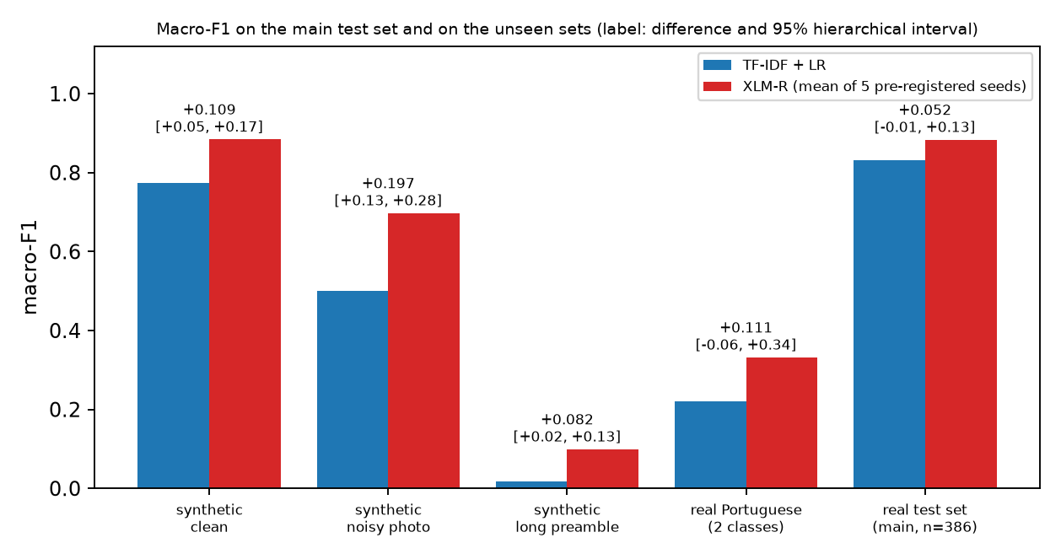
Fig. 21. Macro-F1 on the main real test set and on the unseen sets; labels give the XLM-R minus TF-IDF difference and its 95% hierarchical interval.
What is verified. (1) On clean and noisy synthetic documents XLM-R is ahead of TF-IDF with intervals that exclude zero (+0.109 and +0.197); the ten-seed pooled difference is +0.134. (2) The long-preamble condition does not separate the models: 99% of its documents are predicted non_expense by TF-IDF and 94% (mean over seeds) by XLM-R, although only 6% are non_expense, so both fail because the generic boilerplate resembles a letter or notice. This condition therefore does not isolate truncation (applying the same 256-token cut to TF-IDF changes its macro-F1 from 0.017 to 0.017), and the small XLM-R lead there (+0.082) sits on a floor. (3) On the real Portuguese documents both models are poor (macro-F1 0.221 for TF-IDF, 0.332 for XLM-R), the difference is inconclusive (-0.056 to +0.344), and XLM-R accuracy varies strongly between seeds (0.12 to 0.41 over ten seeds), so single-seed results on out-of-domain documents are unreliable.
What is not verified (hypotheses). The clean-condition gain may arise because TF-IDF depends on training-set wording - on the clean set TF-IDF predicts food for 25% of documents against 7% for XLM-R although every class has the same number of documents - while XLM-R uses the meaning of words learned in pre-training; no ablation was run to test this. The noisy-condition gain could instead reflect different sensitivity to OCR errors. Neither hypothesis was tested, and the real Portuguese set could not confirm or reject them. Label caveat: the project's own labels treat groceries as miscellaneous, but its models may have learned to call groceries food; the Portuguese labels follow the project's convention, so part of the poor real-set scores may be a labelling-convention mismatch rather than a model failure.
Consequence for the conclusion. The pre-registered rule applied to the synthetic set gives a practically meaningful XLM-R advantage in the clean, noisy and pooled analyses, and an inconclusive result on the real unseen documents. The synthetic result shows that XLM-R copes better with shifted wording and image noise on documents of this kind; it does not show that it is better on real HR documents, where the primary comparison stays inconclusive. The measured cost is unchanged, and the recommendation therefore stays as above: keep TF-IDF in production and, if robustness to new wording matters, evaluate XLM-R (or a cheaper hybrid) on a larger real, labelled, template-disjoint set before deciding.
4.5.15 Hybrid cascade: TF-IDF first, XLM-R only for uncertain documents
Design (pre-registered in Addendum 4 before any hybrid prediction was computed): TF-IDF classifies every document; when its top probability is below a threshold the document is passed to XLM-R. One hybrid was formed per XLM-R seed, with the threshold chosen on the validation set only (real-only validation macro-F1; thresholds 0.5, 0.45, 0.5, 0.45, 0.35 for seeds 0-4). Nothing was retrained, calibrated or tuned on the test sets.
TABLE XXI. Hybrid cascade (macro-F1; mean over the five pre-registered seeds; A+B/A = hybrid better than TF-IDF by the pre-registered rule, C = inconclusive).
Set | Documents | TF-IDF | XLM-R | Hybrid | Sent to XLM-R | Hybrid - TF-IDF (95% interval) | Hybrid - XLM-R (95% interval) | Verdict vs TF-IDF
Main real test | 386 | 0.831 | 0.883 | 0.879 | 14% | +0.047 (-0.000 to +0.115) | -0.005 (-0.044 to +0.025) | C
Synthetic, clean | 192 | 0.775 | 0.884 | 0.878 | 40% | +0.104 (+0.052 to +0.165) | -0.006 (-0.027 to +0.013) | A+B
Synthetic, noisy | 192 | 0.500 | 0.697 | 0.684 | 57% | +0.184 (+0.118 to +0.262) | -0.013 (-0.046 to +0.009) | A+B
Synthetic, long | 192 | 0.017 | 0.099 | 0.071 | 38% | +0.054 (+0.006 to +0.100) | -0.028 (-0.054 to -0.006) | A
Synthetic, all | 576 | 0.492 | 0.627 | 0.614 | 45% | +0.122 (+0.089 to +0.158) | -0.012 (-0.028 to -0.001) | A+B
Real Portuguese (2 classes) | 328 | 0.221 | 0.332 | 0.281 | 56% | +0.060 (-0.067 to +0.222) | -0.050 (-0.170 to +0.009) | C

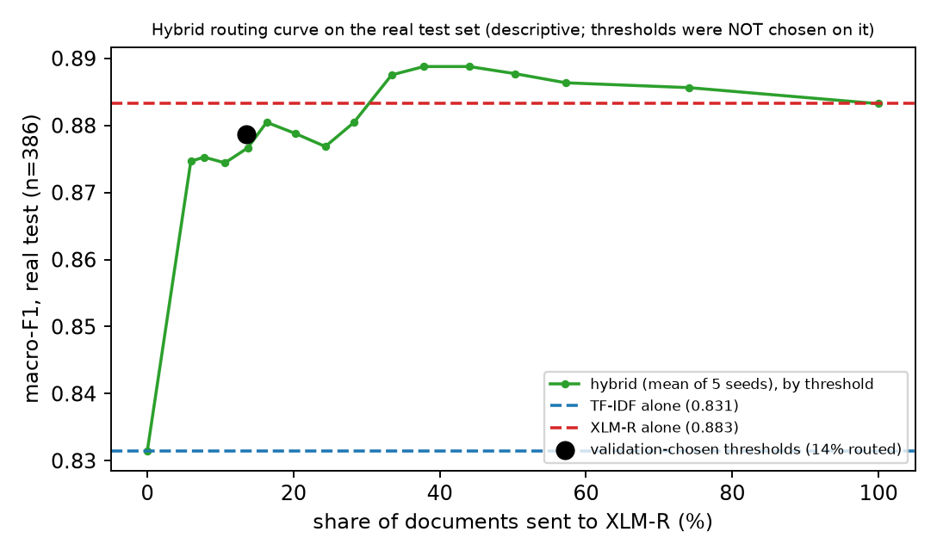
Fig. 22. Macro-F1 of the hybrid on the real test set as a function of the share of documents sent to XLM-R (descriptive only).
Verified. On the main real test set the hybrid scores 0.879 against 0.831 for TF-IDF and 0.883 for XLM-R alone, while sending only 14% of documents to XLM-R; the difference from TF-IDF is +0.047 with hierarchical interval -0.000 to +0.115, whose lower end is essentially zero but not above it, so the pre-registered rule still returns inconclusive (ten seeds: +0.046, -0.001 to +0.111). The difference from XLM-R alone is -0.005 (-0.044 to +0.025), i.e. the hybrid retained nearly all of XLM-R's observed gain on this set. On the synthetic set the hybrid is ahead of TF-IDF in every condition (clean, noisy, pooled: practically meaningful; long: not above the 0.02 threshold) and slightly behind XLM-R alone; on the real Portuguese documents it is inconclusive. Because the hybrid's gain is derived from the same XLM-R predictions, it carries the same test-set uncertainty: it is not independent confirmation of XLM-R's superiority.
Cost (estimate, not a measurement of the combined system). With 14% of documents routed, the expected end-to-end CPU latency is 11.1 ms per document (1.55 ms for TF-IDF plus 14% of 70.6 ms), i.e. 7.2 times TF-IDF alone but 0.16 times XLM-R alone; with XLM-R on a GPU it is 2.3 ms. The worst case (every document routed) is 72.1 ms. The hybrid does not reduce the memory or disk footprint, because both models must be loaded (XLM-R's 25-fold size remains), and it adds a routing threshold to maintain; on the synthetic noisy set, where TF-IDF is unsure more often, 57% of documents were routed, so the saving depends on how uncertain TF-IDF is on the incoming documents.
Hypothesis (not tested). The routing curve in Fig. 22 suggests that most of XLM-R's gain on this test set sits in the few documents on which TF-IDF is uncertain, which is also where the small classes lie; this was not verified separately and the curve was not used to choose thresholds. Conclusion for the hybrid: it is the most cost-effective way to use XLM-R if XLM-R is eventually shown to be better, and it did not alter the primary verdict; it should be re-evaluated on the larger real test set recommended above before any deployment.
4.6 Limitations
The second-stage model has seen only synthetic documents. Its 1.000 scores are a property of the generator (consistent titles and wording), not a measure of real-world accuracy; an earlier baseline trained on synthetic documents scored about 0 on real documents of other classes. Real documents of the 12 new types must be collected, with consent, before any accuracy claim is made. The second stage has no explicit reject class; the 0.60 threshold is the only guard against forcing a document into one of 12 labels. Cheque documents are not covered. Real-test support is small for several Task A classes (medical, water, internet, gas) and for Task B fields such as GSTIN, CGST, SGST; harmonised system of nomenclature (HSN)/services accounting code (SAC) has no real annotation. Task B is a research-grade baseline. LayoutLMv3 weights are non-commercial (CC-BY-NC-SA-4.0); some real documents have unverified redistribution rights, so models and data should stay internal.
5. CONCLUSION
We built a working two-stage pipeline that reads Indian employee bills, classifies them, extracts fields, hands documents the first model cannot place to a second document-type classifier, and routes uncertain cases to HR. Stage 1 reaches 0.907 real accuracy and 0.839 real macro-F1 with calibrated confidence (93.0% auto-coverage at 0.944 precision), and the hybrid extractor reaches 0.663 real micro-F1, significantly above the rule baseline. Final XLM-R study (Section 4.5, 5 seeds, pre-registered rule): C: inconclusive. XLM-R reached macro-F1 0.883 on average against 0.831 for TF-IDF (+0.052; interval -0.005 to +0.127); all 5 of 5 seeds scored higher, but the finite real test set (386 documents) does not establish superiority; its cost is 45 times the CPU latency and 25 times the size, so TF-IDF + logistic regression remains the recommended production classifier until a larger test set decides the question. The new second stage recognises 12 tax-evidence and financial document types that were previously shown as non_expense; the application now shows non_expense only when the second model also cannot place the document. Its perfect synthetic scores prove the integration, not real-world accuracy; the strongest next step is a consented collection of real rent receipts, insurance, school-fee and similar documents, followed by retraining with a reject class. Strong points of the work are group-aware, real-only evaluation, calibrated abstention, full provenance of data and an honest account of limits.
6. REFERENCES
[1] Y. Huang, T. Lv, L. Cui, Y. Lu, F. Wei, "LayoutLMv3: Pre-training for Document AI with Unified Text and Image Masking," Proc. 30th ACM International Conference on Multimedia (MM '22), pp. 4083-4091, 2022, doi:10.1145/3503161.3548112.
[2] Y. Xu, Y. Xu, T. Lv, L. Cui, F. Wei, G. Wang, Y. Lu, D. Florencio, C. Zhang, W. Che, M. Zhang, L. Zhou, "LayoutLMv2: Multi-modal Pre-training for Visually-rich Document Understanding," Proc. 59th Annual Meeting of the ACL and 11th IJCNLP (Long Papers), pp. 2579-2591, 2021, doi:10.18653/v1/2021.acl-long.201.
[3] J. Li, Y. Xu, T. Lv, L. Cui, C. Zhang, F. Wei, "DiT: Self-supervised Pre-training for Document Image Transformer," Proc. 30th ACM International Conference on Multimedia (MM '22), 2022, arXiv:2203.02378.
[4] A. Yeghiazaryan, K. Khechoyan, G. Nalbandyan, S. Muradyan, "TokenGrid: Toward More Efficient Data Extraction From Unstructured Documents," IEEE Access, vol. 10, pp. 39261-39268, 2022, doi:10.1109/ACCESS.2022.3164674.
[5] Z. Yan, Z. Ye, J. Ge, J. Qin, J. Liu, Y. Cheng, C. Gurrin, "DocExtractNet: A novel framework for enhanced information extraction from business documents," Information Processing & Management, vol. 62, no. 3, 2025, doi:10.1016/j.ipm.2024.104046.
[6] S. Larson, G. Lim, K. Leach, "On Evaluation of Document Classification with RVL-CDIP," Proc. 17th Conference of the European Chapter of the ACL (EACL), pp. 2665-2678, 2023, doi:10.18653/v1/2023.eacl-main.195.
[7] L. Cui, Y. Xu, T. Lv, F. Wei, "Document AI: Benchmarks, Models and Applications," arXiv:2111.08609, 2021.
[8] A. M. Rombach, P. Fettke, "Deep Learning based Key Information Extraction from Business Documents: Systematic Literature Review," ACM Computing Surveys, vol. 58, no. 2, pp. 1-37, 2025, doi:10.1145/3749369.
[9] W. Wang, H. Hu, Z. Zhang, Z. Li, H. Shao, D. Dahlmeier, "Document Intelligence in the Era of Large Language Models: A Survey," arXiv:2510.13366, 2025.
[10] J. Wang, L. Jin, K. Ding, "LiLT: A Simple yet Effective Language-Independent Layout Transformer for Structured Document Understanding," Proc. 60th Annual Meeting of the ACL (Long Papers), pp. 7747-7757, 2022, doi:10.18653/v1/2022.acl-long.534.
[11] S. Appalaraju, B. Jasani, B. U. Kota, Y. Xie, R. Manmatha, "DocFormer: End-to-End Transformer for Document Understanding," Proc. IEEE/CVF International Conference on Computer Vision (ICCV), 2021, arXiv:2106.11539.
[12] G. Kim, T. Hong, M. Yim, J. Nam, J. Park, J. Yim, W. Hwang, S. Yun, D. Han, S. Park, "OCR-free Document Understanding Transformer," Proc. European Conference on Computer Vision (ECCV), 2022, arXiv:2111.15664.
[13] Z. Liu, H. Mao, C.-Y. Wu, C. Feichtenhofer, T. Darrell, S. Xie, "A ConvNet for the 2020s," Proc. IEEE/CVF Conference on Computer Vision and Pattern Recognition (CVPR), pp. 11976-11986, 2022.
[14] C. Guo, G. Pleiss, Y. Sun, K. Q. Weinberger, "On Calibration of Modern Neural Networks," Proc. 34th International Conference on Machine Learning, PMLR 70, pp. 1321-1330, 2017.
[15] Z. Huang, K. Chen, J. He, X. Bai, D. Karatzas, S. Lu, C. V. Jawahar, "ICDAR2019 Competition on Scanned Receipt OCR and Information Extraction," Proc. International Conference on Document Analysis and Recognition (ICDAR), 2019, arXiv:2103.10213.
[16] X. Mifsud, L. Grech, A. Baldacchino, L. Keller, G. Valentino, A. Muscat, "Receipt Information Extraction with Joint Multi-Modal Transformer and Rule-Based Model," Machine Learning and Knowledge Extraction, vol. 7, no. 4, p. 167, 2025, doi:10.3390/make7040167.
[17] L. Liu, Z. Wang, T. Qiu, Q. Chen, Y. Lu, C. Y. Suen, "Document image classification: Progress over two decades," Neurocomputing, vol. 453, pp. 223-240, 2021, doi:10.1016/j.neucom.2021.04.114.
[18] J. Gawlikowski, C. R. N. Tassi, M. Ali, J. Lee, M. Humt, J. Feng, A. Kruspe, R. Triebel, P. Jung, R. Roscher, M. Shahzad, W. Yang, R. Bamler, X. X. Zhu, "A survey of uncertainty in deep neural networks," Artificial Intelligence Review, vol. 56, suppl. 1, pp. 1513-1589, 2023, doi:10.1007/s10462-023-10562-9.
[19] H. T. Ha, A. Horak, "Information extraction from scanned invoice images using text analysis and layout features," Signal Processing: Image Communication, vol. 102, p. 116601, 2022, doi:10.1016/j.image.2021.116601.
[20] D. Baviskar, S. Ahirrao, K. Kotecha, "Multi-Layout Unstructured Invoice Documents Dataset: A Dataset for Template-Free Invoice Processing and Its Evaluation Using AI Approaches," IEEE Access, vol. 9, pp. 101494-101512, 2021, doi:10.1109/ACCESS.2021.3096739.
[21] Saifullah, S. Agne, A. Dengel, S. Ahmed, "The Reality of High Performing Deep Learning Models: A Case Study on Document Image Classification," IEEE Access, vol. 12, pp. 103537-103564, 2024, doi:10.1109/ACCESS.2024.3425910.
[22] S. I. Omurca, E. Ekinci, S. Sevim, E. B. Edinc, S. Eken, A. Sayar, "A document image classification system fusing deep and machine learning models," Applied Intelligence, vol. 53, no. 12, pp. 15295-15310, 2023, doi:10.1007/s10489-022-04306-5.
[23] H. Gbada, K. Kalti, M. A. Mahjoub, "Multimodal weighted graph representation for information extraction from visually rich documents," Neurocomputing, vol. 573, p. 127223, 2024, doi:10.1016/j.neucom.2023.127223.
[24] H. Gbada, K. Kalti, M. A. Mahjoub, "Deep learning approaches for information extraction from visually rich documents: datasets, challenges and methods," International Journal on Document Analysis and Recognition (IJDAR), 2024 (online first), doi:10.1007/s10032-024-00493-8.
[25] S. A. Balanya, J. Maronas, D. Ramos, "Adaptive temperature scaling for robust calibration of deep neural networks," Neural Computing and Applications, vol. 36, no. 14, pp. 8073-8095, 2024, doi:10.1007/s00521-024-09505-4.
[26] K. R. M. Fernando, C. P. Tsokos, "Dynamically Weighted Balanced Loss: Class Imbalanced Learning and Confidence Calibration of Deep Neural Networks," IEEE Transactions on Neural Networks and Learning Systems, vol. 33, no. 7, pp. 2940-2951, 2022, doi:10.1109/TNNLS.2020.3047335.
[27] J. Luxemburk, T. Cejka, "Fine-grained TLS services classification with reject option," Computer Networks, vol. 220, p. 109467, 2023, doi:10.1016/j.comnet.2022.109467.

