ML-Based Automated HR Expense Claim Intelligence: Two-Stage Bill Classification, OCR Field Extraction and Tax-Document Recognition for Indian Employee Claims
[Student name(s), registration number(s)] - [Guide name, department, institute]

ABSTRACT
- Employee expense claims arrive as photographs, scans and PDFs of very different bills, and HR teams sort and key them in by hand; this project automates that step end to end.
- We propose a pipeline that runs OCR, classifies each bill with a calibrated fusion of three models (Task A, 16 expense categories), extracts 34 fields (Task B), and passes anything the first model cannot place to a second document-type classifier covering rent receipts, rental agreements, insurance premiums, school fees, loan certificates and statements, investment proofs, meal vouchers, EV documents, Form 16, salary slips and bank statements.
- This matters because tax-saving documents (HRA, 80C, 80D, 24(b), 80EEB) were previously rejected as 'non_expense', and because a confidence-gated hand-off to HR keeps automation safe.
- On held-out real documents the Task A fusion reaches 0.907 accuracy / 0.839 macro-F1 (auto-processed share 93.0% at 94.4% precision) and the Task B hybrid reaches 0.663 micro-F1; the second stage separates its 12 classes perfectly on synthetic held-out layouts, which is evidence that the integration works, not of real-world accuracy.
- Against the project's own baselines the fusion scores slightly higher than the best single model (macro-F1 0.839 vs 0.831; the paired interval of the difference includes zero, so the gain is not statistically established), the hybrid extractor improves real micro-F1 over the rule baseline by 0.219, and a measured comparison with BiLSTM, attention, LexRank-summarised and Transformer text models is given in Section 4.4; numbers are not compared with published papers because datasets differ.

Keywords: expense claim automation; document classification; OCR; LayoutLMv3; information extraction; confidence calibration; two-stage classifier; Indian tax documents.
1. INTRODUCTION
Reimbursement and tax-declaration workflows in Indian organisations depend on employees uploading bills: electricity and gas statements, restaurant and fuel receipts, train and flight tickets, hotel folios, and, at year end, rent receipts, insurance premium receipts, school-fee receipts and loan-interest certificates. HR staff must decide what each document is, read its amount, date and vendor, and file it under the right head. The work is repetitive, error-prone and slow, and the documents are visually diverse: phone photographs with perspective and noise, screenshots, scanned PDFs, regional-language headings and many vendor layouts.
Automating it needs three capabilities: reading the page (OCR), deciding what kind of document it is, and extracting structured fields. Recent document-AI models such as LayoutLMv3 jointly use text, layout and image and set strong results on form and receipt understanding benchmarks [1], but benchmark scores are usually reported on clean, English, largely non-Indian data, and a deployed claim system also needs calibrated confidence so that uncertain bills are routed to a person instead of being silently mis-filed.
This project builds such a system as a working prototype. Task A classifies a bill into one of 16 expense categories using a calibrated fusion of a TF-IDF text model, a ConvNeXt-Tiny image model and a LayoutLMv3 model. Task B extracts up to 34 fields with a per-field hybrid of rules, a gradient-boosted candidate ranker and LayoutLMv3. A rule layer proposes income-tax sections as suggestions only; eligibility is left to HR. A Streamlit application and an e-mail ingestion worker expose the pipeline.
A limitation of the first version motivates the present work: its 16 labels describe what money was spent on, so tax-evidence documents (rent receipt, Form 16, salary slip, insurance premium, school fee, loan certificate, investment proof, meal-voucher statement, EV document, bank statement) fell into the 'non_expense' class. We therefore add a second-stage document-type classifier that is consulted whenever the first model finds no expense category, and the application no longer reports 'non_expense' unless the second model also cannot place the document. No public labelled dataset exists for these Indian document types, so the second stage is trained on synthetic data only; this report states plainly what that does and does not prove.
2. LITERATURE SURVEY
Table 1. Related work reviewed: existing method, advantage, disadvantage and how this work addresses it.
Table 1 reviews recent work on document understanding, information extraction and confidence calibration (mostly 2021-2025; two earlier foundational papers are marked). For each: the existing work, its advantage, its disadvantage, and how this project addresses it.
Ref | Existing work | Advantage | Disadvantage | How this work overcomes it
[1] Huang et al., 2022 | LayoutLMv3: unified text and image masking, word-patch alignment pre-training for Document AI. | State of the art on form, receipt, VQA, classification and layout tasks with one architecture. | Needs fine-tuning data; weights are CC-BY-NC-SA (non-commercial); benchmarks are not Indian bills. | Fine-tuned on our bills and used inside a calibrated fusion and a hybrid extractor, with real-only evaluation.
[2] Xu et al., 2021 | LayoutLMv2: multi-modal pre-training with spatial-aware attention for visually-rich documents. | Adds visual and 2-D relative-position cues to text; strong on FUNSD, CORD, SROIE. | Heavier visual backbone; still needs OCR and in-domain labels. | We use OCR once and share it among all models; cheaper TF-IDF model is part of the fusion.
[3] Li et al., 2022 | DiT: self-supervised pre-training of a document image transformer. | Strong image-only document classification (RVL-CDIP) without OCR. | Document-type labels are generic (letter, memo...), not tax-evidence types; zero-shot DiT could not separate our types. | We trained an OCR-text document-type model for the missing Indian types.
[4] Yeghiazaryan et al., 2022 (IEEE Access) | TokenGrid: GCN over text segments plus BiLSTM-CRF for key information extraction from unstructured documents. | Uses text, visual and spatial cues together; efficient. | Needs annotated field data per layout; limited public Indian data. | Hybrid extractor picks the best system per field on validation; fields without evidence are left empty, not guessed.
[5] Yan et al., 2025 (Information Processing & Management) | DocExtractNet: LayoutLMv3-based framework for receipts with an ImageEnhance step for low-quality images and a PrecisionHints strategy that supplements missing key-value pairs. | Reports F1 of 97.38% on CORD (96.56% for the LayoutLMv3 baseline). | Evaluated on CORD, FUNSD and a finance-receipt set, not on Indian bills; extraction accuracy is the focus, not routing of uncertain cases. | We evaluate on real Indian bills and add calibrated abstention and an HR-review route.
[6] Larson, Lim and Leach, 2023 (EACL) | Critical evaluation of RVL-CDIP: estimated 8.1% label noise, ambiguous documents, train-test overlap and personal data. | Shows reported accuracies may be inflated. | Diagnoses the problem but supplies no new data. | Group-aware splits, near-duplicate audit, real-only headline metrics; synthetic scores reported separately.
[7] Cui et al., 2021 | Survey 'Document AI: Benchmarks, Models and Applications'. | Maps tasks, datasets and pre-training approaches. | Survey only; no deployment guidance. | Used to select the model families (text, image, layout) combined here.
[8] Rombach and Fettke, 2025 (ACM Computing Surveys) | Systematic literature review of deep-learning key information extraction from business documents, covering 130 approaches published 2017-2024. | Compares approaches and datasets across the field. | A survey: it does not supply labelled Indian tax-document data. | Dataset audit with provenance and licence register; synthetic data clearly separated from real.
[9] Wang et al., 2025 (arXiv 2510.13366) | Survey 'Document Intelligence in the Era of Large Language Models'. | Covers LLM-based document understanding. | LLM output can be wrong or ungrounded. | Optional local LLM may only confirm values found in the OCR text and never overwrites the extractor.
[10] Wang et al., 2022 (LiLT) | Language-independent layout transformer for structured document understanding. | Transfers across languages by decoupling layout from text. | Needs per-language fine-tuning for best results. | Indian bills with Hindi headings are handled by the TF-IDF and image branches as well.
[11] Appalaraju et al., 2021 (DocFormer) | Multi-modal transformer with shared spatial features for document understanding. | Strong on RVL-CDIP and entity tasks. | Large pre-training cost. | Smaller fine-tuned models on a 6 GB GPU.
[12] Kim et al., 2022 (Donut) | OCR-free document understanding transformer. | Avoids OCR error propagation. | Heavy; weaker on small noisy photos with little data. | We keep OCR but fall back to the image model when OCR is empty.
[13] Liu et al., 2022 (ConvNeXt) | Modernised pure-ConvNet image backbone. | Efficient, accurate image features. | Image-only; weak at reading amounts or titles. | Used as the image branch of the fusion.
[14] Guo et al., 2017 (foundational) | Temperature scaling for calibrating neural network confidence. | Simple, effective, one parameter. | Calibration alone does not decide when to defer. | Per-model temperatures plus a validation-chosen routing threshold tau = 0.61.
[15] Huang et al., 2019 (foundational) | ICDAR 2019 SROIE: scanned receipt OCR and information extraction competition and dataset of 1,000 receipt images. | Standard receipt benchmark. | Not Indian bills and limited to a few key fields. | Used as one real source among several, never as the only evidence.
[16] Mifsud et al., 2025 (Machine Learning and Knowledge Extraction) | Receipt information extraction with a joint multi-modal transformer and a rule-based model, on a dataset of real and synthetic receipts (DocTR for OCR). | Reports overall F1 of 0.98 on classifying receipt text, including line items; shows that a rule layer can add to the transformer. | Receipt extraction only; no document-type or tax-evidence classification. | We also combine learned models with a rule layer (document profile and tax suggestions) and add a second-stage document-type model.
[17] Liu et al., 2021 (Neurocomputing) | Survey 'Document image classification: Progress over two decades': textual, structural, visual and hybrid methods on public benchmarks. | Organises classification methods and open issues. | Survey; benchmark document types are generic, not tax-evidence types. | Hybrid text + image + layout fusion for Task A and a text model for the new tax-document types.
[18] Gawlikowski et al., 2023 (Artificial Intelligence Review) | A survey of uncertainty in deep neural networks. | Reviews ways to estimate and use model uncertainty. | General; not specific to bills or documents. | Calibrated confidence plus a validation-chosen routing threshold sends uncertain bills to HR.

Summary: published work shows that multimodal transformers are accurate on benchmark documents, that benchmark labels can be noisy [6], and that confidence calibration is needed for deployment [14]. None of the surveyed work provides a classifier for Indian tax-evidence document types or an end-to-end claim workflow with a human-review route; this project fills that gap with the limits stated in Section 4.
3. PROPOSED WORK
The system accepts a bill image or PDF (or an e-mail attachment), validates it, renders pages and runs RapidOCR on the GPU once. Stage 1 (Task A) fuses three classifiers - TF-IDF + logistic regression on OCR text, ConvNeXt-Tiny on the image and LayoutLMv3 on text, layout and image - after per-model temperature scaling, with weights 0.5 / 0.3 / 0.2 selected on validation only. A bill whose fused confidence is below tau = 0.61 is flagged for HR review. In parallel, Task B extracts 34 fields (merchant, invoice number and date, totals, GSTIN, CGST/SGST/IGST, travel and hotel fields and so on) with a per-field choice between a rule baseline, a gradient-boosted candidate ranker and a LayoutLMv3 token classifier.
Stage 2 (new) is a document-type classifier for the categories Stage 1 has no label for: rent_receipt, rental_agreement, insurance_premium_receipt, school_fee_receipt, loan_interest_certificate, loan_statement, investment_certificate, meal_voucher_statement, ev_document, form_16, salary_slip and bank_statement (cheque has no approved data and is not covered). It is a TF-IDF (character 2-5 grams + word 1-2 grams) logistic-regression model on OCR text, trained only on synthetic documents generated by the project (11 types, 110 documents each) plus a synthetic bank-statement set, with whole layouts held out for validation and test. It is invoked only when Stage 1 returns 'non_expense', fails, or is below the routing threshold, and its answer is accepted only at probability >= 0.60. When accepted for a 'non_expense' bill, the new type replaces the label everywhere in the application and the bill is filed under it; otherwise the bill stays non_expense. The result is always marked for HR review because the model has never seen a real document of these types.
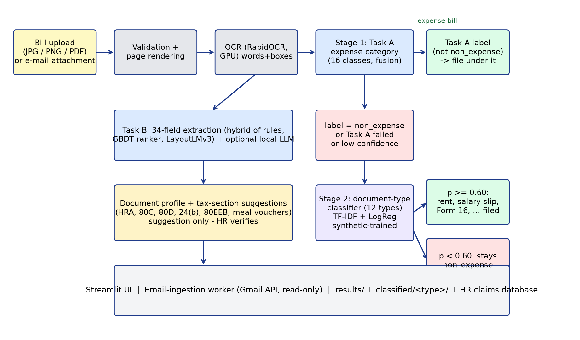
Fig. 1. Architecture and flow of the two-stage bill classification and extraction pipeline.
Implementation notes: Python, PyTorch, scikit-learn, RapidOCR (ONNX), Streamlit; the e-mail worker polls a Gmail mailbox read-only and processes only registered senders. The second stage lives in app/second_classifier.py and is wired in app/service.py; the training script is scripts/doc_type_new/train_new_classes.py.
4. PERFORMANCE ANALYSIS
4.1 Parameters, data and testing
Data. The expense dataset has 7,924 documents (5,494 real, 2,430 synthetic Indian). Splits are by document group (template, merchant, near-duplicate family) with an independent audit finding no validation or test image within perceptual-hash distance 4 of training. Task A: train 4,848 (2,904 real), validation 634 (391 real), test 629 (386 real). Task B: 6,442 documents (2,932 real, 3,510 synthetic), split 5,160 / 646 / 636. All hyper-parameters, fusion weights, temperatures and thresholds were chosen on validation data; the test set was evaluated once per model.
Metrics. Real-document accuracy and macro-F1 are the headline numbers because templated synthetic bills score about 1.0 for every model. Confidence intervals are bootstrap over document groups. Expected calibration error (ECE) measures how well confidence matches correctness; auto-coverage and auto-precision describe the HR routing rule. Task B uses per-field precision, recall and F1 and the micro-F1 over fields.
Second-stage test design. The 12 new classes were trained on two layouts, validated on a third and tested on an unseen layout (layout D; held-out templates for bank statements): 357 validation and 274 test documents. To choose the acceptance threshold, we measured the maximum second-stage probability on 600 synthetic test bills of the existing types: median 0.18, 99th percentile 0.47, while correct new-type documents scored at least 0.93 at the 1st percentile; the threshold was therefore set to 0.60.
4.2 Results obtained
Table 2. Task A (expense category) on the held-out test set, real documents.
Model | Real acc. | Real macro-F1 (95% CI) | Real-Indian acc. | ECE
TF-IDF + LogReg (OCR text) | 0.883 | 0.831 (0.75-0.87) | 0.936 | 0.026
ConvNeXt-Tiny (image) | 0.800 | 0.627 (0.54-0.67) | 0.836 | 0.068
LayoutLMv3-base | 0.863 | 0.704 (0.62-0.77) | 0.909 | 0.045
Calibrated fusion (final) | 0.907 | 0.839 (0.75-0.89) | 0.955 | 0.020

Routing: with tau = 0.61 the test result is 93.0% auto-coverage at 0.944 auto-precision (27 of 386 real documents sent to HR). Group 5-fold cross-validation of the text model gives 0.857 real accuracy / 0.838 macro-F1.
Table 3. Task B (field extraction), real test documents.
System | Real micro-F1 (95% CI) | Real macro-F1 | Indian-real micro-F1
Rule baseline | 0.444 (0.414-0.480) | 0.358 | 0.467
GBDT candidate ranker | 0.546 (0.501-0.588) | 0.451 | 0.449
LayoutLMv3 | 0.646 (0.606-0.685) | 0.549 | 0.534
Hybrid (final) | 0.663 (0.621-0.697) | 0.578 | 0.599

Per-field real F1 of the hybrid: total_amount 0.820, tax_total 0.821, merchant_address 0.829, subtotal 0.765, invoice_date 0.750, merchant_name 0.543, invoice_number 0.422. Merchant name and invoice number remain weak and should be verified by a person.
Table 4. Second-stage classifier (synthetic data only; 12 classes).
Split | Documents | Accuracy | Macro-F1 | Notes
Validation (held-out layout) | 357 | 1.000 | 1.000 | no confusions
Test (unseen layout / templates) | 274 | 1.000 | 1.000 | refit on train+val for the saved model

End-to-end checks in the application: all 12 new document types were uploaded through the Streamlit interface; the second stage accepted and filed each under its type (confidence 0.93-0.99). A confident expense bill (food) never reached the second stage, and text the model cannot place (a generic thank-you line, empty text) stays non_expense. The application's self-test passes 32 of 32 checks, including the second-stage cases. Thirteen real bills from the held-out test split (one per expense category, e.g. electricity, gas, water, parking, train, hotel) were re-run through the full pipeline and all were classified correctly with confidence 0.989-1.000. Runtime: models load in about 7-8 s; OCR runs at roughly 170 images per minute on an RTX 4050 (6 GB); a bill takes on the order of ten seconds from upload to result in the interface.
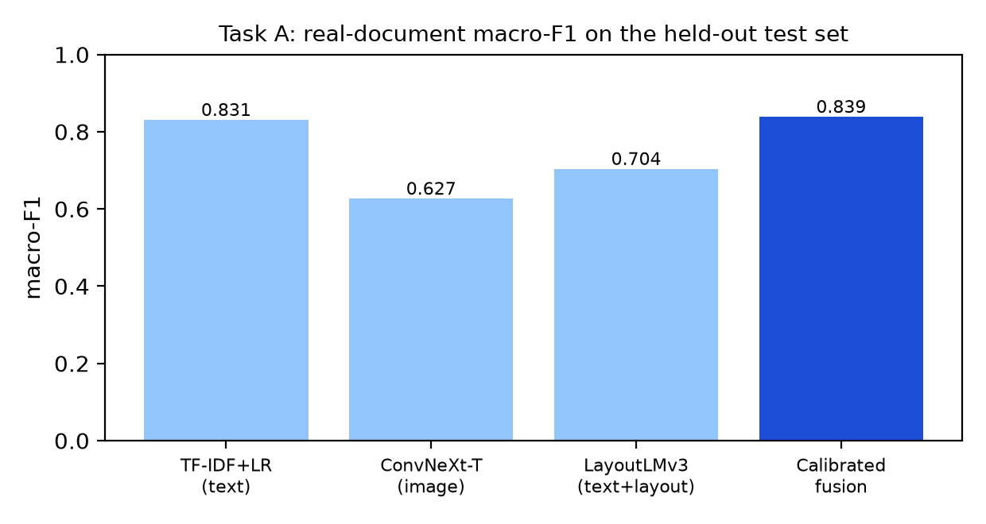
Fig. 2. Task A real macro-F1 per model: the calibrated fusion is the best.
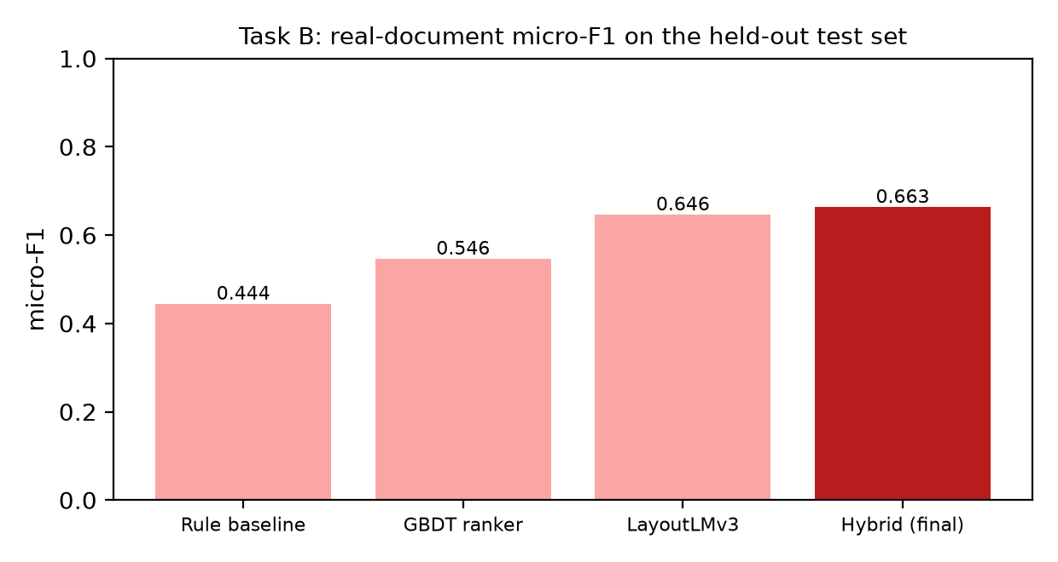
Fig. 3. Task B real micro-F1 per system: the hybrid is the best.
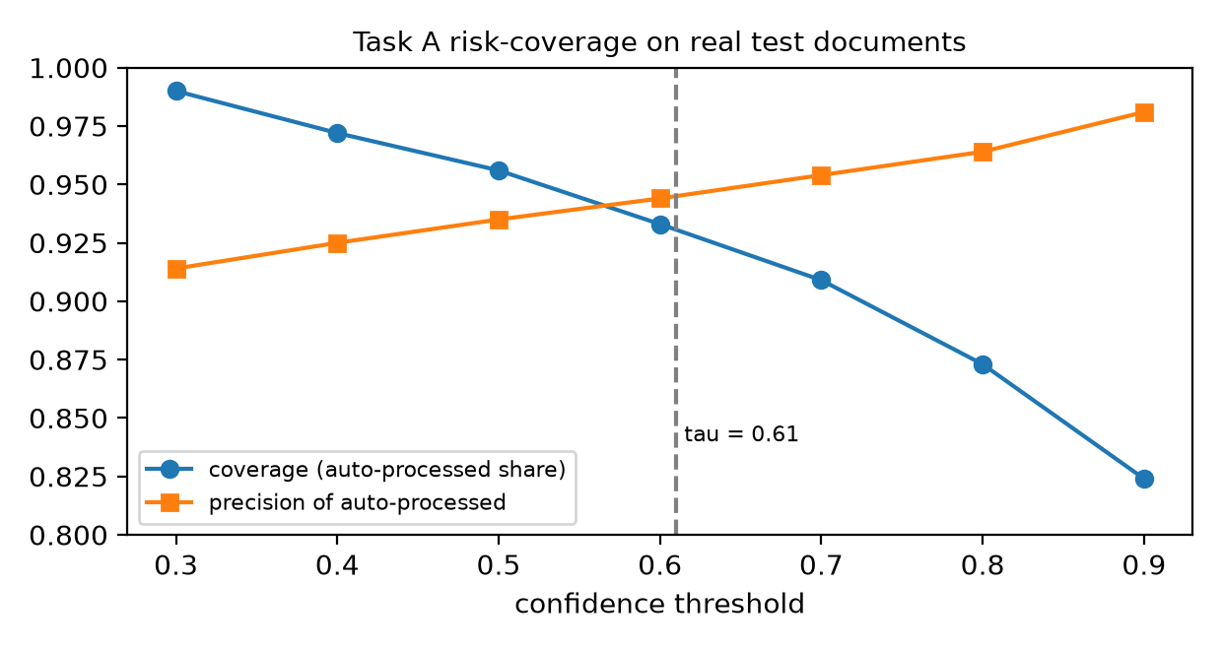
Fig. 4. Task A risk-coverage on real test documents; the dashed line is the chosen threshold.
4.3 Comparative analysis
The comparison above is against this project's own baselines (single models; rule, ranker and LayoutLMv3 extractors), all evaluated on the same held-out real documents: fusion scores slightly higher than the best single model (macro-F1 0.839 vs 0.831; accuracy 0.907 vs 0.883), but a paired bootstrap (Section 4.4) finds the difference from TF-IDF alone not statistically established, and its ECE (0.020) is only modestly lower than TF-IDF's (0.026) without an interval; the hybrid extractor the hybrid extractor beats the rule baseline by 0.219 micro-F1 with a paired bootstrap interval of [0.192, 0.247]. A numeric comparison with figures published in the surveyed papers (for example RVL-CDIP accuracies in the mid-to-high 90s, or SROIE/CORD field F1) would be misleading: those use different datasets, label sets and splits, and [6] shows that even the benchmark labels carry noise. Qualitatively, our system adds what the surveyed models do not: calibrated abstention, an HR route, Indian document types and a complete claim workflow.
4.4 Comparative Evaluation of OCR and Text Classification Approaches
4.4.1 Objective
A reviewer asked why TF-IDF is used and why RNNs, LexRank, attention or Transformer models are not. Two different questions are hidden in this. (A) OCR text recognition turns pixels into characters; TF-IDF plays no role there. (B) OCR text classification takes the text that OCR has already produced and assigns one of the 16 expense categories; this is where TF-IDF is used. We therefore measured both separately, on the project's existing splits, with the project's own ground truth, and report failures as well as successes. LexRank is an extractive summariser: it cannot read an image and cannot classify, so it is evaluated only as a summarise-then-classify pipeline and has no OCR row.
4.4.2 Methodology
Data and splits. Text classification uses the unchanged Task A splits (train 4,848 / validation 634 / test 629 documents; 16 categories). The headline numbers are on the REAL test documents (n = 386), as in the rest of this report; results on all 629 test documents (incl. synthetic) are in the CSV files. Every text model receives the same OCR text of the same documents (the stored RapidOCR output). Hyper-parameters, epochs and early stopping use validation data only; the test set was never used to choose hyper-parameters, epochs or seeds (for transparency the three seeds of each BiLSTM and the four LexRank settings were all scored on it; the reported seed was chosen by validation macro-F1 and the 50% LexRank setting was fixed in advance). One temperature per model is fitted on validation logits and applied to test (the same recipe as the production fusion), so ECE, NLL and Brier are reported raw and temperature-scaled; ECE uses 10 equal-width confidence bins.
Models. (1) TF-IDF + logistic regression: the production configuration, re-fitted and verified to reproduce the production probabilities exactly (word 1-2 + character 2-5 grams, C = 10, class-balanced). (2) BiLSTM: 128-d embeddings trained from scratch, 1 bidirectional LSTM layer with 128 hidden units, dropout 0.4, 256 tokens. (3) BiLSTM + additive attention pooling: identical except for the pooling. Both: AdamW, learning rate 2e-3, batch 64, up to 30 epochs, early stopping on validation macro-F1, class-balanced loss, three seeds (the seed with the best VALIDATION macro-F1 is reported). (4) LexRank summarisation + the same TF-IDF/LR: OCR lines are the units, LexRank (similarity threshold 0.10, damping 0.85) keeps the most central 75 / 50 / 25 percent of the lines; the 50% setting was fixed as the headline before the results were seen. (5) XLM-RoBERTa-base, a pretrained multilingual Transformer (the data contains English, German, Portuguese, Indonesian and Japanese), fine-tuned (all encoder layers and the classification head; the 192M-parameter word-embedding matrix was frozen so that training fits in 6 GB): 256 tokens, learning rate 3e-5, batch 16, bf16, up to 6 epochs, early stopping, one seed, no hyper-parameter search. (6) LayoutLMv3-base and the production fusion, taken read-only from the production checkpoints as reference rows; unlike the other models they also use the page image and layout.
Statistics. Differences from TF-IDF use a paired group bootstrap (2,000 resamples of whole templates/merchants; the same resampled documents for every model) with 95% intervals. Several models are compared with the same test set, so an isolated 'significant' interval can arise by chance; we call a difference established only when its interval excludes zero, and treat borderline cases as unresolved.
Environment: NVIDIA GeForce RTX 4050 Laptop GPU, 6 GB; Python 3.12.3, PyTorch 2.9.1+cu128, scikit-learn 1.9.1, transformers 5.18.0; seed 42. Latency is the median per-document time at batch size 1 after warm-up (GPU timings synchronised), classifier only (OCR excluded); CPU numbers use 4 threads. Timings were taken on a shared machine while other jobs ran, so differences of a few milliseconds are not meaningful.
4.4.3 OCR recognition comparison
Ground truth: the project's SROIE (receipt lines) and FUNSD (form words) transcriptions, test-split documents only (11 + 18 documents, 2,862 cropped lines/words). Each recogniser reads the same GT crops (no detector, so layout errors do not mix into CER/WER). Strict CER/WER compare the text exactly; the SROIE ground truth is upper-case and keeps spaces, whereas the production recogniser drops spaces and keeps the printed case, so the case/space-insensitive CER is the fairer accuracy measure. The CRNN was trained here from scratch on the training-split crops and is a small experiment, not a replacement candidate.
Table 5. OCR recognition on test-split ground-truth crops (norm. = case- and space-insensitive).
OCR model | Architecture | CER strict | CER norm. | CER norm. SROIE / FUNSD | WER strict | WER case-ins. | Latency (ms/page) | Pages/s | Size (MB) | Status
RapidOCR PP-OCRv4 recogniser (production) | PP-OCRv4 text recognizer (ONNX, CTC decoding) | 0.135 | 0.036 | 0.012 / 0.046 | 0.302 | 0.216 | 482.2 | 2.0 | 10.4 | completed
CRNN (CNN + BiLSTM + CTC), trained here | CRNN: 6-conv VGG-style CNN (height 32) + 2-layer BiLSTM(256) + CTC, gr | 0.056 | 0.050 | 0.032 / 0.058 | 0.188 | 0.174 | 128.9 | 7.0 | 31.4 | completed
TrOCR-small-printed (Transformer) | TrOCR-small-printed: ViT-style image encoder + Transformer text decode | 0.304 | 0.035 | 0.002 / 0.049 | 0.392 | 0.152 | 1084.5 | 0.8 | 234 | completed (SROIE possibly seen in pre-training)

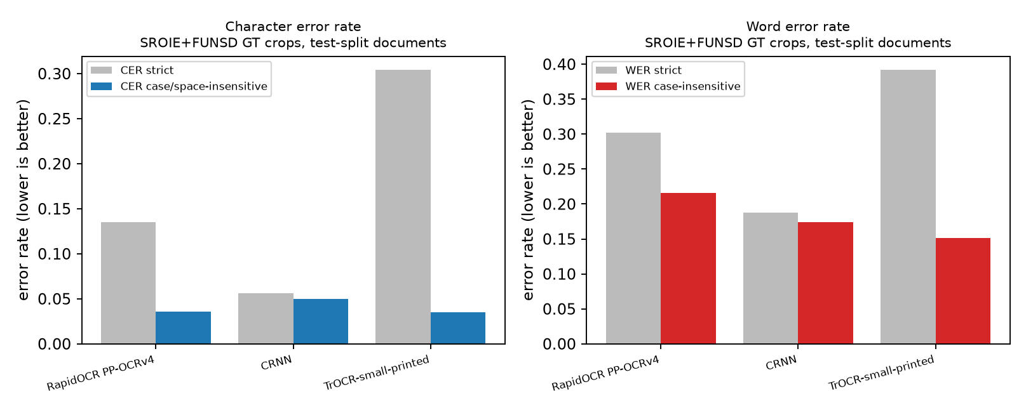
Fig. 5. Character and word error rates of the OCR recognisers on the same ground-truth crops.
4.4.4 Text-classification comparison
Table 6. Expense-category classification on the REAL test documents (n = 386). Same OCR text, same split; temperature fitted on validation. Latency excludes OCR; the fusion latency is the sum of its branches and was not re-measured.
Model | Layout / image? | Acc. | Macro-P | Macro-R | Macro-F1 (95% CI) | Weighted-F1 | ECE raw / T-scaled | NLL (T) | Latency CPU / GPU (ms) | Size (MB)
TF-IDF + Logistic Regression | no | 0.883 | 0.910 | 0.796 | 0.831 (0.75-0.88) | 0.880 | 0.124 / 0.026 | 0.362 | 2.05 / N/A | 48.4
BiLSTM | no | 0.712 | 0.656 | 0.587 | 0.598 (0.51-0.66) | 0.696 | 0.168 / 0.057 | 1.020 | 4.70 / 1.74 | 7.9
BiLSTM + attention | no | 0.777 | 0.789 | 0.659 | 0.683 (0.59-0.74) | 0.772 | 0.159 / 0.046 | 0.883 | 4.93 / 1.92 | 8.0
LexRank 50% summary + TF-IDF/LR | no | 0.852 | 0.908 | 0.765 | 0.807 (0.72-0.86) | 0.845 | 0.130 / 0.024 | 0.474 | 2.17 / N/A | N/A
XLM-RoBERTa-base (fine-tuned) | no | 0.899 | 0.900 | 0.881 | 0.884 (0.82-0.92) | 0.900 | 0.076 / 0.041 | 0.395 | 75.6 / 5.85 | 1064
LayoutLMv3-base (production) | yes | 0.863 | 0.772 | 0.712 | 0.704 (0.62-0.77) | 0.857 | 0.050 / 0.045 | 0.561 | N/A / 53.4 | 480
Calibrated fusion (production, 3 models) | yes | 0.907 | 0.915 | 0.814 | 0.839 (0.75-0.89) | 0.903 | 0.025 / 0.020 | 0.299 | N/A / N/A | N/A

Table 7. Training and inference resources. Peak memory is the GPU memory allocated during training (N/A for CPU models); LayoutLMv3's training time is taken from its original training log.
Model | Training time (s) | Device | Peak memory (MB) | CPU / GPU latency (ms) | Model size (MB) | Completed
TF-IDF + Logistic Regression | 55 | CPU | N/A | 2.05 / N/A | 48.4 | yes
BiLSTM | 45 | GPU | 439 | 4.70 / 1.74 | 7.9 | yes
BiLSTM + attention | 72 | GPU | 423 | 4.93 / 1.92 | 8.0 | yes
LexRank 50% summary + TF-IDF/LR | 41 | CPU | N/A | 2.17 / N/A | N/A | yes
XLM-RoBERTa-base (fine-tuned) | 405 | GPU | 3568 | 75.6 / 5.85 | 1064 | yes
LayoutLMv3-base (production) | 3310 | GPU | 827 | N/A / 53.4 | 480 | yes
Calibrated fusion (production, 3 models) | N/A | GPU | N/A | N/A / N/A | N/A | yes

Table 8. Per-class F1 on categories with at least 8 real test documents (precision, recall and the small categories are in table_D_per_class.csv).
Category (real test support) | TF-IDF+LR | BiLSTM | BiLSTM+attn | LexRank+TF-IDF | XLM-R | LayoutLMv3
bus (n=13) | 0.750 | 0.643 | 0.593 | 0.750 | 0.727 | 0.595
electricity (n=12) | 0.917 | 0.692 | 0.800 | 0.880 | 0.923 | 0.880
flight (n=13) | 0.960 | 0.348 | 0.783 | 0.960 | 0.846 | 0.813
food (n=109) | 0.924 | 0.811 | 0.861 | 0.882 | 0.936 | 0.967
fuel (n=13) | 0.880 | 0.786 | 0.815 | 0.846 | 0.880 | 0.733
hotel (n=23) | 0.818 | 0.651 | 0.718 | 0.864 | 0.933 | 0.936
miscellaneous (n=50) | 0.909 | 0.722 | 0.804 | 0.869 | 0.857 | 0.920
non_expense (n=80) | 0.912 | 0.789 | 0.835 | 0.885 | 0.945 | 0.970
parking (n=8) | 0.800 | 0.308 | 0.625 | 0.857 | 0.941 | 0.769
train (n=28) | 0.783 | 0.389 | 0.634 | 0.634 | 0.816 | 0.585
transport (n=14) | 0.828 | 0.710 | 0.558 | 0.815 | 0.800 | 0.714

Table 9. LexRank summarisation + the same TF-IDF/LR classifier, with random-line and first-line controls of similar length (real test documents).
Configuration | Words/doc | Text reduction | Accuracy | Macro-F1 | Summarise (ms) | Classify (ms)
Full OCR text (Model 1, flat text) | 109.7 | 0.0% | 0.883 | 0.831 | 0.00 | 2.05
All OCR lines re-joined (LexRank 100%) | 109.7 | 0.0% | 0.886 | 0.834 | 0.00 | 1.80
LexRank 75% of lines | 88.0 | 19.8% | 0.865 | 0.811 | 0.81 | 2.15
LexRank 50% of lines | 63.1 | 42.5% | 0.852 | 0.807 | 0.71 | 1.47
LexRank 25% of lines | 35.0 | 68.1% | 0.790 | 0.697 | 0.71 | 1.15
CONTROL: random 50% of lines (mean of 3 seeds) | 54.5 | 50.3% | 0.845 | 0.770 | - | -
CONTROL: first lines 50% of lines (mean of 1 seed) | 48.2 | 56.0% | 0.858 | 0.798 | - | -
CONTROL: random 25% of lines (mean of 3 seeds) | 27.2 | 75.2% | 0.782 | 0.687 | - | -
CONTROL: first lines 25% of lines (mean of 1 seed) | 23.1 | 79.0% | 0.816 | 0.747 | - | -

4.4.5 Graphical analysis
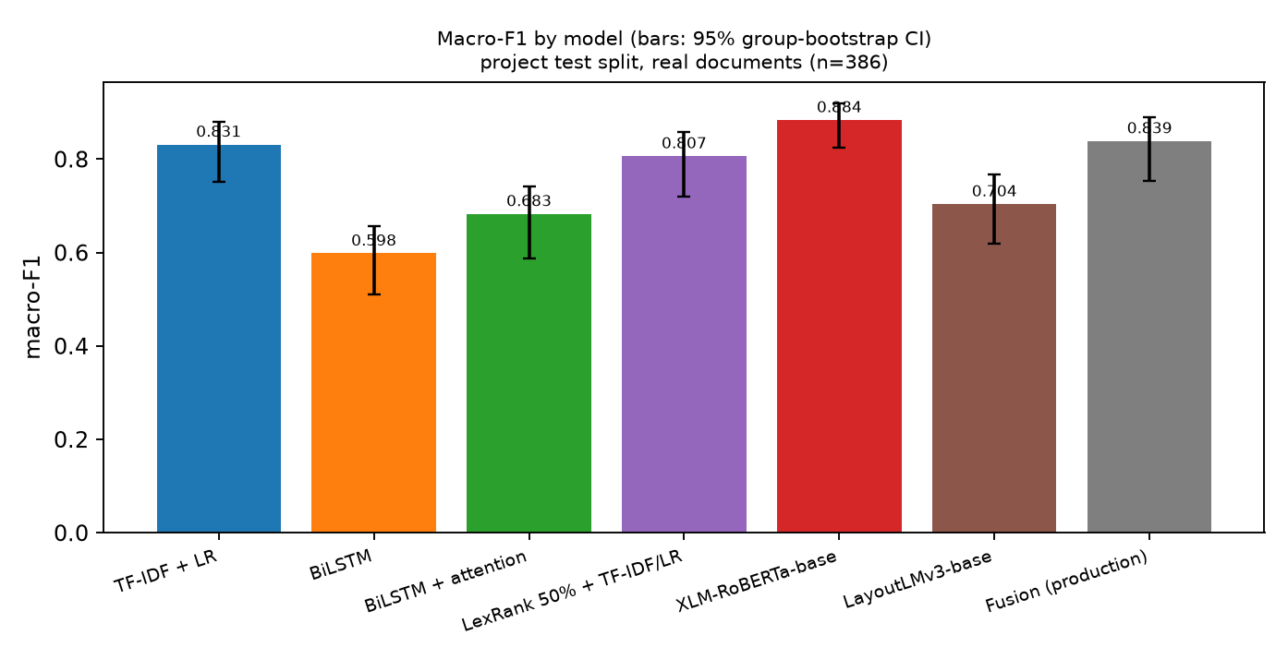
Fig. 6. Macro-F1 by model with 95% group-bootstrap intervals (real test documents).
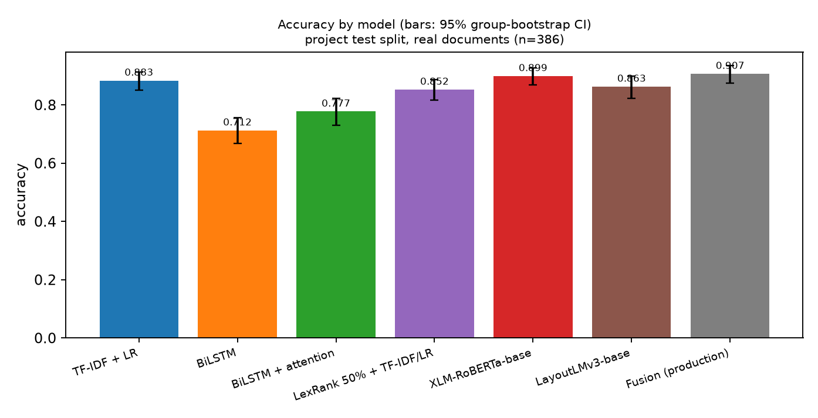
Fig. 7. Accuracy by model with 95% group-bootstrap intervals.
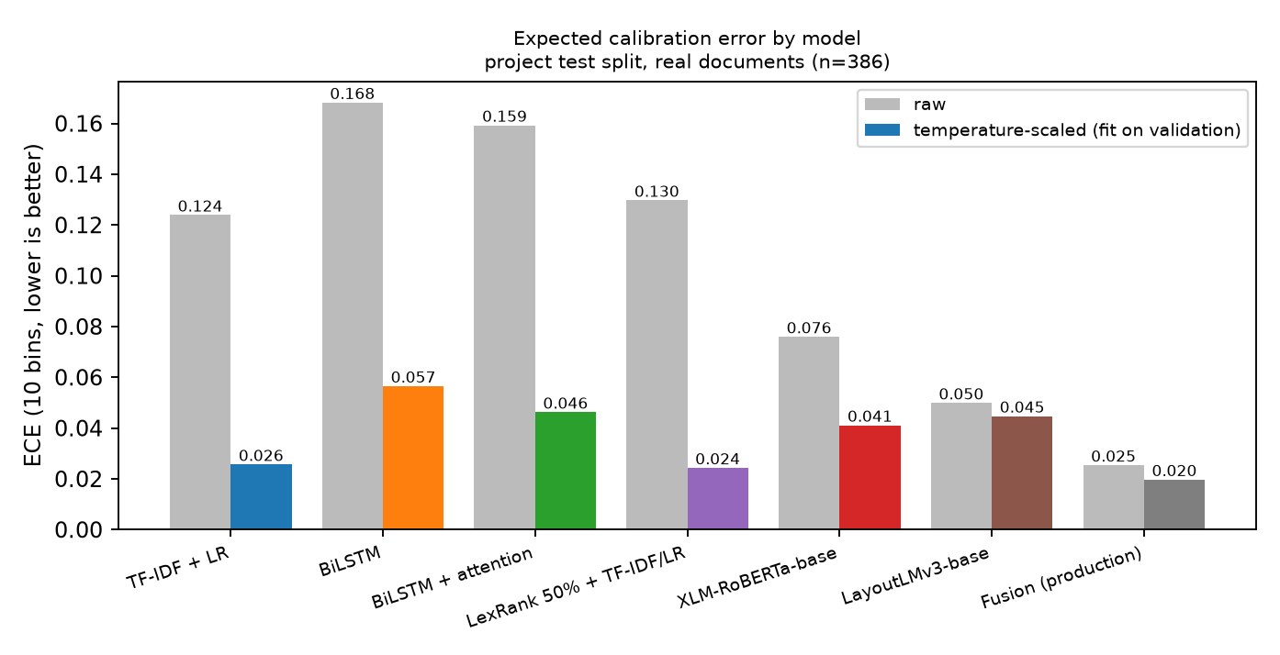
Fig. 8. Expected calibration error before and after temperature scaling.
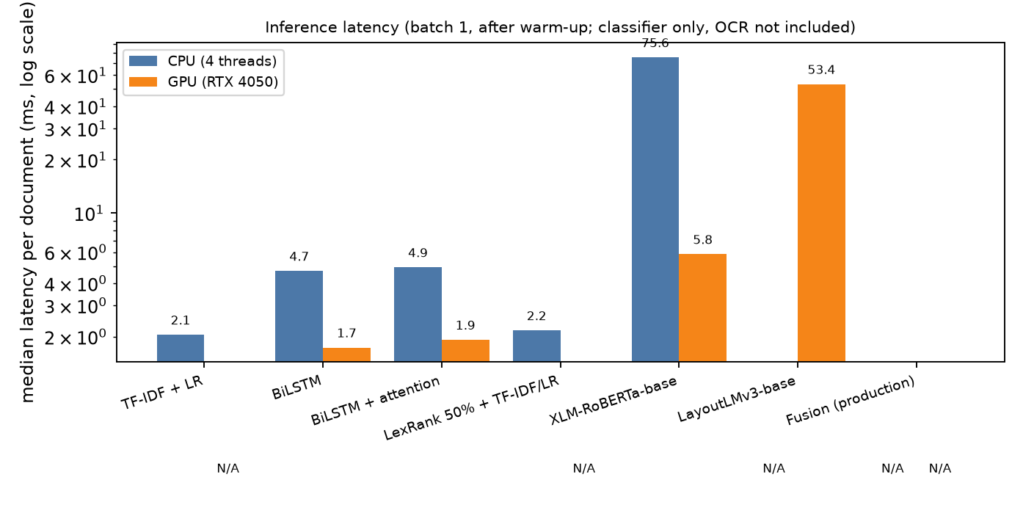
Fig. 9. Inference latency (log scale).
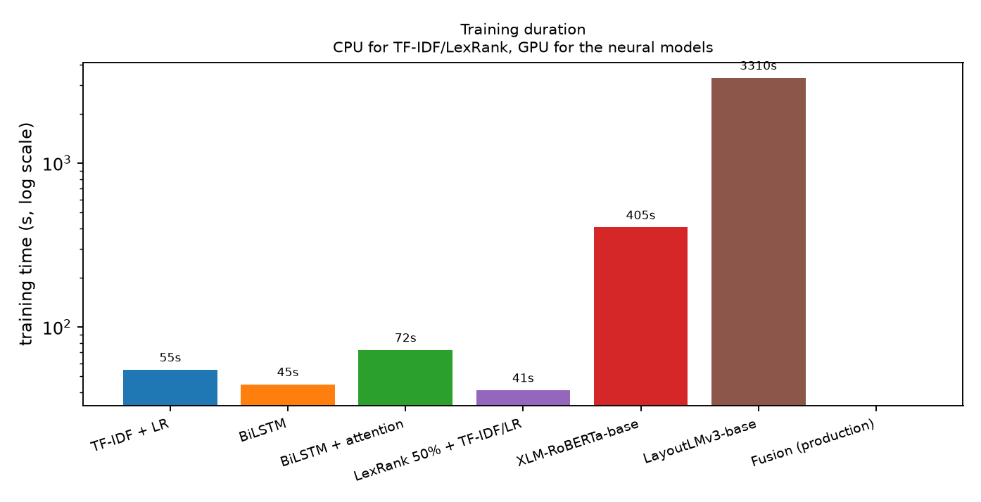
Fig. 10. Training duration (log scale).
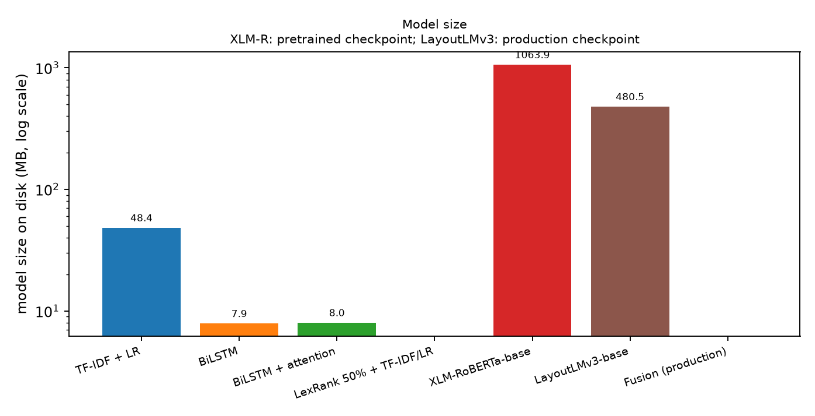
Fig. 11. Model size on disk (log scale).
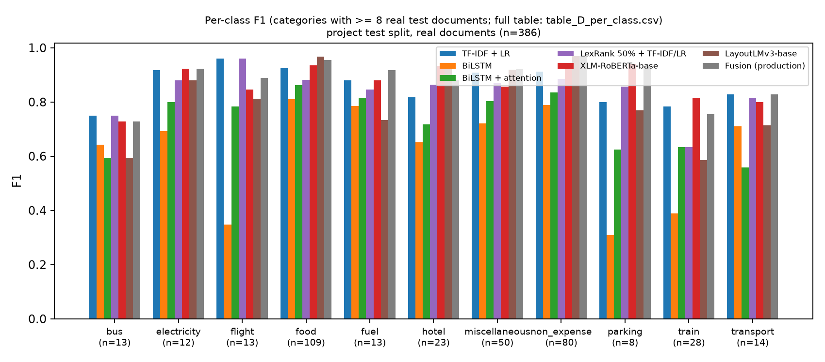
Fig. 12. Per-class F1 on categories with at least 8 real test documents.
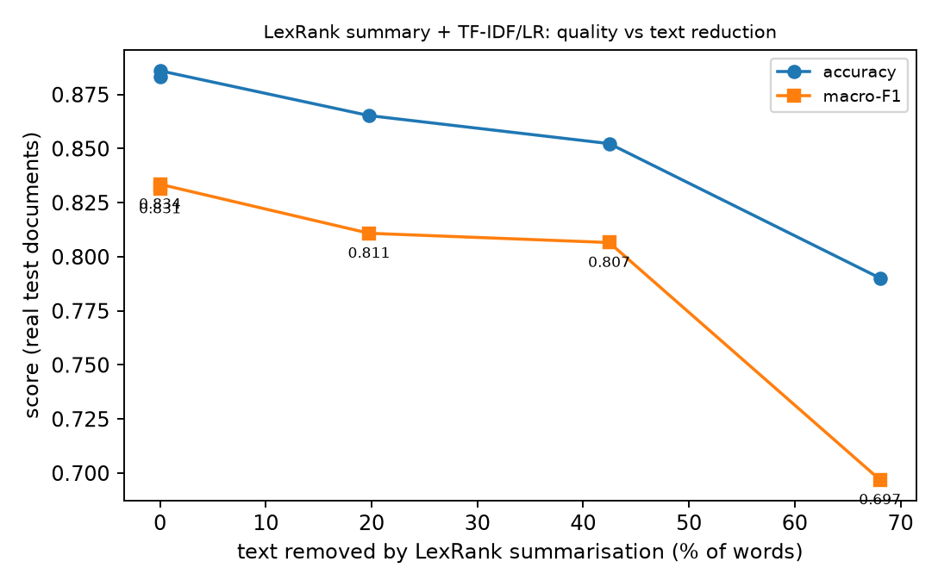
Fig. 13. LexRank summarisation: accuracy and macro-F1 against the share of text removed.
4.4.6 Interpretation
- Best text-only model by macro-F1: XLM-RoBERTa-base (fine-tuned) (0.884); by accuracy: XLM-RoBERTa-base (fine-tuned) (0.899). The production fusion, which also uses the image and layout, reaches macro-F1 0.839 / accuracy 0.907.
- Best calibrated (temperature-scaled ECE, lowest): LexRank 50% summary + TF-IDF/LR (0.024); lowest NLL: TF-IDF + Logistic Regression (0.362). Before temperature scaling every model is over- or under-confident; the scaling uses validation data only.
- Fastest on CPU: TF-IDF + Logistic Regression (2.1 ms/document); smallest on disk: BiLSTM (7.9 MB).
- A BiLSTM trained from scratch vs TF-IDF/LR: macro-F1 -0.237 (95% CI -0.318 to -0.154), accuracy -0.171 (-0.217 to -0.128) -> worse, established by the paired bootstrap.
- A BiLSTM with attention pooling vs TF-IDF/LR: macro-F1 -0.150 (95% CI -0.224 to -0.078), accuracy -0.105 (-0.149 to -0.065) -> worse, established by the paired bootstrap.
- The fine-tuned XLM-RoBERTa Transformer vs TF-IDF/LR: macro-F1 +0.057 (95% CI -0.004 to +0.124), accuracy +0.015 (-0.016 to +0.047) -> not distinguishable from TF-IDF on this test set (the interval includes zero).
- LexRank summarisation before the same classifier vs TF-IDF/LR: macro-F1 -0.026 (95% CI -0.061 to +0.001), accuracy -0.031 (-0.052 to -0.010) -> not distinguishable from TF-IDF on this test set (the interval includes zero).
LexRank keeps 58% of the words and loses -0.025 macro-F1 relative to the full text. Controls with similar reduction give random 50% of lines: macro-F1 0.770 (accuracy 0.845); first lines 50% of lines: macro-F1 0.798 (accuracy 0.858), versus 0.807 for LexRank. Summarisation therefore saves classifier input but does not improve accuracy, and selecting lines by centrality is not shown to beat simply truncating or sampling lines: on bills the useful signal (merchant name, a few key words) is spread over short lines, not concentrated in 'central' sentences.
Attention vs the plain BiLSTM (same data, same split): macro-F1 +0.086 (95% CI +0.003 to +0.174 from 2,000 resamples); an independent re-computation with 10,000 resamples gives -0.004 to +0.174 -> borderline: the lower end of the interval sits at zero, so the improvement is suggestive but not established (and it does not survive a correction for the seven comparisons made). Seed-to-seed variation is also large (see results.json: nn_seed_variation), so a gain of this size from one selected seed must not be read as a property of attention.
Cost versus benefit. TF-IDF/LR is a 48 MB model that trains on a CPU in about 55 s and answers in about 2.1 ms per document. The fine-tuned Transformer needs a GPU for training and is about 22 times larger on disk. The BiLSTMs are cheap but clearly less accurate, so they are not a good trade. Whether the Transformer's extra cost is justified depends on whether its higher macro-F1 survives a larger test set; here it is suggestive, not established.
4.4.7 Limitations of this comparison
- The real test set has 386 documents and several categories have fewer than 10 (gas 4, internet 6, medical 6, water 7); per-class numbers and small macro-F1 differences are therefore noisy, and the paired intervals above are wide. Many models are compared on one test set, which raises the chance that one looks better by luck; we only call differences established when the interval excludes zero.
- The neural text models are small-data baselines: the BiLSTMs learn their embeddings from about 4,800 training documents (no pretrained embeddings), use a word tokenizer although the OCR engine often drops spaces (words run together, e.g. 'GSTID:000433614848'), and were not tuned beyond the documented configuration. The Transformer was fine-tuned once (one seed, no hyper-parameter search, 256 tokens, frozen word-embedding matrix). A better-tuned or larger model could do better; this experiment does not rule that out.
- TF-IDF and LayoutLMv3 come from the original, independent training runs; the other models were trained here with a similar but not identical protocol. LayoutLMv3 also uses the page image and layout, so it is not a like-for-like text comparison.
- The OCR comparison uses only 29 test-split documents with ground-truth boxes (SROIE receipts and FUNSD forms), recognises GT crops rather than whole pages (detector excluded), and the ground-truth conventions (upper case, spaces, masked '***' regions) penalise the production recogniser under strict CER. The CRNN was trained on about 40,000 crops from the training split and is not a drop-in replacement; the TrOCR checkpoint may have seen SROIE during its own fine-tuning, so its SROIE score is not clean.
- Timings were measured on a shared 6 GB laptop GPU/CPU with other jobs running; they show orders of magnitude, not precise ratios. The results concern one dataset, mostly English with some German, Portuguese, Indonesian and Japanese, and do not show that any method is universally better.
- Unequal input length: TF-IDF/LR reads the whole OCR text, but XLM-R sees only the first 256 sub-word tokens and the BiLSTMs the first 256 word tokens. 47% of the real test documents exceed 256 XLM-R tokens (34% exceed 256 word tokens), so the neural models never saw the end of those bills (totals, tax lines), while the LexRank pipeline deliberately drops lines. Longer inputs or chunking could change the neural results; this was not tested.
4.4.8 Conclusion of the comparison
No neural text model was established to beat TF-IDF + logistic regression. The fine-tuned Transformer scored higher (macro-F1 0.884 vs 0.831, accuracy 0.899 vs 0.883), but the paired interval for the macro-F1 difference (-0.004 to +0.124) includes zero, so this test set does not establish that it is better; the two BiLSTMs were clearly worse. The Transformer needed a GPU, about 405 s of fine-tuning, a 1064 MB model and 76 ms per document on the CPU, against 2.1 ms and 48 MB for TF-IDF/LR. LexRank is a valid summarisation method but neither an OCR engine nor a classifier; as a pre-processing step it did not improve classification and its line choice was not shown to be better than a random or first-lines cut. The attention BiLSTM scored higher than the plain BiLSTM, but that gain was not firmly established (its interval is borderline), and both trailed TF-IDF clearly. The best-performing system overall is the production fusion (image and layout added), whose edge over TF-IDF alone is also not established statistically. Recommendation: keep TF-IDF + logistic regression as the low-cost text branch; treat a fine-tuned multilingual Transformer as the most promising upgrade, to be confirmed with several seeds, more epochs (the best epoch was the last one tried) and a larger real test set before it replaces or joins the fusion.
4.5 Limitations
- The second-stage model has seen only synthetic documents. Its 1.000 scores are a property of the generator (consistent titles and wording), not a measure of real-world accuracy; an earlier baseline trained on synthetic documents scored about 0 on real documents of other classes. Real documents of the 12 new types must be collected, with consent, before any accuracy claim is made.
- The second stage has no explicit reject class; the 0.60 threshold is the only guard against forcing a document into one of 12 labels. Cheque documents are not covered.
- Real-test support is small for several Task A classes (medical, water, internet, gas) and for Task B fields such as GSTIN, CGST, SGST; HSN/SAC has no real annotation. Task B is a research-grade baseline.
- LayoutLMv3 weights are non-commercial (CC-BY-NC-SA-4.0); some real documents have unverified redistribution rights, so models and data should stay internal.
5. CONCLUSION
- We built a working two-stage pipeline that reads Indian employee bills, classifies them, extracts fields, hands documents the first model cannot place to a second document-type classifier, and routes uncertain cases to HR.
- Stage 1 reaches 0.907 real accuracy and 0.839 real macro-F1 with calibrated confidence (93.0% auto-coverage at 0.944 precision), and the hybrid extractor reaches 0.663 real micro-F1, significantly above the rule baseline.
- A measured comparison on identical OCR text (Section 4.4) found that no BiLSTM, attention-BiLSTM or LexRank-summarised model beat TF-IDF + logistic regression, and that a fine-tuned XLM-RoBERTa scored higher but not by a margin the test set can establish; OCR recognition was evaluated separately on ground-truth crops, where LexRank has no role.
- The new second stage recognises 12 tax-evidence and financial document types that were previously shown as non_expense; the application now shows non_expense only when the second model also cannot place the document.
- Its perfect synthetic scores prove the integration, not real-world accuracy; the strongest next step is a consented collection of real rent receipts, insurance, school-fee and similar documents, followed by retraining with a reject class.
- Strong points of the work are group-aware, real-only evaluation, calibrated abstention, full provenance of data and an honest account of limits.
6. REFERENCES
[1] Y. Huang, T. Lv, L. Cui, Y. Lu, F. Wei, "LayoutLMv3: Pre-training for Document AI with Unified Text and Image Masking," Proc. 30th ACM International Conference on Multimedia (MM '22), Lisbon, 2022, doi:10.1145/3503161.3548112.
[2] Y. Xu, Y. Xu, T. Lv, L. Cui, F. Wei, G. Wang, Y. Lu, D. Florencio, C. Zhang, W. Che, M. Zhang, L. Zhou, "LayoutLMv2: Multi-modal Pre-training for Visually-rich Document Understanding," Proc. 59th Annual Meeting of the ACL and 11th IJCNLP (Long Papers), pp. 2579-2591, 2021, doi:10.18653/v1/2021.acl-long.201.
[3] J. Li, Y. Xu, T. Lv, L. Cui, C. Zhang, F. Wei, "DiT: Self-supervised Pre-training for Document Image Transformer," Proc. 30th ACM International Conference on Multimedia (MM '22), 2022, arXiv:2203.02378.
[4] A. Yeghiazaryan, K. Khechoyan, G. Nalbandyan, S. Muradyan, "TokenGrid: Toward More Efficient Data Extraction From Unstructured Documents," IEEE Access, vol. 10, pp. 39261-39268, 2022, doi:10.1109/ACCESS.2022.3164674.
[5] Z. Yan, Z. Ye, J. Ge, J. Qin, J. Liu, Y. Cheng, C. Gurrin, "DocExtractNet: A novel framework for enhanced information extraction from business documents," Information Processing & Management, vol. 62, no. 3, 2025, doi:10.1016/j.ipm.2024.104046.
[6] S. Larson, G. Lim, K. Leach, "On Evaluation of Document Classification with RVL-CDIP," Proc. 17th Conference of the European Chapter of the ACL (EACL), pp. 2665-2678, 2023, doi:10.18653/v1/2023.eacl-main.195.
[7] L. Cui, Y. Xu, T. Lv, F. Wei, "Document AI: Benchmarks, Models and Applications," arXiv:2111.08609, 2021.
[8] A. M. Rombach, P. Fettke, "Deep Learning based Key Information Extraction from Business Documents: Systematic Literature Review," ACM Computing Surveys, vol. 58, no. 2, art. 45, 2025, doi:10.1145/3749369.
[9] W. Wang, H. Hu, Z. Zhang, Z. Li, H. Shao, D. Dahlmeier, "Document Intelligence in the Era of Large Language Models: A Survey," arXiv:2510.13366, 2025.
[10] J. Wang, L. Jin, K. Ding, "LiLT: A Simple yet Effective Language-Independent Layout Transformer for Structured Document Understanding," Proc. 60th Annual Meeting of the ACL (Long Papers), pp. 7747-7757, 2022, doi:10.18653/v1/2022.acl-long.534.
[11] S. Appalaraju, B. Jasani, B. U. Kota, Y. Xie, R. Manmatha, "DocFormer: End-to-End Transformer for Document Understanding," Proc. IEEE/CVF International Conference on Computer Vision (ICCV), 2021, arXiv:2106.11539.
[12] G. Kim, T. Hong, M. Yim, J. Nam, J. Park, J. Yim, W. Hwang, S. Yun, D. Han, S. Park, "OCR-free Document Understanding Transformer," Proc. European Conference on Computer Vision (ECCV), 2022, arXiv:2111.15664.
[13] Z. Liu, H. Mao, C.-Y. Wu, C. Feichtenhofer, T. Darrell, S. Xie, "A ConvNet for the 2020s," Proc. IEEE/CVF Conference on Computer Vision and Pattern Recognition (CVPR), pp. 11976-11986, 2022.
[14] C. Guo, G. Pleiss, Y. Sun, K. Q. Weinberger, "On Calibration of Modern Neural Networks," Proc. 34th International Conference on Machine Learning, PMLR 70, pp. 1321-1330, 2017. (foundational)
[15] Z. Huang, K. Chen, J. He, X. Bai, D. Karatzas, S. Lu, C. V. Jawahar, "ICDAR2019 Competition on Scanned Receipt OCR and Information Extraction," Proc. International Conference on Document Analysis and Recognition (ICDAR), 2019, arXiv:2103.10213. (foundational)
[16] X. Mifsud, L. Grech, A. Baldacchino, L. Keller, G. Valentino, A. Muscat, "Receipt Information Extraction with Joint Multi-Modal Transformer and Rule-Based Model," Machine Learning and Knowledge Extraction, vol. 7, no. 4, art. 167, 2025, doi:10.3390/make7040167.
[17] L. Liu, Z. Wang, T. Qiu, Q. Chen, Y. Lu, C. Y. Suen, "Document image classification: Progress over two decades," Neurocomputing, vol. 453, pp. 223-240, 2021, doi:10.1016/j.neucom.2021.04.114.
[18] J. Gawlikowski, C. R. N. Tassi, M. Ali, J. Lee, M. Humt, J. Feng, A. Kruspe, R. Triebel, P. Jung, R. Roscher, M. Shahzad, W. Yang, R. Bamler, X. X. Zhu, "A survey of uncertainty in deep neural networks," Artificial Intelligence Review, vol. 56, suppl. 1, pp. 1513-1589, 2023, doi:10.1007/s10462-023-10562-9.

