


Machine Learning Operations
Course Project 2025-2026
Students:
2014553 António Varela
Miguel Venâncio
Maria Cruz
Carlos Amorim

Table of Contents
1. Introduction
1.1 Problem Context and Data Selection
1.2 Project Objective and Success Metrics
2. Project Planning and MLOps Architecture
2.1 Agile-Inspired Project Plan
2.2 Kedro Pipeline Architecture
3. Data Exploration and Model Development
3.1 Data Preparation and Feature Engineering
3.2 Temporal Train–Validation–Test Split
3.3 Baseline and Challenger Models
3.4 Model Results and Explainability
4. Validation, Monitoring and Reproducibility
4.1 Data Quality Validation
4.2 Automated Tests
4.3 Data Drift Evaluation
4.4 Reproducible Pipeline Execution
5. Experiment Tracking, Feature Store and Deployment
5.1 MLflow Experiment Tracking and Model Registry
5.2 Hopsworks Feature Store
5.3 FastAPI Model Serving
5.4 Docker Containerisation
6. Conclusion and Production Roadmap
6.1 Main Achievements
6.2 Risks, Limitations and Mitigations
6.3 Future Work
References
Appendices
A. Evidence Screenshots
B. Package Versions
C. Reproducibility Commands
D. Additional Technical Details

Introduction
This project was developed as a proof of concept to predict whether the S&P 500 index will move up or down on the following trading day. Historical market data was collected from Yahoo Finance and processed through a reproducible Kedro pipeline, including cleaning, feature engineering and temporal train-validation-test splitting. Great Expectations was used to validate the quality of the engineered dataset before model training. A Logistic Regression baseline was compared with a Random Forest challenger, with experiments, metrics and model versions tracked in MLflow. The project also includes automated tests, data-drift monitoring, FastAPI serving and Docker containerisation, while Hopsworks was used as an optional Feature Store to store reusable features and maintain feature lineage.

Project Planning and MLOps Architecture

2.1 Agile-Inspired Project Plan
The project was developed through an iterative and incremental approach inspired by Agile principles. The work was divided into small implementation stages: data ingestion and validation, feature engineering, model development, experiment tracking, feature storage, model serving, containerisation and monitoring. Each stage was tested before progressing to the next one, allowing technical issues to be identified early and reducing the risk of building an incomplete end-to-end solution. This approach also made it possible to improve the pipeline progressively while keeping the project reproducible.

2.2 Kedro Pipeline Architecture
Kedro was used as the main orchestration framework to structure the machine learning workflow into modular and reusable pipeline nodes. The pipeline starts with the validation and cleaning of raw S&P 500 market data, followed by feature engineering and a chronological train-validation-test split. The split data is then used to train and evaluate two models: a Logistic Regression baseline and a Random Forest challenger. The final outputs include trained models, predictions and evaluation metrics for both approaches.
The Kedro architecture separates data inputs, transformation logic and model outputs, making the workflow easier to maintain, reproduce and extend. The complete pipeline was successfully executed with all eight tasks completed, demonstrating that the local end-to-end workflow is operational.
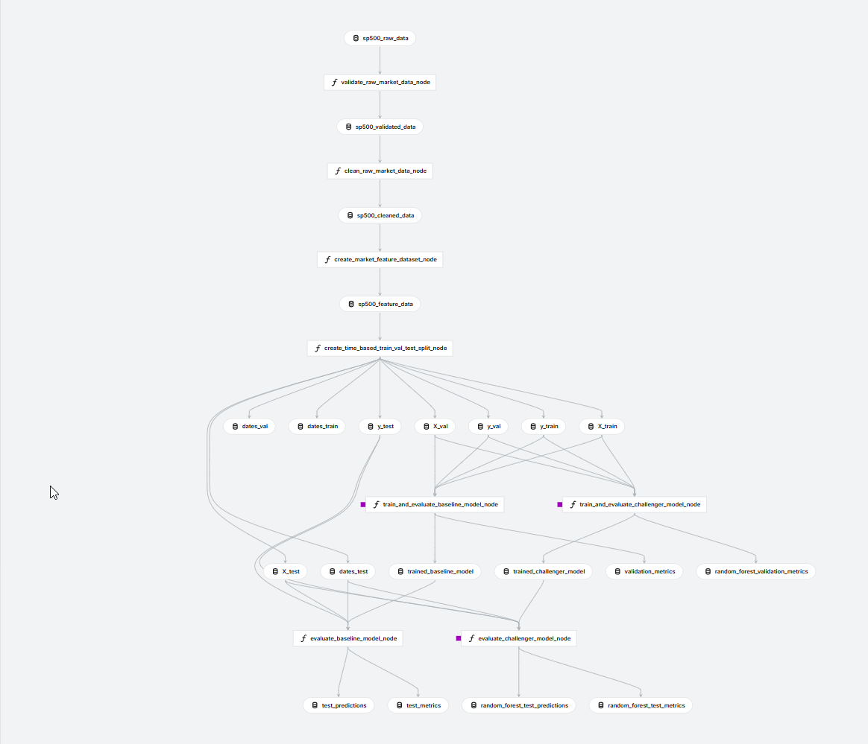
Figure 1: Kedro Viz representation of the end-to-end S&P 500 MLOps pipeline, covering data validation, cleaning, feature engineering, temporal splitting, baseline and challenger model training, and final test evaluation.

Data Exploration and Model Development

3.1 Data Preparation and Feature Engineering
The modelling dataset was built from historical S&P 500 market data obtained through Yahoo Finance using the ^GSPC ticker. The raw data was cleaned and transformed into a feature dataset containing daily returns, moving averages, relative moving-average ratios, RSI, rolling volatility and volume variation. The target variable represents the expected market direction for the following trading day.
Before model training, the engineered dataset was validated using Great Expectations. The validation process checked the structure, feature availability and quality rules of the dataset, with all 27 defined expectations successfully satisfied. This step helps reduce the risk of training models with incomplete, inconsistent or invalid input data.
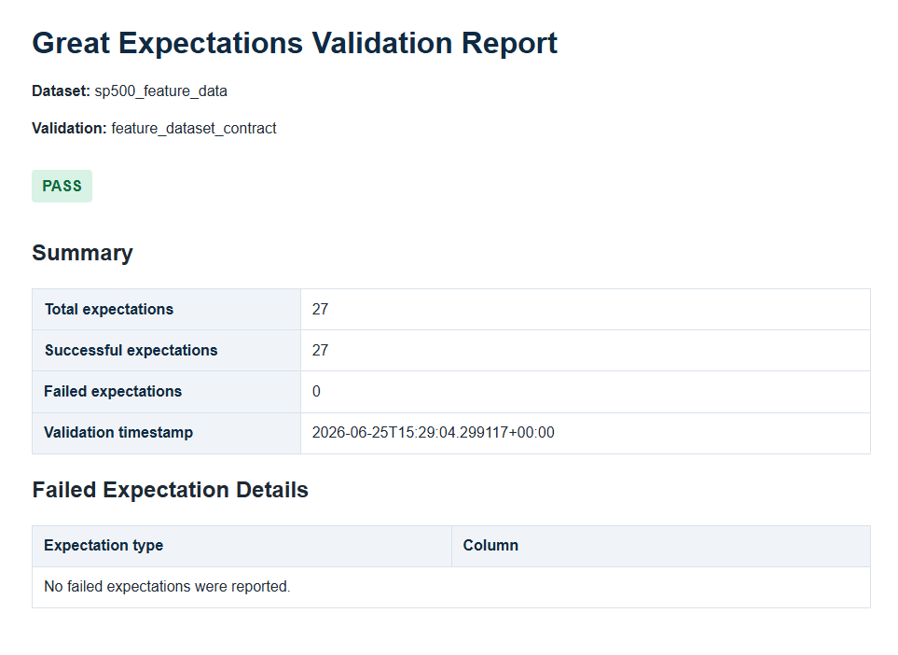
Figure 2. Great Expectations validation of the engineered feature dataset, with 27 out of 27 data-quality expectations successfully satisfied.

Validation, Monitoring and Reproducibility

4.1 Data Quality Validation
Data quality was incorporated into the workflow through Great Expectations. The engineered feature dataset was validated against a defined set of expectations before being used for model development. The validation report confirmed that all 27 expectations were successfully satisfied, providing evidence that the dataset complied with the expected structure and quality requirements.
This validation layer is important because machine learning models are highly dependent on the quality and consistency of their input data. By checking the dataset before training, the pipeline reduces the risk of propagating missing, invalid or incorrectly formatted values into later stages.

4.2 Automated Testing
Automated tests were implemented with pytest to validate relevant data-processing, pipeline and model-related functions. The final test execution completed successfully with 119 tests passed. Temporary generated folders were excluded from the command because they contain temporary pytest outputs and are not part of the source-code test suite.
This testing layer supports maintainability and reduces the probability that future changes to the pipeline introduce regressions.
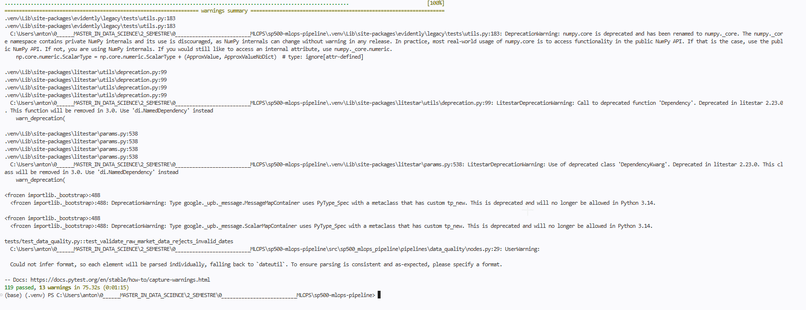Figure 3. Automated test execution with pytest: 119 tests passed, covering relevant data-quality, pipeline and model-related functions.

4.3 Data Drift Evaluation
The project includes a data-drift report to monitor whether the distribution of current input features differs from the reference dataset used during model development. The evaluation detected drift in 4 of the 8 monitored features, corresponding to 50% of the feature set.
This result does not prove that the model has degraded, because the report evaluates changes in the input-data distribution rather than predictive performance. However, it provides an operational signal that the model should be investigated, retrained or evaluated again on more recent labelled data.
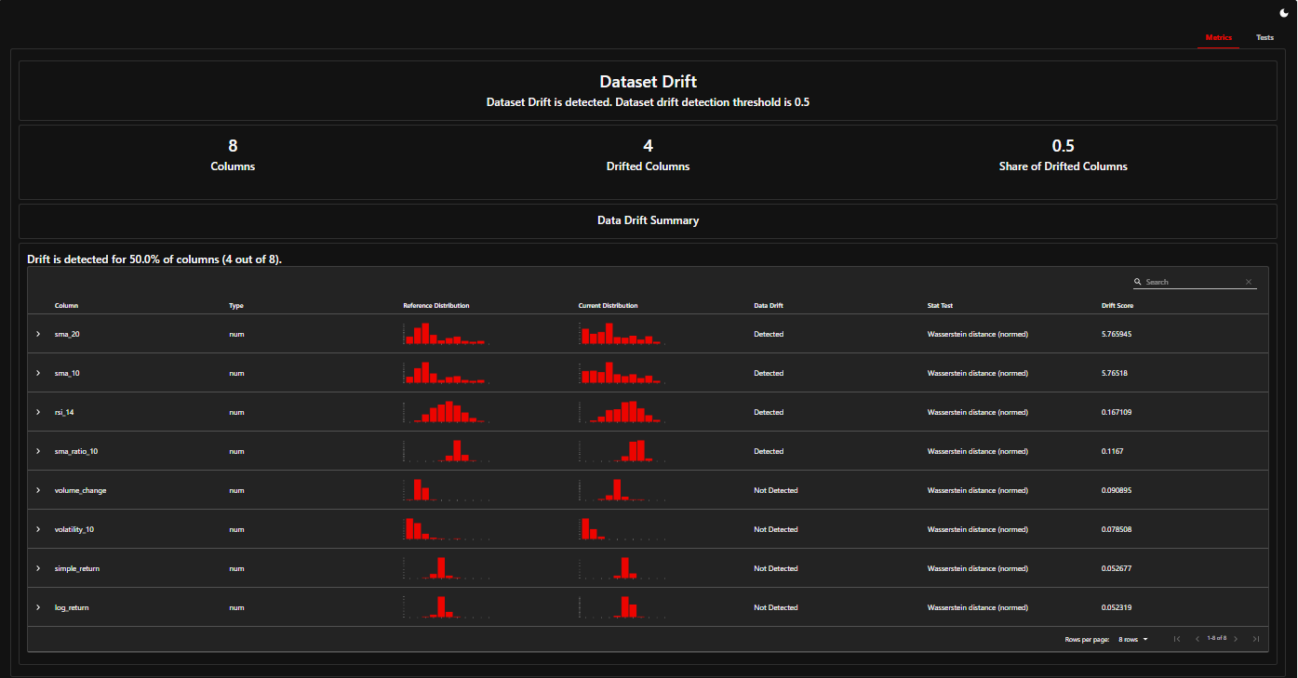Figure 4. Data-drift evaluation of the monitored feature set. Drift was detected in 4 of 8 features (50%), triggering an investigation or retraining assessment signal.

4.4 Reproducible Pipeline Execution
The end-to-end workflow was executed through Kedro, which orchestrates the data validation, transformation, feature engineering, temporal splitting, training and evaluation stages. The complete pipeline executed successfully, with all 8 tasks completed in approximately 61.5 seconds.
Reproducibility is further supported through the project configuration, version-controlled code, modular pipeline structure and MLflow experiment tracking. Together, these components make it easier to repeat experiments, compare results and trace the model used in the serving layer.

Experiment Tracking, Feature Store and Deployment

5.1 MLflow Experiment Tracking and Model Registry
MLflow was used to track the experiments performed during model development. The Logistic Regression baseline and the Random Forest challenger were logged with their parameters, classification metrics and model artefacts. This makes the experiments easier to compare and supports traceability between a specific training run and its resulting model.
The selected serving model was registered in MLflow as sp500_direction_model, version 3, and assigned the alias candidate_champion. The use of a registered model and alias makes deployment more controlled because the serving application loads the selected version through a stable reference instead of relying on a local file path.
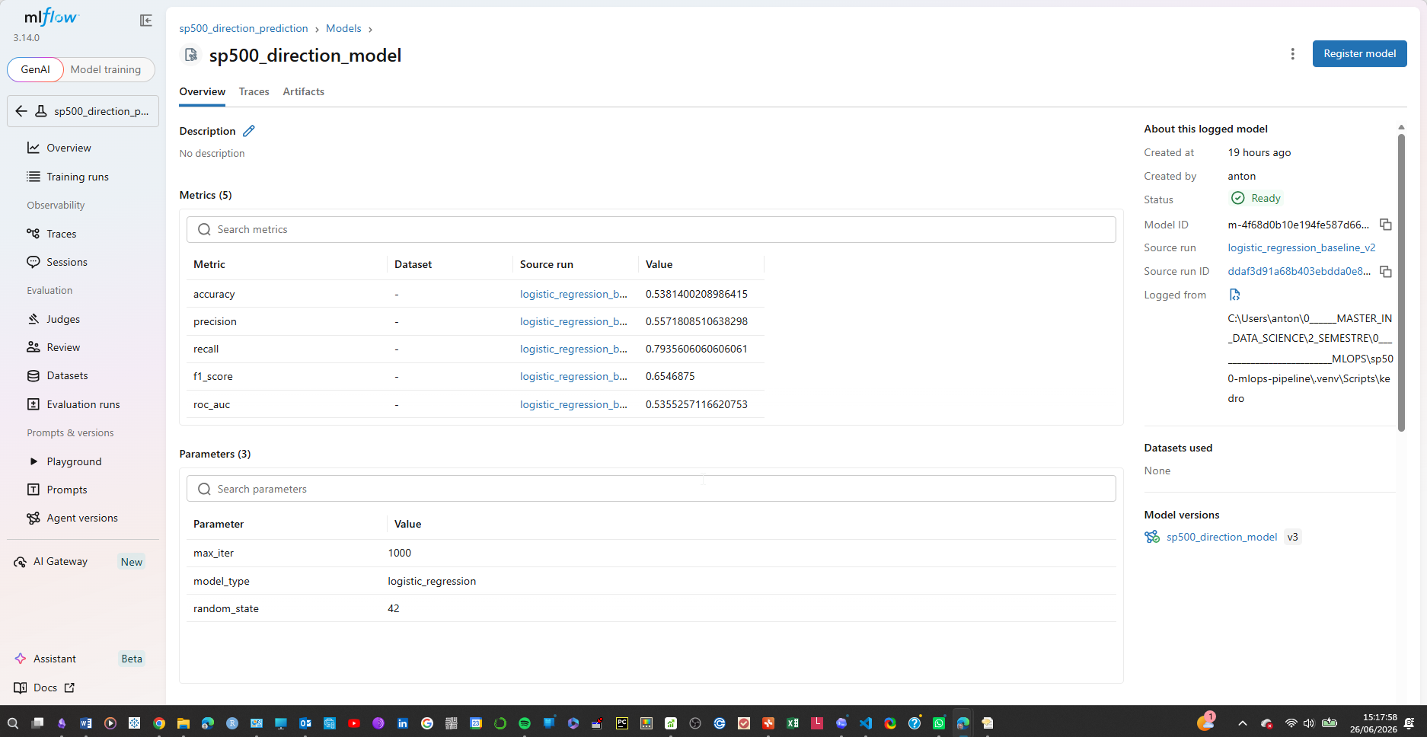
Figure 5: MLflow registered model sp500_direction_model, version 3, with tracked classification metrics, parameters and source training run.

5.2 Hopsworks Feature Store
Hopsworks was integrated as an optional Feature Store layer for the engineered market features. The Feature Group sp500_market_features, version 1, stores the processed feature dataset, while the Feature View sp500_direction_training_view, version 1, provides a reusable training view for model development.
The Feature Store integration supports feature reuse, lineage and more consistent access to the same feature definitions across future training workflows. The uploaded Feature Group contained 6,386 rows, demonstrating that the engineered dataset was successfully materialised in Hopsworks.
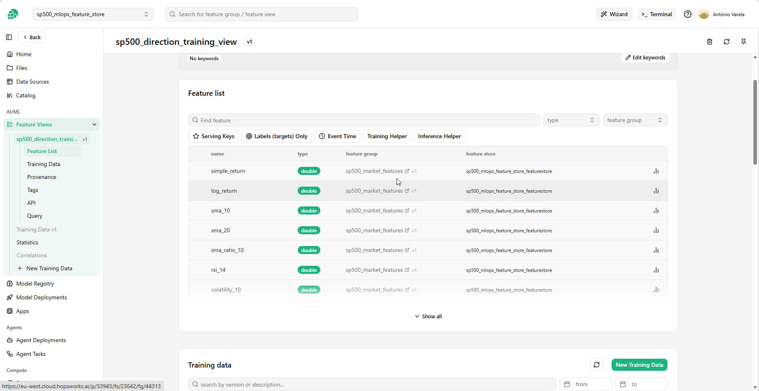Figure 6 Hopsworks Feature View sp500_direction_training_view, version 1, exposing engineered market features from Feature Group sp500_market_features, version 1, for offline model training.
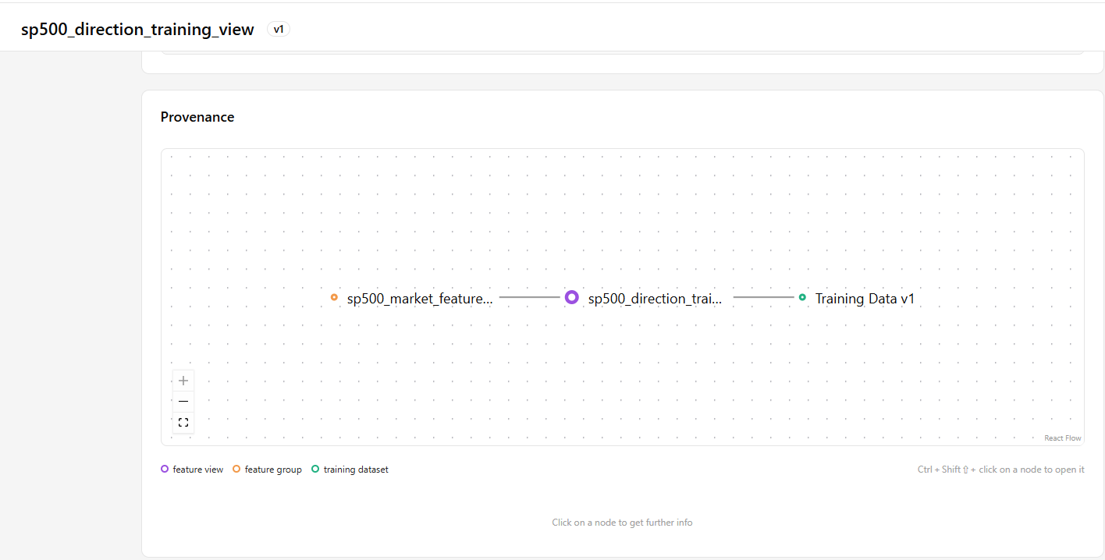
Figure 7. Hopsworks provenance graph showing the lineage from the sp500_market_features Feature Group to the sp500_direction_training_view Feature View and its resulting training dataset.

5.3 FastAPI Model Serving
The selected model was exposed through a FastAPI application. The service provides /health, /model-info and /predict endpoints. The /model-info endpoint confirms the model name, version, alias and the eight-feature serving contract, while the /predict endpoint returns the predicted market direction and class probabilities.
The local service was successfully validated using the MLflow registered model version 3 through the candidate_champion alias. This confirms that the model can be loaded dynamically from the Model Registry and used through a simple REST API.
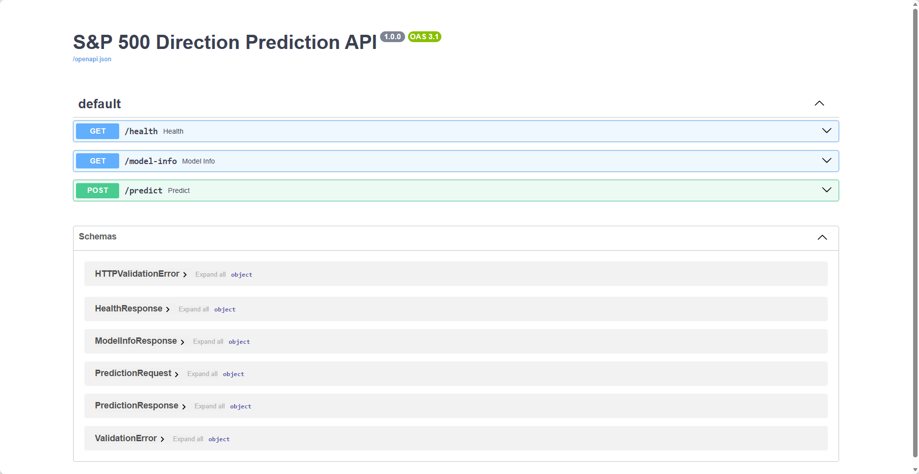Figure 8. FastAPI Swagger interface for the S&P 500 Direction Prediction API, documenting the available /health, /model-info and /predict endpoints and their request and response schemas.
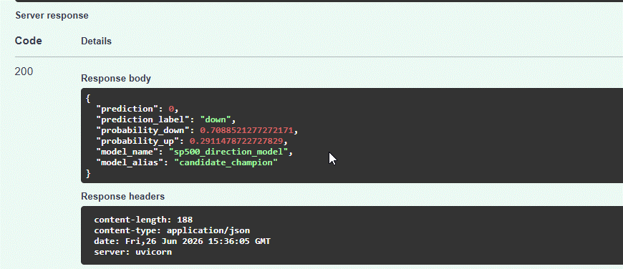
Figure 9. Successful FastAPI /predict inference request, returning a market-direction prediction, class probabilities and the MLflow model reference used by the serving layer.

5.4 Docker Containerisation
The FastAPI service was packaged into a Docker image to provide a more portable and reproducible deployment unit. The containerised API was exposed through port 8001 on the host machine and validated through the /model-info endpoint.
The successful response from the Dockerised service demonstrates that the application can run independently from the local Python environment while connecting to the external MLflow tracking and Model Registry service. This is a first step towards deployment on a cloud platform or a container orchestration environment.

6. Conclusion and Production Roadmap

6.1 Main Achievements
This project delivered a functional end-to-end MLOps proof of concept for predicting the next-day direction of the S&P 500 index. The workflow includes reproducible Kedro orchestration, Great Expectations data validation, temporal data splitting, baseline and challenger model training, MLflow experiment tracking and model versioning, automated testing, data-drift monitoring and API deployment.
The complete local pipeline was successfully executed, the dataset validation rules were satisfied, and the model was served through both local FastAPI and a Dockerised container. The integration with Hopsworks also demonstrated how engineered features can be stored and reused through a Feature Store.

6.2 Risks, Limitations and Mitigations
The main limitation is that financial markets are non-stationary and the relationship between technical indicators and market direction can change over time. The detected data drift in 4 of the 8 monitored features reinforces the need for frequent monitoring and periodic retraining assessment. In addition, Yahoo Finance is an external data source and may introduce availability, data-quality or rate-limit risks.
The current solution is suitable as a proof of concept but would require further production hardening. Important improvements include automated retraining triggers, performance monitoring with newly labelled data, secure secret management, CI/CD integration, cloud deployment and a more scalable data-storage solution for larger datasets.

6.3 Future Work
Future work should include scheduled data ingestion, automated drift-based retraining evaluation and continuous monitoring of predictive performance after deployment. Additional models, feature-selection techniques and explainability methods such as SHAP could also be tested to improve model interpretation.
The deployment layer could be extended to a cloud environment using managed container services, a remote MLflow backend and automated CI/CD workflows. These improvements would transform the current proof of concept into a more robust and production-ready MLOps solution.

