FEEDBACK FORM SUMMARY OF THE HELLA FRIES BOOTH
The following are questions and the results in the survey conducted by the product manager for further feedback from customers on what we can improve and provide insight on their experience at our booth and their satisfaction with our product.
- How would you rate your overall experience at our booth?
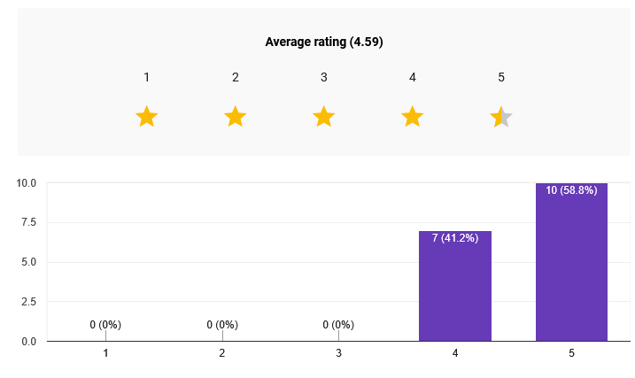
From the graph above, we can conclude that all if not majority of customers are satisfied with their experience at our booth and rate it extremely positively, detailing a 4.59 rating.

- How would you rate the taste of our fries?
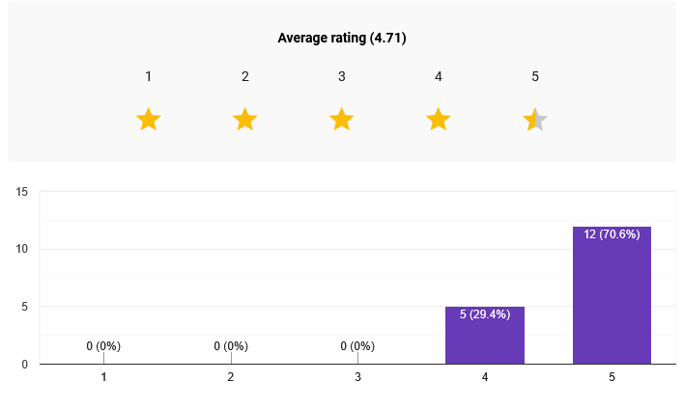
From the table shown above, most customers are satisfied and love the taste of our fries, giving it an average rating of 4.71.
- How would you rate the taste of our cheese sticks?
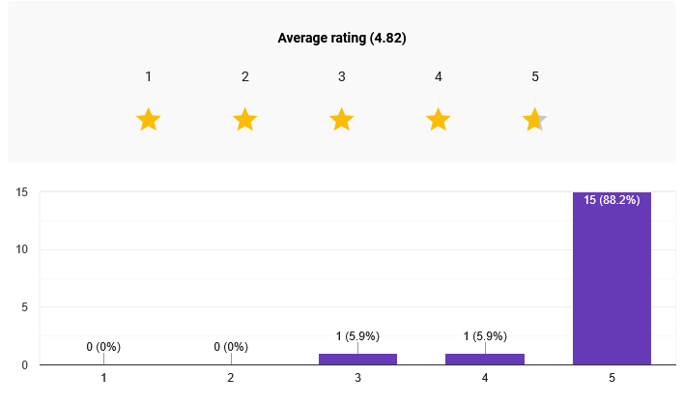
The cheese sticks also received positive feedback, though the data shows they scored slightly lower than the fries with an average rating 4.82.

- How would you rate the flavor options (dips and powders)
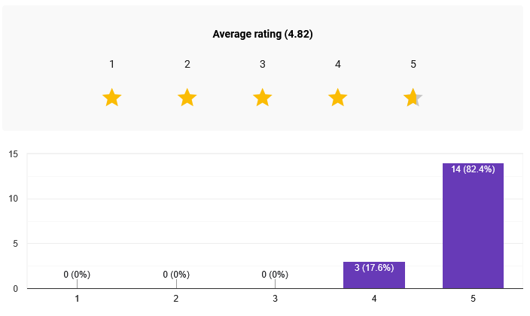
Customers rated the variety and quality of dips and powders positively. This category scored well, indicating that the customization options are a strong point for the booth.

- Was the serving size enough for you?
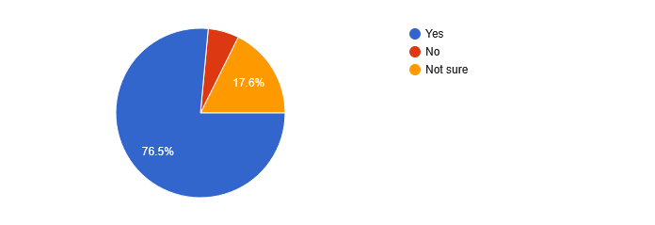
The majority of customers felt that the serving size was sufficient. While most responses were positive, this category showed slight variance compared to the taste ratings, suggesting a few customers may have wanted larger portions.

- How would you rate the price for the quality and quantity?
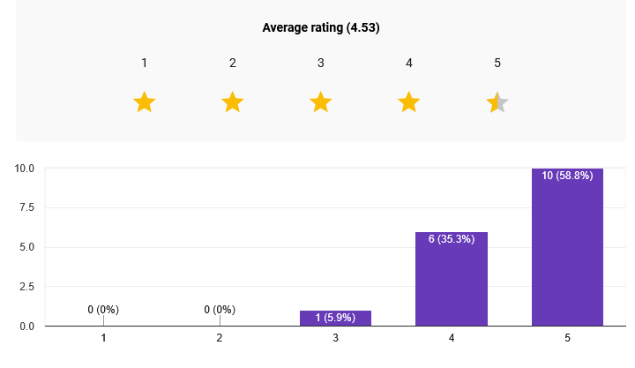
Respondents rated the value for money highly. The average rating indicates that customers feel the product quality justifies the price point.

- How would you rate our customer service?
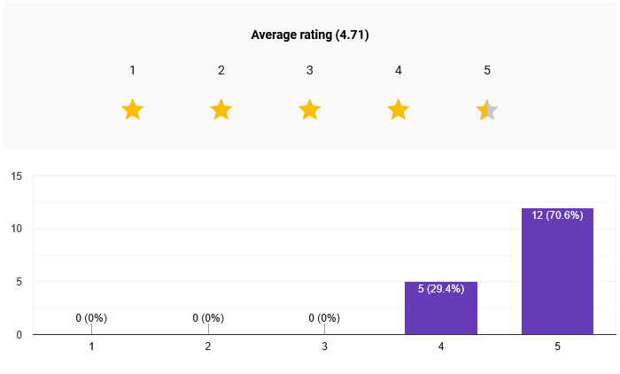
The service team received excellent marks, with ratings nearly as high as the food quality. This suggests that staff interactions significantly enhanced the customer experience.
- How long did you wait for your order?
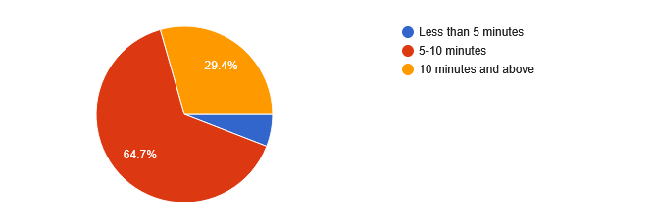
Most customers reported short wait times. However, this category showed the widest range of responses, indicating that while most orders were fast, some customers experienced delays.

- Would you buy from us again?
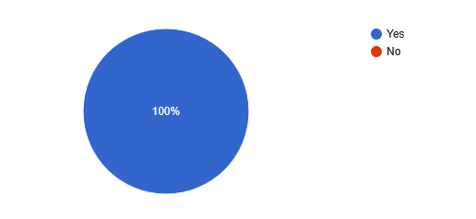
Loyalty is high, with the vast majority of respondents indicating they would buy from the booth again. This reflects strong overall satisfaction with the product and service.
- Do you have any additional remarks/comments on what we can improve?
- While most customers did not have any comments to say, a large number of customers reported to minimize prep time for the fries, complaining that the fries took too long to prepare and that the time management and customer service needed work. Additionally, some customers wanted bigger servings, and an adjustment in the cheese sauce to become more viscous, and finally a complaint about some members not doing anything during the booth instead of servicing customers.
Conclusion
The Hella Fries Booth received overwhelmingly positive feedback, with an overall experience rating of 4.59 out of 5 and the fries earning the highest score at 4.71, while customers also rated flavor options, value for money, and customer service favorably, and the vast majority indicated they would buy again. However, qualitative comments revealed critical areas for improvement: many customers reported that fries took too long to prepare, pointing to time management and operational efficiency as recurring issues; some noted that certain staff members appeared idle instead of assisting with service; a number of customers requested larger serving sizes; and a specific suggestion was made to make the cheese sauce more viscous. Addressing these operational bottlenecks, improving staff utilization, and considering portion size adjustments would further elevate an already well-received booth experience.

Prepared by:
_JOHNREV GABRIEL C. HALE_
Product Manager

