
JESUS AND MARY
Clinical Laboratory and Drug Test Center
105 MLW Commercial Center, Sampaguita St., San Jose, Balanga City, Bataan
Tel No. (047) 237-4020

Name: VERGARA, CYRUS | Age: 24 | Sex: M | Date: 1-18-26

URINALYSIS
PHYSICAL | RESULT | MICROSCOPIC | RESULT
Color | LT YELLOW | Pus cells | 1-3 | /HPF
Transparency | CLEAR | R B C | 0-1 | /HPF
Reaction | 5.0 | Epithelial cells | FEW
Specific gravity | 1.010 | Mucus threads | FEW
Albumin | NEGATIVE | Bacteria
Sugar | NEGATIVE | Crystals
 |  | Amorphous urates

FECALYSIS
 | RESULT | PARASITE OR OVA
Color | BROWN | No Parasite Seen
Consistency | FORMED
Pus cells/ WBC
RBC
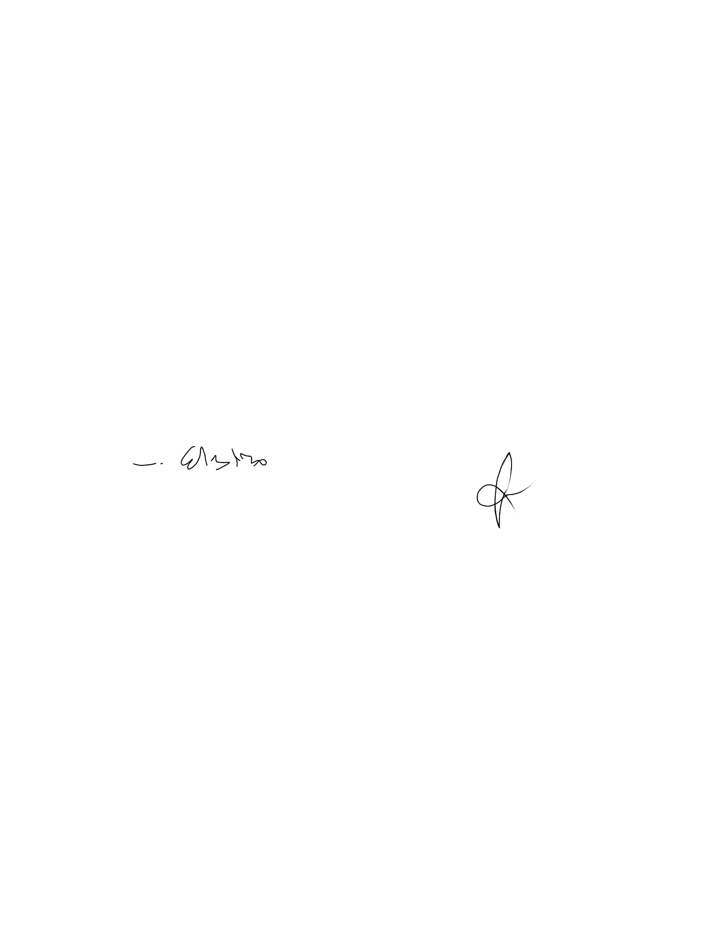
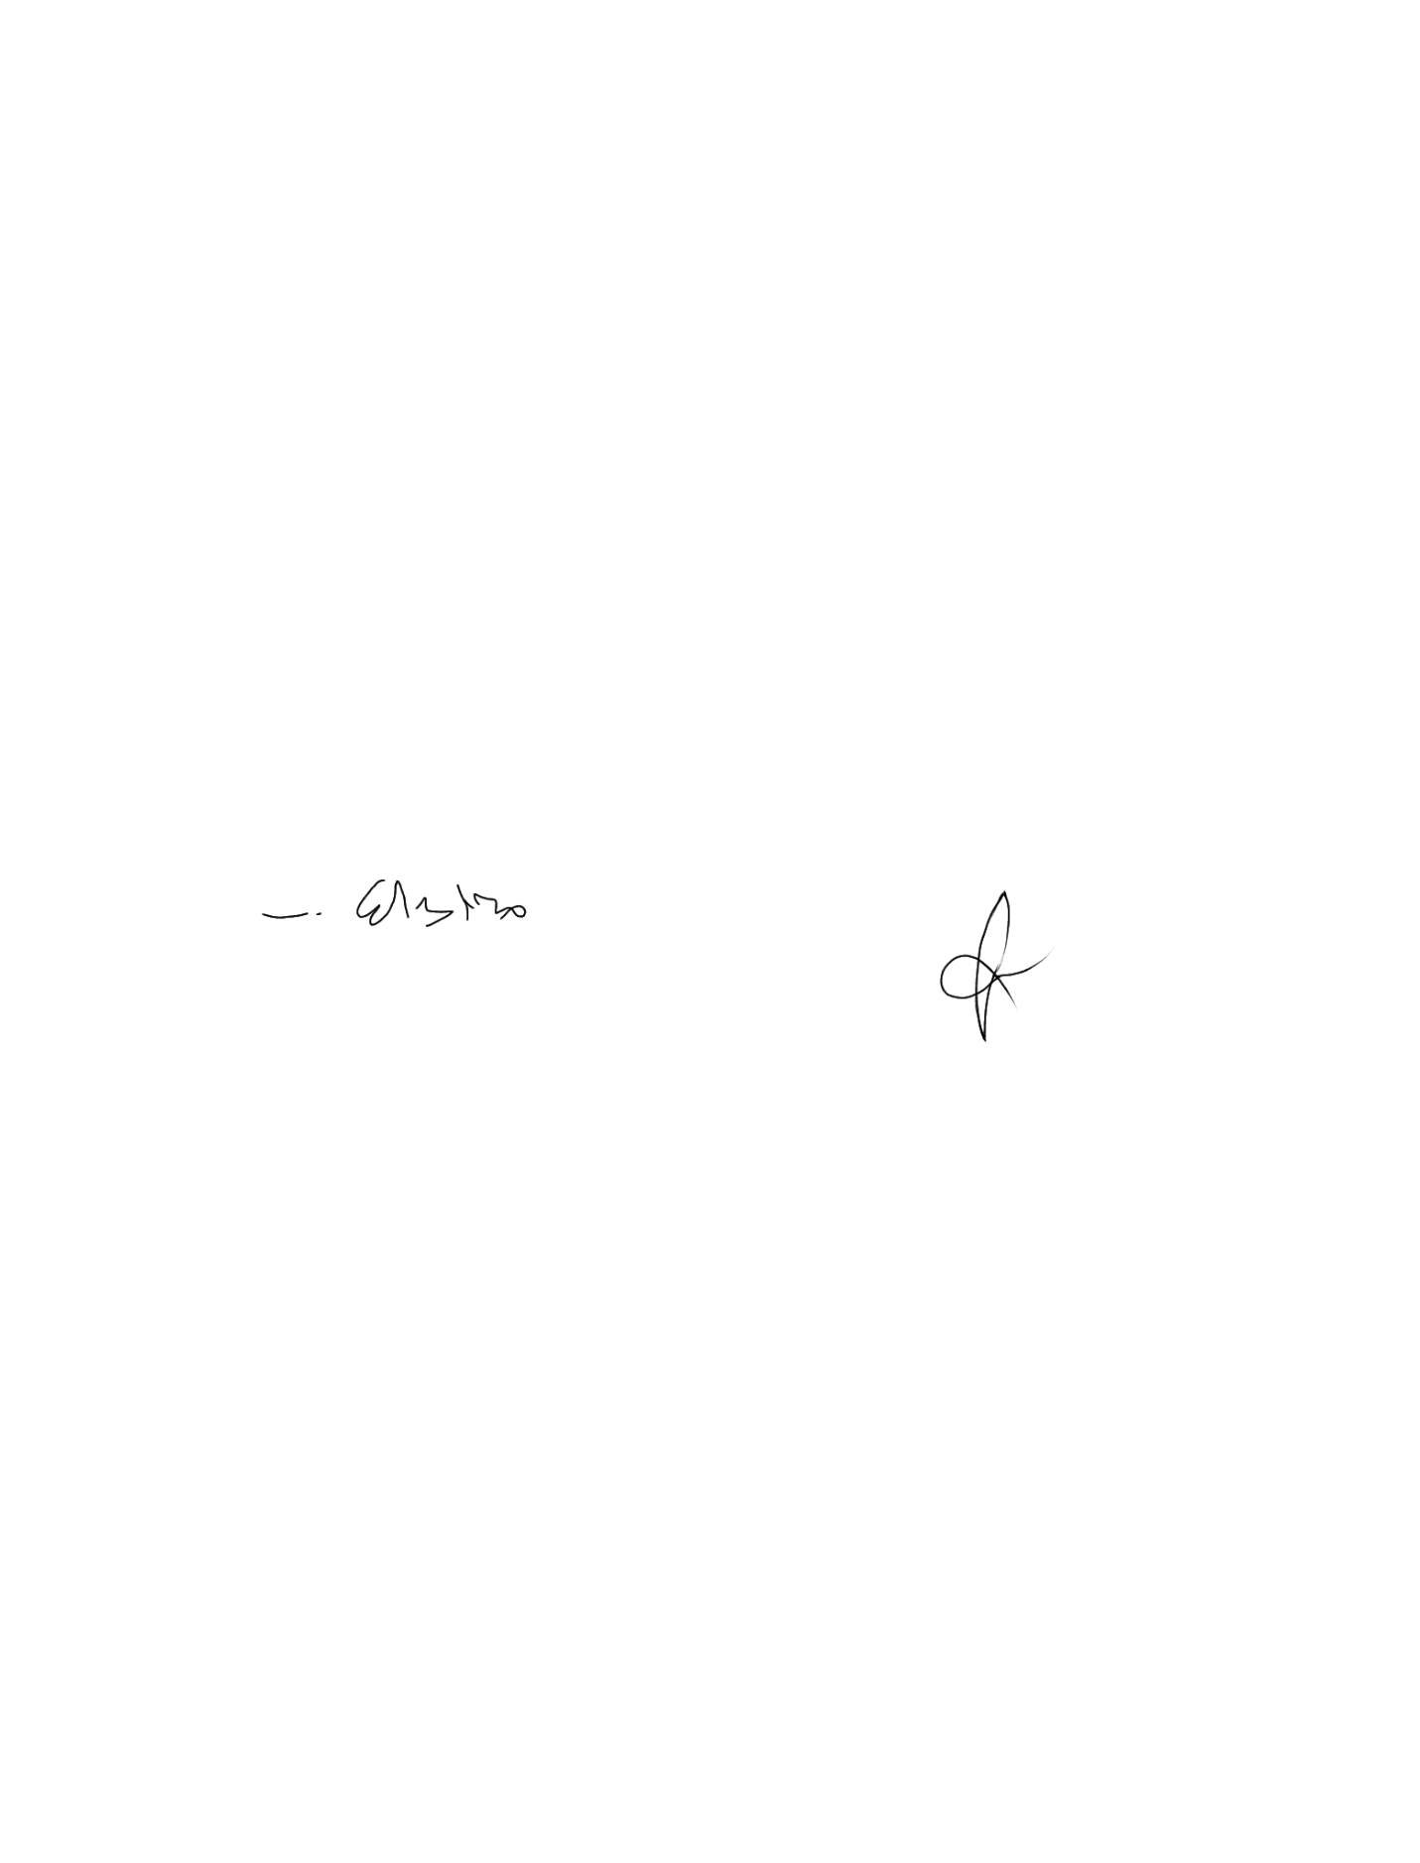

LUISITO D.J. CELESTINO, MD,FPSP, Rph  License No.:78844 | JENIBET M. MONARES, RMT  License No.: 0070186
PATHOLOGIST | MEDICAL TECHNOLOGIST

