[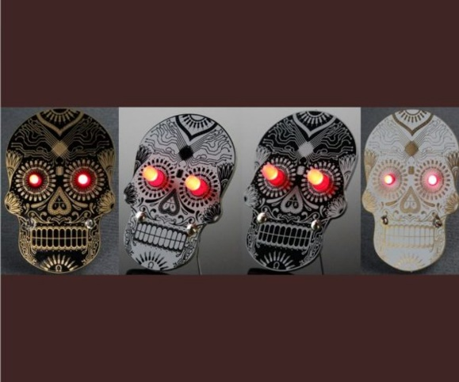](https://proto-pic.co.uk/day-of-the-geek-badge)

This is a short guide on how to assemble the day of the geek badge.

First up you need to check that you have everything you need:

**Included:**

* Skull PCB
* 20mm Battery holder
* LEDs
* Pin back

**Not included:**

* CR2032 Battery
* Soldering Iron
* Solder
* Pliers
* Flush cutters

**Step 1.**

Place the battery holder into the provided holes and solder to the board, make sure you get this the correct way around! You need to be able to insert the battery from the bottom of the badge.

**Step 2.**

You need to apply solder to the center of the pin back pad on the PCB. Tin your soldering iron, then, hold the tip against the large round pad on the rear of the PCB, then apply solder; you want to cover about half of the area of the circle in the center.

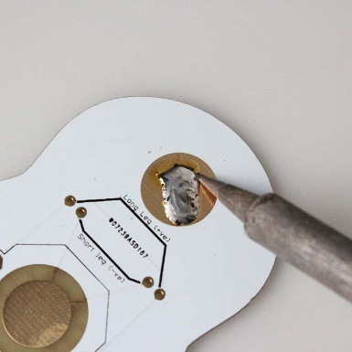

**Step 3.**

Using your pliers hold the pin back onto the center of the pad you have just applied the solder to. While holding down with the pliers heat the pin back and hold the iron in place until you notice the solder flow to the edge.

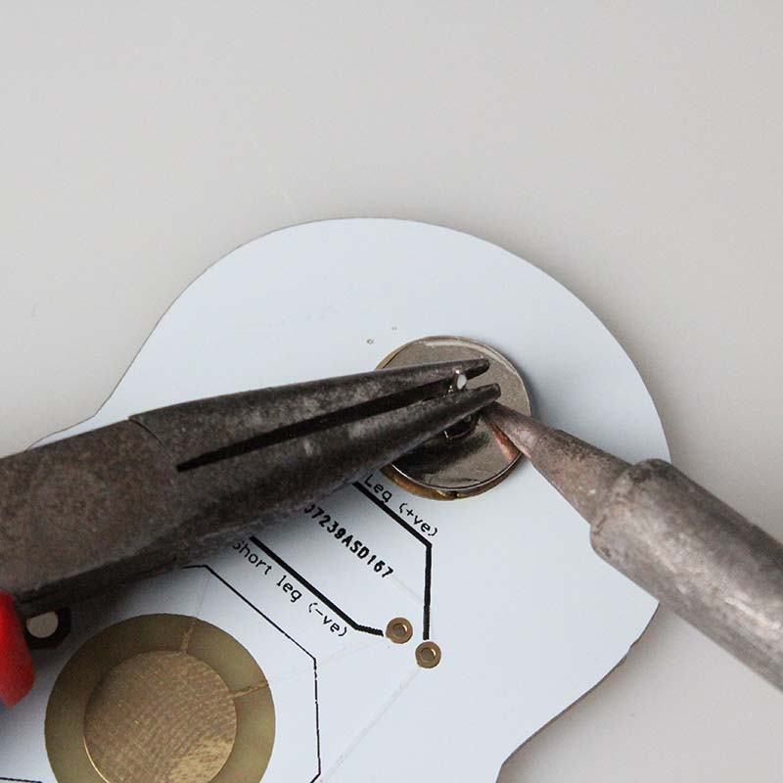

Next remove the iron while still holding in place with the pliers. This will stay very hot for a while so be careful!

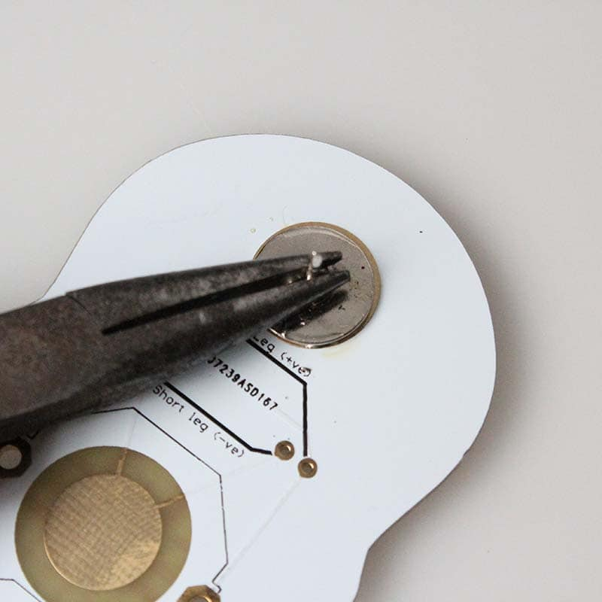

**Step 4.**

Turn the board over and insert the LEDs, ensuring the short legs are toward the center of the board. Next, turn the board back over again and solder the legs in place.

**Step 5.**

Using your cutters it's time to snip the legs from the LEDs. You should wear eye protection as the legs can fly off!

If you want to have your badge stand up on a desk only snip the inner two legs and bend the remaining legs down slightly.

**Step 6.**

Insert the battery writing side facing out and you are ready to augment your best threads with some Dia de los Muertos geek fusion!