# [How to Use a Soldering Iron: A Beginner’s Guide](https://www.howtogeek.com/63630/how-to-use-a-soldering-iron-a-beginners-guide/)

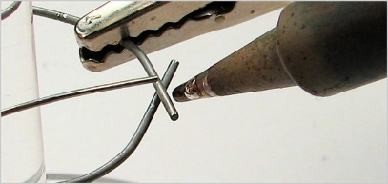One art form that geeks really appreciate is soldering, but not all of us know the proper technique. It is an easy skill to add to your geek resume, so let us learn how and some old projects off the shelf.

(Image credit: [oskay](http://www.flickr.com/photos/oskay/437342029/))

What Is Soldering?

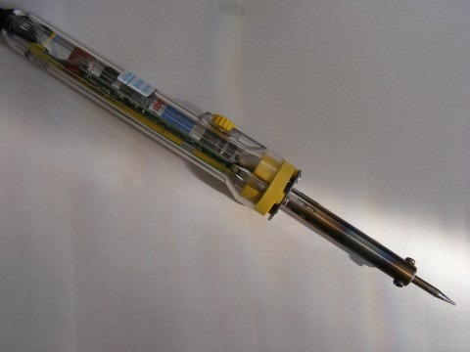(Image credit: [Public Domain Photos](http://www.flickr.com/photos/free-stock/4904404001/))

A soldering iron is a tool with a metal tip that gets really hot. We are talking like eight hundred degrees Fahrenheit, though you can adjust the temperature on a good iron. Its job is to transfer heat to things like wires, transistor leads, and pads on PCBs. After the appropriate areas are heated properly, solder is applied. If you plan on soldering, then you are better off spending $30-$40 on a 20-30-watt iron instead of on a cheap $15 one. You will get a longer-lasting tool that will work for a much wider variety of applications, and you will get proper heat control to boot. There are also soldering guns available, but you should only use these when repairing thick cables and never on PCBs, as the tips have a live voltage running through them that can damage sensitive electronics.

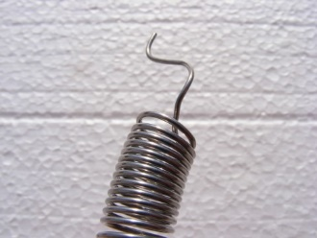(Image credit: [Public Domain Photos](http://www.flickr.com/photos/free-stock/4791855222/))

Solder is a thin tube, usually rolled in spools, made of various metal alloys. Its job is to hold the individual components together. The individual components and their quantities can vary, but for computer electronics, you are usually looking at 60% tin and 40% lead. Lead-free solder is also available, though it has higher melting temperatures and less “wettability,” meaning you may need a better soldering iron to use it, and removing it can be more tedious. Lead-free solders are better for the environment and have other benefits, and they function more or less the same way.

The inside of the tube is filled with “flux,” a substance that gets rid of oxidation and helps clean the surfaces involved in the fusing process. For electronic use, you want rosin-core/rosin-flux solder. Acid-flux is used in plumbing, and the acid can damage the sensitive components of PCBs.

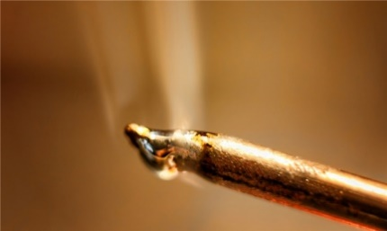Safety First!

(Image credit: [intherough](http://www.flickr.com/photos/intherough/4965847276/))

Many who have never used a soldering iron are afraid of damaging equipment, but more important is the danger to yourself! Soldering irons get really hot (think, solder itself is molten metal). Be sure to wear safety glasses, keep loose clothing and hair out of the way, and be careful with your fingers. Better still, use protective gloves. Solder can contain lead, so be sure to wash your hands thoroughly after handling it. It is also really important to work in a well-ventilated area because the fumes from the rosin can cause damage to your lungs when inhaled. Honestly, it is more common sense and preparation than anything. Just take proper precautions, and you will be fine.

Cleaning and Tinning the Tip

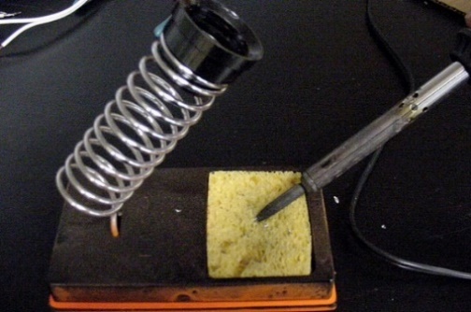

(Image credit: [Mae Labs](http://www.maelabs.ucsd.edu/mae_guides/howto/soldering/))

In order to conduct heat properly, your soldering iron needs to be free of any old solder. After being exposed to air, it oxidizes and thus insulates against heat. We want heat to conduct so that we can apply everything quickly and efficiently. A dirty tip means that you will have to hold the iron on longer and risk heat damage to the PCB, and nobody wants that. Keep a wet sponge handy, and after the soldering iron is fully heated, softly scrape it against the sponge to remove the old solder. The tip should be nice and shiny, or at least very close to it.

Next, we are going to “tin” the tip. This will protect the tip and allow heat to conduct better via the presence of a new solder. Carefully apply a small amount of fresh solder on the hot iron and coat the tip. It should still be shiny if you have done it right. As soon as you tin the tip, you should start soldering your components together. After every few joins, clean and re-tin, and again before putting your iron away into storage. This will help increase the longevity of your tool. A good soldering iron should easily last years this way.

Joining Parts

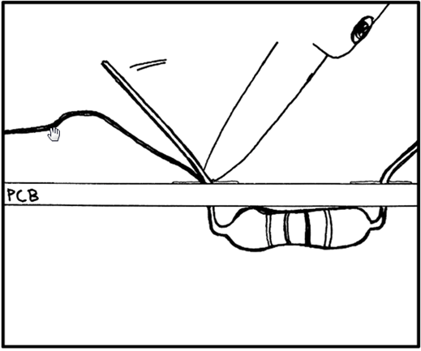

(Image credit: [Soldering Is Easy Comic Book](http://mightyohm.com/blog/2011/04/soldering-is-easy-comic-book/))

Hold the iron in your dominant hand and a long piece of solder in your other hand. When soldering two components together, you want to touch the area where they join with the soldering iron. Hold it there for about a second, then slide the solder underneath the tip of the iron, sandwiching it to the PCB (refer to the above image; cursor points to solder). Hold it for another second or two, feeding in how much solder you need. This amount will vary depending on the project, application, and diameter of the solder, so check your instructions and study the pictures to get a good idea of the end result.

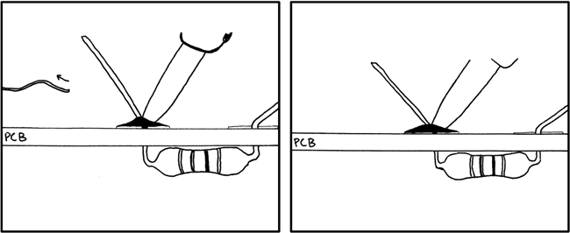

(Image credit: [Soldering Is Easy Comic Book](http://mightyohm.com/blog/2011/04/soldering-is-easy-comic-book/))

Now, this is important. Pull away the solder first and continue holding the iron for another second. This allows the solder to continue to melt and pool, forming a good joint. Then, you can remove the iron. The total process should not take more than 5 seconds; you are usually aiming for 3-4.

Wait a few seconds, and do not disturb the solder. It cools very quickly, but moving or blowing on the joint will cause it to deteriorate. A bad solder connection will look really oxidized, overly dull, and grainy. It also looks like a ball of solder formed in the area. A good connection should be smooth and uniform, and its sides will be concave. It will not look like a raised ball; it will look flat.

# Desoldering

When removing a connection or undoing a mistake, you can often resolder over the original and add a touch of new solder. If you want to take the extra step and do it right, you can remove the old solder completely and start with a fresh work area. There are two tools you can use for this, a vacuum-based “solder sucker” or a solder wick.

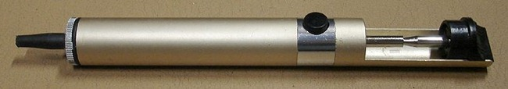

(Image credit: [Wikimedia Commons](http://en.wikipedia.org/wiki/File:Solder_sucker.jpg))

A solder sucker is a tiny hand-held syringe-like pump. It creates and uses vacuum pressure to suck solder off of whatever it is on. It is a great tool to have and works well.

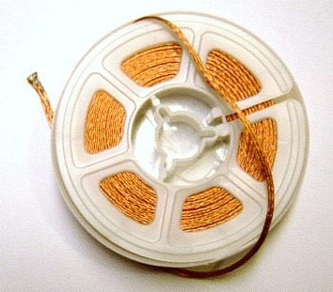

(Image credit: [Wikimedia Commons](http://en.wikipedia.org/wiki/File:Solder_wick_rolled.jpg))

A solder wick is woven copper, which the old solder bonds to. It’s more expensive and expendable, so I usually don’t recommend it. Some jobs, however, will benefit from the clean finishing touches that a solder wick provides. Both tools have their strong points, and the odds are that you will need to use one or the other specifically from time to time in your soldering career. A clean working area is really important, as it provides the best results and minimizes the risk of damage.

Soldering is not particularly difficult. You need to focus, keep a steady hand, and be safe. A good soldering iron will be a wonderful investment, leading to a much wider arrangement of geek projects at your disposal. Now that you know how to practice so that, you are ready to show off your skills!