Autoencoder
. It means that f has to throw away some information present in x, or at least represent it with less precision. On the other hand, to make reconstruction error small on the training set, examples that are neighbors on a high-density manifold must be represented with sufficiently different values of f(x) or r(x). Otherwise, it would not be possible to distinguish and hence correctly reconstruct these examples.

Deep Autoencoders
They provide flexible mappings both ways.
They learning time is linear (or better) in the number of training cases.
The final encoding model is fairly compact and fast.
But it turned out to be very difficult to optimize deep autoencoders using backpropagation.
--With small initial weights the backpropagation gradient dies.
Better ways to optimize them:
Use unsupervised layer-by-layer pre-training.
Or just initialize the weights carefully as in Echo-State Nets.

Typical choices for the activation and cost functions are the softmax and cross entropy functions for classification tasks, with sigmoid and standard error functions used for regression or prediction tasks with normalized inputs.

As for autoencoder,

fθ(x) = sf (b + W x) (20)
gθ(h) = sg(d + W0 h) (21)

A natural choice for an unbounded domain is a linear decoder with a 14 squared reconstruction error, i.e. sg(a) = a and L(x, r) = ||x − r||**2 .

If inputs are bounded between 0 and 1 however, ensuring a similarly-bounded reconstruction can be achieved by using sg = sigmoid. In addition if the inputs are of a binary nature, a binary cross-entropy loss14 is sometimes used.

If both encoder and decoder use a sigmoid non-linearity, then fθ(x) and gθ(h) have the exact same form as the conditionals P(h | v) and P(v | h) of binary RBMs (

Denoising Autoencoder:

. Corruptions considered in Vincent et al. (2010) include additive isotropic Gaussian noise, salt and pepper noise for gray-scale images, and masking noise (salt or pepper only), e.g., setting some randomly chosen inputs to 0 (independently per example)

The DAE and CAE have been successfully used to win the final phase of the Unsupervised and Transfer Learning Challenge (Mesnil et al., 2011).
Random Gaussian noise injection is quite similar to L2 regularization (it has been called "jitter" for a long time now), and generally noise injection can be seen as a type of regularization.

Regularlizer
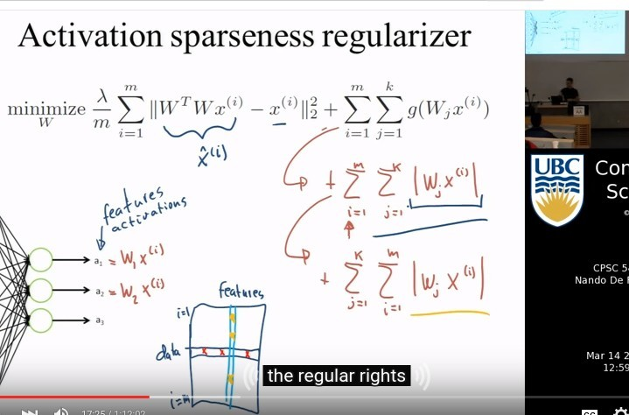
红色第一个regularizer公式，该regularizer的关注点在W。在minimize过程中，会使W×X趋近于0. i和j不相等时，使其W×X等于0, 是与corss validation的一种tradeoff方式, （这个regularizer可以理解为，在提取数据样本的特征时，若样本满足于某一个特征Wj，那么对于与该特征属性垂直的特征Wj' ，它与该样本的乘机必然等于0）。

红色第二个regularizer公式，该regularizer的关注点在neuron（a）上。让feature（W）在部分的sample上fire，或者说，对某个sample，不希望让很多的neuron fire。

Hinton & Salakhutdinov 2006

video : https://www.youtube.com/watch?v=O6itYc2nnnM
pdf:www.iro.umontreal.ca/~bengioy/talks/deep-learning-gss2012.html
including:
temple coherence and scales:
One of the hints from nature about different explanatory factors:
Rapidly changing factors(often noise)
Slowly changing (generally more abstract)
Different factors at different time scales
presentation learning competition:
