PCB Cross Section Details

copper
copper
FR4
Board information

Total Thickness: 30mil

Individual Layers View

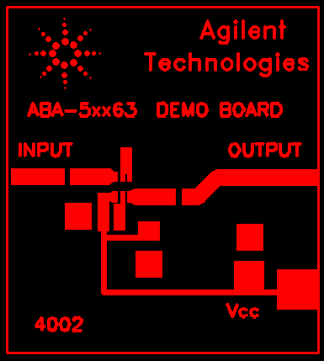 | 
LAYER 1.gbr | LAYER 2.gbr
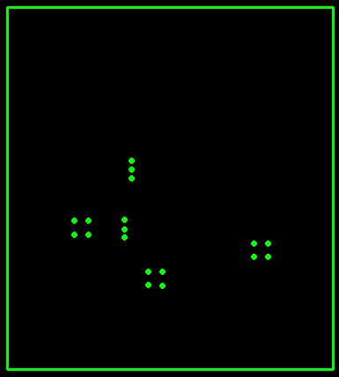
PLOT.gbr

