SAA Comfort Air LLC
Field Service Manual
3-Ton Condenser Replacement — Split System
Katy · Sugar Land · Houston, TX
TDLR ACR License #TACLB00167405E
Revision 1.0
Purpose & Scope
This manual covers the field replacement of the outdoor condensing unit ("condenser") in a residential split system, where the existing furnace/air handler and evaporator coil remain in place. It is written for licensed technicians working under SAA Comfort Air LLC's TDLR ACR contractor license, and assumes the technician holds current EPA Section 608 certification for refrigerant handling.
Follow local mechanical/electrical code and manufacturer instructions where they differ from the general guidance in this manual — manufacturer specifications and the City permitting office having jurisdiction always take precedence.
⚠ EPA Section 608 certification is required before recovering, handling, or charging refrigerant. Refrigerant may never be vented to the atmosphere.

1. Safety Prerequisites
☐ Verify the disconnect is off and confirm zero voltage with a meter before touching electrical components
☐ Lock out / tag out the breaker at the panel in addition to the local disconnect where possible
☐ Wear safety glasses, gloves, and appropriate PPE for refrigerant handling and brazing
☐ Set up a fire watch / have a fire extinguisher on hand before brazing near structures, fences, or landscaping
☐ Confirm safe footing and lifting plan before moving the old/new condenser — units commonly weigh 150-250+ lb
☐ Have a nitrogen cylinder, regulator, and recovery machine on the truck before starting
☐ Confirm the recovery cylinder is not overfilled — check tare weight and rated capacity

2. Initial Assessment — Confirm Condenser Replacement Is Needed
A condenser replacement is a major repair. Confirm the condenser itself — not the coil, a control, or a simple part failure — is the actual cause before quoting or ordering a replacement.
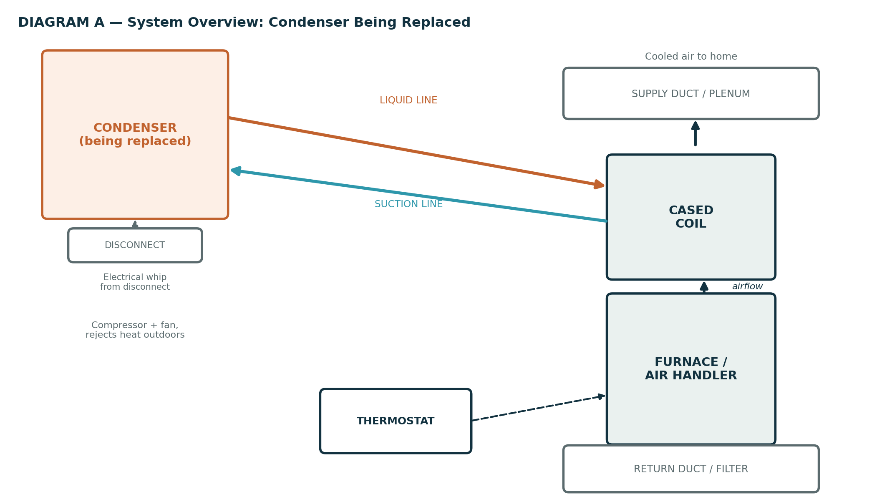

Common Reasons for Condenser Replacement
- Compressor failure (mechanical seizure, electrical winding failure, or locked rotor) — confirm with amp draw, insulation resistance (megohm) test, and visual/audible inspection
- Refrigerant leak isolated to the condenser coil or internal components, uneconomical to repair
- Cabinet or coil corrosion from age and Houston humidity/coastal air exposure
- System age and efficiency — R-22 systems are obsolete; low-SEER systems may no longer be cost-effective to keep running versus replacing
- Storm or impact damage (hail, flooding, falling debris — common in Houston after severe weather)

Before Ordering — Rule Out Cheaper Fixes
- Check capacitor and contactor condition — a failed run capacitor can mimic compressor failure symptoms
- Check for a simple electrical fault (blown fuse, tripped breaker, failed disconnect) before condemning the compressor
- Confirm refrigerant charge and airflow are correct — an undercharged or airflow-starved system can overwork and trip a compressor without the compressor itself being defective
⚠ Do not quote a full condenser replacement on a locked-rotor reading alone. Confirm with a hard-start test and megohm check, and rule out a simple capacitor/contactor failure first — a wasted replacement quoted on the wrong diagnosis costs real money and erodes customer trust.

3. Identifying the Correct Replacement Condenser

Match to the Existing System
- Tonnage must match the existing coil and furnace/air handler airflow rating — a mismatched condenser hurts efficiency and can cause coil freezing or poor dehumidification.
- Confirm voltage/phase matches the home's electrical service (208/230V single-phase is standard residential).
- Refrigerant type must match the existing coil and line set (R-410A vs A2L such as R-454B) — do not mix refrigerant types across components.
- Where possible, keep the system as an AHRI-matched combination with the existing coil and furnace — an unmatched combination can underperform its rated efficiency and may affect manufacturer warranty coverage on the coil.
- Confirm the new unit meets current SEER2 minimum efficiency standards under the DOE's regional requirements.
- Check footprint and service clearance against the existing pad and surrounding structures — newer high-efficiency units are sometimes physically larger than the unit being replaced.

Metering Device & Line Set Compatibility
- Confirm whether the existing coil uses a TXV or fixed orifice, and that the new condenser's charging method matches.
- Inspect the existing line set for contamination, correct sizing, and condition — reuse only if it is clean, correctly sized for the new tonnage, and free of kinks or repairs of concern.

4. Tools & Materials
A full itemized tools/materials/accessories list with specifications and cost tracking is maintained in the companion spreadsheet: SAA_3Ton_Condenser_Replacement_Quote_Sheet.xlsx. Summary below.

Tools
- Recovery machine, rated recovery cylinder, and refrigerant scale
- Digital manifold gauge set, vacuum pump (2-stage) with micron gauge
- Nitrogen cylinder with regulator; brazing torch, rod, and flux as needed
- Tubing cutter, flaring/swaging tools, tubing bender
- Multimeter with amp clamp, torque screwdriver/wrench
- Levels, cordless drill/driver, wet/dry vacuum, appliance dolly

Materials
- New condenser (correct tonnage, voltage, refrigerant type — see Section 3)
- Matching refrigerant, weighed to nameplate spec (not estimated)
- POE refrigerant oil compatible with the system
- Line-set flare nuts/couplings, condenser pad, pad shims
- Electrical whip sized to the new unit's MCA/MOCP, disconnect switch if the existing one is undersized
- Liquid-line filter drier (replace any time the system is opened)
- Wire nuts, electrical tape, anti-oxidant compound for aluminum connections

5. Step-by-Step Replacement Procedure

A. Recovery & Disconnect
- Confirm power is off at the disconnect and breaker; verify zero voltage with a meter.
- Connect gauges and record standing pressures and system readings before touching anything, for before/after documentation.
- Recover refrigerant into a rated recovery cylinder using an EPA-approved recovery machine. Never vent refrigerant to the atmosphere. Record the recovered weight.
- Disconnect and label the electrical whip at the condenser contactor/terminal block.
- Cut or unsweat the line-set connections at the condenser service valves. Cap the open line-set ends immediately to keep moisture and contaminants out of the system.
- Disconnect the old condenser from the pad (mounting brackets, vibration pads, or tie-downs) and remove it from the site.

B. Pad Prep & Placement
- Inspect the existing pad for level, cracking, and settling. Replace or re-level as needed — do not set a new unit on a compromised pad.
- Confirm manufacturer clearance requirements are met on all sides and above the unit for airflow and service access — see Diagram B.
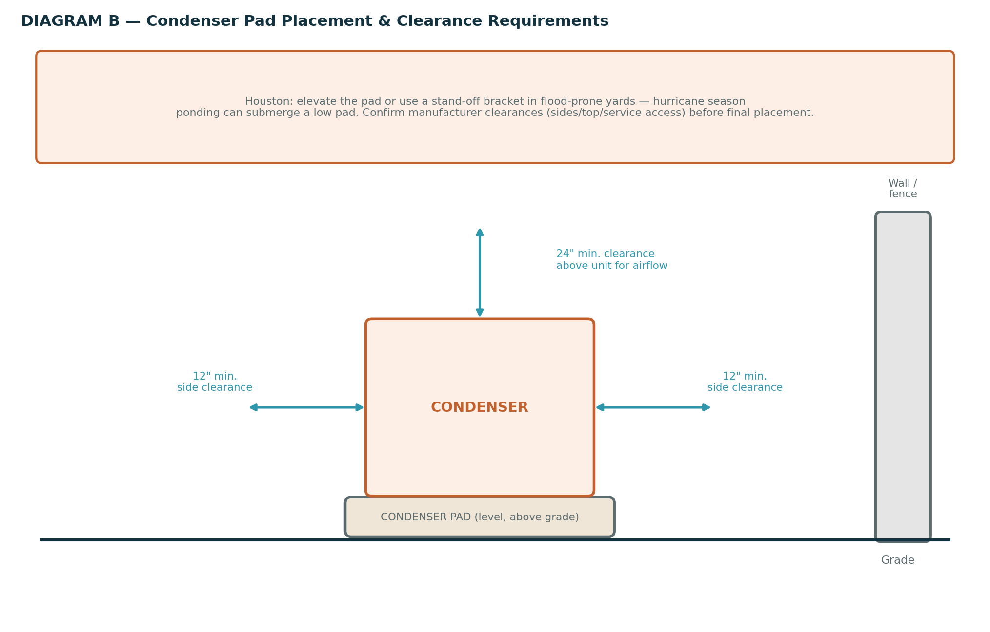
- Set the new condenser on the pad, level and oriented per manufacturer instructions (service valve access, airflow direction).
- Secure the unit per manufacturer/local wind-load requirements (tie-downs or brackets), and confirm vibration isolation pads are in place.

C. Line Set & Electrical Connection
- Inspect the line set for contamination. If the failure involved a compressor burnout, flush the line set or replace it, and always replace the liquid-line filter drier.
- Connect the line set to the new condenser's service valves. Braze copper joints using a nitrogen purge through the system during brazing — see Diagram C. Continue nitrogen flow until the joint has cooled.
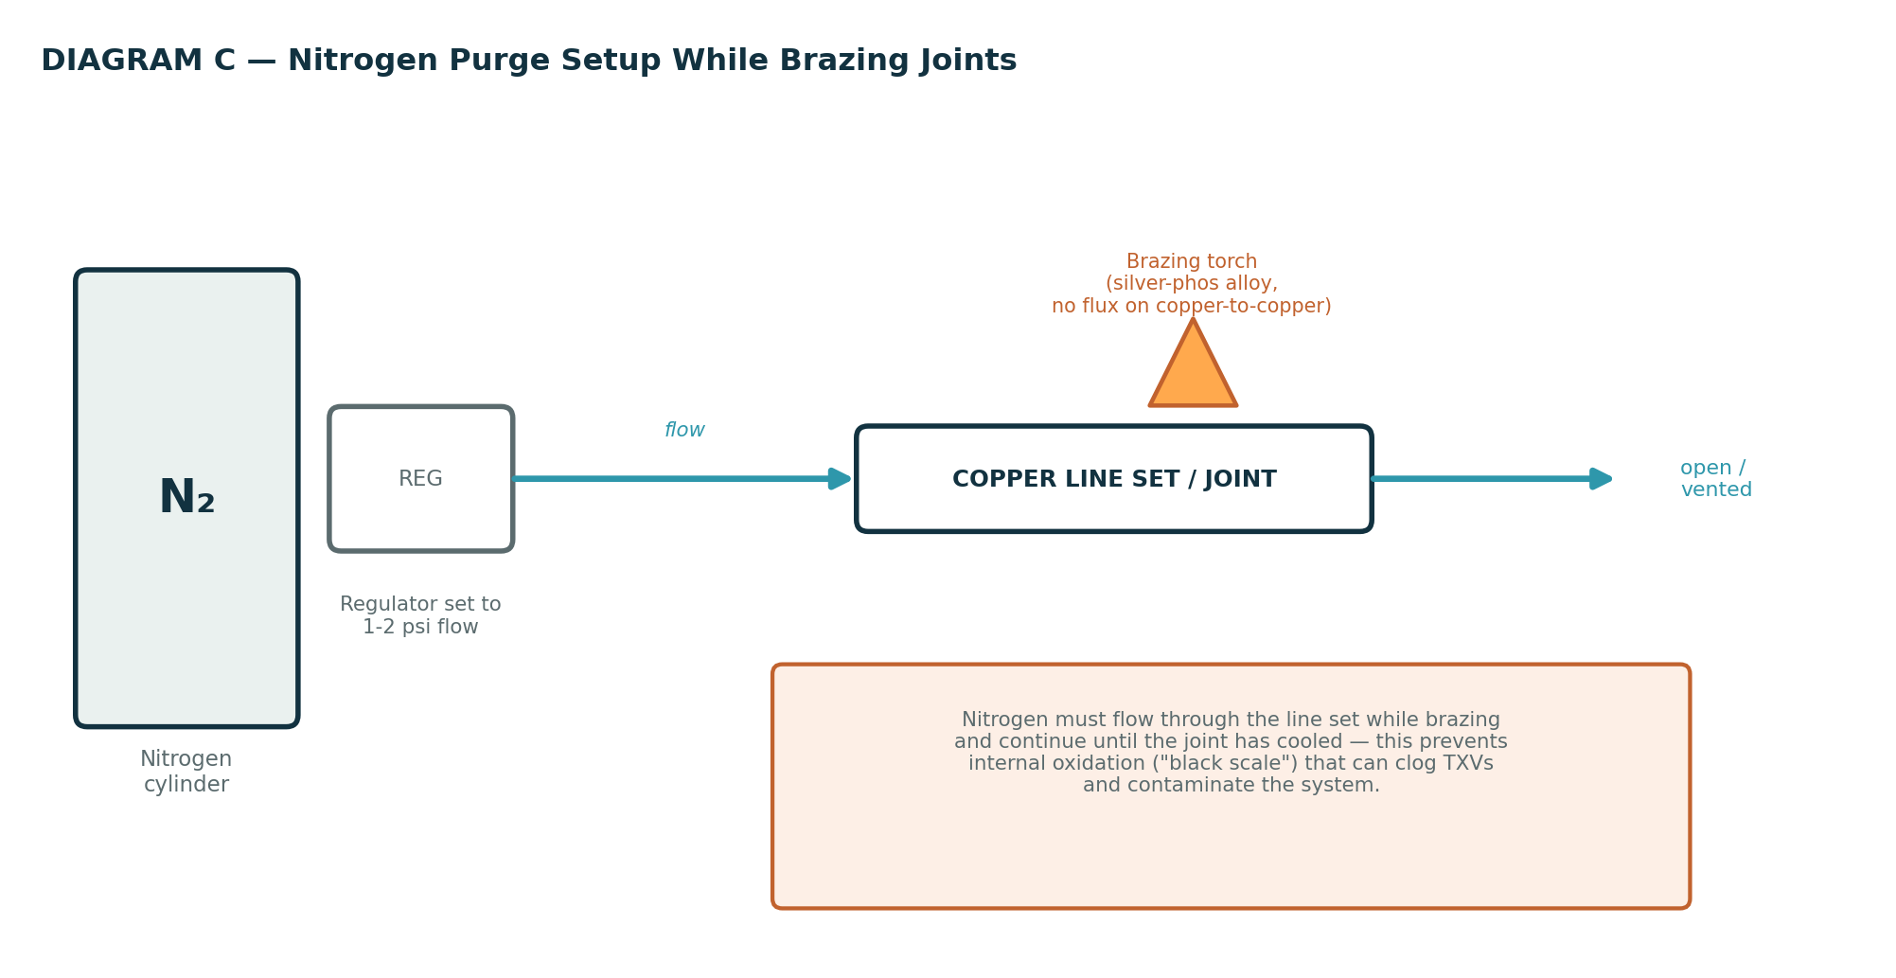
- Confirm the disconnect and breaker are correctly sized for the new condenser's MOCP/MCA nameplate rating before reconnecting power — see Diagram D.
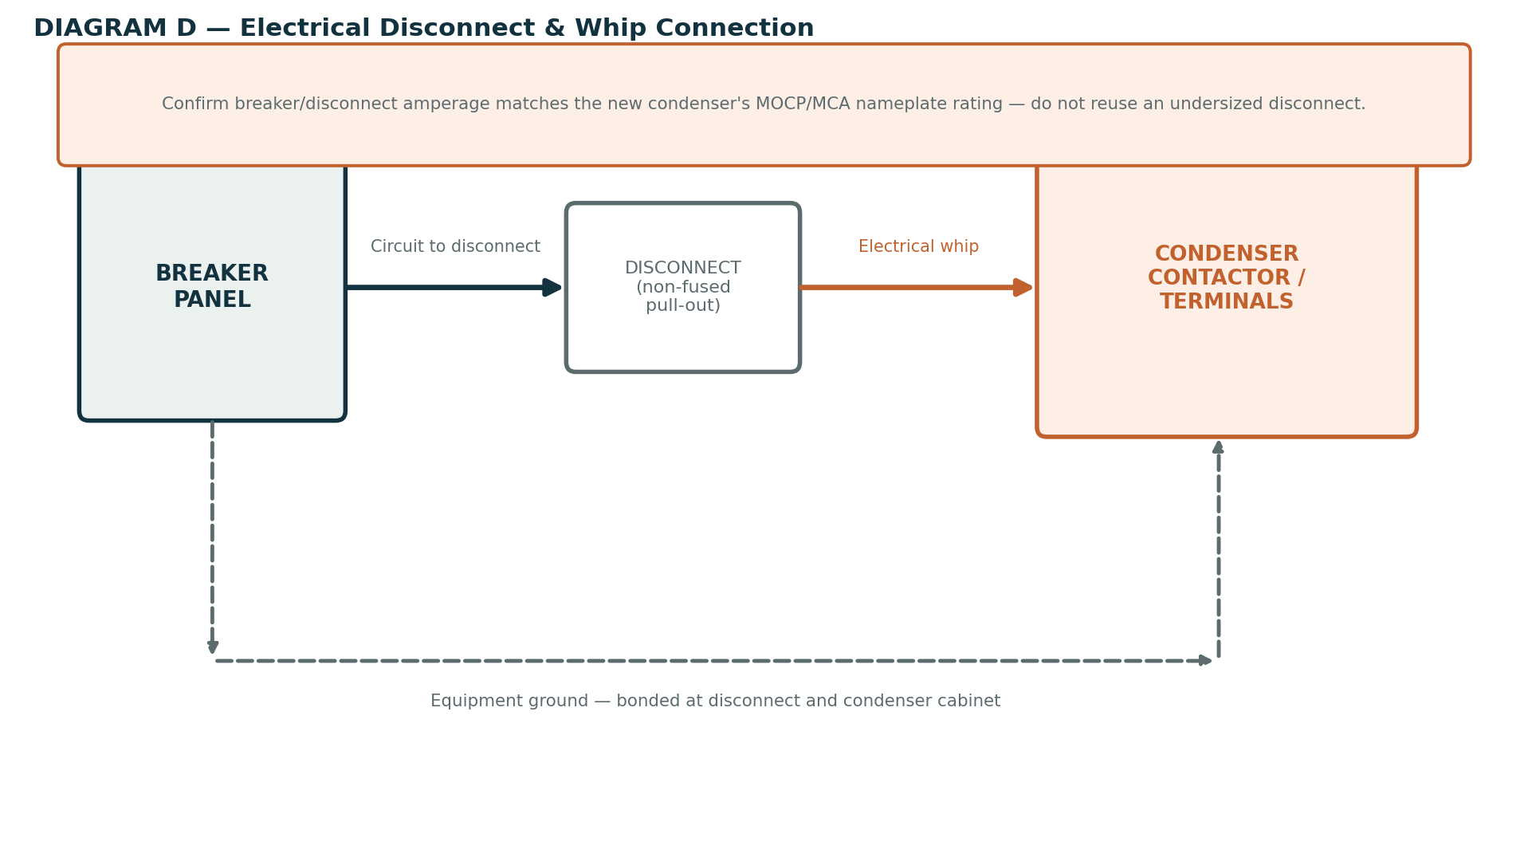
- Reconnect the electrical whip to the contactor/terminal block per the wiring diagram on the unit. Confirm the equipment ground is bonded at both the disconnect and the condenser cabinet.
- Torque all electrical terminal connections to manufacturer spec.

D. Pressure Test, Evacuate & Charge
- Pressure-test the system with dry nitrogen to the pressure specified by the manufacturer. Soap-test every new joint and hold the test pressure per your standard hold time to confirm no leaks.
- Release the nitrogen and connect the vacuum pump. Evacuate the system to 500 microns or the manufacturer's specified vacuum level.
- Isolate the vacuum pump and confirm the vacuum holds (rise test) before breaking vacuum — a fast rise indicates a leak or residual moisture.
- Weigh in the refrigerant charge to the nameplate specification. For long line sets, apply the manufacturer's charge adjustment for line length.
- Fine-tune the charge using superheat (fixed orifice) or subcooling (TXV) targets referenced to actual outdoor ambient and indoor wet-bulb conditions at the time of charging.

6. Electrical Considerations
- Confirm the breaker and disconnect amperage match the new condenser's nameplate MOCP (Maximum Overcurrent Protection) and MCA (Minimum Circuit Ampacity) — do not reuse an undersized disconnect just because it fit the old unit.
- Confirm the whip gauge is sized correctly for the new unit's ampacity and run length.
- Verify equipment grounding at both the disconnect and the condenser cabinet.
- Recommend a whole-unit surge protector, especially in Houston given storm-related grid surges during hurricane season.
- If the new condenser includes a factory crankcase heater, confirm it is wired correctly — this matters most for units that will see winter freeze-event operation.

7. Outdoor Ambient Temperature Considerations

7.1 Very High Ambient (Houston Summer, 95°F+)
- High ambient raises head pressure and baseline discharge temperature — expect higher readings than a mild-day chart and reference the manufacturer's high-ambient chart if available.
- Charge by subcooling where the system uses a TXV — subcooling is more stable than superheat in high-ambient, high-load conditions.
- Weigh in the charge rather than relying on a "feel" method — high ambient makes line temperatures unreliable as a charging cue.
- Shade gauges, hoses, and the recovery machine where practical — direct sun on equipment skews readings and stresses hose seals.
- Protect yourself: hydrate, take shade breaks, and be alert for heat-stress symptoms.

7.2 Very Low Ambient (Winter Freeze Events)
Rare in Houston, but freeze events do happen and standard charging methods lose accuracy below roughly 55–60°F outdoor ambient.
- Use the manufacturer's low-ambient charging procedure or chart — standard superheat/subcooling targets assume a warm-weather load and will mislead you in cold conditions.
- If the new condenser has a low-ambient control kit (fan cycling or a hard-start kit), confirm it is functioning before charging in cold weather.
- Avoid running the compressor for extended periods in very low ambient without adequate load — risk of liquid refrigerant migration/slugging into the compressor is higher.
- Where possible, and where the customer's timeline allows, consider completing final charge verification on a milder day if extreme cold makes accurate charging impractical — document this clearly for the customer and follow up promptly.
- Nitrogen pressure-testing is unaffected by cold ambient, but remember gas pressure varies with temperature — don't mistake a temperature-driven pressure drop for a leak on a cold morning.

8. Houston-Specific Considerations
- Elevate the pad or use a stand-off bracket in flood-prone yards — hurricane season ponding can submerge a low pad and damage the compressor.
- Confirm mechanical/electrical permit requirements with the local permitting office (City of Houston, Katy, Sugar Land, or the applicable jurisdiction) before starting work that requires a permit, and schedule the required inspection.
- A2L refrigerant transition (R-32/R-454B) is ongoing — confirm refrigerant type compatibility across the condenser, coil, and line set, and confirm your recovery equipment is rated for the refrigerant in use.
- Humidity and coastal air quality favor a condenser coil with strong corrosion resistance — consider this when a customer is deciding between base and upgraded models.
- Secure or cage exposed condensers in areas with a history of theft (copper/unit theft is a recurring issue in the Houston area).

9. Startup, Commissioning & Documentation
- Restore power and start the system. Confirm the compressor and condenser fan both operate correctly and rotation/airflow direction is correct.
- Verify amp draw on the compressor and fan motor against nameplate RLA/FLA.
- Confirm final superheat/subcooling against target, and record head and suction pressures.
- Leak-check every new joint again after the system has run and reached operating pressure and temperature.
- Confirm the indoor system (coil, furnace/air handler, thermostat) is operating correctly with the new condenser through a full cooling cycle.
- Photograph the completed install, gauge readings, and the condenser model/serial number for the job file.
- Walk the customer through what was done, and register the new condenser with the manufacturer for warranty where applicable.

10. Master Checklist

Pre-Job
☐ Confirm diagnosis: condenser, not another component, is the cause
☐ Correct replacement condenser ordered — tonnage, voltage, refrigerant type, AHRI match confirmed
☐ Permit pulled if required by local jurisdiction
☐ Tools, materials, nitrogen, and recovery equipment loaded on the truck

Safety
☐ Power confirmed off with a meter before work begins; breaker locked out/tagged where possible
☐ PPE worn; fire watch/extinguisher ready before brazing
☐ Lifting plan confirmed for old/new unit

Removal
☐ Refrigerant recovered into a rated cylinder — weight recorded
☐ Electrical whip disconnected and labeled
☐ Line-set ends capped immediately after cutting
☐ Old condenser removed from pad and site

Pad & Placement
☐ Pad level, undamaged, and rated for the new unit's weight
☐ Manufacturer side/top clearances confirmed
☐ Unit secured (tie-downs/brackets) and vibration pads in place

Line Set & Electrical
☐ Line set inspected/flushed if contamination risk; filter drier replaced
☐ Joints brazed with continuous nitrogen purge
☐ Disconnect/breaker amperage confirmed to match new unit's MOCP/MCA
☐ Electrical whip reconnected; ground bonded at disconnect and cabinet
☐ Terminal connections torqued to spec

Pressure Test, Evacuation & Charge
☐ New Filter drier added
☐ Nitrogen pressure test held with no leaks at every new joint
☐ System evacuated to 500 microns (or manufacturer spec); vacuum rise test passed
☐ Refrigerant charge weighed in to nameplate spec, adjusted for line length
☐ Charge fine-tuned by superheat/subcooling for actual ambient conditions

Startup & Documentation
☐ Compressor and fan verified; amp draw checked against nameplate
☐ Pressures and superheat/subcooling recorded
☐ Post-startup leak check completed on all new joints
☐ Full cooling cycle verified at the thermostat
☐ Photos taken; condenser model/serial documented; customer walkthrough completed
☐ Manufacturer warranty registration submitted
This manual reflects general trade practice and common Houston-area (Katy / Sugar Land / Houston) code themes as of this writing. Always confirm current requirements with the applicable permitting office and the condenser manufacturer's published specifications before finalizing a job.

