Purpose | Moments of roots of a polynomial.
Syntax | m = moments(p)
Description | Consider a polynomial 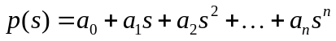. Denote 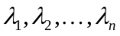the set of roots of p(s) including multiplicities. Then the k-th moment 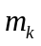 is defined as 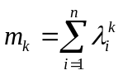  The function moments returns a vector 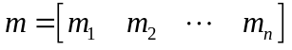.  If the polynomial p(s) is monic then the first n moments determine the coefficients of the polynomial uniquely.
Examples | >> p = prand(3)  p =  1.2 - 0.038s + 0.33s^2 + 0.17s^3  >> m = moments(p)  m =  -1.8741 3.9433 -28.2217
Algorithm | Solution to the linear system  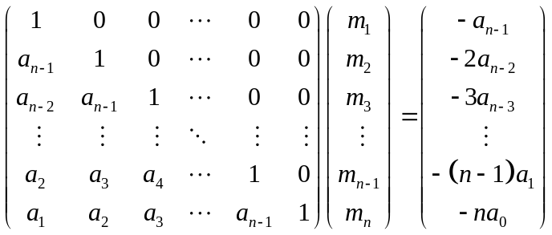  where the coefficients  were taken from the monic polynomial 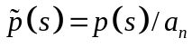.
See also | roots | Roots of a polynomial
References | Horn, R.A., Johnson, C.R.: Matrix analysis. Cambridge University Press, 1985, pp.44.

