Purpose | Plot the spectral set for a spherical polynomial family.
Syntax | sphspectrum(p0,r)  sphspectrum(p0,r,x,y)  sphspectrum(...,'fill');
Description | sphspectrum(p0,r) plots the spectral set for a spherical polynomial family 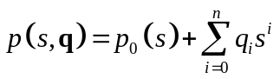  where 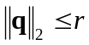 for a range of values of the parameter r.  sphspectrum(p0,r,x,y) The parameters x and y are vectors of (real) values at real and imaginary axes for which the gridding is performed.  sphspectrum(...,'fill') fills the contours describing the spectral set.
Examples | The nominal polynomial p₀(s) is  p0 = s^6 + 2*s^5 + 3*s^4 + 4*s^3 + 5*s^2 + 6*s + 7;  The vector of bounds on the Euclidean norm of the uncertain parameter q is  r = [0.3 0.6 0.9];  The spectral set (set of roots of the uncertain polynomial) can be visualized as  sphspectrum(p0,r)  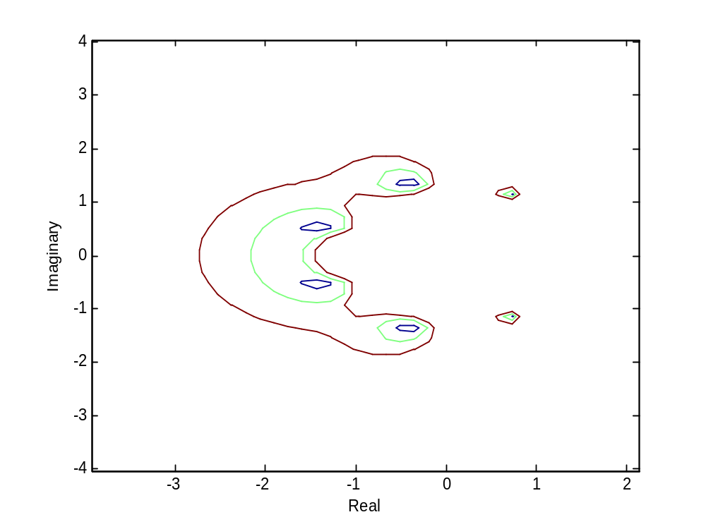  To supply your own tighter and denser grid, choose  x = -3:0.02:1;  for the real axis and  y = -2:0.02:2;  for the imaginary axis.  (note that s = x +j*y)  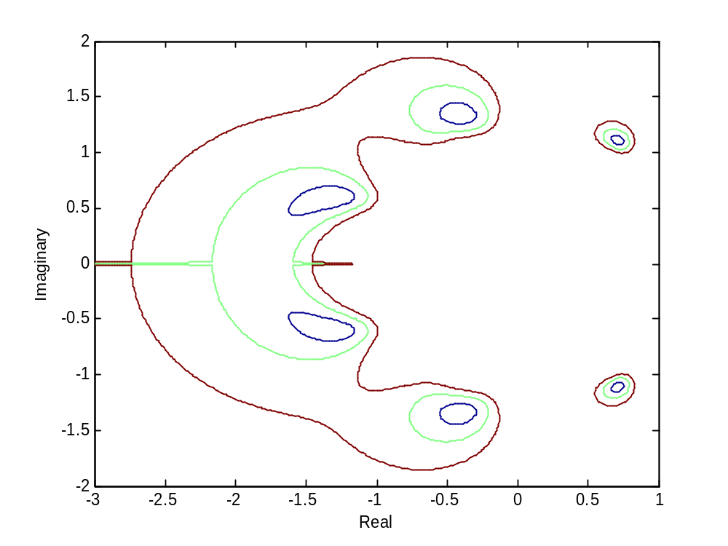  The spectral set (set of roots of the uncertain polynomial) can be visualized as  sphspecsetplot(p0,r,x,y)  sphspectrum(p0,r,x,y,'fill')
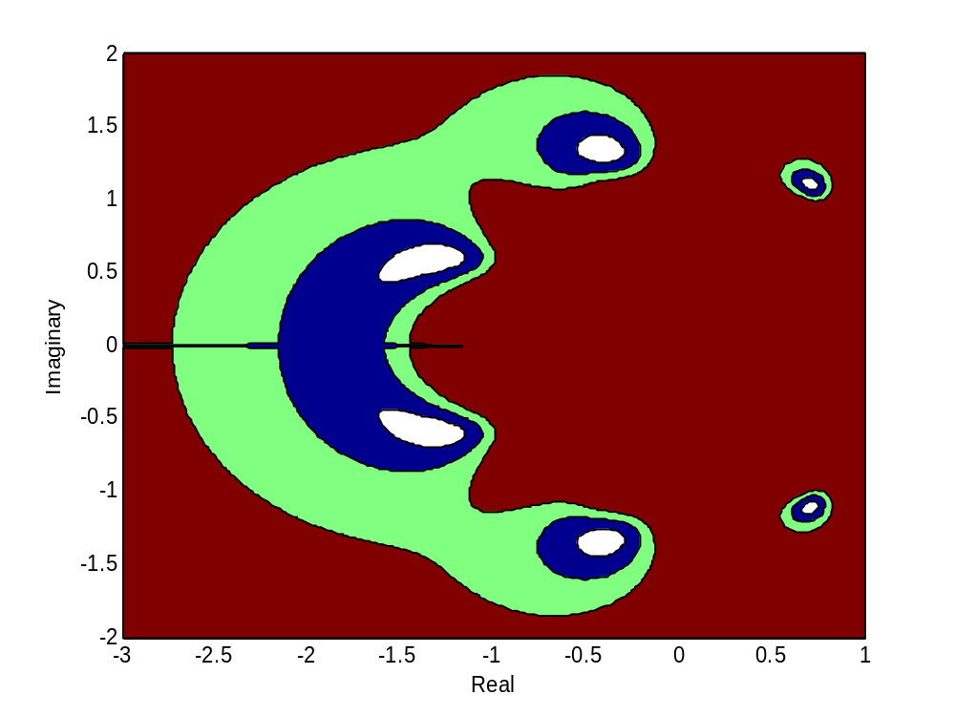  See also | spherplot | value set plotting for a spherical polynomial family for a grid of frequencies.
References | B.R.Barmish (1994). New Tools for Robustness of Linear Systems, Macmillan, pp.281.

