MulMatrix CUDA
#include <cuda_runtime.h>
#include <cstdlib>
#include <cuda.h>
#include <device_launch_parameters.h>
#include <iostream>
#include <ctime>
#include <fstream>
using namespace std;

__global__ void MatrixMul(int *a, int *b, int *c, int N) {
//Calculate the global row and colomn for each thread
int row = blockIdx.y * blockDim.y + threadIdx.y;
int col = blockIdx.x * blockDim.x + threadIdx.x;

if (row < N && col < N) {
int temp = 0;
for (int i = 0; i < N; i++) {
temp += a[row * N + i] * b[i * N + col];
}

//Write back the resolt
c[row * N + col] = temp;
}
}

void CreateMatrix(int *a, int N) {
for (int i = 0; i < N * N; i++)
a[i] = rand() % 100;
}

clock_t Test(int N) {

size_t bytes = N * N * sizeof(int);
clock_t clocks;

//Alocate memory
int* a, * b, * c;

cudaMallocManaged(&a, bytes);
cudaMallocManaged(&b, bytes);
cudaMallocManaged(&c, bytes);

//Create matrix
CreateMatrix(a, N);
CreateMatrix(b, N);

//Set CTA and grid dimension
int threads = 16;
int blocks = (N + threads - 1) / threads;

dim3 THREADS(threads, threads);
dim3 BLOCKS(blocks, blocks);

clocks = clock();
MatrixMul <<<BLOCKS, THREADS >>> (a, b, c, N);
cudaDeviceSynchronize();
clocks = clock() - clocks;

cout << "Program completed successfully " << endl;
cout << "Dimension: "<< N << " Clocks: " << clocks << " Time: " << (double)clocks / CLOCKS_PER_SEC << endl;

cudaFree(a);
cudaFree(b);
cudaFree(c);

return clocks;
}

int main() {
int i = 0;
cout << " PRogram starting " << i << endl;
clock_t clk;
ofstream resolt;
resolt.open("resolt.txt");

while (i <= 10000) {
clk = Test(i);
resolt << i << " " << clk << " " << (double)clk / CLOCKS_PER_SEC << endl;
if (i < 100)
i += 10;
else if (i < 1000)
i += 100;
else
i += 1000;
}
resolt.close();
return 0;
}

Matrix dimension (NxN) | Number of clocks | Time
0 | 0 | 0
10 | 0 | 0
20 | 0 | 0
30 | 0 | 0
40 | 0 | 0
50 | 1 | 0.001
60 | 1 | 0.001
70 | 0 | 0
80 | 0 | 0
90 | 0 | 0
100 | 1 | 0.001
200 | 1 | 0.001
300 | 2 | 0.002
400 | 4 | 0.004
500 | 6 | 0.006
600 | 9 | 0.009
700 | 14 | 0.014
800 | 21 | 0.021
900 | 33 | 0.033
1000 | 44 | 0.044
2000 | 262 | 0.262
3000 | 691 | 0.691
4000 | 1608 | 1.608
5000 | 3126 | 3.126
6000 | 5252 | 5.252
7000 | 8399 | 8.399
8000 | 12291 | 12.291
9000 | 17454 | 17.454
10000 | 23952 | 23.952

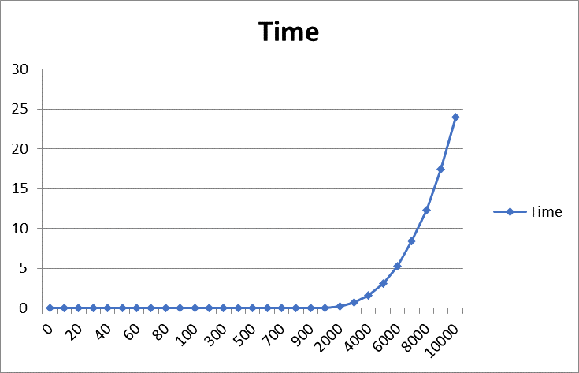

MulMatrix CPU
#include <iostream>
#include <ctime>
#include <random>
#include <cstdlib>
#include <fstream>
#include <iomanip>
using namespace std;

void CreateMatrinx(int** &a, int NUM) {
a = new int* [NUM];
for (int i = 0; i < NUM; i++)
a[i] = new int[NUM];

}

void FildMatrix(int** a, int NUM) {
const int NUMRANGE = 10;
for (int i = 0; i < NUM; i++)
for (int j = 0; j < NUM; j++)
a[i][j] = rand() * NUMRANGE / RAND_MAX + 1;
}

void PrintMatrix(int** a, int NUM) {
for (int i = 0; i < NUM; i++) {
for (int j = 0; j < NUM; j++)
printf("%d ", a[i][j]);
printf("\n");
}
printf("\n");
}

void DeleteMatrix(int** a, int NUM) {
for (int i = 0; i < NUM; ++i)
delete[] a[i];
delete[] a;
}

void MulMatrix(int** a, int** b, int** c, int NUM) {
for (int i = 0; i < NUM; i++)
for (int j = 0; j < NUM; j++) {
c[i][j] = 0;
for (int k = 0; k < NUM; k++)
c[i][j] += a[i][k] * b[k][j];
}
}

clock_t Test(int NUM) {
int** a = nullptr;
int** b = nullptr;
int** c = nullptr;
clock_t clocks;

CreateMatrinx(a, NUM);
FildMatrix(a, NUM);

CreateMatrinx(b, NUM);
FildMatrix(b, NUM);

CreateMatrinx(c, NUM);
clocks = clock();
MulMatrix(a, b, c, NUM);
clocks = clock() - clocks;
printf("Dimension matrix: %d\nClock nambers: %d\nTime: %f\n", NUM, clocks, (double)clocks / CLOCKS_PER_SEC);

DeleteMatrix(a, NUM);
DeleteMatrix(b, NUM);
DeleteMatrix(c, NUM);

return clocks;
}

int main()
{
int i = 1;
clock_t clk;
ofstream resolt;
resolt.open("resolt.txt");
while (i < 1500) {
clk = Test(i);
resolt << i << " " << clk << " " << (double)clk / CLOCKS_PER_SEC << endl;
if (i < 10)
i += 1;
else if (i < 500)
i += 10;
else
i += 100;
}
resolt.close();
return 0;
}
 | Matrix dimension (NxN) | Number of clocks | Time
 | 1 | 0 | 0
 | 2 | 0 | 0
 | 3 | 0 | 0
 | 4 | 0 | 0
 | 5 | 0 | 0
 | 6 | 0 | 0
 | 7 | 0 | 0
 | 8 | 0 | 0
 | 9 | 0 | 0
 | 10 | 0 | 0
 | 20 | 1 | 0.001
 | 30 | 0 | 0
 | 40 | 0 | 0
 | 50 | 0 | 0
 | 60 | 0 | 0
 | 70 | 1 | 0.001
 | 80 | 2 | 0.002
 | 90 | 3 | 0.003
 | 100 | 5 | 0.005
 | 110 | 5 | 0.005
 | 120 | 6 | 0.006
 | 130 | 8 | 0.008
 | 140 | 10 | 0.01
 | 150 | 12 | 0.012
 | 160 | 15 | 0.015
 | 170 | 17 | 0.017
 | 180 | 22 | 0.022
 | 190 | 23 | 0.023
 | 200 | 26 | 0.026
 | 210 | 32 | 0.032
 | 220 | 36 | 0.036
 | 230 | 47 | 0.047
 | 240 | 46 | 0.046
 | 250 | 56 | 0.056
 | 260 | 64 | 0.064
 | 270 | 78 | 0.078
 | 280 | 91 | 0.091
 | 290 | 101 | 0.101
 | 300 | 103 | 0.103
 | 310 | 166 | 0.166
 | 320 | 152 | 0.152
 | 330 | 162 | 0.162
 | 340 | 146 | 0.146
 | 350 | 162 | 0.162
 | 360 | 218 | 0.218
 | 370 | 227 | 0.227
 | 380 | 210 | 0.21
 | 390 | 225 | 0.225
 | 400 | 267 | 0.267
 | 410 | 259 | 0.259
 | 420 | 283 | 0.283
 | 430 | 310 | 0.31
 | 440 | 347 | 0.347
 | 450 | 354 | 0.354
 | 460 | 428 | 0.428
 | 470 | 458 | 0.458
 | 480 | 427 | 0.427
 | 490 | 473 | 0.473
 | 500 | 504 | 0.504
 | 600 | 871 | 0.871
 | 700 | 1431 | 1.431
 | 800 | 2208 | 2.208
 | 900 | 3371 | 3.371
 | 1000 | 6986 | 6.986
 | 1100 | 8091 | 8.091
 | 1200 | 12462 | 12.462
 | 1300 | 18328 | 18.328
 | 1400 | 24987 | 24.987
