Build, change, and destroy AWS infrastructure using Terraform
Infrastructure as Code with Terraform with the simple declarative configuration language (HashiCorp Configuration Language)
Step 1. Building the infrastructure, Wrote terraform configuration to launch the AWS EC2 t2.micro instance
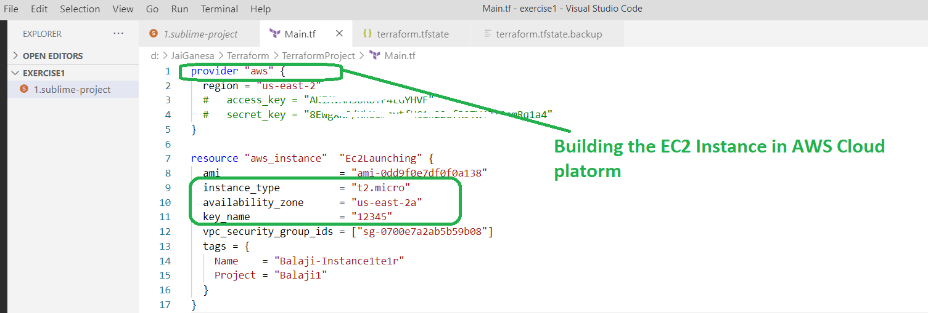

Terraform init
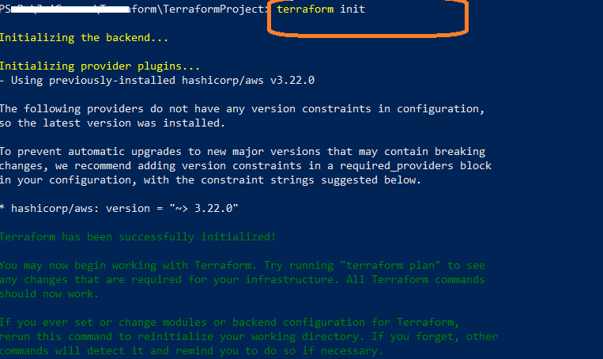
Terraform plan
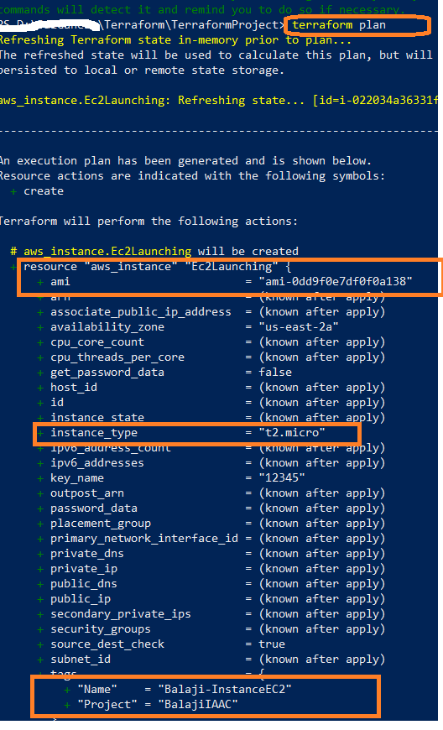

Terraform apply
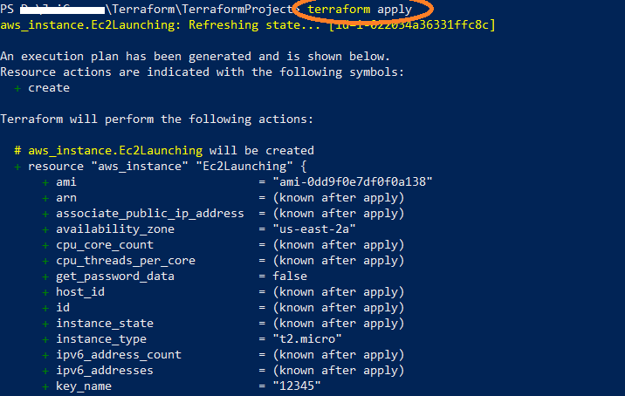

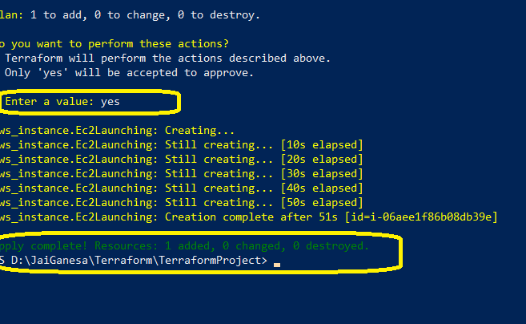
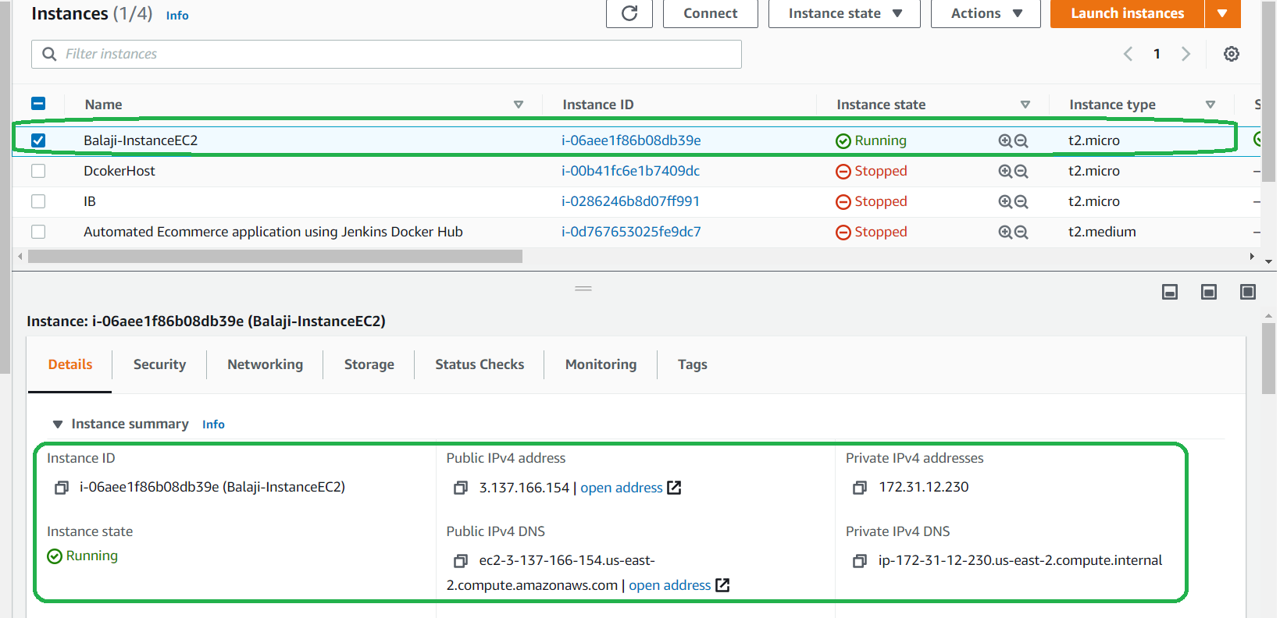

Step 2: Changing/ Update the Building the infrastructure
Terraform configuration file launch the AWS EC2 from t2.micro instance to t2.small
If user face any AWS connection error respective IAM credentials are stored here C:\Users\malay\.aws
Step 3. Destroy the infrastructure with respective command (terraform destroy)

