

**Tribhuvan University**

**Faculty of Humanities and Social Sciences**

## “Thaekedar”

**A PROJECT REPORT**

**Submitted to:**

**Department of Computer Application**

**Kathmandu Business Campus**

***In partial fulfillment of the requirements for the Bachelors in Computer Application***

**Submitted by:**

**Name: Bivek Raj Shakya Roll no. : 7**

**Name: Sandesh Rana Magar Roll no. : 29**

Under the Supervision of

**Supervisor**



**Tribhuvan University**

**Faculty of Humanities and Social Sciences**

**Kathmandu Business Campus**

**Supervisor’s Recommendation**

I hereby recommend that this project prepared under my supervision by Bivek Raj Shakya and Sandesh Rana Magar entitled **“Thaekedar(Contact Management System)”** in partial fulfillment of the requirements for the degree of Bachelor of Computer Application is recommended for the final evaluation.

**SIGNATURE**

**SUPERVISOR**



**Tribhuvan University Faculty of Humanities and Social Sciences**

**Kathmandu Business Campus**

**LETTER OF APPROVAL**

This is to certify that this project prepared by Bivek Raj Shakya and Sandesh Rana Magar entitled **“Thaekedar(Contact Management System)”** in partial fulfillment of the requirements for the degree of Bachelor in Computer Application has been evaluated. In our opinion it is satisfactory in the scope and quality as a project for the required degree.

|  |  |
| --- | --- |
| **SIGNATURE of Supervisor** | **SIGNATURE of HOD/ Coordinator** |
| **SIGNATURE of Internal Examiner** | **SIGNATURE of External Examiner** |

**Kathmandu Business Campus**

Ref No:

Date:

**Subject: Approval of Project Proposal**

The project entitled “Thaekedar” proposed by Mr. Bivek raj Shakya and Mr. Sandesh Rana Magar for the partial fulfillment of the requirement for Bachelor in Computer Application (BCA), fourth semester has been approved for further development.

**Proposal Evaluation Committee**

1. **_______________________**
2. **_______________________**
3. **_______________________**
4. **_______________________**

Mr.

Campus Chief (.)

**Table of Contents**

“Thaekedar” 1

Chapter 1: Introduction 5

1.1 Introduction of Proposed project: 5

1.2 Problem Statement: 6

1.3 Objectives 6

1.4 Scope and Limitations 7

Limitations 7

Chapter 2: Literature Review 8

Chapter 3: Methodology 9

3.1 System Analysis: 9

Requirements Identification: 10

1. Functional Requirements: 10

2. Non-Functional Requirements: 10

Feasibility Study: 10

Tools: 11

3.2 System Design 11

Chapter 4: Conclusion 15

4.1 Expected Outcome 15

Reference 16

1) Literature review [Founder(Miraj K Dhungana) of dalaydai.com] 16

# 

# Chapter 1: Introduction

## Introduction of Proposed project:

Introducing Thaekedar – A platform where your every needs of resources from lawyers, Suppliers, while building a house or be it when you are outsourcing it to construction agencies. This Project is a complete go to Tech(Website) to contact with the preferred agencies/ people to get your Dream House done.

Thaekedar is a simple Contact Management System similar to linkedin with a lots of features disabled, which only helps you to get the contact of preferred people/ agencies while building your house.

## Problem Statement:

In the context of Nepal,

* + - Lack of proper networking with people while building a house.
    - Most people get scammed by so called “Thaekedar”.
    - Third party people charging more due to their connections.
    - Expensive and Time consuming process working with people who outsources the process too.

## Objectives

Our objective is:

* + - To provide the contact of desired human resources / agencies.
    - To provide simple yet effective UI/UX.
    - To provide each agency/human resources as source of inbound leads.

## Scope and Limitations

**Scope**

* + - Facilitate with connection of agencies / human resources.
    - It is Simple and easy to use UI.
    - It reduces time and manpower.

## Limitations

* + - * It doesn’t facilitate with buying and selling of houses and land.
      * It uses different platforms like social media, phone, email to help connect so user will have to open another tab to connect with peoples.
      * It must have stable internet connectivity.

# Chapter 2: Literature Review

From the different research and analysis, We found some of the related Websites. One of them being [dalaydai.com](https://dalaydai.com/) . We found out that it have the multi-feature of adding houses to rent, buying and selling and there comes the feature of adding contacts of agencies and suppliers.

While asking the Founder of dalaydai.com we found that they has an average visitor of 12,000 per month and when it comes to feature of adding agencies, supplier their metrics where low and only 10% from the overall visitor per month visit the page which has the feature we are building. We also found out that there were using Django Framework, Vue Js while we are using technologies like HTML, CSS and JavaScript and also Php.

Our approach is simple and effective because it only connects people/agencies while he/she is building a house none other than that so we have niche down rather than doing it all. This will bring the quality to improve only on a certain niche.

# Chapter 3: Methodology

Our project has specific documentation, time and the fixed requirements, which makes the waterfall methodology the most appropriate system for this development life cycle. This is the reason why we are using Waterfall Model.

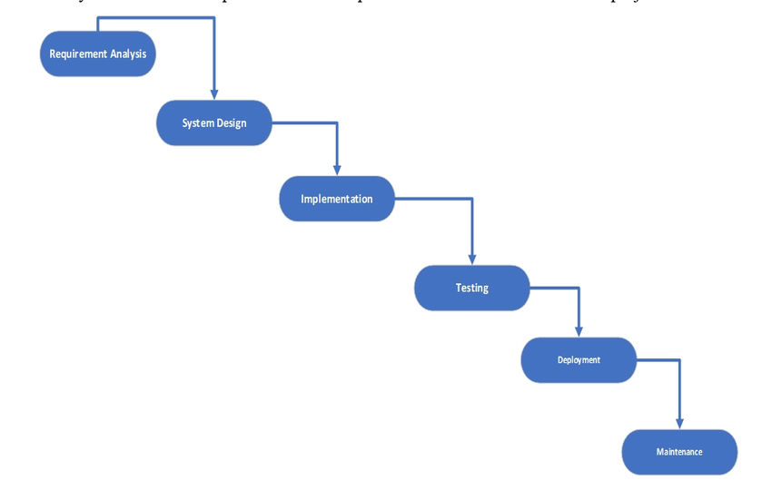

**Fig: Waterfall Model**

The Waterfall Model was the first Process Model. It is also referred as a linear- sequential life cycle model. It is very simple to understand as well as for the use. Each phase must be completed before the next phase can begin.

Watefall model can’t be used to develop the software having high risk and complex nature.

## System Analysis:

System Analysis is the process in which a system is studied in such way that an information system can be analyzes, modeled, and a logical alternative can be chosen.

It is conducted for the purpose of studying a system or its parts in order to identify its objectives. It is a problem solving technique that improves the system and ensures that all the components of the system work efficiently to accomplish their purpose.

## Requirements Identification:

Requirement identification is a most needed step in the development of our project contact management system. System needs to fulfill following function and non-functional requirements.

## Functional Requirements:

* + - Users will be able register and login.
    - Users will be able to apply for adding agencies/their commodities.
    - Admin will be able to approve or reject user’s request for adding agencies/commodities looking his/her proper document and license.
    - User will be able to give feedback and rating.

## Non-Functional Requirements:

* + - **Availability**: Our system(website) will be available online.
    - **Security**: This system will be secured as the document/license of the user will not be visible to other except admin.
    - **Performance**: This system will be optimized to have a smooth performance.
    - **Reliability**: It will be very reliable for the users as we exclude every other third parties.
    - **Usability:** This system will be focused for user experience and user friendly interface.

## Feasibility Study:

A feasibility study is an analysis that consider all of a project’s affecting factors like economic, technical, legal and scheduling considerations.

* + - * **Technical Feasibility:** This system(website) is technically feasible because we are using pre-existing technical tools and software that are most commonly used.
      * **Economic Feasibility:** The cost for this development is minimum other than internet and it doesn’t require extra software and hardware so it is affordable.
      * **Operational Feasibility:** This system is user friendly and uses simple technology. So, everyone can use without any tutorial.

## Tools:

**Front End:**

**Back End:**

* Html
* CSS
* JavaScript
* Photoshop
* Figma
* PHP
* My SQL

## System Design

**Context Level:**

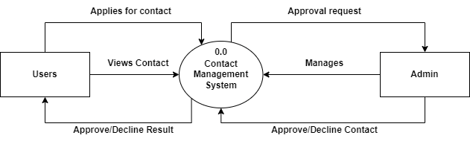

**Fig: Context Level Diagram**

**1st Level DFD Diagram:**

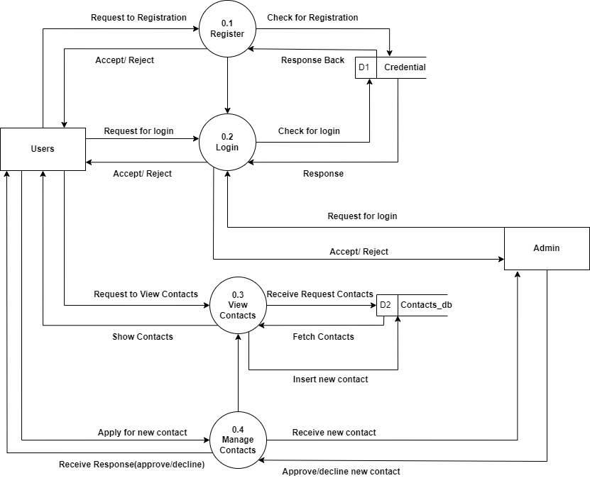

**Fig: Level 1 DFD**

**E-R Diagram:**

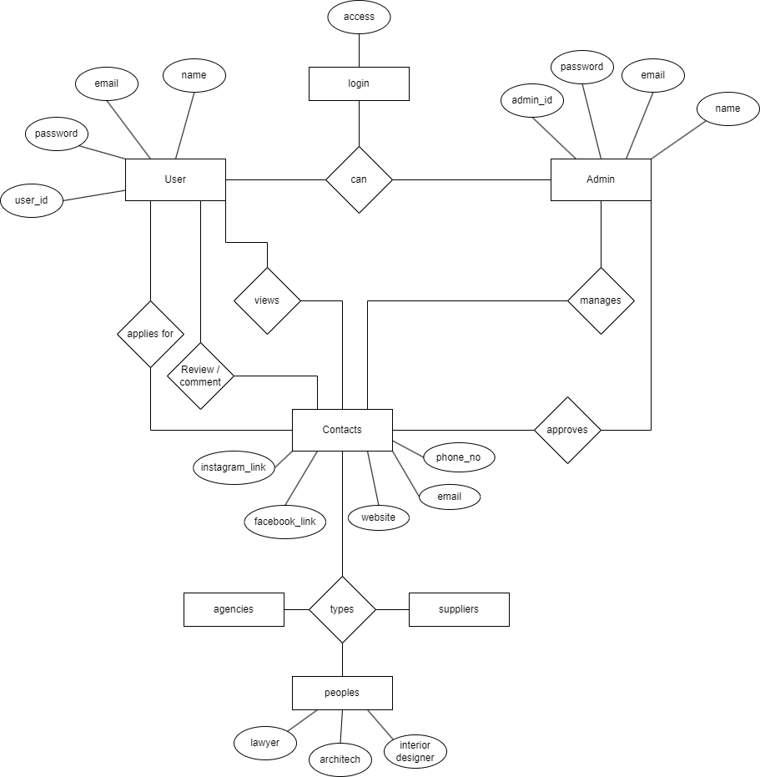

**Fig: E-R Diagram**

**Gantt Chart (Project Schedule):**

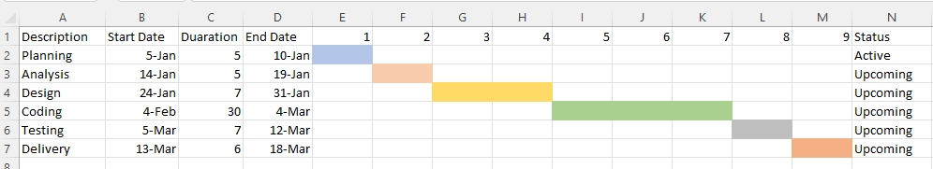

**Fig: Gantt Chart**

By using a Gantt chart, we can visualize the project schedule, identify critical path tasks, and manage dependencies to ensure that the project is completed on time and within budget.

# Chapter 4: Conclusion

Thaekedar, a revolutionary platform which serves as the ultimate destination for all your resource needs while building your dream house. Whether you are seeking legal assistance, reliable suppliers, or trustworthy construction agencies, Thaekedar simplifies the process through its comprehensive tech-driven website.

This Platform aims to streamline the entire journey of constructing a house by connecting users with preferred professionals and agencies. Thaekedar redefines the way individuals navigate the complexities of the construction process, offering a straightforward solution to meet their specific needs.

## 4.1 Expected Outcome

This system will help people who has hard finding a reliable agencies or peoples to work with while in the process of building their house excluding third party involvement, It will provide direct contacts of preferred agencies, suppliers, etc. It will be able to save time and money

It overcomes the complexities while he/she is building a house. Ultimately, the expected outcome is a successful, stress-free, and well-coordinated construction experience.

# Reference

# Literature review [Founder(Miraj K Dhungana) of dalaydai.com]