# 

Contents

Introduction 1

1.1 Introduction of Proposed project: 1

1.2 Problem Statement: 1

1.3 Objectives 1

1.4 Scope and Limitations 2

Literature Review 3

Methodology 4

3.1 System Analysis: 4

3.1.1. Requirements Identification: 5

3.1.1.1. Functional Requirements: 5

3.1.1.2.Non-Functional Requirements: 5

3.2. Feasibility Study: 6

3.4. System Design: 7

3.4.1 Data Flow Diagram: 7

3.4.2 ER Diagram:……………………………..……………………………………………8

Gantt Chart(Project Schedule)………...………………………………………………………9

Expected Outcome 10

References 11

# Introduction

## Introduction of Proposed project:

**Construction Contact Management System** (**Thaekedar**) will be a platform where your every needs of resources from architect to suppliers, while building a house or be it when you are outsourcing it to construction agencies. This Project will be a complete goto Tech (Website) to contact with the preferred agencies/ people to get your Dream House done.

Thaekedar help to get wide range of the contacts of preferred people/ agencies while building your house.

## Problem Statement:

* + - Lack of proper networking with people while building a house.
    - Third party people charging more due to their connections.
    - Expensive, Time consuming process working with people who outsources the process too.

## Objectives

* + - To provide users with the contact of desired people while you are building a house including agencies, architect, engineer, interior designer, suppliers.
    - To provide each agency, architect, engineer, interior designer, supplier that are registered to get clients from the platform.

## Scope and Limitations

**Scope**

* It will be web-based platform connecting users with architect, suppliers and construction agencies.
* It reduces time and manpower by removing middle man and reduces commission.

## Limitations

* It doesn’t facilitate with buying and selling of houses and land.
* It doesn’t include messaging service or direct communication medium.

# Literature Review

From the different research and analysis, We found some of the related Websites. [1] One of them being [dalaydai.com](https://dalaydai.com/) . We found out that it have the multi-feature of adding houses to rent, buying and selling and there comes the feature of adding contacts of agencies and 5suppliers.

While asking the Founder of dalaydai.com we found that they has an average visitor of 12,000 per month and when it comes to feature of adding agencies, supplier their metrics where low and only 10% from the overall visitor per month visit the page which has the feature we are building. We also found out that there were using Django Framework, Vue J while we are using technologies like HTML, CSS and JavaScript and also PHP.

Our approach is simple and effective because it only connects people/agencies while he/she is building a house none other than that so we have niche down rather than doing it all. This will bring the quality to improve only on a certain niche.

# Methodology

Our project has specific documentation, time and the fixed requirements, which makes the waterfall methodology the most appropriate system for this development life cycle. This is the reason why we are using Waterfall Model.

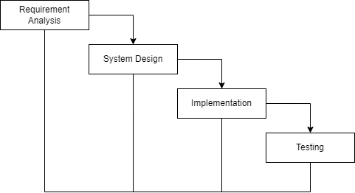

**Figure: Waterfall Model**

The Waterfall Model was the first Process Model. It is also referred as a linear- sequential life cycle model. It is very simple to understand as well as for the use. Each phase must be completed before the next phase can begin.

Waterfall model can’t be used to develop the software having high risk and complex nature.

## System Analysis:

System Analysis is the process in which a system is studied in such way that an information system can be analyzes, modeled, and a logical alternative can be chosen.

It is conducted for the purpose of studying a system or its parts in order to identify its objectives. It is a problem-solving technique that improves the system and ensures that all the components of the system work efficiently to accomplish their purpose.

## 3.1.1. Requirements Identification:

Requirement identification is a most needed step in the development of our project contact management system. System needs to fulfill following function and non-functional requirements.

## 3.1.1.1. Functional Requirements:

* + - Users will be able register and login.
    - Users will be able to apply for adding agencies/their commodities.
    - Admin will be able to approve or reject user’s request for adding agencies/commodities looking his/her proper document and license.
    - User will be able to give feedback and rating.

## Non-Functional Requirements:

* + - **Availability**: Our system(website) will be available online.
    - **Security**: This system will be secured as the document/license of the user will not be visible to other except admin.
    - **Performance**: This system will be optimized to have a smooth performance.
    - **Reliability**: It will be very reliable for the users as we exclude every other third parties.
    - **Usability:** This system will be focused for user experience and user-friendly interface.

## 3.2. Feasibility Study:

A feasibility study is an analysis that consider all of a project’s affecting factors like economic, technical, legal and scheduling considerations.

* + - * **Technical Feasibility:** This system(website) is technically feasible because we are using pre-existing technical tools and software that are most commonly used.
      * **Economic Feasibility:** The cost for this development is minimum other than internet and it doesn’t require extra software and hardware so it is affordable.
      * **Operational Feasibility:** This system is user friendly and uses simple technology. So, everyone can use without any tutorial.

**3.3 Tools:**

**Frontend:**

* HTML
* CSS
* JavaScript

**Backend:**

* PHP
* MYSQL

**Design Tools:**

* Photoshop
* Figma

## 3.4. System Design:

## 3.4.1 Data Flow Diagram:

**Context Level:**

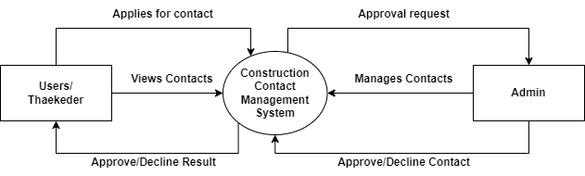

**Figure: Context Level Diagram**

**3.4.2 E-R Diagram:**

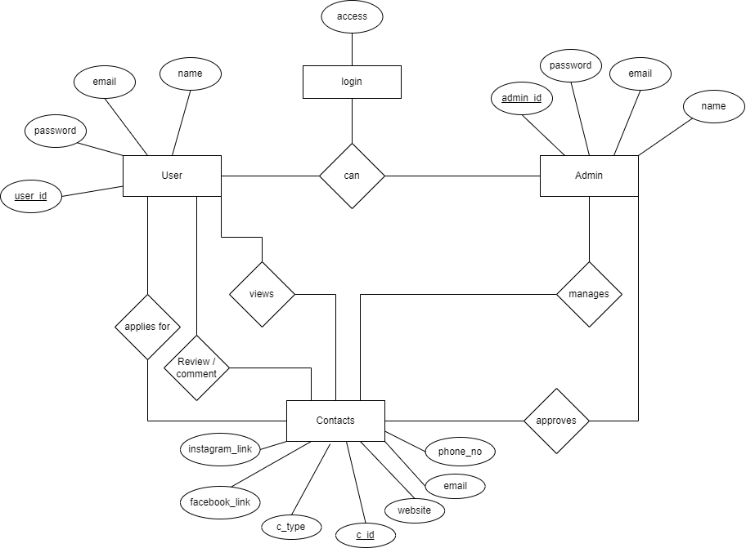

**Figure: E-R Diagram**

**Gantt Chart (Project Schedule)**

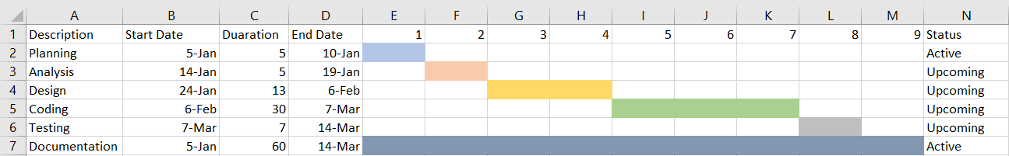

**Fig: Gantt Chart**

By using a Gantt chart, we can visualize the project schedule, identify critical path tasks, and manage dependencies to ensure that the project is completed on time and within budget.

According to our Gantt chart, Task 1, Planning is the first step in the project and is expected to take 5 days. Task 2, Analysis is expected to take 5 days. Task 3, Design is expected to take 13 days. Task 4, Coding is expected to take 30 days. Task 5, Testing is expected to take 7 days. Task 6, Documentation is an ever-going process so, it is active all the time from start of the project to the end of the project.

## Expected Outcome

This system will help people who has hard finding a reliable agencies or peoples to work with while in the process of building their house excluding third party involvement and will provide direct contacts of preferred agencies, suppliers, etc. It will be able to save time and money

It overcomes the complexities while he/she is building a house. Ultimately, the expected outcome is a successful, stress-free, and well-coordinated construction experience.

# References

|  |  |
| --- | --- |
| [1] | M. K. Dhungana, Interviewee, *Dalay Dai.* [Interview]. 06 01 2024. |
| [2] |  |