INF-2301: Assignment 2 Report

1 Introduction
This assignment consists of two parts, where the first is implementing secure data sharing between a file sharing server and a receiving client. The second part is about discussing to what extent the implementation fulfills the security principles C.I.A and A.A.A.

2 Technical Background
This assignment is about implementing a file sharing application, where a client requests for a file and the server sends it. But file sharing introduces security risks, so this assignment naturally has as its main focus how the implementation stands up to the two security triads C.I.A (Confidentiality, Integrity and Availability), and A.A.A (Assurance, Authenticity and Anonymity).
Symmetric cryptography requires that the server and client are using the same secret key, and it is used for both encryption of plain text and decryption of cipher text. The Advanced Encryption Standard (AES), comprises three block ciphers: AES-128, AES-192 and AES-256[1].
With public-key cryptography, a private/public key-pair is created, where the public-key is a subset of the private key. In contrast to symmetric key cryptography, an RSA private-key is normally 2048, or 4096 bit. It is close to impossible to determine the private-key from the public-key.
The public key is used for encryption before sending to the other part, while the private is used for decryption. In a server-client architecture, a client must share its public-key with the server, before the server can start sending encrypted data back to the client.
Public-key cryptography is more secure, but is slower because of its larger keys. Symmetric cryptography is faster, but less secure than public-key cryptography. This is mostly because of smaller keys, and the symmetric key must be shared between the communicating parties so therefore it has a security disadvantage compared to the public-key method. In public-key cryptography, the private key used for decryption is not broadcasted like the symmetric key which is also used for decryption. However a common way of increasing security with AES is to switch keys regularly, and to use a secure key-exchange using public-keys.
In this assignment, public-key and symmetric key cryptography is combined.

3 Design
The implementation design uses RSA for key-exchange, and AES cipher-block chaining (CBC) for encryption/decryption of transferred files.
The server receives a public-key from the client, and uses this to encrypt a newly created symmetric key, before sending the encrypted key to the client, which then uses its own private key to decrypt the symmetric key. Once the symmetric AES key is shared between the server and the client, the actual file data is encrypted by the server, sent to the client, and decrypted by the client with this AES key. This is illustrated in figure 1.

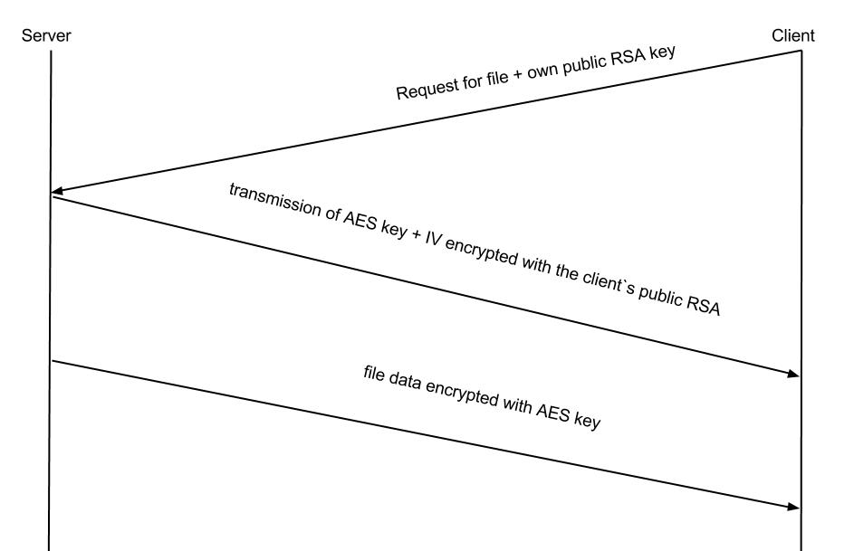
Figure 1: Secure sharing of the symmetric AES key between server and client.

4 Implementation
The server and client programs are implemented in Python 2.7.6 using cryptographic algorithms provided by the PyCrypto toolkit and the socket module that python offers by starting the script with 'import socket'.
The server is started with a file name as argument and starts listening for connections. The client connects to the server, and sends a request, as well as sending its public-key.
The server implementation is currently not flexible with regards to choosing port, and the client will only send requests to “localhost:50000”. The client is not able to request specific files, as it will be served the file that the server received as start up argument. Most of the implementation is a happy-path implementation, but does handle errors when establishing connections with the client.

5 Discussion

5.1 Part A
This CBC-mode works on fixed-sized blocks, which in this implementation is set to be 16 bytes. A disadvantage of using CBC is that padding must be applied to make sure every block is equal in size, in this case 16 bytes.

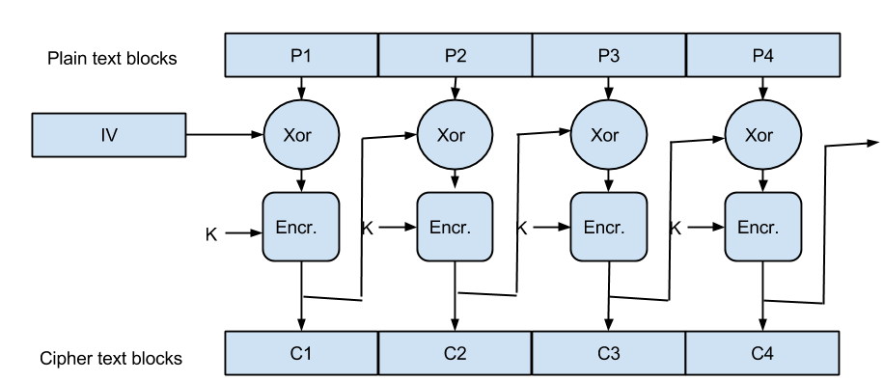
Figure 2: AES with mode cipher-block chaining.

In CBC-mode a plain text block and an initialization vector is exclusive-Ored, then used as input into the encryption algorithm together with the 128-bit AES key. The strength of this encryption mode is that after the first block which uses IV, the cipher-block from the previous block is used instead and thereby ⊕ with the current plain text block( for example plain text block P2). A dependency is present in the encryption process because it always needs to know the cipher-block of the previously encrypted plain text block(except the very first block), therefore cipher-block chaining mode encryption can not be executed in parallel, but CBC-mode decryption can, because the cipher text blocks are immediately available[7].

5.2 Part B

The two important security triads are: C.I.A and A.A.A:

In the context of the file server implemented in part A, threats that can occur is discussed in order to see which of the two triads` principles are being attacked.

Since the server is transmitting data to the client, an attack on confidentiality could occur while the data is being transmitted. For example in the case of an eavesdropper that gain access to data that might be sensitive and personal, like extracting personal information like someone’s credit card number or social security number. Secondly an attack on confidentiality would be if the server has no way of restricting access and a client gains access to files that are either not meant to be served or gains access to files that belong to other clients. Key words: access control and authorization.

if the data is manipulated or tampered with as well, this also becomes an attack on the integrity of this data.

If our file server in part B was extended into serving thousands of clients, with a huge database storing files, attempts by an attacker to crash the server, would become an attack on availability. This could be because an attacker had already successfully read or gained access to what he was looking for originally, therefore damaging the availability could potentially make it difficult to find out which file or customer that was the target(had his or her information stolen for example). This is because it would make the investigation of who was responsible more difficult and maybe even who was the target.

Alteration attack
Man-in-the-middle attacks that modify a file while in transmission between file server and client, for example injecting viruses or spyware into a file that seems completely normal in the case of an executable file. But any tampering with the original file is considered to be an attack on integrity, because the receiving client might not have a clue that what he or she received is in fact not the original version of the file. This is an attack on integrity.

Denial-of-Service attack
attempts to crash servers and affect the important files of users(denial-of-service)

6 Conclusion

7 References

[1] Frederic P. Miller, Agnes F. Vandome, and John McBrewster. 2009. Advanced Encryption Standard. Alpha Press.

[2] Bendersky, Eli. AES encryption of files in Python with PyCrypto. Web. 20 Sep. 2014
<http://eli.thegreenplace.net/2010/06/25/aes-encryption-of-files-in-python-with-pycrypto/>

[3] Goodrich, Michael, and Tamassia Roberto. Introduction to Computer Security.
Pearson Education Limited, 2011. Print. pp. 2-45

[4] Litzenberger, Dwayne. Python Cryptography Toolkit(pycrypto). Web. 21 Sept. 2014.
< https://pypi.python.org/pypi/pycrypto />.

[5] Wikipedia contributors. "Block cipher mode of operation." Wikipedia, The Free Encyclopedia. Wikipedia, The Free Encyclopedia, 24 Sep. 2014. Web. 29 Sep. 2014.

[6] Kaminsky, Alan. “How Does Your PC Talk to a Secure Web Site?”.
30 june 2010. Rochester Institute of Technology – Department of Computer Science.
29 September 2014. < http://www.cs.rit.edu/~ark/lectures/https02/https.shtml />

[7] Dworkin, Morris. Recommendation for Block Cipher Modes of Operation. N.p.: National Institute of Standards and Technology, 2001. Web. 02. Oct. 2014.

