Overview
Seize the Day is a game of battles for two players. Each player commands an army, moving units across a tabletop battlefield and using dice to resolve shooting and close combat.
You do not need to collect miniatures or prepare an army beforehand. The units are represented by cards, which act as both playing pieces and reference cards. At the start of the game, you take turns choosing these units and placing terrain, creating your armies and battlefield together.
During the game, you move and turn your unit cards to outmanoeuvre the enemy. Good positioning matters: you can gain an advantage by attacking from the flank, holding useful terrain, or staying outside an enemy’s reach.
The game is played over a series of rounds. At the start of each round, both players secretly bid for control of the turn order. A lower bid gives you more control over who acts when, but a higher bid lets you command more units. You must decide which matters more each round.
You win if half your opponent’s units route, when his or her leader routes, or when your leader reaches your opponent’s camp. The rules are deliberately simple and abstract, focusing on the key decisions of a tabletop battle rather than detailed simulation.

Components
24 unit cards
12 terrain tiles
24 strain markers
12 command markers
1 measuring stick
10 six-sided dice
2 overview cards
2 Leader markers
2 Camp cards

Unit basics

Fronts and flanks
A unit’s front consists of its front edge and two front corners. Every other part of the card - both side edges, both rear corners and the rear edge - is its flank.
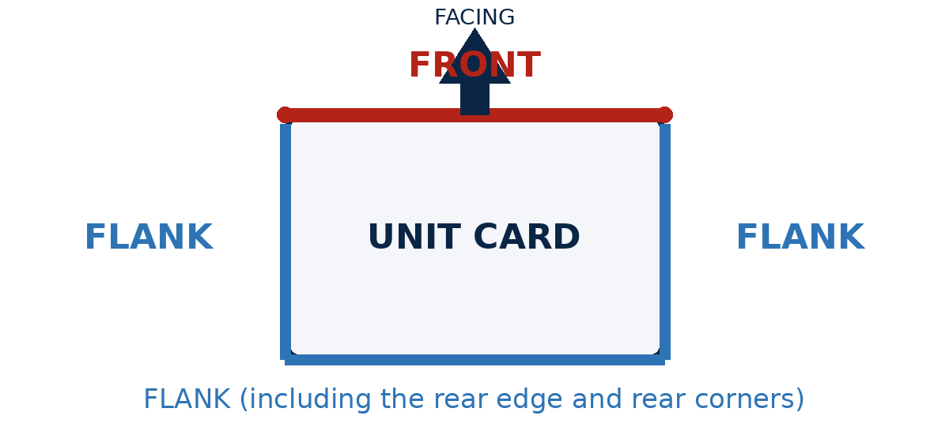
Figure 1. A unit's front and flank
A unit can touch an enemy’s flank and front corner at the same time. This still counts as touching its flank.

Stats
Pace: How far the unit can move in inches.
Mobility: How many times it can pivot. High Mobility units are also flexible enough to evade missile fire.
Melee: How well it fights in hand-to-hand.
Shoot: How well it shoots.
Range: How far it can shoot in inches.
Defence: How hard it is to attack. Low Defence units can also move fast in slowing terrain.
An asterisk beside a Melee or Shoot value means that attack is armour-piercing.

Setup

Prepare the battlefield
A space 4 feet wide by 3 feet deep works best.
Sit opposite your opponent, each at one long table edge.
Place a camp card in the middle of your edge.
Each deployment zone runs along one player's table edge, and extends 6 inches toward the centre. This leaves a 24-inch gap between the two zones. If you’re playing on a larger surface, just make sure there are as close to 24 inches between the zones as possible, and that they’re as deep as each other.

First game
For your first game, you can use the prepared armies and battlefield below instead of drafting units and placing terrain. Choose a random player to count as having picked first. Otherwise, continue with Prepare the Draft Pool.

Prepare the draft pool
- Choose 12 unit cards at random and place them at random face up in an evenly spread-out 4 x 3 grid between the deployment zones. No card may touch a deployment zone.
- Shuffle the terrain tiles into a face-up stack, randomizing which face of each tile is uppermost. Players may see the top tile but not the tiles beneath it.
- Randomly choose the player to pick first in the draft.
If you have miniatures, feel free to place them on the cards, choosing the 12 units freely, instead of randomly, to suit your collection.

Draft units and place terrain
Players alternate picking a unit. When it’s your turn to pick, complete these steps in order:
- Choose a unit. Select one unit card from the draft pool. Leave it in place for now.
- Draw terrain. Take the visible top terrain tile without flipping it over.
- Place or discard the tile. If the tile shows a terrain feature, place it so that it overlaps the chosen unit card and touches no terrain tile, deployment zone or the battlefield’s edge. Rotate it as you like. It may overlap undrafted units, just place those units on top in the same position they were in. If it shows only open ground, return it to the box. If you can’t legally place the tile, return it to the box.
- Deploy the unit. Place the chosen unit completely within your deployment zone, facing in any direction. It can’t overlap another unit or impassable terrain.
- The first unit you deploy is your leader. Mark it with a leader marker.
The other player then takes a draft turn. Continue until all 12 units have been deployed.
Unit cards are double-sided; the two sides differ only in appearance. One player uses the dark side of every unit and the other uses the light side.
TODO: Example

Winning the game
You win when any of these is true:
- half or more, rounded up, of your opponent’s starting units have routed
- your opponent’s leader has routed
- your leader touches your opponent’s camp

Round sequence
Play rounds until a player wins. Each round has three parts: bid for Master Tactician, command units, then clean up.

Bid for Master Tactician
The Master Tactician controls the timing of the round, but usually commands fewer units.
- Secretly choose a bid from 1 up to how many units you have on the battlefield. Set a die to your bid and cover it with your hand.
- Reveal both bids at the same time.
- Take command markers equal to your bid.
- The player with the lower bid becomes the Master Tactician for this round.
- If the bids tie, the previous round's Master Tactician keeps the title. In the first round, the player who picked second during the draft wins a tied bid.
Example: Brian secretly sets a die to 4, Irina secretly sets one to 2. They reveal them at the same time. Brian gets 4 command markers, Irina 2. Irina becomes the Master Tactician.

Command units
Players spend command markers to activate units in this order:
- The Master Tactician activates units one at a time, deciding after each activation whether to activate another unit or pass. They may also pass before activating any units.
- The other player then activates units in the same way.
- When that player passes, the Master Tactician may resume activating units. When the Master Tactician passes again, the command phase ends and any unspent command markers are lost.

Measuring, stating intentions and resolving disputes
You may measure distances and check lines of sight at any time. When you move a unit, state your intended result so that disagreements can be resolved before the position becomes difficult to reconstruct. For example:
- I will move my archers here, where they’ll have a clear shot at your spearmen and remain outside your cavalry's charge range.
- I will pivot my swords to protect their flank from your cavalry.
- I will leave my fanatics 6 inches from your Heavy Infantry, so I can charge next round but you can’t charge me.
If you can’t resolve a dispute, roll a die to determine who’s right.
You can use your overview cards to work out hypothetical moves before making them.

Activating Units
To activate a unit:
- Choose one of your units that does not have a command marker. Place an unspent command marker on it. The marker is now spent.
- The unit may take one Move, Shoot, Strike, Pivot or Rally action.
- During its activation (even if it forgoes its action, the unit may make a number of pivots up to its Mobility.
The unit may make each of its Mobility pivots before or after its action. During a Move, it may make them at any point, as described below.
A unit can never overlap or pass through another unit, impassable terrain or the battlefield’s edge and can’t make contact with an enemy except by charging.

Pivot
The unit makes one pivot. This pivot does not use any of the pivots granted by its Mobility.
TODO Example

Pivoting
Whether as an action or from Mobility, each pivot turns the unit by up to 90 degrees around its centre.
Units can’t pivot while touching an enemy and can’t pivot into contact with a new enemy. Pivots may not sweep through units, impassable terrain or the battlefield’s edge.

Actions

Move
A unit touching an enemy can’t move. The Master Tactician ignores this restriction.
When a unit moves, choose whether it will move forwards up to its Pace in inches or backwards up to half its Pace in inches. It can’t change direction during the same Move.
As well as before and after, it may also perform Mobility pivots during its Move. If it does, it then continues along its chosen direction relative to its new facing.
Unit’s can’t move through units, impassable terrain or the battlefield’s edge.

Charging
A forward move that brings a unit into contact with one or more enemies is called a charge. The unit may perform Mobility pivots before it begins moving, but must then move straight forwards without pivoting. A unit can’t make contact with an enemy in any other way.
When the unit moves into contact with one or more enemies:
- its movement ends,
- it may not pivot and
- it may strike as a bonus action.
TODO: Example

Shoot
Only a unit with a Shoot value may take the Shoot action. It can’t shoot if it’s touching an enemy.
To shoot:
- Select one enemy that is not touching any of your units.
- To shoot, both of the following must be true:
  - Range - The distance between the two closest points of the shooter and the target can’t be longer than the shooter’s range.
  - Line of Sight - No line from the centre of the shooter’s front edge to the target passes through the shooter, another unit or concealing terrain before reaching the target. (The target can’t be blocked at all).

Pivot
Units touching an enemy can’t pivot.
The unit makes one pivot, as described above. This does not use any of the pivots allowed by its Mobility.
TODO: Example

Strike
Choose one enemy any part of your unit is touching and make an attack roll against it using your unit’s Melee stat.

Rally
If the unit has any strain, reduce its strain by one.

Attack rolls
Resolve shots and strikes as follows:

Build the attack pool
- Begin with a number of dice equal to the attacker's relevant stat.
- Apply every relevant combat modifier below. Add that many dice for positive modifiers and remove that many for negative ones.
- If the final pool would contain fewer than one die, roll one die instead.

Apply combat modifiers

Outflanking
A unit is outflanking an enemy if it is touching the enemy’s flank without touching any other enemy.
- The target is outflanked: +2
- The attacker is outflanked: -2
The outflanking unit need not be the attacker or the defender. The modifier applies once, however many flankers there are.

Height
- The attacker is higher than the target: +1
- It is lower: -1
If the attacker charged this round, use its height at the start of its move.

Evasion
- Shooting at a target with Mobility 3 or greater: -3

Initiative
- Striking a target that does not have a command marker: +1

Roll to attack
Roll the final attack pool. Each result equal to or greater than the target's Defence gives the target one strain.

Armour-piercing
If the stat used for the attack has an asterisk, instead the target number is the lower of the target’s Defence and 3.

Critical Hits
For each 6 rolled, as well as dealing strain, roll an additional attack die against the same target number. Additional dice can also generate additional dice, for potentially infinite strain.

Apply Strain and rout units
Track each unit’s strain with strain markers.
If a unit has seven or more strain, it routes and is immediately removed from the battlefield, along with any markers on it.
TODO: Example

Terrain
A unit is in a terrain feature if any part of its card overlaps the printed image of that feature. The grassy part of a terrain tile counts as open terrain, and has no effect on movement or line of sight.

Terrain traits

Impassable
Units cannot overlap or pass through impassable terrain while moving or pivoting.

Concealing
Concealing terrain blocks line of sight.

TODO: Several examples

Slowing
A Move that overlaps slowing terrain at any point is limited to 4 inches. This can make entering slowing terrain impossible, if the unit has already moved more than 4 inches.

TODO: Example

Elevated
Elevated terrain blocks line of sight unless the shooter or target is in it. A shooter in elevated terrain can trace line of sight over intervening units.

Sample terrain
Hill: Elevated.
TODO: Example
Forest: Concealing; Slowing.
Mountain: Concealing; Impassable.
Swamp: Impassable.
Field: Slowing.

