SEIZE THE DAY

Overview
Seize the Day is a game of small battles for two players. Each player commands an army, moving units across a tabletop battlefield and using dice to resolve shooting and close combat.
You do not need to collect miniatures or prepare an army beforehand. The units are represented by cards, which act as both playing pieces and reference cards. At the start of the game, you take turns choosing these units and placing terrain, creating your armies and battlefield together.
During the game, you move and turn your unit cards to outmanoeuvre the enemy. Good positioning matters: you can gain an advantage by attacking from the flank, holding useful terrain, or staying outside an enemy’s reach.
The game is played over a series of rounds. At the start of each round, both players secretly bid for control of the turn order. A lower bid gives you more control over who acts when, but a higher bid lets you command more units. You must decide which matters more each round.
You win as soon as your opponent has only half of their starting units remaining. The rules are deliberately simple and abstract, focusing on the key decisions of a tabletop battle rather than detailed simulation.

Components
24 unit cards
12 terrain tiles
24 wound markers
12 command markers
1 measuring stick
10 dice
2 overview cards

Unit basics

Fronts and flanks
A unit card has a front and a flank. Its front consists of its front edge and two front corners. Every other part of the card - both side edges, both rear corners and the rear edge - is its flank.
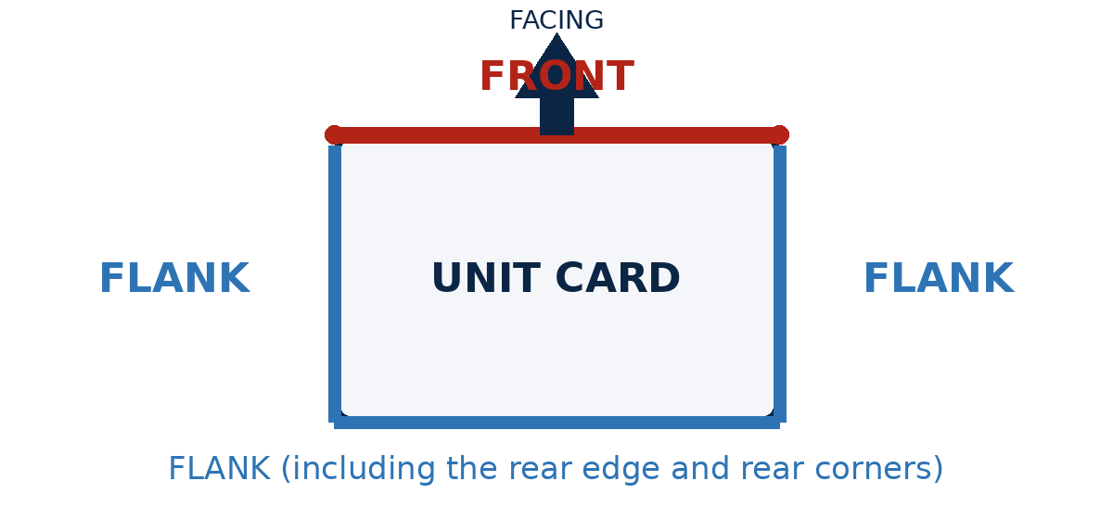
Figure 1. A unit's front and flank

Stats
A unit's stats are printed along its rear edge - the edge opposite its front.
Speed: First movement number. How far the unit can move.
Drill: Second movement number. How often it can pivot.
Strike: How well it attacks in hand to hand combat.
Shoot (first number): How well it shoots.
Shoot (second number): How far it shoots.
Defence: How hard it is to wound. Every unit dies when it takes its 7th wound.
An asterisk beside a Strike or Shoot value means that attack is armour-piercing.

Setup

Prepare the battlefield
A space roughly 4 feet wide by 3 feet deep works best. Small variations do not matter.
Sit opposite your opponent, each at one long table edge.
Each deployment zone runs along one player's table edge. Leave a 24-inch gap between the two zones. On a 3-foot-deep battlefield, the zones will each be about 6 inches deep.

Prepare the draft pool
- Choose 12 unit cards at random and place them face up in a spread-out 4 x 3 grid between the deployment zones. No card may touch a deployment zone.
- Shuffle all terrain tiles into a deck, randomizing which side of each tile faces up.
- Randomly choose the first player in the draft.
If you have miniatures, feel free to place them on the cards, choosing the 12 units freely, instead of randomly. to suit your collection.

Draft units and place terrain
Players alternate draft turns. On your draft turn, complete these steps in order:
- Choose a unit. Select one unit card from the draft pool. Leave it in place for now.
- Draw terrain. Take the top terrain tile without flipping it over.
- Place or discard the tile. If the tile shows a terrain feature, place it so that it touches the chosen unit card and overlaps no unit card or terrain tile. If it shows only open ground, return it to the box.
- Deploy the unit. Move the chosen unit into your deployment zone. The whole unit card must be inside the zone.
The other player then takes a draft turn. Continue until all 12 units have been deployed. Each player will normally begin with six units.
Unit cards are double-sided; the two sides differ only in appearance. One player uses the dark side of every unit and the other uses the light side.

First game
In your first game, you might not know enough to draft well, so consider using this set up instead.

Winning the game
You win immediately when your opponent has half or fewer of their starting units remaining. In a standard game, a player starts with six units and loses as soon as only three remain.

Round sequence
Play rounds until a player wins. Each round has three parts: bid for Master Tactician, command units, then clean up.

Bid for Master Tactician
The Master Tactician controls the timing of the round, but usually commands fewer units.
- Secretly choose a number from 1 up to the number of units you currently have. Show the number on a die and cover it with your hand.
- Reveal both bids at the same time.
- Take command markers equal to your bid.
- The player with the lower bid becomes the Master Tactician for this round.
- If the bids tie, the previous round's Master Tactician keeps the title. In the first round, the player who picked second during the draft wins a tied bid.

Command units
Players spend command markers to activate units in this order:
- Master Tactician spends any number of his or her commands, including zero.
- Other player spends all of his or her commands.
- Master Tactician spends all of his or her remaining commands, if any.

Clean up
- Remove all command markers from units.
- Discard any unusable commands if no eligible unit remains to receive them.

Measuring and stating intentions
You may measure distances at any time. State your intended result while moving a unit so that disagreements can be resolved before the position becomes difficult to reconstruct. For example:
- I will move my archers here. They will have a clear shot at your spearmen and remain outside your cavalry's charge range.
- I will pivot my swords so they can charge the spearmen's flank next round.
- I will leave my fanatics 6 inches from your Heavy Infantry, so I can charge next round but you cannot charge me.

Activating Units

Activation Sequence
To activate a unit:
Choose a unit
Choose one of your units that has not activated this round. Place an unspent command marker beside it.
Pivot before acting
The unit may make any pivots allowed by its Drill.
Take an action
The unit may take one action:
- Move, or
- Shoot.
The unit may choose not to take an action.
Pivot after acting
The unit may make any remaining pivots allowed by its Drill.
Strike
If the unit is touching one or more enemies, it may Strike one of them.

Actions

Move
Your unit can’t move if it is touching an enemy’s front, unless you are the Master Tactician.
When a unit takes the Move action, choose one:
- Move it straight forward by up to its Speed in inches.
- Move it straight backward by up to half its Speed in inches.
A unit cannot overlap a unit or impassible terrain at any point during its move.
A unit can make contact with an enemy only while moving forward.

Shoot
Your unit can’t shoot if it’s touching an enemy.
Only a unit with a Shoot value may take the Shoot action.
To shoot:
- Select one enemy that is not touching any of your units.
- At least part of the target must be inside the shooter’s firing lane.
- No unit or concealing terrain may lie even partially within the firing lane between the shooter and the target.
- Make a shooting attack roll using the shooter’s Shoot value.

Firing lane
A unit's firing lane is an imaginary rectangle directly in front of it. The lane is as wide as the unit's front edge and as long as its Range. At least part of the target card must be inside this rectangle.

Clear shot
The shot is not allowed if part of any other unit or concealing terrain feature lies inside the firing lane between the shooter and the target. Elevated units may ignore some intervening units; see Elevated Terrain.

Pivoting
Your unit can’t pivot if it’s touching an enemy’s front, unless you are the Master Tactician.
Each pivot turns the unit by up to 90 degrees around the centre of its card.
A unit may make each of its allowed pivots either before or after its action (even if it chooses to do nothing).
While pivoting, the unit’s card may sweep across units and impassable terrain. It must be wholly clear when the pivot ends.
A unit’s Drill determines how many times it may pivot during its activation.
- Drill 0: Pivot once, but only if it doesn’t move as its action.
- Drill 1+: Pivot that many times.

Strike
At the end of its activation, a unit touching one or more enemies may Strike one of them.

Attack rolls
Resolve shooting and strike attacks in five steps.

Build the attack pool
- For a strike, begin with a number of dice equal to the attacker's Strike value.
- For a shot, begin with a number of dice equal to the attacker's Shoot value.
- Apply every relevant combat modifier. Add dice for positive modifiers and remove dice for negative modifiers.
- If the final pool would contain fewer than one die, roll one die instead.

Apply combat modifiers

Outflanking
A unit is outflanking an enemy if it’s touching its flank and is touching no enemy’s front.
For each unit outflanking the target: +1

Height
The attacker is higher than the target: +1
If the attacker moves this activation, use its height at the start of its move.

Disruption
For each wound the attacker has suffered this round: -1

Roll to wound
Roll the final attack pool. Each die result equal to or greater than the target's Defence causes one wound.
- Armour-piercing. If the Strike or Shoot value used for the attack has an asterisk, every result of 3 or more causes a wound instead of using the target's Defence.
- Critical hits. For every unmodified roll of 6, roll one additional attack die. Each additional die can also generate another die on an unmodified 6, so critical hits can chain without limit.

Apply wounds and destroy units
Place one wound marker on the target for each wound it suffers. If a unit ever has seven or more wounds, it is destroyed immediately and removed from the battlefield.
Track current-round wounds: Disruption counts only wounds suffered during the current round. Keep those markers grouped or offset to distinguish them from older wounds.

Terrain
A unit is in a terrain feature if any part of its card overlaps the printed image of that feature. The blank part of a terrain tile does not count as terrain.

Terrain traits
Impassable: Units can’t overlap this.
Concealing: Blocks shots when in the firing lane.
Slowing: A unit in the feature cannot move more than 3 inches during the current round. This can prevent a unit that has already moved more than 3 inches from entering. Units with Defence 3 or lower ignore this trait.
Elevated: A unit in the feature is higher than a unit that is not. If both units are in the same elevated feature, the unit nearer the crest is higher. When checking whether a higher shooter has a clear shot at a lower target, ignore intervening units that are lower than the shooter. Do not ignore intervening terrain.

Sample terrain
- Hill: Elevated; Concealing; Defensible against attacks from lower ground.
- Forest: Concealing; Slowing; Defensible against attacks made from outside the forest.
- Mountain:Concealing; Impassable.
- Swamp: Impassable.
- Field: Slowing.

