# Lab: Functions

Problems for in-class lab for the ["Technology Fundamentals" course @ SoftUni](https://softuni.bg/modules/57/tech-module-4-0).

Submit your solutions in the SoftUni judge system at: [Functions -Lab](https://judge.softuni.bg/Contests/1230/Functions-and-Forms-Lab)

## Car Tax Calculator

Write a function that **receives a power** in kWof car's**,** and **prints** the tax you have to pay in lv.

* under 37 kW - 0.43 lv./kW
* 37.01 – 55 kW - 0.50 lv./kW
* 55.01 – 74.00 - 0.68 lv./kW
* 74.01 – 110.00 - 1.38 lv./kW
* up 110.00 - 1.54 lv./kW

### Examples

|  |  |
| --- | --- |
| **Input** | **Output** |
| 57.50 | 39.10 lv. |
| 90 | 124.20 lv. |
| 255.9 | 394.09 lv. |

### Hint

Receive the power in kW from the console and pass it to a function

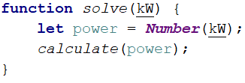

Then create the method and make the if statements for each case

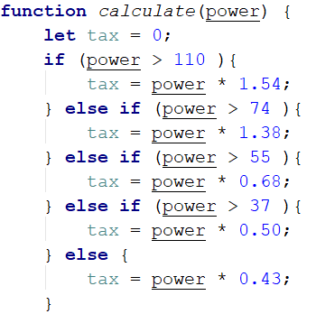

## Car Tax Calculator II

Add a new tax calculation function to the previous code, according to the age of the vehicle. Second parameter is a **car age**. Multiply by tax on the previous task. The coefficient depends on the age of the vehicle as follows. Print the result.

* under 5 year - 2.80
* 5 – 14 year - 1.50
* up to– 14 - 1.00

### Example

|  |  |
| --- | --- |
| **Input** | **Output** |
| 45  10 | 33.75 lv. |
| 90  7 | 186.30 lv. |
| 310  0.5 | 1336.72 lv. |

### Hints

Receive two parameters, and then make an additional function to calculator.

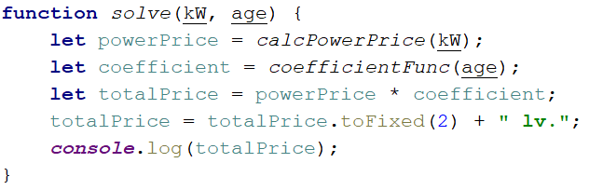

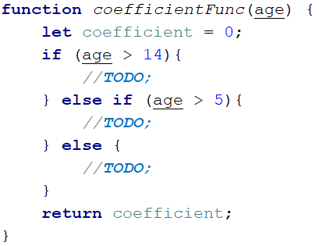

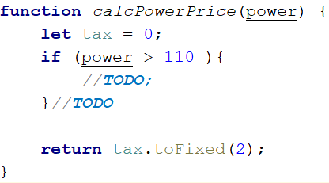

## Car Tax Calculator III

Add a new functionality to the calculator for the **motorcycle tax**. First parameter is **type** of vehicle, second is for **volume** (for motorcycle's engine) or **power** (for the car's engine). Third is for **years** like second task.

### Examples

|  |  |
| --- | --- |
| **Input** | **Output** |
| 'motorcycle'  450  10 | 63.00 lv. |
| 'car'  90  7 | 186.30 lv. |

### Hints

1. You can use a function with parameters of functions (nested functions).

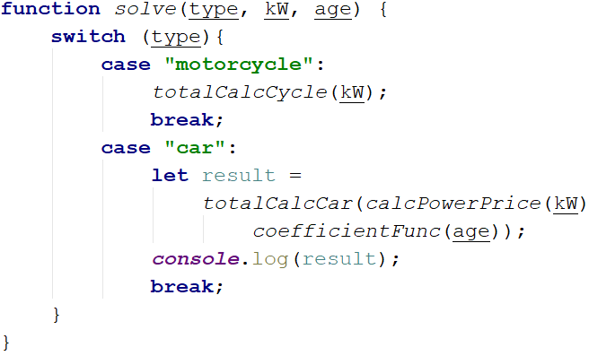

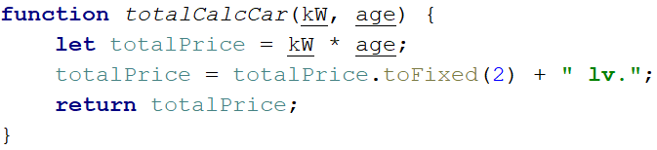

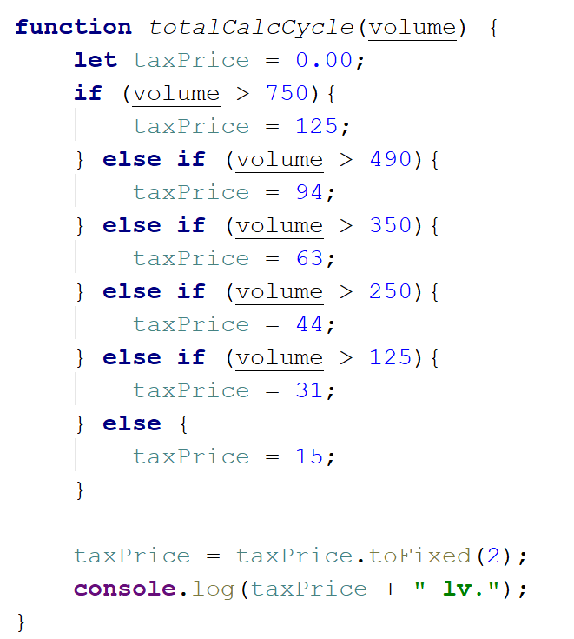

Write the rest of the functions

## Simple Calculator

Write a function that **receives three parameters** and write an arrow function that calculate result depending of operator. Operator can be 'multiply', 'divide', 'add', 'subtract'.

The input comes as parameters named **numOne, numTwo, operator**.

|  |  |
| --- | --- |
| **Input** | **Output** |
| 5  5  'multiply' | 25 |
| 40  8  'divide' | 5 |
| 12  19  'add' | 31 |
| 50  13  'subtract' | 37 |

### Hints

Use switch statements for the different operators

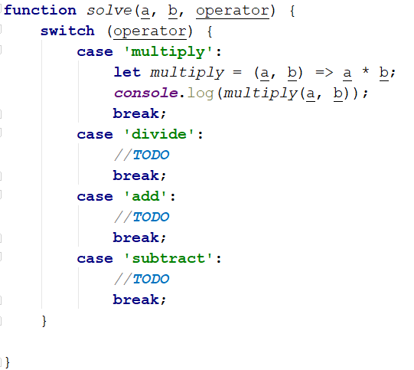

## Wrong Result

You are given a JS function, that calculate the result of **numOne * numTwo * numThree** (the product) is **negative** or **positive**. Try to do this **WITHOUT** multiplying the 3 numbers.

The input comes as parameters named **numOne * numTwo * numThree**.

### Example

|  |  |
| --- | --- |
| **Input** | **Output** |
| 5  12  -15 | Negative |
| -6  -12  14 | Positive |
| -1  -2  -3 | Negative |
| -1  0  1 | Positive |

### Hints

Check all the different variantions for the three numbers

