Optimization

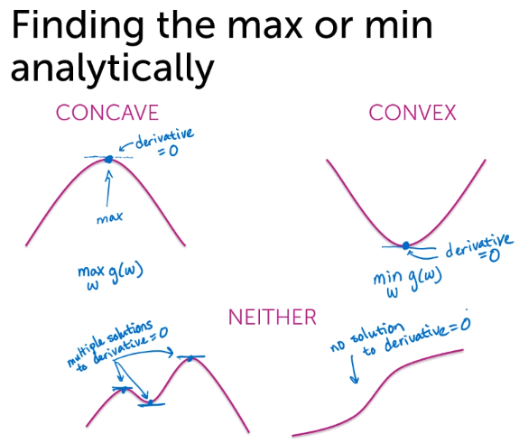

* Finding max/min:
  + Approach 1 - First order derivative = 0
    - For convex or concave functions, can take first order derivative that equals to zero and find unique solution
    - In reality we might have various local maximums/minimums
  + Approach 2 – hill climbing
    - If derivative>0, move to the left. If derv<0, move to right. If der=0 (or close to 0), stop!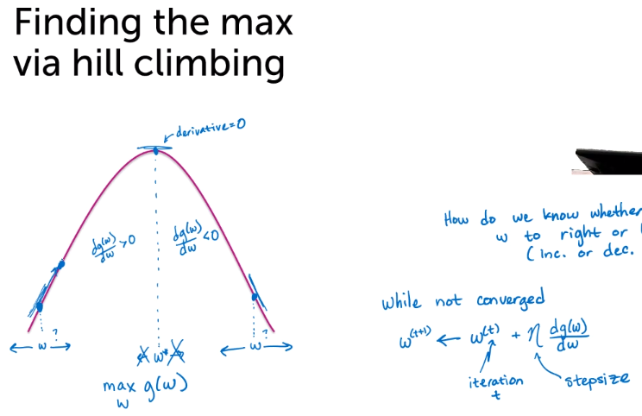
    - 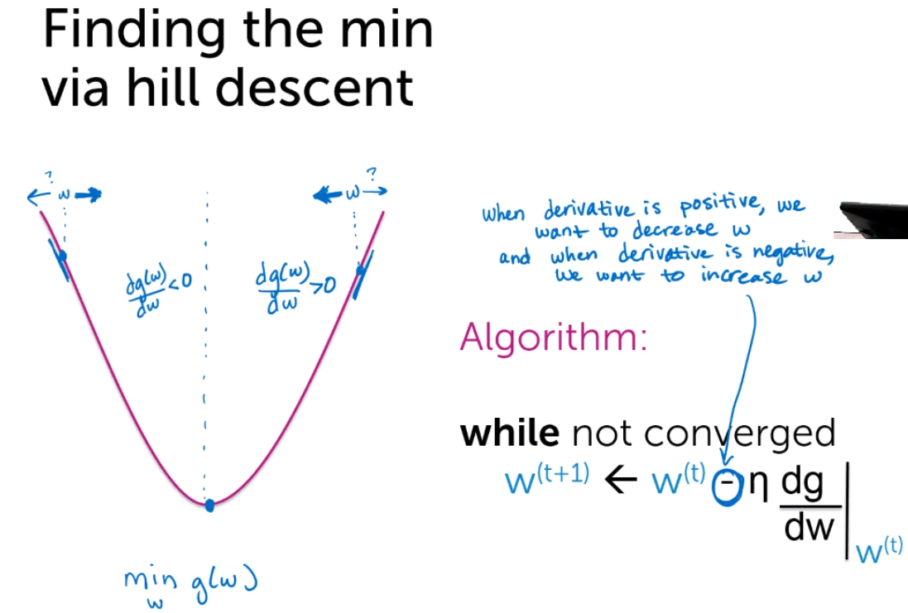
* Gradient – similarly to hill climbing, but for multiple dimensions. We calculate partial derivatives of cost function with respect to each coefficient (dimension). Vector of all these derivatives shows whether we will increase or decrease cost function and how much
  + - 
     