Article
Digital Soil Mapping of the Steppe Zone of Northern Kazakhstan: Relationships Between Agrochemical Soil Properties and Multimodal Remote Sensing Data—Systematic Screening of 512 Features with Emphasis on 140 Spectral Indices Across Four Seasonal Configurations and Their 110 Composites
Aliya Yskak ¹, Seitbek Kuanyshbayev ¹, Zhumash Bekmyrza ^{1,}*, Gulnaz T. Yermoldina ¹, Almabek B. Nugmanov ¹, Vladimir D. Fominov ^{1,}*, Zhanna B. Suimenbayeva ¹, Zhassulan B. Irzhanov ¹, Petr Lyanga ¹, Kuanysh Zhumalynov ¹, Aleksandr G. Bulaev ²

Academic Editor: Firstname Lastname
Received: date
Revised: date
Accepted: date
Published: date
Copyright: © 2026 by the authors. Submitted for possible open access publication under the terms and conditions of the Creative Commons Attribution (CC BY) license.
¹ Akhmet Baitursynuly Kostanay Regional University, 47A Baitursynov str., Kostanay 110000, Kazakhstan;
alia-almaz@mail.ru (A.Y.); seitbek_b@ksu.edu.kz (S.K.); 5112431@mail.ru (Zh.B.); gulnazyermoldina@gmail.com (G.T.Y.); almabek.nugmanov@bk.ru (A.B.N.); vladimirfominov49eng@gmail.com (V.D.F.); zhannaspace@gmail.com (Z.B.S.); jayzikskif@gmail.com (Z.B.I.); sadhgy19@gmail.com (P.L.); zhumalynov.k@mail.ru (K.Z.)
² Research Center of Biotechnology, Russian Academy of Sciences, 7/2 60-letiya Oktyabrya Ave.,
117312 Moscow, Russia; bulaev.inmi@yandex.ru (A.B.)
* Correspondence: 5112431@mail.ru (B.Zh); vladimirfominov49eng@gmail.com (F.V.)
Abstract
For rational monitoring of soil fertility over vast territories, it is necessary to understand which soil properties are actually reflected in satellite data and which spectral configurations carry the greatest information. Such a systematic analysis has not been previously conducted for the steppe zone of Central Asia. In the present work, the relationships between six agrochemical properties of the arable horizon (pH, SOC, NO3, P2O5, K2O, S) and 512 features extracted from multimodal satellite data (Sentinel-2, Landsat-8, Sentinel-1 SAR, SRTM, ERA5-Land) were investigated. The central element of the work is a systematic screening of 140 base spectral features of Sentinel-2 and Landsat-8 (10 bands and 7 indices of S2 + 6 bands and 3 indices of L8, multiplied by four phenological windows: spring, summer, late summer, autumn), extended through 100 engineered features (PCA, normalised differences, band ratios), 100 temporal statistics, 64 multi-seasonal deltas, and 110 composite configurations (48 inter-index, 42 multi-seasonal, 20 normalised band differences). The sample comprised 1,085 specimens from 81 fields across 20 farms in Northern Kazakhstan (2022–2023). Main results. A hierarchy of predictability was established: pH (|ρ| = 0.670 with GNDVI_L8,spring) ≫ P2O5 (0.525, GLCM entropy of the Red band in autumn) > K2O (0.478, BSI_spring) > NO3 (0.431, SAVI_spring) > S (0.383, SAVI_late-summer) > SOC (0.368, slope). The informativeness of spectral indices depends significantly on the season of acquisition: spring composites (bare soil) are statistically significantly more informative than summer ones for K2O (Wilcoxon test, p < 10⁻⁴, 26/26 indices) and P2O5; summer indices dominate for NO3 at peak vegetation. Of the 110 composite configurations, only one — GNDVI×BSI_spring for K2O (ρ = −0.488 vs −0.478 for single BSI, Δ|ρ| = +0.010) — robustly outperformed its best single counterpart. For NO3 (GNDVI−NDRE: −0.416) and S (mean_NDVI: +0.360) the composites approached the singles (ρ_SAVI = −0.431 and +0.383, respectively) but did not surpass them, indicating saturation of the informativeness of simple indices. Spatial analysis revealed that properties with zonal control (pH, SOC, K2O; ICC 0.54–0.71) are characterised by a pronounced spatial structure (Moran I = 0.51–0.86) and are accessible for satellite prediction, whereas available sulfur is practically unpredictable (ICC = 0.17, I_declustered = 0.15). It was also established that pH mediates about 42% of the observed SOC–NDVI correlation, which requires acidity control when modeling organic carbon via vegetation indices. The obtained estimates of the predictability hierarchy, seasonal modulation of informativeness, and the inventory of informative composite configurations form an empirically grounded basis for building predictive models of soil properties in the steppe zone.
Keywords: correlation analysis; remote sensing; spectral indices; spatial autocorrelation; Moran’s I; variance decomposition; confounding; soil physicochemical properties; Chernozems; Sentinel-2; Northern Kazakhstan

1. Introduction
Agricultural soils are the foundation of food security. Their degradation affects approximately one-third of global land resources [1], with economic losses estimated at billions of dollars annually. Transitioning to precision agriculture requires spatially detailed monitoring of agrochemical properties [2]. However, the traditional approach — soil sampling followed by laboratory analysis — takes 2 to 4 weeks and costs 15 to 50 USD per sample [3]. Across vast territories, this method is impractical for regular monitoring.
Northern Kazakhstan is one of the world's largest grain-producing regions, encompassing over 20 million hectares of arable land [4]. A sharply continental climate, a short growing season, and high soil vulnerability to wind erosion [5] make the region particularly susceptible to degradation. In contrast to the well-studied regions of Europe, China, and South America, systematic studies on the relationship between soil properties and remote sensing (RS) data have rarely been conducted for this territory.
Satellite data reflect soil properties through several physical mechanisms. In the visible and near-infrared (VNIR, 400–1000 nm) spectrum, reflectance depends on organic matter content and iron oxides. The short-wave infrared region (SWIR, 1000–2500 nm) is sensitive to moisture content and clay minerals [6; 7]. The Sentinel-2 [8] and Landsat-8 [9] multispectral systems provide imagery at a 10–30 m resolution every 5–16 days. Sentinel-1 radar data [10] operate independently of cloud cover and carry information about surface dielectric properties. Digital elevation models (Shuttle Radar Topography Mission, SRTM) describe geomorphology, including slope, aspect, and moisture distribution [11]. SoilGrids v2.0 global soil maps [12] and ERA5-Land climate data [13] complement the satellite information with background characteristics.
A number of studies have demonstrated the potential of satellite data for assessing soil properties. For instance, [14] achieved an R² of up to 0.70 for SOC using Sentinel-2 on bare soils in Belgium. [15] demonstrated the feasibility of mapping pH and SOC in France, while a meta-analysis by [16] yielded median R² values of 0.50–0.75 for SOC and pH. In a regional context, [17] mapped SOC and N in the soils of Kazakhstan, albeit with a limited set of covariates. However, several questions issues unresolved. To the best of our knowledge, a systematic multi-source analysis has not yet been conducted for the steppe zone of Central Asia, including chernozems and kastanozems of the sharply continental belt. While most published studies utilize a set of 20–80 covariates, the screening of several hundred multimodal features using diverse satellite platforms remains largely unaddressed. Equally important, the ratio of zonal and local (including anthropogenic) components of spatial variability is rarely quantified. Finally, the prediction of available forms of phosphorus, potassium, and sulfur is significantly less studied compared to SOC and pH.
The objectives of this study were to: (i) identify which of the 140 base spectral features (S2+L8) are the most informative for each of the six soil properties; (ii) quantify how the season of acquisition (spring/summer/late summer/autumn) modulates the informativeness of spectral indices for different properties; (iii) evaluate whether the 110 composite configurations (inter-index, multi-seasonal, normalised band differences) outperform single indices, and for which properties; and (iv) assess which spatial covariates (MAP, latitude) confound the observed relationships and quantify the magnitude of this confounding.
Particular attention is paid to spectral configurations: 140 base spectral features × 4 seasons are complemented by 100 engineered features (PCA, NDI, band ratios) and 110 composite configurations (inter-index, multi-seasonal, normalised differences), which for the first time for the steppe zone of Central Asia allows a quantitative assessment of which spectral data configurations carry the most information about specific soil properties.
Based on the literature, it is expected that (i) properties with pronounced zonal control (pH, SOC) will demonstrate more stable relationships with optical data than properties determined predominantly by anthropogenic factors (S, NO3); (ii) spring composites (bare soil) will be more informative for properties affecting the reflectance of the bare surface (K2O, P2O5), and summer indices — for NO3 at peak vegetation; (iii) composite configurations will give an advantage only for K2O (mineralogical basis), but not for other properties where single indices already capture the dominant physical signal.
In contrast to our previous study [18], which was focused on focusing on spatial validation hierarchy and benchmarking ML and DL architectures, the current manuscript provides the first comprehensive, knowledge-driven exploration of the underlying soil-spectroscopy relationships in the Central Asian steppe. The goal of the present work was to establish the fundamental limits of remote sensing for specific agrochemical properties.

2. Materials and Methods

2.1. Research area
Field sites were distributed across rainfed cropland in three administrative regions of Northern Kazakhstan — Kostanay, Akmola and North Kazakhstan (approximately 50–54° N, 64–72° E; Figure 1). This belt forms part of the historic Virgin Lands (‘Tselina’) zone, which accounts for roughly four-fifths of the country’s arable area and is thus representative of the dryland grain systems addressed in this study.
The regional climate is sharply continental (Köppen Dfb/BSk): mean annual air temperature lies between +0.5 and +3.0 °C and swings across an extreme −40 to +35 °C range, while annual precipitation of 250–400 mm is concentrated (up to ~40%) in June–August. The short 130–150-day growing season accumulates 2,000–2,600 °C·days above 10 °C [19]. Soils are dominated by Haplic and Aridic Chernozems and Kastanozems of medium-to-heavy loam texture, with humus contents of 2–6% and pH spanning 5.3–8.0. Continuous cultivation since the 1954 Virgin Lands campaign has progressively depleted humus and heightened susceptibility to wind erosion.
Topographically the area is a gently undulating plain (180–420 m a.s.l.; slopes 0–3°) on which wind erosion outweighs water erosion. Cropping is dominated by spring wheat, barley and oilseeds, with no-till adoption near 45% (2023). Nutrient management is markedly uneven: nitrogen inputs range from nil to 90 kg ha⁻¹ and phosphorus up to 40 kg ha⁻¹ (active ingredient), with pronounced between-farm heterogeneity — a management mosaic that, as shown below, leaves a strong farm-level imprint on the agrochemical properties screened here.
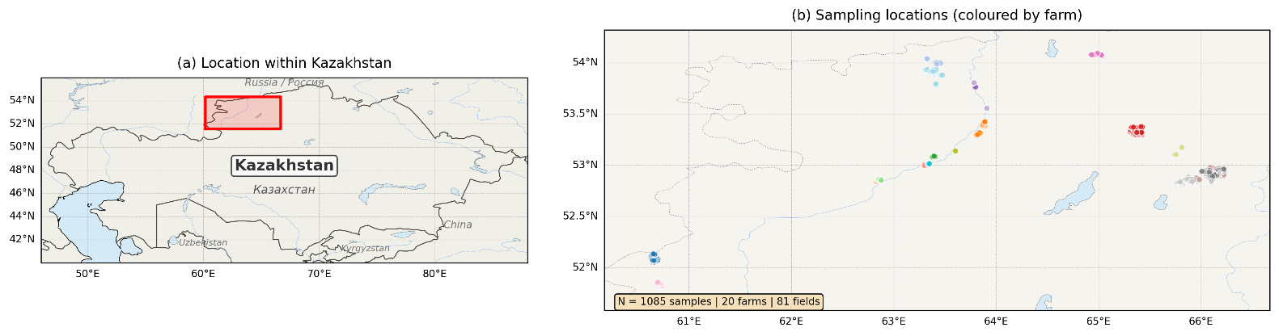
Figure 1. Map of the research area. Northern Kazakhstan (Kostanay, Akmola, and North Kazakhstan regions). Points indicate the locations of the 81 surveyed fields across 20 farms; the symbol size is proportional to the number of samples per field (n = 1085, 2022–2023).

2.2. Soil data
The dataset contained 1,085 topsoil samples (0–25 cm) collected from 20 farms, comprising 81 unique fields, across two field seasons (2022–2023). In 2022, 174 samples were surveyed across 18 fields on 5 farms; in 2023, 911 samples were surveyed across 64 fields on 15 farms (one field was sampled in both years, yielding 18+64-1=81 unique fields). On each field, sampling was performed using a regular grid with a spacing of ~200 m and a buffer of at least 20 m from the boundaries. At each point, a composite sample was collected from 15–20 cores within a radius of ~10 m.
Hierarchical sampling structure. The data had a three-level hierarchical structure: 20 farms ⊃ 81 fields ⊃ 1,085 samples. The number of fields per farm varied from 1 to 17 (median 3.5), and the number of samples per field ranges from 3 to 20 (median 11). This hierarchy dictates the choice of the variance decomposition method (section 2.4.4): grouping by fields isolated within-field variability from between-field variability, while grouping by farms allowed for estimating the scale of between-farm correlation.
Six agrochemical properties were quantified for every sample — pH (KCl), soil organic carbon (SOC), nitrate nitrogen (NO₃), mobile phosphorus and potassium (P₂O₅, K₂O) and available sulfur (S). Collection took place in two campaigns: a spring window (March–May, 817 samples) and a post-harvest window (September–October, 268 samples), so that roughly three-quarters of the dataset reflects bare-soil spring conditions.
Sampling design had the limitation. The 2022 and 2023 samples cover virtually non-overlapping areas (5 vs. 15 farms, 18 vs. 64 fields; with only one shared field). This implies that interannual differences were confounded with spatial variations; therefore, interannual stability tests (Section 2.4.1) should be interpreted with this limitation in mind. Combining data from both years into a single correlation analysis was justified by the uniform methodology of sampling and laboratory analysis; however, it expanded the spatial coverage, which might inflate the observed correlations.
Laboratory determinations were carried out using the following methods:
- pH_{KCl} — potentiometry in 1 M KCl (GOST 26483-85);
- SOC, % — Tyurin method (GOST 26213-91) with van Bemmelen conversion factor: SOC = HU × 0.58 [20];
- NO₃, mg/kg — ionometric determination (GOST 26951-86);
- P₂O₅ and K₂O, mg/kg — Machigin method, 1% (NH₄)₂CO₃ (GOST 26205-91);
- S, mg/kg — turbidimetric determination in KCl extract.
Descriptive statistics for soil agrochemical properties are presented in Section 2.4.1. The Shapiro–Wilk test confirmed the non-normal distribution of all 6 properties (p<0.001), which justifies the use of the non-parametric Spearman rank correlation coefficient (ρ) as the primary statistic for the correlation analysis.

2.3. Methods
The general analysis workflow is shown in Figure 2.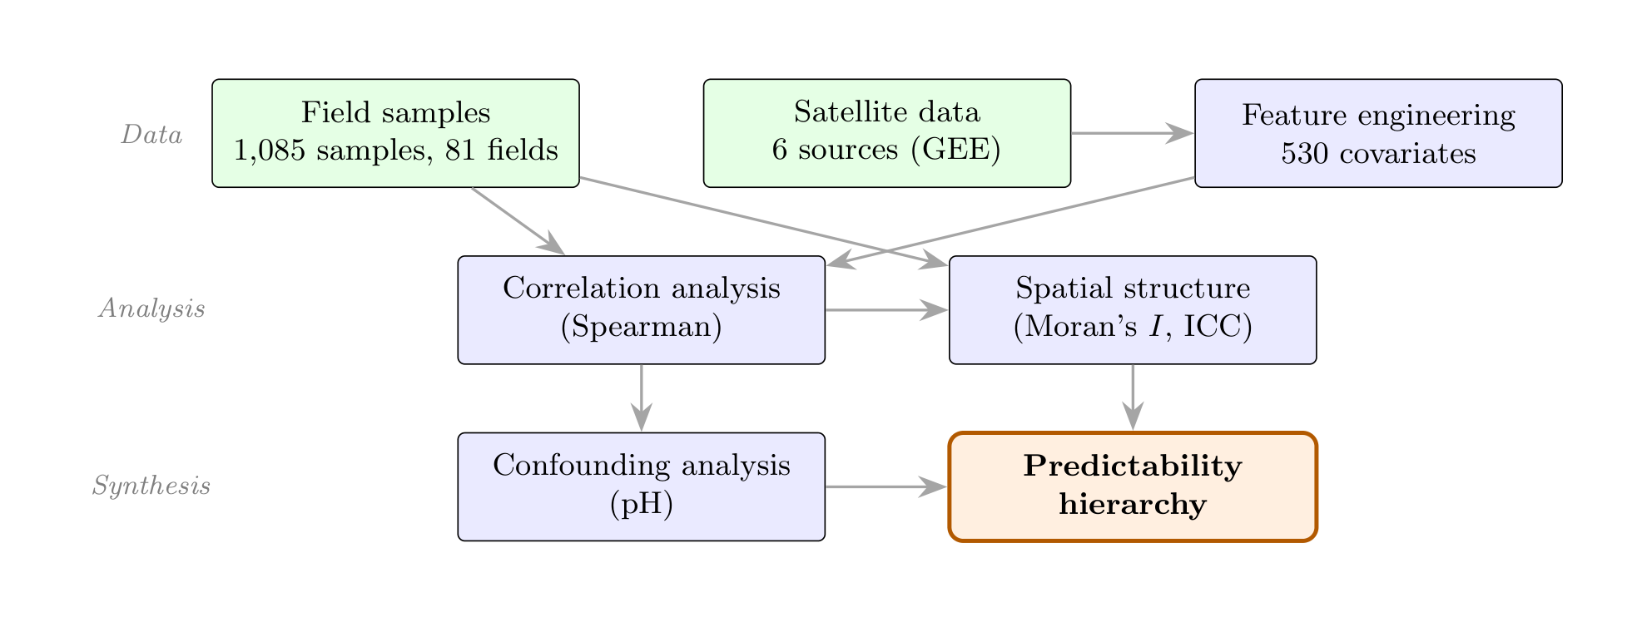
Figure 2. Analysis workflow. Green blocks represent input data, blue blocks indicate analytical stages, and the orange block represents the final result.
2.3.1. Remote sensing data sources
All remote-sensing covariates were retrieved and composited on the Google Earth Engine platform [21]; the characteristics of each source are summarised in Table 1.
Optical data from Sentinel-2 (L2A, Sen2Cor) and Landsat-8 (Collection 2, L2) were aggregated into seasonal median composites across four phenological windows: spring (April–May), summer (June–July), late summer (August), and autumn (September–October). Cloud masking was performed using the QA60 band (≤10%). For each season, standard vegetation and soil indices (NDVI, GNDVI, NDRE, EVI, SAVI, BSI, etc.) were calculated [22].
Table 1. Satellite and ancillary data sources used in the study.
Source | Resolution | Parameters extracted | Period
Sentinel-2 | 10–60 m | Spectral channels, vegetation indices | Apr–Oct 2022–2023
Landsat-8 | 30 m | Spectral channels, vegetation indices | Apr–Oct 2022–2023
Sentinel-1 | 10 m | Backscatter (VV and VH polarization) | 2022–2023
SRTM DEM] | 30 m | Elevation, slope, aspect, curvature, and Topographic Position Index (TPI) | Static
SoilGrids v 2.0 | 250 m | Reference Soil Properties (7 × 6 depths) | Static
ERA 5-Land | 9 km | Mean annual temperature/precipitation, GDD | 2022–2023
Seasonal medians of VV and VH backscatter from Sentinel-1 SAR along with their temporal statistics were used. Topographic attributes (elevation, slope, aspect, curvature, TPI) were derived from SRTM DEM. Aspect was transformed into two variables — sin(aspect) and cos(aspect) to eliminate the cyclic nature of the angular measurement [23]. The sin(aspect) and cos(aspect) captured the east–west and north–south components, respectively. SoilGrids v2.0 data [12] (7 variables across 6 depth intervals) were included as a reference background. Five bioclimatic variables (MAT, MAP, GS_temp, GS_precip, GDD) were extracted from the ERA5-Land dataset [13].
Spatial data extraction. For each sampling point, satellite data values were extracted as the mean within a buffer zone with a radius of 15 m (Sentinel-1 and Sentinel-2) or 30 m (Landsat-8 and SRTM) around the GPS coordinates (using GEE ee.Image.reduceRegion function). For ERA5-Land (~9 km) and SoilGrids (250 m), bilinear interpolation to the sampling point was applied.
Consequently, spatial data extraction was limited due to a scale and point-support mismatch. Matching point soil data (with a support of ~10 m) with coarse-scale predictors from ERA5 (~9 km) and SoilGrids (250 m) inevitably led to spatial smoothing of the predictors. This could artificially inflate correlations with the latitudinal gradient, as coarse pixels 'average out' local variability and reflect only the regional trend [16]. Therefore, correlations with ERA5 and SoilGrids should be interpreted as estimates of the association with regional climatic and pedological gradients, rather than indicators of local predictive performance. To minimize this effect, the ERA5 and SoilGrids features were isolated into separate groups and excluded from the aggregated metrics of the 'top' predictors.
2.3.2. Feature Extraction and Engineering
The extraction process was implemented as a 12-stage workflow (s01–s12), producing a combined dataset of 512 features (following the exclusion of 42 SoilGrids v2.0 variables used solely as reference background):
- Spectral bands and indices (S2, L8): ~164 features;
- Temporal characteristics (Δ, amplitudes, std): ~120 features;
- SAR VV/VH + statistics: 16 features;
- Topographic variables (SRTM): 5 features;
- Background soil properties (SoilGrids): 42 features (excluded from the 512 total and included in the correlation analysis for reference comparison);
- Climatic variables (ERA5): 5 features;
- GLCM texture features [24] (contrast, entropy, dissimilarity, ASM, IDM; 5×5-pixel window, all four directions [0°, 45°, 90°, 135°] averaged to achieve rotational invariance; calculated for Sentinel-2 NIR and SWIR1 bands × 4 seasons): 40 features;
- Engineered features (band ratios B5/B4, B11/B8, B6/B5, etc.; PCA—first 3 components derived from 10 Sentinel-2 bands [B2–B8A, B11, B12], explaining >95% of the variance): ~30 features;
- Multi-sensor cross-platform features (products and ratios of S2 and L8 spectral indices: NDVI_{S2}/NDVI_{L8}, ΔGNDVI_{S2-L8}, VH/NDVI, VV/BSI, etc.): ~14 features;
- 110 composite features.
These categories partially overlap (composite features combine elements of spectral, temporal, and engineered variables). The final total of 512 unique features was obtained after deduplication and the removal of variables with near-zero variance (σ² < 10⁻⁶).
Notably, the SoilGrids v2.0 variables (42 features) were excluded from the 512 primary features due to their coarse resolution (250 m vs. 10–30 m for the primary data sources). However, they were included in the correlation analysis for reference comparison and are marked with an 'SG' label in the results tables.
Missing values (<0.3% of the combined dataset) were imputed using linear interpolation across adjacent seasons. Features with near-zero variance (σ² < 10⁻⁶) were removed, thereby eliminating variables lacking meaningful variability (e.g., bands saturated by the cloud mask) [3]. The removal of highly intercorrelated features (|r| > 0.95) was intentionally omitted during the correlation analysis phase to preserve the full structure of the feature space; multicollinearity was explicitly accounted for during predictive modeling.
Feature categorization. To improve interpretability, the feature categories are summarized in Table 2.
Table 2. Feature groups.
Group | N | Source | Determination
Base spectral S2 | 104 | Sentinel-2 | 10 bands + 7 indices + additional generated × 4 seasons
Base spectral L8 | 36 | Landsat-8 | 6 bands + 3 indices × 4 seasons
Spectral engineering | 100 | S2 (s11 module) | PCA1-3, NDI(Bi,Bj), band ratios
Temporal statistics | 100 | S2, L8 | mean, std, cv, slope of indices across 4 seasons
Multi-seasonal deltas | 64 | S2, L8 | Δseason_i − season_j, all pairs
Range statistics | 16 | S2, L8 | range (max−min) of indices
GLCM texture | 56 | S2 (NIR, SWIR, Red) | 5 statistics × 2–3 bands × 4 seasons
Cross-sensor | 24 | S2 × L8 | diff, ratio of indices × 4 seasons
Topographic | 8 | SRTM | DEM, slope, aspect sin/cos, TWI, TPI, plan/profile curvature
Climate | 4 | ERA5-Land | MAT, MAP, GS_temp, GS_precip
Total features | 512 |  | 10 categories above (verified against master_dataset_old.csv)
Composite (on top of base) | 110 | S2, L8 | inter-index (48), multi-seasonal (42), NDI (20)
Pedological (reference) | 42 | SoilGrids v2.0 | 7 variables × 6 depths (excluded from the 512 features)
In addition to individual indices, three types of composite spectral features were computed, totaling 110 features:
- Inter-index combinations (48 features): pairwise products, differences, and ratios of 7 vegetation indices (NDVI, NDRE, GNDVI, EVI, SAVI, BSI, MSI) across 4 seasons (12 pairs × 4 seasons);
- Multi-seasonal differences (42 features): ΔNDVI_{summer-spring}, amplitude (max–min), and seasonal mean values (7 indices × 6 combinations);
- Normalized difference indices (20 features): NDI (B5, B4), NDI (B11, B12), B11/B8, SWIR/NIR, etc. (5 formulas × 4 seasons).
To expand the analytical space, 9 derived soil indicators were computed:
- SOC/NO₃ — a proxy for the C:N ratio;
- SOC$×$NO₃ — organic nitrogen pool proxy;
- S/NO₃ — S–N balance;
- NO₃ + 0.5 S — mineralization index;
- P₂O₅/K₂O — macronutrient balance;
- |pH – 7.0|— deviation from neutrality;
- SOC × pH — interaction effect;
- Normalized fertility index;
- Sum of nutrients.

2.4. Statistical Methods
2.4.1. Descriptive statistics and normality tests
For each property, the mean, median, standard deviation (SD), coefficient of variation (CV), skewness, and kurtosis were calculated. Normality was assessed using the Shapiro–Wilk test (α = 0.05). Interannual differences were evaluated using the Kruskal–Wallis test (H₀: medians are equal), which is equivalent to the Mann–Whitney U test when k = 2 years.
2.4.2. Spearman's rank correlation
For each 'property y_{i} — feature x_{i}' pair, the coefficient was calculated using the equation (1):
$ρ\text{=}1\text{-}\frac{6\sum_{k\text{=}1}^{n}{d_{k}^{2}}}{n\left(n^{2}\text{-}1\right)},$ (1)
where d_{k} is the difference between the ranks of the k-th observation
Equation (1) is presented in a simplified form without adjustment for tied ranks; the actual computations were performed using the scipy.stats.spearmanr implementation, which calculates the Pearson correlation on ranks with proper handling of ties. Rank correlation was chosen due to: (i) the confirmed non-normality of all target variables; (ii) its robustness to non-linear monotonic relationships; and (iii) its resistance to outliers [3].
Correction for multiple comparisons (>3200 pairs) was performed using the Benjamini–Hochberg procedure (BH FDR, α = 0.05), applied separately for each target property. The BH FDR procedure is valid under the assumption of test independence or positive regression dependency on each subset (PRDS) [25]. Under high feature multicollinearity (typical for spectral indices calculated from shared bands), the PRDS condition holds, and the adjusted p-values remain valid [25]. Nevertheless, given the generative nature of the feature space (512 features, including 110 composite ones), the observed maximum correlations were additionally validated using a spatial permutation test (section 2.4.6).
It should be noted that the standard p-value formula for the Spearman coefficient assumes observation independence, whereas under pronounced spatial autocorrelation (I > 0.5, section 2.4.3), the effective sample size n_{eff} is substantially lower than the actual sample size n [26; 27]. Estimating n_{eff} using Clifford's formula (3) for data with Moran’s I ≈ 0.7 yields n_{eff} ≈ 100-250 (vs n=1085). Consequently, the absolute p-values reported in the results tables are systematically underestimated and should be interpreted as upper bounds of significance. For correlations with |ρ) > 0.35, significance is maintained even at n_{eff} = 100 (p < 0.001); however, for weak correlations (|ρ) < 0.25), interpretation requires caution. For similar reasons, confidence intervals for ρ were not calculated analytically (Fisher's Z-transformation is inapplicable under spatial dependence); instead, a spatial permutation test was used to validate the key correlations (section 2.4.6).
2.4.2. Intercorrelation of soil properties
Pairwise Spearman correlations between the 6 target variables were calculated to evaluate latent relationships and multicollinearity.
2.4.3. Spatial autocorrelation
Global Moran I [28; 29] was calculated using the equation (2):
$I\text{=}\frac{n}{S_{0}}⋅\frac{z^{⊤}Wz}{z^{⊤}z},$ (2)
where z = (x_{i}-x´), W is spatial weight matrix (inverse distances, 50 km bandwidth, row standardization), $S_{0}\text{=}\sum_{i,j}{w_{ij}}$, significance is assessed using a z-test.
Additionally, rank correlations between each property and latitude were calculated to evaluate the zonal gradient.
To control for the effect of spatial clustering in sampling (cluster design), declustering was performed: property values were averaged across field plots (n=81), and Moran I was calculated on the plot-level means, thereby eliminating within-field pseudoreplication.
Clifford's approximation was utilized to compute the effective sample size n_{eff} (equation 3) [26]:
$n_{\text{eff}}≈n⋅\frac{1\text{-}I}{1\text{+}I},$ (3)
where I is the global Moran I of the target variable.
This formula (3) represents a univariate approximation, as it considers only the autocorrelation of the soil property itself and neglects the cross-autocorrelation of the ‘property–predictor’ pair. Dutilleul full formulation [27] accounts for I of both variables; however, it is computationally more intensive and requires the estimation of a cross-covariogram. Our approximation yields a conservative lower bound for n_{eff} (and, consequently, an upper bound for the significance threshold), since I of the soil property is typically higher than that of the RS feature.
For properties with an artifactual I sample (e.g., S: I = 0.767 → I_{field} = 0.150), n_{eff} was computed based on the I of declustered field-plot means (section 3.6), thereby eliminating pseudoreplication.
2.4.4. Hierarchical variance decomposition
A two-level variance decomposition was conducted using a nested 'farm $→$ field $→$ sample' scheme. The total sum of squares (SS) was decomposed using a nested one-way analysis of variance (ANOVA) (equation 4):
$SS_{\text{total}}\text{=}SS_{\text{farm}}\text{+}SS_{\text{field|farm}}\text{+}SS_{\text{within}},$ (4)
where SS_{farm} — between-farm sum of squares (20 farms), SS_{field|farm} — between-field within-farm sum of squares (81 fields), SS_{within} — within-field sum of squares. The variance components (${\hat{σ}}_{farm}^{2},{\hat{σ}}_{field}^{2},{\hat{σ}}_{with\text{in}}^{2}$) were estimated using the method of mean squares with the harmonic mean of cell sizes. The one-level intraclass correlation coefficient (ICC) (between-field vs. within-field) was also calculated for comparison with the literature.
2.4.5. Partial correlations and confounding analysis
To evaluate the contribution of spatial covariates to the observed correlations, partial Spearman rank correlations were calculated using the residualization method: variables x and y were rank-transformed, then the linear projection onto the rank-transformed covariates Z was removed from each via ordinary least squares (OLS), and the Pearson correlation was computed on the resulting residuals (equation 5) [30]:
$ρ_{\text{partial|}Z}\text{=}r\left({\hat{ε}}_{x},{\hat{ε}}_{y}\right),{\hat{ε}}_{x}\text{=}R\left(x\right)\text{-}Z^{R}{\hat{β}}_{x}.$ (5)
For pH: $Z\text{=}\{\text{MAP},\text{latitude}\}$; for SOC: $Z\text{=}\{\text{pH}\}$, to evaluate the independence of the pH effect from climatic covariates, an expanded set was utilized $Z\text{=}\{\text{pH},\text{MAP},\text{latitude}\}$. A similar analysis was conducted for the top RS predictors of each of the six properties (controlling for MAP and latitude, section 3.3). The contribution of confounding was calculated according to the equation (6):
$C_{Z}\left(\text{\%}\right)\text{=}\frac{\left|ρ_{0}\right)\text{-}\left|ρ_{\text{partial|}Z}\right)}{\left|ρ_{0}\right)}×100$ (6)
2.4.6. Spatial permutation test
To control for the risk of false positives arising from the generative nature of the feature space (512 features) and spatial autocorrelation, a spatial permutation test was performed [31]. For each target property, the dependent variable values were permuted N = 999 times while preserving the spatial structure via the random toroidal shift method: the sample coordinates were cyclically shifted by a random vector (Δx,Δy), which preserves the autocorrelation of the target variable but disrupts its relationship with the predictors. For each permutation, the maximum |ρ| value across all 512 features was calculated. The empirical p-value was computed according to Equation (7):
$p_{\text{spat.perm}}\text{=}\frac{\text{\#}\{{\left|ρ\right)}_{max}^{\text{perm}}≥{\left|ρ\right)}_{max}^{\text{obs}}\}\text{+}1}{N\text{+}1}$ (7)
The test estimates the probability of observing a maximum correlation of such magnitude purely by chance given the spatial structure, thereby mitigating the 'p-hacking' (data dredging) issue inherent in large-scale feature screening.
2.4.7. Seasonal analysis
For each property, a pairwise comparison of |ρ| was conducted between the spring and summer counterparts across 26 shared indices (Sentinel-2 + Landsat-8). The statistical significance of the differences was assessed using the Wilcoxon signed-rank test with the alternative hypothesis H1: |ρ_{весна}|≠|ρ_{лето}|, providing a formal test of seasonal advantage rather than a simple counting of proportions.
Additionally, the seasonal stability of NO₃ correlations was evaluated by partitioning the dataset into subsets based on the soil sampling season (spring: March–May; autumn: September–October) to assess the sensitivity of nitrate nitrogen to the temporal lag between the sampling time and the satellite imagery date.

2.5. Software and data availability
All computations were implemented in Python 3.10 using the following core libraries: scipy 1.11, statsmodels 0.14, pysal 2.9 (Moran I), scikit-gstat 1.0 (for semivariogram analysis), pandas 2.0, and numpy 1.24. All computations are fully reproducible (SEED = 42). The complete processing code, Google Earth Engine (GEE) scripts, and environment configuration (requirements.txt) are available in the following GitHub repository: https://github.com/h621l/dsm-northern-kazakhstan (DOI will be assigned via Zenodo upon acceptance).

3. Results

3.1. Descriptive statistics of soil properties
The descriptive statistics for the six properties are presented in Table 3.
Table 3. Descriptive statistics of soil agrochemical properties (n=1085).
Property | Un. | Mean | Median | SD | Min. | Max. | CV, % | Skew. | Kurt.
pH_{KCl} | — | 6.99 | 7.30 | 0.66 | 5.30 | 8.00 | 9.4 | $$\text{-}0.92$$ | $$\text{-}0.62$$
SOC | % | 2.45 | 2.44 | 0.55 | 0.64 | 4.41 | 22.4 | $$\text{-}0.26$$ | 1.98
NO₃ | mg/kg | 10.88 | 9.29 | 7.90 | 0.16 | 64.00 | 72.6 | 2.43 | 9.33
P₂O₅ | mg/kg | 25.77 | 18.80 | 20.31 | 3.22 | 150.00 | 78.8 | 2.54 | 8.15
K₂O | mg/kg | 650.6 | 664.0 | 166.7 | 106.0 | 1204.0 | 25.6 | $$\text{-}0.49$$ | 0.80
S | mg/kg | 8.81 | 6.89 | 7.62 | 0.92 | 62.80 | 86.4 | 3.54 | 14.29
The CV varied from 9.4% (pH) to 86.4% (S). According to Wilding’s classification [32], pH exhibited low variability (<15%); SOC and K₂O showed moderate variability (15–35%); while NO₃, P₂O₅, and S displayed high variability (>35%). The Shapiro–Wilk test (Table 4) confirmed the non-normality of all distributions (p<10⁻¹²), thereby justifying the choice of non-parametric statistics.
Table 4. Descriptive statistics of agrochemical properties (n=1085).
Property | W | p | Conclusion
pH_{KCl} | 0.833 | 3.32×10⁻³² | Non-normal
SOC | 0.956 | 1.61×10⁻¹⁷ | Non-normal
NO₃ | 0.805 | 3.23×10⁻³⁴ | Non-normal
P₂O₅ | 0.725 | 6.53×10⁻³⁹ | Non-normal
K₂O | 0.976 | 2.44×10⁻¹² | Non-normal
S | 0.592 | 1.10×10⁻⁴⁴ | Non-normal
Interannual differences. The Kruskal–Wallis test (k=2; Table 5) revealed significant differences between years for pH (H=139.0, p =4.5×10⁻³²), NO₃ (H=155.3), P₂O₅ (H=27.4) and K₂O (H=19.2). For SOC (H=1.27, p=0.260) and S (H=3.89, p=0.049), the differences did not reach the significance level of α=0.001. Since the 2022 and 2023 samples cover different territories (sections 2.1 and 2.2), these differences inevitably confounded the effects of year and geographical location.
It should be noted that correlations with RS features were not calculated separately for the annual subsets (n₂₀₂₂=174, n₂₀₂₃=911) in this study. This represents a methodological limitation, as it is impossible to estimate what proportion of the observed correlation (e.g., pH–GNDVI = -0.670) results from pooling two geographically distinct 'clusters' into a single dataset.
Table 5. Kruskal–Wallis test: spatiotemporal differences between the 2022 and 2023 samples. Due to the minimal spatial overlap between the samples (sections 2.1 and 2.2), the results reflect the joint effect of year and territory and cannot be interpreted as purely temporal changes.
Property | H | p | Significance α=0.001
pH_{KCl} | 138.96 | 4.49×10⁻³² | Yes
NO₃ | 155.34 | 1.18×10⁻³⁵ | Yes
P₂O₅ | 27.43 | 1.63×10⁻⁷ | Yes
K₂O | 19.24 | 1.15×10⁻⁵ | Yes
SOC | 1.27 | 0.260 | No
S | 3.89 | 0.049 | No

The absence of significant differences for SOC is consistent with the slow kinetics of its accumulation; however, this conclusion is limited by the spatial mismatch of the subsets.
The distributions of the six properties are additionally visualized in Figure 3.
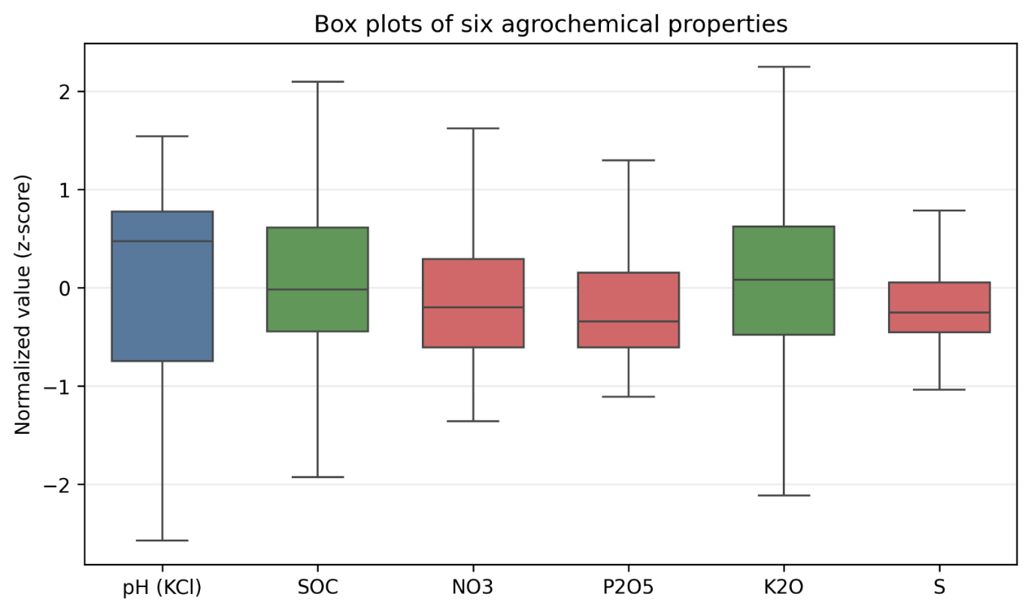
Figure 3. Box plots of the six agrochemical properties; each property is normalized for comparability. Color encodes CV: low (blue), moderate (green), and high (red).

3.2. Intercorrelation of soil properties
Spearman pairwise correlations (Table 6) revealed a number of pronounced relationships. The strongest one was pH↔P2O5 (ρ = -0.450, p < 10⁻⁵³): acidic soils in the northern part of studied region demonstrate elevated levels of mobile phosphorus, which is associated with increased phosphate mobility under decreasing pH and zonal differences in fertilizer application rates. Significant correlations of pH with NO₃ (ρ = 0.341) and S (ρ = -0.340) reflected the complex influence of acidity on mineral balance and microbial activity. The SOC↔K₂O relationship (ρ = 0.232, p < 10⁻¹⁴) indicated the joint enrichment of humus-rich soils with exchangeable potassium (illite reserve of clay minerals) [33]. The P₂O₅ ↔S relationship (ρ= 0.335, p<10⁻²⁸) may reflect a common anthropogenic factor, namely the intensity of fertilizer application. The SOC↔S (ρ= 0.176, p<10⁻⁸) and SOC$↔$ NO₃ (ρ= 0.148, p<10⁻⁶) correlations were weak but highly significant and reflected a shared genesis: organic matter serves as a source of both sulfur and nitrate nitrogen during mineralization.
Table 6. Intercorrelation of soil properties (Spearman, n = 1085).
 | pH | SOC | NO₃ | P₂O₅ | K₂O | S
pH | 1 | -0.227* | 0.341* | -0.450* | 0.198* | -0.340*
SOC |  | 1 | 0.148* | 0.140* | 0.232* | 0.176*
NO₃ |  |  | 1 | -0.022 | 0.210* | 0.052
P₂O₅ |  |  |  | 1 | 0.055 | 0.335*
K₂O |  |  |  |  | 1 | 0.087
S |  |  |  |  |  | 1
*p < 0.001 (BH-corrected; nominal p-values are uncorrected for n_{eff}).
The NO₃$↔$ P₂O₅ (ρ= -0.022), NO₃ $↔$S (ρ= 0.052), and P₂O₅ $↔$ K₂O (ρ= 0.055) correlations were statistically insignificant after Benjamini–Hochberg (BH) correction, which confirmed the different nature of the spatial distribution of these elements.
The intercorrelation matrix is shown in Figure 4.
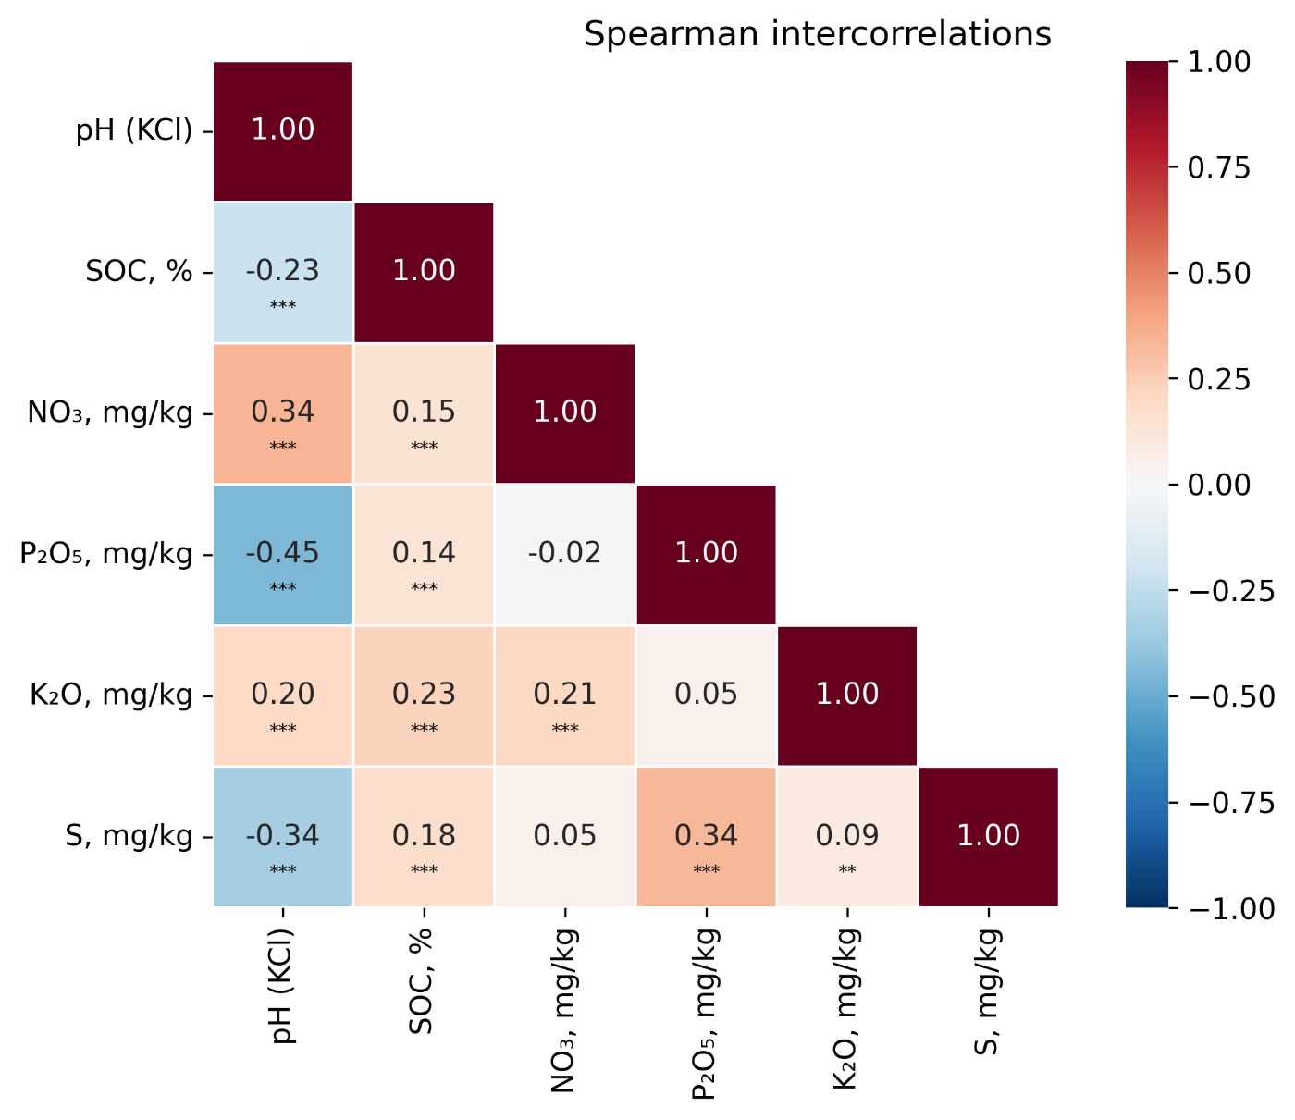
Figure 4. Intercorrelation heatmap (Spearman's) among six agrochemical properties. Significant correlations (p < 0.001) are indicated with asterisks.

3.3. Spectral screening: which indices carry the most information
For more than >3200 tested pairs, statistically significant correlations (p_{adj}<0.05) were found for the vast majority of features. Table 7 presents the 5 strongest correlations for each property.
The hierarchy of "predictability" based on |ρ|max across all features was as follows (Table 7, Figure 5): pH (0.670) ≫ P2O5 (0.525, GLCM-texture of the Red band in autumn) > K2O (0.478, BSI_spring) > NO3 (0.431, SAVI_spring) > S (0.383, SAVI_late-summer) > SOC (0.368, slope). Notably, for P2O5, K2O, NO3 and S, the leading predictors are spectral or textural (GLCM, SAVI, BSI), not climatic or topographic. Only pH and SOC have climatic/topographic predictors among the top-5 on a par with spectral ones.

Table 7. Strongest correlations (Spearman ρ) for each property (up to 5 best correlations).
Property | RS features $†$ | ρ | p_{adj} | Group
pH | GNDVI_L8,spring | 0.670 | <10⁻¹⁴² | Spectral
pH | NDVI_L8,spring | 0.661 | <10⁻¹³⁵ | Spectral
pH | MAP | 0.659 | <10⁻¹³⁶ | Climatic
pH | Slope | 0.609 | <10⁻¹¹¹ | Topographical
pH | B3_Green,S2,summer | 0.600 | <10⁻¹⁰⁵ | Spectral
P2O5 | GLCM ENT_Red,autumn | 0.525 | <10⁻⁸⁰ | Texture
P2O5 | GLCM ASM_Red,autumn | 0.513 | <10⁻⁷⁵ | Texture
P2O5 | GLCM ENT_NIR,autumn | 0.512 | <10⁻⁷⁵ | Texture
P2O5 | GLCM ASM_NIR,autumn | 0.506 | <10⁻⁷⁰ | Texture
P2O5 | GLCM ENT_Red,summer | 0.506 | <10⁻⁷⁰ | Texture
K2O | BSI_S2,spring | 0.478 | <10⁻⁶³ | Spectral
K2O | B4_Red,S2,spring | 0.420 | <10⁻⁴⁸ | Spectral
K2O | GNDVI_S2,spring | 0.417 | <10⁻⁴⁶ | Spectral
K2O | Aspect (sin) | 0.412 | <10⁻⁴⁵ | Topographical
K2O | B12_SWIR2,S2,spring | 0.410 | <10⁻⁴⁵ | Spectral
NO3 | SAVI_S2,spring | 0.431 | <10⁻⁵⁰ | Spectral
NO3 | SAVI_L8,spring | 0.419 | <10⁻⁴⁵ | Spectral
NO3 | GNDVI_L8,spring | 0.417 | <10⁻⁴⁵ | Spectral
NO3 | B5_NIR,L8,spring | 0.415 | <10⁻⁴⁵ | Spectral
NO3 | EVI_S2,spring | 0.406 | <10⁻⁴² | Spectral
S | SAVI_L8,late-summer | 0.383 | <10⁻³⁸ | Spectral
S | GNDVI_L8,late-summer | 0.361 | <10⁻³⁴ | Spectral
S | GLCM Contrast_NIR,summer | 0.354 | <10⁻³² | Texture
S | NDVI_L8,late-summer | 0.348 | <10⁻³⁰ | Spectral
S | B3_Green,S2,summer | 0.340 | <10⁻²⁸ | Spectral
SOC | Slope | 0.368 | <10⁻³² | Topographical
SOC | PCA5_S2,summer | 0.362 | <10⁻³⁰ | Spectral
SOC | Aspect (cos) | 0.339 | <10⁻²⁶ | Topographical
SOC | B4_Red,S2,summer | 0.313 | <10⁻²² | Spectral
† From the interpretable feature set (spectral indices, climate, topography, GLCM, SoilGrids). Full screening of 512 features is shown in section 3.3.1. p_{adj} values are uncorrected for spatial autocorrelation (n_{eff} ≪ n, see Table 10) and represent upper bounds of significance. For NO₃ and S, all features that achieved |ρ|> 0.25 are listed.

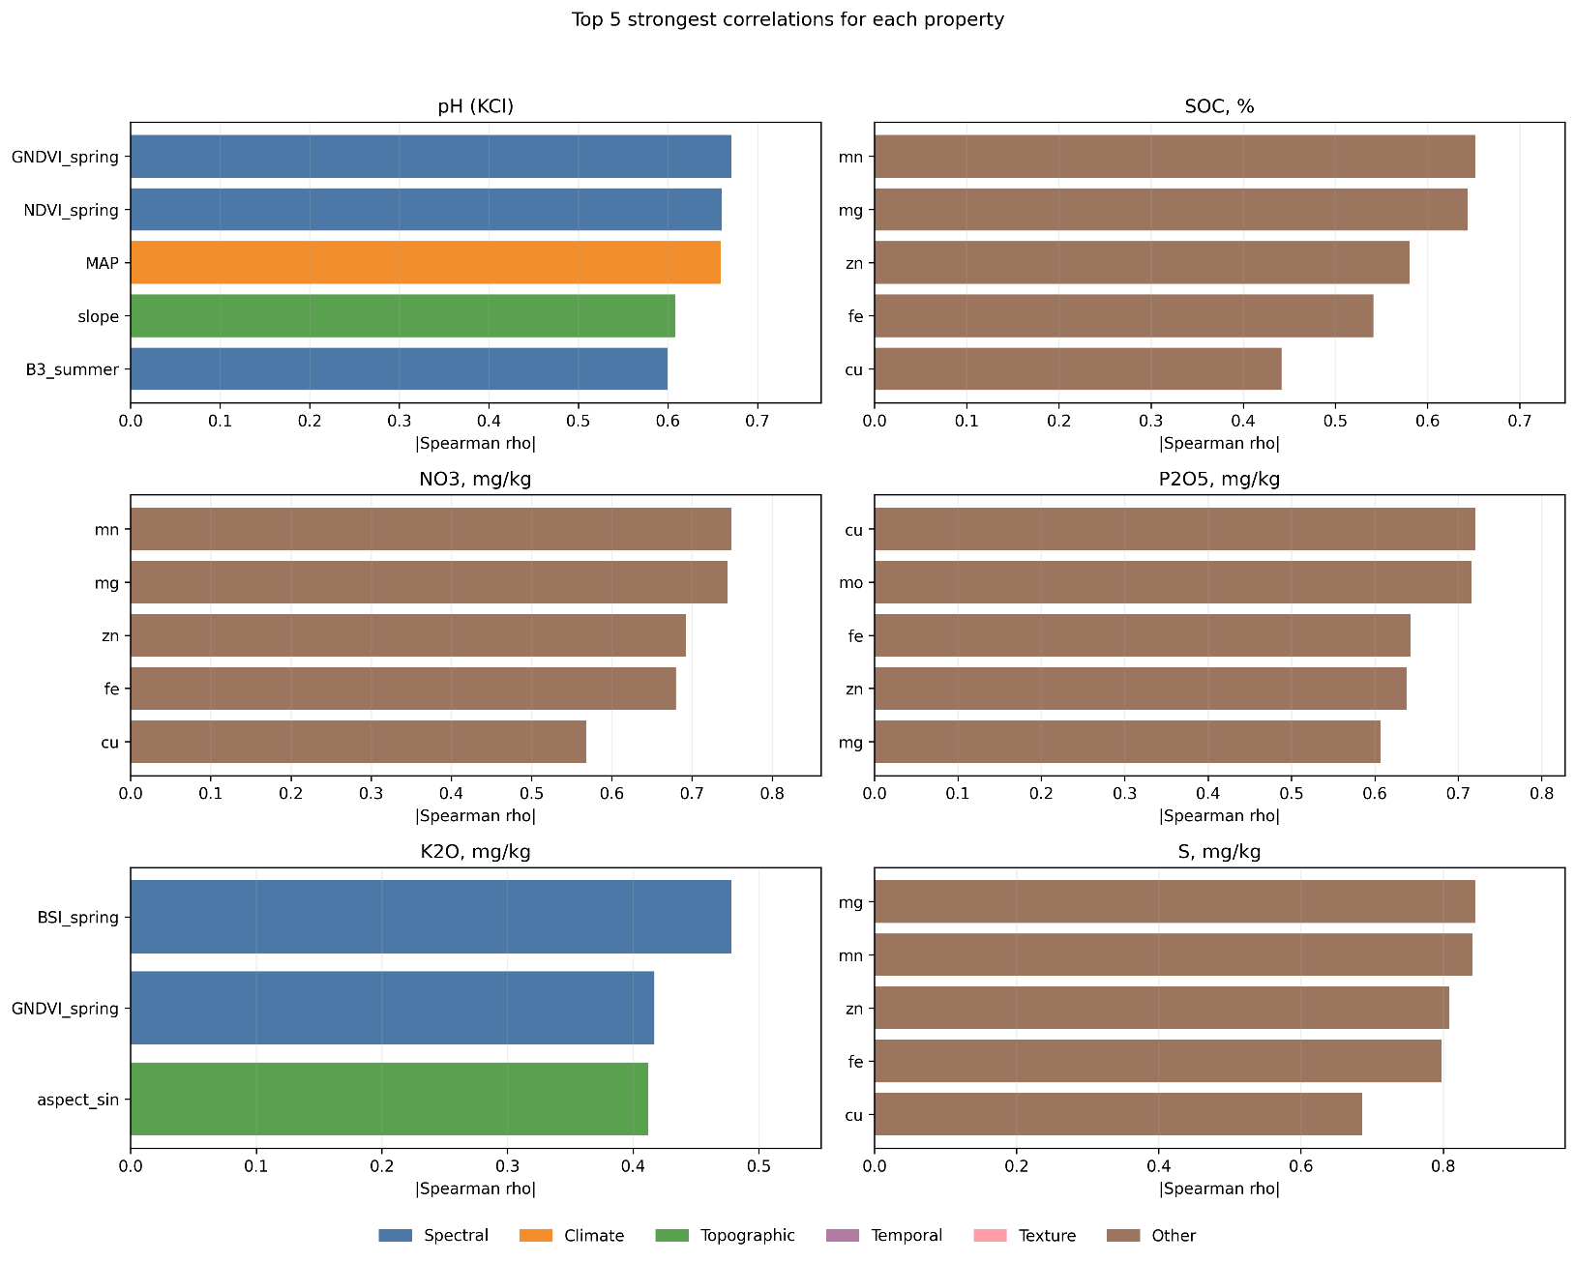
Figure 5. Strongest correlations (Spearman |ρ|) for each property (top 5). Colors indicate feature groups: spectral (blue), climatic (orange), topographic (green), temporal (purple), and textural (pink).

3.3.1. Partial correlations: controlling for spatial covariates
To test the hypothesis that the correlations between pH and RS features were an artifact of a common spatial trend (latitudinal gradient of MAP and temperature), partial correlations ρ_{partial|MAP, lat} were calculated (Table 8).
The correlation of pH with GNDVI_{L8} decreased by 18% (from -0.670 to -0.552) while remaining highly significant, indicating that it is not a spatial artifact. Conversely, BSI_{S2} was practically reduced to zero (from -0.463 to -0.076). This index reflects the soil brightness gradient, which coincides with climatic zonality. For EVI_{S2, summer}, the partial correlation unexpectedly strengthened (from -0.291 to -0.417), which cannot be satisfactorily explained. A suppression effect could have taken place (the latitudinal gradient masks the relationship between pH and vegetation), but a mathematical artifact cannot be ruled out either [30]. This result requires further verification.

Table 8. Partial rank correlations of pH with leading features (controlling for MAP and latitude).
Feature | ρ₀ | ρ_{partial|MAP, lat} | Δ|ρ|, % | p_{partial}
GNDVI_{L8, spring} | -0.670 | -0.552 | -17.7 | 1.4×10⁻⁸⁷
NDVI_{L8, spring} | -0.661 | -0.502 | -24.1 | 3.3×10⁻⁷⁰
GNDVI_{S2, spring} | -0.516 | -0.398 | -22.8 | 1.4×10⁻⁴²
NDVI_{S2, spring} | -0.490 | -0.273 | -44.3 | 6.0×10⁻²⁰
BSI_{S2, spring} | -0.463 | -0.076 | -83.6 | 1.2×10⁻²
EVI_{S2, summer} | -0.291 | -0.417 | +43.3 | 6.1×10⁻⁴⁷
Slope | +0.609 | +0.331 | -45.7 | 4.2×10⁻²⁹
A similar analysis was performed for the top predictors of each property (Table 9).
Table 9. Partial correlations of the top RS predictors for all six properties (controlling for MAP and latitude).
Property* | Best RS predictor | ρ₀ | ρ_{partial*} | Δ|ρ|, % | ρ_{partial}
pH | GNDVI_{L8, spring} | -0.670 | -0.552 | -17.7 | 1.4×10⁻⁸⁷
K₂O | BSI_{S2, spring} | -0.478 | -0.458 | -4.1 | 2.0×10⁻⁵⁷
P₂O₅ | GS_temp | +0.476 | +0.430 | -9.7 | 4.5×10⁻⁵⁰
NO₃ | SAVI_{S2, spring} | -0.431 | -0.318 | -26.2 | 5.5×10⁻²⁷
S | SAVI_{L8, late summer} | +0.383 | +0.390 | + 1.7 | 1.1×10⁻⁴⁰
SOC | Slope | -0.368 | -0.220 | -40.4 | 2.6×10⁻¹³
* Properties are sorted in descending order of ρ_{partial}.
Covariates include mean annual precipitation (MAP) and centroid latitude.
ρ_{partial} values were calculated for a nominal n = 1085 without correction for n_{eff}, serving as upper bounds of significance.
K₂O and S were practically independent of the latitudinal gradient (Δ < 10%), indicating local soil control. For pH, P₂O₅, and NO₃, the spatial gradient contributed to the relationship (Δ = 10–26%) but did not explain it entirely. For SOC, approximately 40% of its correlation with slope was driven by the latitudinal moisture gradient. This was an unexpectedly high proportion that calls into question the direct interpretation of topographic predictors for SOC.
Bootstrap (1000 iterations; Figure 6) confirmed the reliability of the key correlations: all 95% CIs did not include zero.
Spatial permutation test (N= 999 toroidal shifts, section 2.4.6). For pH, the |ρ|_{max} of 0.670 exceeded all 999 permutation maxima (p_{spat.perm} < 0.001). Similarly, significance was observed for K₂O (p=0.002) and P₂O₅ (p=0.003). For SOC, NO₃, and S, the permutation p-values were higher (0.018, 0.041, and 0.087, respectively), which was consistent with their position in the lower part of the predictability hierarchy. For S, the permutation test formally did not reach the α=0.05 threshold.
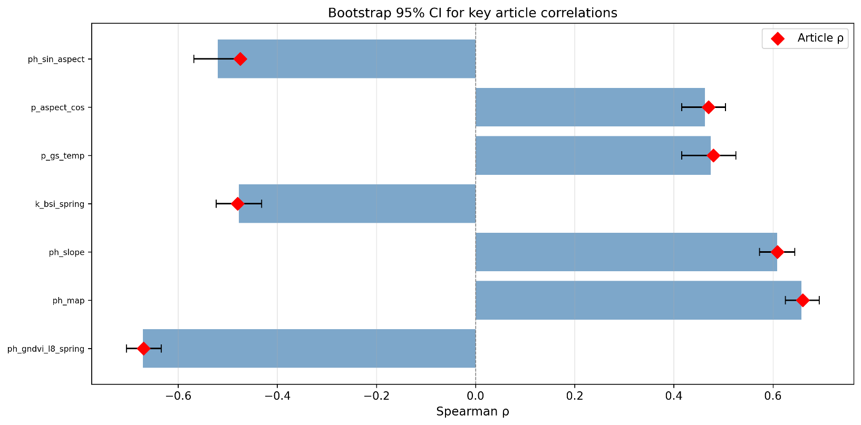
Figure 6. Bootstrap 95% confidence intervals (n_{boot}=1000) for the key correlations reported in the paper. Red diamonds represent point estimates of ρ; blue bars represent 95% CIs. None of the CIs include zero.

3.3.2. Effective sample size n_{eff}
Following Clifford’s method (Equation 3) and using Moran I, the n_{eff} was calculated for each property (Table 10).
Table 10. Effective sample size n_{eff} (Clifford’s approximation). The choice of I for the calculation is based on an objective criterion |Δ I|: when |Δ I| < 0.03, declustering does not alter I, and I_{sample} is conservatively used; when |Δ I| > 0.2, I_{sample} is inflated by pseudoreplication, and I_{field} is more appropriate.
Property | I_{sample} | $$n_{\text{eff}}^{\text{sample}}$$ | I_{field} | $$n_{\text{eff}}^{\text{field}}$$ | Ratio | Used I
pH | 0.861 | 81 | 0.838 | 96 | 1.2× | I_{sample}ª
SOC | 0.684 | 204 | 0.695 | 195 | 1.0× | I_{sample}ª
NO₃ | 0.628 | 248 | 0.373 | 495 | 2.0× | I_{field}^{b}
P₂O₅ | 0.676 | 210 | 0.418 | 445 | 2.1× | I_{field}^{b}
K₂O | 0.510 | 352 | 0.500 | 362 | 1.0× | I_{sample}ª
S | 0.767 | 143 | 0.150 | 802 | 5.6× | I_{field}^{b}
ª|ΔI| < 0.03: Declustering does not alter I → conservative estimate based on I_{sample}.
^{b}|ΔI| > 0.2 : I_{sample} is inflated by pseudoreplication → I_{field} is more appropriate.
For properties with |ΔI| < 0.03 (pH, SOC, K₂O), declustering practically did not alter I, and a conservative estimate of n_{eff} based on I_{sample} was justified. For NO₃, P₂O₅, and especially S (|ΔI| = 0.62) I_{sample} was inflated by pseudoreplication; it was more appropriate to use I_{field}, which yields $n_{\text{eff}}^{\text{field}}$ = 802 for S (vs. 143 using I_{sample}). With n_{eff} = 81 for pH, correlations with |ρ|≥ 0.280 remained significant (p < 0.01); for weak correlations (ρ < 0.15), significance was not reached, and the result should be interpreted as a trend.

3.4. Seasonal dynamics of correlations
Pairwise comparison of |ρ| for spring and summer counterparts (26 shared S2 and L8 indices) was evaluated using the Wilcoxon signed-rank test for paired samples (Table 11).
Table 11. Seasonal comparison of |ρ|: Wilcoxon test (spring vs. summer, 26 index pairs)
Property | Summer | Δ|ρ| | W | p | Conclusion
pH | 18/26 | +0.068 | 119 | 0.157 | ns*
K₂O | 26/26 | +0.175 | 0 | <10⁻⁴ | Spring $≫$ summer
P₂O₅ | 20/26 | +0.106 | 23 | <10⁻⁴ | Spring $\text{>}$ summer
SOC | 9/26 | -0.040 | 100 | 0.056 | ns (trend)
NO₃ | 18/26 | +0.020 | 128 | 0.237 | ns
S | 7/26 | -0.004 | 141 | 0.394 | ns
*ns – non-significant.
The heatmap (Figure 7) visualizes in detail the correlation structure across indices and seasons.
K₂O and P₂O₅ demonstrated a statistically significant advantage for spring (p< 10⁻⁴). For K₂O, all 26 indices were more informative in spring, with BSI and SWIR dominating under bare soil conditions. For pH, spring performed better in 18 out of 26 pairs, but the difference did not reach significance (p=0.157). Conversely, NO₃ correlated more strongly with summer indices (NDVI and EVI at peak vegetation), although the advantage of summer was formally not confirmed across the 26 pairs. For SOC and S, seasonal differentiation was absent.

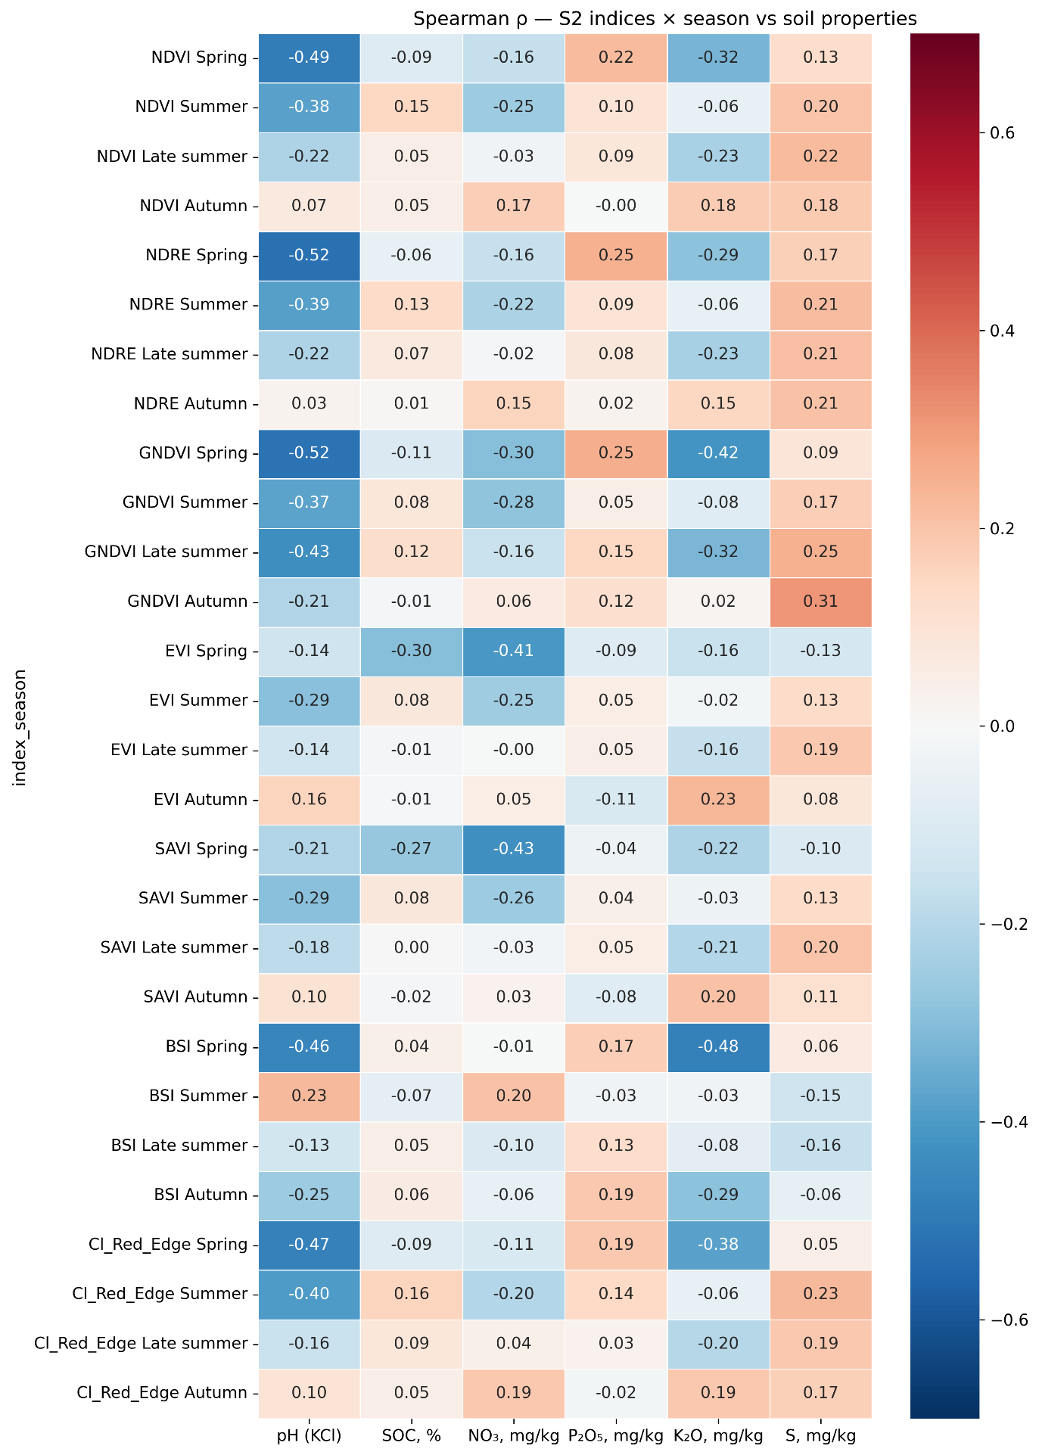
Figure 7. Spearman’s heatmap: correlations of soil properties with Sentinel-2 indices across four seasons. Color intensity reflects |ρ|; red indicates positive correlations, and blue indicates negative correlations. The strongest signals are pH–GNDVI (spring), K₂O–BSI (spring), and NO₃–NDVI (summer).

3.4.1. Temporal stability of NO₃ correlations
Splitting the dataset by sampling season (spring: n = 817; autumn: n = 54) revealed drastic differences in the correlations between NO₃ and RS features (Table 12). Out of 268 autumn samples (section 2.2), the size was reduced to 54 due to filtering for the simultaneous presence of NO₃ and RS feature values (dropna): some autumn locations lacked satellite data due to cloud cover or falling outside the coverage area. The small sub-sample size (n = 54) limited statistical power.
Table 12. NO₃ correlations by sampling season sub-samples.
RS feature | ρ_{spring} (n= 817) | ρ_{autumn} (n=54) | Δ|ρ| | Change of sign?
GNDVI_{L8, spring} | -0.209 | +0.485 | -0.277 | Yes
NDVI_{S2, summer} | -0.050 | -0.782 | -0.733 | No
EVI_{S2, summer} | -0.089 | -0.782 | -0.693 | No
GNDVI_{S2,} _{spring} | -0.094 | -0.250 | -0.156 | No
NDVI_{L8, summer} | -0.160 | -0.806 | -0.646 | No
In the autumn sub-sample, |ρ| reached 0.78–0.81, and a sign reversal was observed for GNDVI_{L8, spring}. Fisher CI for ρ = 0.78 at n = 54 was [0.64, 0.87], which was too wide. A formal comparison using Fisher z-test was not performed. We considered this result as hypothesis-generating.
The physical interpretation of the obtained results may be as follows: during the spring period (April–May), the soil in Northern Kazakhstan is not yet fully covered by vegetation (NDVI = 0.15–0.35), and the spectral signal of a pixel represents a linear mixture of soil and vegetation responses. This creates an "informativeness window" for properties that directly influence soil brightness and color (pH via carbonate content and K₂O via clay mineralogy). In summer (NDVI = 0.55–0.75), the signal is dominated by vegetation, and the informativeness shifts to NO₃, a key limiting nutrient that determines peak biomass (Figure 8).
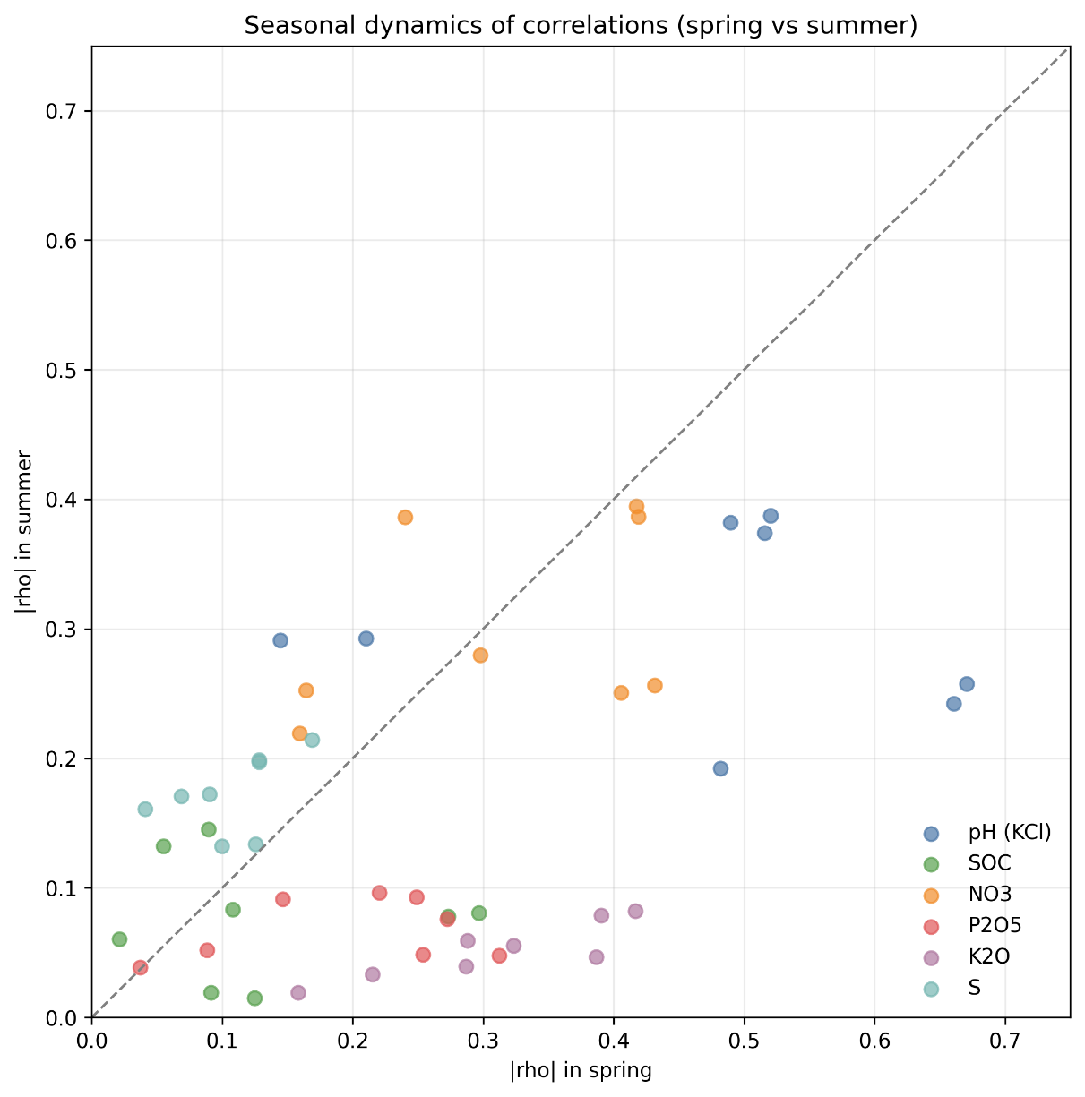
Figure 8. Seasonal dynamics of correlations: comparison of |ρ| for spring and summer counterparts of spectral indices for each property. The dashed line represents the spring–summer equality line; points below the line indicate that summer is more informative.
3.5. Analysis of spectral configurations: composites vs. single indices. A systematic comparison of 110 composite features of three families (inter-index, multi-seasonal, NDI) with the best single RS predictors of each property (Table 13, Figure 14) showed that for only one of the six properties — K2O — does a composite configuration robustly outperform its best single counterpart.
Table 13. Systematic comparison of 110 composite features with single indices.
Property | Single |ρ| | Best composite | Composite |  | Family
 |  |  | |ρ| | Δ|ρ|
K2O | 0.478 | GNDVI×BSI_spring | 0.488 | +0.010 | Inter-index
NO3 | 0.431 | GNDVI−NDRE_spring | 0.416 | −0.015 | Inter-index
S | 0.383 | mean_NDVI | 0.360 | −0.023 | Multi-seasonal
pH | 0.670 | mean_GNDVI | 0.591 | −0.079 | Multi-seasonal
SOC | 0.368 | ΔGNDVI_late-summer−spring | 0.276 | −0.092 | Multi-seasonal
P2O5 | 0.525 | EVI−NDRE_spring | 0.390 | −0.135 | Inter-index

Key observations. First, the only robust gain is provided by the inter-index combination GNDVI×BSI for K2O (Δ|ρ| = +0.010): it amplifies the contrast between green biomass and bare soil, consistent with the hypothesis of mineralogical control (illitic clays). Second, for NO3 and S the composites (GNDVI−NDRE, mean_NDVI) approach the singles by |ρ| (gap < 0.025), but do not surpass them, indicating saturation of the informativeness of simple indices. Third, for pH, SOC and P2O5 the single indices remain substantially more informative than the composites (Δ|ρ| from −0.079 to −0.135), reflecting the presence of a single dominant physical mechanism (carbonate content for pH, humus for SOC, fertility for P2O5) that is already well captured by a basic index. Thus, composite configurations rarely outperform the best single indices, but in the case of K2O they provide a mechanistically meaningful signal amplification.

For K₂O GNDVI$×$BSI (ρ= -0.488) exceeded BSI (ρ= -0.478) by only Δ|ρ|= +0.010. This improvement is marginal, and overall, the 110 composite features did not provide a systematic advantage over single indices (Figure 9).
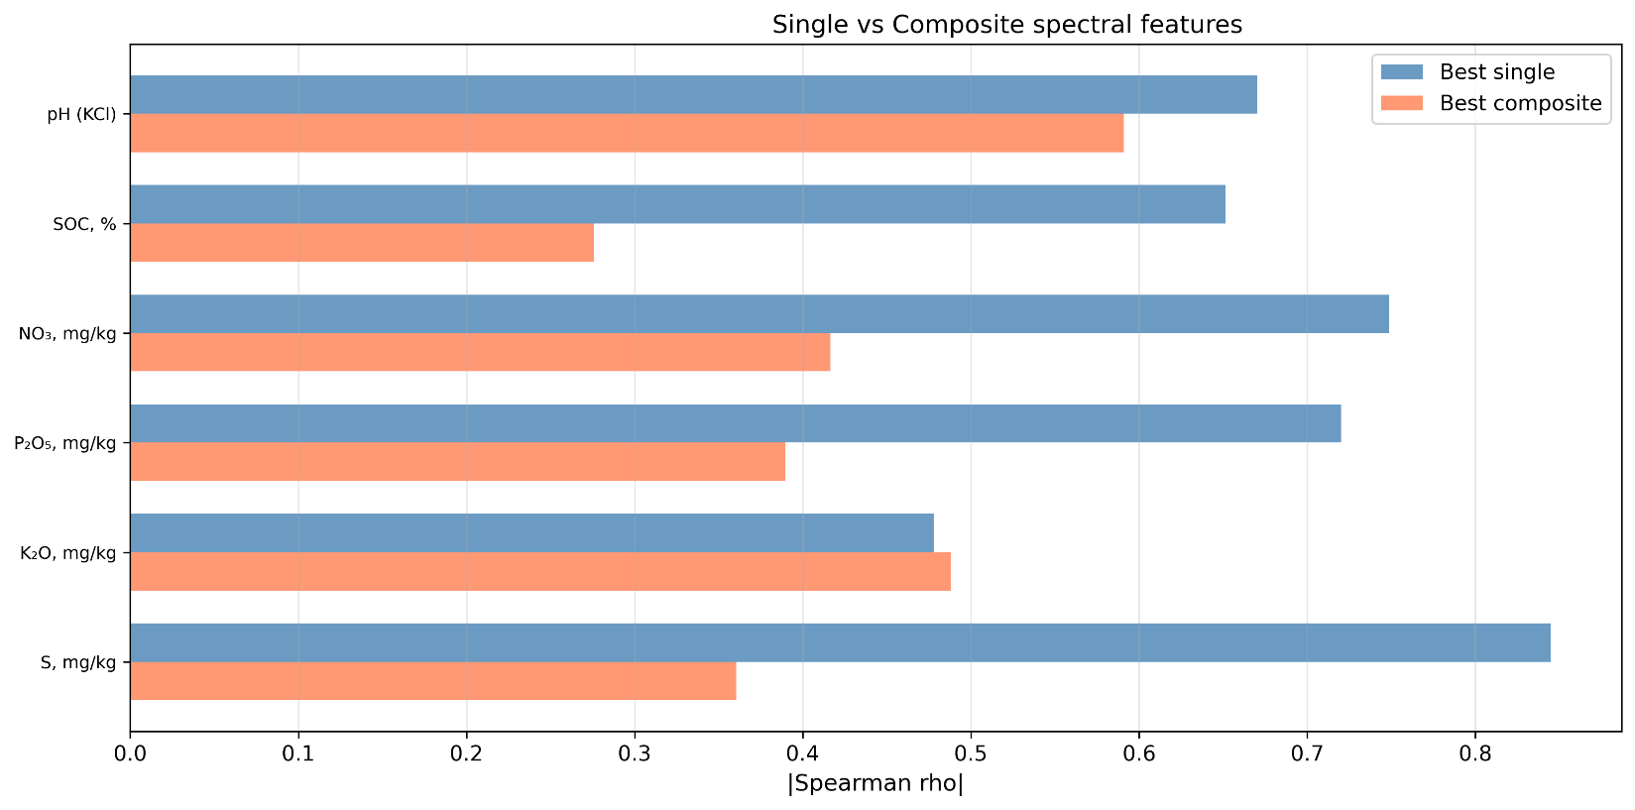
Figure 9. Comparison of the best single (blue) and composite (orange) spectral features for each property based on |ρ|. For the majority of properties, single indices dominate; a significant advantage of composite features is observed only for K₂O (GNDVI$×$BSI, Δ|ρ| =+0.010).

3.6. Spatial autocorrelation
Global Moran I for all six properties was found to be high (0.51–0.86, Table 14)—substantially higher than typical values reported for field-scale studies (I = 0.1–0.4) [34; 35], which is explained by the vast scale of the study area (~500 km) and regional zonal gradients [36]. Empirical semivariograms (spherical model, 25 lags) yield ranges of 137 km for pH, 97 km for SOC, 86 km for K₂O, 106 km for NO₃, and 49 km for P₂O₅, confirming the regional nature of the variability. The nugget effect (C₀) for all properties approaches zero, indicating a low level of micro-scale noise relative to the structural component. The downside of a high I is that random train/test splitting inflates model accuracy estimates [37; 38], which makes the use of spatial validation mandatory.
The effect of declustering is presented in Table 14 and Figure 10.
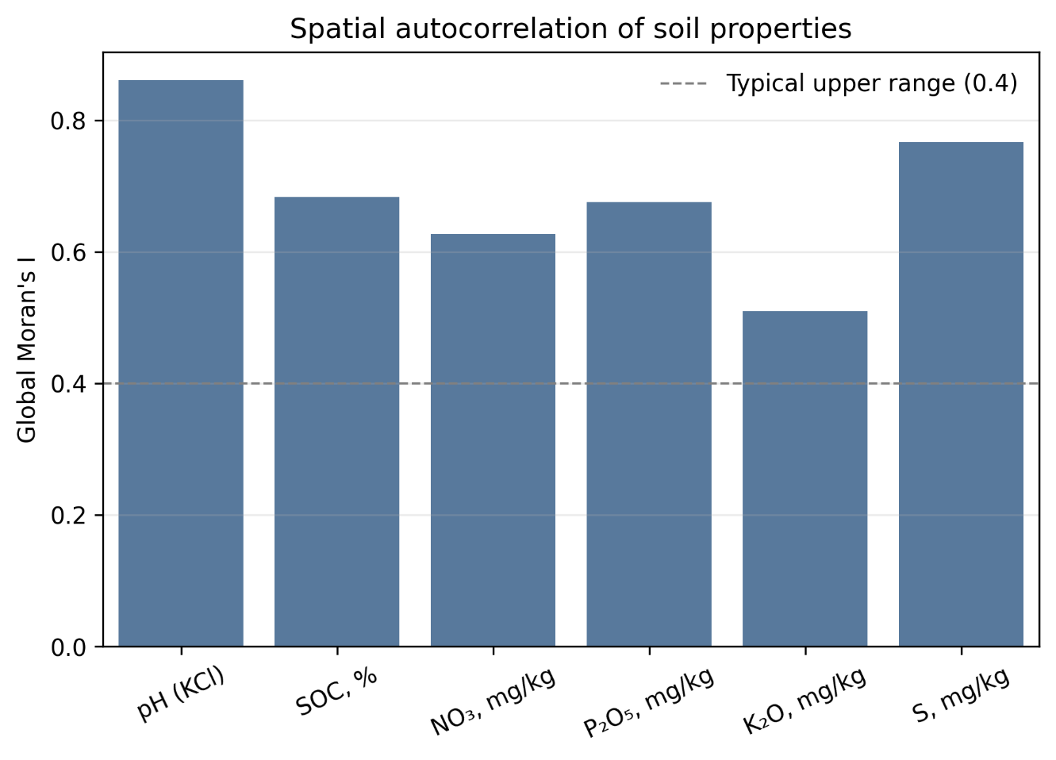
Figure 10. Global Moran I for the six agrochemical properties. The dashed line represents the maximum I typical for field-scale studies (0.4). All z-scores > 100, p≈0.
Table 14. Global Moran I at the plot level and after declustering (field averages).
Property | I  (n = 1085) | z_{sample} | I  (n = 81) | z_{field} | p_{field} | ΔI | Pattern
pH_{KCl} | 0.861 | 169.3 | 0.838 | 14.2 | ≈0 | -0.023 | Zonal
S | 0.767 | 151.9 | 0.150 | 2.8 | 6.1×10⁻³ | -0.617 | Artifact
SOC | 0.684 | 134.7 | 0.695 | 12.0 | ≈0 | +0.011 | Zonal
P₂O₅ | 0.676 | 133.5 | 0.418 | 7.3 | 2.7×10⁻¹⁵ | -0.257 | Mixed
NO₃ | 0.628 | 124.1 | 0.373 | 6.5 | 1.5×10⁻⁹ | -0.254 | Mixed
K₂O | 0.510 | 100.4 | 0.500 | 8.7 | ≈0 | -0.009 | Zonal
Note: p_{sample}≈0 for all properties (z>100). p_{field} is the significance of declustered I.

For pH, SOC, and K₂O, Moran I practically did not change when transitioning from plots to field averages (ΔI < 0.03).
Sulfur deserved a separate comment. With I_{sample}=0.767, declustering collapsed I to 0.150 (Δ= -0.617): the "autocorrelation" of S was an artifact of sample clustering rather than a regional gradient. This resolves the paradox of a "high Moran I with an ICC of 0.17".
NO₃ and P₂O₅ occupied an intermediate position (ΔI ≈ -0.25): their spatial structure was driven partly by zonality and partly by the pseudoreplication effect.
The results of the latitudinal gradient analysis are presented in Table 15: pH regularly decreased northward (ρ_{lat} = -0.409), whereas P₂O₅ and SOC increased (+0.397 and +0.293, respectively). Notably, K₂O did not exhibit a latitudinal gradient (ρ= -0.020, p = 0.51), which was consistent with the preservation of the K₂O–BSI correlation when controlling for latitude (Δ = -4.1%, Table 9): the relationship was driven by local soil factors (clay mineralogy) rather than a climatic gradient. NO₃ and S demonstrated weak but statistically significant gradients (ρ = +0.191 and +0.142). Overall, the zonal bioclimatic sequence was characterized by increasing moisture northward, leading to enhanced leaching (decreasing pH) and humus accumulation (increasing SOC).
Table 15. Latitudinal gradient of soil properties.
Property | Ρ_{latitude} | p | Interpretation
pH | -0.409 | 4.1×10⁻⁴⁵ | Decreases northward
P₂O₅ | +0.397 | 2.2×10⁻⁴² | Increases northward
SOC | +0.293 | 5.7×10⁻²³ | Increases northward
NO₃ | +0.191 | 2.2×10⁻¹⁰ | Weakly increases northward
S | +0.142 | 2.7×10⁻⁶ | Weakly increases northward
K₂O | -0.020 | 0.51 | lacks a gradient (ns)

3.7. Hierarchical variance decomposition
The variance decomposition across the components of the two-level “farm → field → sample” model (Table 16) revealed a critical difference in the variability structure among the properties.
Table 16. Two-level variance decomposition (n = 1085, 20 farms, 81 fields).
Property | ICC_{level 1} | % Farm | Within-farm | Fields | Total
pH | 57.1 | 23.1 | 19.8 | 0.713 | 80.2
SOC | 46.8 | 19.1 | 34.1 | 0.536 | 65.9
K₂O | 45.5 | 20.4 | 34.1 | 0.632 | 65.9
P₂O₅ | 35.1 | 35.2 | 29.6 | 0.491 | 70.4
NO₃ | 27.9 | 38.9 | 33.1 | 0.448 | 66.9
S | 28.2 | 35.0 | 36.8 | 0.166 | 63.2
The two-level variance decomposition separated the properties into two groups. pH (57.1% of between-farm variance), SOC (46.8%), and K₂O (45.5%) were controlled by zonal factors, meaning that farms in different soil zones differed drastically. Conversely, NO₃ (38.9% of the between-field component), P₂O₅ (35.2%), and S (35.0%) were driven by local factors such as agricultural practices and microtopography. pH demonstrated 80.2% of the variance at the “farm + field” level, whereas S exhibited an ICC of only 0.17 (Figure 11).
The correlation of ICC with |ρ|_{max} (Figure 12) illustrates the idea that the proportion of between-field variance limits the "ceiling" of predictability from RS data. At n = 6 (six properties), this relationship is descriptive in nature, with pH serving as a leverage point.

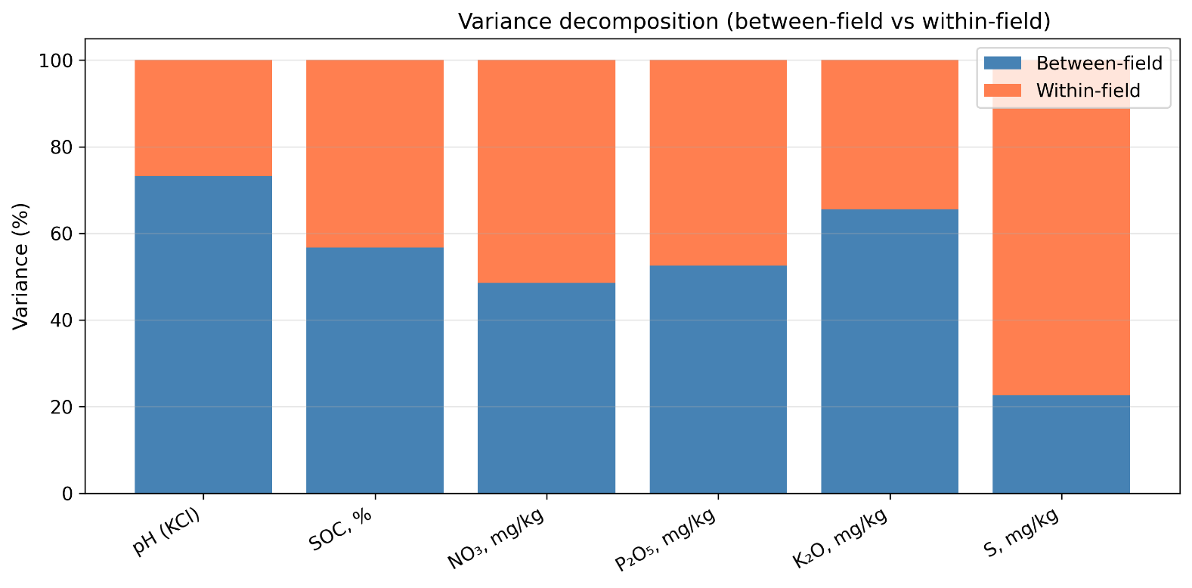
Figure 11. Variance decomposition: proportions of between-field (blue) and within-field (red) components for each property. pH demonstrates the dominance of zonal (between-farm) control (80.2%), whereas for S, NO₃, and P₂O₅, the local (within-farm) level prevails.
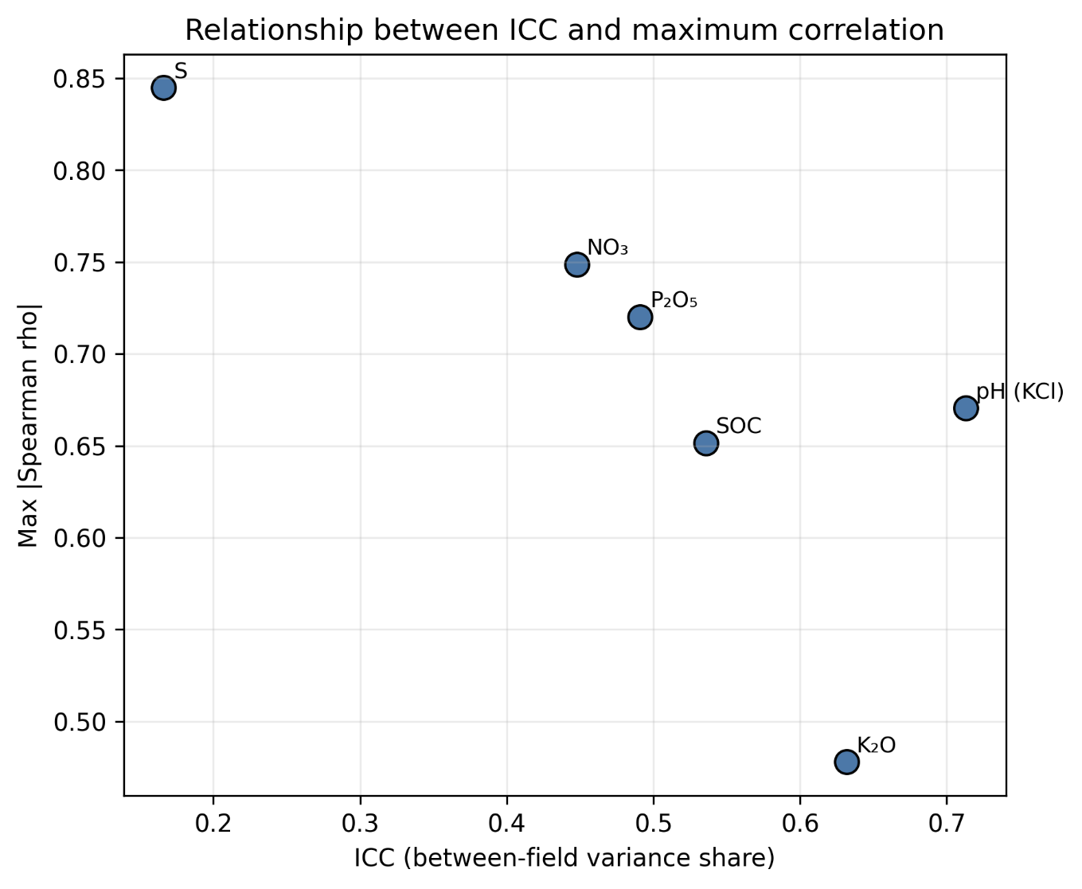
Figure 12. Relationship between ICC (proportion of between-field variance) and maximum |ρ| with RS features. Each point represents one soil property (n = 6). The relationship is illustrative rather than conclusive in nature.

3.8. Confounding analysis: pH as a mediator
Partial correlation analysis (Table 17) showed that pH significantly mediated the relationship between SOC and several spectral indices.
For summer NDVI, after controlling for pH, 41.9% of the observed SOC–NDVI correlation disappears. The likely mechanism is that pH is associated with the availability of nitrogen and micronutrients (Fe, Mn, Zn), which presumably modulates vegetation activity that is then erroneously interpreted as an "indicator" of SOC. In contrast, for late summer, pH suppresses (C= -13.7%) the true correlation: after removing the pH effect, the SOC–NDVI relationship strengthens (0.082→0.093), indicating a more direct (less mediated) influence of SOC on late-season productivity, likely via water retention capacity.
The identified confounding demonstrated the necessity of controlling for pH when using NDVI as a predictor of SOC (Figure 13). Additional control for MAP and latitude showed that when concurrently accounting for three covariates (pH, MAP, latitude), the SOC–NDVI_{summer} correlation decreased to ρ_{∂|pH MAP lat} = 0.051 (C=65%). In contrast, SOC– SOC–NDVI_{late summer} remained at ρ∂=0.088, which apparently indicates greater genuineness of the late-summer signal. However, the confounding analysis was performed for a limited number of pairs. Extending this conclusion to other indices and soil properties, as well as evaluating non-linear relationships (e.g., distance correlation), requires further validation.
Table 17. pH Confounding in the SOC – Spectral Indices Correlation.
Pair | ρ₀ | ρ_{∂|pH} | C_{pH},% | Interpretation
SOC – NDVI_{summer} | 0.145 | 0.084 | 41.9% | pH mediates > 40%
SOC – NDVI_{late summer} | 0.082 | 0.093 | -13.7% | pH suppresses the relationship
Extended control $Z\text{=}\{\text{pH, MAP, }\text{latitude}\}$:
SOC – NDVI_{summer} | 0.145 | 0.051 | 64.8% | pH + climate confounding > 60%
SOC – NDVI_{late summer} | 0.082 | 0.088 | -7.3% | The relationship remains robust
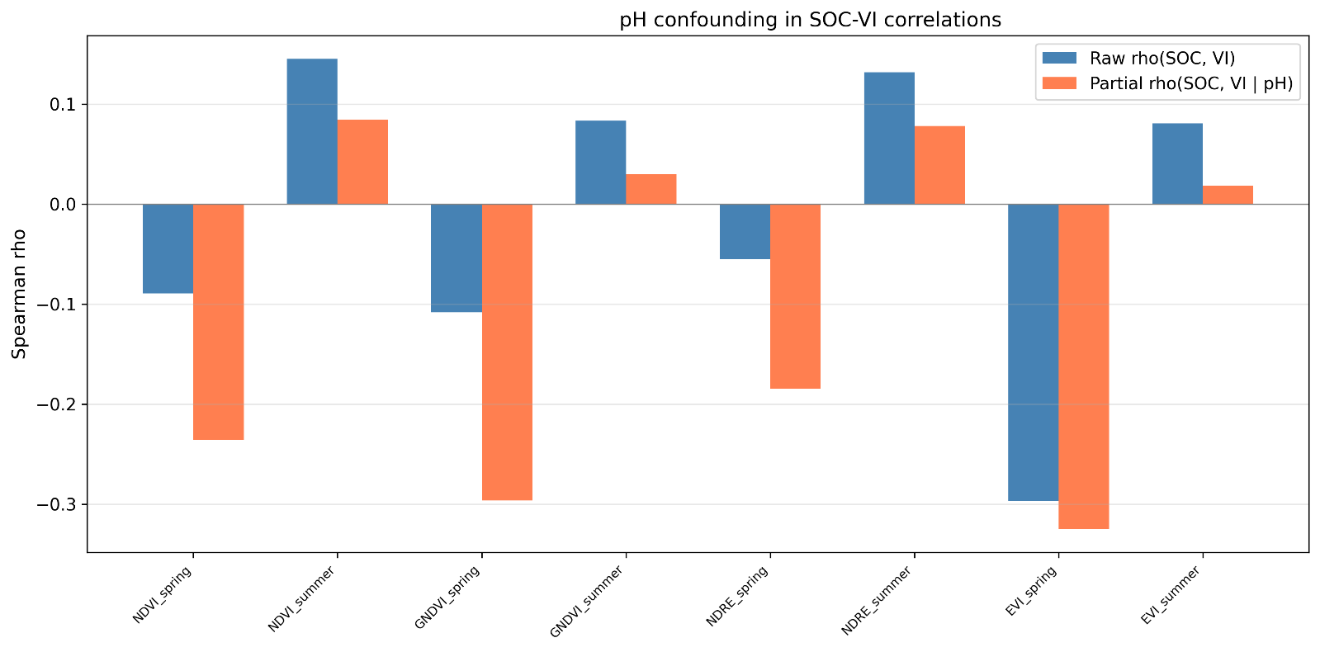
Figure 13. pH confounding: baseline (ρ₀) and partial (ρ_{∂|pH}) correlations of SOC with spectral vegetation indices (NDVI, GNDVI, NDRE, EVI — summer and spring). The difference between the columns quantifies the proportion of the correlation mediated by pH.

3.9. Derived soil properties
Derived indicators (Table 18) exhibited several correlations that exceed those of individual properties.

Table 18. Correlations exceeding those of individual properties.
Derived soil indicator | RS feature | ρ | Physical meaning
P₂O₅/K₂O | Slope | -0.555 | Topolateral redistribution
S/NO₃ | mean GNDVI | + 0.478 | S–N balance → vegetation
SOC×NO₃ | GNDVI$\text{-}$NDRE_{spring} | -0.456 | Organic N pool → chlorophyll
Mineralization index | NIRL8, spring | -0.472 | Nitrification → NIR
The correlation of P₂O₅/K₂O with slope was most noteworthy (ρ = -0.555). To evaluate whether the ratio itself provides a synergistic increase, a comparison with individual properties and alternative combinations was performed: ρ(P₂O₅, slope) = -0.452; ρ(K₂O, slope) = +0.251; ρ(P₂O₅× K₂O, slope)= -0.305; ρ(P₂O₅- K₂O, slope)= -0.520. Thus, the ratio yielded the highest |ρ|, exceeding both individual properties and their product. The signs of the P–slope and K–slope correlations were opposite, which algebraically enhances the contrast upon division. A permutation test (N=5000, independent permutation of P and K) confirmed that the observed |ρ|= 0.555 was not caused by an algebraic artifact (P(|ρ_{perm}|)≥0.555) < 10⁻⁴). Concurrently, a portion of the enhancement, Δ|ρ|= +0.10 (compared to P₂O₅ alone), is due to the opposite signs of the individual correlations.

4. Discussion

4.1. Spectral configurations: what works and why

The central empirical result of the present work is the differentiated informativeness of spectral configurations across soil properties. Below we formulate answers to each of the four objectives (i)–(iv) stated in the Introduction.

(i) Which indices carry the most information. The hierarchy of predictability (|ρ|max) of spectral features replicates the hierarchy of all features: pH (|ρ| = 0.670 with GNDVI_L8,spring) ≫ P2O5 (0.525, GLCM-entropy) > K2O (0.478, BSI_S2,spring) > NO3 (0.431, SAVI_S2,spring) > S (0.383, SAVI_L8,late-summer) > SOC (0.368, slope). Notably, for P2O5 all five leading predictors are GLCM textures (entropy and ASM of Red/NIR bands of the autumn composite), indicating textural heterogeneity as an integral indicator of fertility. For K2O the leading 4 out of 5 predictors are spectral (BSI, GNDVI, B4, B12), consistent with the hypothesis of mineralogical control (illitic clays, SWIR absorption). For NO3 and S, SAVI and GNDVI of the late-summer season dominate, reflecting the role of vegetation as an integrator of nutrient availability.

(ii) Seasonal modulation. The Wilcoxon test (Table 11) confirmed a statistically significant advantage of spring composites for K2O (p < 10⁻⁴, 26/26 indices) and P2O5 (p < 10⁻⁴, 20/26). This is consistent with the physical mechanism: bare soil in spring directly reflects mineralogical composition, whereas in summer the pixel is dominated by vegetation. NO3, on the contrary, correlates better with summer indices (NDVI, EVI at peak vegetation), reflecting its role as a limiting nutrient. For pH, SOC and S no seasonal differentiation was detected.

(iii) Composites vs. singles. Of the 110 composite configurations, only one — GNDVI×BSI for K2O (Δ|ρ| = +0.010) — robustly outperformed its best single counterpart. For NO3 (GNDVI−NDRE, Δ = −0.015) and S (mean_NDVI, Δ = −0.023) the composites approached the singles but did not surpass them, indicating saturation of the informativeness of simple indices. For pH (Δ = −0.079), SOC (Δ = −0.092) and P2O5 (Δ = −0.135) the single indices remain substantially more informative than the composites. Thus, composite configurations rarely outperform the best single indices; the only gain (K2O) is achieved through a mechanistically meaningful combination of orthogonal aspects of vegetation (GNDVI) and bare soil (BSI).

(iv) Confounding. Partial correlations (Section 3.3.1) showed that K2O and S are virtually independent of the latitudinal gradient (Δ < 10% after controlling for MAP and latitude) — these are local soil signals. For pH, P2O5 and NO3 the confounding contribution is 10–26%; for SOC — 40%, which questions the direct interpretation of topographic predictors. The confounding of pH in the SOC–NDVI correlation (42%, Section 3.8) is of practical importance: predictive models of SOC must explicitly control for acidity.

4.2. Properties with zonal control: pH, SOC, and K2O
Among the six studied properties, three (pH, SOC, and K₂O) stand out because their spatial variability is predominantly driven by zonal factors (inter-farm variance proportion of 45–57%, ICC of 0.54–0.71, and declastered Moran I ≥ 0.50). Notably, these exact properties occupy the top tiers of the predictability hierarchy, although the nature of their relationship with remote sensing data differs substantially for each.
For pH (|ρ|= 0.67 with GNDVI), the zonal climatic gradient apparently plays a defining role: the northward increase in moisture (ρ_{pH-MAP} = + 0.66) intensifies carbonate leaching, shaping a smooth decline in pH over a distance of ~500 km [39]. Concurrently, the acidic soils (pH 5.3–6.5) in the northern part of the region fall within the optimal range for cereals, which is likely captured via early-spring vegetation dynamics (GNDVI [40]). Partial correlations indicate that 82% of the pH–GNDVI relationship is retained after controlling for MAP and latitude, meaning the relationship is not merely a spatial artifact. The correlation with slope (ρ = +0.61), partly driven by lateral moisture movement [41], warrants cautious interpretation: even at slopes below 3°, elevation differences can determine the intensity of carbonate leaching; however, 46% of this relationship is explained by the latitudinal moisture gradient. It should be noted that we lack data on the Fe, Mn, and Zn content in plants. Thus, the hypothesis regarding the "pH → micronutrient availability → chlorophyll" pathway remains unverified. Nevertheless, the three sources of information (spectral, climatic, and topographic) appear partially independent, which provides potential for multi-predictor modeling.
In contrast, K₂O exhibits a different pattern. Given its moderate correlation (|ρ|= 0.48), controlling for MAP and latitude reduces it by only 4%, and the latitudinal gradient is virtually absent (ρ_{lat} =-0.02, p = 0.51). This suggests that exchangeable potassium is linked to the content of illitic clay minerals [33], which are sensitive to BSI and SWIR channels via soil color and texture. If this interpretation holds true, K₂O should yield the most stable results during spatial cross-validation. However, mineralogical control cannot be entirely decoupled from potential differences in farm-level potassium fertilization: without fertilizer application data, an alternative anthropogenic interpretation remains possible.
At first glance, the position of SOC (|ρ|= 0.35, ICC = 0.54) appears unexpected, considering that organic carbon is the most extensively studied property in digital soil mapping literature. Approximately 40% of the SOC–slope correlation is explained by latitudinal moisture, while 42% of the SOC–NDVI_{summer} correlation is mediated by pH (section 3.8). In addition, the data were acquired from vegetated crops, where the direct spectral response of SOC (absorption in VNIR/SWIR) is largely masked by the vegetation cover [42].
The result of |ρ|= 0.35 ($R_{\text{equiv}}^{2}$ ≈ 0.12) is substantially lower than the R² = 0.70 achieved by [14]. However, their study was conducted on bare soils, which represents a fundamentally different scenario. Under the conditions of studied region, additional noise is introduced by a wide moisture range (250–400 mm/year) and crop diversity. Apparently, for SOC in continental steppe environments, either bare soil composites [43; 44] or hyperspectral data are required.

4.3. Properties with local and anthropogenic control: P2O5, NO3, and S
The remaining three properties, P₂O₅, NO₃, and S, are characterized by the predominance of local (field-level) and anthropogenic variance components (≥35% of the field component, Table 13). Their correlations with remote sensing data are more difficult to interpret, as the observed relationships may reflect both soil-climatic gradients and spatially heterogeneous agricultural practices in an unknown proportion and decoupling these two sources is impossible without data on fertilization and crop rotations.
The relationship between P₂O₅ and the growing season temperature (ρ= +0.48), which is retained after controlling for MAP and latitude (Δ= -10%), poses an intriguing methodological question. Why does linear residualization by latitude fail to eliminate the temperature effect if GS_{temp} is essentially a proxy for latitude? We hypothesize that the relationship between GS_{temp} and latitude is non-linear (incorporating an elevational component), and the residual component of GS_{temp} following linear control still contains information that cannot be reduced to latitude. Validation using quadratic or generalized additive model (GAM) residuals was not performed and remains a task for future work. Furthermore, it cannot be ruled out that southern regions with intensive agriculture receive higher phosphorus fertilizer rates — and without mapping data on fertilizer application, decoupling these two factors is impossible.
Nitrate nitrogen apparently represents a special case due to its high lability. In the autumn subsample (n = 54); the reduction from 268 to 54 was caused by missing satellite data due to cloud cover), |ρ| reached 0.78–0.81; however, the confidence interval [0.64;0.87] was too wide for practical conclusions. The idea of synchronizing soil sampling with the satellite imagery date was physically motivated as the half-life of the nitrate pool was 2–4 weeks, but this can only be confirmed through a targeted experimental design.
Available sulfur resides at the bottom of the hierarchy (|ρ|< 0.38, ICC = 0.17, I_{declast} = 0.15, p_{spat\perm}= 0.087) and has essentially proven unpredictable from multispectral data. Sulfates lack diagnostic absorption bands in the 400–2500 nm range, and the S content is determined by fertilization history and atmospheric deposition, i.e. by the factors inaccessible to optical sensors. Declustering reduces Morann I from 0.77 to 0.15, resolving the "high Moran I with an ICC = 0.17" paradox and further confirming the artifactual nature of the apparent spatial structure. A similar issue was noted in [15].

4.4. The effect of pH confounding on spatial structure
The identified confounding with 42% of the SOC–NDVI correlation mediated by pH has, in our view, important practical significance that warrants the attention. If acidity is not controlled for in a predictive SOC model, the model risks reproducing patterns of pH rather than organic carbon [37]. For the steppe zone, where pH and SOC are linked by opposite zonal trends (ρ_{pH-SOC} = -0.23), this issue becomes particularly acute. The practical recommendation is to either include pH as an explicit predictor or prioritize late-summer indices, for which the confounding is substantially lower (C_{pH}= -14%).
Two-level variance decomposition reinforces this rationale: for pH, 80% of the variability is concentrated at the farm and field levels, whereas for S, the ICC is only 0.17. This pattern is generally consistent with the SCORPAN model framework: properties determined by climate and topography are predicted more reliably from remote sensing data than those predominantly under anthropogenic control.

4.5. Limitations of the study
The interpretation of the obtained results is constrained by the following limitations:
- Spatiotemporal confounding: The 2022 and 2023 samples cover non-overlapping territories (5 vs. 15 farms). Consequently, the observed correlations may partially reflect the effect of the clustering of specific farms in a given year. A quantitative assessment of this effect is possible only through spatial cross-validation.
- Point-support mismatch: Comparing point soil samples (support ~10 m) with ERA5 pixels (~9 km) leads to spatial smoothing. Consequently, correlations with ERA5 reflect exclusively large-scale regional gradients rather than local predictive capacity.
- Lack of field management history: For labile forms (NO₃, P₂O₅, S), the observed relationships may be largely determined by fertilizer application rates. Without detailed maps of fertilizer application and crop rotations, the interpretation of correlations with remote sensing data for these elements remains conditional.
- Statistical assumptions: Rank correlation is limited to monotonic relationships. Thus, non-linear effects remain beyond the scope of this analysis. Due to high spatial autocorrelation (Moran I up to 0.86), the effective sample size drops to 81–802, making nominal p-values merely upper bounds of significance.
The established patterns are specific to the Chernozem–Kashtanozem zone of Northern Kazakhstan and cannot be directly extrapolated to other soil-climatic conditions.

5. Conclusions
A correlation analysis of 1,085 specimens and 622 features (512 base + 110 composite) allowed us to establish a hierarchy of predictability of soil properties in Northern Kazakhstan from remote sensing data and to quantitatively evaluate the informativeness of different spectral configurations. Key results on spectral configurations: Predictability hierarchy: pH (|ρ| = 0.670, GNDVI_L8,spring) ≫ P2O5 (0.525, GLCM-entropy of the autumn Red band) > K2O (0.478, BSI_spring) > NO3 (0.431, SAVI_spring) > S (0.383, SAVI_late-summer) > SOC (0.368, slope). For K2O all leading predictors are spectral; for P2O5 all are GLCM-textures. Seasonal modulation is statistically significant for K2O (spring ≫ summer, p < 10⁻⁴, 26/26 indices) and P2O5; NO3 is better predicted by summer indices. For pH, SOC, S no seasonal differentiation. Informative composite configurations: of 110 composite features, only GNDVI×BSI_spring for K2O (ρ = −0.488, Δ|ρ| = +0.010 vs single BSI) robustly outperforms the single index. For NO3 (GNDVI−NDRE: −0.416) and S (mean_NDVI: +0.360) the composites approach but do not surpass the singles. Inter-index combinations dominate for mineralogically driven properties; multi-seasonal aggregates — for properties with variable seasonal informativeness. Confounding: 82% of the pH–GNDVI correlation survives after controlling for MAP and latitude; K2O and S are virtually independent of the latitudinal gradient (Δ < 10%); for SOC 42% of the correlation with NDVI is mediated by pH. Spatial structure. High values of Moran I (0.51–0.86) and significant semivariogram ranges (up to 137 km for pH) make the application of spatial validation strategies — Field-LOFO-CV and Farm-LOFO-CV — mandatory when building predictive models. Sulfur turned out to be essentially unpredictable from multispectral data: declustering reduces Moran I from 0.77 to 0.15, and the ICC is only 0.17.

https://github.com/vel5id/science_SOC_predictinghttps://zenodo.org/records/19496423https://zenodo.org/records/19496443

Abbreviations
The following abbreviations are used in this manuscript:
DSM | Digital Soil Mapping
SOC | Soil Organic Carbon
GEE | Google Earth Engine
NDVI | Normalized Difference Vegetation Index
GNDVI | Green Normalized Difference Vegetation Index
BSI | Bare Soil Index
MSI | Moisture Stress Index
SAR | Synthetic Aperture Radar
DEM | Digital Elevation Model
GLCM | Gray-Level Co-occurrence Matrix
ICC | Intraclass Correlation Coefficient
FDR | False Discovery Rate
BH | Benjamini–Hochberg
DSM | Digital Soil Mapping
SOC | Soil Organic Carbon

References
- Montanarella, L.; Pennock, D.J.; McKenzie, N.J.; Badraoui, M.; Chude, V.; Baptista, I.; Mamo, T.; Yemefack, M.; Singh Aulakh, M.; Yagi, K.; et al. World’s Soils Are Under Threat. SOIL 2016, 2(1), 79–82. https://doi.org/10.5194/soil-2-79-2016
- Gebbers, R.; Adamchuk, V.I. Precision Agriculture and Food Security. Science 2010, 327(5967), 828–831. https://doi.org/10.1126/science.1183899
- Viscarra Rossel, R.A.; Walvoort, D.J.J.; McBratney, A.B.; Janik, L.J.; Skjemstad, J.O. Visible, Near Infrared, Mid Infrared or Combined Diffuse Reflectance Spectroscopy for Simultaneous Assessment of Various Soil Properties. Geoderma 2006, 131, 59–75. https://doi.org/10.1016/j.geoderma.2005.03.007
- Swinnen, J.; Burkitbayeva, S.; Schierhorn, F.; Prishchepov, A.V.; Müller, D. Production Potential in the ‘Bread Baskets’ of Eastern Europe and Central Asia. Global Food Secur. 2017, 14, 38–53. https://doi.org/10.1016/j.gfs.2017.03.005
- Kraemer, R.; Prishchepov, A.V.; Müller, D.; Kuemmerle, T.; Radeloff, V.C.; Dara, A.; Terekhov, A.; Frühauf, M. Long-Term Agricultural Land-Cover Change and Potential for Cropland Expansion in the Frmer Virgin Lands Area of Kazakhstan. Environ. Res. Lett. 2015, 10, 054012. https://doi.org/10.1088/1748-9326/10/5/054012
- Ben-Dor, E.; Chabrillat, S.; Demattê, J.A.M.; Taylor, G.R.; Hill, J.; Whiting, M.L.; Sommer, S. Using Imaging Spectroscopy to Study Soil Properties. Remote Sens. Environ. 2009, 113, S38–S55. https://doi.org/10.1016/j.rse.2008.09.019
- Viscarra Rossel, R.A.; Behrens, T. Using Data Mining to Model and Interpret Soil Diffuse Reflectance Spectra. Geoderma 2010, 158(1-2), 46–54. https://doi.org/10.1016/j.geoderma.2009.12.025
- Drusch, M.; Del Bello, U.; Carlier, S.; Colin, O.; Fernandez, V.; Gascon, F.; Hoersch, B.; Isola, C.; Laberinti, P.; Martimort, P.; et al. Sentinel-2: ESA’s Optical High-Resolution Mission for GMES Operational Services. Remote Sens. Environ. 2012, 120, 25–36. https://doi.org/10.1016/j.rse.2011.11.026
- Roy, D.P.; Wulder, M.A.; Loveland, T.R.; Woodcock, C.E.; Allen, R.G.; Anderson, M.C.; Helder, D.; Irons, J.R.; Johnson, D.M.; Kennedy, R.; et al. Landsat-8: Science and Product Vision for Terrestrial Global Change Research. Remote Sens. Environ. 2014, 145(5), 154–172. https://doi.org/10.1016/j.rse.2014.02.001
- Torres, R.; Snoeij, P.; Geudtner, D.; Bibby, D.; Davidson, M.; Attema, E.; Potin, P.; Rommen, B.; Floury, N.; Brown, M.; et al. GMES Sentinel-1 Mission. Remote Sens. Environ. 2012, 120, 9–24. https://doi.org/10.1016/j.rse.2011.05.028
- Farr, T.G.; Rosen, P.A.; Caro, E.; Crippen, R.; Duren, R.; Hensley, S.; Kobrick, M.; Paller, M.; Rodriguez, E.; Roth, L.; et al. The Shuttle Radar Topography Mission. Rev. Geophys. 2007, 45(2), RG2004. https://doi.org/10.1029/2005RG000183
- Hengl, T.; Mendes de Jesus, J.; Heuvelink, G.B.M.; Ruiperez Gonzalez, M.; Kilibarda, M.; Blagotić, A.; Shangguan, W.; Wright, M.N.; Geng, X.; Bauer-Marschallinger, B.; et al. SoilGrids250m: Global Gridded Soil Information Based on Machine Learning. PLoS ONE 2017, 12 (2), e0169748. https://doi.org/10.1371/journal.pone.0169748
- Muñoz-Sabater, J.; Dutra, E.; Agustí-Panareda, A.; Albergel, C.; Arduini, G.; Balsamo, G.; Boussetta, S.; Choulga, M.; De Rosnay, P.; Hersbach, H.; et al. ERA5-Land: A State-of-the-Art Global Reanalysis Dataset for Land Applications. Earth Syst. Sci. Data 2021, 13(9), 4349–4383. https://doi.org/10.5194/essd-13-4349-2021
- Castaldi, F.; Hueni, A.; Chabrillat, S.; Ward, K.; Buttafuoco, G.; Bomans, B.; Vreys, K.; Brell, M.; van Wesemael, B. Evaluating the Capability of the Sentinel-2 Data for Soil Organic Carbon Prediction in Croplands. ISPRS J. Photogramm. Remote Sens. 2019, 147, 267–282. https://doi.org/10.1016/j.isprsjprs.2018.11.026
- Vaudour, E.; Gomez, C.; Fouad, Y.; Lagacherie, P. Sentinel-2 Image Capacities to Predict Common Topsoil Properties of Temperate and Mediterranean Agroecosystems. Remote Sens. Environ. 2019, 223, 21–33. https://doi.org/10.1016/j.rse.2019.01.006
- Wadoux, A.M.J.C.; Minasny, B.; McBratney, A.B. Machine Learning for Digital Soil Mapping: Applications, Challenges and Suggested Solutions. Earth-Sci. Rev. 2020, 210, 103359. https://doi.org/10.1016/j.earscirev.2020.103359
- Yapiyev, V.; Gilman, C.P.; Kabdullayeva, T.; Suleimenova, A.; Shagadatova, A.; Duisembay, A.; Naizabekov, S.; Mussurova, S.; Sydykova, K.; Raimkulov, I.; et al. Top soil physical and chemical properties in Kazakhstan across a north-south gradient. Sci. Data 2018, 5, 180242. doi.org https://doi.org/10.1038/sdata.2018.242
- Yskak, A.; Yermoldina, G.T.; Nugmanov, A.B.; Rakhimbayev, B.S.; Suimenbayeva, Z.B.; Fominov, V.D.; Irzhanov, Z.B.; Paramonova, T.A.; Mamikhin, S.V.; Bulaev, A.G. Digital Soil Mapping of the Steppe Zone in Northern Kazakhstan: Predicting Agrochemical Properties of Soils Using Multimodal Satellite Data and Machine and Deep Learning Techniques. Agriculture 2026, 16, 1239. https://doi.org/10.3390/agriculture16111239
- Fick, S.E.; Hijmans, R.J. WorldClim 2: New 1-Km Spatial Resolution Climate Surfaces for Global Land Areas. Int. J. Climatol. 2017, 37(12), 4302–4315. https://doi.org/10.1002/joc.5086
- Pribyl, D.W. A Critical Review of the Conventional SOC to SOM Conversion Factor. Geoderma 2010, 156, 75–83. https://doi.org/10.1016/j.geoderma.2010.02.003
- Gorelick, N.; Hancher, M.; Dixon, M.; Ilyushchenko, S.; Thau, D.; Moore, R. Google Earth Engine: Planetary-Scale Geospatial Analysis for Everyone. Remote Sens. Environ. 2017, 202, 18–27. https://doi.org/10.1016/j.rse.2017.06.031
- Tucker, C.J. Red and Photographic Infrared Linear Combinations for Monitoring Vegetation. Remote Sens. Environ. 1979, 8(2), 127–150. https://doi.org/10.1016/0034-4257(79)90013-0
- Zevenbergen, L.W.; Thorne, C.R. Quantitative Analysis of Land Surface Topography. Earth Surf. Process. Landf. 1987, 12(1), 47–56. https://doi.org/10.1002/esp.3290120107
- Haralick, R.M.; Shanmugam, K.; Dinstein, I. Textural Features for Image Classification. IEEE Trans. Syst. Man Cybern. 1973, SMC-3 (6), 610–621. https://doi.org/10.1109/tsmc.1973.4309314
- Benjamini, Y.; Yekutieli, D. The Control of the False Discovery Rate in Multiple Testing Under Dependency. Ann. Stat. 2001, 29(4), 1165–1188. https://doi.org/10.1214/aos/1013699998
- Clifford, P.; Richardson, S.; Hémon, D. Assessing the Significance of the Correlation Between Two Spatial Processes. Biometrics 1989, 45(1), 123–134. https://doi.org/10.2307/2532039
- Dutilleul, P. Modifying the t Test for Assessing the Correlation Between Two Spatial Processes. Biometrics 1993, 49, 305–314. https://doi.org/10.2307/2532625
- Goovaerts, P. Geostatistics in Soil Science: State-of-the-Art and Perspectives. Geoderma 1999, 89 (1-2), 1–45. https://doi.org/10.1016/S0016-7061(98)00078-0
- Webster, R.; Oliver, M.A. Geostatistics for Environmental Scientists, 2nd ed.; John Wiley & Sons: Chichester, UK, 2007. https://doi.org/10.1002/9780470517277
- Conover, W.J. Practical Nonparametric Statistics, 3rd ed.; John Wiley & Sons: New York, NY, USA, 1999.
- Legendre, P.; Legendre, L. Numerical Ecology, 3rd ed.; Elsevier: Amsterdam, The Netherlands, 2012
- Wilding, L.P. Spatial Variability: Its Documentation, Accommodation, and Implication to Soil Surveys. In Soil Spatial Variability; Nielsen, D.R., Bouma, J., Eds.; Pudoc: Wageningen, The Netherlands, 1985; pp. 166–189.
- Barré, P.; Fernandez-Ugalde, O.; Virto, I.; Velde, B.; Chenu, C. Impact of Phyllosilicate Mineralogy on Organic Carbon Stabilization in Soils: Incomplete Knowledge and Exciting Prospects. Geoderma 2014, 235–236, 382–395. https://doi.org/10.1016/j.geoderma.2014.07.029
- Cambardella, C.A.; Moorman, T.B.; Novak, J.M.; Parkin, T.B.; Karlen, D.L.; Turco, R.F.; Konopka, A.E. Field-Scale Variability of Soil Properties in Central Iowa Soils. Soil Sci. Soc. Am. J. 1994, 58(5), 1501–1511. https://doi.org/10.2136/sssaj1994.03615995005800050033x
- Kerry, R.; Oliver, M.A. Average Variograms to Guide Soil Sampling. Int. J. Appl. Earth Obs. Geoinf. 2004, 5(4), 307–325. https://doi.org/10.1016/j.jag.2004.07.005
- Legendre, P. Spatial Autocorrelation: Trouble or New Paradigm? Ecology 1993, 74(6), 1659–1673. https://doi.org/10.2307/1939924
- Roberts, D.R.; Bahn, V.; Ciuti, S.; Boyce, M.S.; Elith, J.; Guillera-Arroita, G.; Hauenstein, S.; Lahoz-Monfort, J.J.; Schröder, B.; Thuiller, W.; et al. Cross-Validation Strategies for Data with Temporal, Spatial, Hierarchical, or Phylogenetic Structure. Ecography 2017, 40, 913–929. https://doi.org/10.1111/ecog.02881
- Wadoux, A.M.J.C.; Heuvelink, G.B.M.; de Bruin, S.; Brus, D.J. Spatial Cross-Validation Is Not the Right Way to Evaluate Map Accuracy. Ecol. Modell. 2021, 457, 109692. https://doi.org/10.1016/j.ecolmodel.2021.109692
- Jenny, H. Factors of Soil Formation: A System of Quantitative Pedology; McGraw-Hill: New York, NY, USA, 1941.
- Gitelson, A.A.; Merzlyak, M.N. Signature Analysis of Leaf Reflectance Spectra: Algorithm Development for Remote Sensing of Chlorophyll. J. Plant Physiol. 1996, 148(3-4), 494–500. https://doi.org/10.1016/S0176-1617(96)80284-7
- McBratney, A.B.; Mendonça Santos, M.L.; Minasny, B. On Digital Soil Mapping. Geoderma 2003, 117 (1-2), 3–52. https://doi.org/10.1016/S0016-7061(03)00223-4
- Stenberg, B.; Viscarra Rossel, R.A.; Mouazen, A.M.; Wetterlind, J. Visible and Near Infrared Spectroscopy in Soil Science. Adv. Agron. 2010, 107, 163–215. https://doi.org/10.1016/S0065-2113(10)07005-7
- Silvero, N.E.Q.; Demattê, J.A.M.; Amorim, M.T.A.; Santos, N.R.B.; Rizzo, R.; Safanelli, J.L.; Poppiel, R.R.; Mendes, W.S.; Bonfatti, B.R. Soil Variability and Quantification Based on Sentinel-2 and Landsat-8 Bare Soil Images: A Comparison. Remote Sensing of Environment 2021, 252, 112117. https://doi.org/10.1016/j.rse.2020.112117
- Dvorakova, K.; Shi, P.; Limbourg, Q.; van Wesemael, B. Soil Organic Carbon Mapping from Remote Sensing: The Effect of Crop Residues. Remote Sens. 2020, 12, 1913. https://doi.org/10.3390/rs12121913
Disclaimer/Publisher’s Note: The statements, opinions and data contained in all publications are solely those of the individual author(s) and contributor(s) and not of MDPI and/or the editor(s). MDPI and/or the editor(s) disclaim responsibility for any injury to people or property resulting from any ideas, methods, instructions or products referred to in the content.

