
SYMBIOSIS INSTITUTE OF TECHNOLOGY, PUNE
Symbiosis International (Deemed University)
(Established under section 3 of the UGC Act, 1956)
Re-accredited by NAAC with ‘A’ grade (3.58/4) | Awarded Category – I by UGC
Founder: Prof. Dr. S. B. Mujumdar, M. Sc., Ph. D. (Awarded Padma Bhushan and Padma Shri by President of India)

Assignment No. 02

Subject: | DevOps Lab
TCODE: | TE7950
Name of Student | Velagala Prapul Krishna Reddy
PRN No. | 23070122232
Branch | CSE, Batch (2023-27), L3
Academic Year &  Semester | 25 – 26, Sem VII
Date of Performance | 16th July, 2026
Title of Assignment: | Git Branching & Merging
Theory: | Git branching is a feature that allows developers to work on new features or bug fixes independently without affecting the main project. A branch creates a separate line of development where changes can be made safely. Once the work is completed and tested, the branch can be merged back into the main branch using the git merge command. This workflow helps in parallel development, better collaboration, and maintaining a stable main branch.  Commands Used  - git status – Checked the current repository status and confirmed that the working tree was clean and the local main branch was up to date.  - git checkout -b feature-update – Created a new branch named feature-update and switched to it.  - git branch – Displayed all local branches and verified that feature-update was the active branch.  - git status – Checked the repository status after modifying the README.md file and confirmed that the changes were detected.  - git add README.md – Added the modified README.md file to the staging area.  - git commit -m "Update README on feature branch" – Committed the staged changes to the feature-update branch with a descriptive commit message.  - git status – Verified that the working tree was clean after committing the changes.  - git checkout main – Switched back to the main branch.  - type README.md (Windows) – Displayed the contents of the README.md file to verify that the changes from the feature branch were not yet present.  - git merge feature-update – Merged the feature-update branch into the main branch using a fast-forward merge.  - type README.md (Windows) – Verified that the merged changes were now present in the README.md file.  - git push origin main – Pushed the updated main branch with the merged changes to the remote GitHub repository.
Implementation: | Step 1: Verify Current Repository Status  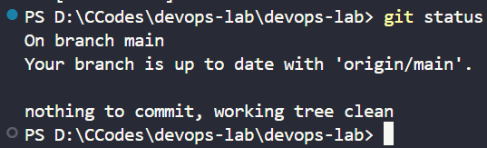  Verified Repository Status — Checked the repository status and confirmed that the working tree was clean and the local main branch was up to date with the remote repository.  Step 2: Create and Switch to a New Branch  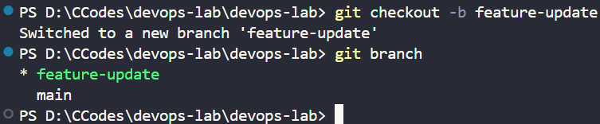  Created Feature Branch — Created a new branch named feature-update and switched to it successfully using git checkout -b.  Step 3: Modify README.md  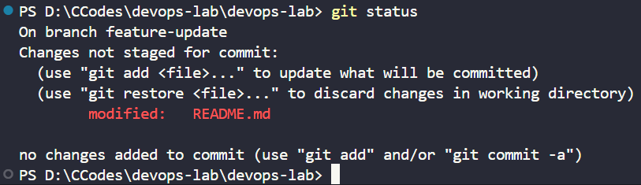  Modified README.md — Updated the README.md file on the feature-update branch and verified that Git detected the modified file.  Step 4: Stage and Commit the Changes  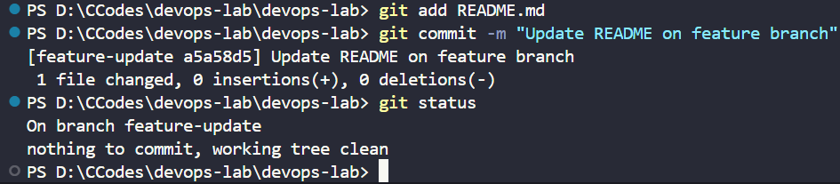  Committed Feature Changes — Staged and committed the updated README.md file on the feature-update branch with a descriptive commit message.  Step 5: Switch Back to Main Branch  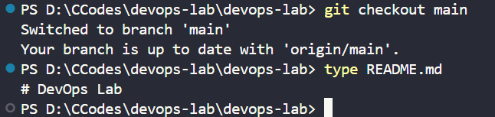  Switched to Main Branch — Switched back to the main branch and verified that the feature branch changes were not yet available.  Step 6: Merge the Feature Branch  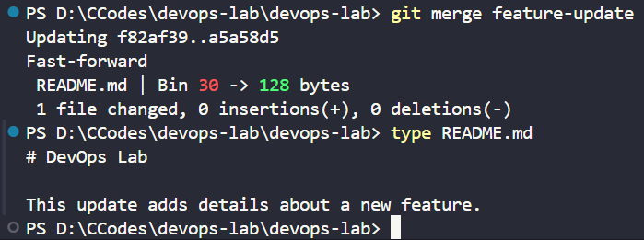Merged Feature Branch — Successfully merged the feature-update branch into the main branch using a fast-forward merge.  Step 7: Push Updated Main Branch  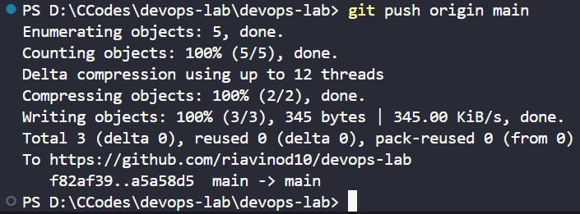Pushed Updated Main Branch — Uploaded the merged changes from the local main branch to the remote GitHub repository.  Step 8: Verify on GitHub  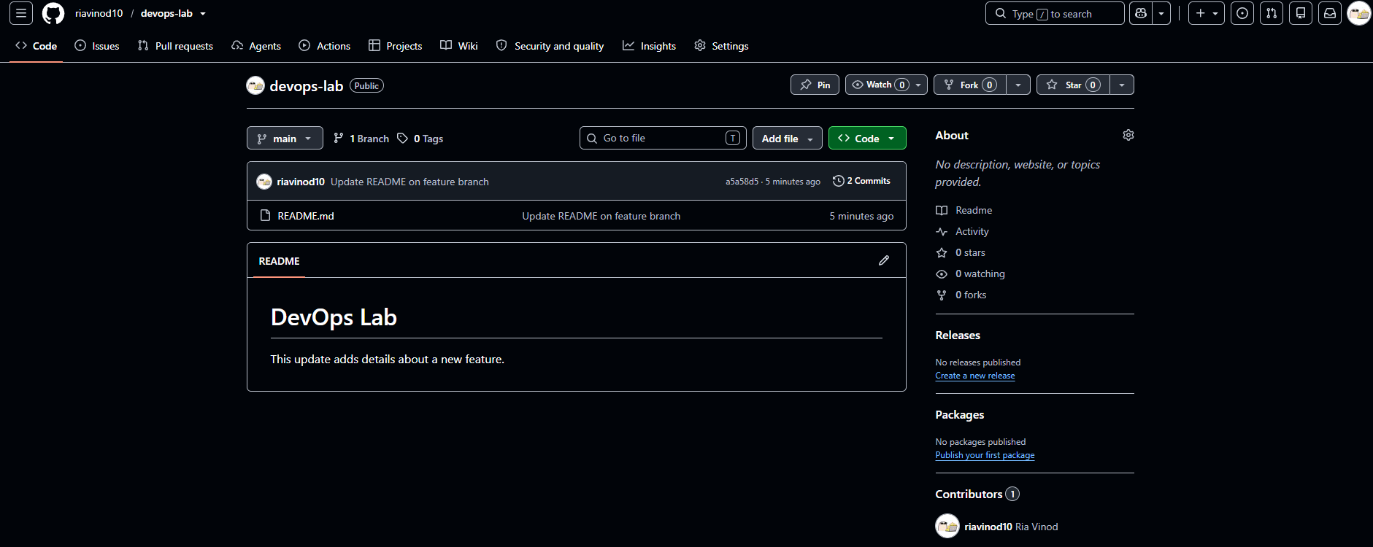  Repository Verified — Verified on GitHub that the merged changes are present in the main branch and that the commit history reflects both commits.

Subject Faculty Name: Prof. Arijit Dutta

