Emirates - Guidelines

Dina,
Here are some examples of images and topics that we would like clarification on as we are going through all of the lessons.


Yes
No
Comments
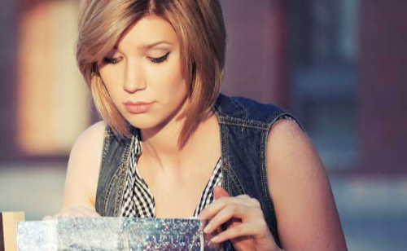

Yes
No
Comment

Yes
No
Comment
 Yoga outfits and people in the yoga studio.
Yes
No
Comments

Yes
No
Comments

Yes
No
Comments

Questions
Do people on stage such as ballerinas / opera singers need covered arms as well?
Yes
No
Comments

Is a regular bathing suit on women who are swimming or on the water ie: on a surfboard or paddleboard acceptable?
Yes
No
Comments
Acceptable if it’s a one piece bathing suit

Can a brother and sister be touching in images?
Yes
No
Comments

Can male female friends be touching ie: on the shoulder or arm?
Yes
No
Comments

At places where people are having acupuncture or at a spa can we show the woman’s shoulders or back uncovered? Is this different for men?
Yes
No
Comments
Can show people at a spa, just not with their backs uncovered. Same for men.

Can we show wine glasses that are empty on a table set for dinner?
Yes
No
Comments

Can we show wine glasses with water in them?
Yes
No
Comments

In a conversation can a woman talk about talk about dancing with a man?
Yes
No
Comments

Is a text talking about Malala Yousafzai and the work she is doing okay?
Yes
No
Comments

Can women complain in conversations that their husbands do not help with the housework?
Yes
No
Comments

Can men or women comment that someone is beautiful or handsome?
Yes
No
Comments

Is it okay in a text for a woman friend to add her phone number to her male friend’s phone?
Yes
No
Comments

Can people talk about being healthy because they do not drink alcohol or take drugs?
Yes
No
Comments

We have a text that is an Inuit ‘creation of sea animals’ folk tale where a mysterious stranger (who may have been an animal transformed into a man) stay with a family - the daughter subsequently becomes pregnant.
Yes
No
Comments

We have a story where elephant claves get drunk eating fermented fruit and other elephants find a fermented drink in an African village, get drunk, then storm through the village and into homes to find more of the alcoholic drink.
Yes
No
Comments

Thank you for your help with this.

