# Load the libraries  
library(readr)

## Warning: package 'readr' was built under R version 4.4.1

library(ggplot2)

## Warning: package 'ggplot2' was built under R version 4.4.1

library(lubridate)

## Warning: package 'lubridate' was built under R version 4.4.1

##   
## Attaching package: 'lubridate'

## The following objects are masked from 'package:base':  
##   
## date, intersect, setdiff, union

# Load the data from the CSV file  
file_path <- "C:\\Users\\ASUS\\Downloads\\velan.csv"  
data <- read_csv(file_path)

## Rows: 267 Columns: 9  
## ── Column specification ────────────────────────────────────────────────────────  
## Delimiter: ","  
## chr (4): Region, Date, Frequency, Region2  
## dbl (5): Estimated Unemployment Rate (%), Estimated Employed, Estimated Labo...  
##   
## ℹ Use `spec()` to retrieve the full column specification for this data.  
## ℹ Specify the column types or set `show_col_types = FALSE` to quiet this message.

# Convert Date column to Date type  
data$Date <- dmy(data$Date)

# Line plot of Estimated Unemployment Rate over Time  
ggplot(data, aes(x = Date, y = `Estimated Unemployment Rate (%)`, color = Region)) +  
 geom_line() +  
 labs(title = "Estimated Unemployment Rate over Time", x = "Date", y = "Unemployment Rate (%)")

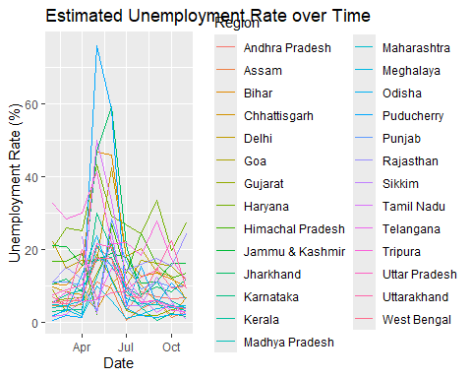

# Bar chart of Estimated Employed by Region  
ggplot(data, aes(x = Region, y = `Estimated Employed`, fill = Region)) +  
 geom_bar(stat = "identity") +  
 labs(title = "Estimated Employed by Region", x = "Region", y = "Estimated Employed") +  
 theme(axis.text.x = element_text(angle = 45, hjust = 1))

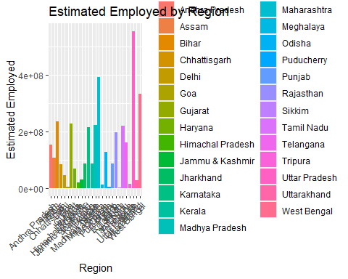

# Scatter plot of Labour Participation Rate vs. Unemployment Rate  
ggplot(data, aes(x = `Estimated Labour Participation Rate (%)`, y = `Estimated Unemployment Rate (%)`, color = Region)) +  
 geom_point() +  
 labs(title = "Labour Participation Rate vs. Unemployment Rate", x = "Labour Participation Rate (%)", y = "Unemployment Rate (%)")

