PHASE 5 – PROJECT DEVELOPMENT
AI StudyBuddy

INTRODUCTION:
TEAM ID: SWTID-2026-9682
TEAM LEADER : VELAN.P
MAIL ID: velan4490@gmail.com

TEAM MEMBERS:
NAME | MAIL ID
THARUN KUMAR.S | tharunkumar2610@gmail.com
VARUN KRISHNA.S.N | varunzoro2@gmail.com
VIGNESH.B | vigneshbala302@gmail.com

1. Development Overview
LearnMate – AI StudyBuddy is developed as a modular Node.js and Express.js backend using MongoDB/Mongoose and Google Gemini AI.

2. Project Setup
- Create the AI StudyBuddy project folder and open it in Visual Studio Code.
- Initialize the Node.js project.
- Install Express, Mongoose, bcryptjs, jsonwebtoken, cors, dotenv, multer and @google/genai.
- Install Nodemon for development.
- Create index.js, .env, package.json and .gitignore.

3. Environment Configuration
Required environment variables include PORT=5000, MONGO_URI, JWT_SECRET and GEMINI_API_KEY. Secret values must not be uploaded publicly.

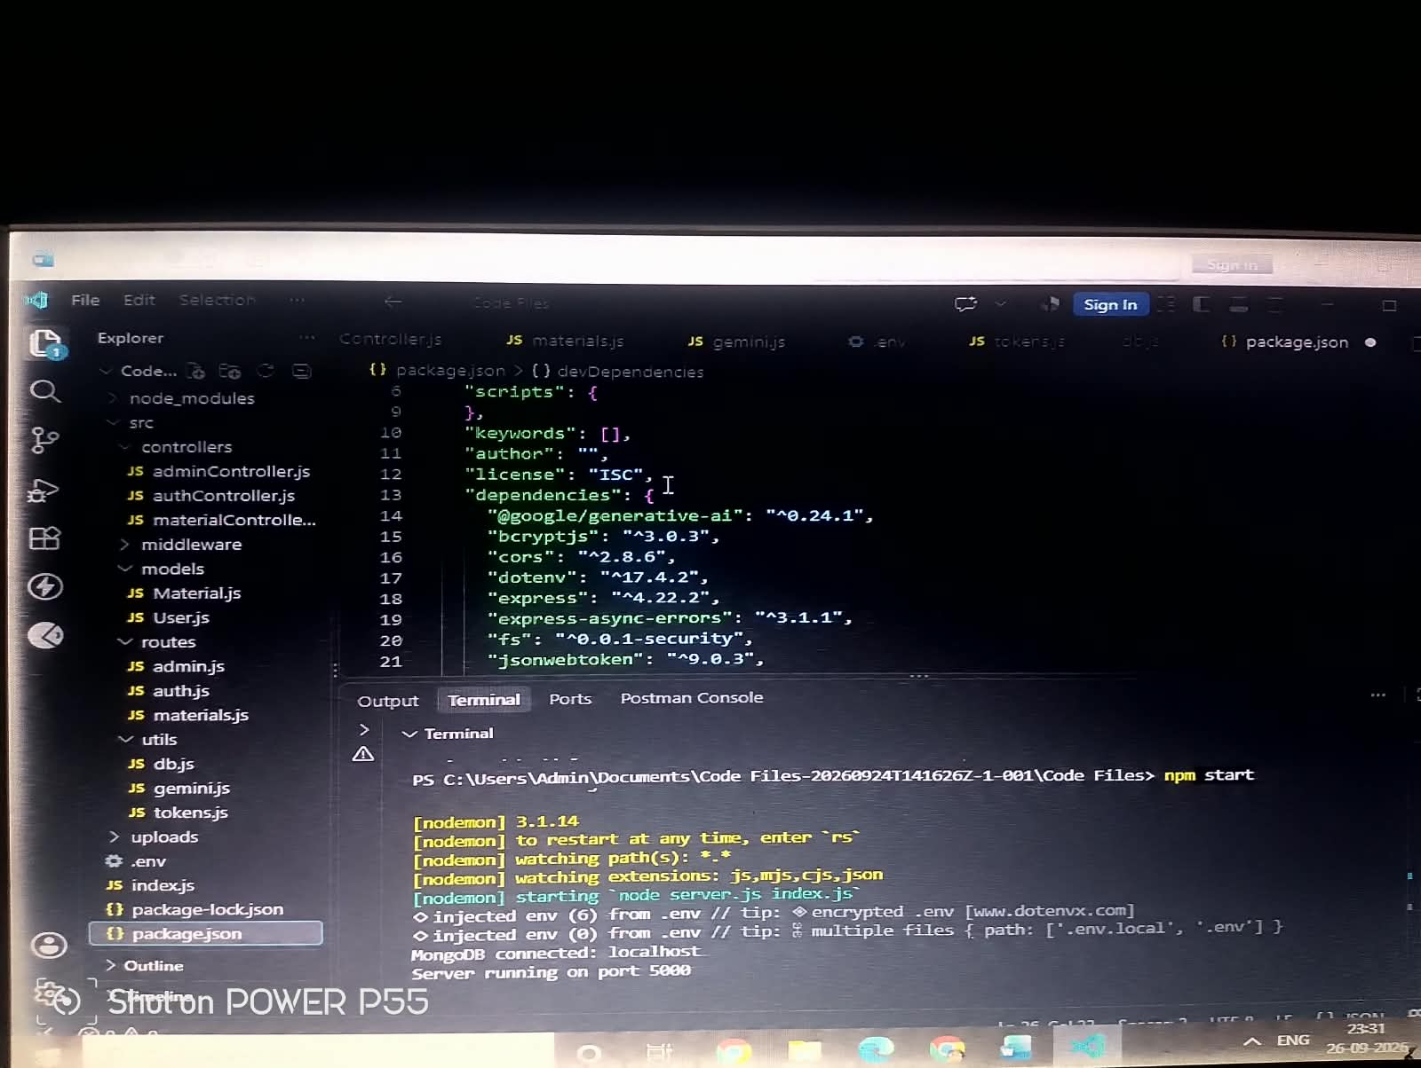

4. Backend Modules
- index.js – initializes Express, middleware, database connection and routes.
- src/utils/db.js – establishes MongoDB connection using Mongoose.
- src/middleware/auth.js – verifies JWT access tokens and role-based authorization.
- src/utils/gemini.js – communicates with Google Gemini for summaries, flashcards, quizzes and study plans.
- src/middleware/upload.js – handles and validates study-material uploads.

5. Database Development
- User schema stores name, email, password and role.
- Study Material schema stores uploaded learning content.
- MongoDB stores users, study materials and AI-generated learning resources.

6. API Endpoints
Method / Endpoint | Purpose
POST /api/auth/register | Register user
POST /api/auth/login | Login and generate JWT
POST /api/material/upload | Upload study material
POST /api/materials/:id/summarize | Generate summary
POST /api/ai/flashcards | Generate flashcards
POST /api/ai/quiz | Generate quiz
POST /api/ai/study-plan | Generate study plan

7. Development Deliverables
- Complete backend source code
- Database schemas
- Authentication middleware
- AI integration
- File-upload middleware
- REST API endpoints

API Study Material and AI Features :
The supplied API tests demonstrate material upload and AI-assisted generation of a summary, flashcards, quiz and study plan.

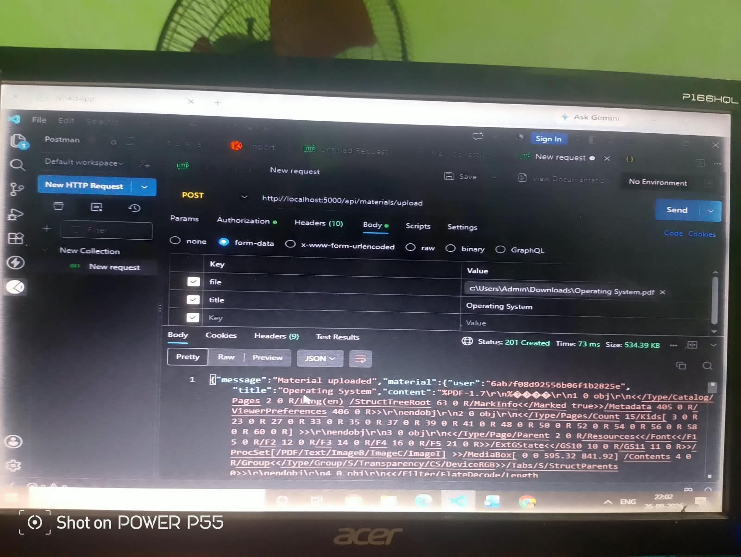

Generate AI Material Upload

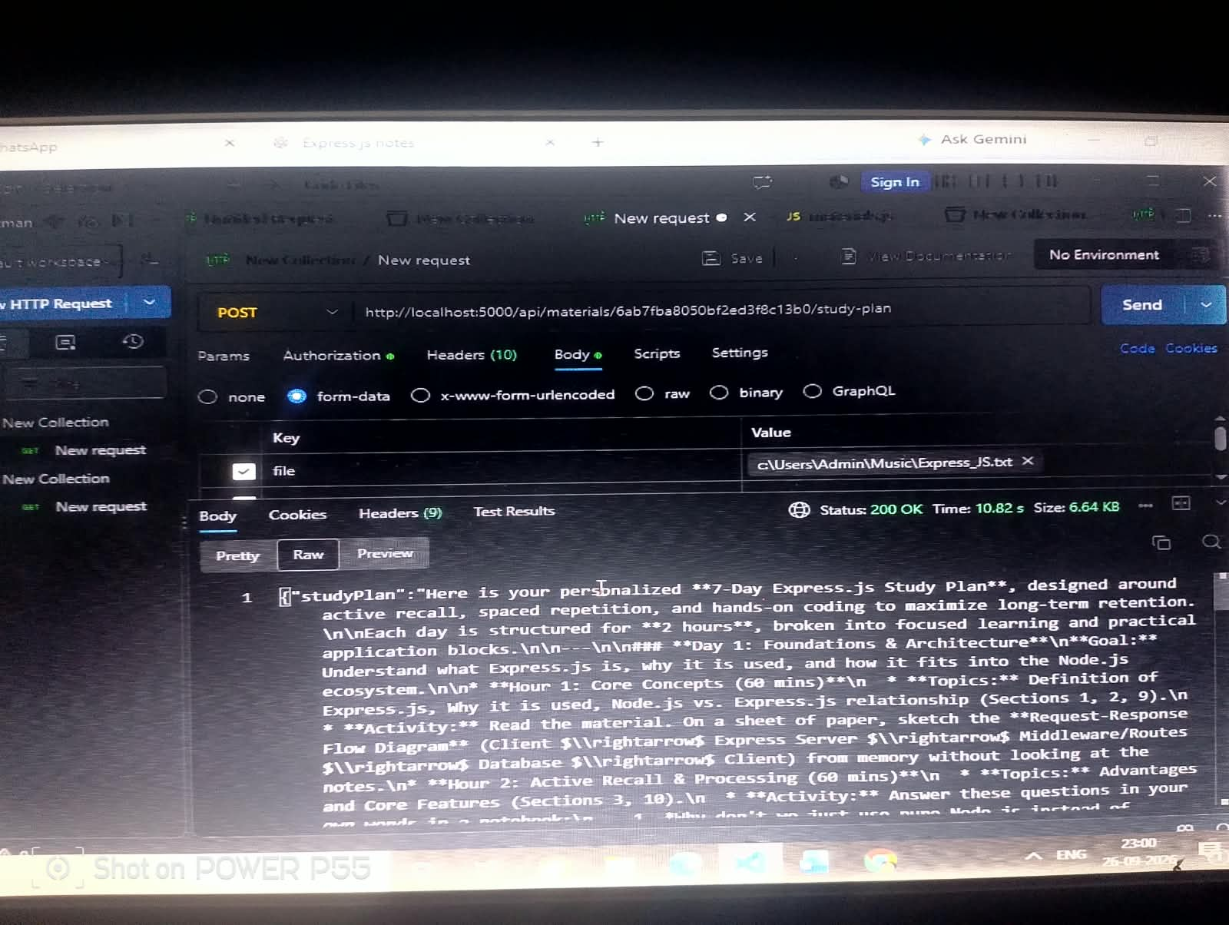
- Generate AI Study Plan

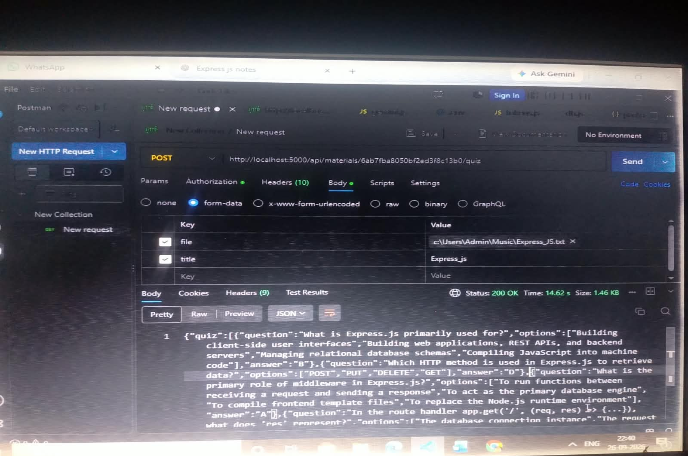

- Generate AI Quiz

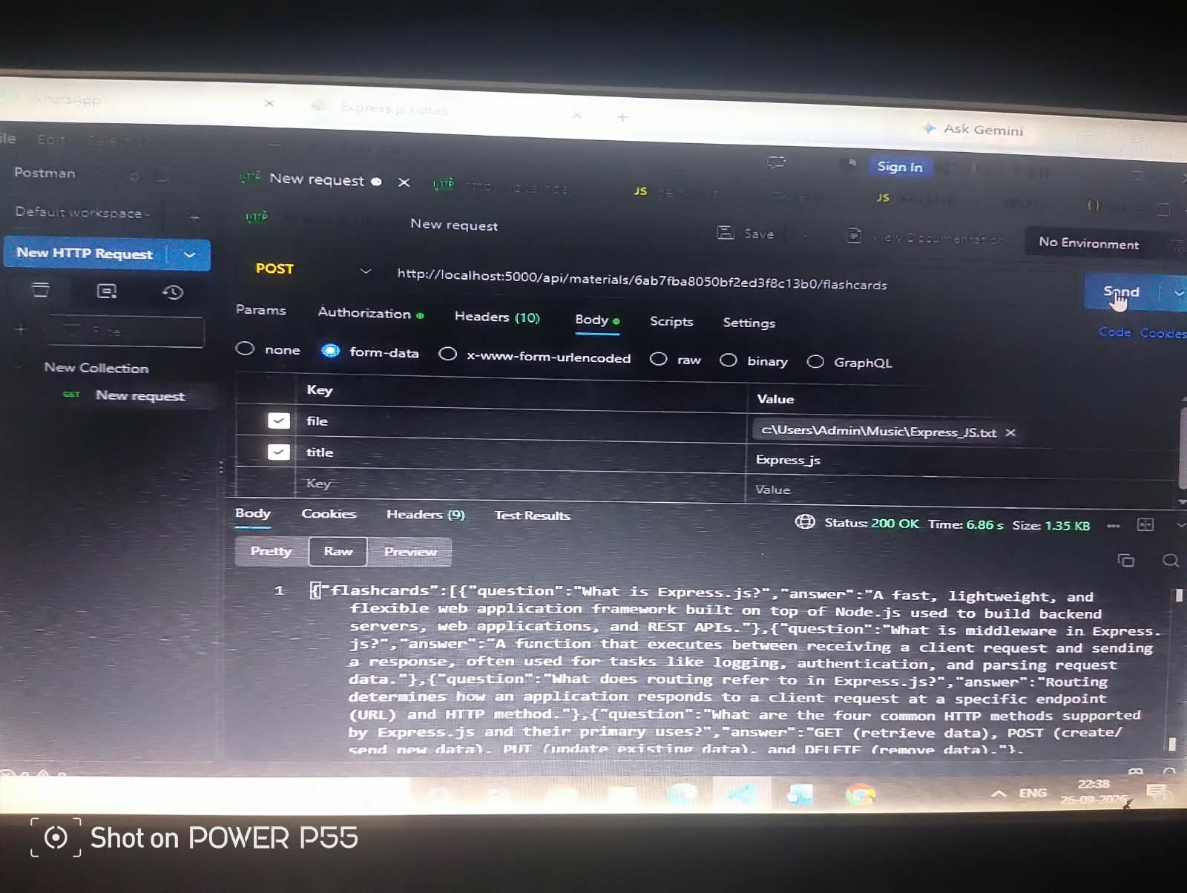
Generate AI Flashcards

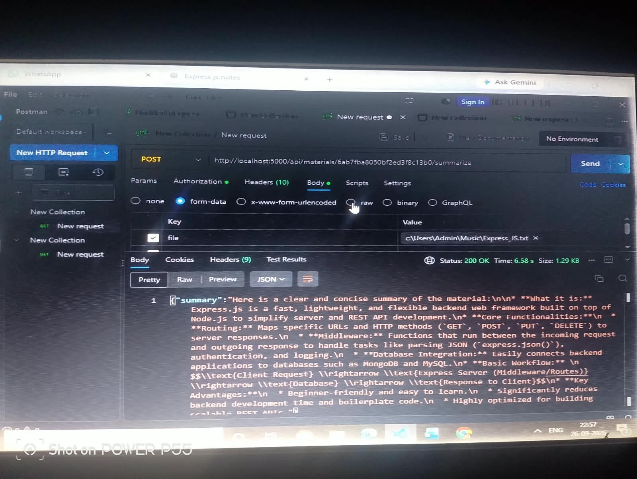
Generate AI Summary

