PHASE 6 – PROJECT TESTING
AI StudyBuddy

INTRODUCTION:
TEAM ID: SWTID-2026-9682
TEAM LEADER : VELAN.P
MAIL ID: velan4490@gmail.com

TEAM MEMBERS:
NAME | MAIL ID
THARUN KUMAR.S | tharunkumar2610@gmail.com
VARUN KRISHNA.S.N | varunzoro2@gmail.com
VIGNESH.B | vigneshbala302@gmail.com

1. Testing Objective
Testing verifies that authentication, study-material handling, AI features, database operations and protected APIs work as intended.

2. API Test Cases
Test | Observed Result
Dependency installation | Successful
MongoDB connection | Successful
Server startup | Successful – port 5000
Student registration | 201 Created
Student login | 200 OK
Material upload | 201 Created
Summary | 200 OK
Flashcards | 200 OK
Quiz | 200 OK
Study plan | 200 OK
Administrator registration | 201 Created

3. Testing Tools
- Postman or Thunder Client
- MongoDB/Mongoose database verification
- Server console/log inspection

4. Bug Tracking
Record each issue found during testing, its cause, correction and retest result in the project folder.

5. Evidence to Upload
- API request/response screenshots
- Successful and failed test screenshots
- Database evidence where applicable
- Bug-fix evidence
- Final test-results table
Important: The status fields above are intentionally left for the actual execution results; they should not be marked Pass/Fail until the corresponding test is performed.
6.Material and AI Tests:

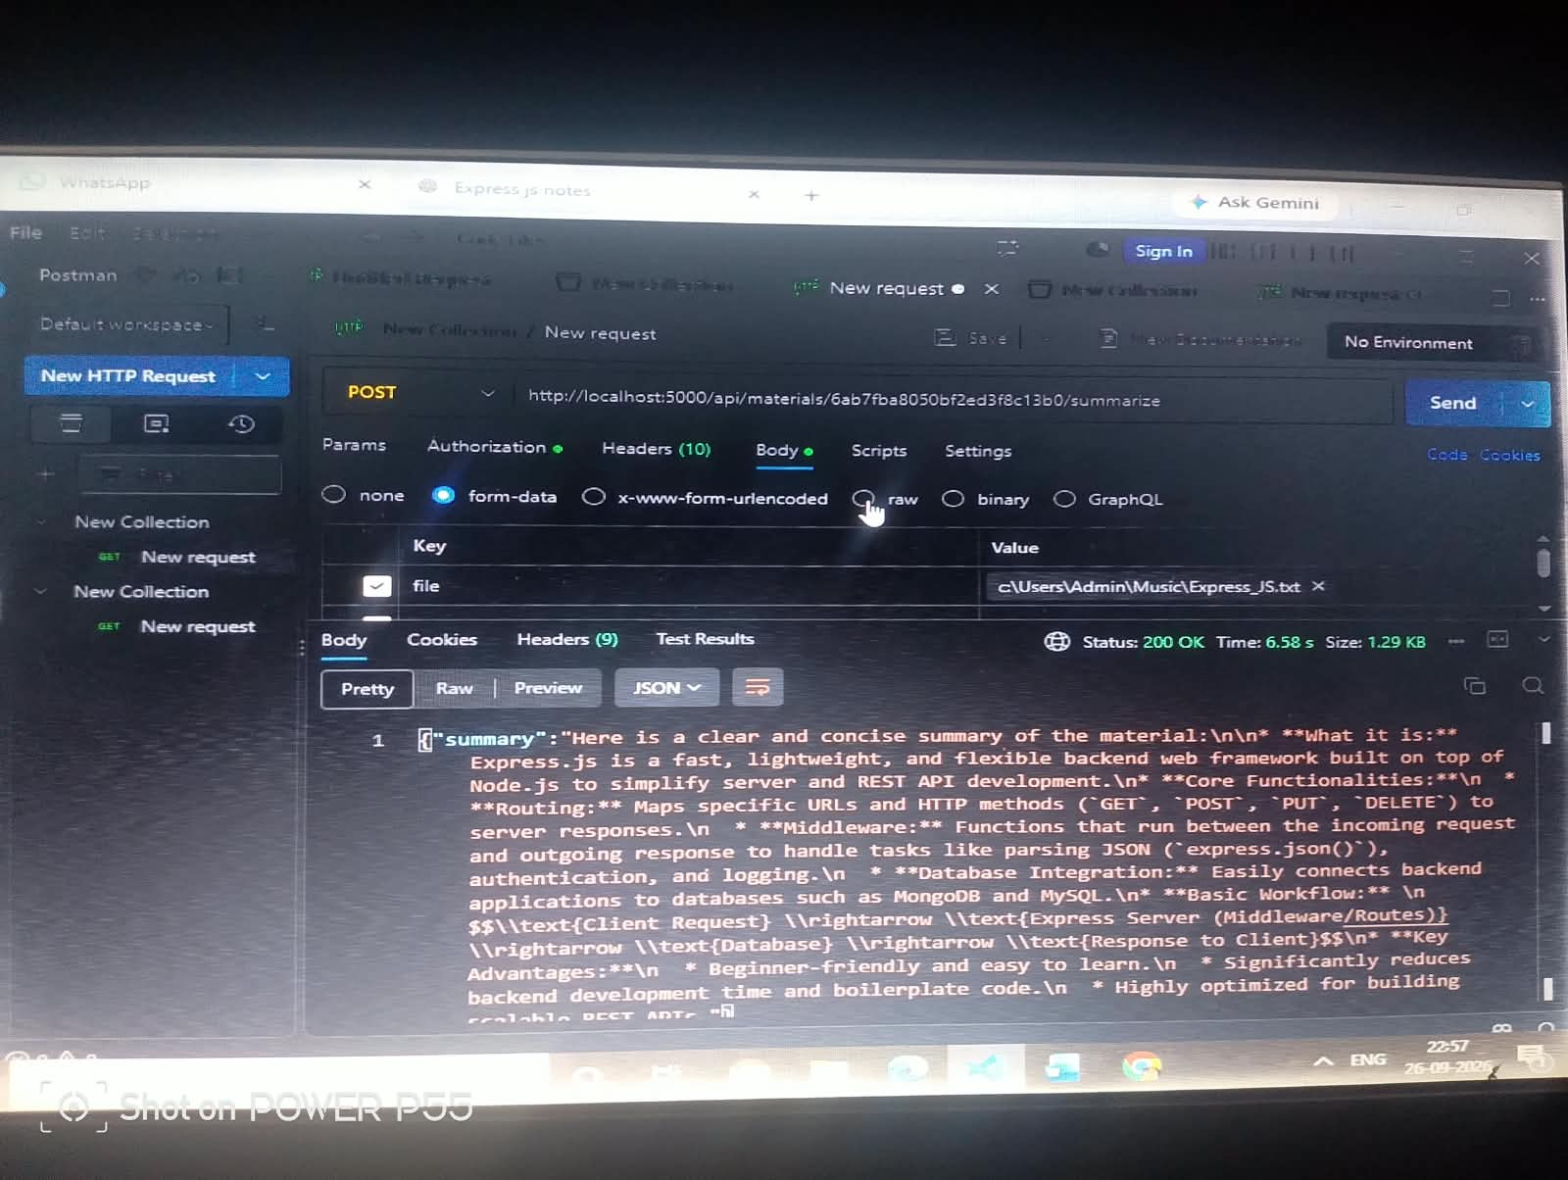
Generate AI Summarize

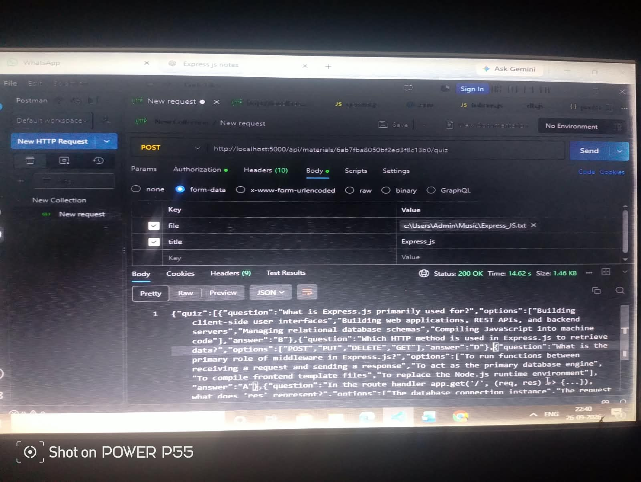
Generate AI Quiz

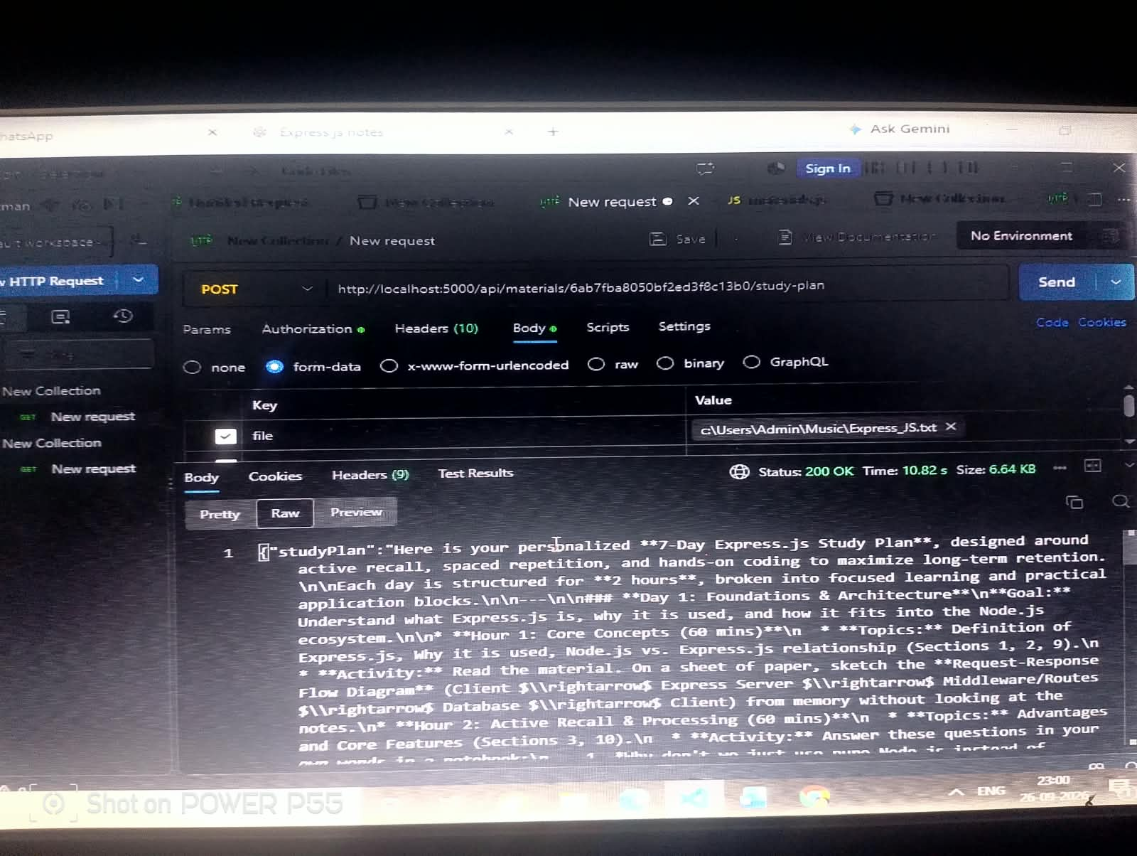
Generate AI Study Plan
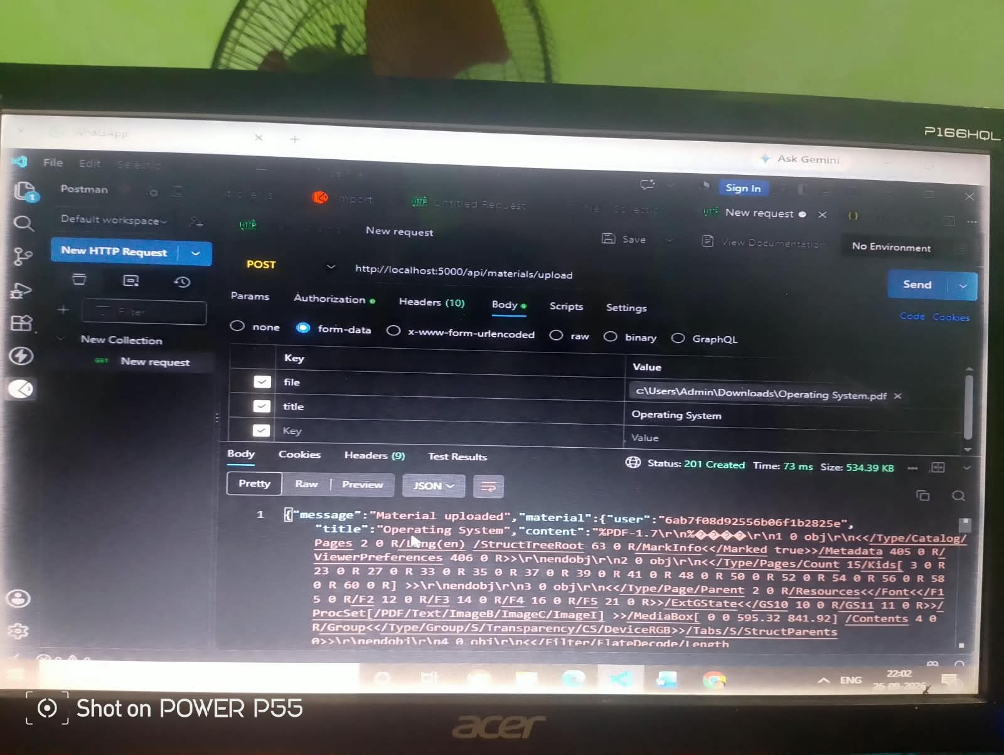
Generate AI Material Uploads

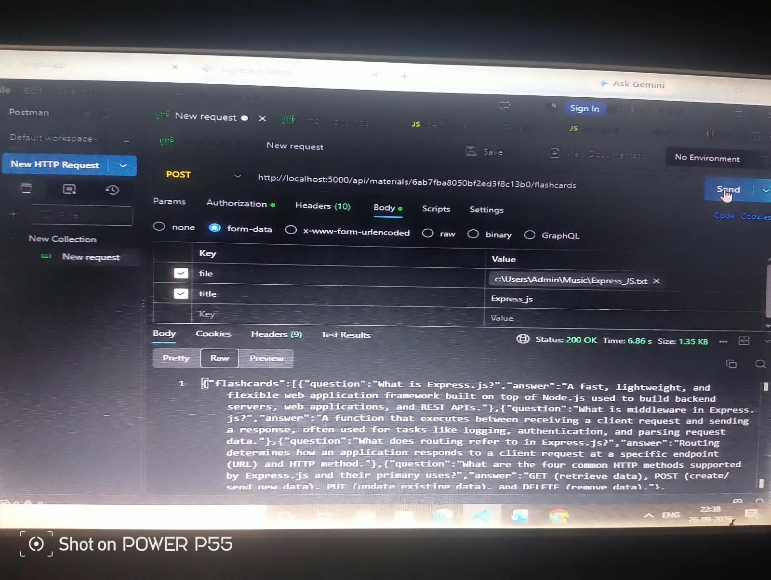
Generate AI Flashcards

Environment :
