PHASE 7 – PROJECT DOCUMENTATION
AI StudyBuddy

INTRODUCTION:
TEAM ID: SWTID-2026-9682
TEAM LEADER : VELAN.P
MAIL ID: velan4490@gmail.com

TEAM MEMBERS:
NAME | MAIL ID
THARUN KUMAR.S | tharunkumar2610@gmail.com
VARUN KRISHNA.S.N | varunzoro2@gmail.com
VIGNESH.B | vigneshbala302@gmail.com

1. Documentation Purpose
This phase provides a complete project record so that a new reader can understand the problem, design, implementation, testing and outcome of LearnMate – AI StudyBuddy.

2. Final Report Structure
- Project Title
- Abstract
- Introduction
- Problem Statement
- Objectives
- Existing System
- Proposed System
- Requirements
- Technology Used
- System Design
- Implementation
- Testing
- Results
- Advantages
- Limitations
- Future Enhancement
- Conclusion
- References

3. Project-Specific Content
The project documentation should explain the AI-powered learning platform, its Node.js/Express REST backend, MongoDB/Mongoose database, JWT/RBAC security, Gemini AI integration, study-material management, summaries, flashcards, quizzes and study plans.

4. Screenshots to Include
- Project folder / source structure
- Server running on the configured port
- MongoDB connection/database
- Registration and login API testing
- Study-material upload
- AI summary response
- AI flashcard response
- AI quiz response
- AI study-plan response
- Final application output

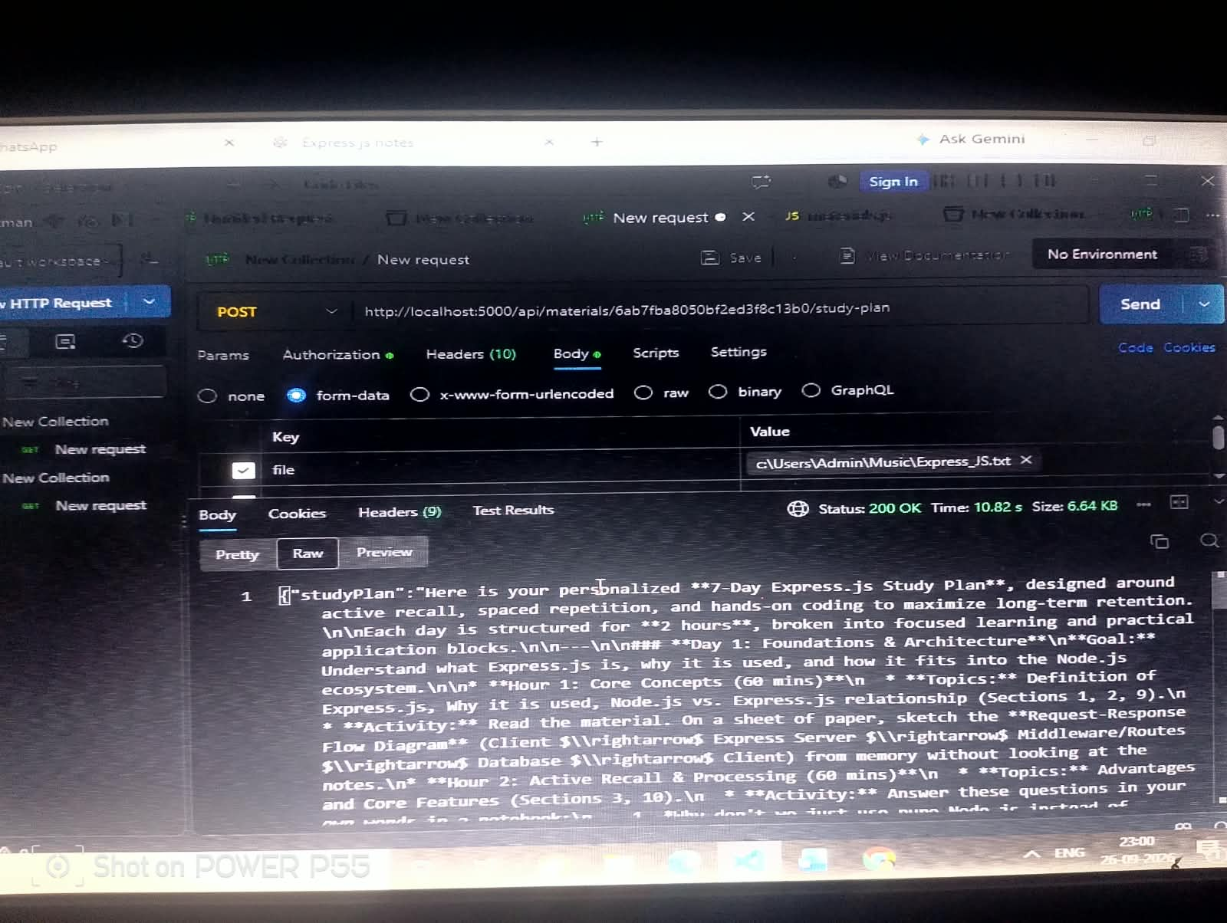
Generate AI Study Plan
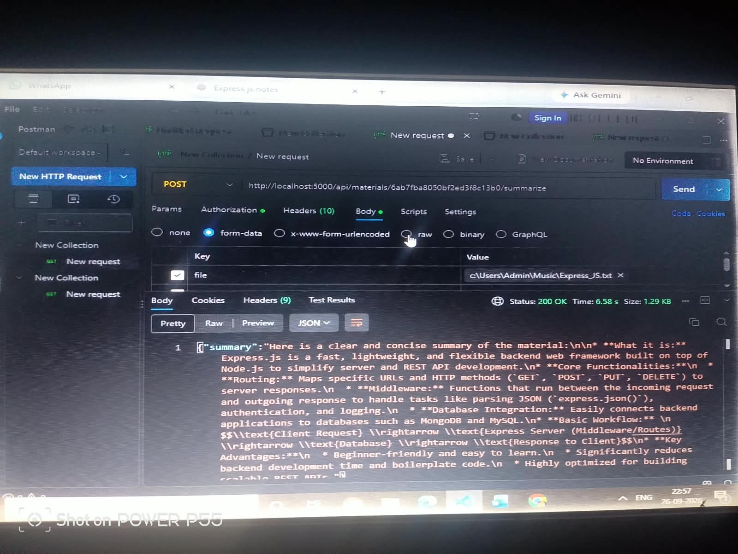
Generate AI Summarize

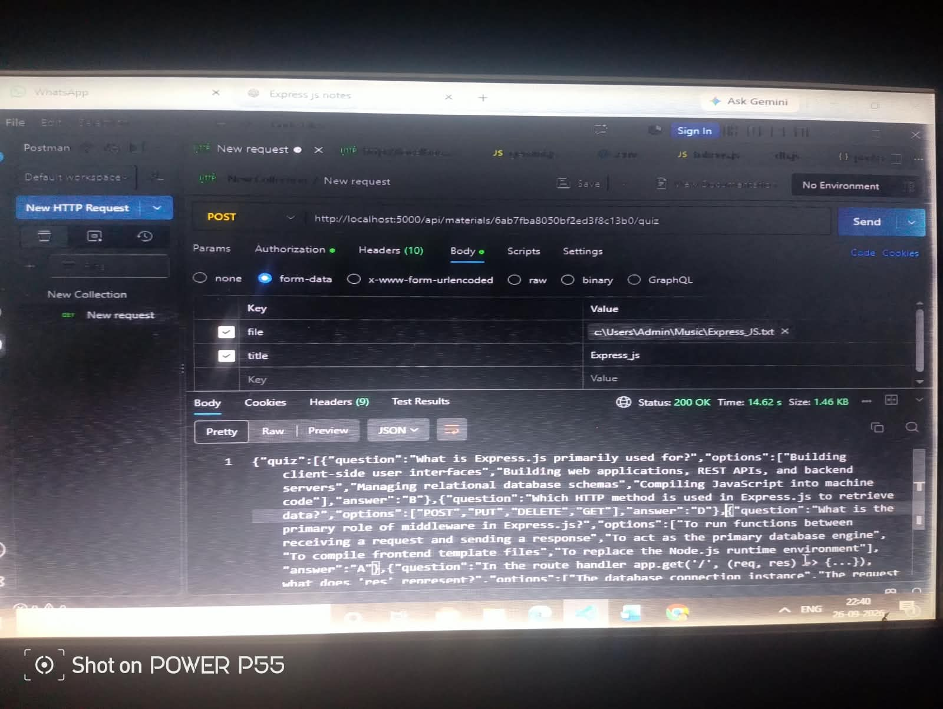

Generate AI Quiz

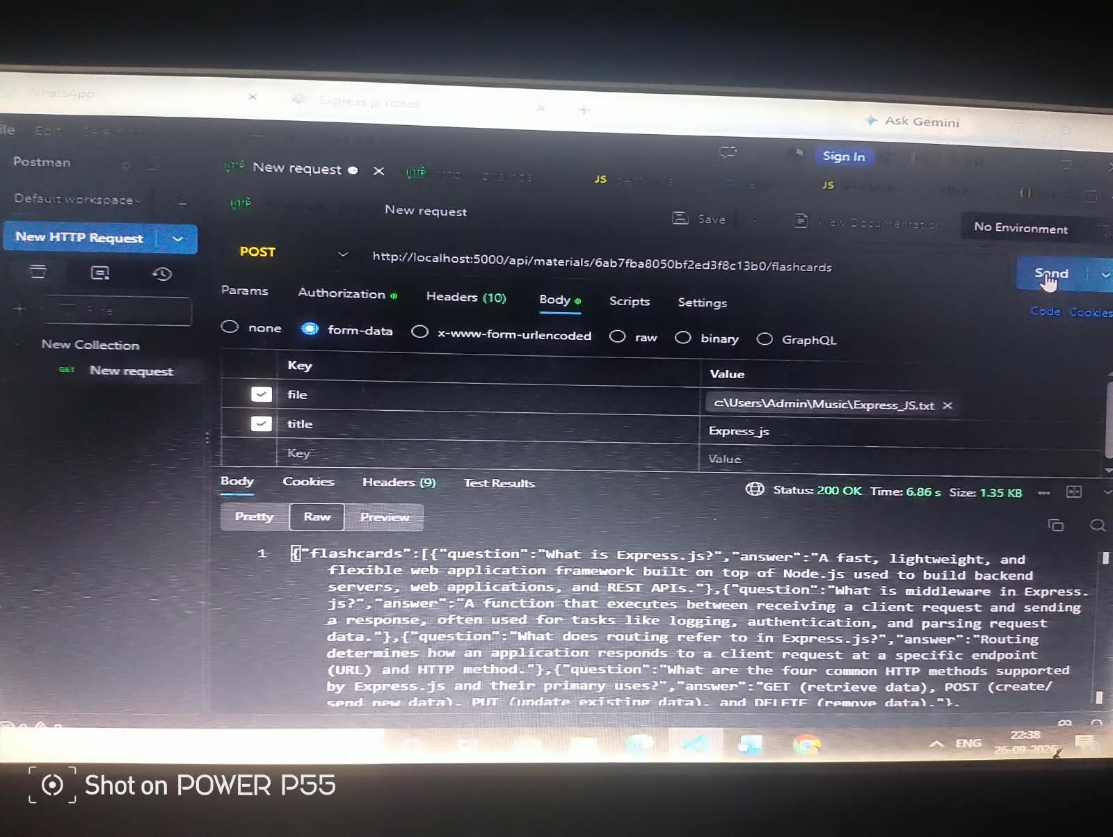
Generate AI Flashcards
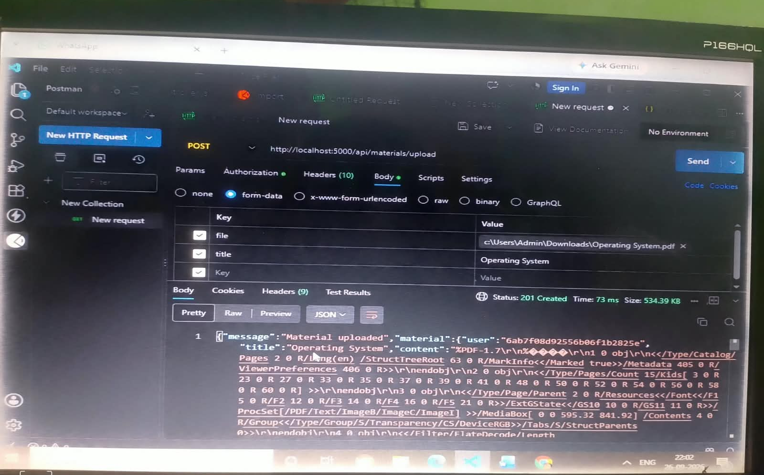

Generate AI Materials Upload

5. Files for GitHub Phase Folder
- Final Project Report
- Screenshots
- References
- User Guide, if required

6. Documentation Note
Use screenshots from your actual project execution and replace any placeholder testing results with your real results.

