

Simulation Data Management

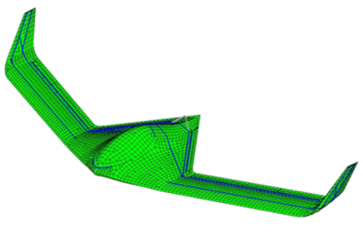

EDM_VELaSSCo

System Operation v0.01


Table of content
1 Scope 4
2 System Requirements 4
2.1 EDMopenSimDM server 4
2.1.1 Hardware Requirements 4
2.1.2 Software Requirements 4
2.1.3 Software Requirements 4
3 Release Notes 4
4 System installation 4
4.1 EXPRESS Data Manager™ installation. 5
4.1.1 Install the EDM Server 5
4.1.2 Installing EDM License 5
4.2 Starting the Server 5
4.3 Uninstalling the EDMopenSimDM Server 5

Table of figures
Figure 11. EDM License installation 5
Figure 13. EDMopenSimDM Server location 5

Scope
This document describes for the EDM_VELaSSCo server
- Relase notes
- System requirements
- Installation procedures.
- Operation procedures

System Requirements

EDMopenSimDM server

Hardware Requirements
Minimum:
- 4 GB RAM
- 3 GB free disk space on the computer hard drive. This includes the software and needed temporary space for running the server, but this does not include space for back-ups.
The hardware recommendations above are based on a system running one EDMserver™ with three EDMapplicationServers™. If you only have 4 GB RAM, you should use only one EDMapplicationServer™. Normally, the parameter that affects performance the most is the size of the available virtual memory and disk access speed. Another factor that affects performance is the typical size of CAD/CAE files that are converted to the VCollab CAX format. If the typical file size is 5 GB, the recommended RAM size on the server is 5 GB.

Software Requirements
64-bits Operating System:
- Windows Vista.

Release Notes
Version v00.001 is the first version of EDM_VELaSSCo server.

System installation
The EDM_VELaSSCo server 3 different modules:
- EDMsix database.
- EDM_server_dll.
- EDM Storage Module

EDMsix installation.

EDM server plugin(s) installation.
The plug-in(s) executes sub-queries on each HPC node. They must be installed in the following folder:
…/edmsix/bin/VELaSSCo_plugins
where …/edmsix/bin is the folder where the EDMsix binaries are installed.

In addition to work with data in the EDMsix database it stores and retrieves data on separate files for improved response times. If for example the plug-in executes calculate boundary of a mesh, it stores the calculated triangles on separate files. The next time a user ask for the boundary of the mesh of this model, the data are read from the binary file and the user will experience good response times. In which disk folder the plug-in shall store the query results must be decided at installation time. The exact path of this folder must be set as an environment variable named QUERY_RESULT_FOLDER, in the start-up script of the EDMsix application server. Example:

SET EDM_BIN=%EDM_HOME_VELaSSCo%\bin
SET BASE_FOLDER=E:\VELaSSCo\installation\database
set EDM_SERVER_CLIENTS_FILES_PATH=%BASE_FOLDER%\temp
set QUERY_RESULT_FOLDER=%BASE_FOLDER%\results

start /min %EDM_BIN%\edmappserver.exe -w -t -s9090
start /min %EDM_BIN%\edmappserver.exe -w -t -s9090
start /min %EDM_BIN%\edmappserver.exe -w -t -s9090

If the query result folder does not exist before the plug-in use it, the folder will be created. Query results for one specific model will be stored in a sub-model named QUERY_RESULT_FOLDER/repositoryName/modelName.

EDM Storage Module installation.

EXPRESS Data Manager™ installation.
The EDM setup process will be called automatically.

Install the EDM Server
Installation can take several minites.
Press Finish to end the installation process and start the license installation process.

Installing EDM License
The license installation program shall start automatically after the EDM installation is finished. If it does not start, run the following command:
%EDM_HOME%\bin\InstallLicenseKey.exe
Enter the license ID and password that were provided to you by Jotne and enter the machine name, which you may select yourself. To install the license press the "Start installation" button. Close the program after the license has been installed.
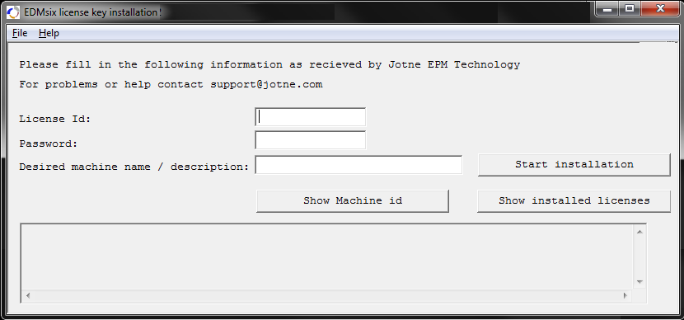
Figure 1. EDM License installation

Starting the Server

Uninstalling the EDMopenSimDM Server
Figure 2. EDMopenSimDM Server location
After pressing the Uninstall button, the wizard will uninstall or call the components uninstaller application.

