Fine tuning with Keras (Roberto’s scripts)

0) Install numpy+mkl and scipy wheels (already done on the GPU machine).
Wheel files can be downloaded here :
http://www.lfd.uci.edu/~gohlke/pythonlibs/#numpy (numpy + mkl)
http://www.lfd.uci.edu/~gohlke/pythonlibs/#scipy (scipy)

Be careful to download the version that match the current python version installed on the machine and your operating system (64bits / 32bits). Python versions are referred in the whl file name by « cp35 » for python 3.5 etc.

Install the libraries with : pip install path\to\whl\file.whl

1) Install keras : pip install keras

By default keras will be configured to work with tensorflow as backend but it can also use theano or CNTK backend.

2) Install scikit : pip install -U scikit-learn

3) Install tqdm : pip install tqdm

4) Shape the working directory as follows :

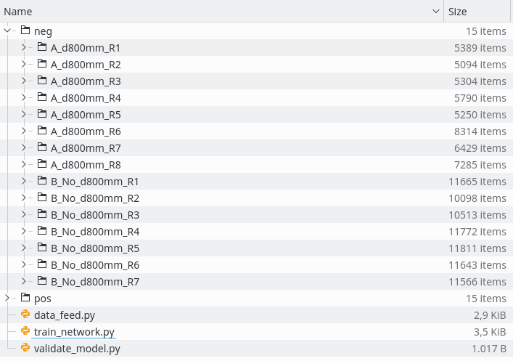
A_d800_mm_R* and B_No_d800_mm_R* containing sample images.

5) Edit train_network.py script and edit the path to save the model to the location you want (line 32-33)

6) Launch train_network.py

