Project Title
HashGuard – Plagiarism Detection Platform
Project Report submitted for the partial fulfilment of grade for the course

Data Structures and Algorithms -3 (25CS2103E)
in

A.Y. 2026-2027

Submitted by
Lekkala Pranavi (2520030050)
Sohith Veldi (2520030389)

Team Number:
Section:

Under the guidance of

Mrs. J. Yamini Devi

Assistant Professor, Department of Computer Science and Engineering
Hyderabad-500090, Telangana, India.

K L (Deemed to be) University
DEPARTMENT OF COMPUTER SCIENCE AND ENGINEERING



DECLARATION

The Mini Project Report entitled “HashGuard – Plagiarism Detection Platform” is a record of Bonafide work of Lekkala Pranavi – 2520030050, Sohith Veldi – 2520030389 submitted in partial fulfillment for the award of B.Tech in Computer Science and Engineering to the K L University. The results embodied in this report have not been copied from any other department/University/Institute.

Lekkala Pranavi – 2520030050
Sohith Veldi – 2520030389

K L (Deemed to be) University
DEPARTMENT OF COMPUTER SCIENCE AND ENGINEERING
CERTIFICATE

This is to certify that the mini project based report entitled “HashGuard – Plagiarism Detection Platform” is a bonafide work done and submitted by Lekkala Pranavi – 2520030050, Sohith Veldi – 2520030389 in partial fulfillment of the requirements for the award of the degree of BACHELOR OF TECHNOLOGY in Department of Computer Science and Engineering, K L (Deemed to be University), during the academic year 2026-2027.

Signature of the Supervisor

Signature of the HOD Signature of the External Examiner

ACKNOWLEDGEMENT

The success in this project would not have been possible but for the timely help and guidance rendered by many people. Our wish to express my sincere thanks to all those who has assisted us in one way or the other for the completion of my project.

Our greatest appreciation to our guide, Mrs. J. Yamini Devi, Assistant Professor, Department of Computer Science and Engineering which cannot be expressed in words for her tremendous support, encouragement and guidance for this project.

We express our gratitude to Dr. P. Venkateshwar Rao, Head of the Department of Computer Science and Engineering, for providing us with adequate facilities, ways and means by which we were able to complete this project-based lab.

We thank all the members of teaching and non-teaching staff members, and also who have assisted me directly or indirectly for successful completion of this project. Finally, I sincerely thank my parents, friends and classmates for their kind help and cooperation during my work.

Lekkala Pranavi – 2520030050
Sohith Veldi – 2520030389

TABLE OF CONTENTS

S.No. | Contents | Page no.
1. | Abstract | 6
2. | Introduction | 7
3. | Literature survey | 8
4. | Problem Statement and Objectives | 10
5. | Hardware and Software requirements | 11
6. | Implementation | 12
7. | Results & Discussion | 21
8. | Conclusion & Future Scope | 25
9. | References | 26
LIST OF FIGURES
Figure 6.1: System architecture of HashGuard 13
Figure 6.2: Flowchart of the matching process 17
Figure 7.1: Application landing page 21
Figure 7.2: Upload screen 22
Figure 7.3: Example document comparison 22
Figure 7.4: Highlighted matching passages 22
Figure 7.5: Similarity percentage 22
Figure 7.6: Unsupported-format message 22
LIST OF TABLES
Table 6.1: Window hashes of the worked example 15
Table 6.2: Scanning document B in the worked example 15
Table 7.1: Test cases and test results 21
1.ABSTRACT

HashGuard is a browser-based plagiarism detection platform that identifies matching text across documents using string matching and rolling hash techniques. It extracts text from TXT, PDF and DOCX files, normalizes it, and compares fixed-length text windows using a polynomial rolling hash in the style of the Rabin–Karp algorithm. Every hash match is verified against the actual text to avoid false matches caused by hash collisions. Verified matches are highlighted as passages, and an overlap-based similarity percentage is displayed. The interface also offers demonstration accounts and browser-stored history. The current version detects exact matches after normalization and cannot reliably detect paraphrased ideas; its score is an estimate, not proof of plagiarism. HashGuard can be extended with more algorithms, secure server-side storage and semantic similarity techniques.
Team Name: HashGuard

Team Logo (if any): Not applicable



Team Members:
- Lekkala Pranavi, 2520030050
- Sohith Veldi, 2520030389

- INTRODUCTION

Plagiarism is the use of another person's words, ideas or content without appropriate acknowledgement. It is a recurring concern in academic assignments, research papers, reports, articles and other written material. Checking long documents for copied passages by reading them side by side is slow, and matching passages are easy to overlook, especially when several documents have to be compared.
HashGuard is a browser-based application that automates this comparison. The user uploads supported documents or enters text; the application extracts and normalizes the text, applies rolling hash-based matching to locate candidate matching windows, verifies each candidate against the actual text, and presents the matching passages together with a similarity percentage.
The motivation for the project is to connect theory from Data Structures and Algorithms with a practical program. The Rabin–Karp string-matching algorithm, rolling hashes, hash tables and text preprocessing are all used directly in the working application. Hashing allows most non-matching windows to be rejected by comparing integers instead of comparing every character, and an explicit verification step keeps the results correct.
The remainder of this report is organized as follows: Section 3 reviews related tools and techniques; Section 4 states the problem and objectives; Section 5 lists the hardware and software requirements; Section 6 describes the implementation and its main modules; Section 7 presents the results and discussion; Section 8 gives the conclusion and future scope; and Section 9 lists the references.
- LITERATURE SURVEY
This section reviews existing plagiarism-detection tools and the algorithmic work that HashGuard builds on. The tools are commercial or institutional services, while the algorithms are the techniques that such tools and similar research systems rely on.
1. Turnitin. Turnitin is a widely used similarity-checking service in educational institutions. A submitted document is compared against a large collection of web pages and previously submitted papers, and the service returns a similarity report in which matched text is highlighted. It is a hosted commercial service, so access depends on an institutional subscription.
2. MOSS (Measure Of Software Similarity). MOSS is a service developed at Stanford University for detecting similarity between programming assignments. It is based on document fingerprinting using the winnowing algorithm and ignores differences such as whitespace and identifier names, which makes it well suited to source code rather than ordinary prose.
3. Copyleaks. Copyleaks is an online plagiarism-detection platform that scans text and common document formats and reports matching sources. It offers an interface for uploading files and also provides programmatic access for integration with other applications. It is also a hosted service that requires an account.
4. Quetext. Quetext is a web-based plagiarism checker in which the user pastes or uploads text and receives highlighted matches with their sources. It is representative of lightweight online tools that provide quick checks but depend on an internet connection and on the provider's own matching method.
5. Karp–Rabin pattern matching (1987). Karp and Rabin introduced a string-matching algorithm that compares hash values of the pattern and of each text window, and updates the window hash incrementally with a rolling hash. Windows whose hashes differ cannot match, so only the remaining candidates are checked character by character. HashGuard applies this idea to document comparison.
6. Winnowing: document fingerprinting (Schleimer, Wilkerson and Aiken, 2003). The winnowing technique selects a guaranteed subset of hashes of overlapping substrings (k-grams) as a document's fingerprint, so that long shared passages are always detected while the stored fingerprint stays small. It is the basis of MOSS and a natural next step beyond HashGuard's fixed-window comparison.
7. Resemblance of documents by shingling (Broder, 1997). Broder proposed representing a document as a set of contiguous word sequences (shingles) and measuring similarity from the overlap of those sets. This set-overlap view is close to the overlap-based score used in HashGuard, though HashGuard measures covered characters rather than shingle sets.
8. Finding similar files in a large file system (Manber, 1994). Manber's sif tool finds similar files by computing fingerprints of substrings chosen by their content and comparing the fingerprints. The work shows that hash-based fingerprints can find near-duplicate content efficiently without comparing every pair of files character by character.
Summary. Existing services are convenient but are hosted, often subscription-based and use their own undisclosed similarity measures. The algorithmic literature shows that hash-based matching is a sound and efficient basis for detecting copied text. HashGuard combines a rolling hash with explicit verification in a client-side application that is simple to run and whose matching logic can be inspected and explained.
Existing System
Traditional plagiarism checking may involve manual comparison of documents, searching for repeated phrases, basic text comparison tools, and external plagiarism checking services. Their general limitations are:
- Manual comparison is time-consuming.
- Large documents are difficult to inspect manually.
- Simple text comparison may not clearly identify copied passages.
- Some tools require subscriptions or internet access.
- Different tools may use different similarity calculation methods.
These are general limitations of the problem domain and are not measured results of any specific product.
Proposed System
HashGuard provides a browser-based interface for comparing document content. The proposed workflow is:
1. The user opens the application.
2. The user accesses the interface and selects the document analysis feature.
3. The user uploads supported documents or enters text where supported.
4. The application extracts the document text.
5. The text is normalized for comparison.
6. A rolling hash is calculated for text windows.
7. Hash matches are checked against the actual text.
8. Matching passages are collected.
9. A similarity score is calculated.
10. The application displays the matching passages and analysis results.
- Problem Statement and Objectives

Problem Statement: Manual plagiarism checking of long documents, or of several documents at once, is slow and unreliable, so an automated and accessible tool for finding matching passages is needed.

Problem Description: Searching for repeated sentences by hand takes considerable time and can miss matching passages. The system must compare supported documents, identify exact matching passages within its matching-window approach, and present a similarity percentage in an understandable form.
Objectives:
1. Develop an interactive plagiarism detection interface.
2. Implement rolling hash-based string matching.
3. Compare text extracted from supported document formats (TXT, PDF and DOCX).
4. Identify and highlight matching passages.
5. Calculate and display a document similarity score.
6. Reduce unnecessary character-by-character comparisons through hash-based candidate matching.
7. Demonstrate the application of data structures and algorithms to a real-world problem.
8. Provide a foundation for future extensions, including additional matching algorithms and backend integration.
- HARDWARE AND SOFTWARE REQUIREMENTS
Hardware Requirements:
- A computer or laptop running Windows, macOS or Linux.
- A modern processor.
- Sufficient RAM to run a browser and process the uploaded documents.
- Storage for the application files and test documents.
- An internet connection for the externally hosted PDF.js and Mammoth.js libraries (not needed if they are bundled locally).
Software Requirements:
- Operating system: Windows, macOS or Linux with a supported browser.
- Frontend: HTML5, CSS3 and JavaScript.
- Browser: a modern browser such as Google Chrome or Microsoft Edge.
- Text comparison: JavaScript implementation of a Rabin–Karp-style rolling hash.
- PDF text extraction: PDF.js library.
- DOCX text extraction: Mammoth.js library.
- Account demonstration and history: browser localStorage.
- Local hosting: optional Python HTTP server.
- IMPLEMENTATION
6.1 System Architecture
The architecture of the current version consists of the following logical layers, all of which run in the web browser. Figure 6.1 shows the layers and the way data flows between them.
User Interface Layer. Landing page, sign-up and sign-in screens, dashboard and scan interface, document upload and text input, and the results and history views.
Document Processing Layer. File type detection, PDF, DOCX or TXT text extraction, text normalization, and conversion of the extracted text into comparable strings.
Matching Engine. Rolling hash calculation, candidate window comparison, verification of hash matches, collection of matching passages, and similarity score calculation.
Results Layer. Similarity percentage, matching passage display, highlighting of duplicated text, and analysis history where supported by the browser implementation.
Local Storage Layer. Browser-local demonstration account and history data.
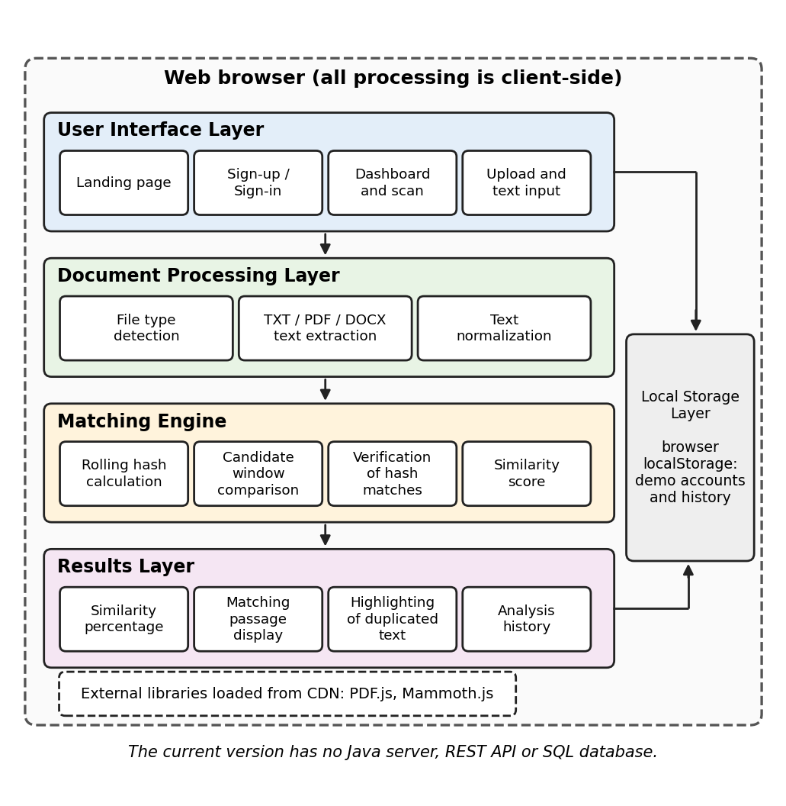
Figure 6.1: System architecture of HashGuard. The current version is browser-based and contains no Java server, REST API or SQL database.
6.2 Algorithm Design
A. Text Preprocessing
The application normalizes text before comparison. It converts text to lowercase, standardizes punctuation and spacing, and retains position information so that matches can be mapped back to the original document. For example, the input "Hash, Table!" becomes "hash table". Differences in capitalization or repeated spaces are therefore not treated as different content.
B. Rabin–Karp String Matching
Rabin–Karp is a string-matching algorithm that uses hash values to find candidate occurrences of a pattern in a text. Let T be the text of length n and P the pattern of length m. A hash is calculated for the pattern and for every text window of length m. If the hashes differ, the window cannot be an exact match under the same hash function. If the hashes are equal, the actual strings must be compared, because hash collisions are possible.
C. Rolling Hash
For a window s[i..i+m−1] the polynomial hash is H(i) = (s[i]·b^(m−1) + s[i+1]·b^(m−2) + … + s[i+m−1]) mod q, where b is the base and q is the modulus. Instead of recomputing the sum for every window, the hash is updated when the window moves one character forward: H(i+1) = ((H(i) − s[i]·b^(m−1))·b + s[i+m]) mod q. The outgoing character is removed and the incoming character is added in constant time.
D. Matching Passage Detection
HashGuard treats every window of one document as a pattern and every window of the other as text. The window hashes of document A are stored in a hash table. Each window hash of document B is looked up in the table, and every candidate is verified by comparing the actual text. Verified windows are collected as matching passages and are used to highlight the duplicated text. The current implementation detects exact matching windows after normalization. It is not a semantic plagiarism detector and cannot reliably detect paraphrased ideas.
E. Similarity Calculation
Similarity (%) = 100 × (C_A + C_B) / (L_A + L_B), where C_A and C_B are the numbers of normalized characters of documents A and B covered by verified matching windows, and L_A and L_B are the normalized lengths of the two documents. The score is an overlap-based estimate. It is not a standardized plagiarism percentage and is not proof of plagiarism.
F. Worked Example
Let the normalized documents be A = "hash table" (10 characters) and B = "hash tree" (9 characters), with window length w = 3. To keep the numbers readable, letters are valued a = 1 … z = 26, a space is valued 27 (written _ in the tables), the base is b = 10 and the modulus is q = 13. The small modulus is chosen so that a hash collision occurs and the verification step can be seen; a practical implementation uses a much larger modulus so that collisions are rare.
Step 1 – hash of the first window. For "has": (8·100 + 1·10 + 19) mod 13 = 829 mod 13 = 10.
Step 2 – rolling update. To move from "has" to "ash", b^(w−1) mod q = 100 mod 13 = 9. The outgoing character h (8) contributes 8·9 mod 13 = 7, so H = (10 − 7) = 3; then H = (3·10 + 8) mod 13 = 12, which equals the hash of "ash" in Table 6.1.
Table 6.1: Window hashes of the worked example (_ denotes a space).
Position | Window of A | Hash of A | Window of B | Hash of B
0 | has | 10 | has | 10
1 | ash | 12 | ash | 12
2 | sh_ | 5 | sh_ | 5
3 | h_t | 11 | h_t | 11
4 | _ta | 2 | _tr | 6
5 | tab | 10 | tre | 1
6 | abl | 2 | ree | 9
7 | ble | 0 | — | —

Step 3 – hash table of A. The window positions of A are stored by hash value: 10 → {0, 5}; 12 → {1}; 5 → {2}; 11 → {3}; 2 → {4, 6}; 0 → {7}. Note that "has" (position 0) and "tab" (position 5) share the hash 10.
Step 4 – scan document B. Each window of B is hashed with the rolling update and looked up in the table (Table 6.2).
Table 6.2: Scanning document B in the worked example.
Position in B | Window | Hash | Candidates in A | Verification
0 | has | 10 | 0, 5 | A[0] equal; A[5] different
1 | ash | 12 | 1 | A[1] equal
2 | sh_ | 5 | 2 | A[2] equal
3 | h_t | 11 | 3 | A[3] equal
4 | _tr | 6 | none | no candidate
5 | tre | 1 | none | no candidate
6 | ree | 9 | none | no candidate

The window "has" has hash 10, so positions 0 and 5 of A are candidates. Comparing the actual text shows that A[0] = "has" is equal but A[5] = "tab" is different; the collision is rejected. Four windows (A positions 0–3 and B positions 0–3) are verified, and they cover the first 6 characters of each document ("hash t"). Step 5 – similarity: (6 + 6) / (10 + 9) × 100 = 63.16%.
G. Pseudocode
Algorithm FindMatches(A, B, w)
Input : normalized texts A and B, window length w
Output: list of verified matching positions (i, j)
1 if |A| < w or |B| < w then return empty list
2 pow <- BASE^(w-1) mod MOD
3 table <- empty hash table
4 for each window of A at position i, with hash H computed by Roll:
5 append i to table[H]
6 matches <- empty list
7 for each window of B at position j, with hash H computed by Roll:
8 for each i in table[H]:
9 if A[i..i+w-1] = B[j..j+w-1] then // verification
10 append (i, j) to matches
11 return matches

Procedure Roll(H, outgoing, incoming)
H <- (H - outgoing * pow) mod MOD // remove outgoing character
H <- (H * BASE + incoming) mod MOD // add incoming character
return H

Algorithm Similarity(matches, |A|, |B|, w)
mark every character of A and of B covered by a verified window
covered <- (marked characters in A) + (marked characters in B)
return 100 * covered / (|A| + |B|)

Complexity. Computing all window hashes of a text of n characters takes O(n) time because each rolling update is O(1). Each hash-table lookup takes expected O(1) time, and each verification costs O(w). The classical Rabin–Karp algorithm has an average running time of O(n + m) and a worst case of O(nm) when many hash collisions occur.
H. Flowchart
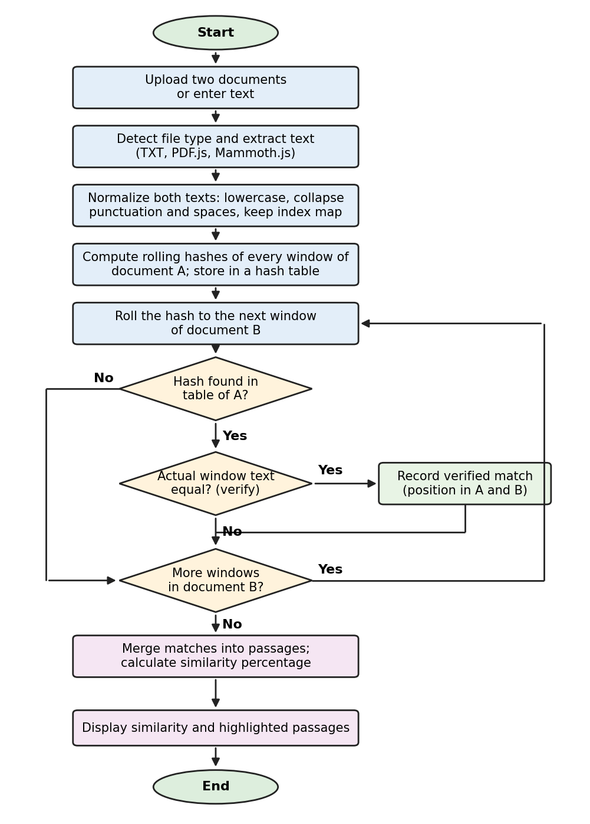
Figure 6.2: Flowchart of the matching process. The loop repeats for every window of document B.
6.3 Module Description
Module 1: User Interface. Displays the application pages, navigation, buttons, forms, document upload controls and analysis results.
Module 2: Account Demonstration. Provides sign-up and sign-in interface functionality. Demonstration account information is stored in browser localStorage with client-side hashing. It is not production-grade authentication.
Module 3: Document Upload. Allows users to select supported files for analysis. The supported formats in the current HTML implementation are TXT, PDF and DOCX. The .doc format is not supported by the current file-reading logic.
Module 4: Text Extraction. TXT files are read as text, PDF files are processed using PDF.js and DOCX files are processed using Mammoth.js. PDF and DOCX extraction depend on the corresponding libraries being available.
Module 5: Text Preprocessing. Normalizes text to make the comparison more consistent.
Module 6: Matching Engine. Uses polynomial rolling hashes to identify candidate matching windows and verifies actual text matches.
Module 7: Similarity Analysis. Collects matching text, determines the overlap-based score and prepares the results.
Module 8: Results and History. Displays similarity results, matching passages and browser-based analysis history where supported.
6.4 Core Source Code
This section gives the core modules of the application. Each module is written in JavaScript and runs entirely in the browser.
Code Listing 1: Text Extraction (Module 4)
TXT files are read as text, DOCX files are processed with Mammoth.js, and PDF files are processed page by page with PDF.js. Files of any other type are rejected.
async function extractText(file) {
const ext = file.name.split('.').pop().toLowerCase();
if (ext === 'txt') return file.text();
const buffer = await file.arrayBuffer();
if (ext === 'docx') {
const result = await mammoth.extractRawText({ arrayBuffer: buffer });
return result.value;
}
if (ext === 'pdf') {
const pdf = await pdfjsLib.getDocument({ data: buffer }).promise;
let text = '';
for (let p = 1; p <= pdf.numPages; p++) {
const page = await pdf.getPage(p);
const content = await page.getTextContent();
text += content.items.map(it => it.str).join(' ') + '\n';
}
return text;
}
throw new Error('Unsupported file type: .' + ext);
}

Code Listing 2: Text Preprocessing (Module 5)
The text is converted to lowercase and punctuation and repeated spaces are collapsed into single spaces. An index map is kept so that a match found in the normalized text can be traced back to its position in the original document for highlighting.
function normalize(raw) {
let text = '', map = [], lastSpace = true;
for (let i = 0; i < raw.length; i++) {
const ch = raw[i].toLowerCase();
if (/[\p{L}\p{N}]/u.test(ch)) { // keep letters and digits
text += ch; map.push(i); lastSpace = false;
} else if (!lastSpace) { // collapse punctuation/spaces
text += ' '; map.push(i); lastSpace = true;
}
}
return { text: text.trim(), map }; // map: normalized index -> original index
}

Code Listing 3: Rolling Hash Matching Engine (Module 6)
A polynomial rolling hash is calculated for every window of WINDOW characters. Window hashes of the first document are stored in a hash table; each window hash of the second document is looked up, and every candidate is verified by comparing the actual text before it is accepted as a match.
const BASE = 257, MOD = 1000000007, WINDOW = 30;

function windowHashes(text, w) {
const hashes = [];
if (text.length < w) return hashes;
let pow = 1, h = 0;
for (let i = 1; i < w; i++) pow = (pow * BASE) % MOD;
for (let i = 0; i < w; i++) h = (h * BASE + text.charCodeAt(i)) % MOD;
hashes.push(h);
for (let i = w; i < text.length; i++) { // rolling update
h = (h - (text.charCodeAt(i - w) * pow) % MOD + MOD) % MOD;
h = (h * BASE + text.charCodeAt(i)) % MOD;
hashes.push(h);
}
return hashes;
}

function findMatches(a, b, w) {
const table = new Map(); // hash -> positions in text a
windowHashes(a, w).forEach((h, i) => {
if (!table.has(h)) table.set(h, []);
table.get(h).push(i);
});
const matches = [];
windowHashes(b, w).forEach((h, j) => {
for (const i of table.get(h) || []) {
if (a.substr(i, w) === b.substr(j, w)) // verify: hashes can collide
matches.push({ a: i, b: j });
}
});
return matches;
}

Code Listing 4: Similarity Calculation (Module 7)
The score is the number of normalized characters covered by verified matching windows in both documents, divided by the combined normalized length of the two documents, expressed as a percentage. It is an overlap-based estimate and not a standardized plagiarism percentage.
function similarity(matches, lenA, lenB, w) {
const covered = (key, len) => {
const mark = new Uint8Array(len);
for (const m of matches) mark.fill(1, m[key], m[key] + w);
return mark.reduce((sum, v) => sum + v, 0);
};
const total = covered('a', lenA) + covered('b', lenB);
return Number((100 * total / (lenA + lenB)).toFixed(2));
}

- RESULTS & DISCUSSION
7.1 Testing
The following test cases are to be performed on the running application. The Result column (Pass or Fail) and the observation must be recorded only after the test has actually been performed.
Table 7.1: Test cases and test results.
Test ID | Test case | Expected result | Actual observation | Result
TC01 | Open the application | The landing page loads | [Record after testing] | [Pass / Fail]
TC02 | Enter valid demonstration account details | The account interface responds as implemented | [Record after testing] | [Pass / Fail]
TC03 | Upload a TXT file | Text is read successfully | [Record after testing] | [Pass / Fail]
TC04 | Upload a supported PDF | Text is extracted if PDF.js is available | [Record after testing] | [Pass / Fail]
TC05 | Upload a DOCX file | Text is extracted if Mammoth.js is available | [Record after testing] | [Pass / Fail]
TC06 | Upload an unsupported file | The application reports an unsupported format | [Record after testing] | [Pass / Fail]
TC07 | Compare identical documents | Matching passages are detected | [Record after testing] | [Pass / Fail]
TC08 | Compare documents with partial copied text | Shared text windows are identified | [Record after testing] | [Pass / Fail]
TC09 | Compare documents with no common passages | No verified matching passages should be reported | [Record after testing] | [Pass / Fail]
TC10 | Compare documents with different capitalization or spacing | Normalization may allow corresponding text to match | [Record after testing] | [Pass / Fail]
TC11 | Refresh the application | Browser-stored state persists only where implemented | [Record after testing] | [Pass / Fail]
TC12 | Disconnect the internet before loading external libraries | PDF/DOCX extraction may fail if the libraries are unavailable | [Record after testing] | [Pass / Fail]

7.2 Test Results
Screenshots of the actual test results are inserted below. Only screenshots taken from the submitted version of the application should be used.
[Insert screenshot: Application landing page]
Figure 7.1: Application landing page. This screenshot shows the page displayed when the application is opened.
[Insert screenshot: Upload screen]
Figure 7.2: Upload screen. This screenshot shows the controls used to select documents or enter text.
[Insert screenshot: Example document comparison]
Figure 7.3: Example document comparison. This screenshot shows two documents that were compared in a test.
[Insert screenshot: Highlighted matching passages]
Figure 7.4: Highlighted matching passages. This screenshot shows the duplicated text highlighted by the application.
[Insert screenshot: Similarity percentage]
Figure 7.5: Similarity percentage. This screenshot shows the overlap-based score displayed for the compared documents.
[Insert screenshot: Unsupported-format message]
Figure 7.6: Unsupported-format message. This screenshot shows the message displayed when an unsupported file is uploaded.
7.3 Discussion
The expected outcome is a working interface that accepts supported documents, extracts their text, compares normalized text windows using rolling hash techniques, and displays verified matching passages with an overlap-based similarity score. After testing, the following points are to be completed with the actual observations.
Reading of supported files. TXT files are read as text; PDF and DOCX files depend on PDF.js and Mammoth.js being available (TC03–TC05, TC12). Observed: [complete after testing].
Identical documents. Every window of one document should have a verified match in the other, so matching passages covering the whole text are expected (TC07). Observed: [complete after testing].
Partial copying. Only the windows inside the copied passage should be verified and highlighted (TC08). Observed: [complete after testing].
Effect of normalization. Lowercasing and collapsing punctuation and spaces may allow text that differs only in capitalization or spacing to match (TC10). Observed: [complete after testing].
Presentation of results. The interface shows the similarity percentage and highlights the matching passages. Observed: [complete after testing].
Short or paraphrased passages. Passages shorter than the window length, and paraphrased passages, are not expected to be matched because only exact windows are compared. Observed: [complete after testing].
7.4 Implemented Features
- Browser-based interface built with HTML, CSS and JavaScript.
- Demonstration sign-up and sign-in using browser localStorage with client-side hashing.
- Upload of TXT, PDF and DOCX files, and text input where supported.
- Text extraction using PDF.js (PDF) and Mammoth.js (DOCX).
- Text normalization with position mapping.
- Rabin–Karp-style polynomial rolling hash matching with verification of every candidate against the actual text.
- Highlighting of matching passages.
- Overlap-based similarity percentage.
- Browser-based analysis history where supported.
7.5 Advantages
- Interactive and accessible interface.
- Automated comparison of supported documents.
- Rolling hash-based candidate matching.
- Highlights matching passages.
- Displays a similarity estimate.
- Demonstrates a practical application of string matching.
- Does not require a Java backend for the current browser-only version.
7.6 Limitations
- The current version primarily detects matching text windows rather than semantic similarity.
- Paraphrased content may not be detected.
- Similarity depends on normalization, window size and matching logic.
- Hash collisions require actual text verification.
- The similarity percentage is an overlap estimate, not a definitive plagiarism verdict.
- Only TXT, PDF and DOCX are supported by the current upload logic.
- PDF and DOCX extraction depends on external JavaScript libraries unless they are bundled locally.
- Demonstration accounts and history are browser-local and are not secure multi-user server-side records.
- The current HTML application does not include a Java backend or SQL database.
- CONCLUSION & FUTURE SCOPE
8.1 Conclusion
HashGuard demonstrates how data structures, string matching and rolling hash techniques can be applied to document comparison. The application processes supported document formats, normalizes text, identifies verified matching windows, and displays matching passages alongside a similarity estimate.
The project provides practical experience in algorithm implementation, frontend development, text processing and user interface design. Although it has limitations in semantic analysis and secure multi-user storage, it provides a foundation for future enhancements involving additional algorithms, improved document support and backend integration.
8.2 Future Scope
The following are potential improvements. They are future enhancements and are not features of the current version.
1. Add KMP, Z-algorithm and other string-matching algorithms for comparison.
2. Add suffix array and LCP-based approaches for repeated substring analysis.
3. Improve matching of short passages.
4. Add configurable matching-window sizes.
5. Improve text extraction from complex documents.
6. Add support for additional document formats.
7. Integrate secure server-side authentication.
8. Add a backend and database for persistent multi-user records.
9. Provide downloadable comparison reports.
10. Explore semantic similarity techniques for paraphrased content.
11. Improve performance for very large documents.
12. Bundle document extraction libraries locally to reduce dependence on external CDNs.
- REFERENCES
1. Turnitin. Similarity checking service. https://www.turnitin.com Accessed: [add date].
2. A. Aiken et al. MOSS: A System for Detecting Software Similarity, Stanford University. https://theory.stanford.edu/~aiken/moss/ Accessed: [add date].
3. Copyleaks. Plagiarism detection platform. https://copyleaks.com Accessed: [add date].
4. Quetext. Online plagiarism checker. https://www.quetext.com Accessed: [add date].
5. R. M. Karp and M. O. Rabin, "Efficient randomized pattern-matching algorithms," IBM Journal of Research and Development, vol. 31, no. 2, pp. 249–260, 1987.
6. S. Schleimer, D. S. Wilkerson and A. Aiken, "Winnowing: Local algorithms for document fingerprinting," Proc. ACM SIGMOD International Conference on Management of Data, 2003.
7. A. Z. Broder, "On the resemblance and containment of documents," Proc. Compression and Complexity of Sequences, IEEE, 1997.
8. U. Manber, "Finding similar files in a large file system," Proc. USENIX Winter Technical Conference, 1994.
9. T. H. Cormen, C. E. Leiserson, R. L. Rivest and C. Stein, Introduction to Algorithms, 4th ed. MIT Press, 2022 (string matching and algorithm analysis). [Confirm the edition consulted.]
10. Mozilla. PDF.js documentation. https://mozilla.github.io/pdf.js/ Accessed: [add date].
11. M. Williamson. Mammoth.js documentation. https://github.com/mwilliamson/mammoth.js Accessed: [add date].
12. Mozilla Developer Network. JavaScript reference: String, Array and Map objects, and Web Storage API (localStorage). https://developer.mozilla.org Accessed: [add date].
13. Course notes and prescribed material, Data Structures and Algorithms – 3 (25CS2103E), K L (Deemed to be) University.

