Fieldsman
The road towards a European outdoor kitchen champion
Raymon H. Veldman | EMBA Sep 2024
2026

Acknowledgements
I would like to thank several people who made this capstone and the EMBA journey possible.
First, my advisor Thibault Vanès for his guidance and critical feedback throughout this project.
I am grateful to Ferry Niers, CFO at Glaspoort, for offering me the opportunity to pursue the HEC Paris Executive MBA and supporting my development toward a finance leadership role.
To my wife, thank you for your patience and support during two demanding years of balancing work, study, and Fieldsman, and for bringing our first child into the world during this journey. Becoming a father in the midst of the EMBA has given me new perspective on what I'm building and why.
To my brothers Jurrian and Herald, co-founders, partners, and family—thank you for building Fieldsman together and for trusting this process to shape our next chapter.
Finally, to my fellow EMBA participants: thank you for the debates, the perspectives, and for helping me sharpen the strategy in this report. The best ideas rarely emerge alone.
Raymon H. Veldman
January 2026

About the Author & Context

About the Author
Raymon Veldman is Manager Business Control & IT at Glaspoort, a Dutch fiber infrastructure company. His career spans over a decade in finance, including positions at BAM, one of the Netherlands' largest construction companies. His experience covers accounting, controlling, treasury, and M&A, complemented by a strong affinity for technology and IT. He holds a Master's degree in Finance and a Bachelor's degree in Business Economics.
In 2021, Raymon co-founded Fieldsman with his brothers Jurrian and Herald. What began as a hobby project, designing and building an outdoor kitchen for personal use, evolved into a direct-to-consumer brand addressing the gap between low-quality budget options and unaffordable premium solutions. Raymon serves as CEO/CFO (strategy, sales, marketing, finance, IT), Jurrian as COO (product design, supply chain), and Herald leads operations (assembly, delivery, service).

Why This Capstone
Glaspoort offered Raymon the opportunity to pursue the HEC Paris Executive MBA as preparation for a future CFO role. However, the program has had an unexpected effect: rather than reinforcing a corporate path, the EMBA has deepened his interest in entrepreneurship.
When the EMBA began, Fieldsman was not part of the plan. The product was fixed, not modular, each kitchen required extensive custom work, making it nearly impossible to scale. But as the program progressed, something shifted. Each subject—strategy, operations, finance, marketing—became a lens through which to rethink Fieldsman. The venture that seemed like a side project started to look like a real opportunity.
This capstone documents a transformation that has already begun. Over the past eighteen months, we have redesigned the entire product into a modular system enabling mass customization. We have invested in a laser cutting machine, a welding robot, and a waterjet cutting machine. We have built a 3D configurator. We have established a supplier in China that now produces 80% of our modules. And we have secured a countertop slab supplier, with the first delivery arriving in February 2026, when we will begin cutting countertops in-house.
The strategic question is no longer theoretical. The foundations are in place. This capstone provides the roadmap for what comes next: scaling in the Netherlands in 2026, then expanding into Belgium and Germany. It also answers a personal question: whether Fieldsman can become significant enough to pursue as a primary career. The analysis that follows provides the foundation for that decision.

Glossary of Terms
ASP | Average Selling Price — the average revenue per kitchen sold
CAC | Customer Acquisition Cost — total marketing spend divided by new customers acquired
COGS | Cost of Goods Sold — direct costs of producing kitchens (materials, labor, logistics)
D2C | Direct-to-Consumer — selling directly to end customers without retail intermediaries
EBITDA | Earnings Before Interest, Taxes, Depreciation, and Amortization
ESG | Environmental, Social, and Governance — framework for measuring sustainability
GTM | Go-to-Market — strategy for launching and selling products
KPI | Key Performance Indicator — measurable value demonstrating progress toward objectives
KSF | Key Success Factor — critical element required to compete successfully
LTV | Lifetime Value — total revenue expected from a customer over their relationship
NPS | Net Promoter Score — measure of customer loyalty and satisfaction
P&L | Profit and Loss statement — financial statement showing revenues and expenses
QC | Quality Control — processes ensuring products meet quality standards
SAM | Serviceable Available Market — portion of TAM targetable with current business model
SFA | Suitability, Feasibility, Acceptability — framework for evaluating strategic options
SOM | Serviceable Obtainable Market — realistic portion of SAM that can be captured
TAM | Total Addressable Market — total market demand for a product or service
VRIO | Value, Rarity, Imitability, Organization — framework for assessing competitive advantage

Executive Summary

Can Fieldsman become a European outdoor kitchen champion? Yes, by owning the "Missing Middle."
The European outdoor kitchen market has a gap. At the bottom: cheap, low-quality carts that deteriorate within seasons. At the top: bespoke luxury kitchens at €15,000–€50,000, out of reach for most households. In between, the "Missing Middle" from €3,000 to €5,000, no scaled player exists. This is a €110M opportunity across the Netherlands, Belgium, and Germany, and Fieldsman is positioned to capture it.
The market is ready. Outdoor living is growing as homeowners invest in gardens as social spaces. Kamado culture is expanding at 5–8% annually. Customers want premium design and durability but refuse to pay indoor kitchen prices for seasonal use. They will pay €3,000–€5,000 for a kitchen that feels like €15,000, if someone offers it.
Fieldsman has proven product-market fit, with almost no marketing. The company sells around 50-75 kitchens annually, generating €150-200K revenue at 40% margins, on less than €5,000 in advertising spend. Demand exceeds supply: we stop advertising each May because we cannot fulfill orders, not because demand weakens. The constraint is operational, not commercial. If €5K in advertising generates €200K in revenue, the opportunity to scale through professional marketing is enormous.
The solution: a transformed operating model built on four pillars.
- First, production transformation. Redesign the product into a modular system enabling mass customization. Outsource steel frames to China (scalable, stockable) and invest in waterjet cutting to bring countertop production in-house, addressing the true bottleneck where the supplier market fails on cost (€900 → €100) and lead time (8 weeks → 2 weeks). This unlocks capacity from 50 to 5,000 kitchens per year.
- Second, a professional multi-channel marketing engine. Scaling from €200K to €22–35M requires more than increasing ad spend. It demands a full marketing transformation: SEO to capture high-intent search traffic, paid social campaigns on Instagram and Pinterest where outdoor living inspiration happens, strategic influencer partnerships with kamado and outdoor lifestyle creators, presence at garden and BBQ events, and targeted paid advertising across Meta and Google. Equally important is building brand legitimacy through systematic collection of online reviews and customer testimonials, creating a moat of social proof that competitors cannot easily replicate.
- Third, AI-first commercial operations. Rather than building large sales and service teams, Fieldsman scales through AI-enabled configuration support, lead qualification, and customer service. A 3D configurator drives conversion. Partner showrooms provide physical trust without the 30–40% retail margins that would destroy our price positioning.
- Fourth, phased geographic expansion. Scale the Netherlands in 2026. Enter Belgium and pilot Germany in 2027. Accelerate Germany, the anchor market at €251M TAM, through 2030.
The financial outcome is compelling. Revenue grows from €200K (2025) to €22–35M (2030). Volume scales from 50 to 2,200–3,400 kitchens per year. EBITDA margins reach 35–36% as operating leverage builds.
Key risks are execution-focused: supplier quality, lead time stability, marketing effectiveness, and founder bandwidth. Mitigations include supplier certification, inventory buffers, dual sourcing from 2028, continuous marketing optimization, and key hires in 2026.
Fieldsman can become a European outdoor kitchen champion. Execution, not strategy, is now the determining variable.
FIELDSMAN
CONTENTS

Contents
1. Introduction

4
2. External Analysis

7
3. Internal Analysis

12
4. Strategic Options

17
5. Implementation

22
6. Action Plan

28
7. Financial Plan

31
8. Risk Management

33
9. Conclusion

35
Appendix

36
A. PESTLE Analysis

36
B. Market Sizing Methodology

37
C. Customer Personas

38
D. Competitor Analysis

39
E. Business Model Canvas

40
F. Modular Architecture

41
1

Introduction
The Fieldsman Story and Scaling Challenge
FIELDSMAN
SECTION 1: INTRODUCTION
Fieldsman has a problem most startups would envy: it stops advertising every May, not because demand weakens, but because it cannot produce enough kitchens to meet it. This capstone addresses how to solve that constraint and scale the company into a European market leader.

1.1 Company Background: Three Brothers, One Gap in the Market
Fieldsman is a direct-to-consumer outdoor kitchen company founded by three brothers: Raymon Veldman, Jurrian Veldman, and Herald Veldman. The company designs and sells modular outdoor kitchens that enable customers to configure a personalized kitchen at a price point significantly more accessible than traditional premium brands.
Fieldsman's positioning addresses a clear gap in the market. At the low end, outdoor kitchens are often non-customizable and built with low-durability materials. At the high end, premium solutions cost between €10,000 and €50,000, out of reach for most households. In between lies the "Missing Middle": customers who want premium design and durability but will not pay luxury prices. Fieldsman targets this gap with high-quality materials, modular customization, and strong design aesthetics at a mid-premium price, enabled by a direct-to-consumer model and controlled product complexity.
The company is currently operated part-time alongside the founders' professional activities, supported by approximately 3–5 part-time employees. Despite this setup, Fieldsman has demonstrated clear market traction: approximately 50 kitchens per year, generating around €200K in revenue and €80K in profit, on less than €5,000 in advertising spend. These results indicate strong product-market fit and a margin structure that can fund growth.
However, growth is constrained not by demand but by operational capacity. Fieldsman reduces marketing activity and stops advertising around May, even though demand continues to peak later in the season. This protects lead times and quality, but it also leaves significant revenue on the table.

1.2 The Scaling Dilemma: Demand Exceeds Capacity
The European outdoor living market is expanding. Consumers increasingly invest in gardens, patios, and outdoor social spaces. Kamado cooking culture is growing beyond the Netherlands into Belgium and Germany, supporting a broader shift toward outdoor cooking as a lifestyle. These trends create a favorable window for a scalable, mid-premium outdoor kitchen brand.
Fieldsman's target customers are typically upper-middle-class households aged 30–60 who value hosting and social gatherings. Customer feedback consistently highlights the emotional value of the product, the "wow effect" and pride of ownership, as a major purchase driver.
At the same time, willingness to pay differs from indoor kitchens. Customers view outdoor kitchens as complementary purchases, not primary investments. They accept trade-offs: fewer built-in features, self-installation, lower service levels, provided the product delivers strong design, quality, and customization at a fair price. This trade-off logic is central to Fieldsman's positioning and explains why a well-designed mid-premium proposition can scale.
The strategic challenge is clear: scale Fieldsman into a national leader and international challenger while preserving brand equity and operational control. This requires overcoming two bottlenecks. First, steel frame production limits capacity. Second, ceramic countertops, currently outsourced, cost approximately €900 per kitchen with lead times of 8 weeks. Together, these constraints cap annual production and prevent sustained marketing investment.
FIELDSMAN
SECTION 1: INTRODUCTION

1.3 Strategic Question and Objectives
This capstone addresses a single strategic question:
What go-to-market and production model will allow Fieldsman to scale nationally and expand internationally within five years, while preserving its brand equity and operational control?
To answer this question, the report pursues four objectives:
- Assess the market opportunity for a mid-premium outdoor kitchen proposition in the Netherlands, Belgium, and Germany.
- Clarify Fieldsman's competitive positioning and the customer value drivers that differentiate it from low-end and high-end competitors.
- Evaluate strategic options for scaling and select the most viable approach.
- Translate the chosen strategy into an action plan with milestones, KPIs, risks, and funding requirements.

1.4 Scope and Structure
This capstone focuses on the period 2026–2030. The Netherlands is the base market for accelerated scaling; Germany and Belgium are priority markets for international expansion from 2027.
The report is structured as follows:
- Chapter 2 analyzes the external environment: market dynamics, customer behavior, competition, and key success factors.
- Chapter 3 assesses Fieldsman's internal capabilities and constraints.
- Chapter 4 presents strategic options and the decision rationale.
- Chapter 5 outlines the required transformations and implementation roadmap.
- Chapter 6 details the action plan with milestones and KPIs.
- Chapter 7 presents financial and extra-financial impact.
- Chapter 8 covers risks and sensitivity analysis.
- Chapter 9 concludes with the recommended path and immediate next steps.
2

External Analysis
A €315M Opportunity Without a Scaled Leader
FIELDSMAN
SECTION 2: EXTERNAL ANALYSIS
This chapter evaluates whether Fieldsman's ambition to scale nationally and expand internationally within five years is supported by the external market environment. It quantifies the market opportunity in the Netherlands, Belgium, and Germany, analyzes structural demand drivers, and assesses customer needs, competitive dynamics, and industry attractiveness.

2.1 Market Definition: The Mid-Premium Outdoor Kitchen Segment
The outdoor kitchen market comprises modular or built-in outdoor cooking and preparation units intended for permanent or semi-permanent placement in residential outdoor spaces. These solutions typically integrate cooking appliances such as kamado grills, gas grills, and pizza ovens, along with preparation space, storage modules, and optional utilities.
Fieldsman competes in the mid-premium segment, where customers expect high-quality design and durability but are unwilling to pay luxury price points. This segment spans approximately €2,000 to €10,000 depending on configuration. The market excludes portable grills and BBQ carts at mass retail prices, high-end landscaping projects exceeding €50,000, and indoor kitchen products not designed for outdoor durability.
The geographic scope covers three markets. The Netherlands serves as the base market, with Belgium and Germany as priority expansion targets. Home ownership rates in the Netherlands and Belgium (70–77%) support high garden access and installation permission. Germany's lower home ownership rate (51%) creates a larger rental segment where modular portability becomes an important buying driver.

2.2 A €315M Opportunity Across Three Markets
For a detailed breakdown of the bottom-up market sizing methodology, see Appendix B.
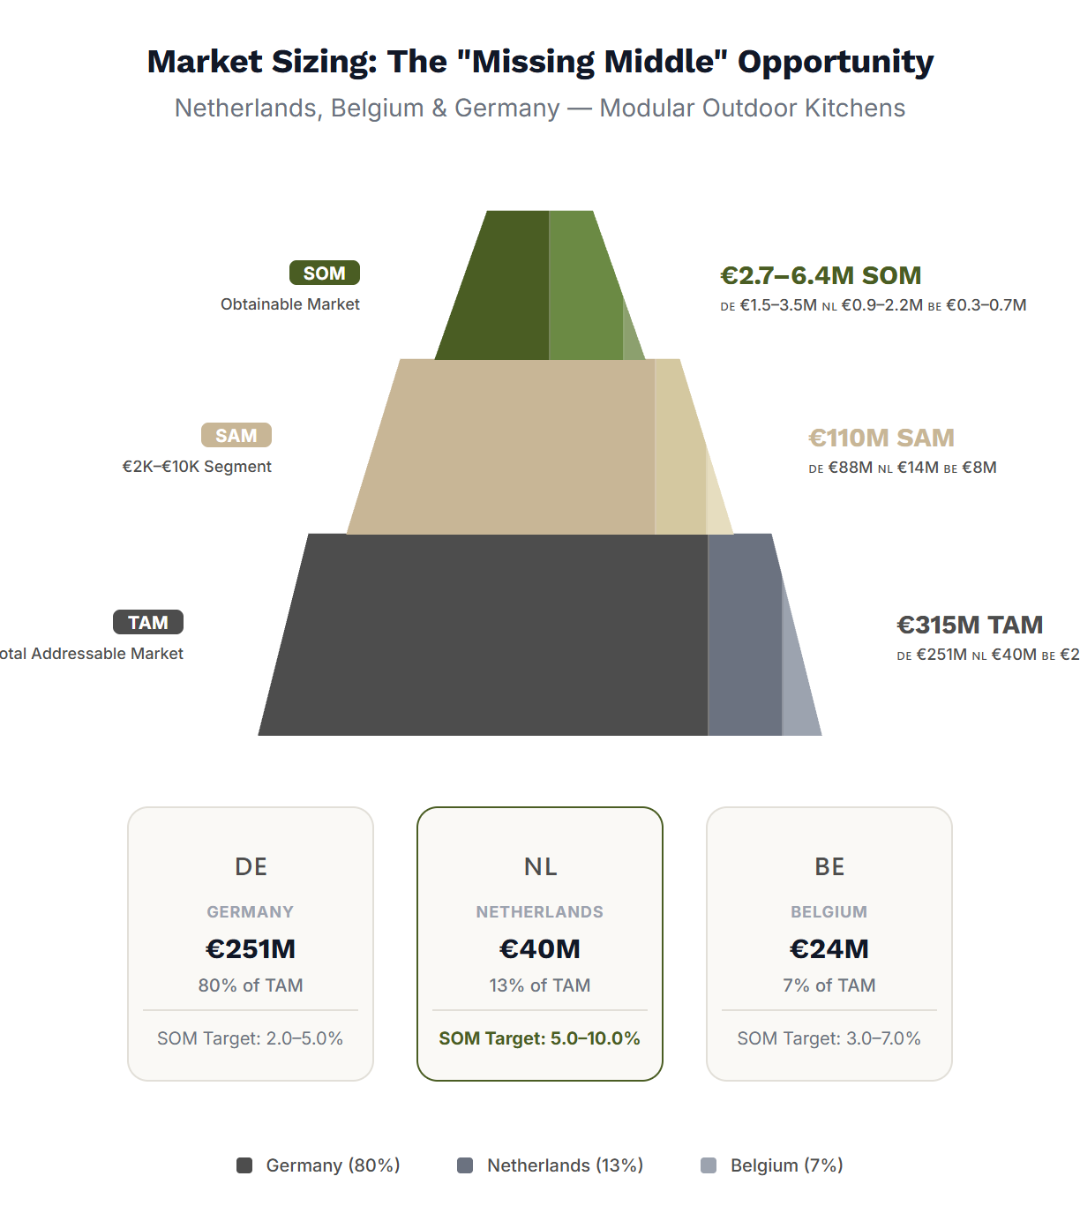
Using a bottom-up household adoption model, the Total Addressable Market across the Netherlands, Belgium, and Germany reaches €315M annually, representing approximately 79,000 units. Germany dominates with €251M of the total, making it the anchor market for any European scaling ambition. The Netherlands contributes €40M and Belgium €24M.
The Serviceable Addressable Market, representing mid-premium modular outdoor kitchens in the €2K–€10K range, accounts for 35% of TAM, or €110M. This is Fieldsman's competitive arena: the "Missing Middle" where customers want premium quality without luxury prices.
The Serviceable Obtainable Market by 2030 represents what a single scalable challenger can realistically capture. With target shares of 5–10% in the Netherlands, 3–7% in Belgium, and 2–5% in Germany, this translates to €2.7–6.4M in revenue and 550–1,270 kitchens per year. These volumes align with Fieldsman's production capacity ambition and confirm that Germany is essential for European-scale outcomes.
FIELDSMAN
SECTION 2: EXTERNAL ANALYSIS

2.3 Four Tailwinds Driving Demand
Four structural trends support category growth and strengthen the scaling thesis:

1. Outdoor living as an extension of the home
Households increasingly invest in gardens and terraces as "second living rooms." Outdoor kitchens combine functional, aesthetic, and social value, making them attractive lifestyle purchases beyond pure cooking utility. The COVID-19 pandemic accelerated this trend, and consumer behavior has not reverted.

2. Premiumization and kamado culture
Kamado grills represent approximately 5–10% of barbecue ownership across NL/BE/DE, corresponding to approximately 0.3–0.5M Dutch households, 0.2–0.3M Belgian households, and ~2.0M German households. Kamado category growth is estimated at 5–8% annually, faster than the broader European BBQ market at 4–5%. Kamado owners are a natural feeder segment for outdoor kitchen purchases: they have already invested in premium outdoor cooking and seek a proper setting for their equipment.

3. Experience-driven consumption
Outdoor kitchens function as social infrastructure. For many households, the purchase is motivated by hosting, lifestyle pride, and status signaling. Customer feedback consistently highlights the "wow effect" and pride of ownership as central to perceived value. This emotional dimension supports premium pricing and brand differentiation.

4. A polarized market structure
The market is polarized between low-budget DIY solutions and premium bespoke kitchens priced at €15,000–€50,000+. This price gap, the "Missing Middle," creates a structural opportunity for mid-premium brands offering high-quality design and durability at accessible pricing. Customers in this segment are underserved: they want more than cheap carts but cannot justify luxury prices for seasonal use.

Purchase Cycle: Seasonal High-Immediacy
Demand is strongly seasonal, peaking in Spring/Summer (April–July). During this window, "Time to Enjoy" is the primary conversion driver. Lead times >4 weeks kill conversion as customers want to use the product immediately. Fieldsman's stock-based model captures this urgency better than bespoke make-to-order competitors.

Lifetime Value: One-Off + Upgrades
The core unit is typically a one-time high-ticket investment (10-15 year lifespan). However, the modular system unlocks secondary CLV through module additions (e.g., adding a fridge or bar later) and accessory upgrades, extending value beyond the initial transaction.
To validate the macro-environment for expansion, a comprehensive PESTLE analysis was conducted. The visual below summarizes the key strategic drivers, while the full detailed analysis is available in Appendix A.
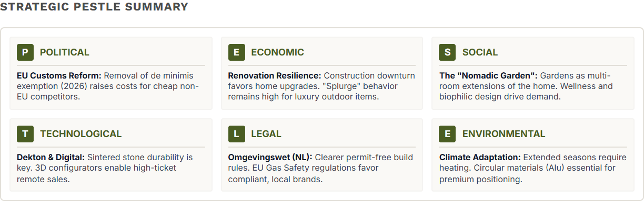
FIELDSMAN
SECTION 2: EXTERNAL ANALYSIS

2.4 What Customers Want: Design, Durability, and the "Wow Effect"
Detailed persona profiles and empathy maps are available in Appendix C.
Fieldsman's core customer is "The Proud Host": aged 35–60, upper-middle income but value-conscious, owning a home with garden or terrace, typically a family or hosting-centric couple. Their budget sits in the €3K–€8K mid-premium comfort zone. They want something premium, but not a crazy luxury spend. Their job-to-be-done is clear: create a garden centerpiece that makes hosting effortless and earns compliments.
Outdoor kitchen buyers seek three value dimensions. Functional durability ensures products withstand outdoor weather for years. Aesthetic integration makes the kitchen a central design element in the garden. Emotional value delivers hosting satisfaction, pride of ownership, and lifestyle identity.
Willingness to pay is constrained by comparison to indoor kitchens. For most households, an outdoor kitchen is discretionary and cannot justify the same investment as an indoor renovation. Customers mentally anchor to their indoor kitchen price and apply a discount for lower usage frequency. The key objection is always: "Outdoor kitchens are used less, is this worth it?" The answer lies in reassurance via durability, long lifespan, and pride of ownership. This creates a natural ceiling: most buyers will not exceed €3,000–€8,000 unless they belong to the true luxury segment.
Customers accept trade-offs if design and durability remain strong. Reduced built-ins, self-installation, fewer drawers, and lower-touch service are acceptable. Strong design, quality materials, and customization at a fair price are not negotiable. This trade-off logic aligns directly with Fieldsman's proposition: deliver what matters, eliminate what does not, and pass the savings to the customer.
The customer journey is digital-first but requires reassurance. The Proud Host discovers brands through Instagram, Pinterest, search, and lifestyle content. They use visualization tools like configurators. But for purchases in the €3,000–€8,000 range, they seek showroom reassurance before committing to a €5K+ online purchase. Pains include uncertainty about durability ("How will it look after 2 winters?"), trust concerns ("Can I trust €5K+ online?"), and access barriers ("Showrooms are too far"). Scaling requires a "phygital" model: digital acquisition combined with trust-building through content, reviews, influencers, and cost-efficient showroom access.
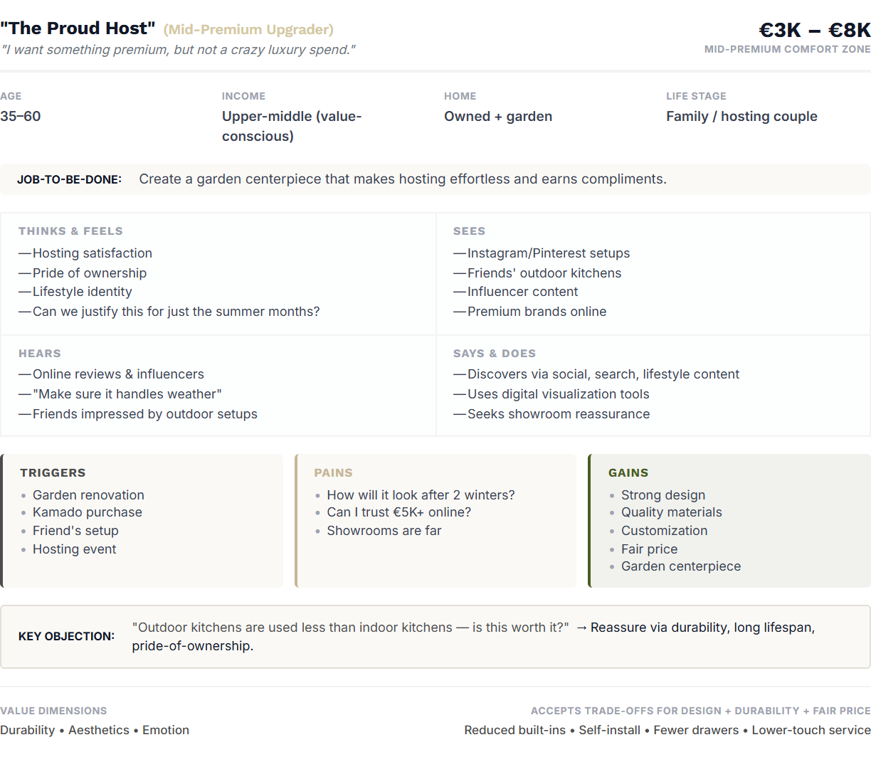
FIELDSMAN
SECTION 2: EXTERNAL ANALYSIS

2.5 A Fragmented Market Without a Scaled Leader
For a comprehensive feature-by-feature competitor audit, see Appendix D.
The competitive landscape is fragmented and structurally polarized into five segments spanning from low budget to luxury. This polarization creates a clear gap, the "Missing Middle", where Fieldsman's modular strategy delivers unique value by combining premium quality with operational efficiency.
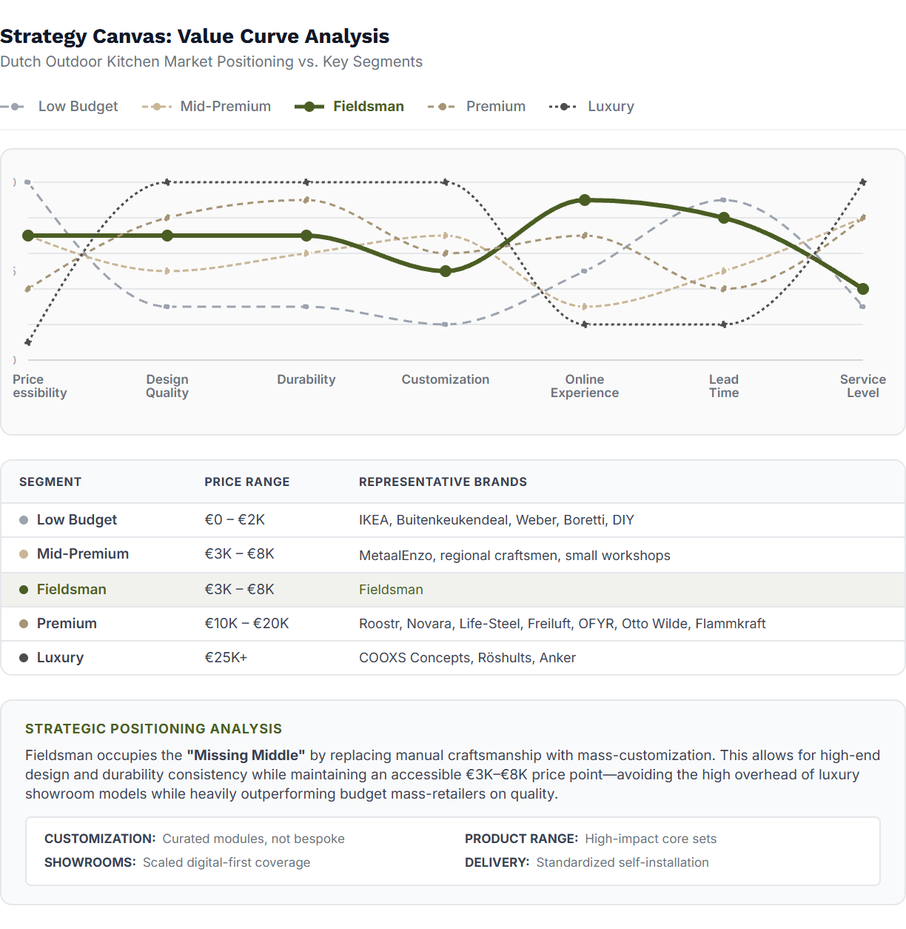
The low budget segment (€0–€2K) includes IKEA, Buitenkeukendeal, Weber, Boretti, and DIY solutions. These players score high on price accessibility but low on design quality, durability, and customization. They anchor customer reference pricing but are not direct competitors to Fieldsman.
The mid-premium segment (€3K–€8K) consists of players like MetaalEnzo, regional craftsmen, and small workshops. These players offer design focus and quality materials but suffer from limited production capacity, inconsistent online experience, and longer lead times due to manual production. This is Fieldsman's competitive arena.
The premium segment (€10K–€20K) includes established brands such as Roostr, Novara, Life-Steel, Freiluft, OFYR, Otto Wilde, and Flammkraft. They deliver high design quality and durability but operate showroom-heavy models with higher prices and longer lead times.
The luxury segment (€25K+) features players like COOXS Concepts, Röshults, and Anker. They offer fully bespoke designs and high-touch consultancy but serve a limited addressable market with extended lead times and premium pricing.

Strategic Differentiation
Fieldsman's value curve is built on a deliberate strategic choice to compete in the €3K–€8K segment by replacing traditional bespoke craftsmanship with mass-customization through standardized modules. This modular architecture allows Fieldsman to deliver higher design consistency, reliable durability, a superior online configuration and purchase experience, and significantly faster lead times than mid-premium workshops.
The competitive implication is clear: the mid-premium segment is growing but lacks a dominant scalable European player. Competition is driven by design differentiation, brand trust, and lead-time reliability, not price alone. This creates an opportunity for Fieldsman to become the category leader by scaling operational excellence.
FIELDSMAN
SECTION 2: EXTERNAL ANALYSIS

2.6 Industry Attractiveness: Room for a Challenger
Porter's Five Forces analysis indicates that the outdoor kitchen industry is attractive for a challenger that can combine modular design with operational control.
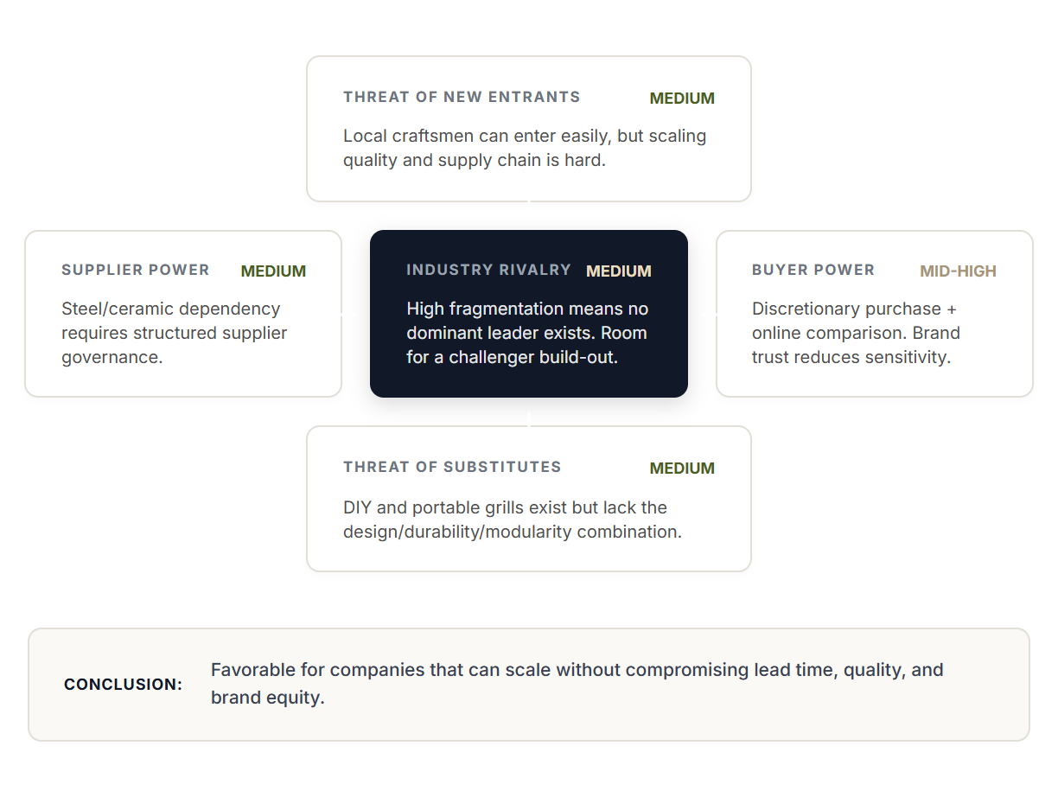

2.7 KEY EXTERNAL TAKEAWAYS
1
The Missing Middle: A €110M SAM opportunity exists for players bridging the gap between DIY carts and luxury bespoke kitchens.
2
Germany is Critical: expansion is mandatory for scale; the German market represents ~80% of total addressable revenue across prioritization zones.
3
Reassurance First: "The Proud Host" prioritizes durability and design over price; scaling requires trust-building via "phygital" touchpoints.
4
Window of Opportunity: Favorable industry structure with moderate supplier power and fragmented competition enables a modular challenger to win.
3

Internal Analysis
A Strong Foundation Constrained by Capacity
FIELDSMAN
SECTION 3: INTERNAL ANALYSIS
This chapter evaluates whether Fieldsman has the internal capabilities and resources required to execute its growth ambition. It analyzes the current business model, product architecture, capabilities, operational constraints, and the elements of brand equity that must be preserved. The objective is to identify what Fieldsman can leverage, what must be transformed, and what execution risks must be managed.

3.1 The D2C Model: High Margins, Limited Capacity
Fieldsman operates as a direct-to-consumer brand. Customers configure their outdoor kitchen online via a proprietary 3D configurator, after which the kitchen is produced and delivered directly. This model avoids retail margins and maintains strong profitability while offering accessible pricing relative to premium competitors.

The D2C Value Chain Advantage
D2C pricing removes distributor & showroom economics — enabling ~40% savings while maintaining Manufacturer Profitability.
Traditional Retail Model
Typical Retail Price: €8,500
COGS
€1.8k
OPS
€0.6k
MKTG
€0.8k
PROFIT
€1.9k
RETAIL MARGIN (40%)
~€3.4k
*Retail Model: Manufacturer sells to distributor/retailer. Brand marketing investment is significant.
Fieldsman D2C Model
Target Price: ~€5,000
COGS
€1.8k
OPS
€0.6k
MKTG
€1.0k
PROFIT
€1.6k (32%)
Customer savings: ~€3.5k (40%)
*OPS = Delivery + Install + Service

Strategic Imperative: Meeting Consumer Willingness To Pay
The decision to bypass traditional retail is not just about cost efficiency, but about market viability. Our analysis indicates the target customer's maximum Willingness to Pay for this modular category is approximately €3,000–€8,000.
As the visual demonstrates, a traditional retail model demands a ~40% margin, pushing the price to €8,500+—limitng volume. By trading off this retail margin, Fieldsman accepts a lower per-unit potential but unlocks significantly higher volume by fitting precisely within the €5k adoption sweet spot. This "Volume Strategy" maximizes total profit pool rather than unit margin percentage.
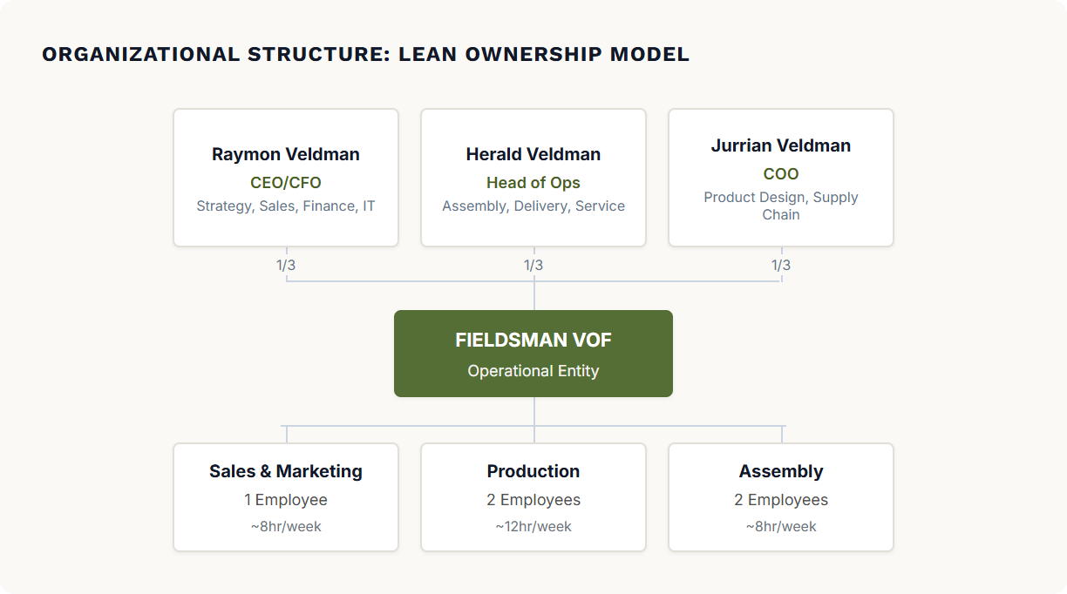

Current Performance Snapshot
40%
Profit Margin
~€80k Profit on €200k Net Rev
<€100
CAC
Customer Acquisition Cost
40x
ROAS
Return on Ad Spend
The company sells approximately 50 kitchens per year with remarkable efficiency. Marketing investment is less than €5,000 annually. This implies a customer acquisition cost under €100 and a return on ad spend exceeding 40x. The demand is clearly there. The constraint has never been commercial; it has always been operational.

DIRECT FEEDBACK LOOP
Unlike competitors who rely on dealer reports, Fieldsman owns the customer relationship. Every conversation is a data point. This "Pulse of the Market" allows for rapid iteration of the 3D configurator and product features based on real-time feedback.

CASH EFFICIENCY
The showroom-less model eliminates high fixed rental costs. Furthermore, the D2C model operates on negative working capital: customers pay deposits upfront, funding production before costs are incurred. This is a crucial engine for self-funded growth.
FIELDSMAN
SECTION 3: INTERNAL ANALYSIS

3.2 The Bottleneck: Why Growth Stops in May
Fieldsman’s current production constraint is not the modular product design itself, but the structural setup of the organization: production capacity is limited because the team operates largely part-time, with a small number of skilled people who carry multiple roles. This makes output highly dependent on a few individuals and prevents rapid scaling when demand peaks in spring and summer. The business simply does not have the fixed workforce or continuous operating rhythm required to increase throughput materially.
While the detailed modular architecture (see Appendix F) theoretically allows for pre-season stock building to smooth demand, this would require massive inventory investment at the start of the year. Given the high cost of components, this creates prohibitive working capital pressure and storage costs, making "building to stock" a financially risky strategy for a bootstrapped company.
At the same time, scaling production fully in-house is structurally inefficient due to strong seasonality. Outdoor kitchen demand drops significantly in winter, which would create overcapacity and idle skilled labor if Fieldsman invested in a larger permanent internal team and equipment. Temporary labor is not a practical solution because the work requires craftsmanship, quality control, and product knowledge that cannot be learned quickly.
Adding to this complexity is the supply chain for ceramic countertops. Currently outsourced to local suppliers, this component introduces severe unpredictability, with lead times frequently exceeding 8 weeks during high season. This external bottleneck effectively caps total output regardless of internal improvements, as finished frames cannot be shipped without their tops.
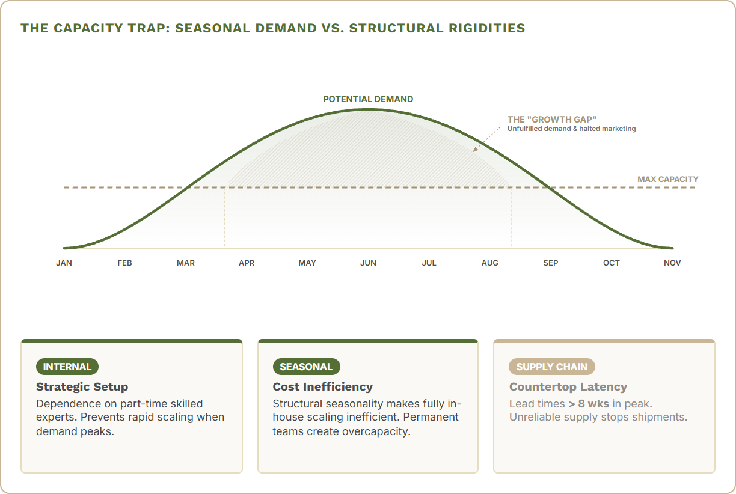
Implication: To scale from 50 to 5,000 kitchens per year, Fieldsman must transform its production system. The goal is to move from fixed manual labor to a scalable hybrid model: outsourced steel (flexibility) and in-house robotic countertop cutting (cost & speed control).
4

Strategic Options
Three Paths Forward, One Clear Winner
FIELDSMAN
SECTION 4: STRATEGIC OPTIONS

4.2 Recommended Strategy: Brand-Led Scale-Up
Visualized in detail in the Business Model Canvas (Appendix E).

STRATEGIC INTENT: THE "PHYGITAL" ENGINE
Fieldsman will build a scalable European outdoor kitchen brand by executing a repeatable D2C "phygital" model: leveraging online inspiration and digital configurators for customer acquisition, supported by cost-efficient physical experience points. This strategy transforms the supply chain by leveraging modular architecture to shift from high-cost local fabrication to a hybrid assembly model (Chinese component scale + Dutch precision finishing), enabling national and international growth without proportional headcount increases.

Core Strategy Design Choices

Value Chain Control
Retain 100% of brand, pricing, and customer data ownership. This ensures direct "learning loops" essential for product optimization and high-margin D2C sales.

Production Model
Modular Hybrid: Standardize components for global outsourcing (scale/cost) while retaining final assembly in NL (quality/speed) to decouple complexity from growth.

Go-To-Market
D2C Phygital: Focus on configurator-led digital sales supported by a decentralized network of low-CAPEX experience points, bypassing traditional retail margins.

Funding & Control
Organic / Minority: Prioritize majority control to maintain long-term brand integrity and strategic agility during the critical 2026-2030 scale-up phase.

TARGETED OUTCOMES BY 2030
REVENUE
€22–35M
VOLUME
~3k units
MARKETS
NL • BE • DE
OWNERSHIP
Majority
Conclusion: By choosing Option 1, Fieldsman avoids the "complexity trap" of premature M&A and the "control trap" of master franchising. This path ensures the company remains the master of its own data and brand, which are the foundations for the AI-driven operational efficiencies planned in Section 5 (Implementation).

4.3 KEY TAKEAWAYS
1
Phased Scale: Organic growth allows "failing small" before aggressive expansion into Germany.
2
Protect the DNA: Direct customer feedback and D2C margins are the non-negotiables.
5

Implementation
Transforming Fieldsman for Scale
FIELDSMAN
SECTION 5: IMPLEMENTATION
This chapter defines the strategic transformations required to scale Fieldsman from 50 to 3,000 kitchens per year. The implementation starts with the defining value proposition and brand positioning, flows into the commercial growth engine, and concludes with the operational transformation and expansion roadmap.

5.1 Value Proposition, Offering & Branding

5.1.1 The Value Proposition: Accessible Luxury
Fieldsman disrupts the market by decoupling "premium" from "expensive." Traditional buying journeys force a binary choice: expensive custom masonry (€15k–30k) with long lead times, or flimsy DIY kits (€1k–2k) that degrade quickly. There is almost no middle ground for the design-conscious homeowner.
Fieldsman occupies this "Blue Ocean" by delivering €15,000 perceived value at a €3,500–8,000 price point. This is not a discount strategy; it is a structural cost advantage achieved through standardized customization. By operating at **industrial scale**, Fieldsman outcompetes local bespoke players on price while offering superior durability and design precision.

Explicit Trade-Offs
- Mass-customization over Bespoke
- Self-installation over White-glove (at entry)
- Showroom-light over Dense retail
- Curated efficiency over Infinite choice
- Stock-Driven Speed over Made-to-Order

5.1.2 The Offering: One Base, Three Tiers
One modular system serves three distinct segments. Customers move up the value pyramid by adding options, not by changing the core product structure. (See Appendix F for Modular Architecture)
TOP – LUXURY EXPRESSION
8+ Modules • Fully equipped & curated
€6k - 10k
Accessible luxury, perfected.
MIDDLE – ASPIRATIONAL TIER
4-6 Modules • Enhanced comfort & design
€3.5k - 5.5k
Personalized outdoor living.
BASE – ACCESSIBLE ENTRY POINT
2 Modules • DIY and affordable quality
€2k - 2.5k
Luxury starts here.

5.1.3 Brand Positioning: Core Identity & The "Job to be Done"
Branding is essential to transform Fieldsman into a professional premium brand. By establishing brand legitimacy, Fieldsman secures a sustainable competitive advantage in a market where trust and aesthetics drive high-involvement purchase decisions. Strong branding allows Fieldsman to escape pure price competition and justify healthier margins. By turning the modular system into a desirable lifestyle investment with a recognizable “Fieldsman Look,” Fieldsman enables rapid, profitable scale.
Brand Essence: "Authentic Craftmanship. Built for Bringing People Together."
The brand bridges two worlds: The Three Brothers (Grounded, Honest, Makers) and the Design-Conscious Host (Social, Aspirational, Connector). Fieldsman uses authentic Dutch craftmanship to build the perfect stage for the client's sense of belonging.

The Client's "Job to be Done"

The Brand Identity System
Functional: "Reliable & Easy"
Needs to last (Steel/Ceramic). Needs to adapt. Affordable.
Organization: The Staphorst Roots
Heritage of integrity. "We don't over-promise, we build." Legitimacy through action.
Emotional: "Pride & Reward"
"I designed this." "We deserve this milestone."
Symbol: The Fieldsman Seal
The "Maker's Mark". Stamped on every frame. A personal guarantee of integrity from the brothers.
Social: "Recognition without Ego"
“We love having people over.” “This fits who we are.”
Personality: The Capable Connector
Grounded. Competent. "The friend who knows how to fix it."
Proudly Simple. Built for Life.
FIELDSMAN
SECTION 5: IMPLEMENTATION

5.2 Go-to-Market: Building a Scalable Commercial Engine
Scaling from €200K to €22–35M requires a fundamental transformation of how Fieldsman generates demand. The current founder-driven sales model cannot scale. The new commercial engine is built on a unified strategic framework, beginning with a deep understanding of the customer's path to purchase.
To move beyond founder-led sales, Fieldsman must stop treating sales as a series of ad-hoc conversations and start managing them as a designed product. This defined Customer Journey serves as the backbone of the new commercial engine, orchestrating every digital and physical touchpoint into a seamless, reproducible experience.

The Multi-Channel Customer Journey
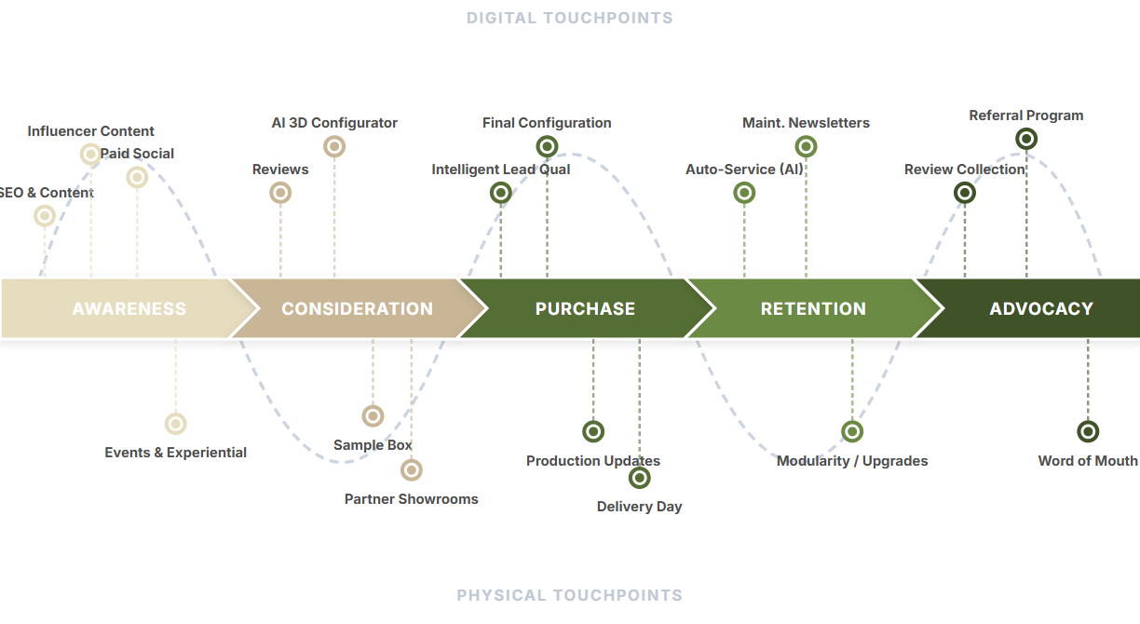
The operationalization of this journey is architected into three integrated layers: Marketing (Inflow), AI Operations (Throughput), and Phygital Service (Trust). This unified commercial engine ensures efficiency does not come at the cost of the "Proud Host" experience.
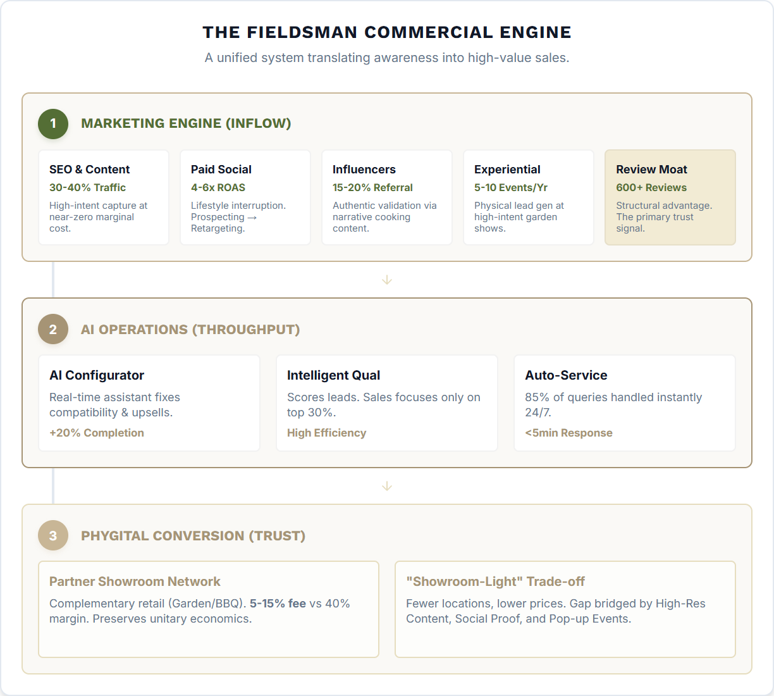
FIELDSMAN
SECTION 5: IMPLEMENTATION

5.3 Production Transformation: Controlling the Bottleneck

The Challenge: The Seasonal Capacity Trap
The fundamental challenge of the outdoor living market is extreme seasonality: 80% of consumer demand occurs between March and July. Under the current model, scaling production requires hiring permanent skilled craftsmen. This creates a "Capacity Trap": you either under-produce during the summer peak (losing revenue) or carry massive overhead during the winter trough (destroying margin).

The Solution: The Integrated Hub Strategy
The Transformation solves this by decoupling component stability from assembly flexibility. By moving to an Integrated Hub Model, Fieldsman can flatten the production curve:
- Winter (Stockpile): Steady production of standardized modules from global partners fills the buffer.
- Summer (Assemble): The NL Hub scales final assembly using flexible labor to meet the 5x demand spike, drawing from the buffer.
Steel Modules (Dual Sourcing):
Standardized frames are sourced via a **Dual Vendor Strategy (China & East Europe)**. This balances cost efficiency with supply chain resilience, converting fixed labor into variable unit costs.
Ceramics & Cutting (Value Add):
Slabs are sourced globally (**China & Spain**), but cutting is vertically integrated in the NL Hub. This reduces unit costs from
€900 to €100
and lead times from
8 weeks to 2 weeks
.
Flex Assembly Hub (Quality):
The NL Hub acts as a critical **seasonal buffer** and quality gate. Centralized final assembly ensures
100% quality control
before dispatch, scaling with temporary labor during peak demand.
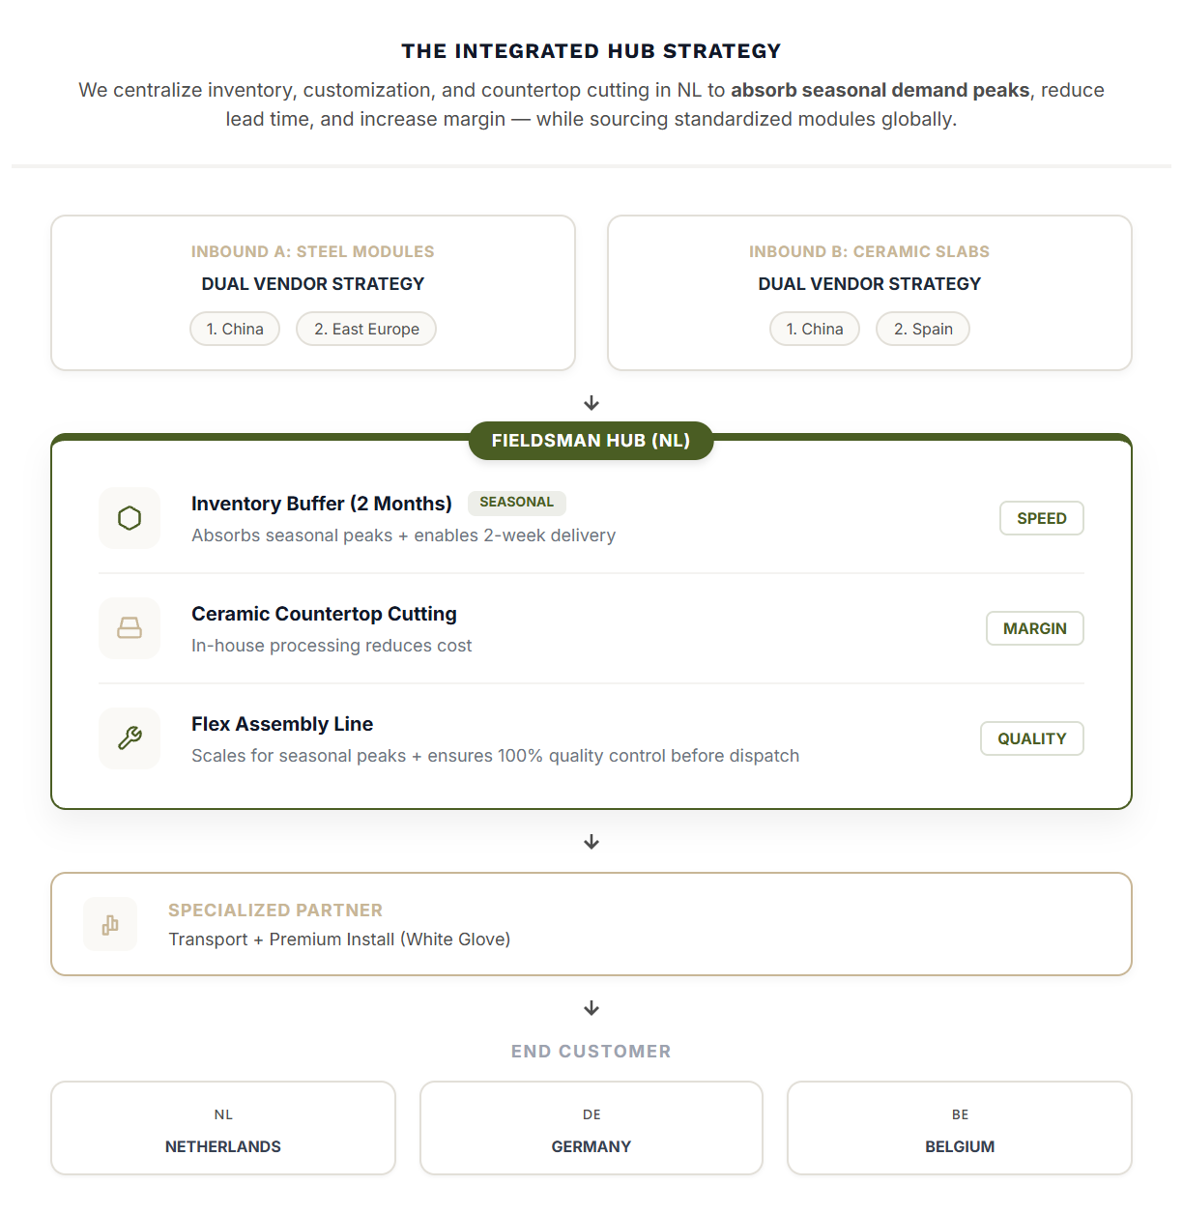
FIELDSMAN
SECTION 5: IMPLEMENTATION

5.4 Organization Plan: Leading the Scale-Up
To successfully execute the 2026–2027 growth strategy, Fieldsman must transition from a flexible startup to a disciplined scale-up organization. This requires a fundamental shift in the founders' commitment: realizing this growth potential demands fully invested, full-time leadership. The founders must step out of daily execution to own strategic pillars, supported by a specialized team structure that replaces generalist roles with dedicated functional experts. The chart below outlines the target structure required to support the new Integrated Hub model.
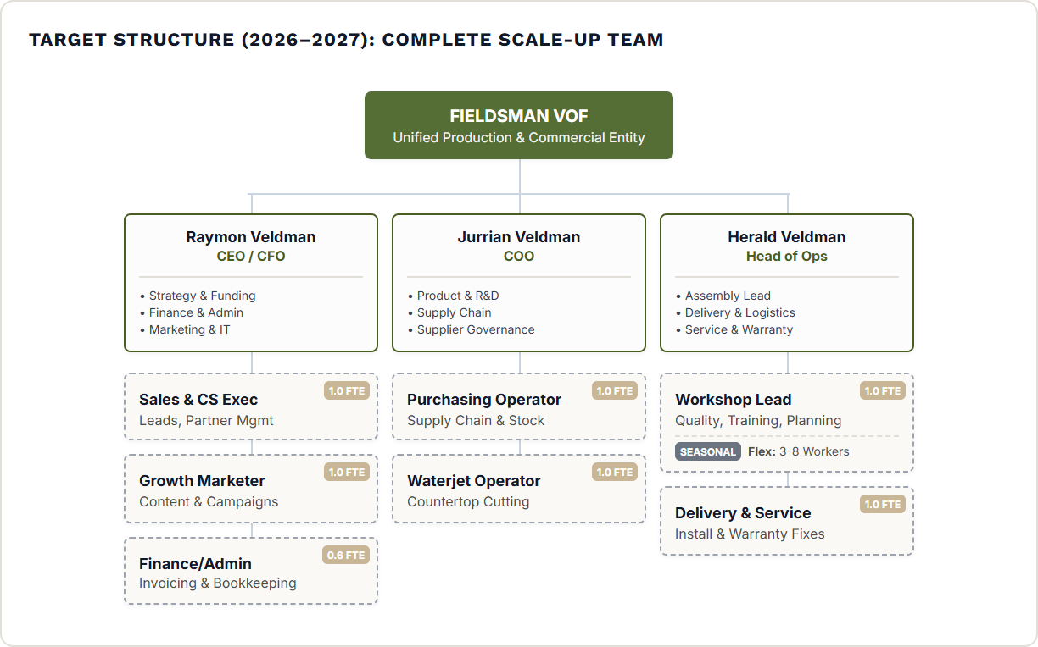

5.5 Geographic Expansion: Capability-Gated Sequencing
Expansion follows operational readiness, not calendar ambition. Each market entry is gated by demonstrated capability in the current footprint.
PHASE 1: 2026

Netherlands
PROVE THE MODEL
The foundation market. Must demonstrate that production can scale reliably, marketing converts efficiently, and quality maintains high NPS at volume.
Entry Gate:
Production transformation complete, Lead times stable (2 wks).

Target: 250–400 units
PHASE 2: 2027

Belgium
TEST INTERNATIONAL OPS
Logical first step due to proximity and language. Tests cross-border delivery, service, and partner management.
Entry Gate:
NL operating at 400+ units, Configurator localized.

Target: 100–200 units
PHASE 3: 2027–30

Germany
ANCHOR MARKET FOR SCALE
The strategic prize (€88M SAM, 80% of opportunity). Requires full localization (language, preferences) and serves as the volume engine.
Entry Gate:
BE profitable, Production capacity 600+.

Target: 40–50% of total vol

5.6 KEY IMPLEMENTATION TAKEAWAYS
1
Accessible Luxury: Value proposition is defined by clear trade-offs that enable premium design at mass-market prices.
2
AI Scalability: Commercial engine uses AI for configuration, lead qual, and service to decouple revenue growth from headcount.
3
Reverse Logic: Transformation implies outsourcing standardized modules (**Global Dual-Sourcing**) while vertically integrating custom countertops (**NL Hub**).
4
Gated Expansion: International growth is capability-gated, ensuring the core NL model is proven before scale-up in Germany.
6

Action Plan
From 50 to 3,000 Kitchens (2026-2030)
FIELDSMAN
SECTION 6: ACTION PLAN

6.1 Phased Roadmap: From Foundation to Leadership
Executing this strategy requires a disciplined, phased approach. The roadmap is structured into four distinct phases, each with clear operational milestones and financial targets.
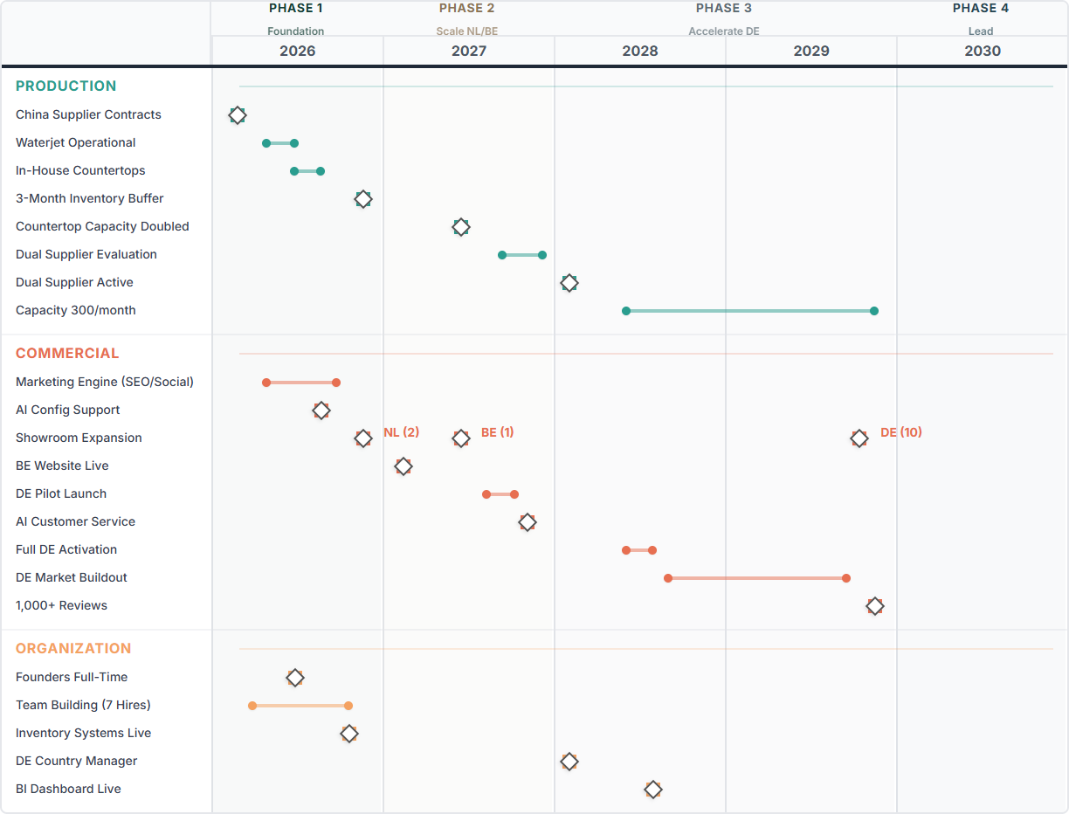

6.2 KPI Dashboard: Balanced Performance Measurement
Success requires tracking both short-term execution and long-term strategic progress. This balanced scorecard ensures accountability across Commercial growth, Operational excellence, and Financial sustainability.
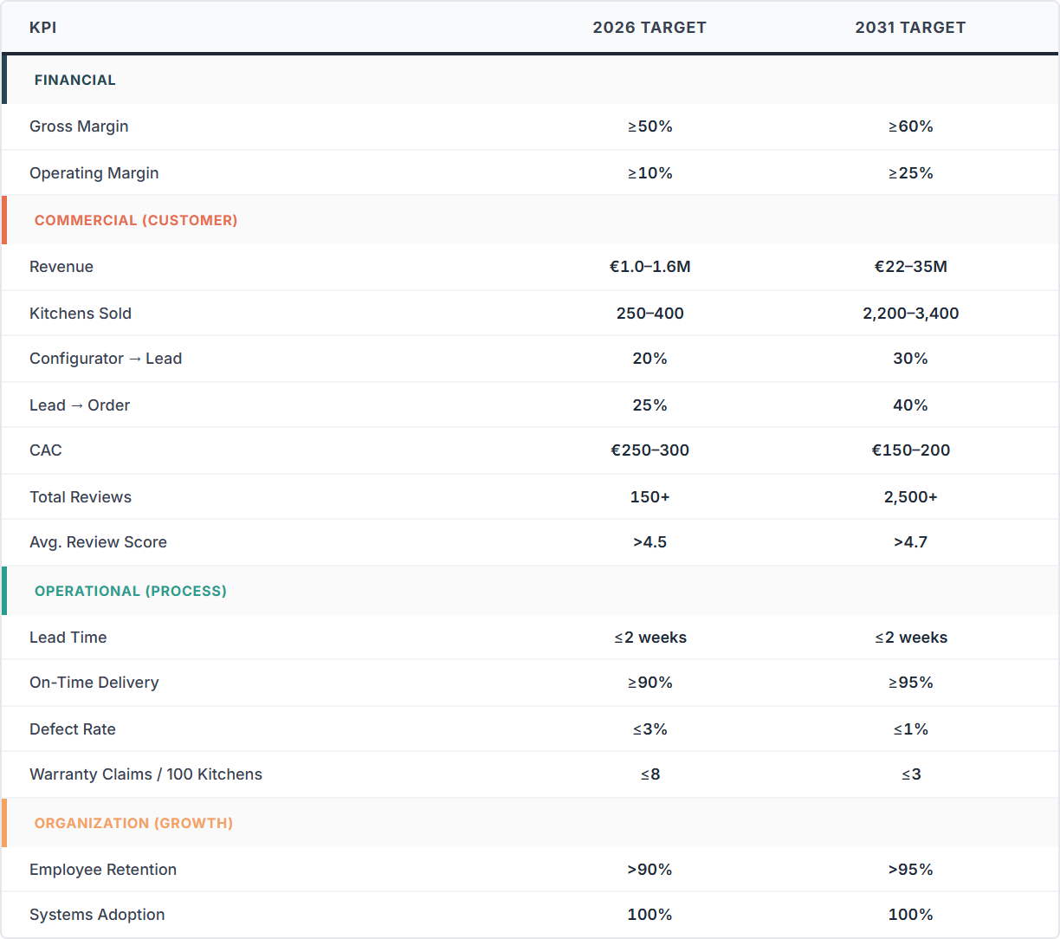
7

FINANCIAL PLAN
PROJECTIONS & PERFORMANCE METRICS (2025-2030)
FIELDSMAN
SECTION 7: FINANCIAL PLAN

7.1 Overview
This section outlines the projected financial performance of Fieldsman from 2025 through 2030, demonstrating the path to profitability and scale.

7.2 Five-Year P&L Summary ([2025]–[2030])
[Placeholder: Five-Year P&L Summary Table]

7.3 Cash Flow and Working Capital
[Placeholder: Cash Flow & Working Capital Chart]

7.5 Extra-Financial Impact (ESG)
Beyond financial metrics, Fieldsman is committed to sustainable operations. This covers material sourcing reliability, energy-efficient production, and fair labor practices in the supply chain.
[Placeholder: ESG Impact Metrics]

7.6 Sensitivities
Analysis of key risks and their potential impact on the financial projections, including variations in material costs, demand uptake, and operational efficiency.
[Placeholder: Sensitivity Analysis Chart]
8

RISK MANAGEMENT
RISK REGISTER & MITIGATION STRATEGIES
9

CONCLUSION
STRATEGIC SYNTHESIS & RECOMMENDATION
FIELDSMAN
SECTION 9: CONCLUSION

9.1 Strategic Summary
A final synthesis of the Fieldsman opportunity, summarizing the strategic fit, financial potential, and the path to becoming a market leader in the B2B kitchen segment.
[Placeholder: Final Strategic Synthesis]

9.2 Final Recommendation
[Placeholder: Go/No-Go Recommendation]

Appendix
Supporting Materials
FIELDSMAN
APPENDIX

Appendix A: Advanced Strategic PESTLE Analysis
The luxury outdoor kitchen market in the Netherlands, Germany, and Belgium represents a sophisticated intersection of architectural innovation, shifting domestic lifestyles, and a maturing direct-to-consumer economic model. For an enterprise such as Fieldsman.nl, which operates on a vertically integrated manufacturing and sales platform, the current landscape offers significant opportunities tempered by complex regulatory and macroeconomic challenges. The broader European outdoor kitchen market is poised for robust expansion, with projected revenues reaching US$ 13,967.3 million by 2033, sustained by a compound annual growth rate of 8.9%. This evolution is driven by a fundamental redefinition of the "home" from a purely interior living space to a holistic environment where the garden serves as a functional extension of the culinary and social heart of the residence.

Political Landscape: Regulatory Harmonization & Protectionism

EU Customs Reform and the Domestic Advantage
A critical political shift affecting the competitive landscape is the European Commission’s aggressive move to eliminate de minimis exemptions for low-value imports. Historically, parcels valued below €150 entered the EU duty-free. The Council of the EU has agreed to remove this exemption, introducing a €3 customs duty per item starting in July 2026. This measure serves as a structural barrier against low-cost international competitors, reinforcing the value of localized "Made in Europe" manufacturing.

Logistics Policy and the Green Transition
Governments in Germany and the Netherlands are incentivizing the use of digital logistics hubs and LTL (Less than Truckload) shipping to reduce carbon emissions. Approximately 50% of heavy goods vehicles in Europe currently operate with empty loads, prompting political support for optimized freight shipping networks.
Policy or Regulation | Effective Date | Geographical Scope | Strategic Impact for Fieldsman.nl
De Minimis Removal | July 2026 | European Union | Reduces competition from non-EU budget platforms.
Union Handling Fee | November 2026 | European Union | Increases operational costs for foreign importers.
Omgevingswet (Planning) | Jan 1, 2024 | Netherlands | Simplifies but clarifies permit-free building zones.
6% VAT Rate (Renovation) | Current | Belgium | Incentivizes home upgrades over new builds.
Dutch Consignment Fee | Feb 1, 2026 | Netherlands | Early-stage trade protectionism for domestic e-commerce.

Economic Factors: Volatility & High-Ticket Consumption

The Construction Paradox and Renovation Resilience
The residential construction industry in Northern Europe is in flux. In Germany, completions are expected to drop to 175,000 dwellings in 2026. However, this slump has strengthened the renovation market. Homeowners unable to move are investing in existing homes. In Belgium, a reduced VAT rate of 6% for renovation provides a significant economic incentive.

Consumer Purchasing Power and the 'Splurge' Behavior
Despite economic pressures, 43% of German consumers plan to "treat themselves" with high-ticket purchases. 78% of Baby Boomers and 68% of Millennials are willing to spend more than $5,000 on an aesthetic outdoor space. Fieldsman.nl’s 30% saving model appeals to both the affluent "splurge" buyer and price-conscious segments.
Economic Metric | Germany | Netherlands | Belgium
DIY Sector Sales Growth (2025) | 2.9% Rebound | Fragile Growth | Stable
Inflation Forecast (2025) | ~2.3% | ~2.3% | ~2.3%
Residential Construction Outlook | Significant Decline | Slight Recovery | Legislative Support
Consumer Confidence Indicator | Cautiously Optimistic | Mixed Sentiment | Impacted by Inflation

Social Determinants: The 'Outdoor Room' Evolution

The 'Nomadic Garden' and Domestic Sanctuary
The "Nomadic Garden" concept treats the backyard as a versatile living space with distinct "rooms." This reflects a societal move toward "cocooning," where the home is a sanctuary. Gardens now feature intimate reading nooks, breakfast terraces, and central social cooking hubs.

Generational Nuances & Wellness
Gen X holds the highest purchasing power for durable upgrades. Millennials drive social cooking trends (pizza ovens, beer taps). Boomers prioritize durability and warranties. Additionally, "wellness real estate" integrates biophilic design, transforming outdoor kitchens into health-conscious spaces.
Social Trend | Target Demographic | Core Value Proposition
Nomadic Garden | Gen X / Millennials | Versatility, "Room" division, mobility.
Cocooning | Families | Safety, privacy, domestic sanctuary.
Biophilic Design | High-Net-Worth Individuals | Wellness, nature connection, stress reduction.
Social Cooking | Millennials | Professional-grade appliances, pizza ovens, beer taps.
Year-Round Living | All Generations | Built-in heating, weather-resistant materials.

Technological Advancements: Digital Sales & Materials

Digital Transformation of the Customer Journey
3D configurators and AR tools allow users to visualize complex modular systems, reducing dissatisfaction and accelerating decisions. Social commerce (Instagram, TikTok) reshapes discovery for younger demographics.

Material Science: The Preeminence of Dekton
Dekton (particle sintering technology) offers zero porosity, UV stability, and thermal shock resistance, superior to traditional granite or quartz.
Technology Category | Innovation | Key Functional Benefit
Sales Channel | 3D Configurator | Direct-to-consumer customization; reduced sales friction.
Surface Material | Particle Sintered Stone (Dekton) | UV stability, zero porosity, extreme heat resistance.
Cabinetry | Marine-Grade Aluminum | Rust-proof, lightweight, RAL color flexibility.
Connectivity | Wi-Fi/App Integration | Remote monitoring of grill temperatures and lighting.
Power | Integrated Electrification | Built-in sockets and USB charging ports for outdoor devices.

Legal Requirements: Zoning, Safety, & Compliance

The Dutch Omgevingswet and Permit-Free Building
The Omgevingswet (Jan 1, 2024) unifies planning law but maintains strict criteria for permit-free building. Structures within 4m of the house are height-capped. Outbuildings >4m away must have pitched roofs if over 3m high.

Gas Safety and European Regulation
Regulation (EU) 2016/426 mandates CE marking for gas appliances. Devices must have flame control to prevent leaks. Retailers are liable for compliance verification.
Legal Domain | Regulatory Body/Act | Core Requirement
Planning (NL) | Omgevingswet | Max 5m height; functionally subordinate to house.
Gas Safety (EU) | Regulation (EU) 2016/426 | Mandatory CE marking and type-examination.
Consumer Rights | E-Commerce Directive | 14-day return right; no geo-blocking.
Environment (BE) | Environmental Permit | Integrated permit for construction and existence.
Fire Safety (DE) | National Fire Regulations | Three-level framework for building safety.

Environmental Impact: Sustainability & Climate

Circular Economy and Material Selection
Aluminum is favored for 100% recyclability. HPL and polymer composites resist rot, reducing replacement needs.

Climate Adaptation
Warming trends extend the "usage window" into spring/autumn, driving demand for built-in heating. Smart irrigation and rainwater harvesting are becoming standard for resource efficiency.
Environmental Factor | Strategic Response | Long-term Benefit
Climate Change | Built-in heating and pergolas | Extended usage seasons and better comfort.
Resource Scarcity | Smart water management | Reduced water consumption in drought periods.
Waste Reduction | Recyclable aluminum/composites | Lower lifecycle impact and high durability.
Energy Poverty | Solar and LED lighting | Reduced household energy costs.
Overheating Risk | Bioclimatic structures | Maintainable living space during heatwaves.

Competitive Dynamics & Strategic Synthesis

Competitor Positioning
Bifurcated market: High-end bespoke German (Burnout, Cubic Outdoor) vs. Flexible Modular & Social (Wwoo, OFYR). Fieldsman.nl targets the "Strategic Sweet Spot": Premium quality with D2C economic efficiency.

Logistical Challenges
Shipping bulky goods is the primary operational hurdle. Parcel delivery (NL-DE) costs €30-€70, while freight costs €250-€600+. Tailgate services and weight limits (>68kg) require specialized handling.

Future Outlook
The market is transforming through the convergence of the "outdoor room" trend and high-performance materials like Dekton. Fieldsman.nl's D2C model and vertical integration offer a hedge against economic volatility and construction downturns. Success will depend on navigating the "wellness" agenda, integrating smart technology, and managing cross-border logistics costs while maintaining the price advantage that protects against de minimis removal and diverse competitor tiers.
FIELDSMAN
APPENDIX

Appendix B: Market Sizing Methodology

Appendix B: Market Sizing Methodology

M2. Bottom-Up Approach
This section documents the bottom-up market sizing approach used to quantify the outdoor kitchen opportunity across the Netherlands, Belgium, and Germany.

M2.1 Market Definition
The outdoor kitchen market is defined as permanent or semi-permanent outdoor cooking and preparation units for residential households. The definition includes modular outdoor kitchens, built-in units, and cooking modules integrating kamado grills, gas grills, and pizza ovens.
Exclusions: Portable grills and BBQ carts (<€500), masonry structures in large landscaping projects (>€50,000), and indoor kitchen products not designed for outdoor durability.

M2.2 TAM Calculation Logic
TAM is calculated using a bottom-up household adoption model:
TAM (€) = Households × Garden Access % × Annual Adoption Rate × ASP

M2.3 Input Assumptions by Country
Parameter | Netherlands | Belgium | Germany | Source/Rationale
Households | 8.3M | 4.9M | 41.6M | CBS, Statbel, Destatis
Garden Access % | 60% | 62% | 50% | Home ownership + estimates
Annual Adoption | 0.24% | 0.24% | 0.29% | Conservative BBQ estimate
Blended ASP | €3,350 | €3,350 | €4,200 | Competitor analysis
Units/Year | 11,952 | 7,288 | 59,758 | Calculated
TAM | €40M | €24M | €251M | Calculated

Combined TAM (NL+BE+DE): €315M (78,998 units/year)

M2.4 SAM Calculation (Mid-Premium Segment)
SAM represents the mid-premium segment (€2,000–€10,000) where Fieldsman competes. Based on competitor analysis, this represents 35% of TAM.
Market | TAM | Mid-Premium Share | SAM
Netherlands | €40M | 35% | €14M
Belgium | €24M | 35% | €8M
Germany | €251M | 35% | €88M
Total | €315M | 35% | €110M

M2.5 SOM Calculation (Target 2030/2031)
Market | SAM | Target Share | SOM Revenue | SOM Units
Netherlands | €14M | 5–10% | €5–7M | 500–600
Belgium | €8M | 3–7% | €2–3M | 200–300
Germany | €88M | 2–5% | €15–25M | 1,500–2,500
Total | €110M | — | €22–35M | 2,200–3,400

FIELDSMAN
APPENDIX
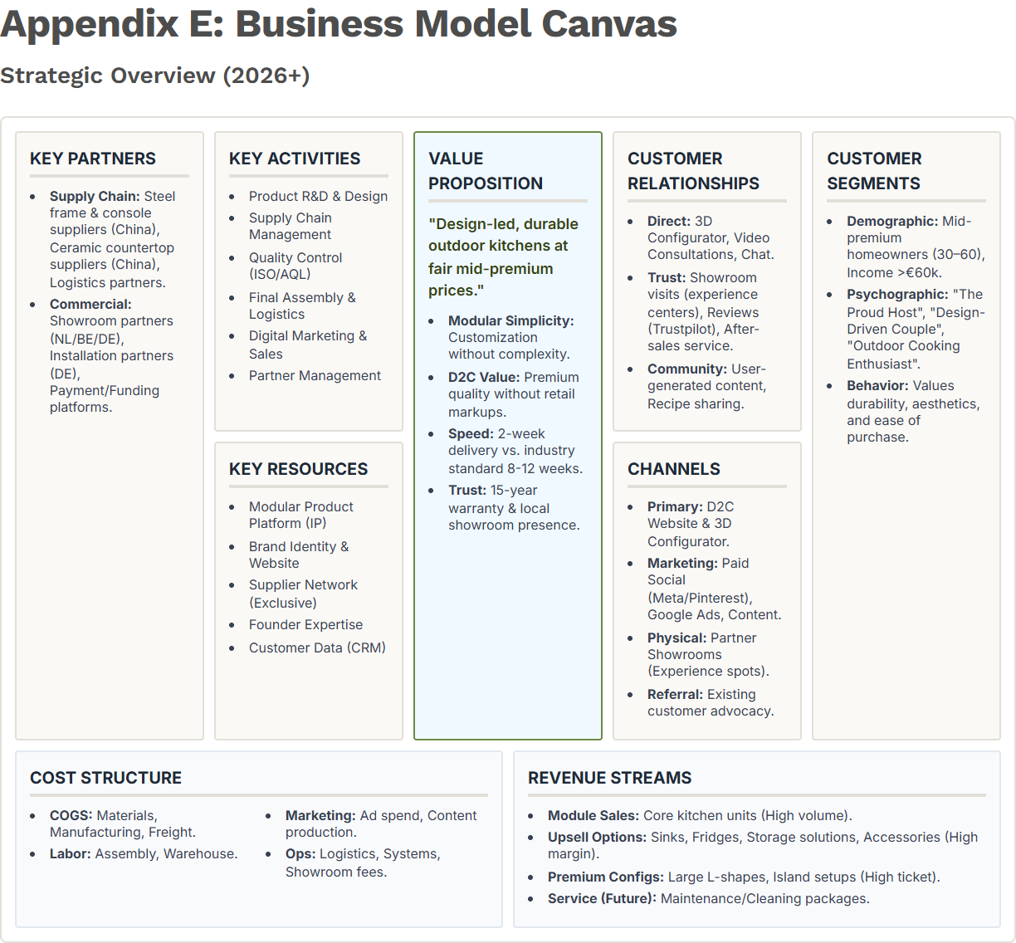
FIELDSMAN
APPENDIX

Appendix F: Modular Product Architecture

Customization Without Complexity
Fieldsman's core strategic asset is its modular product architecture. The outdoor kitchen is built from standardized modules that can be combined and expanded, allowing customers to design configurations that fit their space and preferences while enabling scalable production.
The Module System:
- Compact Module (49.5 cm): Storage and compact setups.
- Ruim Module (63 cm): Primary workspace building block.
- Kamado Module (68 cm): Anchors most configurations.
- Corner Module (80 cm): Enables L-shaped layouts.
Customization options include panel materials (steel or composite in teak, oak, or graphite finishes), steel colors (black or white), and ceramic countertops. This design creates perceived personalization while limiting complexity.
The Scaling Rationale: Modularity is the foundation of mass customization. A stable module set allows Fieldsman to optimize cutting patterns, standardize assembly, and scale to 1,000–5,000 kitchens per year without redesigning the product. This solves the "mid-premium dilemma": offering customization without the unscalable costs of bespoke craftsmanship.
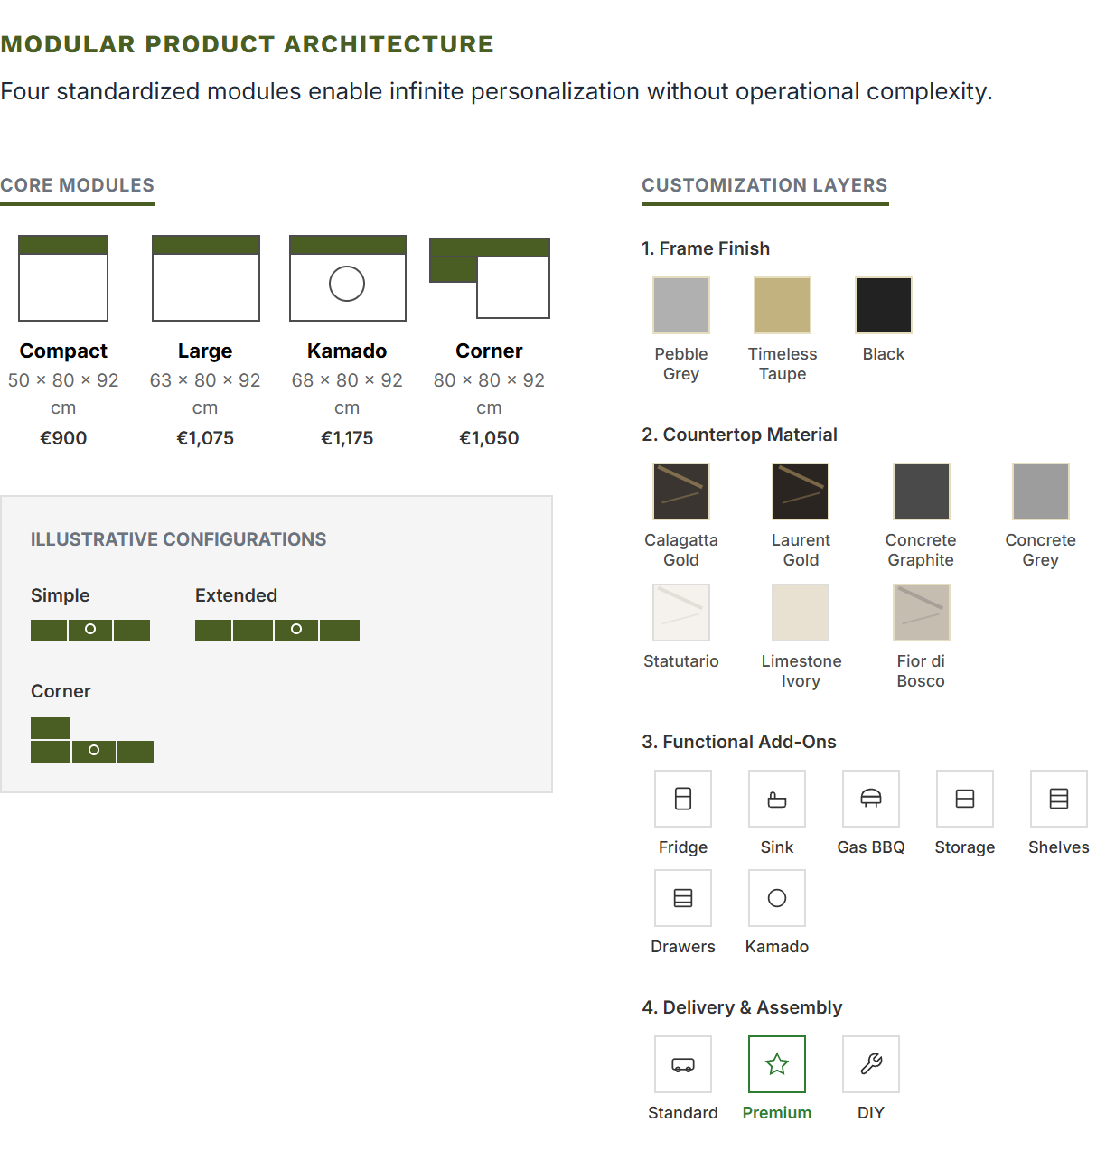

Pricing Architecture
The D2C model supports a modular pricing ladder that captures customers at multiple entry points without changing the core production logic.
ENTRY
€2,000+
2 modules. Targets price-sensitive first-time buyers.
CORE
€3k – €5k
4–6 modules. Primary mid-premium target segment.
PREMIUM
€6k – €10k
8+ modules. Design-driven, full outdoor kitchen.

The Modularity Moat

VS Regional Craftsmen
Regional craftsmen offer unlimited bespoke options but cannot scale. Their costs are tied to manual labor and one-off designs. Fieldsman delivers the "Wow Effect" at scale.

VS Mass Retailers
Mass retailers offer standardization but no personalization. Their products are generic. Fieldsman offers high-end aesthetic control while maintaining retail-like operational efficiency.

