Solutions Architecture Document — Forge
Veldris Ltd
Data Operations — a post-quantum, AI-assisted data-operations platform
Author: Veldris Ltd (company no. 17366869)
Version: 1.0 · Date: 2026-07-02 · Classification: PUBLIC, published with the Midgard repository
Document type: Forward-looking design specification (greenfield). Provenance tags: [DD-*] design driver, [FR-*]/[NFR-*] requirement, [STD:*] external standard.

1. Executive Summary
Forge is the data-operations product of the Midgard suite. It ingests data from any source, transforms it through low-code and pro-code pipelines, versions every dataset like source control, and projects the result into the Midgard object fabric. Forge goes beyond established data platforms in three deliberate ways: native post-quantum encryption of all data at rest and in transit; local AI assistance for pipeline authoring served by the Mimir layer (Mistral Small 3.2) rather than a hosted model; and a sovereignty-first design that runs fully air-gapped. [DD-1] [DD-3] [DD-4] [DD-7]
This is a forward-looking design specification for a greenfield system; every decision carries a provenance tag ([DD-n], [FR-n], [NFR-n], [STD:...]) rather than a repository citation.
Standalone and composable. Forge runs atop Midgard core alone (Midgard + Forge) to deliver data operations. With Mimir present it gains AI-assisted transforms; with Bifrost it gains governed pipeline promotion; with Heimdall its curated objects feed the operational picture. [DD-6]

1.1 Top design facts
- Dual-mode pipelines: a visual low-code builder and a pro-code IDE over the same dataset contracts, interoperable in one pipeline. [FR-F-1]
- Git-style data versioning: every dataset is versioned with full lineage, branches, and reproducible rebuilds. [FR-F-3]
- PQ-native storage: datasets encrypted with AES-256-GCM under ML-KEM-1024-wrapped keys. [NFR-PQ-2]
- Local AI transforms: natural-language-to-transform and data-quality suggestions from Mimir, in-enclosure. [DD-4]
- Object projection: curated datasets map directly to Midgard object/link types. [DD-1]

1.2 Top design risks
- Pipeline health at scale: complex DAGs can silently drift; mitigated by expectations/health checks on every build. [FR-F-6]
- Connector sprawl: many source types raise maintenance cost; mitigated by a typed connector SDK. [FR-F-2]
- AI-suggested transforms correctness: Mimir suggestions must be verifiable; mitigated by preview + human approval before commit. [NFR-AI-1]

2. Introduction & Scope

2.1 Purpose
To define Forge's target architecture: ingestion, transformation, versioning, data health, and projection into the object fabric, plus its dependencies on Midgard core and optional dependencies on Mimir, Bifrost, and Heimdall.

2.2 Intended audience
- Data engineers and pipeline authors.
- Platform admins governing data pipelines.
- Security reviewers of the data plane.

2.3 Scope
In scope | Out of scope
Connectors, pipelines (low/pro-code), versioning, health, object projection | Object fabric internals (Midgard SAD)
Forge-specific APIs and UI | Model serving internals (Mimir SAD)
Forge deployment within the enclosure | Deployment orchestration internals (Bifrost SAD)

2.4 Definitions
Term | Meaning
Forge | Data-operations product. Ingest, transform, version, and model data into the Midgard object fabric.
Mimir | Reasoning/AI product. Local, agentic, self-* generative AI on Mistral Small 3.2. Also the shared inference layer for the other products.
Object fabric | Midgard's semantic + kinetic data layer: objects, properties, links (semantics) and actions, functions, dynamic security (kinetics).
OAG | Ontology-Augmented Generation: grounding the LLM in the object fabric's data, logic, and actions.
Seal | The Veldris post-quantum encryption action applied to objects and artefacts.
Enclosure | The Midgard trust boundary; the defended, sovereign space within which all products run.

3. Business & Solution Context

3.1 Competitive positioning
Capability | Established platforms | Forge (design intent)
Pipelines | Pipeline Builder + Code Repositories | Low-code builder + pro-code IDE, same contracts [FR-F-1]
Crypto | Standard cloud encryption | Native PQ at rest + in transit [NFR-PQ-2]
AI assist | Hosted LLM features | Local Mimir (Mistral Small 3.2), air-gap capable [DD-4]
Deployment | Cloud / hybrid | Self-host / air-gap first [DD-7]
Licensing | Proprietary | Open-source core [DD-2]

3.2 System context (C4 L1)
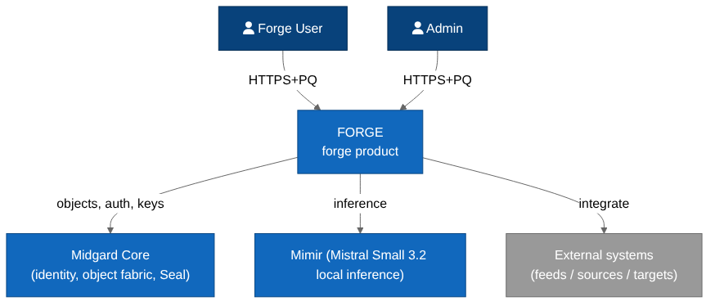 Figure 3.1 — Forge system context within the Midgard enclosure.

3.3 Actors & external systems
Actor / system | Interaction
Data engineer | Builds and runs pipelines via UI/SDK.
External data sources | Pulled by connectors; inbound only. [FR-F-2]
Midgard object fabric | Receives projected objects/links. [DD-1]
Mimir (optional) | Serves AI transform/quality suggestions. [DD-4]

4. Architecture Drivers

4.1 Functional requirements
ID | Requirement
FR-F-1 | Provide a low-code visual pipeline builder and a pro-code IDE over identical dataset contracts.
FR-F-2 | Provide a typed connector SDK; ship reference connectors for databases, object stores, APIs, files, and streams.
FR-F-3 | Version every dataset with full lineage, branching, and reproducible rebuilds.
FR-F-4 | Project curated datasets into Midgard object/link types via a mapping layer.
FR-F-5 | Support batch and streaming pipelines with schedule/trigger management.
FR-F-6 | Enforce data-health expectations on every build; block promotion on failure.
FR-F-7 | Offer AI-assisted transforms (NL→transform, quality suggestions) via Mimir, preview-before-commit.

4.2 Inherited NFRs
ID | Requirement | Provenance
NFR-PQ-1 | All data-in-transit uses a hybrid TLS 1.3 handshake combining X25519 with ML-KEM-768 (Kyber) key agreement. | STD:NIST FIPS 203
NFR-PQ-2 | All data-at-rest is encrypted with AES-256-GCM under keys wrapped by ML-KEM-1024; key material is sealed to an HSM/TPM where present. | STD:NIST FIPS 203 / FIPS 197
NFR-SEC-2 | Role-, marking-, and purpose-based access control is enforced at the data and object layer, with full audit lineage. | STD:NIST AC-3 / AC-16
NFR-PRV-1 | The suite runs fully offline / air-gapped with no outbound network dependency for any core function. | DD-7
NFR-OSS-1 | All core components build reproducibly from source; an SBOM (CycloneDX) is emitted per release. | DD-2
NFR-AI-1 | Every agentic action is traceable, evaluated against an Evals suite, and reversible or human-gated where it mutates state. | DD-5

5. Solution Strategy
Concern | Decision | Provenance
Transform engine | Distributed batch + stream engine behind a builder abstraction | [FR-F-1] [FR-F-5]
Versioning | Immutable dataset snapshots + branch refs (content-addressed) | [FR-F-3]
Connectors | Typed connector SDK; sandboxed execution | [FR-F-2]
AI assist | Mimir functions invoked with preview + approval | [FR-F-7] [NFR-AI-1]
Crypto | Inherited from Midgard KMS (PQ) | [NFR-PQ-2]
KDD — AI never silently mutates data. Every Mimir-suggested transform is rendered as a previewable, diffable change requiring human approval before it is committed to a dataset version. [NFR-AI-1]

6. Logical Architecture (C4 L2)
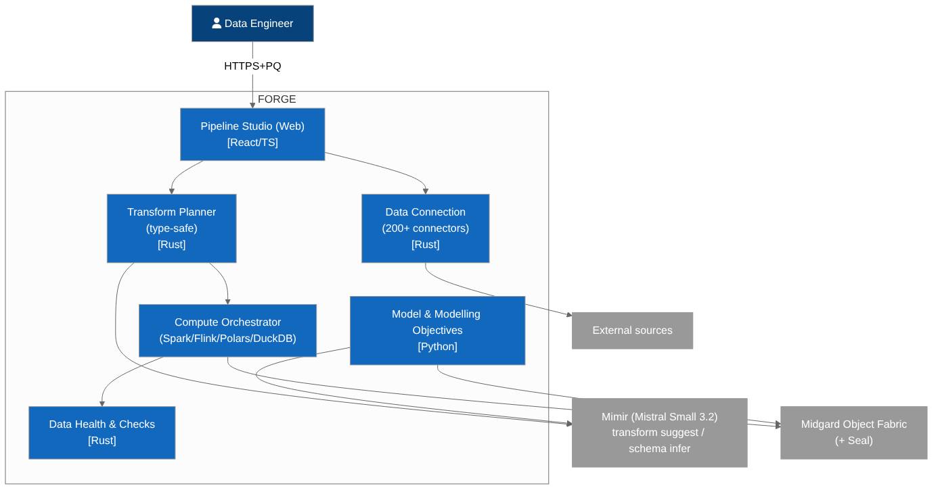 Figure 6.1 — Forge containers.

6.1 Connector service
Runs typed connectors in sandboxes; pulls source data into raw datasets; manages sync schedules and credentials (via Midgard KMS). [FR-F-2]

6.2 Pipeline service
Compiles builder graphs and pro-code transforms into execution plans on the batch/stream engine; enforces type-safety and health checks. [FR-F-1] [FR-F-6]

6.3 Dataset & versioning store
Content-addressed, immutable dataset snapshots with branch refs and lineage; PQ-encrypted at rest. [FR-F-3] [NFR-PQ-2]

6.4 Projection service
Maps curated datasets to Midgard object/link types and drives the write funnel. [FR-F-4]

6.5 AI-assist adapter
Bridges pipeline authoring to Mimir functions for NL→transform and quality suggestions, with preview/approval. [FR-F-7]

7. Component Architecture (C4 L3)
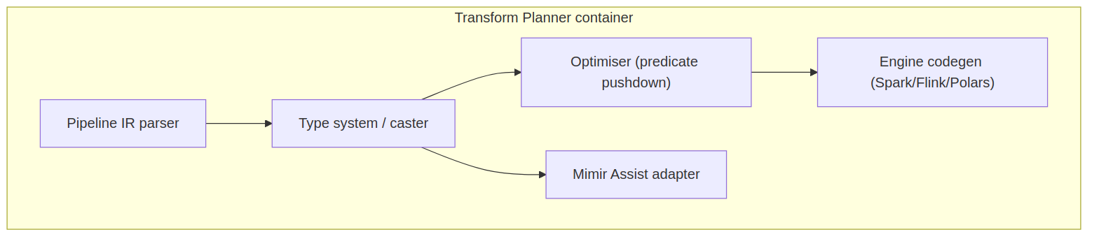 Figure 7.1 — Pipeline service components.
Component | Responsibility
Graph compiler | Builder graph → typed execution plan. [FR-F-1]
Transform library | Reusable, type-checked transforms.
Health engine | Expectations/checks per build. [FR-F-6]
Scheduler adapter | Batch/stream triggers via Midgard compute. [FR-F-5]
Lineage recorder | Emits lineage + audit to governance. [NFR-SEC-2]

8. Data Architecture
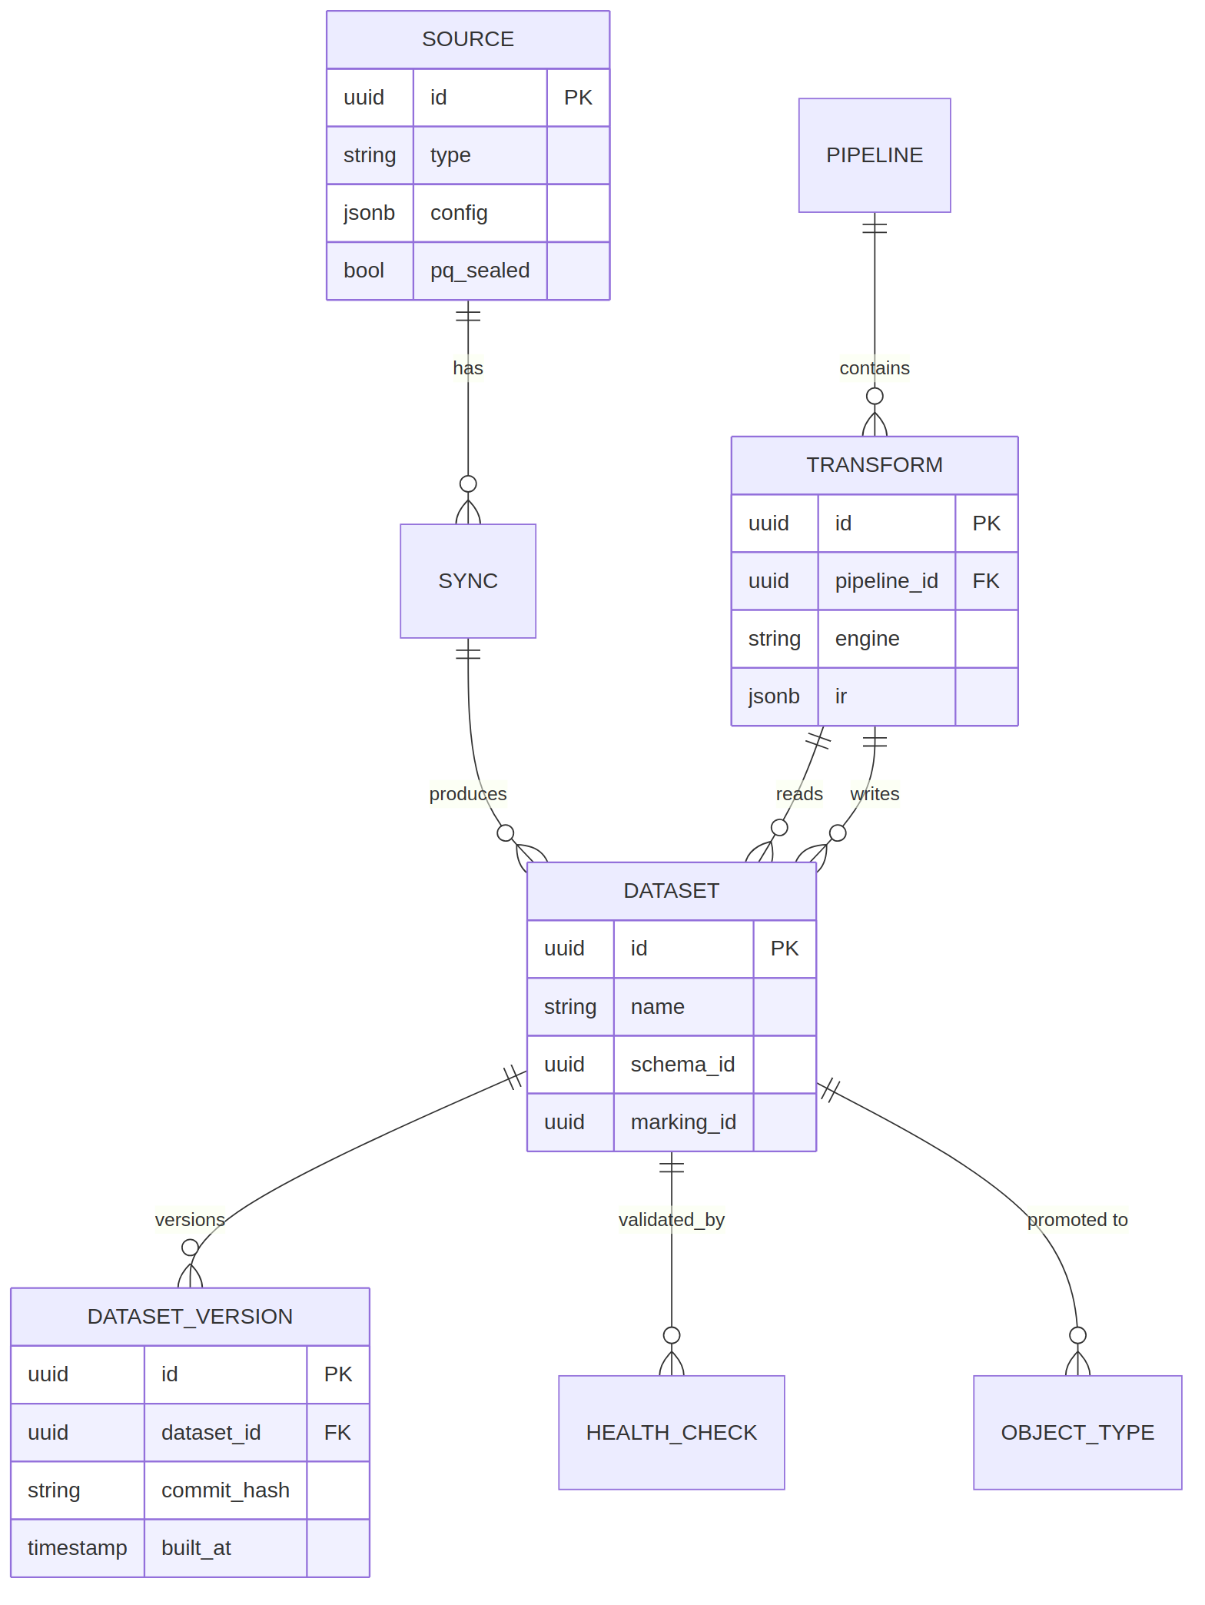 Figure 8.1 — Forge data model (datasets, versions, pipelines, mappings).
Entity | Purpose
Connector | Source binding + credentials ref.
Dataset | Named, versioned data artefact.
DatasetVersion | Immutable content-addressed snapshot. [FR-F-3]
Pipeline | Graph/pro-code transform definition.
BuildRun | One execution with health results. [FR-F-6]
ObjectMapping | Dataset→object/link projection. [FR-F-4]

8.2 Data stores
Store | Contents | Crypto
Dataset store | Snapshots, branches | PQ-wrapped AES-256-GCM [NFR-PQ-2]
Pipeline metadata | Graphs, schedules, health | PQ-wrapped

8.3 Data flow
Source → connector → raw dataset → transforms (versioned) → curated dataset → projection → object fabric, with lineage recorded at each hop. [FR-F-4] [NFR-SEC-2]

9. Integration Architecture
Surface | Protocol | Purpose
Pipeline API | gRPC/REST over PQ-mTLS | Create/run/monitor pipelines
Dataset API | gRPC/REST | Read/write/version datasets
Connector SDK | Library | Author custom connectors [FR-F-2]
Mimir function calls | gRPC (internal) | AI transform/quality assist [FR-F-7]

9.2 Primary sequence
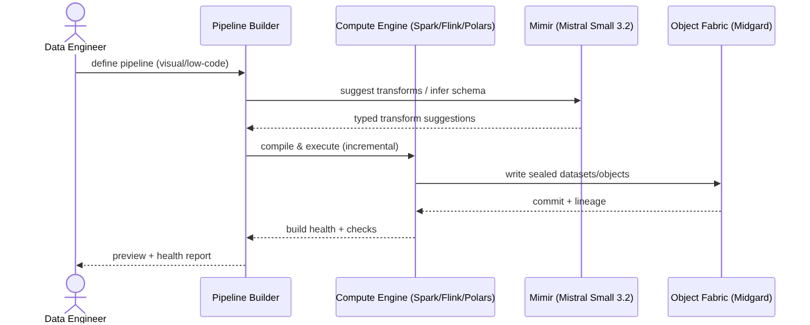 Figure 9.1 — Author → preview (AI-assisted) → health-check → commit version → project to objects.

9.3 User journey
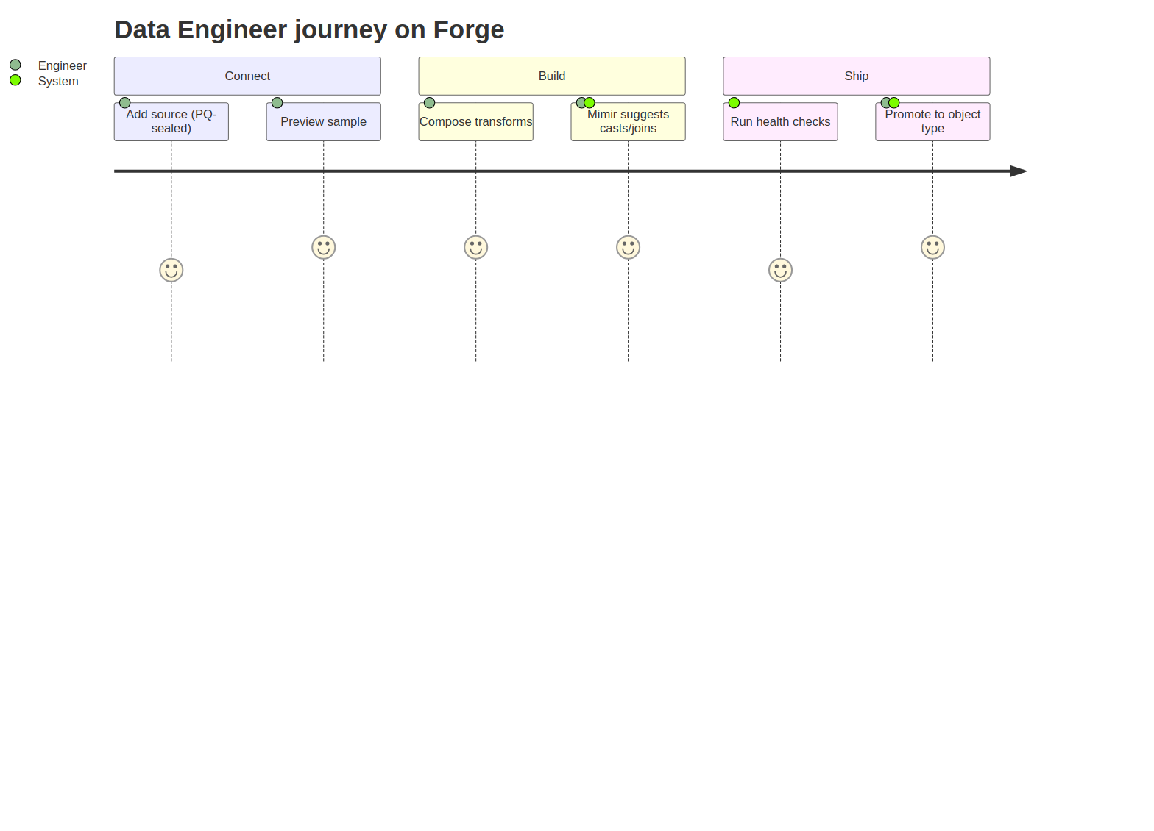 Figure 9.2 — Data engineer primary journey.

10. Infrastructure & Deployment
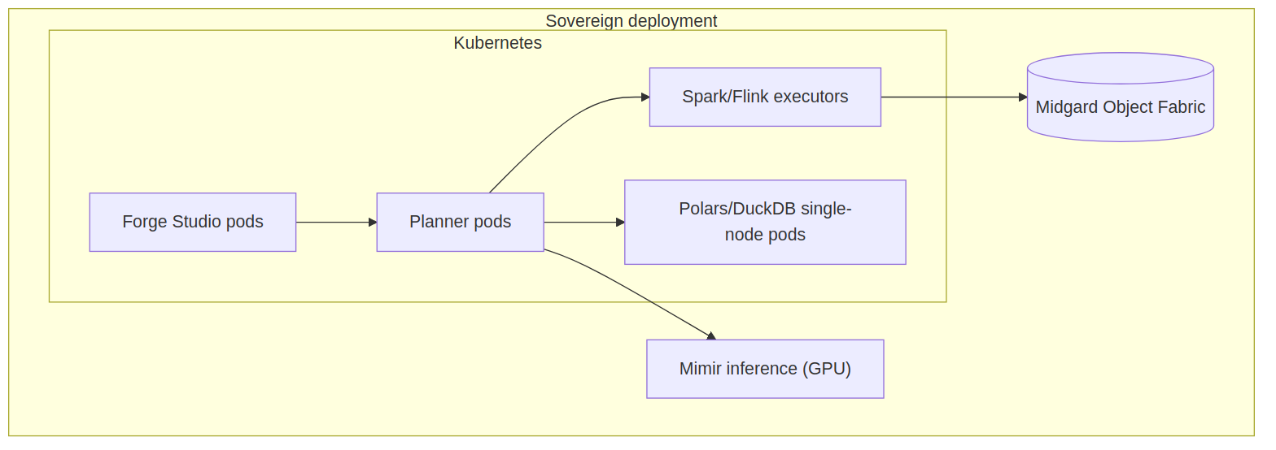 Figure 10.1 — Forge deployment within the enclosure.
Forge runs as stateless pipeline/connector workers plus stateful dataset stores on the Midgard mesh; scales workers horizontally; inherits egress-deny and PQ-mTLS. [NFR-AVA-1] [NFR-SEC-1]

10.2 CI/CD
Figure 10.2 — Forge build/test/sign/deploy pipeline (via Bifrost).

11. Security Architecture
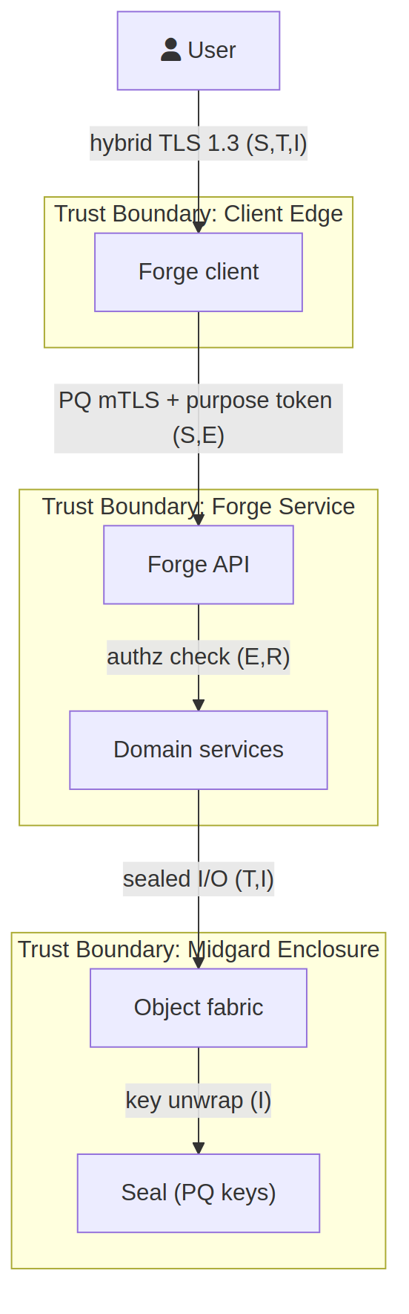 Figure 11.1 — Forge STRIDE data-flow diagram.
Crossing | STRIDE | Control
Source → Connector | S, T, I | Sandboxed connector, credential from KMS, TLS [NFR-PQ-1]
Pipeline → Dataset store | T, I | PQ at rest, integrity tags [NFR-PQ-2]
AI adapter → Mimir | T, R | Internal mTLS, audited calls, preview gate [NFR-AI-1]
Projection → Fabric | T, E | Policy point, marking propagation [NFR-SEC-2]

11.2 Cryptography
All at-rest and in-transit crypto inherited from Midgard: PQ-hybrid transit, PQ-wrapped at rest. [NFR-PQ-1] [NFR-PQ-2]

11.3 Access control
Pipeline and dataset operations authorised by role/marking/purpose; markings propagate through transforms into projected objects. [NFR-SEC-2]

11.4 Known design gaps
Gap | Severity | Recommendation
Third-party connector trust | Medium | Signed connector packages; sandboxed execution. [FR-F-2]
Large-dataset PQ overhead | Low | Chunked envelope encryption; hardware offload. [NFR-PQ-4]

12. Observability
- Per-build health metrics and lineage. [FR-F-6]
- Pipeline run traces; failure alerting.
- In-enclosure log aggregation. [NFR-PRV-1]

13. Operational Concerns
- Dataset snapshots are backups by construction. [FR-F-3]
- Reproducible rebuild from lineage for recovery.
- Horizontal worker scaling for throughput. [NFR-AVA-1]

14. Quality & Testing
- Transform unit tests + golden datasets.
- Contract tests against Midgard object APIs. [DD-6]
- Health-check regression suite. [FR-F-6]

15. Risks & Technical Debt
Risk | Severity | Mitigation
Connector maintenance burden | Medium | Typed SDK + community contributions. [FR-F-2]
Pipeline drift | Medium | Mandatory health checks + alerts. [FR-F-6]

16. Roadmap
- Ship low-code builder + core connectors.
- Add pro-code IDE + versioning.
- Add Mimir AI-assist (preview/approve).
- Add streaming pipelines.

17. Acceptance Criteria
ID | Given / When / Then | Provenance
AC-F-1 | Given a source, when a connector syncs, then a raw dataset is created and encrypted with a PQ-wrapped key. | [FR-F-2] [NFR-PQ-2]
AC-F-2 | Given a pipeline, when built twice from the same inputs, then output dataset versions are content-identical. | [FR-F-3]
AC-F-3 | Given failing health expectations, when a build runs, then promotion is blocked and the failure is reported. | [FR-F-6]
AC-F-4 | Given a curated dataset, when projected, then the corresponding Midgard objects/links appear with markings propagated. | [FR-F-4] [NFR-SEC-2]
AC-F-5 | Given an AI-suggested transform, when proposed, then it is shown as a preview diff and is not committed without approval. | [FR-F-7] [NFR-AI-1]
AC-F-6 | Given Mimir is absent, when authoring, then all non-AI pipeline features remain fully functional (standalone mode). | [DD-6]
AC-F-7 | Given no outbound connectivity, when pipelines run, then all core data operations succeed. | [NFR-PRV-1]

Appendix A — Diagram Source Index
Diagram | Mermaid | draw.io
Context | forge_c4_context.mmd | forge_c4_context.drawio
Containers | forge_c4_containers.mmd | forge_c4_containers.drawio
Components | forge_c4_component.mmd | forge_c4_component.drawio
Data model | forge_er.mmd | forge_er.drawio
Primary sequence | forge_seq_primary.mmd | forge_seq_primary.drawio
Journey | forge_journey.mmd | forge_journey.drawio
Deployment | forge_deployment.mmd | forge_deployment.drawio
CI/CD | product_cicd.mmd | product_cicd.drawio
Threat DFD | forge_threat_dfd.mmd | forge_threat_dfd.drawio

