Midgard Suite — Gungnir (Solutions Architecture Document)
Veldris Ltd
The consequence-projection module — forward-simulation of human-authorised plans, with on-the-ground oversight control
Module: Gungnir · Methodology: Imhotep (arc42 + TOGAF + C4; NIST 800-53 / OWASP ASVS / ISO 27001) New: FR-G-1..14, NFR-G-1..8, AC-G-1..20, prompts A.G-1..3 · v1.0.0 · PUBLIC, published with the Midgard repository Document type: Forward-looking design specification (greenfield). Provenance tags: [DD-], [FR-]/[NFR-], [STD:].
WHAT GUNGNIR IS. A consequence-projection engine. Given a human's intended plan (linear or branched, all human-authorised), it sandboxes the tree, models branch outcomes, computes probability-of-success across the campaign, and surfaces 2nd/3rd-order effects — so the human understands the SUM of a plan before authorising step one. Named for Odin's spear, guided by foresight.
WHAT GUNGNIR IS NOT — BY DESIGN. No execution, no weapon/fire control, no closed-loop engagement, no reach into connected assets. No execution interface and no network path to a real asset exist. No fire-control or weapon-employment models; effects and cyber represented only as planning-level abstractions, never executable/reconstructable logic. Architectural absences, not switches. Real actions remain the human's, via the existing Heimdall human-gate.

1. Scope
Capability | Status
Forward-simulate linear & branched human-authored plans | IN SCOPE (FR-G-1/2)
Probability-of-success across the plan tree | IN SCOPE (FR-G-3)
Cascade / 2nd–3rd order effect projection | IN SCOPE (FR-G-4)
Multi-asset (humanoid/drone/vehicle) behaviour MODELS | IN SCOPE — models, not control (FR-G-5)
Coordination/timing/deconfliction projection | IN SCOPE (FR-G-6)
On-the-ground oversight-operator console | IN SCOPE (FR-G-10..13)
Effect execution / weapon / fire control | EXCLUDED — no execution interface, no fire-control models
Automated / closed-loop engagement | EXCLUDED — closes no loop
Offensive cyber execution / forward-push into assets | EXCLUDED — cyber as abstraction only
Two carve-outs that keep this a planning tool: (1) models THAT an effect occurs and what follows, but contains no weapon-employment/fire-control models — reasons at planning level, not fire-control level; (2) cyber actions are defensive/effect-level abstractions, never executable/reconstructable attack logic.

2. Functional requirements
FR-G-1 accept human-authored plan · FR-G-2 branched plans · FR-G-3 probability-of-success (action/branch/whole) · FR-G-4 cascade 2nd/3rd-order + collateral · FR-G-5 humanoid/drone/vehicle behaviour models (simulate, never command) · FR-G-6 coordination/timing/deconfliction · FR-G-7 projected SUM before authorisation · FR-G-8 compare alternative plans · FR-G-9 assumptions+evidence+uncertainty on every projection · FR-G-10 oversight live monitor · FR-G-11 intervene (pause/adjust/rescope/reject) · FR-G-12 immediate HALT always available · FR-G-13 audited dissent/override · FR-G-14 PQ-signed projection audit.

3. Non-functional requirements
NFR-G-1 hermetic sandbox: no egress to real assets, no execution interface in binary (impossible by construction) · NFR-G-2 read-only world-model copy · NFR-G-3 effect/cyber at planning-level abstraction; no fire-control/weapon-employment/exploit logic · NFR-G-4 PQ crypto throughout · NFR-G-5 air-gap/on-device · NFR-G-6 reproducible projections · NFR-G-7 simulation indelibly distinguished, never promoted · NFR-G-8 admin-governed, dual-control.

4. Architecture
- Context: reads a read-only picture copy, reasons with Mimir, projects to the planner, governed by admin; dashed line to Heimdall (informs the human who may authorise via Heimdall's human-gate — Gungnir has no path to action).
- Containers: plan modeller, probability engine (Monte Carlo/branch), cascade projector, world-model copy, effect/cyber abstraction layer — all inside the hermetic sandbox; PQ-signed audit ledger outside.
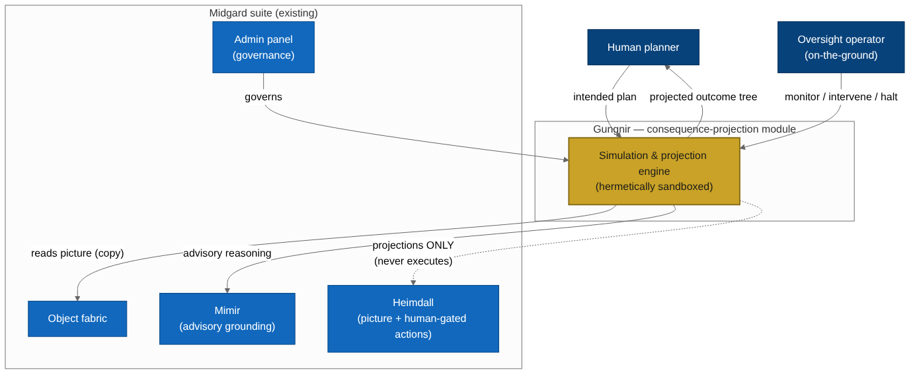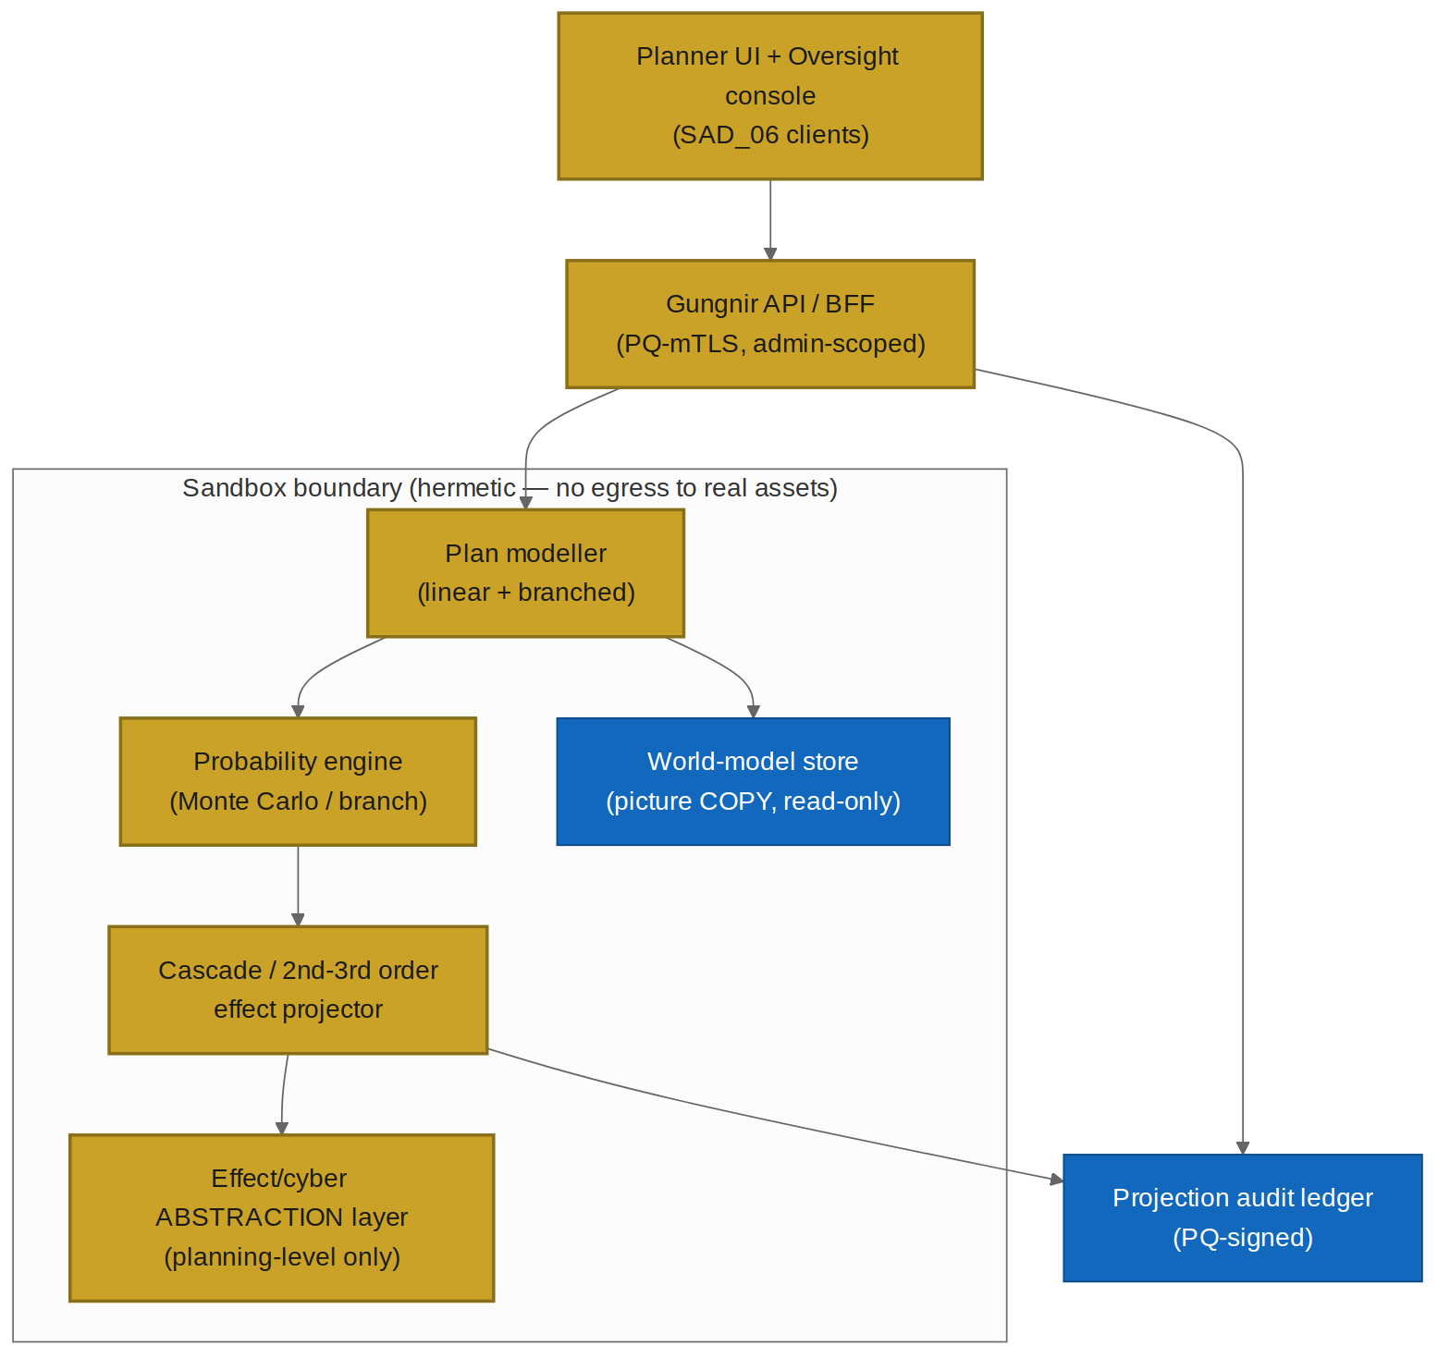

The sandbox (deep dive) — three gates
- G1 No egress: no network route to any real asset (enforced at infrastructure boundary).
- G2 No execution interface: no API/call/path by which a projection becomes a command — absent, not disabled.
- G3 Outputs are data: projections are outcome trees; there is no command type in the schema.
Read-only versioned world-model (can't mutate live picture/fabric). Reproducible (inputs+seed → same tree). Abstraction layer keeps effects/cyber at planning granularity — harmful specifics are not represented at all, not stored at reduced fidelity.
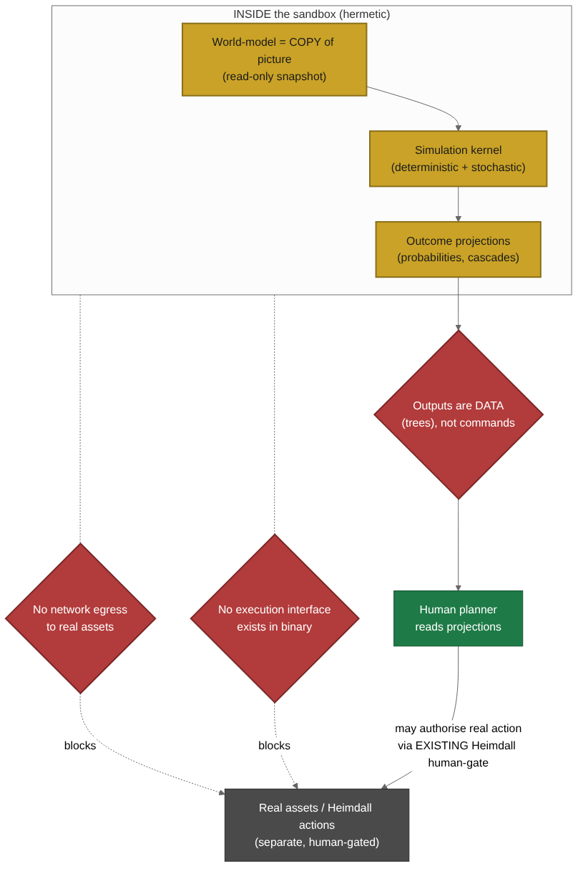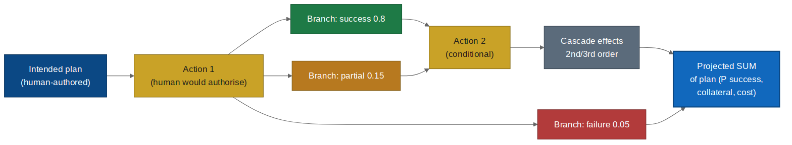

Multi-asset (models, not control)
Humanoid/drone/vehicle behaviour models predict what an asset WOULD do under a human-authorised plan; Gungnir issues no commands. "A drone could hold this orbit 40 min" is planning knowledge, categorically different from an interface that flies the drone.
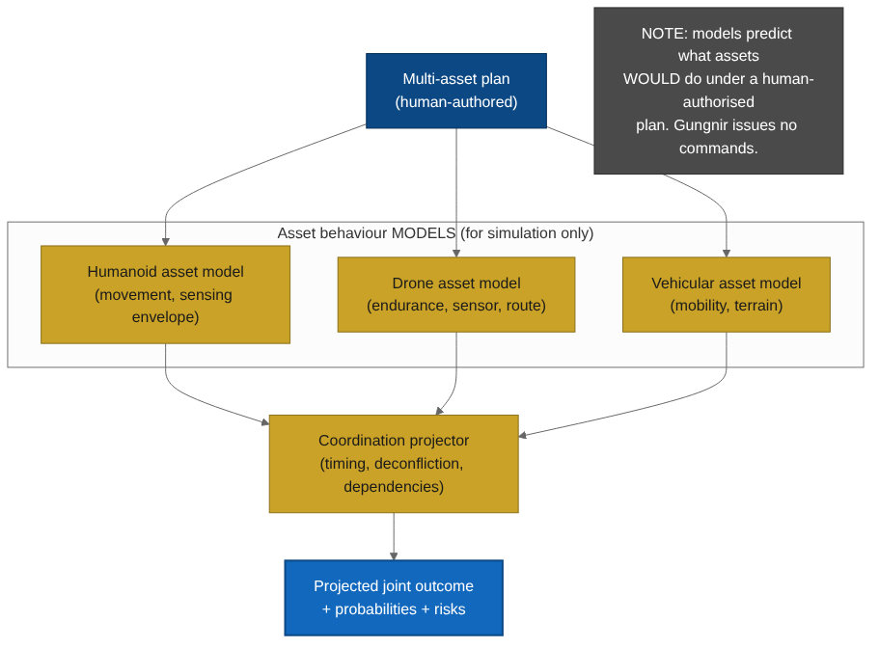

Oversight console (deep dive) — meaningful human control
Live monitor · explainability panel (assumptions/evidence/uncertainty) · intervene (pause/adjust/rescope/reject) · unconditional HALT · audited dissent. Principles: legibility over automation; intervention always available; dissent first-class; the operator is not automatable. Designed against oversight-as-theatre.
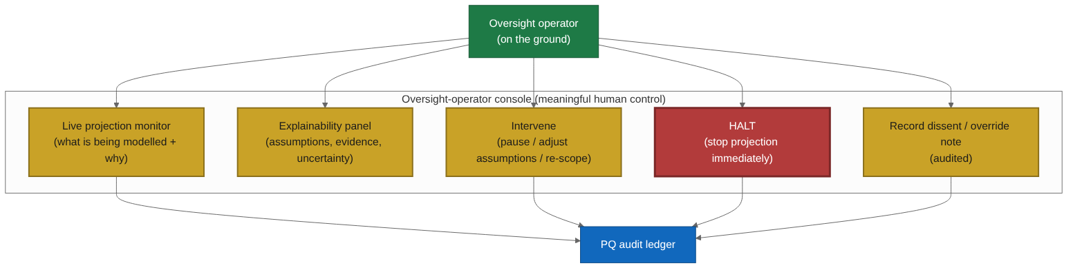

5. Security
STRIDE DFD with PQ controls. Security case: worst-case compromise is a manipulated projection — bad advice to a human who still authorises every real action elsewhere. Blast radius bounded at "wrong forecast", not "an action occurred", because Gungnir has no means to act.
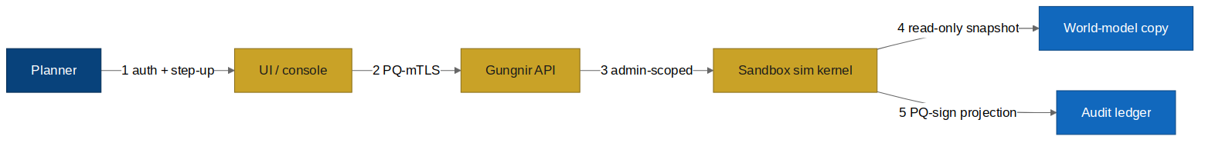
Known gaps: manipulated projection (→ explainability+uncertainty+dissent+reproducible audit+red-team); automation bias (→ mandatory uncertainty, alternative comparison, training); abstraction-layer scope creep (→ design-review gate refuses any fire-control/exploit fidelity).

6. Prompts (extend SAD_05 Part A)
- A.G-1 Plan projector: projects branch outcomes with assumptions/uncertainty; planning-level only; refuses execution (PROJECTION_ONLY); surfaces collateral.
- A.G-2 Cascade analyst: explains 2nd/3rd-order effects; planning-level; recommends nothing.
- A.G-3 Oversight monitor: makes a run legible for the operator; always states HALT/intervene available; supports dissent, never argues the operator out of it.
All emit contract-validated JSON with citations+uncertainty, in Mimir's advisory envelope. Cross-cutting Eval EV-G-INV: no phrasing across any prompt executes, commands an asset, or emits fire-control/exploit logic.

7. Acceptance criteria
AC-G-1..20 covering: linear+branched projection with cited assumptions; mandatory uncertainty; collateral surfaced; multi-asset modelled-not-commanded; coordination; projected SUM before authorisation; alternative comparison; sandbox has no egress + no execution interface (AC-G-9); read-only world-model (AC-G-10); planning-level abstractions only, no fire-control/exploit (AC-G-11); reproducible (AC-G-12); indelibly simulated (AC-G-13); PQ audit; oversight monitor/intervene/unconditional HALT (AC-G-17)/audited dissent; adversarial no-execution proof (AC-G-19); air-gapped operation.

8. Integration & delivery
Heimdall (read-only copy; no execution path added) · Mimir advisory + SAD_02b model supply · SAD_06 client shells · SAD_07 dual-control governance incl. abstraction-layer changes · A.G-1..3 + AC-G-1..20 join SAD_05 (consolidated ACs 92 → 112).
Delivery sequence: sandbox + world-model copy (safety foundation) → projection engine → multi-asset models → oversight console → abstraction-layer review gate + full Eval/acceptance suite. Each capability lands with its safety control.
Closing: Gungnir is the sharpest decision-support in the suite — it lets a human see the whole consequence of a plan before committing to any part. Powerful because bounded: it forecasts reality without touching it. The spear that never misses is guided by foresight, not autonomy.

