AKUMA ENGINEERING LTD.
Solutions Architecture Document

Heimdall
Operational Fusion — a post-quantum, AI-assisted competitor to Palantir Maven

Forward-looking design specification · Version 1.0 · 2026-07-02

CONFIDENTIAL — RECIPIENT EYES ONLY
This document is a forward-looking architectural design specification for a greenfield system. It describes intended design, not implemented and verified code. Every design decision is tagged with its provenance (design driver, requirement ID, or external standard). It is not evidence of an existing implementation.

Document Control
Document Title | Heimdall — Solutions Architecture Document
System | Heimdall
Competitor benchmark | Palantir Maven Smart System
Author | Akuma Engineering Ltd. — Architecture Practice — for JB Benjamin, CEO / Founder
Reviewer
Date | 2026-07-02
Version | 1.0
Classification | CONFIDENTIAL — RECIPIENT EYES ONLY
Generated By | Imhotep skill (Anthropic Claude), greenfield design-spec mode
Document type | Forward-looking design specification (greenfield)

Contents
Right-click and Update Field to build the table of contents.

1. Executive Summary
Heimdall is the operational-fusion product of the Midgard suite and a direct, more capable competitor to Palantir's Maven Smart System. It is the warden of the enclosure boundary: it fuses many data feeds into a single, live operational picture, and drives AI-assisted decision workflows on top of it. Heimdall improves on Maven with native post-quantum encryption across all feeds and the common picture, and with decision intelligence served by the local Mimir layer (GLM 5.2) instead of a hosted model — enabling operation in disconnected and air-gapped environments. [DD-1] [DD-3] [DD-4] [DD-7]
This document is a forward-looking design specification; every decision carries a provenance tag rather than a repository citation.
Human-in-the-loop by design. Heimdall provides decision support — fusion, classification, option generation, and workflow — with humans authorising any consequential action. AI assists; people decide. [NFR-AI-1] [DD-5]
Standalone and composable. Midgard + Heimdall delivers fusion and a common operating picture. With Mimir it gains AI classification and option generation; with Forge it consumes curated object feeds; Bifrost keeps it upgraded. [DD-6]

1.1 Top design facts
- Multi-feed fusion into one live, shared operational picture with layer toggles. [FR-H-1]
- Entity tracking + classification over the object fabric. [FR-H-2]
- AI-assisted option generation (ranked courses of action) via local Mimir, advisory. [FR-H-4] [DD-4]
- Human-gated action workflows with full audit lineage. [FR-H-5] [NFR-AI-1]
- PQ-native feeds, picture, and inter-node sync. [NFR-PQ-1] [NFR-PQ-2]

1.2 Top design risks
- Automation bias: operators may over-trust AI options; mitigated by explainable, cited options + mandatory human authorisation. [NFR-AI-1]
- Feed integrity: spoofed feeds corrupt the picture; mitigated by PQ-authenticated feed sources. [NFR-PQ-3]
- Latency at scale: many high-rate feeds strain fusion; mitigated by streaming fusion + horizontal scale. [NFR-AVA-1]

2. Introduction & Scope

2.1 Purpose
To define Heimdall's target architecture: feed integration, fusion, entity tracking/classification, common operating picture, AI-assisted decision workflows, and dependencies on Midgard core and optional Mimir/Forge.

2.2 Audience
- Operations analysts and decision-makers.
- Integrators connecting feeds.
- Security and safety reviewers.

2.3 Scope
In scope | Out of scope
Feeds, fusion, tracking, classification, common picture, decision workflows | Object fabric internals (Midgard SAD)
Heimdall APIs/UI | Model internals (Mimir SAD); pipeline internals (Forge SAD)

2.4 Definitions
Term | Meaning
Mimir | Reasoning/AI product; competitor to Palantir AIP. Local, agentic, self-* generative AI on GLM 5.2. Also the shared inference layer for the other products.
Heimdall | Operational fusion product; competitor to Palantir Maven. Fuses feeds into a single operational picture with AI-assisted decision workflows.
Object fabric | Midgard's semantic + kinetic data layer: objects, properties, links (semantics) and actions, functions, dynamic security (kinetics).
Enclosure | The Midgard trust boundary; the defended, sovereign space within which all products run.

3. Business & Solution Context

3.1 Competitive positioning
Capability | Palantir Maven (MSS) | Heimdall (design intent)
Fusion | Multi-source single picture | Multi-feed single picture + PQ-authenticated feeds `[NFR-PQ-3]`
Decision support | AI classification + COA | Local-Mimir classification + ranked options `[FR-H-4]`
Autonomy | Human-in-the-loop | Human-gated actions, cited options `[NFR-AI-1]`
Deployment | Cloud/classified cloud | Air-gap capable, PQ-native `[DD-7]`
Licensing | Proprietary | Open-source core `[DD-2]`

3.2 System context (C4 L1)
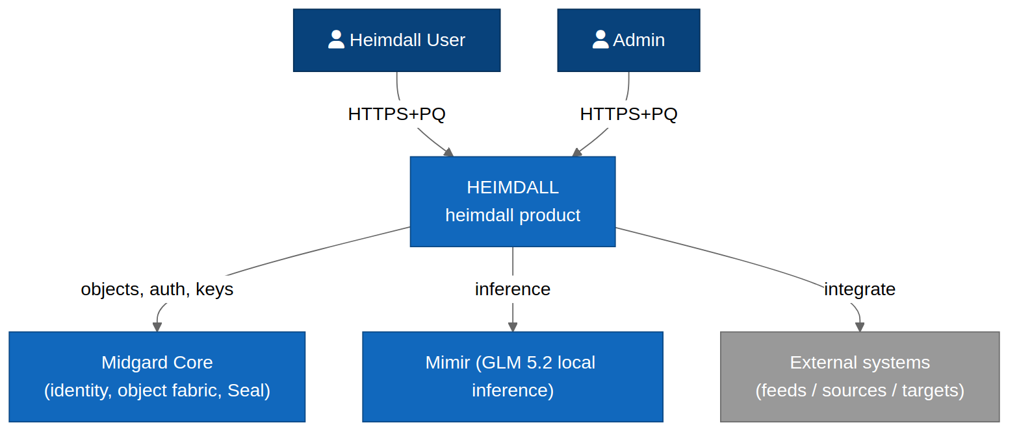
Figure 3.1 — Heimdall system context within the enclosure.

4. Architecture Drivers

4.1 Functional requirements
ID | Requirement
FR-H-1 | Ingest and fuse multiple live feeds into one shared operational picture with layer control.
FR-H-2 | Track and classify entities over time against the object fabric.
FR-H-3 | Authenticate feed sources with PQ signatures; reject unverified feeds.
FR-H-4 | Generate AI-assisted, explainable, cited ranked options via local Mimir (advisory).
FR-H-5 | Drive human-gated action workflows with full audit lineage.
FR-H-6 | Synchronise the common picture across nodes/sites over PQ-mTLS.

4.2 Inherited NFRs
ID | Requirement | Provenance
NFR-PQ-1 | All data-in-transit uses a hybrid TLS 1.3 handshake combining X25519 with ML-KEM-768 (Kyber) key agreement. | STD:NIST FIPS 203
NFR-PQ-3 | All service-to-service and artefact-signing operations use ML-DSA (Dilithium) or SLH-DSA (SPHINCS+) signatures. | STD:NIST FIPS 204 / FIPS 205
NFR-SEC-2 | Role-, marking-, and purpose-based access control is enforced at the data and object layer, with full audit lineage. | STD:NIST AC-3 / AC-16
NFR-AVA-1 | Core control-plane services target 99.9% availability; the platform supports zero-downtime rolling upgrades. | DD-1
NFR-PRV-1 | The suite runs fully offline / air-gapped with no outbound network dependency for any core function. | DD-7
NFR-AI-1 | Every agentic action is traceable, evaluated against an Evals suite, and reversible or human-gated where it mutates state. | DD-5

5. Solution Strategy
Concern | Decision | Provenance
Fusion | Streaming fusion engine over object fabric | `[FR-H-1]` `[NFR-AVA-1]`
Feed trust | PQ-signed feed sources; verify on ingest | `[FR-H-3]` `[NFR-PQ-3]`
Decision support | Mimir options: explainable, cited, advisory | `[FR-H-4]` `[NFR-AI-1]`
Action | Human-gated workflow with audit | `[FR-H-5]`
Sync | PQ-mTLS multi-node picture replication | `[FR-H-6]`

KDD — AI proposes, humans dispose. Heimdall never auto-executes a consequential action; Mimir generates ranked, cited options and a human authorises. Every option and decision is audited. [NFR-AI-1] [FR-H-5]

6. Logical Architecture (C4 L2)
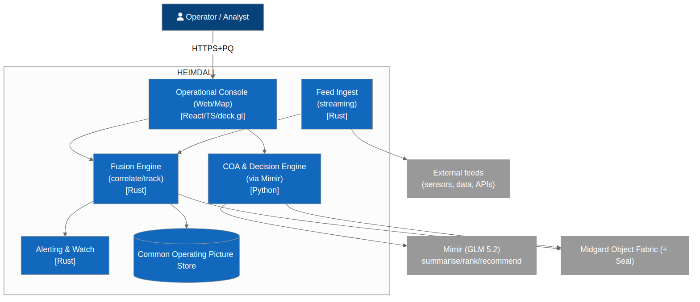
Figure 6.1 — Heimdall containers.

6.1 Feed gateway
Ingests feeds; verifies PQ source signatures; normalises to fabric objects. [FR-H-1] [FR-H-3]

6.2 Fusion engine
Correlates feeds into tracked entities; maintains the live picture. [FR-H-1] [FR-H-2]

6.3 Classification service
Classifies/labels entities (rules + Mimir); writes back with provenance. [FR-H-2]

6.4 Decision-support service
Requests ranked, cited options from Mimir; presents them advisory. [FR-H-4]

6.5 Workflow engine
Human-gated action workflows with audit lineage. [FR-H-5]

6.6 Picture sync
Replicates the common picture across nodes over PQ-mTLS. [FR-H-6]

7. Component Architecture (C4 L3)
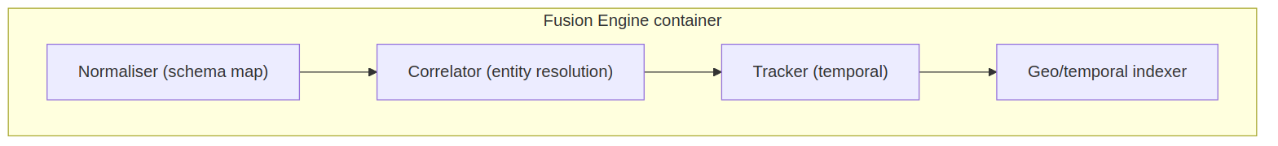
Figure 7.1 — Fusion engine components.

Component | Responsibility
Correlator | Associates feed observations to entities. `[FR-H-1]`
Tracker | Maintains entity state over time. `[FR-H-2]`
Classifier adapter | Rules + Mimir classification. `[FR-H-2]`
Option requester | Cited, ranked options from Mimir. `[FR-H-4]`
Action gate | Human authorisation + audit. `[FR-H-5]`

8. Data Architecture
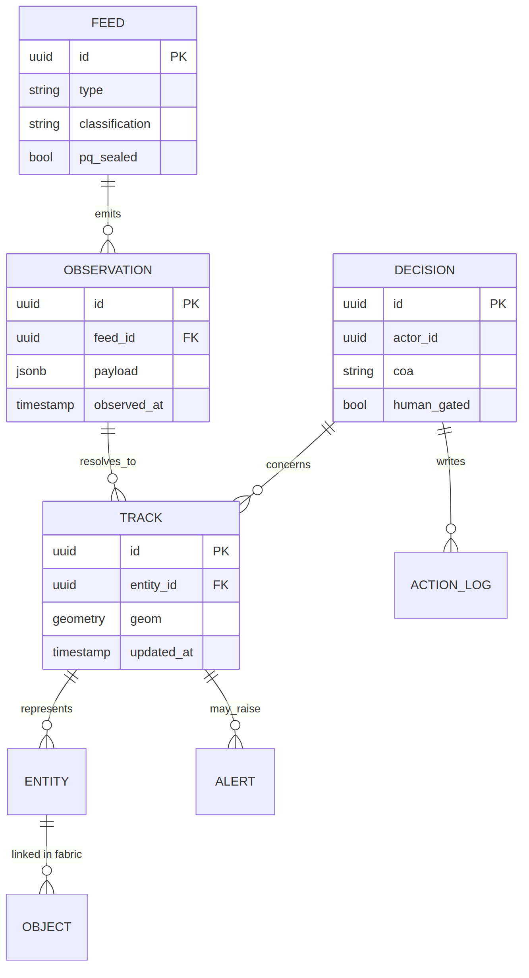
Figure 8.1 — Heimdall data model (feeds, entities, tracks, options, actions).

Entity | Purpose
Feed | A PQ-authenticated source. `[FR-H-3]`
Observation | One datum from a feed.
TrackedEntity | Fused entity over time. `[FR-H-2]`
Classification | Label + provenance. `[FR-H-2]`
OptionSet | Ranked, cited options from Mimir. `[FR-H-4]`
ActionRecord | Human-authorised action + audit. `[FR-H-5]`

8.2 Data stores
Store | Contents | Crypto
Picture store | Tracked entities, current picture | PQ-wrapped `[NFR-PQ-2]`
Feed/audit store | Observations, decisions | PQ-signed, encrypted `[NFR-PQ-3]`

9. Integration Architecture
Surface | Protocol | Purpose
Feed API/SDK | PQ-mTLS | Connect + sign feeds `[FR-H-3]`
Picture API | gRPC/REST | Query the common picture
Workflow API | gRPC/REST | Drive human-gated actions `[FR-H-5]`
Mimir calls | gRPC (internal) | Classification + options `[FR-H-4]`

9.2 Primary sequence
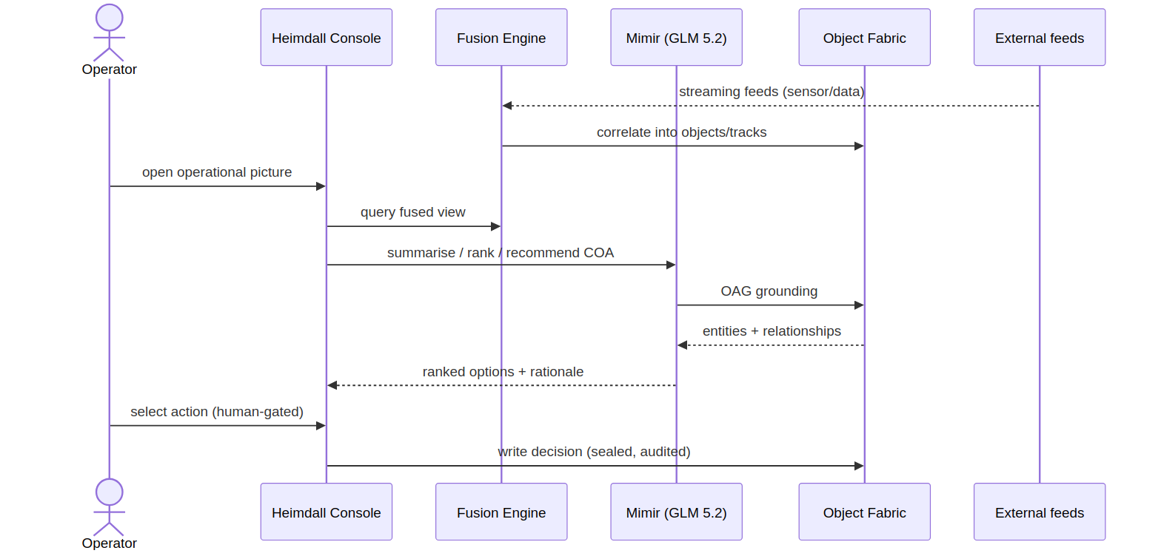
Figure 9.1 — Feed verify → fuse → classify → request options (Mimir) → human authorises → audited action.

9.3 User journey
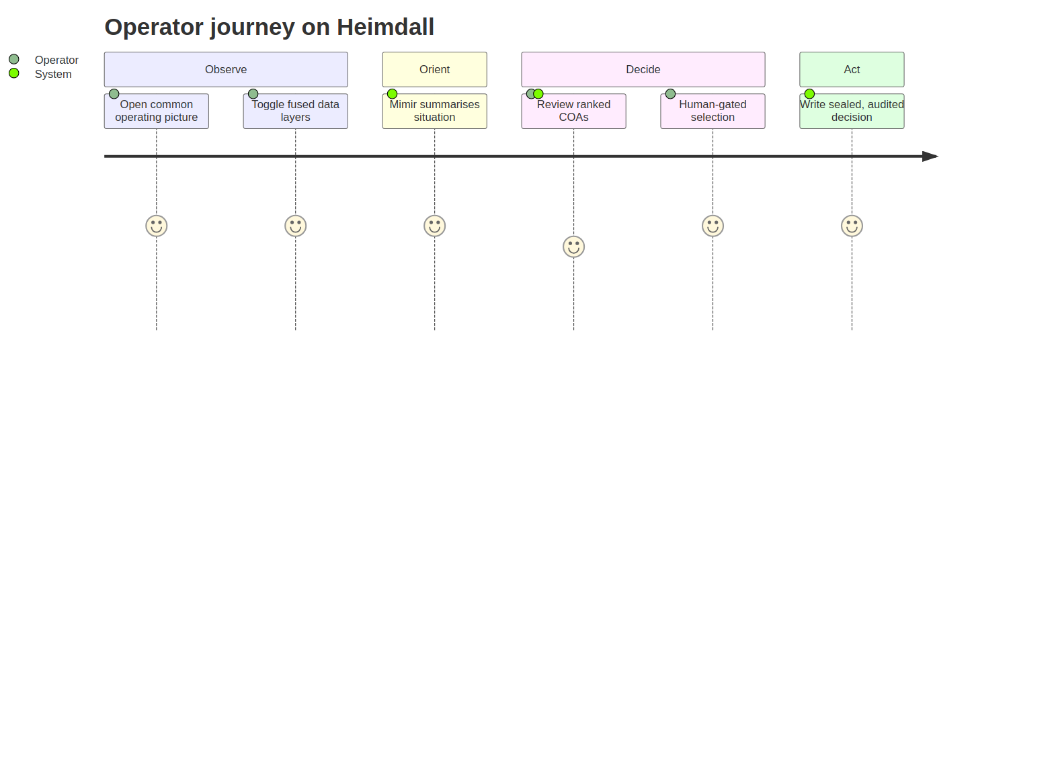
Figure 9.2 — Operations analyst primary journey.

10. Infrastructure & Deployment
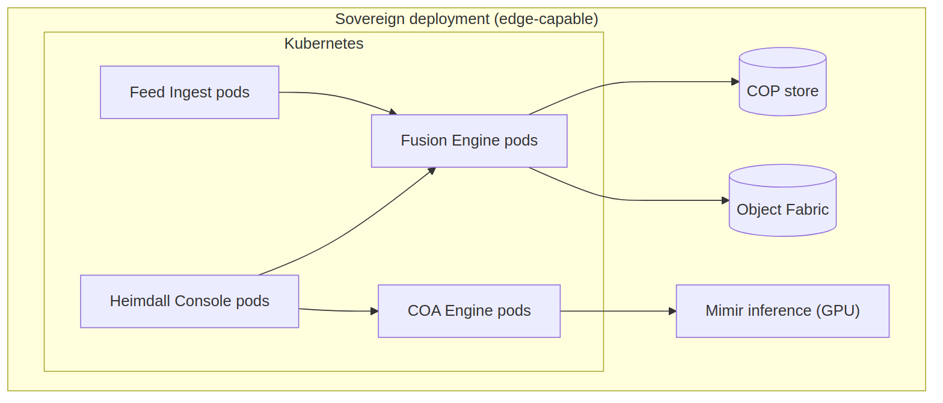
Figure 10.1 — Heimdall deployment (fusion workers + picture sync).

Heimdall runs streaming fusion workers and a picture store on the mesh; supports multi-node/site replication over PQ-mTLS; air-gap capable with local Mimir. [FR-H-6] [NFR-PRV-1]

10.2 CI/CD
Figure 10.2 — Heimdall build/test/sign/deploy pipeline (via Bifrost).

11. Security Architecture
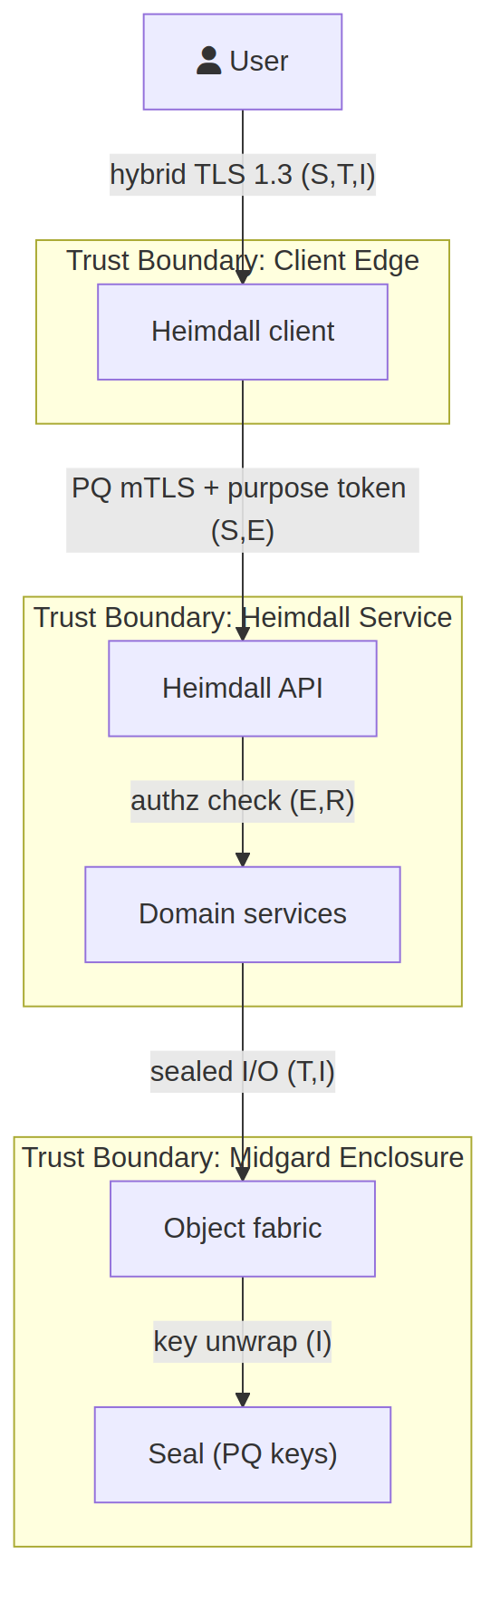
Figure 11.1 — Heimdall STRIDE data-flow diagram.

Crossing | STRIDE | Control
Feed → Gateway | S, T | PQ source signature verify `[FR-H-3]` `[NFR-PQ-3]`
Fusion → Picture store | T, I | PQ at rest, marking-aware `[NFR-PQ-2]`
Decision → Mimir | T, R | Internal mTLS, cited/audited options `[NFR-AI-1]`
Workflow → Action | R, E | Human gate, policy point, audit `[FR-H-5]`

11.2 Decision-safety controls
- Options are explainable and cited to feed evidence. [FR-H-4]
- Consequential actions require human authorisation. [FR-H-5]
- Full audit lineage of options presented and decisions taken. [NFR-AI-1]
- Feed sources PQ-authenticated to prevent spoofing. [NFR-PQ-3]

11.3 Known design gaps
Gap | Severity | Recommendation
Automation bias | High | Explainable cited options + mandatory human gate + training. `[NFR-AI-1]`
Feed spoofing | High | PQ-signed feeds; reject unverified. `[NFR-PQ-3]`

12. Observability
- Fusion latency + feed-health metrics. [NFR-AVA-1]
- Decision audit trail. [FR-H-5]
- Classification accuracy monitoring. [FR-H-2]

13. Operational Concerns
- Multi-node picture replication for resilience. [FR-H-6]
- Degraded mode without Mimir (rules-only classification). [DD-6]
- Horizontal fusion scaling. [NFR-AVA-1]

14. Quality & Testing
- Fusion correctness on replay corpora. [FR-H-1]
- Feed-spoofing negative tests. [FR-H-3]
- Decision-workflow audit completeness. [FR-H-5]

15. Risks & Technical Debt
Risk | Severity | Mitigation
Over-trust in AI options | High | Explainability + human gate + audit. `[NFR-AI-1]`
Feed integrity | High | PQ-authenticated sources. `[NFR-PQ-3]`
High-rate feed load | Medium | Streaming fusion + horizontal scale. `[NFR-AVA-1]`

16. Roadmap
- Feed gateway + fusion + common picture.
- Entity tracking + classification.
- Mimir-assisted cited options.
- Human-gated workflows + multi-node sync.

17. Acceptance Criteria
ID | Given / When / Then | Provenance
AC-H-1 | Given multiple feeds, when ingested, then a single fused picture is produced with per-layer toggles. | `[FR-H-1]`
AC-H-2 | Given an unverified feed source, when it connects, then its data is rejected from the picture. | `[FR-H-3]` `[NFR-PQ-3]`
AC-H-3 | Given a decision point, when options are requested, then Mimir returns ranked options each citing the evidence used. | `[FR-H-4]`
AC-H-4 | Given a consequential action, when proposed, then it is not executed without explicit human authorisation and is fully audited. | `[FR-H-5]` `[NFR-AI-1]`
AC-H-5 | Given multi-node deployment, when the picture updates, then it replicates across nodes over PQ-mTLS. | `[FR-H-6]`
AC-H-6 | Given Mimir is absent, when operating, then fusion and rules-based classification remain fully functional (standalone mode). | `[DD-6]`
AC-H-7 | Given no outbound connectivity, when operating, then fusion, picture, and workflows all function (air-gap). | `[NFR-PRV-1]`

Appendix A — Diagram Source Index
Diagram | Mermaid | draw.io
Context | heimdall_c4_context.mmd | heimdall_c4_context.drawio
Containers | heimdall_c4_containers.mmd | heimdall_c4_containers.drawio
Components | heimdall_c4_component.mmd | heimdall_c4_component.drawio
Data model | heimdall_er.mmd | heimdall_er.drawio
Primary sequence | heimdall_seq_primary.mmd | heimdall_seq_primary.drawio
Journey | heimdall_journey.mmd | heimdall_journey.drawio
Deployment | heimdall_deployment.mmd | heimdall_deployment.drawio
CI/CD | heimdall_cicd.mmd | heimdall_cicd.drawio
Threat DFD | heimdall_threat_dfd.mmd | heimdall_threat_dfd.drawio

