AKUMA ENGINEERING LTD.
Solutions Architecture Document

Mimir
Local Agentic AI (GLM / Nemotron / Gemma) — a self-* , post-quantum competitor to Palantir AIP

Forward-looking design specification · Version 1.0 · 2026-07-02

CONFIDENTIAL — RECIPIENT EYES ONLY
This document is a forward-looking architectural design specification for a greenfield system. It describes intended design, not implemented and verified code. Every design decision is tagged with its provenance (design driver, requirement ID, or external standard). It is not evidence of an existing implementation.

Document Control
Document Title | Mimir — Solutions Architecture Document
System | Mimir
Competitor benchmark | Palantir AIP
Author | Akuma Engineering Ltd. — Architecture Practice — for JB Benjamin, CEO / Founder
Reviewer
Date | 2026-07-02
Version | 1.0
Classification | CONFIDENTIAL — RECIPIENT EYES ONLY
Generated By | Imhotep skill (Anthropic Claude), greenfield design-spec mode
Document type | Forward-looking design specification (greenfield)

Contents
Right-click and Update Field to build the table of contents.

1. Executive Summary
Mimir is the reasoning and AI product of the Midgard suite and a direct, more capable competitor to Palantir AIP. It differs from AIP in a foundational way: all generative AI, reasoning, and inference are served locally, in-enclosure, by GLM 5.2 — there is no dependency on any third-party hosted model. Mimir is also agentic and self-\*: its agents self-learn from governed feedback, self-heal from failures, and self-defend against adversarial input, all within an evaluation-and-guardrail framework. [DD-1] [DD-4] [DD-5] [DD-7]
Mimir is simultaneously a product (the AIP competitor) and a shared service: the same local-inference plane powers AI features in Forge, Bifrost, and Heimdall. This is a deliberate one-model-plane, many-consumers design. [DD-6]
This document is a forward-looking design specification; every decision carries a provenance tag rather than a repository citation.
Self-\* defined. *Self-learning*: agents incorporate governed feedback into retrieval and prompt/policy updates. *Self-healing*: the runtime detects degraded inference or failed tools and re-routes, retries, or rolls back. *Self-defending*: inputs and tool calls pass through guardrail and prompt-injection defences before execution. Every self-\* action is audited, evaluated, and reversible or human-gated where it mutates state. [DD-5] [NFR-AI-1]

1.1 Top design facts
- GLM 5.2 served locally behind a model-serving runtime with batching and KV-cache; no hosted-LLM dependency. [DD-4]
- Ontology-Augmented Generation (OAG): the model is grounded in the Midgard object fabric's data, logic, and actions. [DD-1]
- Agent runtime with tools, memory, planning, and an Evals harness governing every agent. [DD-5] [NFR-AI-1]
- No-code + pro-code builders (Logic / Agent Studio equivalents) for AI functions and agents. [FR-MI-4]
- PQ-native prompts, memory, and model artefacts encrypted; weights PQ-signed. [NFR-PQ-2] [NFR-PQ-3]

1.2 Top design risks
- Autonomy vs. control: agentic self-\* behaviour must never bypass governance; mitigated by mandatory Evals + human-gating on state mutation. [NFR-AI-1]
- Local inference cost: GPU capacity constrains throughput; mitigated by batching, quantisation, and horizontal GPU scaling. [NFR-PERF-1]
- Prompt-injection / model exfiltration: mitigated by the self-defending guardrail layer and strict tool-scoping. [DD-5]

2. Introduction & Scope

2.1 Purpose
To define Mimir's target architecture as both the AIP-competitor product and the shared local-inference layer for the suite: model serving, OAG grounding, the agent runtime, the self-\* control loops, and the governance/Evals framework.

2.2 Audience
- AI/ML engineers and agent authors.
- Governance and safety reviewers.
- Product teams consuming Mimir inference.

2.3 Scope
In scope | Out of scope
Model serving, OAG, agent runtime, self-* loops, Evals, guardrails | Object fabric internals (Midgard SAD)
Mimir builders (Logic / Agent Studio equivalents), MCP tools | Data pipeline internals (Forge SAD)

2.4 Definitions
Term | Meaning
Mimir | Reasoning/AI product; competitor to Palantir AIP. Local, agentic, self-* generative AI on GLM 5.2. Also the shared inference layer for the other products.
GLM 5.2 | A large language model served locally by Mimir. As of the model-supply resolution, Mimir supports the most advanced locally-runnable variants of three families — GLM, NVIDIA Nemotron, and Google Gemma — selectable per workflow.
Object fabric | Midgard's semantic + kinetic data layer: objects, properties, links (semantics) and actions, functions, dynamic security (kinetics).
OAG | Ontology-Augmented Generation: grounding the LLM in the object fabric's data, logic, and actions.
Enclosure | The Midgard trust boundary; the defended, sovereign space within which all products run.

3. Business & Solution Context

3.1 Competitive positioning
Capability | Palantir AIP | Mimir (design intent)
Model access | k-LLM, third-party hosted models | Local GLM 5.2, in-enclosure only `[DD-4]`
Grounding | Ontology-augmented | OAG on Midgard object fabric `[DD-1]`
Agents | Agent Studio, Logic, Evals | Agent runtime + self-* loops + Evals `[DD-5]`
Autonomy | Human-in-the-loop | Agentic self-learn/heal/defend, governed `[DD-5]`
Sovereignty | Cloud-mediated | Air-gap capable, PQ-native `[DD-7]` `[NFR-PQ-2]`

3.2 System context (C4 L1)
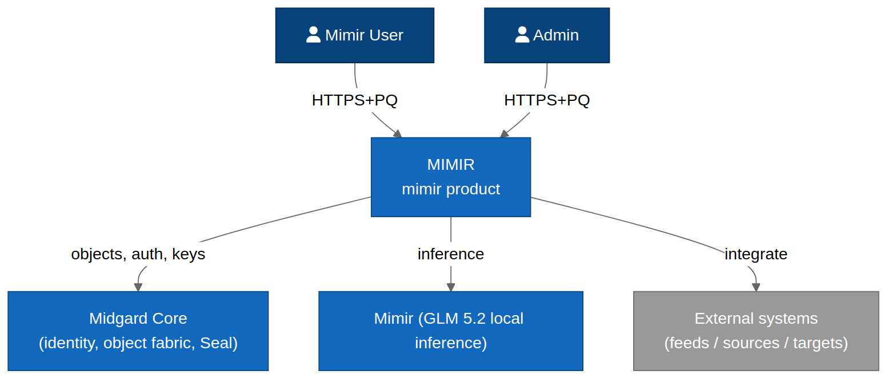
Figure 3.1 — Mimir as product and shared inference service within the enclosure.

4. Architecture Drivers

4.1 Functional requirements
ID | Requirement
FR-MI-1 | Serve models locally with batching, KV-cache, and quantisation; expose a typed inference API. Supported families: GLM, NVIDIA Nemotron, Google Gemma (see the Model-Supply Resolution DCR).
FR-MI-2 | Ground generation in the object fabric (OAG): retrieve objects/logic/actions with citations.
FR-MI-3 | Provide an agent runtime with tools, memory, planning, and per-agent Evals.
FR-MI-4 | Provide no-code (Logic) and pro-code builders for AI functions and agents.
FR-MI-5 | Self-learning: incorporate governed feedback into retrieval and prompt/policy state.
FR-MI-6 | Self-healing: detect degraded inference / failed tools and re-route, retry, or roll back.
FR-MI-7 | Self-defending: filter prompt-injection and adversarial input; scope tools; block exfiltration.
FR-MI-8 | Expose inference to Forge, Bifrost, and Heimdall over internal PQ-mTLS.

4.2 Inherited NFRs
ID | Requirement | Provenance
NFR-PQ-2 | All data-at-rest is encrypted with AES-256-GCM under keys wrapped by ML-KEM-1024; key material is sealed to an HSM/TPM where present. | STD:NIST FIPS 203 / FIPS 197
NFR-PQ-3 | All service-to-service and artefact-signing operations use ML-DSA (Dilithium) or SLH-DSA (SPHINCS+) signatures. | STD:NIST FIPS 204 / FIPS 205
NFR-SEC-1 | Zero-trust: every request between components is mutually authenticated and authorised on identity, device posture, and purpose. | STD:NIST SP 800-207
NFR-PRV-1 | The suite runs fully offline / air-gapped with no outbound network dependency for any core function. | DD-7
NFR-PERF-1 | Local inference first-token latency target < 800 ms on reference hardware (1×80GB GPU class); batch throughput scales horizontally. | DD-4
NFR-AI-1 | Every agentic action is traceable, evaluated against an Evals suite, and reversible or human-gated where it mutates state. | DD-5

5. Solution Strategy
Concern | Decision | Provenance
Serving | Dedicated inference runtime on GPU pool; continuous batching | `[FR-MI-1]` `[NFR-PERF-1]`
Grounding | OAG retriever over object fabric with citation binding | `[FR-MI-2]` `[DD-1]`
Agency | Plan–act–observe loop with typed tools + memory store | `[FR-MI-3]`
Governance | Mandatory Evals + guardrails on every agent action | `[NFR-AI-1]`
Self-* | Closed control loops around learn/heal/defend | `[DD-5]`

KDD — self-\* is bounded autonomy, not unbounded. Every self-learning update, self-healing reroute, and self-defending block is (a) logged with provenance, (b) checked against the Evals suite, and (c) reversible; state-mutating actions require human gating unless explicitly pre-authorised for a narrow, evaluated scope. [NFR-AI-1] [DD-5]

6. Logical Architecture (C4 L2)
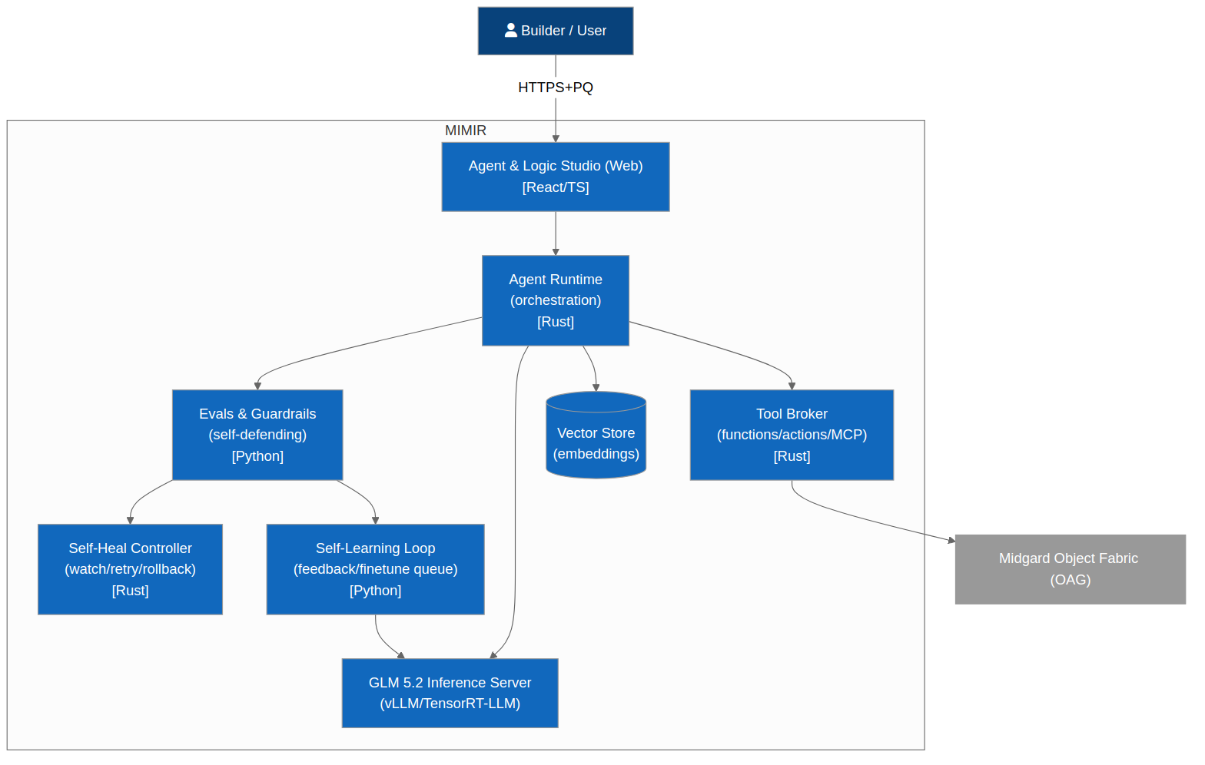
Figure 6.1 — Mimir containers.

6.1 Inference runtime
Serves GLM 5.2 with continuous batching, KV-cache, quantisation; exposes typed completion/embedding APIs; scales across the GPU pool. [FR-MI-1] [NFR-PERF-1]

6.2 OAG retriever
Retrieves grounding context (objects, links, functions, actions) from the fabric and binds citations to generated content. [FR-MI-2] [DD-1]

6.3 Agent runtime
Executes plan–act–observe loops with typed tools (fabric queries, actions, functions, MCP), a memory store, and per-step Evals. [FR-MI-3]

6.4 Guardrail & defence layer
Screens inputs and tool calls for prompt-injection, policy violations, and exfiltration attempts before execution. [FR-MI-7]

6.5 Evals & feedback service
Runs test cases, scores agent behaviour, and feeds governed feedback into self-learning. [FR-MI-5] [NFR-AI-1]

6.6 Builders (Logic / Agent Studio)
No-code and pro-code authoring of AI functions and agents. [FR-MI-4]

7. Component Architecture (C4 L3)
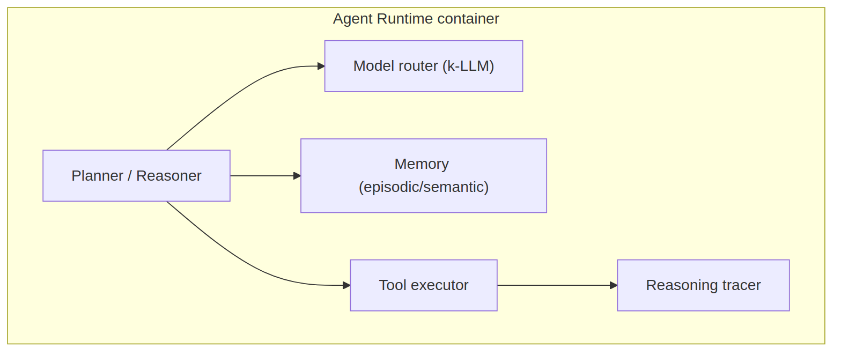
Figure 7.1 — Agent runtime components.

7.1 The self-\* control loops
The self-learning, self-healing, and self-defending behaviours are implemented as explicit closed control loops around the agent runtime, each observable, evaluated, and reversible.
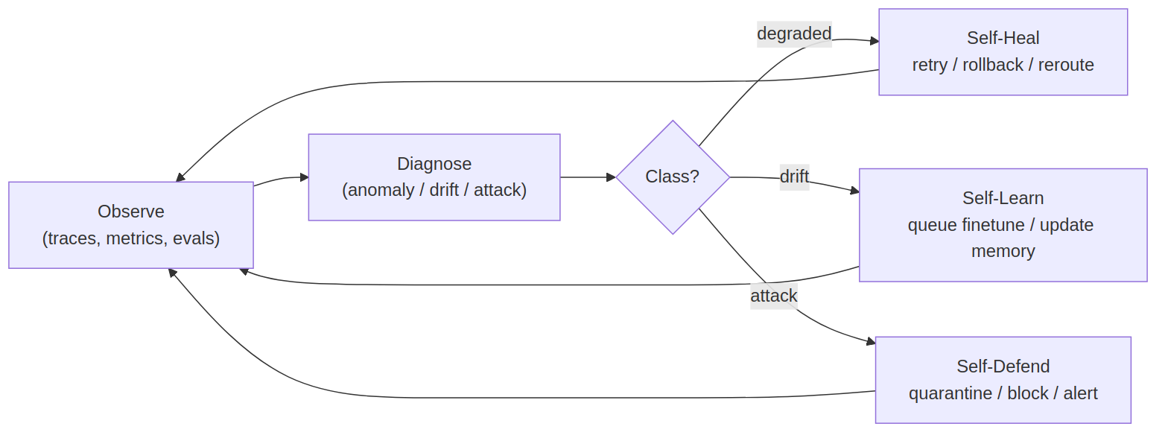
Figure 7.2 — Self-learning / self-healing / self-defending control loops.

Loop | Sensor | Controller | Actuator | Guard
Self-learning | User/Evals feedback | Feedback service | Retrieval + prompt/policy update | Evals gate `[FR-MI-5]`
Self-healing | Health/latency/error signals | Runtime supervisor | Reroute / retry / rollback | Circuit breaker `[FR-MI-6]`
Self-defending | Input + tool-call inspection | Guardrail layer | Block / sanitise / quarantine | Policy point `[FR-MI-7]`

8. Data Architecture
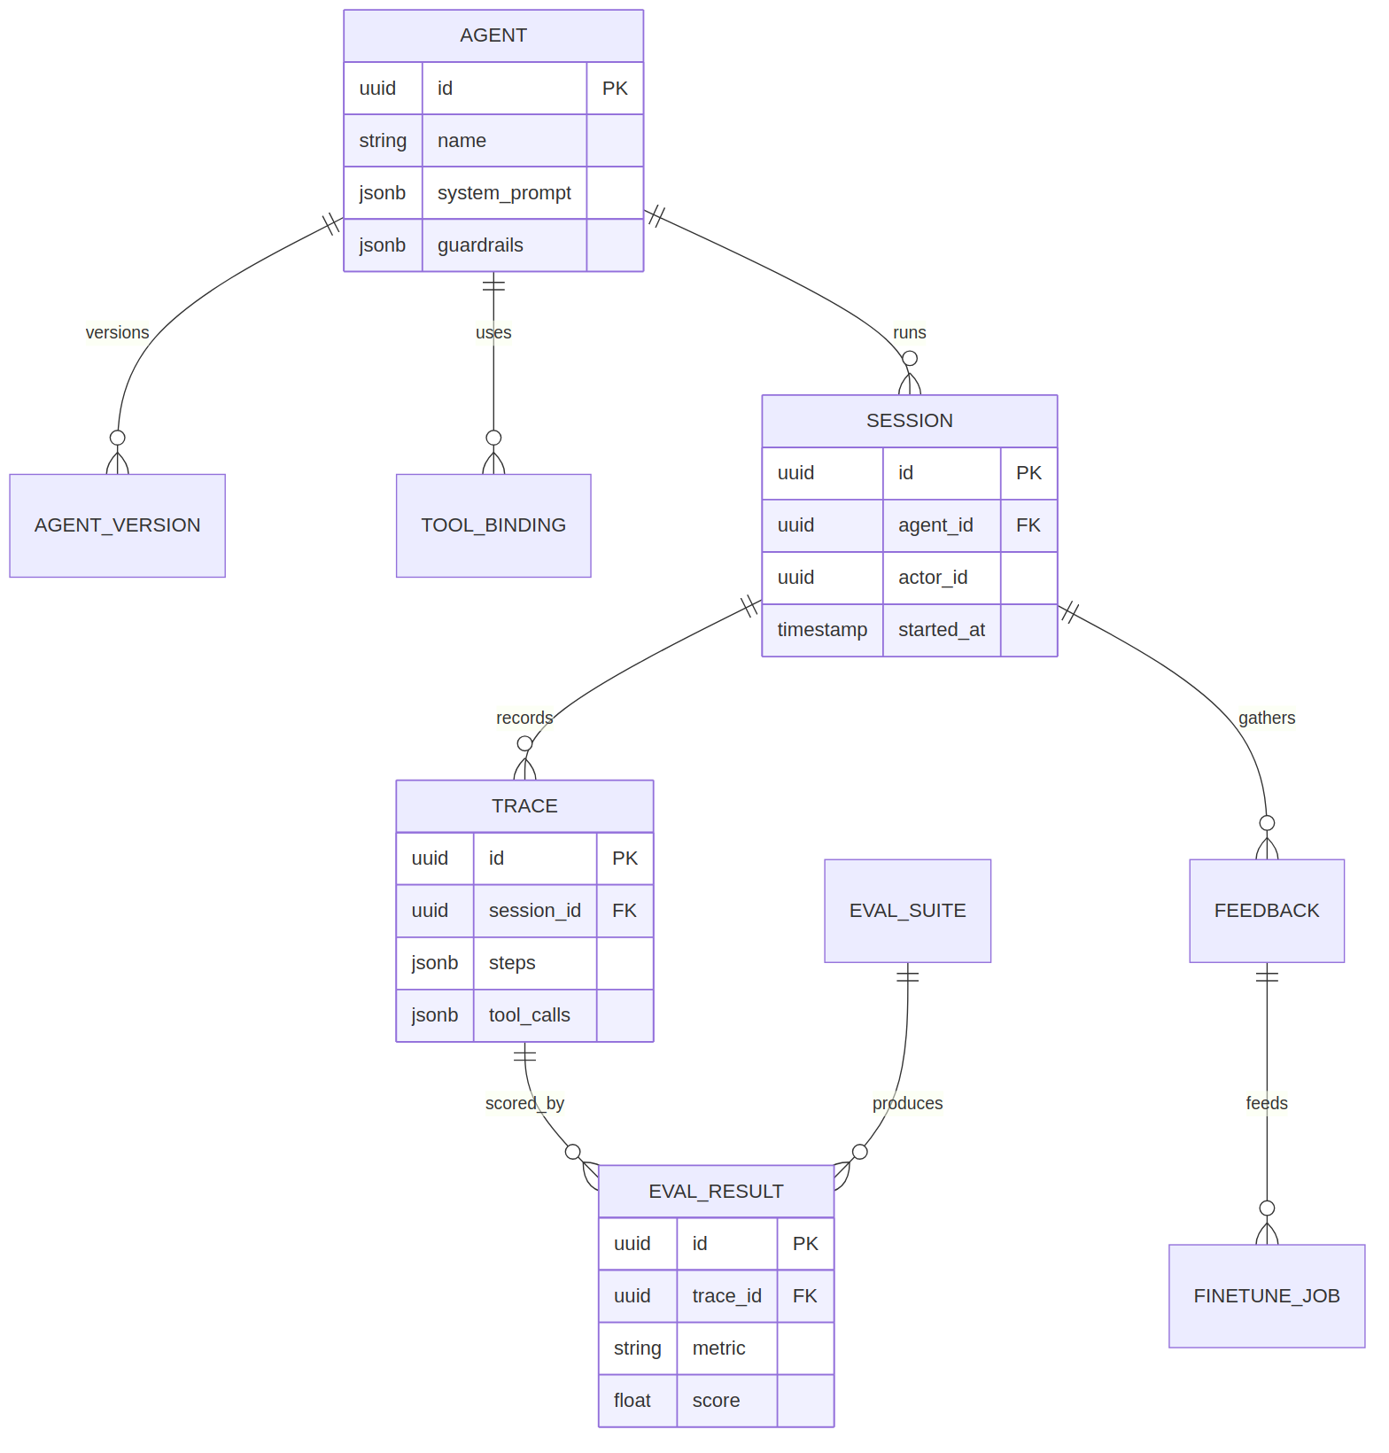
Figure 8.1 — Mimir data model (agents, tools, sessions, memory, evals, feedback).

Entity | Purpose
Agent | Definition: prompt, tools, policies, model binding.
Tool | Typed capability (fabric query, action, function, MCP).
Session | One agent execution with plan/steps.
MemoryRecord | Retrievable agent memory (PQ-encrypted). `[NFR-PQ-2]`
EvalCase / EvalRun | Test case and its scored result. `[NFR-AI-1]`
FeedbackRecord | Governed feedback for self-learning. `[FR-MI-5]`
GuardrailEvent | A self-defending block/sanitise event. `[FR-MI-7]`

8.2 Data stores
Store | Contents | Crypto
Model store | GLM 5.2 weights + adapters | PQ-signed, encrypted `[NFR-PQ-3]`
Vector/memory store | Embeddings, agent memory | PQ-wrapped `[NFR-PQ-2]`
Evals store | Cases, runs, scores | PQ-wrapped

9. Integration Architecture
Surface | Protocol | Purpose
Inference API | gRPC over PQ-mTLS | Completions/embeddings for the suite `[FR-MI-8]`
Agent API | gRPC/REST | Invoke/monitor agents
Logic/Function API | gRPC | Run AI-backed functions (called by Forge/Heimdall)
MCP tools | MCP over PQ-mTLS | Governed tool access to the fabric `[DD-4]`

9.2 Primary sequence
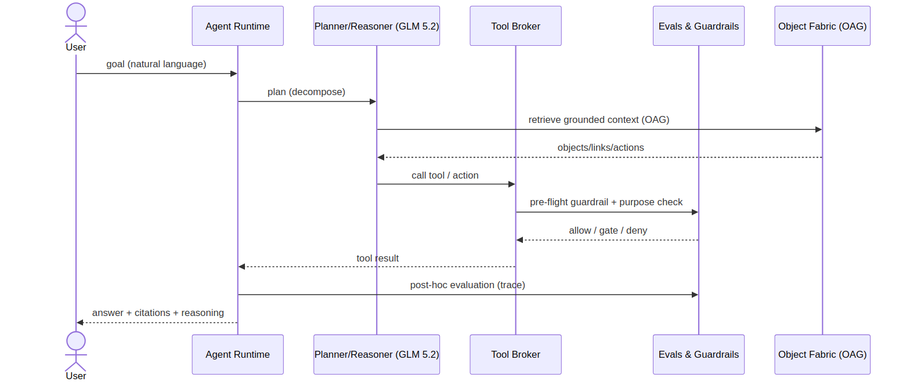
Figure 9.1 — OAG-grounded agent turn: retrieve → plan → guard → act → evaluate → respond.

9.3 User journey
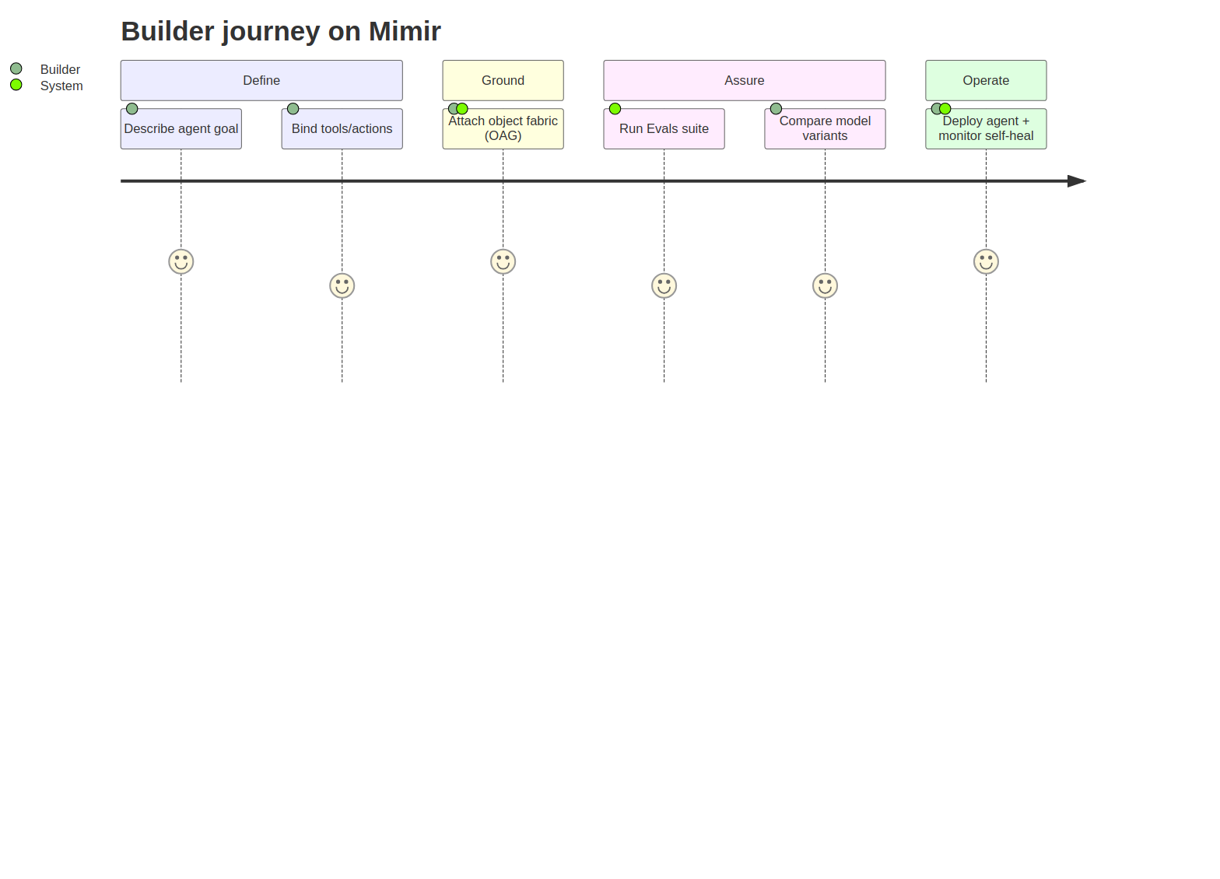
Figure 9.2 — Agent author primary journey.

10. Infrastructure & Deployment
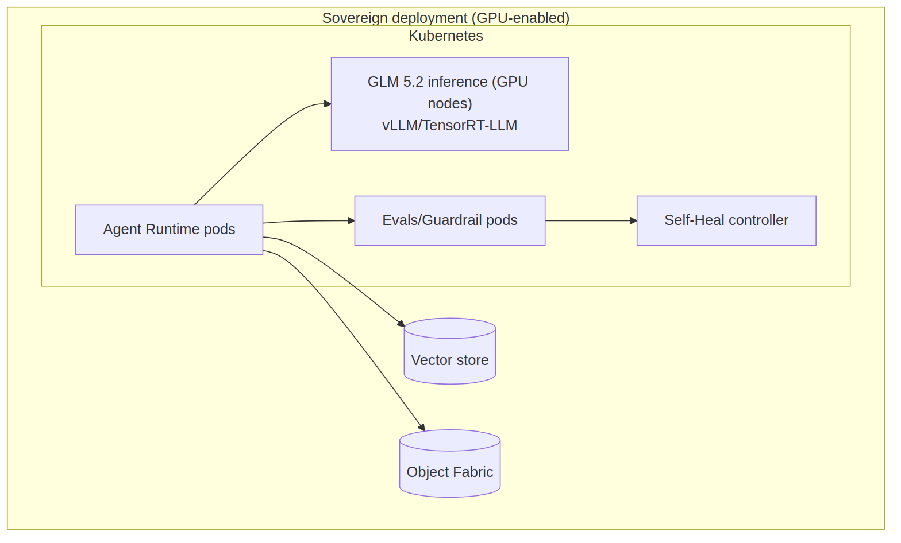
Figure 10.1 — Mimir deployment (GPU inference pool + agent/eval workers).

Inference runs on a GPU node pool; agent, guardrail, and eval services are horizontally scalable CPU workloads; the model store is PQ-signed and verified on load. [NFR-PERF-1] [NFR-PQ-3]

10.2 CI/CD
Figure 10.2 — Mimir pipeline incl. model-artefact signing and Evals gate.

11. Security Architecture
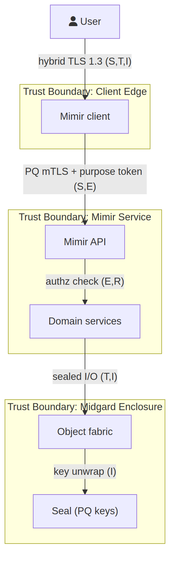
Figure 11.1 — Mimir STRIDE data-flow diagram.

Crossing | STRIDE | Control
Consumer → Inference API | S, T, D | PQ-mTLS, workload identity, quotas `[NFR-SEC-1]`
Prompt → Agent runtime | T, E | Guardrail/injection defence, tool-scoping `[FR-MI-7]`
Agent → Fabric action | R, E | Policy point, human-gate, audit `[NFR-AI-1]`
Model store → Runtime | T | PQ signature verification on load `[NFR-PQ-3]`

11.2 AI-specific security
- Prompt-injection and jailbreak filtering at input and tool-call boundaries. [FR-MI-7]
- Tool-scoping: agents receive least-privilege, purpose-bound tool grants. [NFR-SEC-2]
- Exfiltration defence: output scanning + marking-aware redaction. [FR-MI-7]
- Model-weight integrity: PQ-signed, verified on load. [NFR-PQ-3]

11.3 Known design gaps
Gap | Severity | Recommendation
Novel jailbreaks evade static guards | Medium | Continuous red-team Evals feeding self-defending loop. `[DD-5]`
Autonomous action blast radius | High | Default human-gate on state mutation; narrow pre-authorised scopes only. `[NFR-AI-1]`

12. Observability
- Per-agent traces (plan/act/observe). [FR-MI-3]
- Inference latency/throughput SLOs. [NFR-PERF-1]
- Guardrail + eval event metrics. [FR-MI-7]

13. Operational Concerns
- Model artefact backup + signature registry. [NFR-PQ-3]
- Graceful degradation: consumers fall back to non-AI mode if inference is down. [DD-6]
- GPU autoscaling for load. [NFR-PERF-1]

14. Quality & Testing
- Evals suite as executable acceptance for agent behaviour. [NFR-AI-1]
- Red-team corpus for self-defending. [FR-MI-7]
- Regression on OAG citation accuracy. [FR-MI-2]

15. Risks & Technical Debt
Risk | Severity | Mitigation
Autonomy overreach | High | Bounded autonomy: Evals + human-gate + reversibility. `[NFR-AI-1]`
Inference capacity | Medium | Batching, quantisation, horizontal GPU scale. `[NFR-PERF-1]`
Feedback poisoning of self-learning | Medium | Governed, provenance-checked feedback only. `[FR-MI-5]`

16. Roadmap
- Local GLM 5.2 serving + inference API.
- OAG grounding + citations.
- Agent runtime + Evals.
- Self-* control loops (learn/heal/defend).

17. Acceptance Criteria
ID | Given / When / Then | Provenance
AC-MI-1 | Given no outbound connectivity, when inference is requested, then GLM 5.2 responds locally (no hosted-model dependency). | `[DD-4]` `[NFR-PRV-1]`
AC-MI-2 | Given an OAG query, when answered, then the response cites the object-fabric evidence it used. | `[FR-MI-2]`
AC-MI-3 | Given an agent action that mutates state, when executed, then it is Evals-checked and human-gated unless pre-authorised for an evaluated scope. | `[NFR-AI-1]`
AC-MI-4 | Given governed feedback, when applied, then retrieval/policy updates occur and are logged with provenance (self-learning). | `[FR-MI-5]`
AC-MI-5 | Given degraded inference or a failed tool, when detected, then the runtime reroutes/retries/rolls back automatically (self-healing). | `[FR-MI-6]`
AC-MI-6 | Given a prompt-injection attempt, when received, then it is detected and blocked before any tool executes (self-defending). | `[FR-MI-7]`
AC-MI-7 | Given model weights of any supported family (GLM/Nemotron/Gemma), when loaded, then the Akuma ML-DSA signature, licence policy, and hardware eligibility are verified and loading fails closed on any mismatch. (Superseded/expanded by AC-MS-2 in the Model-Supply Resolution.) | `[NFR-PQ-3]`
AC-MI-8 | Given a consuming product (Forge/Bifrost/Heimdall), when it calls inference, then the call is over internal PQ-mTLS and audited. | `[FR-MI-8]` `[NFR-SEC-1]`

Appendix A — Diagram Source Index
Diagram | Mermaid | draw.io
Context | mimir_c4_context.mmd | mimir_c4_context.drawio
Containers | mimir_c4_containers.mmd | mimir_c4_containers.drawio
Components | mimir_c4_component.mmd | mimir_c4_component.drawio
Self-* loops | mimir_self_loop.mmd | mimir_self_loop.drawio
Data model | mimir_er.mmd | mimir_er.drawio
Primary sequence | mimir_seq_primary.mmd | mimir_seq_primary.drawio
Journey | mimir_journey.mmd | mimir_journey.drawio
Deployment | mimir_deployment.mmd | mimir_deployment.drawio
CI/CD | mimir_cicd.mmd | mimir_cicd.drawio
Threat DFD | mimir_threat_dfd.mmd | mimir_threat_dfd.drawio

