AKUMA ENGINEERING LTD.
Solutions Architecture Document

Mimir — Model-Supply Gap Resolution
Design-change record: sovereign multi-model provenance for GLM, Nemotron & Gemma

Forward-looking design specification · Version 1.0 · 2026-07-02

CONFIDENTIAL — RECIPIENT EYES ONLY
This document is a forward-looking architectural design specification for a greenfield system. It describes intended design, not implemented and verified code. Every design decision is tagged with its provenance (design driver, requirement ID, or external standard). It is not evidence of an existing implementation.

Document Control
Document Title | Mimir — Model-Supply Gap Resolution — Solutions Architecture Document
System | Mimir — Model-Supply Gap Resolution
Competitor benchmark | Palantir AIP (k-LLM model plane)
Author | Akuma Engineering Ltd. — Architecture Practice — for JB Benjamin, CEO / Founder
Reviewer
Date | 2026-07-02
Version | 1.0
Classification | CONFIDENTIAL — RECIPIENT EYES ONLY
Generated By | Imhotep skill (Anthropic Claude), greenfield design-spec mode
Document type | Forward-looking design specification (greenfield)

Contents
Right-click and Update Field to build the table of contents.

1. Purpose & Change Summary
This is a design-change record (DCR) against the Mimir Solutions Architecture Document (SAD_02). It resolves the open design gap recorded in Mimir SAD §11.3 / §15 and Midgard core SAD §11.12 — *local model-weight provenance* — and simultaneously implements an approved capability expansion: users may run the most advanced locally-runnable variants of three model families — GLM, NVIDIA Nemotron, and Google Gemma — inside the enclosure, selectable per workflow. [DD-4] [DD-5] [DD-7]
As with the SADs, this is a forward-looking design specification. Every decision carries a provenance tag ([DD-n], [FR-n], [NFR-n], [STD:...]); it describes intended design, not verified implementation.
Resolution in one sentence. The gap is closed by making model supply a *cryptographic custody-transfer problem solved with the machinery the suite already has*: models are fetched and verified in a network-connected staging enclave, re-signed under Akuma's post-quantum ML-DSA key, delivered across the air gap as signed Bifrost bundles, recorded in a new Model Registry, and verified-on-load by the inference runtime — which fails closed on any signature, licence, or hardware-eligibility mismatch. [NFR-PQ-3] [FR-B-4]

1.1 Change classification
Attribute | Value
Change type | Architecture change — gap resolution + capability addition
Affected products | Mimir (primary); Forge, Bifrost, Heimdall (consumers, via unchanged contract)
Gap closed | Local model-weight provenance (was: medium severity, open)
New severity | Closed (residual items tracked in §9)
New subsystems | Model Registry & Provenance; Model Abstraction Layer
Contract impact | None — Mimir inference API is unchanged; consumers unaffected `[DD-6]`

1.2 Why this was the priority
Mimir is the shared inference dependency for Forge, Bifrost, and Heimdall. An unresolved model-supply gap in Mimir is therefore a latent gap in three other products at once. Closing it — and doing so in a way that preserves the unchanged inference contract — de-risks the whole suite from a single point of change. [DD-6]

2. The Gap, Decomposed
The original finding bundled three distinct problems. A complete resolution must close all three; the multi-model decision expands the third.
Sub-problem | Question it poses | Resolved by
G1 — Acquisition | How do weights enter an air-gapped enclosure with no hosted dependency? | Two-stage air-gap supply chain via Bifrost bundles (§3)
G2 — Provenance & integrity | How does the enclosure prove a weight file is authentic, unmodified, and licence-clean before load? | Staging-side verification + Akuma re-signing + verify-on-load (§3, §4)
G3 — Lifecycle & agility | How are models versioned, rotated, and hot-swapped across families without breaking consumers? | Model Registry + Model Abstraction Layer (§4, §5)

Why the multi-model decision changes G3 specifically. Supporting one model is a provenance problem; supporting three families — each with different formats, tokenizers, chat templates, quantisation schemes, and licences — is a *catalogue-and-abstraction* problem. This is why the resolution introduces the Model Abstraction Layer, which did not exist in the original Mimir SAD. [DD-4]

3. Air-Gap Model Supply Chain
The core mechanism is a two-stage supply chain with cryptographic custody transfer. The enclosure never trusts an upstream source directly; it trusts only Akuma's signing root, which it already trusts for every Bifrost artefact. Acquisition thus collapses into the same trust model as a software release.
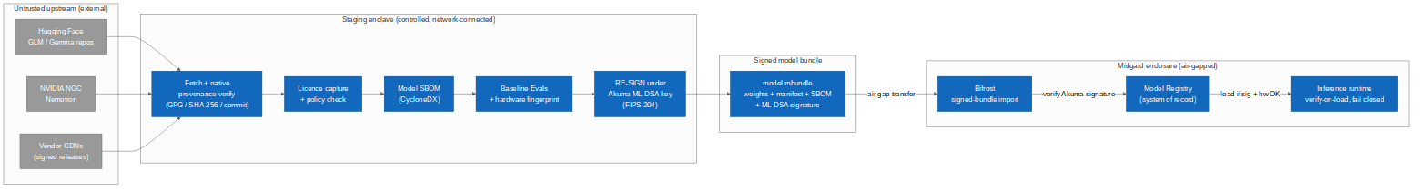
Figure 3.1 — Two-stage air-gap model supply chain with custody transfer under Akuma ML-DSA re-signing.

3.1 Stage 1 — Staging enclave (network-connected, controlled)
- Fetch the target variant from upstream (Hugging Face, NVIDIA NGC, vendor CDN). [FR-MS-1]
- Verify native provenance where it exists: vendor GPG signatures, Hugging Face commit hashes, published SHA-256 digests. Record what was and was not verifiable. [FR-MS-2] [STD:NIST SA-12]
- Capture licence and run the licence-policy check (see §6); block artefacts whose terms are incompatible with the intended deployment. [FR-MS-6]
- Generate a model SBOM (CycloneDX) describing weights, tokenizer, config, and declared lineage. [NFR-OSS-1]
- Run baseline Evals and record a hardware fingerprint (min VRAM, GPU count, multi-node flag). [FR-MS-5]
- Re-sign the assembled bundle under Akuma's ML-DSA (FIPS 204) signing key — the custody-transfer step. [NFR-PQ-3]

3.2 Stage 2 — Enclosure import (air-gapped)
- The signed model.mbundle (weights + manifest + SBOM + ML-DSA signature) crosses the air gap via Bifrost's existing signed-offline-bundle workflow — no new transport is invented. [FR-B-5]
- Bifrost verifies the Akuma signature on import and rejects any bundle that fails (fail closed). [FR-B-4] [NFR-PQ-3]
- The verified artefact is registered in the Model Registry with status approved. [FR-MS-3]
- The inference runtime verifies the signature again on load and refuses to place unverified or hardware-ineligible weights into GPU memory. [FR-MS-4]
The load-time invariant that closes the gap. A model that is not in the registry, whose ML-DSA signature does not verify, whose licence gate is unmet, or whose hardware profile the node cannot satisfy, *cannot be loaded*. This single, testable invariant is what converts the finding from open to closed. [FR-MS-4]

4. Model Registry & Provenance Subsystem
The Model Registry is the in-enclosure system of record for every model the platform may load. It is the durable answer to provenance (G2) and the foundation of lifecycle management (G3).
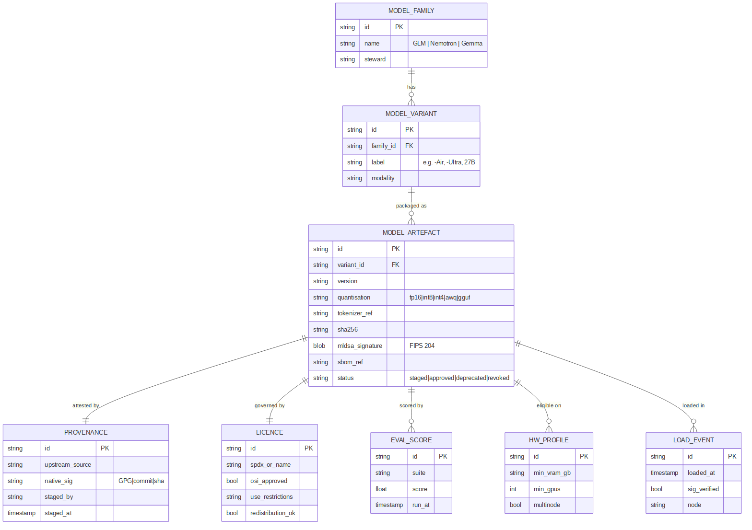
Figure 4.1 — Model Registry data model.

4.1 Entity catalogue
Entity | Purpose | Key attributes
ModelFamily | One of the supported families | id, name (GLM|Nemotron|Gemma), steward
ModelVariant | A specific variant within a family | id, family_id, label, modality
ModelArtefact | A packaged, signed, loadable build | id, version, quantisation, tokenizer_ref, sha256, mldsa_signature, sbom_ref, status
Provenance | How the artefact was obtained/verified | upstream_source, native_sig, staged_by, staged_at
Licence | Governing licence + restrictions | spdx_or_name, osi_approved, use_restrictions, redistribution_ok
EvalScore | Baseline/ongoing eval result | suite, score, run_at
HwProfile | Hardware eligibility | min_vram_gb, min_gpus, multinode
LoadEvent | Audited load attempt | loaded_at, sig_verified, node

4.2 Artefact lifecycle states
State | Meaning | Transition
staged | Assembled and re-signed in staging, not yet imported | → approved on verified import
approved | Verified in-enclosure; loadable | → deprecated or revoked
deprecated | Superseded; loadable but flagged | → revoked
revoked | Withdrawn (e.g. licence/CVE/eval regression); not loadable | terminal

Revocation is enforced at load time: a revoked artefact fails the load invariant even if its signature is otherwise valid, giving a fast kill-switch for a model found to be compromised, licence-breaching, or unsafe. [FR-MS-4] [NFR-AI-1]

5. Model Abstraction Layer & Routing
The Model Abstraction Layer preserves Mimir's unchanged inference contract while internally serving three heterogeneous families. Consumers (Forge, Bifrost, Heimdall, and Mimir's own agent runtime) call one API; the layer resolves which model actually answers.
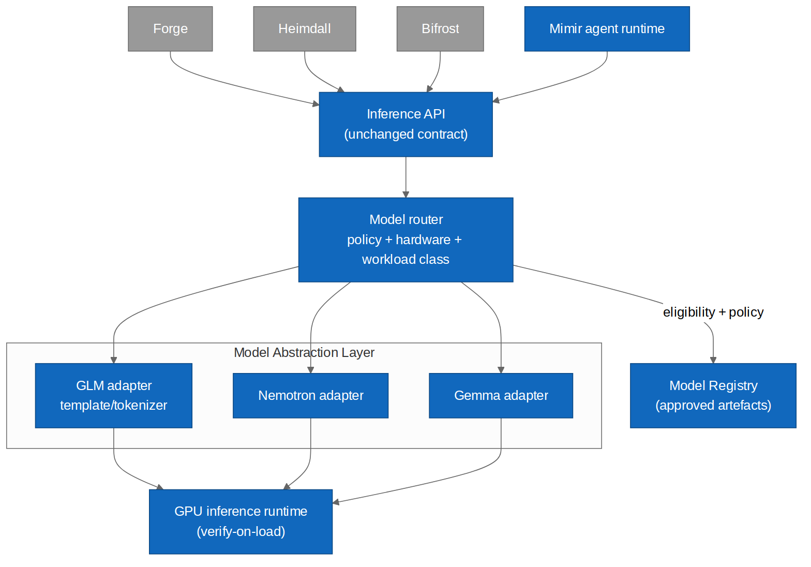
Figure 5.1 — Multi-model abstraction and policy routing behind the unchanged inference API.

5.1 Per-family adapters
Adapter | Handles | Notes
GLM adapter | GLM chat template, tokenizer, serving quirks | Reasoning-strong default `[FR-MS-7]`
Nemotron adapter | Nemotron template/tokenizer, NVIDIA formats | Strong code/agentic tasks `[FR-MS-7]`
Gemma adapter | Gemma template/tokenizer, GGUF/quantised formats | Efficient small-footprint option `[FR-MS-7]`

5.2 The router
The router selects an artefact per request from three inputs: workload class (e.g. fast-transform, deep-reasoning, code-analysis), hardware eligibility (from the artefact's HwProfile against the node), and governance policy (which families/variants are permitted for which markings, purposes, and tenants). Selection is deterministic, logged, and overridable by explicit request. [FR-MS-8] [NFR-SEC-2]
Composability preserved. Because routing lives behind the existing inference API, Forge/Bifrost/Heimdall are unchanged: they still call one contract. Per-workflow model choice becomes a platform capability, not a per-product integration. [DD-6]

5.3 Worked routing examples (design intent)
Consumer / task | Workload class | Typical selection
Forge — NL→transform suggestion | fast-transform | Efficient Gemma variant (low latency)
Heimdall — course-of-action options | deep-reasoning | Largest eligible GLM variant
Bifrost — release-risk analysis | code-analysis | Nemotron variant
Mimir agent — general | balanced | Policy default; overridable per agent

These are illustrative defaults, not hard bindings; the actual mapping is policy-configured by the platform admin. [FR-MS-8]

6. Licence Governance (a first-class concern)
The three families carry materially different licences. This is not a footnote: the suite's open-source-first driver ([DD-2]) requires that non-OSI-licensed models are never folded into the OSS core. They are handled as separately-licensed, user-fetched artefacts with terms surfaced and accepted at install time.
Family | Licence character (design-time assumption) | Handling
GLM | Varies by variant; some open, some restricted | Per-variant licence field; gate on redistribution_ok `[FR-MS-6]`
Nemotron | NVIDIA community/open model licences; conditions vary by model | Capture exact terms; surface use restrictions at install
Gemma | Google Gemma Terms of Use — custom, not OSI-approved, use restrictions apply | Never bundled into OSS core; user fetches + accepts terms

Design rule. The Mimir OSS core ships the *registry, adapters, router, and supply-chain tooling* — all Akuma-authored and OSI-licensed — but ships no third-party model weights. Weights are fetched by the operator into staging, where their licence is recorded and enforced. This keeps the open-source boundary clean while letting users run models they are entitled to use. [DD-2] [FR-MS-6]
Licence status is enforced at load, not merely displayed: an artefact whose licence policy is unmet for a given deployment is treated like a revoked artefact by the load invariant. [FR-MS-4]

7. Hardware Eligibility & Graceful Degradation
“Most advanced variant” is hardware-bound. The largest GLM and Nemotron variants exceed the single-80GB-GPU reference hardware in [NFR-PERF-1] and require multi-GPU or multi-node serving. The registry records a HwProfile per artefact, and the runtime refuses to load a model a node cannot serve — offering the largest *eligible* variant instead.
Node class (illustrative) | Eligible tier (design intent)
Single 24–48 GB GPU | Quantised small/mid variants (e.g. efficient Gemma, int4 GLM/Nemotron)
Single 80 GB GPU (reference) | Mid/large single-GPU variants
Multi-GPU node | Large variants with tensor/pipeline parallelism
Multi-node cluster | Largest “most advanced” variants

Fleet behaviour. Across heterogeneous hardware the capability degrades gracefully rather than failing: every node runs the best model it can, and the router never offers a consumer a model the serving node cannot load. [FR-MS-5] [NFR-PERF-1]

8. Updated & New Acceptance Criteria
The original Mimir acceptance criterion AC-MI-7 (single-model signature verification) is superseded by AC-MS-2 below, generalised across three families. The remaining criteria are new and must all pass for the gap to be certified closed.
ID | Given / When / Then | Provenance
AC-MS-1 | Given an upstream model, when staged, then native provenance is verified where available, a CycloneDX SBOM is generated, the licence is captured, and the bundle is re-signed under Akuma's ML-DSA key. | `[FR-MS-1]` `[FR-MS-2]` `[NFR-PQ-3]`
AC-MS-2 | Given any model artefact of any supported family, when loaded, then its ML-DSA signature is verified and loading fails closed on mismatch (supersedes AC-MI-7). | `[FR-MS-4]`
AC-MS-3 | Given a signed bundle, when imported to an air-gapped enclosure, then it transits only via Bifrost's signed-bundle workflow and is rejected if the Akuma signature fails. | `[FR-B-4]` `[FR-B-5]`
AC-MS-4 | Given three families are registered (GLM, Nemotron, Gemma), when a consumer calls the unchanged inference API, then the router selects an eligible, policy-permitted artefact and the consumer requires no code change. | `[FR-MS-7]` `[FR-MS-8]` `[DD-6]`
AC-MS-5 | Given a node that cannot satisfy a variant's HwProfile, when that variant is requested, then it is not loaded and the largest eligible variant is offered instead. | `[FR-MS-5]`
AC-MS-6 | Given a model whose licence policy is unmet for the deployment, when a load is attempted, then it is refused exactly as a revoked artefact is. | `[FR-MS-6]`
AC-MS-7 | Given an artefact set to revoked (licence/CVE/eval regression), when any load is attempted, then it fails closed regardless of signature validity. | `[FR-MS-4]` `[NFR-AI-1]`
AC-MS-8 | Given no outbound connectivity, when models are used, then all inference proceeds from locally-registered, verified artefacts (no hosted dependency). | `[DD-4]` `[NFR-PRV-1]`
AC-MS-9 | Given a model swap between families, when performed, then it is hot-swappable without changing the inference contract or migrating consumer data (crypto/model agility). | `[NFR-PQ-4]` `[DD-6]`

9. New Functional Requirements
ID | Requirement
FR-MS-1 | Fetch model variants from upstream sources in the staging enclave only.
FR-MS-2 | Verify native upstream provenance where present; record verifiability status.
FR-MS-3 | Maintain an in-enclosure Model Registry as the system of record for all loadable artefacts.
FR-MS-4 | Verify the Akuma ML-DSA signature, licence policy, and hardware eligibility on every load; fail closed.
FR-MS-5 | Record a hardware fingerprint per artefact; enforce hardware eligibility and offer the largest eligible variant.
FR-MS-6 | Capture and enforce per-model licence terms; never bundle non-OSI weights into the OSS core.
FR-MS-7 | Support GLM, Nemotron, and Gemma via per-family adapters behind the unchanged inference contract.
FR-MS-8 | Route inference per request by workload class, hardware eligibility, and governance policy; log every selection.

10. Residual Risks After Resolution
Risk | Severity | Mitigation
Staging enclave compromise (it touches untrusted upstream) | Medium | Isolate staging from the enclosure; only signed bundles cross; staging has no enclosure credentials. `[NFR-SEC-1]`
Upstream weight tampering before fetch | Medium | Verify native signatures/hashes; re-sign only after verification; record unverifiable status for risk acceptance. `[FR-MS-2]`
Licence drift (upstream re-licences a model) | Low | Licence captured at stage time is immutable in the registry; re-evaluation on any refresh. `[FR-MS-6]`
Model-level safety regressions across families | Medium | Per-family baseline + ongoing Evals; revoke on regression. `[NFR-AI-1]`
Signing-key compromise (custody root) | High | HSM-sealed Akuma signing key, rotation, threshold signing (shared with Bifrost). `[NFR-PQ-2]`

Net effect. The original *medium-severity, open* gap (“local model-weight provenance”) is closed. Its residuals are lower-order and are managed by controls the suite already specifies (HSM-sealed keys, Bifrost signing, Evals, zero-trust isolation). [NFR-PQ-2] [NFR-PQ-3]

11. Impact on Forge, Bifrost & Heimdall
Because the resolution lives behind Mimir's unchanged inference contract, the consuming products are unaffected in their integration surface. The only additions are capabilities they inherit for free:
- Forge may now request a fast, efficient model for transform suggestions and a stronger model for complex mappings — same API. [FR-MS-8]
- Bifrost gains a second role: it is the transport for signed model bundles (reusing its signed-bundle workflow) in addition to consuming inference for release analysis. [FR-B-5]
- Heimdall may route course-of-action generation to the largest eligible reasoning model while classification uses a faster one — same API, governed by policy. [FR-MS-8]
- All three retain their defined degraded mode: if no model is loadable, they operate without AI exactly as specified in their SADs. [DD-6]

12. Glossary Delta
Term | Definition
Model bundle (.mbundle) | A signed package of weights + manifest + SBOM + ML-DSA signature that crosses the air gap via Bifrost.
Staging enclave | A network-connected, isolated environment that fetches, verifies, licences, evaluates, and re-signs models before they enter the enclosure.
Model Registry | The in-enclosure system of record for all loadable model artefacts and their provenance, licence, evals, and hardware eligibility.
Model Abstraction Layer | The adapter+router layer that serves GLM, Nemotron, and Gemma behind Mimir's unchanged inference contract.
Verify-on-load invariant | The rule that no model loads unless signature, licence, revocation status, and hardware eligibility all pass.
Custody transfer | Re-signing an externally-sourced artefact under Akuma's key so the enclosure trusts only the Akuma root, not the upstream.
Mimir | Reasoning/AI product; competitor to Palantir AIP. Local, agentic, self-* generative AI on GLM 5.2. Also the shared inference layer for the other products.
GLM 5.2 | A large language model served locally by Mimir. As of the model-supply resolution, Mimir supports the most advanced locally-runnable variants of three families — GLM, NVIDIA Nemotron, and Google Gemma — selectable per workflow.
ML-DSA | Module-Lattice Digital Signature Algorithm (Dilithium), NIST FIPS 204.

Appendix A — New Diagram Source Index
Diagram | Mermaid | draw.io
Model supply chain | mimir_model_supply.mmd | mimir_model_supply.drawio
Model Registry data model | mimir_model_registry_er.mmd | mimir_model_registry_er.drawio
Model abstraction & routing | mimir_model_router.mmd | mimir_model_router.drawio

