AKUMA ENGINEERING LTD.
Solutions Architecture Document

Bifrost
Continuous Delivery — a post-quantum, AI-assisted competitor to Palantir Apollo

Forward-looking design specification · Version 1.0 · 2026-07-02

CONFIDENTIAL — RECIPIENT EYES ONLY
This document is a forward-looking architectural design specification for a greenfield system. It describes intended design, not implemented and verified code. Every design decision is tagged with its provenance (design driver, requirement ID, or external standard). It is not evidence of an existing implementation.

Document Control
Document Title | Bifrost — Solutions Architecture Document
System | Bifrost
Competitor benchmark | Palantir Apollo
Author | Akuma Engineering Ltd. — Architecture Practice — for JB Benjamin, CEO / Founder
Reviewer
Date | 2026-07-02
Version | 1.0
Classification | CONFIDENTIAL — RECIPIENT EYES ONLY
Generated By | Imhotep skill (Anthropic Claude), greenfield design-spec mode
Document type | Forward-looking design specification (greenfield)

Contents
Right-click and Update Field to build the table of contents.

1. Executive Summary
Bifrost is the continuous-delivery product of the Midgard suite and a direct, more capable competitor to Palantir Apollo. It is the bridge across the enclosure boundary: it orchestrates zero-downtime deployment, release management, and fleet upgrades for every product in the suite. Bifrost improves on Apollo with native post-quantum artefact signing, air-gap-native release bundles, and AI-assisted release intelligence served by the local Mimir layer rather than a hosted model. [DD-1] [DD-3] [DD-4] [DD-7]
This document is a forward-looking design specification; every decision carries a provenance tag rather than a repository citation.
Standalone and composable. Midgard + Bifrost delivers CD for the platform itself. With Mimir, Bifrost gains release-risk analysis and anomaly detection; it is the mechanism by which Forge, Mimir, and Heimdall are themselves promoted and upgraded. [DD-6]

1.1 Top design facts
- Zero-downtime rolling upgrades with automatic health-gated rollback across the fleet. [FR-B-2] [NFR-AVA-1]
- PQ-signed artefacts + SBOM attestation verified before every deploy. [NFR-PQ-3] [NFR-OSS-1]
- Air-gap-native bundles: signed offline release bundles for disconnected sites. [FR-B-5] [DD-7]
- Declarative release channels and fleet/installation management. [FR-B-3]
- AI release intelligence (risk scoring, anomaly detection) via local Mimir. [FR-B-6] [DD-4]

1.2 Top design risks
- Bad release propagation: a faulty release could roll out widely; mitigated by staged rings + automatic rollback. [FR-B-2]
- Supply-chain trust: artefacts must be provably built and signed; mitigated by reproducible builds + PQ signatures. [NFR-OSS-1] [NFR-PQ-3]
- Air-gap update lag: disconnected sites update slowly; mitigated by signed bundle workflow. [FR-B-5]

2. Introduction & Scope

2.1 Purpose
To define Bifrost's target architecture: artefact management, release orchestration, fleet/upgrade management, rollback, and AI-assisted release intelligence, plus dependencies on Midgard core and optional Mimir.

2.2 Audience
- Release/platform engineers.
- SREs operating the fleet.
- Security reviewers of the software supply chain.

2.3 Scope
In scope | Out of scope
Artefacts, releases, rings, rollout/rollback, fleet mgmt, release intelligence | Object fabric internals (Midgard SAD)
Bifrost APIs/UI and offline bundles | Model serving internals (Mimir SAD)

2.4 Definitions
Term | Meaning
Mimir | Reasoning/AI product; competitor to Palantir AIP. Local, agentic, self-* generative AI on GLM 5.2. Also the shared inference layer for the other products.
Bifrost | Continuous-delivery product; competitor to Palantir Apollo. Orchestrates zero-downtime deployment across the suite.
ML-DSA | Module-Lattice Digital Signature Algorithm (Dilithium), NIST FIPS 204.
Enclosure | The Midgard trust boundary; the defended, sovereign space within which all products run.

3. Business & Solution Context

3.1 Competitive positioning
Capability | Palantir Apollo | Bifrost (design intent)
Delivery | Continuous, zero-downtime | Continuous, zero-downtime + PQ-signed `[NFR-PQ-3]`
Supply chain | Managed signing | Reproducible build + PQ signature + SBOM `[NFR-OSS-1]`
Air-gap | Cloud-mediated | Native signed offline bundles `[FR-B-5]`
Intelligence | Rules-based | Local Mimir risk/anomaly analysis `[FR-B-6]`

3.2 System context (C4 L1)
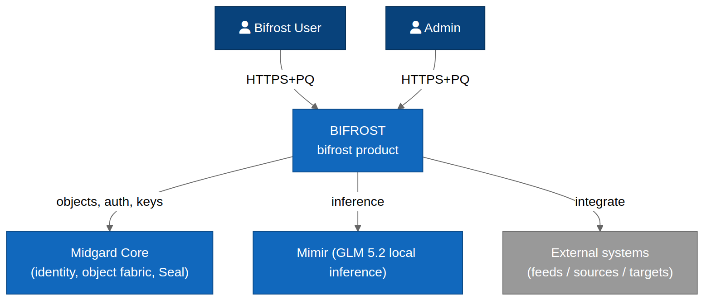
Figure 3.1 — Bifrost system context within the enclosure.

4. Architecture Drivers

4.1 Functional requirements
ID | Requirement
FR-B-1 | Manage signed, versioned deployable artefacts with SBOM attestation.
FR-B-2 | Perform zero-downtime rolling upgrades with automatic health-gated rollback.
FR-B-3 | Provide declarative release channels and fleet/installation management.
FR-B-4 | Verify PQ signatures and SBOM before any deploy; fail closed on mismatch.
FR-B-5 | Produce and consume signed offline release bundles for air-gapped sites.
FR-B-6 | Provide AI-assisted release intelligence (risk scoring, anomaly detection) via Mimir.

4.2 Inherited NFRs
ID | Requirement | Provenance
NFR-PQ-3 | All service-to-service and artefact-signing operations use ML-DSA (Dilithium) or SLH-DSA (SPHINCS+) signatures. | STD:NIST FIPS 204 / FIPS 205
NFR-SEC-1 | Zero-trust: every request between components is mutually authenticated and authorised on identity, device posture, and purpose. | STD:NIST SP 800-207
NFR-AVA-1 | Core control-plane services target 99.9% availability; the platform supports zero-downtime rolling upgrades. | DD-1
NFR-PRV-1 | The suite runs fully offline / air-gapped with no outbound network dependency for any core function. | DD-7
NFR-OSS-1 | All core components build reproducibly from source; an SBOM (CycloneDX) is emitted per release. | DD-2
NFR-AI-1 | Every agentic action is traceable, evaluated against an Evals suite, and reversible or human-gated where it mutates state. | DD-5

5. Solution Strategy
Concern | Decision | Provenance
Rollout | Staged rings (canary→broad) with health gates | `[FR-B-2]`
Trust | Reproducible build + ML-DSA signature + SBOM verify | `[NFR-PQ-3]` `[NFR-OSS-1]`
Air-gap | Signed bundle export/import workflow | `[FR-B-5]`
Intelligence | Mimir functions score release risk; advisory + gate | `[FR-B-6]` `[NFR-AI-1]`

KDD — deploys fail closed on trust. No artefact is deployed unless its PQ signature verifies and its SBOM matches; unknown or tampered artefacts are rejected automatically. [FR-B-4] [NFR-PQ-3]

6. Logical Architecture (C4 L2)
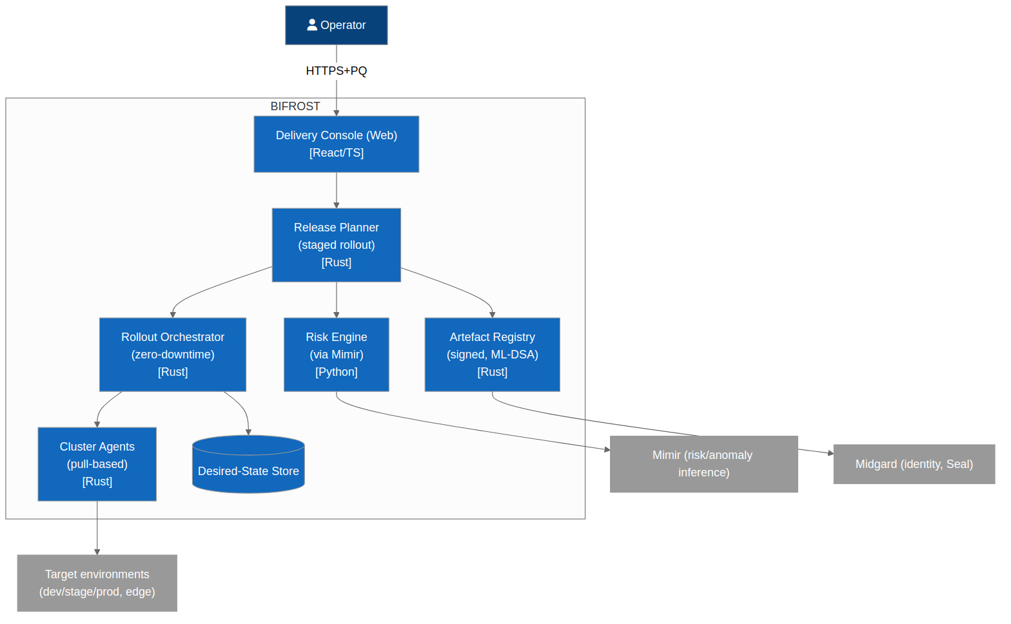
Figure 6.1 — Bifrost containers.

6.1 Artefact registry
Stores signed, versioned artefacts + SBOMs; verifies signatures on ingest and retrieval. [FR-B-1] [NFR-PQ-3]

6.2 Release orchestrator
Executes ring-based rollouts with health gates and automatic rollback. [FR-B-2]

6.3 Fleet manager
Tracks installations, channels, and desired vs actual state across the fleet. [FR-B-3]

6.4 Bundle service
Builds/imports signed offline release bundles for air-gapped sites. [FR-B-5]

6.5 Release-intelligence adapter
Calls Mimir for risk scoring and anomaly detection; advisory or gating. [FR-B-6]

7. Component Architecture (C4 L3)
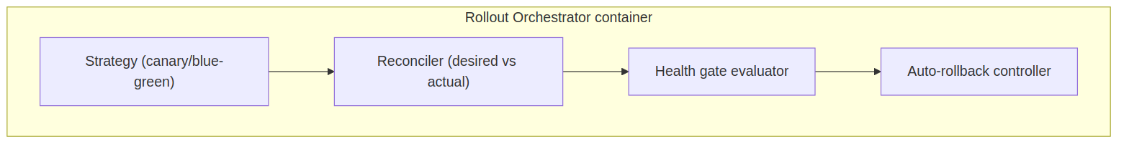
Figure 7.1 — Release orchestrator components.

Component | Responsibility
Ring planner | Computes canary→broad rollout plan. `[FR-B-2]`
Health gate | Evaluates SLO/health signals between rings. `[NFR-AVA-1]`
Rollback controller | Reverts on gate failure. `[FR-B-2]`
Signature verifier | PQ signature + SBOM check. `[FR-B-4]`
State reconciler | Drives fleet to desired state. `[FR-B-3]`

8. Data Architecture
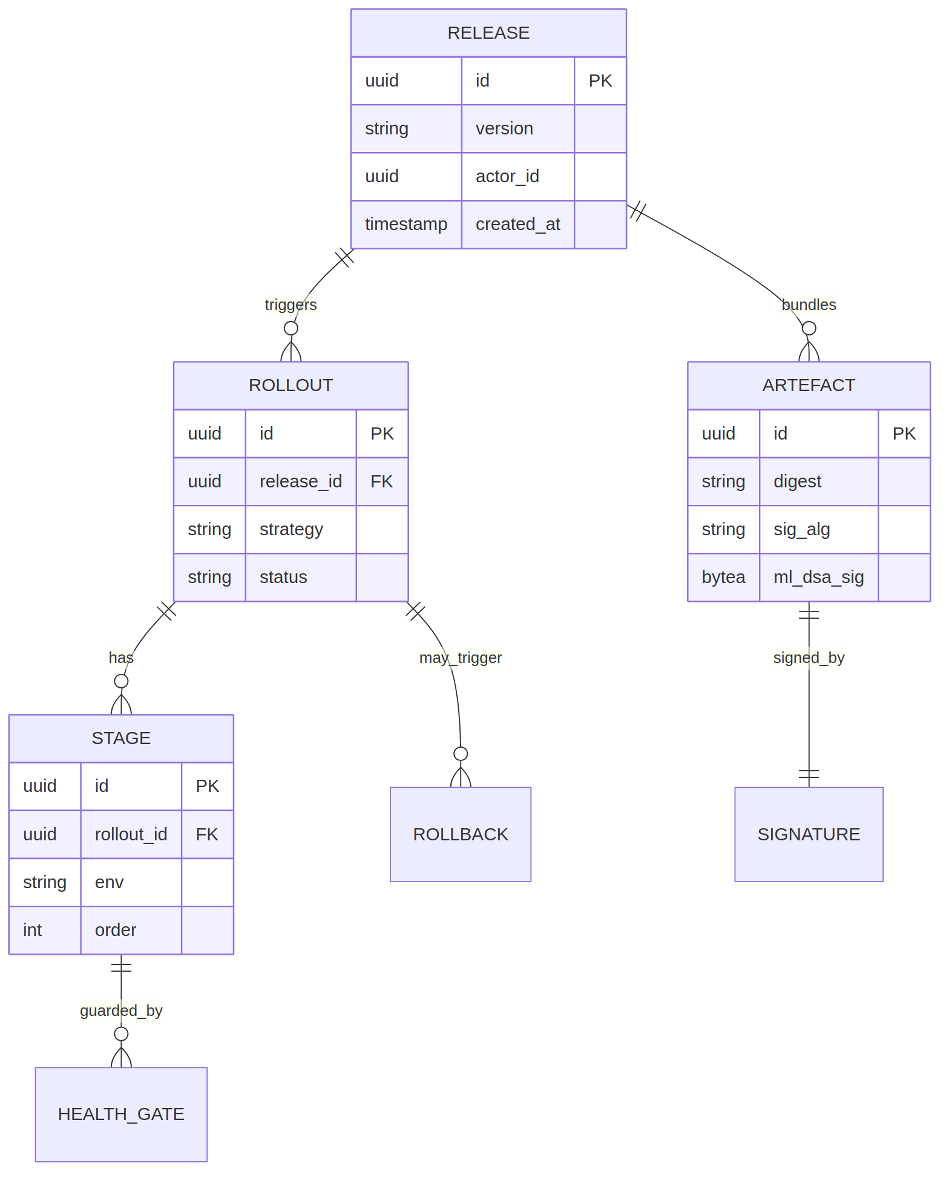
Figure 8.1 — Bifrost data model (artefacts, releases, rings, installations).

Entity | Purpose
Artefact | Signed deployable + SBOM ref. `[FR-B-1]`
Release | A versioned set of artefacts for a channel.
Channel | Named release stream (e.g. stable, edge). `[FR-B-3]`
Ring | Rollout stage with a health gate. `[FR-B-2]`
Installation | One deployed instance in the fleet.
RolloutRun | One orchestrated release execution.
Bundle | Signed offline release package. `[FR-B-5]`

8.2 Data stores
Store | Contents | Crypto
Artefact registry | Artefacts, SBOMs, signatures | ML-DSA-signed, encrypted `[NFR-PQ-3]`
Fleet state store | Installations, desired state | PQ-wrapped `[NFR-PQ-2]`

9. Integration Architecture
Surface | Protocol | Purpose
Release API | gRPC/REST over PQ-mTLS | Define/trigger releases
Fleet API | gRPC/REST | Query/manage installations
Agent (on-host) | PQ-mTLS | Applies changes on each node
Mimir calls | gRPC (internal) | Release risk/anomaly `[FR-B-6]`

9.2 Primary sequence
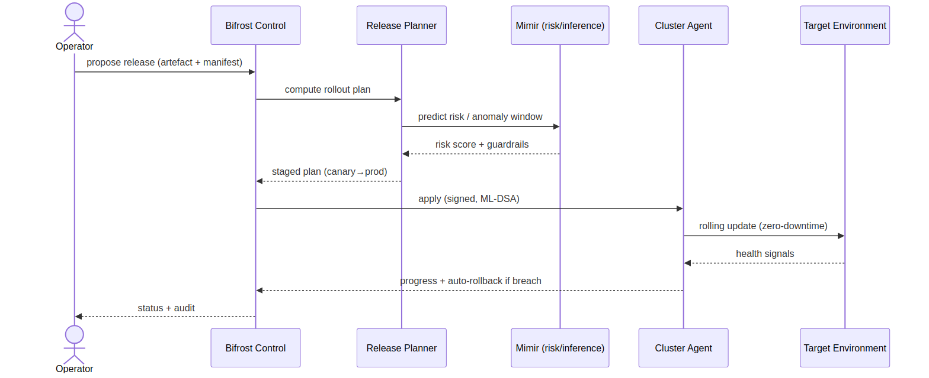
Figure 9.1 — Verify signature → canary ring → health gate → broad rollout → auto-rollback on failure.

9.3 User journey
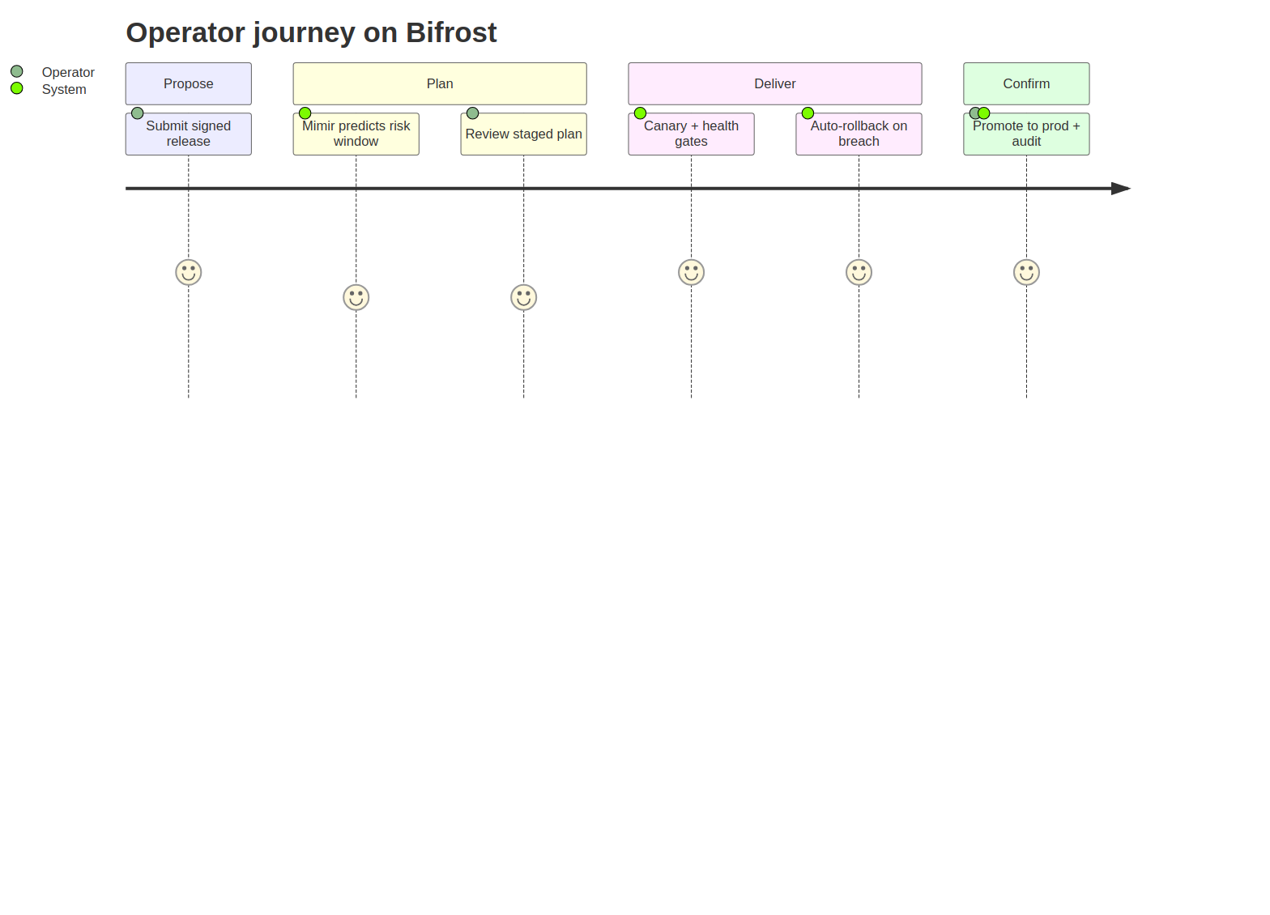
Figure 9.2 — Release engineer primary journey.

10. Infrastructure & Deployment
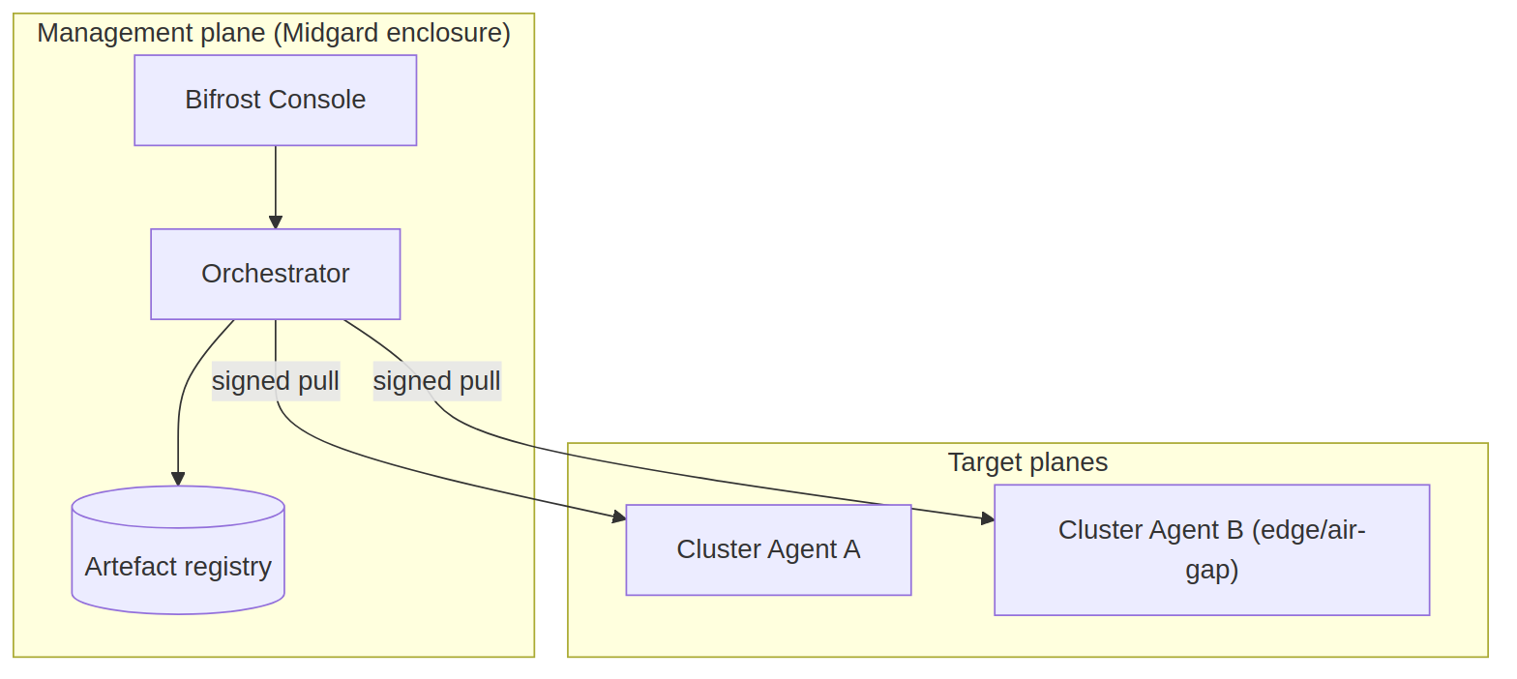
Figure 10.1 — Bifrost deployment (control plane + on-host agents).

Bifrost runs a control plane in the enclosure and a PQ-authenticated agent on each managed node; it deploys itself and every other product; egress-deny with signed bundle import for air-gap. [NFR-SEC-1] [FR-B-5]

10.2 CI/CD
Figure 10.2 — Bifrost's own build/sign/publish pipeline.

11. Security Architecture
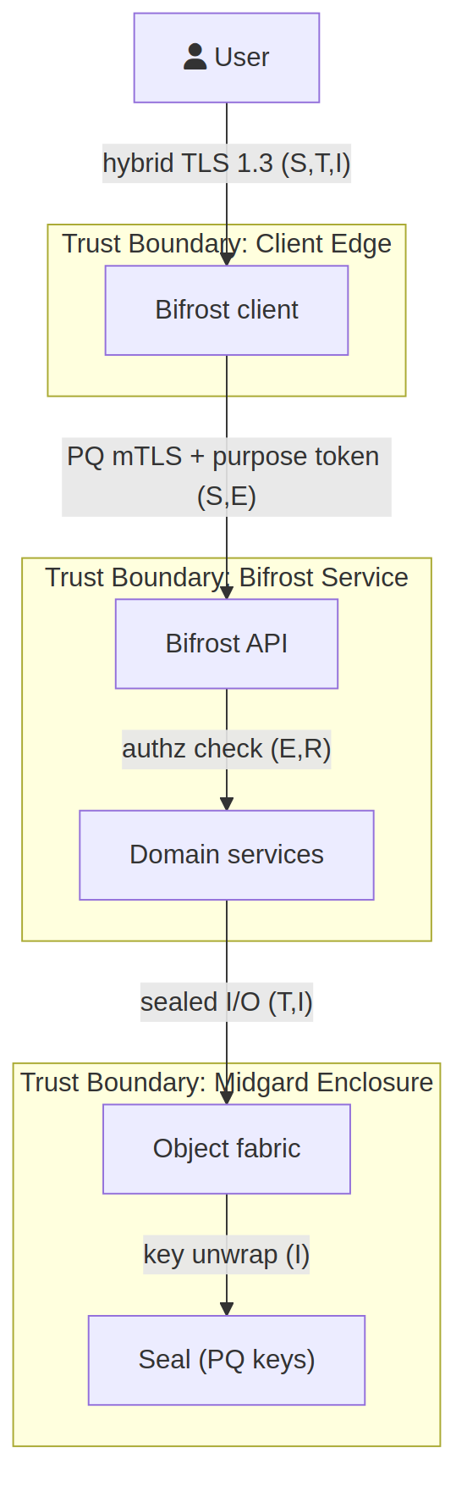
Figure 11.1 — Bifrost STRIDE data-flow diagram.

Crossing | STRIDE | Control
CI → Artefact registry | T, R | Reproducible build, PQ signature, audit `[NFR-PQ-3]`
Registry → Orchestrator | T, S | Signature verify, workload identity `[FR-B-4]`
Orchestrator → On-host agent | S, T, E | PQ-mTLS, least-privilege agent `[NFR-SEC-1]`
Bundle import (air-gap) | T, S | Signed bundle, offline verify `[FR-B-5]`

11.2 Supply-chain security
- Reproducible builds; PQ-signed artefacts; SBOM per release. [NFR-OSS-1] [NFR-PQ-3]
- Fail-closed signature/SBOM verification before deploy. [FR-B-4]
- Least-privilege on-host agents with signed instructions. [NFR-SEC-1]

11.3 Known design gaps
Gap | Severity | Recommendation
Compromised signing key | High | HSM-sealed keys, rotation, threshold signing. `[NFR-PQ-2]`
Canary blind spots | Medium | Mimir anomaly detection augmenting health gates. `[FR-B-6]`

12. Observability
- Rollout progress + ring health metrics. [FR-B-2]
- Fleet drift dashboards. [FR-B-3]
- Signature-verification audit. [NFR-PQ-3]

13. Operational Concerns
- Automatic rollback is the primary recovery path. [FR-B-2]
- Offline bundle workflow for DR at air-gapped sites. [FR-B-5]
- Control-plane HA. [NFR-AVA-1]

14. Quality & Testing
- Chaos/upgrade tests proving zero-downtime + rollback. [NFR-AVA-1]
- Signature-verification negative tests (tampered artefact rejected). [FR-B-4]
- Contract tests vs Midgard/Mimir. [DD-6]

15. Risks & Technical Debt
Risk | Severity | Mitigation
Faulty release fan-out | High | Staged rings + auto-rollback + Mimir risk gate. `[FR-B-2]` `[FR-B-6]`
Signing-key compromise | High | HSM sealing + rotation + threshold signatures. `[NFR-PQ-2]`

16. Roadmap
- Artefact registry + PQ signing.
- Ring-based rollout + rollback.
- Fleet/channel management.
- Offline bundles + Mimir release intelligence.

17. Acceptance Criteria
ID | Given / When / Then | Provenance
AC-B-1 | Given an unsigned or tampered artefact, when a deploy is attempted, then it is rejected (fail closed). | `[FR-B-4]` `[NFR-PQ-3]`
AC-B-2 | Given a rollout, when a ring's health gate fails, then rollback occurs automatically with no downtime. | `[FR-B-2]` `[NFR-AVA-1]`
AC-B-3 | Given an air-gapped site, when a signed bundle is imported, then its signature is verified offline before deploy. | `[FR-B-5]`
AC-B-4 | Given a release, when published, then a CycloneDX SBOM and ML-DSA signature are attached and verifiable. | `[NFR-OSS-1]` `[NFR-PQ-3]`
AC-B-5 | Given Mimir is present, when a release is planned, then a risk score is produced and can gate the rollout. | `[FR-B-6]`
AC-B-6 | Given Mimir is absent, when releasing, then rule-based gates still enforce safe rollout (standalone mode). | `[DD-6]`

Appendix A — Diagram Source Index
Diagram | Mermaid | draw.io
Context | bifrost_c4_context.mmd | bifrost_c4_context.drawio
Containers | bifrost_c4_containers.mmd | bifrost_c4_containers.drawio
Components | bifrost_c4_component.mmd | bifrost_c4_component.drawio
Data model | bifrost_er.mmd | bifrost_er.drawio
Primary sequence | bifrost_seq_primary.mmd | bifrost_seq_primary.drawio
Journey | bifrost_journey.mmd | bifrost_journey.drawio
Deployment | bifrost_deployment.mmd | bifrost_deployment.drawio
CI/CD | bifrost_cicd.mmd | bifrost_cicd.drawio
Threat DFD | bifrost_threat_dfd.mmd | bifrost_threat_dfd.drawio

