Report exam

Vemund Lien

26 11 2021

## Introduction

It is well known that muscles in humans can grow stronger. Many studies have investigated how this phenomenon is working. Some humans responds more to resistance training than others, leaving that genetically factors play a role to muscle gains and strength Timmons (2011) . Training volume and specific training towards a goal seems also to be important in order to achieve performance on a specific sport “Progression Models in Resistance Training for Healthy Adults” (2009) .

## Methods

Data about the participants are presented in (table 1)

|  | Female | | Male | |
| --- | --- | --- | --- | --- |
|  | Include | Exclude | Include | Exclude |
| N | 18 | 4 | 16 | 3 |
| Age (years) | 22 (1.25) | 22.9 (1.57) | 23.6 (4.11) | 24.3 (1.46) |
| Mass (kg) | 64.4 (10.4) | 64.6 (9.71) | 75.8 (10.7) | 88.2 (22.4) |
| Stature (cm) | 168 (6.87) | 166 (7.59) | 183 (5.88) | 189 (4.58) |
| Body fat (%) | 34.1 (5.64) | 28.8 (8.69) | 20.4 (5.99) | 24.3 (15.3) |
| Table 1: Values are mean and (SD) | | | | |

Following tests and measurements were performed during the study:

* Isokinetic and isometric unilateral knee-extension
* One repetition-maximum (1RM) unilateral leggpress and knee-extension
* Muscle cross sectional area (CSA) and body composition
* Hormonal measurements
* Muscle tissue sampling

Isokinetic and isometric unilateral knee-extension was performed on a dynamometer, with maximal torque on 60, 120 and 240 grade * sec-1. The participants were familiarized with the test protocol by performing three submaximal tests at each angular speed. Two attempts were given at 60 grade * sec-1, and three attempts on 120 and 240 grade * sec-1. The highest score obtained was used for analyses.

Towards the 1RM tests, the protocol contained a spesific warm-up of ten, six and three repetitions at 50, 75 and 85% of anticipated maximum before each of the exercise. Then the participants were given six attempts to find 1RM. The last weigth lifted at full range motion was accepted as 1RM.

Muscle cross sectional area was measured on vastus lateralis, medialis, intermedius and rectus femoris, before and after training intervention using magnetic resonance imaging (MRI). Dual-energy X-ray absorptiometry (DXA) was used to measure body composition before and after the training intervention. The participants were told to stay fasted for 2 hours and refrain from any hard physical activity 48 hours before the measurements.

## Results

Gjennomsnittlig forbedring fra pre- til post-test i multiple var 32.2 kg og i single 28.6., som førte til en ikke-signifikant differanse på 3.6 kg (p = 0.26) mellom multiple og single

Figure 1

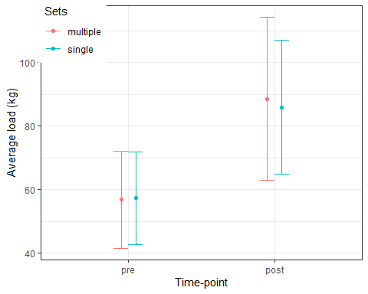

Pre and post legextension

## Discussion

“Progression Models in Resistance Training for Healthy Adults.” 2009. *Medicine & Science in Sports & Exercise* 41 (3): 687–708. <https://doi.org/10.1249/MSS.0b013e3181915670>.

Timmons, James A. 2011. “Variability in Training-Induced Skeletal Muscle Adaptation.” *Journal of Applied Physiology* 110 (3): 846–53. <https://doi.org/10.1152/japplphysiol.00934.2010>.