
Computer Vision
Exercise Course: Assignments I
WS 2015/16

Harald Scheidl, 0725084
Thomas Pinetz, 1227026
Velitchko Filipov, 0726328

Assignment 1: Colorizing Images
The assignment was to align and combine the three channels of an image (R, G, B) to form a colorized image. The NCC (Normalized Cross Correlation) image matching metric is used to compute the correlation of the different channels and find the shift in pixels between the channels of the image. The NCC value refers to how similar two images (color channels) are to each other. If the value from the NCC computation is high that means that there is a larger the shift between the color channels of the image. Once the NCC value has been computed the R, G, B channels can be aligned and combined to form a colorized image. The NCC can be computed using the following formula (implemented in Matlab by the corr2(A, B) function):
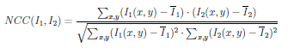
Once the NCC has been computed, the image channels need to be aligned. This is done by using the Matlab function circshift(A, [x y]), which shifts the elements of the matrix (image channel) A by x in the horizontal dimension and y in the vertical dimension. In this specific assignment the shifts in the image channels can be between -15 and 15 pixels in both dimensions therefore, we exhaustively search over the interval [-15,15] for both the x and y dimensions of the image until we find the maximum displacement. The displacement value is then used to align the image channels.

The results of our implementation are presented in the following images:

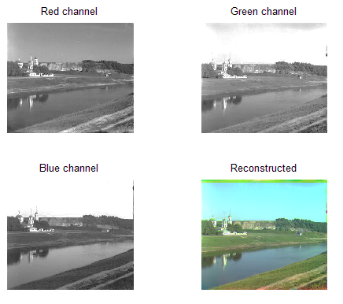
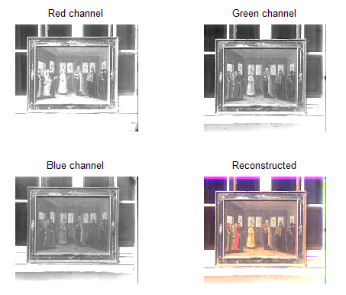
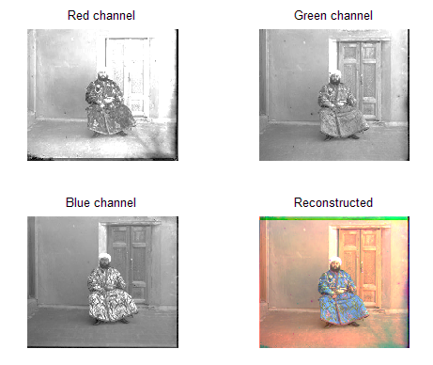
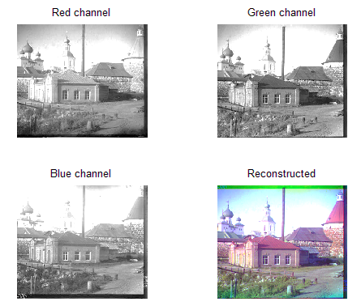
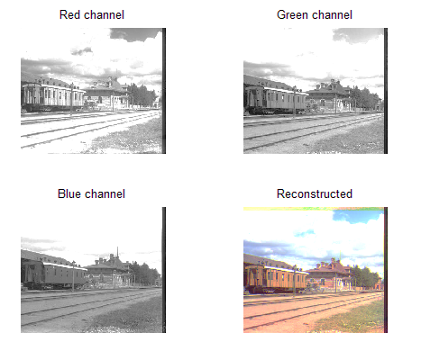
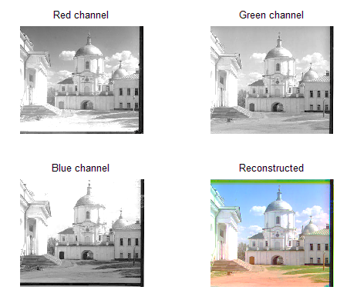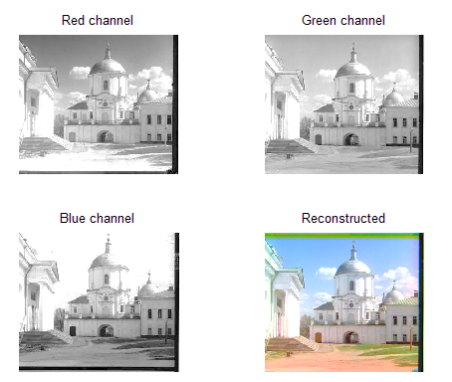

Assignment 2: Image Segmentation by K-Means Clustering

Assignment 3: Scale-Invariant Blob Detection

