17/5/18

Standardize all images with tf.image.per_image_standardization, zero mean unit variance

EXPERIMENTS

- exp_1
  - 1 resnet block in the generator
  - Both generator losses are good, decreasing nicely
  - Discriminator A loss has a decreasing trend at the start but the stalls and oscillates
  - Discriminator B loss steady with an increasing tendency, and oscillating
  - Images a re actually pretty good, all fakes capture digits perfectly. Fake A still retain some of the background texture
  - Fake B are digits, and have clearly defined background texture but no color
  - Attempt with another resnet block in the generator, to maybe capture color

- exp_2
  - One more resnet block in the generator helped the Discriminator A, its loss was decreasing, but it was oscillating
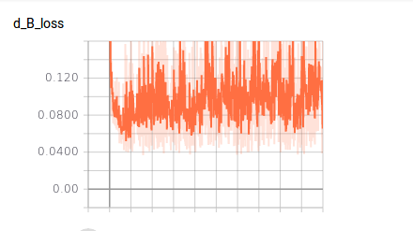
  - Did not help Discriminator B

  - Discriminator B loss is affected by d_B(input_B) = rec_B, by keeping the rec_B images as close to 1. It’s also affected by d_B(fake_B) = fake_rec_B => d_B(g_A(input_A)) = fake_rec_B, by minimizing that value. So since rec_B is actually calculated recursively, I am choosing to assume that what’s at fault here is that gen_A is able to fool disc_B and thus it doesn’t get back any feedback to actually improve the fake_B images.
  - Why is the disc_B fooled by b&w images??? Bad feature extraction?
  - Try to plot the separate losses of the discriminator

- exp_3
  - Plotting the two different losses involved in Discriminator B
  - Ok, what is happening
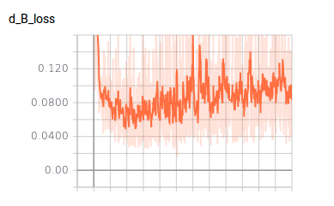

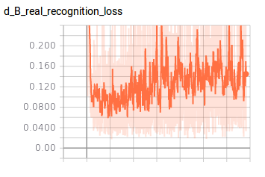
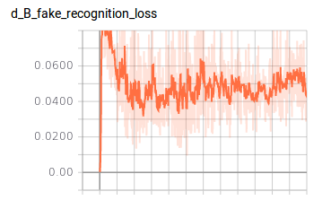

  - Discriminator B is really bad at identifying images of its own domain, d_B_real_recognition_loss corresponds to d_B(input_B) = rec_B
  - Try to increase convolutional layers in the discriminator, and plot the breakdown of the losses for discriminator A, because it currently works pretty good and more losses may break it?

- Exp_4 (git branches from now on)
  - One more conv layer in discriminator & logging separate losses for Discriminator A too
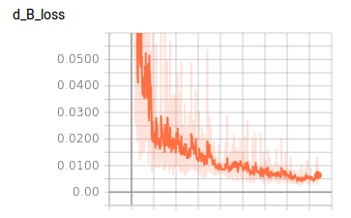

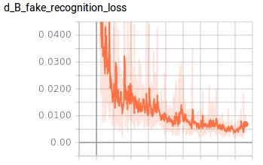
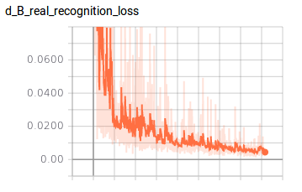

  - Ok, adding one more conv layer to the discriminator had a huge effect
    - The discriminator B is actually able to recognize the real and fake domain B images, as apparent from the loss
    - The discriminator A loss went almost to 0 immediately, so maybe the problem becomes too easy for that architecture?
    - The actual images do not look particularly good

    - input A 99 4 cycle A 99 5 fake A 99 4

    - input B 99 5 cycle B 99 5 fake B 99 5

  - Train for 200 epochs

- exp_5
  - Trained for 200 epochs
    - input A 199 4 cycle A 199 5 fake A 199 4

    - input B 199 5 cycle B 199 5 fake B 199 5

- Ok those still look bad. The B inputs look particularly bad. Try Xing’s standardization and the architecture we have now

- exp_6
  - Xing’s standardization, 100 epochs
  - Both generator losses are oscillating wildly in the e-3 area
  - Both discriminator losses are down to zero, e-3 area
  - Checked generated images, they are garbage, no structure no digits no colors in any domain.
  - Keep using per_image_standardization
  - Increase max_images

- exp_7
  - per_image_standardization
  - double pool size to 100
  - double max images to 200
  - Does not seem to make much difference actually
  - Add another conv layer to the discriminator
- exp_7 addendum
  - I added separate loss summaries for the gan losses and the cycle loss in the generators. Something weird is going on. The full generator losses ARE going down steadily, and so is the cycle loss
  - But the two adversarial GAN losses, are going up! Very much so, reaching pretty much 1!
  - The adversarial loss for gen A tries to minimize gan_loss_A = d_A(fake_A) = d_A(g_B(input_B))
  - But the d_A has very low loss, both in recognizing real, and fake A images
  - I guess that is why the generator losses keep decreasing steadily, but still remain kinda high > 5
  - I don’t know what’s going on
  - Add another conv layer to the discriminator

- exp_8
  - 1 more conv to the discriminator
  - No discernible difference tbh
  - In the paper, they mention that the discriminator loss is divided by 2 to slow down the learning of the discriminator relative to the generator. Our discriminators learn really good, so maybe slow down their learning rate more?
  - Divide discriminator learning by 4

- exp_9
  - Divide discriminator learning by 4
  - That does not help. The problem is that the discriminator loss goes down to 0 very quickly, which is a failure mode. That’s problematic, because no learning takes place in that case.
  - Have to deal with the failure mode

- exp_10
  - Attempt to normalize images in [-1, 1] by

  - Do NOT use per_image_standardization
  - Divide the learning of the discriminator by the original 2
  - This gives some interesting results. The discriminator losses do not go almost immediately to 0, for a start
  - This causes the generator loss to fall below 5, which wasn’t happening before
  - The gan losses are still quite high, but are oscillating WILDLY. gan_loss_b has an upward trend
  - I think the behavior, according to the losses at least, looks better
  - The images still don’t look quite right

- exp_11
  - Allright fuck it, use SVHN
  - Use architecture of exp_10
  - That does not look too promising.
  - The normalization to [-1, 1] produces very dull images, color wise. So the generated ones will by no means be colorful enough.
  - Try no normalization or standardization again

- exp_12
  - SVHN resized to 28x28 using tf.image.resize_images, no normalization or standardization
  - It’s bad, both discriminator losses are down to 0, while the generator losses are in the 1000s (!!!). The cycle loss oscillates between [100, 200] and the gan losses are steady at 1
  - It may be a problem with the SVHN input, the images after resizing are very noisy.
  - Attempt different resizing

- exp_13
  - SVHN resized with tf.image.resize_image_with_crop_or_pad
  - No standardization or normalization
  - The SVHN input looks much better, judged by the TF image summaries
  - The losses behave the exact same way, which leads us to believe that some kind of normalization or standardization is becessary

- exp_14
  - Above architecture but with per_image_standardization, after resizing in the case of SVHN
  - It seems to be the same again. The discriminator losses are down to 0 almost immediately, and the generator losses are > 5. The cycle loss is decreasin steadily, and the gan_losses are around 1
  - Above architecture, normalization of input in [-1, 1]

- exp_15
  - Above architecture, normalize in [-1, 1], after resizing
  - The behavior is a bit better to be honest, but the images are still kinda bad, but the fact that the SVHN images are very noisy does not help either
  - Ok. Since we want better generators, use more layer in the generators maybe?

- exp_16
  - Try the above architecture but with more input images and maybe fewer epochs
  - Tried it for all 2000 images of SVHN format2, with a 50 fake image pool and for 20 epochs
  - The results were not better. The generator losses stalled in the same way

- exp_17
  - Try with SVHN format 1
  - 500 fake image pool size
  - 20 epochs

- exp_18
  - Try the SVHN format2 with SGD on the discriminator
  - max_images = 200
  - SGD with learning rate 1e-3
  - That seems to work the same actually. The discriminators are much more unstable but their loss is quickly < .1 and the generators hover around 4

- exp_19
  - Try SGD with learning rate 1e-3 on the svhn format1
  - use max_images = 2000, pool_size = 500
  - Some interesting stuff here
  - Mainly, the format1 is not useful when resized to 28x28 because all detail is lost
  - The distriminator losses are not stable at all, although the loss itself is again <.1
  - The generator losses are much more stable, and hover around 4
  - The fake SVHN images look kinda good actually
  - The fake MNIST images look bad, because the cropped input SVHN are not clear at all

- exp_20
  - Run above configuration but with SVHN format2
  - Resize mnist to 32x32 with padding
  - The discriminator losses are not 0, but they have huge variance and are spiking
  - Acording to GanHacks that’s a failure mode
  - Run above but with adam only? And maybe introduce decay

- exp_21
  - Run above with Adam opt, and for 150 epochs
  - The generator losses go down to just above 2
  - The discriminator losses slowly go down to 0
  - The fake domain A images are GARBAGE, the GAN tries to turn the non-digit part of the images into digits, even in cases of very clear digits
  - The fake domain B images are a bit better. The digit is always clear, but the background fluctuates wildly, sometimes it’s plausible, others it’s neon
  - The fake domain B images seem to alternate between plausible and bad background every ~10 epochs. weird
  - Introduce extra layers in the generator.
  - Train on 1000 images
  - decay at epoch 75

- exp_22
  - Training on 1000 images
  - decay at 75 epochs
  - Generator with 3 resnet blocks

- exp_23
  - This is blind fumbling around. Figure out exactly what is going on in the network layers
  - Change the network parameters
  - Copy https://github.com/yunjey/mnist-svhn-transfer/blob/master/model.py
  - Generator
 | Original | Copied
generator_first_layer_filter | 8 | 64
stride | 1 | 2 in enc/dec, 1 in resnet
Kernels | First in enc/last in dec: 5, else: 2 | Enc/dec: 4, resnet: 3
  - 2 encoding layers, 2 transfrotm layers, 2 decoding
  - Discriminator
 | Original | Copied
discriminator_first_layer_filters | 16 | 64
kernel | 4 | 4
stride | 2, final_conv: 1 | 2, final_conv: 1
  - 3 convolutions + final
  - Train on 1000 images, 500 pool
  - For 51 epochs
  - decay at 51/2
  - log cycled images too
  - Ok. The generator losses are sitting nice and stable around 2.5. The gan losses are still relatively high at [0.4, 0.6], but they’re lower than before. They are not stable now either. The cycle loss sits nice and stable around 2
  - The discriminator losses are pretty bad. They are a bit higher than usual, but are not stable at all, the variance is enormous and constant. The d_A loss is increasing
  - The images are interesting. It produces good looking images in the MNIST domain, that are actual digits, but it sometimes transforms the SVHN images into different digits
  - The fake SVHN images are terrible they are full of noise
  - Could this noise be reduced with reflection padding? Investigate

- exp_24
  - Adding reflection padding to the generator
  - The resnet blocks have always had reflection padding of 1 anyway
  - Added reflection padding of 2 before the first generator layer and before the output conv layer
  - The number of layers is a bit unbalanced though, especially during upsampling (decoding)
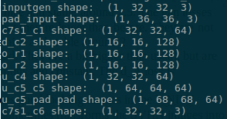

- exp_25
  - Make the discriminator the same size as in the paper

