
5th Serbian International Conference on Applied Artificial Intelligence (SICAAI)
Kragujevac, Serbia, May 20-21, 2026

Hierarchical Feature Fusion for IMPROVED Optical Character Recognition Using CNN-Transformer Architecture with CTC Decoding

Veljko Petković¹[0009-0008-6082-3224]

¹ Faculty of Sciences and Mathematics, University of Niš, Višegradska 33, 18000 Niš, Serbia
e-mail: veljko.petko0022@gmail.com, veljko.petkovic@pmf.edu.rs

Abstract:

Scene text recognition remains a challenging problem in computer vision, particularly under conditions of visual degradation, irregular fonts, and complex backgrounds. In this paper, we propose a Hierarchical Feature Fusion CNN-Transformer (HFF-CNN-Transformer) architecture for optical character recognition (OCR) that improves upon a standard CNN-Transformer baseline by incorporating multi-scale convolutional feature representations. Unlike conventional approaches that pass only the final CNN feature map to the Transformer encoder, the proposed method fuses feature maps extracted from both shallow and deep convolutional layers together with the final CNN output, enabling the model to simultaneously capture fine-grained local patterns and high-level semantic information. Both models are trained using Connectionist Temporal Classification (CTC) loss on a synthetically generated dataset of 100,000 labeled text images, stratified into three augmentation levels: light (20%), moderate (60%), and heavy (20%), designed to simulate varying degrees of real-world visual difficulty. Experimental results demonstrate that the HFF-CNN-Transformer achieves better validation Character Error Rate (CER) of 2.39% at epoch 13 and a test CER of 2.44%, outperforming the baseline CNN-Transformer which reaches a validation CER of 2.60% at epoch 14 and a test CER of 2.62%. The HFF model further achieves a lower test loss of 0.0570 compared to 0.0622 for the baseline, confirming consistent improvement across all evaluation metrics. Total training times were 67.22 minutes and 62.22 minutes respectively, indicating a modest computational overhead introduced by the hierarchical fusion mechanism. These findings highlight the potential of hierarchical feature fusion as a lightweight yet effective enhancement to transformer-based OCR pipelines.

Keywords: Optical Character Recognition, Hierarchical Feature Fusion, Convolutional Neural Networks, Transformer Encoder, Character Error Rate, Deep Learning, Computer Vision

1. Introduction
Optical character recognition (OCR) is a fundamental task in document analysis and image understanding, with applications spanning digitization of printed materials, automated data entry, license plate recognition, and assistive technologies. Despite decades of research, OCR remains a non-trivial problem when faced with variability in fonts, character spacing, image quality, and visual degradation introduced through noise or compression artifacts.
Early OCR systems relied on handcrafted features and rule-based pipelines, which offered limited generalization across diverse text appearances. The advent of deep learning transformed the field significantly, with convolutional neural networks (CNNs) becoming the standard approach for extracting visual features from text images. More recently, Transformer-based architectures, originally proposed for natural language processing, have been successfully adapted for sequence recognition tasks, demonstrating strong performance in capturing long-range dependencies within feature sequences.
A common design in modern OCR systems combines a CNN foundation for feature extraction with a Transformer encoder for sequence modeling, followed by a Connectionist Temporal Classification (CTC) decoder that enables training without requiring explicit character-level segmentation. While this CNN-Transformer-CTC pipeline has proven effective, most existing implementations pass only the final output of the CNN backbone to the Transformer, ignoring potentially useful information encoded in intermediate convolutional layers. Shallow layers capture low-level features such as edges and stroke patterns, while deeper layers encode higher-level structural representations. Ignoring this hierarchical information may limit the model's ability to distinguish visually similar characters or handle low quality inputs.
In this paper, we address this limitation by proposing a Hierarchical Feature Fusion CNN-Transformer (HFF-CNN-Transformer) architecture that explicitly includes feature maps from shallow, deep, and final convolutional layers before passing the fused representation to the Transformer encoder. This multi-scale fusion enables the model to jointly leverage both fine-grained and semantic visual information during sequence modeling.
The main contributions of this work are as follows:
- We propose the HFF-CNN-Transformer, innovative architecture that fuses hierarchical CNN feature maps to enrich the input representation of the Transformer encoder in an OCR procedure.
- We construct and release a synthetically generated training dataset of 100,000 text images with a structured augmentation strategy.
- We conduct a controlled experimental comparison between the baseline CNN-Transformer and the proposed model, demonstrating consistent improvement across all evaluation metrics, with the HFF model achieving a test CER of 2.44% compared to 2.62% for the baseline, equivalent to a relative improvement of 6.87%.
2. Methodology

This section describes the overall methodology of the proposed approach, including the data generation process, dataset preparation, the architecture design and training procedure of the baseline and enhanced models.

2.1 Data Generation and Preparation

The training dataset consists of 100,000 synthetically generated grayscale images, each with a resolution of 288×64 pixels. Text content is generated using two strategies:
- With a probability of 0.8, a random string of characters is sampled from the target alphabet, producing sequences of length between 2 and 12 characters. The target alphabet consists of 63 characters, comprising 26 uppercase Latin letters, 26 lowercase Latin letters, 10 digits, and a space character.
- With a probability of 0.2, one or two real English words are sampled from a vocabulary of 100,000 entries, with the combined length capped at 12 characters. A fixed random seed is applied during generation to ensure reproducibility.
Each image is rendered using one of 14 fonts, selected at random, including typefaces from the DejaVu, Roboto, Arial, Montserrat, and Playfair Display families, among others. Text is drawn in black on a near-white grayscale background, with slight random vertical jitter and variable letter spacing applied during rendering. In 5% of medium and hard difficulty images, a horizontal gradient background is used in place of a uniform fill to introduce additional visual variability. The dataset is stratified into three difficulty tiers that govern the augmentation pipeline applied to each image.
- The easy tier (20% of images) applies minimal augmentation: optional salt-and-pepper noise affecting 10–30 pixels and a small rotation of up to ±1°.
- The medium tier (60% of images) applies a broader set of transformations including noise (50–200 pixels), Gaussian blur, contrast adjustment, gamma correction, brightness variation, and rotation of up to ±2°, with individual augmentations applied stochastically and a maximum of three combined per image.
- The hard tier (20% of images) applies the most aggressive augmentation pipeline, incorporating Gaussian blur, contrast, gamma, brightness, perspective distortion, heavy salt-and-pepper noise (250–350 pixels), and rotation of up to ±3°, again with stochastic application and a cap of four combined augmentations per image.
The full dataset generation process requires approximately 10 minutes on a standard CPU.

2.2 Baseline CNN-Transformer Architecture

The baseline model follows a standard CNN-Transformer-CTC pipeline for sequence recognition. The architecture consists of three main components: a convolutional feature extractor, a Transformer encoder, and a linear classification head.
The CNN structure processes grayscale input images of shape 1×64×288 through four convolutional blocks. The first block applies a 3×3 convolution producing 64 feature maps, followed by batch normalization, ReLU activation, and 2×2 max pooling, halving both spatial dimensions. The second block increases the channel depth to 128 and applies max pooling only along the height axis, preserving the temporal width dimension. The third block consists of two consecutive 3×3 convolutions with 256 channels, again followed by height-only pooling. The fourth block mirrors this structure with 512 channels. A final convolutional layer with a kernel of size 4×1 collapses the remaining height dimension to one, resulting in a feature map of shape 512×1×144. Dropout with a probability of 0.05 is applied after blocks two and three, and 0.1 after the final layer. The resulting feature map is squeezed and transposed to obtain a sequence of 144 feature vectors of dimension 512, which serves as input to the Transformer encoder.
Sinusoidal positional encoding is added to the feature sequence prior to the Transformer encoder to inject temporal order information. The Transformer encoder consists of 6 layers, each with 8 attention heads, a feed-forward hidden dimension of 2048, GELU activation, pre-layer normalization, and a dropout rate of 0.1. A linear classification head projects each position in the output sequence to logits over the full vocabulary of 64 classes (63 characters plus one CTC blank token at index 0). Model CNN-Transformer contains approximately 24.5 million trainable parameters.

2.3 HFF CNN-Transformer Architecture

The proposed Hierarchical Feature Fusion CNN-Transformer extends the baseline architecture by incorporating feature representations from multiple levels of the convolutional structure before passing the fused sequence to the Transformer encoder. The motivation is that the final CNN output, while semantically rich, is neglecting spatial detail encoded in earlier layers. By explicitly retaining and combining shallow, deep, and final feature maps, the model gains access to a broader spectrum of visual information at each sequence position.
The convolutional structure is divided into three named stages. The shallow stage replicates blocks one and two of the baseline, processing the input from 1×64×288 through two convolutional layers to produce a feature map of shape 128×16×144. The deep stage replicates blocks three and four, taking the shallow output and producing a feature map of shape 512×4×144. The collapse stage applies a 4×1 convolution to reduce the remaining height dimension to one, producing the final CNN feature map of shape 512×1×144, identical in shape to the baseline output.
Each of the three feature maps is projected to a common dimensionality of 512 before fusion. The shallow feature map (128×16×144) is first spatially compressed along the height axis using adaptive average pooling, then projected to 512 channels via a 1×1 convolution. The deep feature map (512×4×144) goes through the same height pooling followed by a 1×1 identity projection. The collapsed feature map requires no additional processing. The three resulting tensors, each of shape 512×1×144, are concatenated along the channel dimension to form a 1536-channel representation, which is then projected back to 512 channels through a final 1×1 convolutional fusion layer followed by batch normalization and ReLU activation. This produces a single fused sequence of 144 vectors of dimension 512, which is passed to the Transformer encoder.
An additional component introduced in the HFF model is an adaptive sequence masking mechanism applied at the Transformer encoder input. For each sample in the batch, the energy of each time step is estimated as the mean absolute activation across the feature dimension. Time steps whose energy falls below 5% of the maximum energy for that sample are masked out and excluded from self-attention computation. A minimum of the first 10 positions is always retained to prevent corrupt masking. This mechanism allows the model to focus attention on informative regions of the sequence and ignore padding or low-content columns at the edges of the feature map.
The Transformer encoder, positional encoding scheme, classification head, and all other components are identical to those of the baseline model, ensuring that any performance difference is attributable solely to the hierarchical fusion and adaptive masking mechanisms. The HFF-CNN-Transformer contains approximately 25.6 million trainable parameters.

2.4 Training Procedure

Both models are trained under identical conditions to ensure a fair and reproducible comparison. The dataset is partitioned into three non-overlapping subsets: 80% for training, 10% for validation, and 10% for testing, using a fixed random split.
Both models are optimized using AdamW with a peak learning rate of 7×10⁻⁵ and a weight decay of 10⁻² for L2 regularization. The learning rate schedule consists of a linear warmup phase over the first 3 epochs, during which the learning rate increases to the peak value, followed by cosine decay down to 1% of the peak learning rate over the remaining 12 epochs. Training is conducted for 15 epochs with a batch size of 128 on an NVIDIA L4 GPU. Automatic Mixed Precision (AMP) with float16 is enabled during the training forward and backward pass to reduce memory usage and accelerate computation, with gradient scaling applied to prevent underflow. Validation and test evaluation are performed in full float32 precision. Gradient clipping with a maximum norm of 5.0 is applied at each update step to prevent exploding gradients.
The loss function used for training is Connectionist Temporal Classification (CTC) loss with the blank token assigned to index 0. The zero_infinity flag is enabled to suppress infinite loss values that may arise from numerically unstable alignments, improving training stability.
At the end of each epoch, the model is evaluated on the validation set. The checkpoint corresponding to the lowest validation CER across all epochs is saved and subsequently loaded for final evaluation on the held-out test set.

3. Results

This section presents the experimental results obtained by training and evaluating both models under the conditions described in Section 2.4. Performance is measured using Character Error Rate (CER), computed as the edit distance between the predicted and ground truth character sequences normalized by the ground truth length, and CTC loss evaluated on the held-out test set. Lower values indicate better performance for both metrics.
Table II summarizes the final results for both models. The HFF-CNN-Transformer outperforms the baseline across all reported metrics, achieving a best validation CER of 2.39% at epoch 13 compared to 2.60% at epoch 14 for the baseline. On the test set, the HFF model achieves a CER of 2.44% and a loss of 0.0570, compared to 2.62% and 0.0622 for the baseline CNN-Transformer. The relative improvement in test CER is 6.87%, obtained with identical hyperparameters and training conditions, confirming that the performance gain is attributable solely to the hierarchical feature fusion mechanism and adaptive sequence masking.
Figure 1 illustrates the validation CER progression across all 15 training epochs for both models. The HFF-CNN-Transformer demonstrates lower validation CER from epoch 4 onward, with both models stabilizing in the final epochs as the learning rate approaches its minimum value. The baseline model reaches its best validation performance at epoch 14, suggesting slower convergence, while the HFF model achieves its best result at epoch 13.

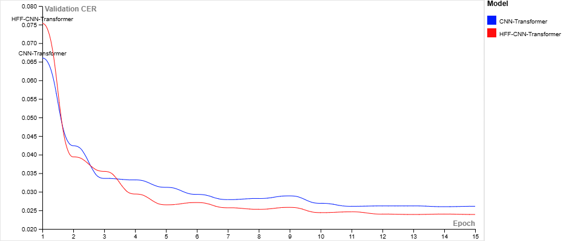
Figure 1. Validation Character Error Rate

Figure 2 presents both models show a rapid decrease in validation loss during the first five epochs, indicating efficient learning in the early stages of training. After epoch 5, both models converge and stabilize, with minor oscillations observed between epoch 8 and 12. In the final epochs, the HFF-CNN-Transformer maintains a consistently lower validation loss, finishing at 0.0570 compared to 0.0622 for the baseline.

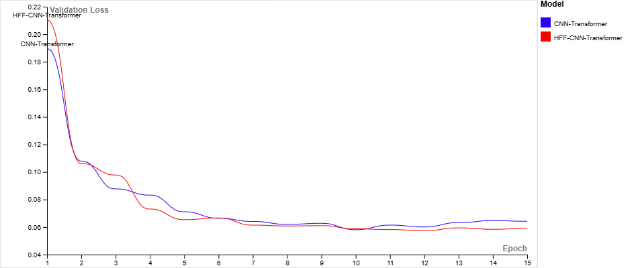
Figure 2. Validation Loss

The additional training time introduced by the HFF model is 5 minutes, representing an additional training time of approximately 8% relative to the baseline. Given the consistent improvement across all evaluation metrics, this additional training time is considered acceptable.

4. Conclusions

In this paper, we proposed the HFF-CNN-Transformer, an architecture that extends the standard CNN-Transformer-CTC pipeline by fusing feature maps from shallow, deep, and final convolutional layers before the Transformer encoder. Experiments on a synthetically generated dataset of 100,000 images demonstrate consistent improvements across all evaluation metrics, reducing the test CER from 2.62% to 2.44%, a relative improvement of 6.87%, with a training time overhead of approximately 8%. These results confirm that intermediate convolutional representations carry complementary information that benefits sequence modeling, and that hierarchical feature fusion is a lightweight yet effective enhancement to transformer-based OCR pipelines. Future work includes evaluation on real-world benchmarks, beam search decoding, and ablation studies to quantify the contribution of each feature scale individually.

References:

- Shi, B., Bai, X., Yao, C., "An End-to-End Trainable Neural Network for Image-based Sequence Recognition and Its Application to Scene Text Recognition," IEEE Transactions on Pattern Analysis and Machine Intelligence, 2017.
- Graves, A., Fernández, S., Gomez, F., Schmidhuber, J., "Connectionist Temporal Classification: Labelling Unsegmented Sequence Data with Recurrent Neural Networks," Proceedings of the 23rd International Conference on Machine Learning (ICML), 2006.
- Atienza, R., "Vision Transformer for Fast and Efficient Scene Text Recognition," Proceedings of the 16th International Conference on Document Analysis and Recognition (ICDAR), 2021.
- Lin, T.-Y., Dollár, P., Girshick, R., He, K., Hariharan, B., Belongie, S., "Feature Pyramid Networks for Object Detection," Proceedings of the IEEE Conference on Computer Vision and Pattern Recognition (CVPR), 2017.
- He, K., Zhang, X., Ren, S., Sun, J., "Deep Residual Learning for Image Recognition," Proceedings of the IEEE Conference on Computer Vision and Pattern Recognition (CVPR), 2016.

