***E-commerce Application on IBM Cloud Foundry***

*\* Our goal is to develop a user-friendly ecommerce application on IBM Cloud Foundry that meets the demands of businesses wanting to sell products and services online.*

*\* This application is efficient order management, scalability,*

*\* The goal is to empower businesses in the digital marketplace by providing a reliable e-commerce solution that ensures a seamless shopping experience while safeguarding customer data.*

***Design Thinking***

***Empathize***

*\* In this phase, we will conduct survey with peoples to get their informations about the existing e-commerce sites. This will help us to build our application more efficiently.Design Thinking.*

***Define***

*\* Identify the key functionalities and features of our application by using the insites were collected from peoples.Design Thinking.*

***Ideate***

*\* Brainstorm possible solutions. Encourage creative thinking and consider various approaches to building the application. Think about how technology, user experience, and business goals can intersect.Design Thinking*

***Prototype***

*\* Create a prototype of our e-commerce application. This could be paper sketches,*

*wireframes, or a basic digital mockup. The goal is to quickly visualize and test your ideas.Design Thinking*

***Test***

*\* Finally test our application. Get the user’s suggestion and redesign the prototype untill it reaches the user satisfication.*

***Development Phases***

*\***In first first phase of we have developed front end for User Interation and designed Database for storing necessarry user’s data. We used HTML, CSS and Javascript for the front end development.*

*\* In the second phasem, we have developed back end for the application with user authentication, cart functionalities and order checkout functionality .We used Laravel for the back end development. Laravel is the php framework.*

***Technical Implementation***

*//Front end code to view products*

@extends('layouts.app')

@section('content')

<div class="container">

<div class="alert alert-success" id="myForm" style="display: none;">

<strong>Success!</strong> added to cart.

</div>

@php

$data = \App\Models\Product::all(); // Replace 'Post' with your model and query as needed

@endphp

<div class="row justify-content-center">

<div class="col-md-8">

<div class="card">

<div class="card-header">{{ __('Choose yours') }}</div>

<section class="shop spad">

<div class="container">

<div class="row">

<div class="col-lg-3">

</div>

<div class="row">

@foreach($data as $item)

<div class="col-lg-4 col-md-6 col-sm-6">

<div class="product__item">

<div class="product__item__pic set-bg" data-setbg="{{ URL::to('img/product/'.$item->imagepath) }}">

</div>

<div class="product__item__text">

<h6>{{ $item->name }}</h6>

<a href="/add-to-cart/{{$item->id}}" class="add-cart" id="showCardButton" onclick="openForm()">+ Add To Cart</a>

<div class="rating">

<i class="fa fa-star-o"></i>

<i class="fa fa-star-o"></i>

<i class="fa fa-star-o"></i>

<i class="fa fa-star-o"></i>

<i class="fa fa-star-o"></i>

</div>

<h5>Rs.{{ $item->price }}</h5>

<div class="product__color__select">

<label for="pc-4">

<input type="radio" id="pc-4">

</label>

<label class="active black" for="pc-5">

<input type="radio" id="pc-5">

</label>

<label class="grey" for="pc-6">

<input type="radio" id="pc-6">

</label>

</div>

</div>

</div>

</div>

@endforeach

</div>

</div>

</div>

<div class="row">

</div>

</div>

</div>

</div>

</div>

</div>

</div>

</div>

<script>

function openForm() {

document.getElementById("myForm").style.display = "block";

}

</script>

</div>

@endsection

*//Front end Code to view Cart and Checkout*

@extends('layouts.app')

@section('content')

<div class="container">

<div class="card-header">{{ __('Your cart') }}</div>

@php

$data = \App\Models\Cart::where('user_id',Auth::user()->id)->get();

$total = DB::table('carts')->sum('product_price');

@endphp

<div class="card-body">

<div class="alert alert-success" id="myForm" style="display: none;">

<strong>Success!</strong> Your order has been placed.

</div>

@foreach($data as $item)

<div class="cart-item">

<h5>{{ $item->product_name }}</h5>

<p>Price: Rs.{{ $item->product_price }}</p>

</div>

@endforeach

<div>

<p>Total: Rs.{{ $total }}</p>

</div>

<a href="/checkout" onclick="openForm()">Proceed to Checkout</a>

<br>

<a href="/home">Continue Shopping</a>

</div>

</div>

</div>

<script>

function openForm() {

document.getElementById("myForm").style.display = "block";

}

</script>

@endsection

*// Back end Code to User’s authentication*

*class RegisterController extends Controller*

{

use RegistersUsers;

@var string

protected $redirectTo = RouteServiceProvider::HOME;

@return void

public function __construct()

{

$this->middleware('guest');

}

@param array $data

@return \Illuminate\Contracts\Validation\Validator

protected function validator(array $data)

{

return Validator::make($data, [

'name' => ['required', 'string', 'max:255'],

'email' => ['required', 'string', 'email', 'max:255', 'unique:users'],

'password' => ['required', 'string', 'min:8', 'confirmed'],

]);

}

@param array $data

@return \App\Models\User

protected function create(array $data)

{

return User::create([

'name' => $data['name'],

'email' => $data['email'],

'mobile' => $data['mobile'],

'address' => $data['address'],

'password' => Hash::make($data['password']),

]);

}

}

*class LoginController extends Controller*

{

use AuthenticatesUsers;’

@var string

protected $redirectTo = RouteServiceProvider::HOME;

@return void

public function __construct()

{

$this->middleware('guest')->except('logout');

}

}

*//Back end code to view carts and checkout*

class UserOrderCartController extends Controller

{

function AddToCart($id) {

$product = Product::find($id);

$user_id = Auth::user()->id;

Cart::create([

'user_id' => $user_id,

'product_id'=> $product->id,

'product_name' => $product->name,

'product_price' => $product->price,

]);

return back();

}

function CheckOut() {

$user_id = Auth::user()->id;

$carts = Cart::where('user_id', Auth::user()->id)->select('user_id', 'product_id', 'product_name', 'product_price')->get();

$array = json_decode($carts, true);

DB::table('orders')->insert($array);

Cart::where('user_id', Auth::user()->id)->delete();

return redirect('/home');

}

}

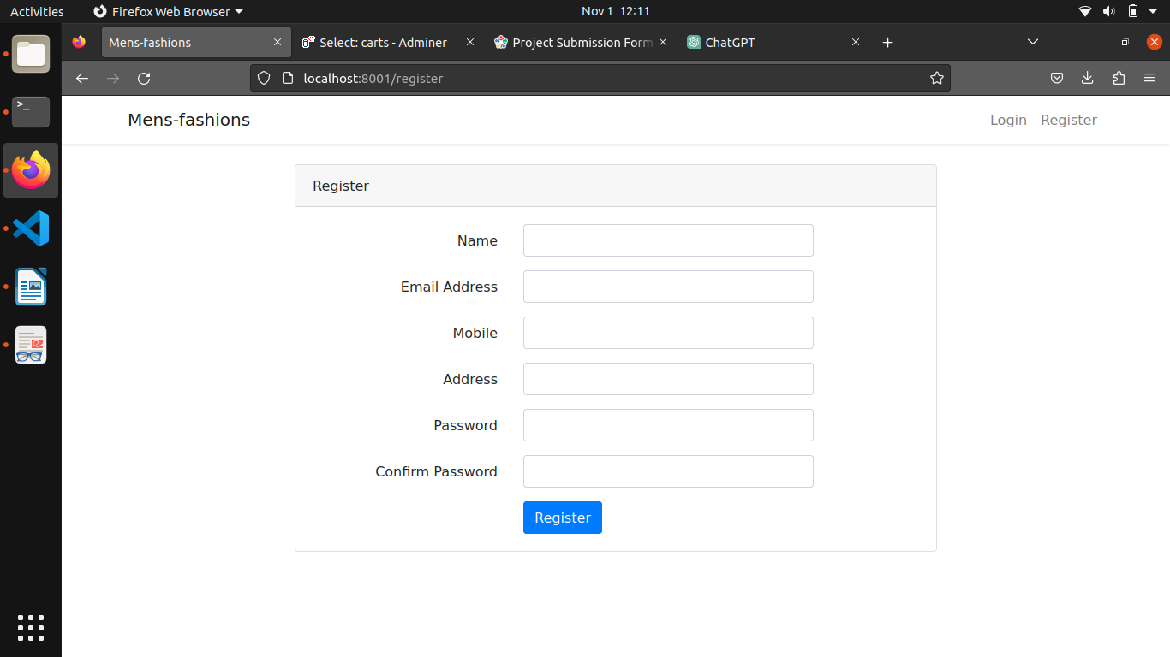*// User registraation page*

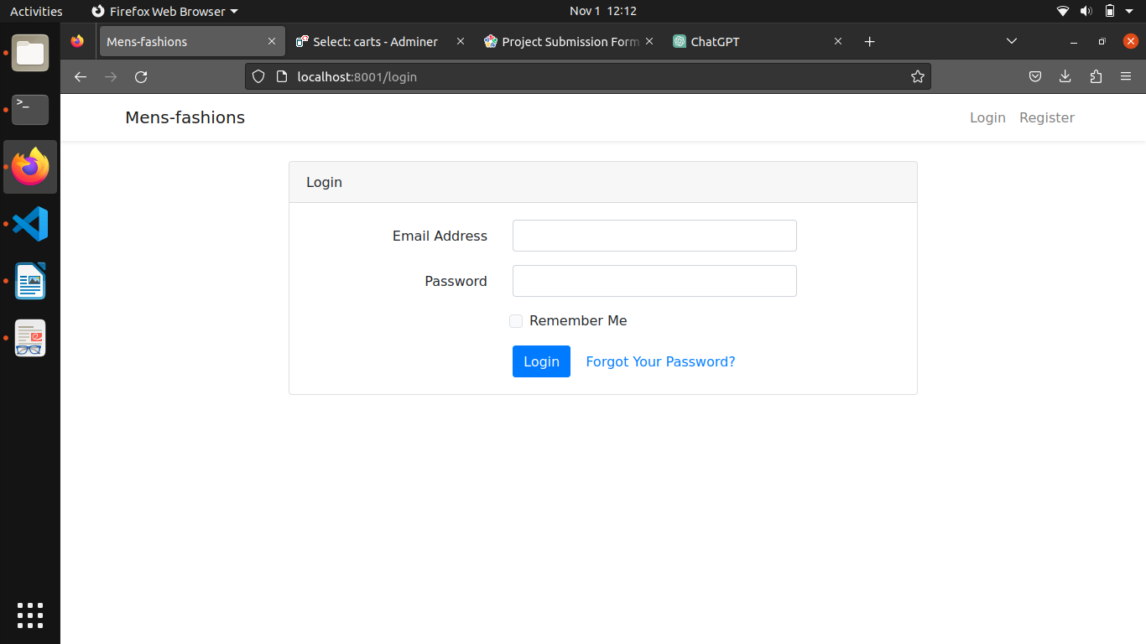*// User login page*

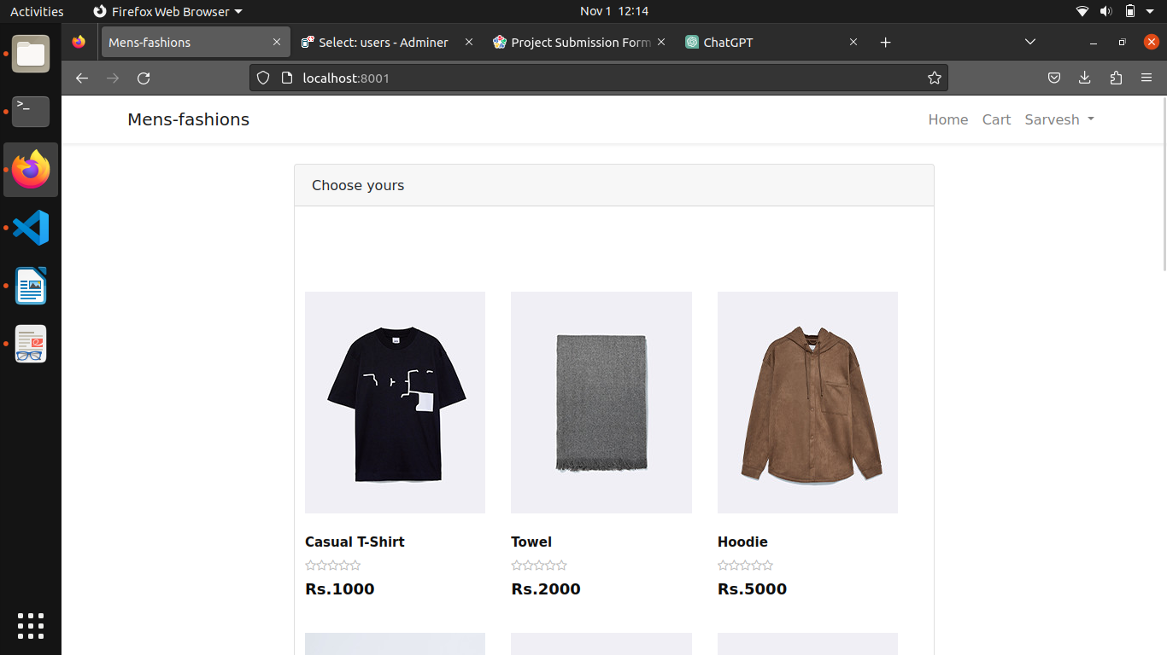*// Home page to view products*

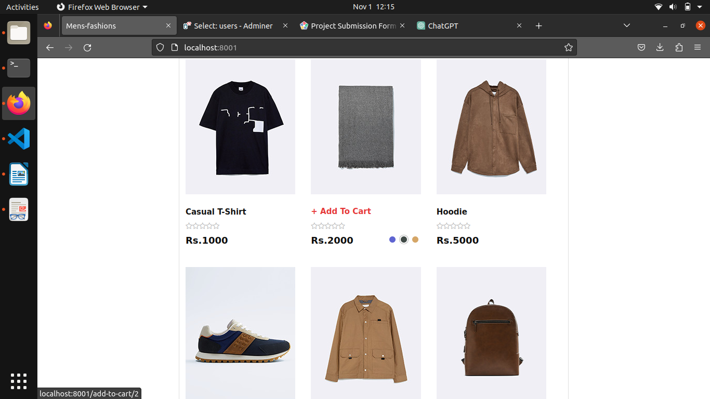*// Home with ‘Add to cart’ functionality*

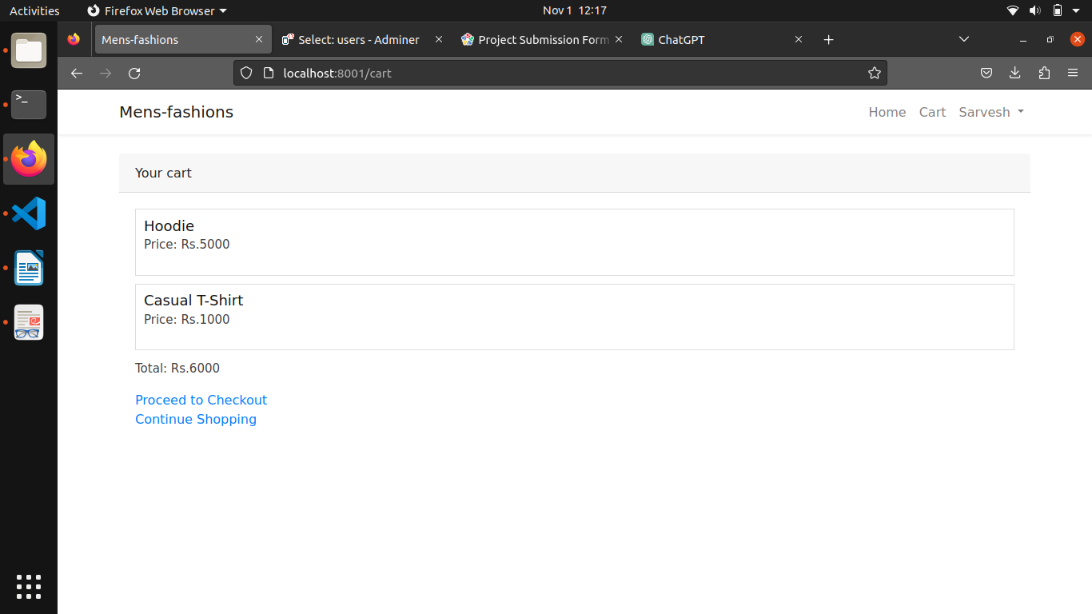*// Cart page*

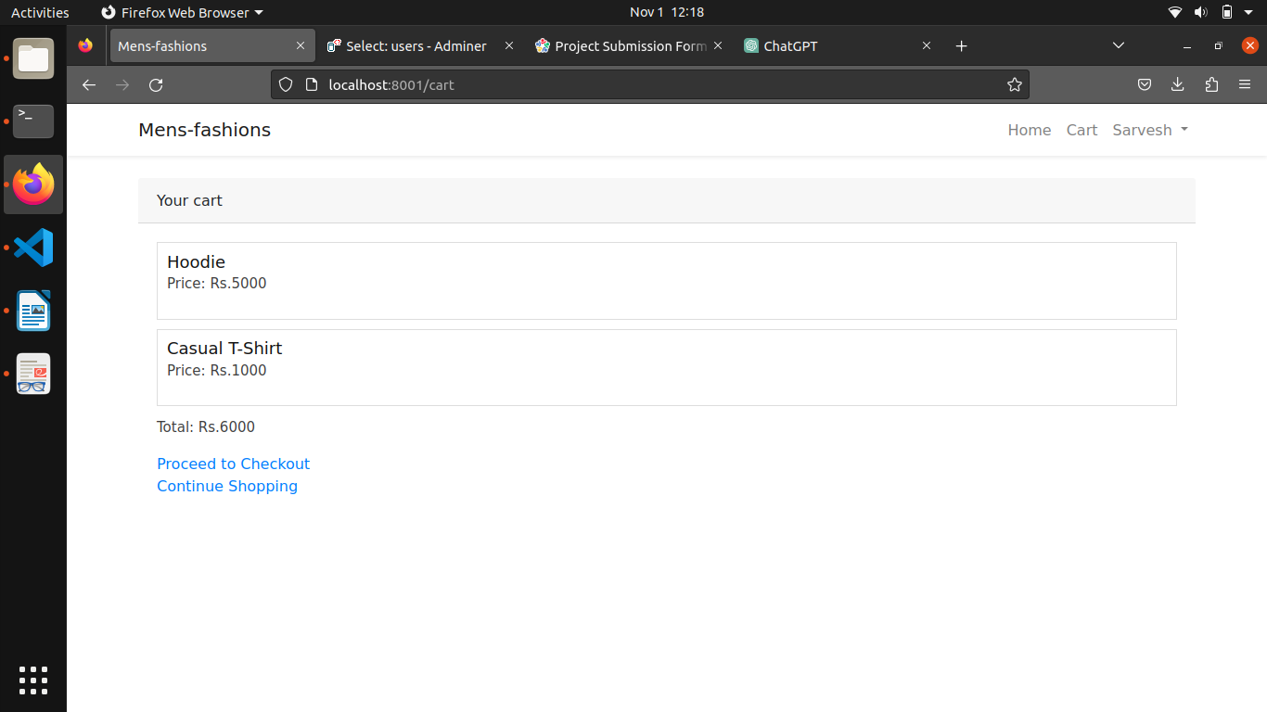*// “Proceed to checkout” button used to place order*