FINWISE
Architecture, Build, AI, Auth, and Deployment Guide
A complete reference for how the Finwise finance tracker was designed, improved, and deployed from scratch.
Prepared for | Vel Kumaran
Project | Finwise: Premium AI Finance Tracker
Scope | Product architecture, implementation journey, environment setup, troubleshooting, and production deployment
Generated on | 30 April 2026, 12:33 AM

This guide documents the real implementation choices used in the live application, including Firebase authentication, Firestore storage, AI proxy architecture, Vercel serverless deployment, and post-launch performance optimization.

Contents
- 1. Product Overview
- 2. Final Feature Set
- 3. Technology Stack
- 4. High-Level Architecture
- 5. Frontend Application Design
- 6. Data Model and Core Calculations
- 7. Authentication System
- 8. AI Insights Platform
- 9. Local Development Workflow
- 10. Production Deployment on Vercel
- 11. Environment Variables and Secrets
- 12. Security and Reliability Decisions
- 13. Performance Optimization and Code Splitting
- 14. Implementation Journey and Major Decisions
- 15. Testing and Validation Checklist
- 16. Troubleshooting Reference
- 17. File and Folder Reference
- 18. Recommended Next Steps

1. Product Overview
Finwise is a premium personal finance tracker built as a React single-page application with Firebase for authentication and transaction storage, plus a backend AI proxy for secure model access. The app evolved from a lighter expense tracker into a broader command center covering income, expenses, investments, insurance, goals, net worth, analytics, AI reasoning, import/export, and account controls.
- The final product is opinionated around practical day-to-day financial management rather than stock-market watching.
- The app is designed to support both manual entry and CSV import, then turn that data into diagnostics, alerts, planning, and AI-assisted explanation.
- The production target is Vercel, with Firebase as the external identity and data backend, and optional AI providers behind serverless endpoints.

2. Final Feature Set
Area | Final capability
Overview Dashboard | Cash position, savings rate, net worth, budget progress, runway, investment rate, goal funding gap, charts, alerts, onboarding setup guidance
Transactions | Income, expense, investment, and insurance types with recurring transaction support
AI Insights | Heuristic analysis, provider-backed insights, ask-anything financial Q&A, anomaly view, savings and investment suggestions
Analytics | Twelve-month trend charts, year-over-year comparisons, average metrics, category trend lines, spending heat map, CSV and PDF export
Goals | Goal templates, progress tracking, monthly pace estimation, status flags, contribution actions
Net Worth | Manual assets, liabilities, liquidity buffer, debt ratio, balance-sheet diagnostics, starter templates
Import | CSV upload, column mapping, preview, validation, staged import
Settings and Account | Theme, budget, notifications, AI provider configuration, email verification, password reset, email change

3. Technology Stack
Layer | Choice | Reason
Frontend | React 19 + Vite 8 | Fast development loop, simple bundling, strong compatibility with modular SPA structure
UI + Visuals | Custom CSS + Recharts | Allowed a tailored product style while still supporting premium charts and dashboards
Authentication | Firebase Auth | Rapid support for email/password, Google sign-in, password reset, email verification, and magic-link sign-in
Data Storage | Cloud Firestore | Simple per-user transaction storage with real-time snapshots
AI Proxy | Node.js server + Vercel serverless functions | Kept provider keys away from the browser and unified multiple model providers
Deployment | Vercel | Straightforward static frontend hosting with `/api` serverless functions and environment variable management

4. High-Level Architecture
The architecture has three major zones: the client app, the backend AI runtime, and the external managed services. Firebase handles identity and transaction storage. The AI runtime handles provider selection and key isolation. The Vercel deployment serves both the frontend bundle and the production API functions.
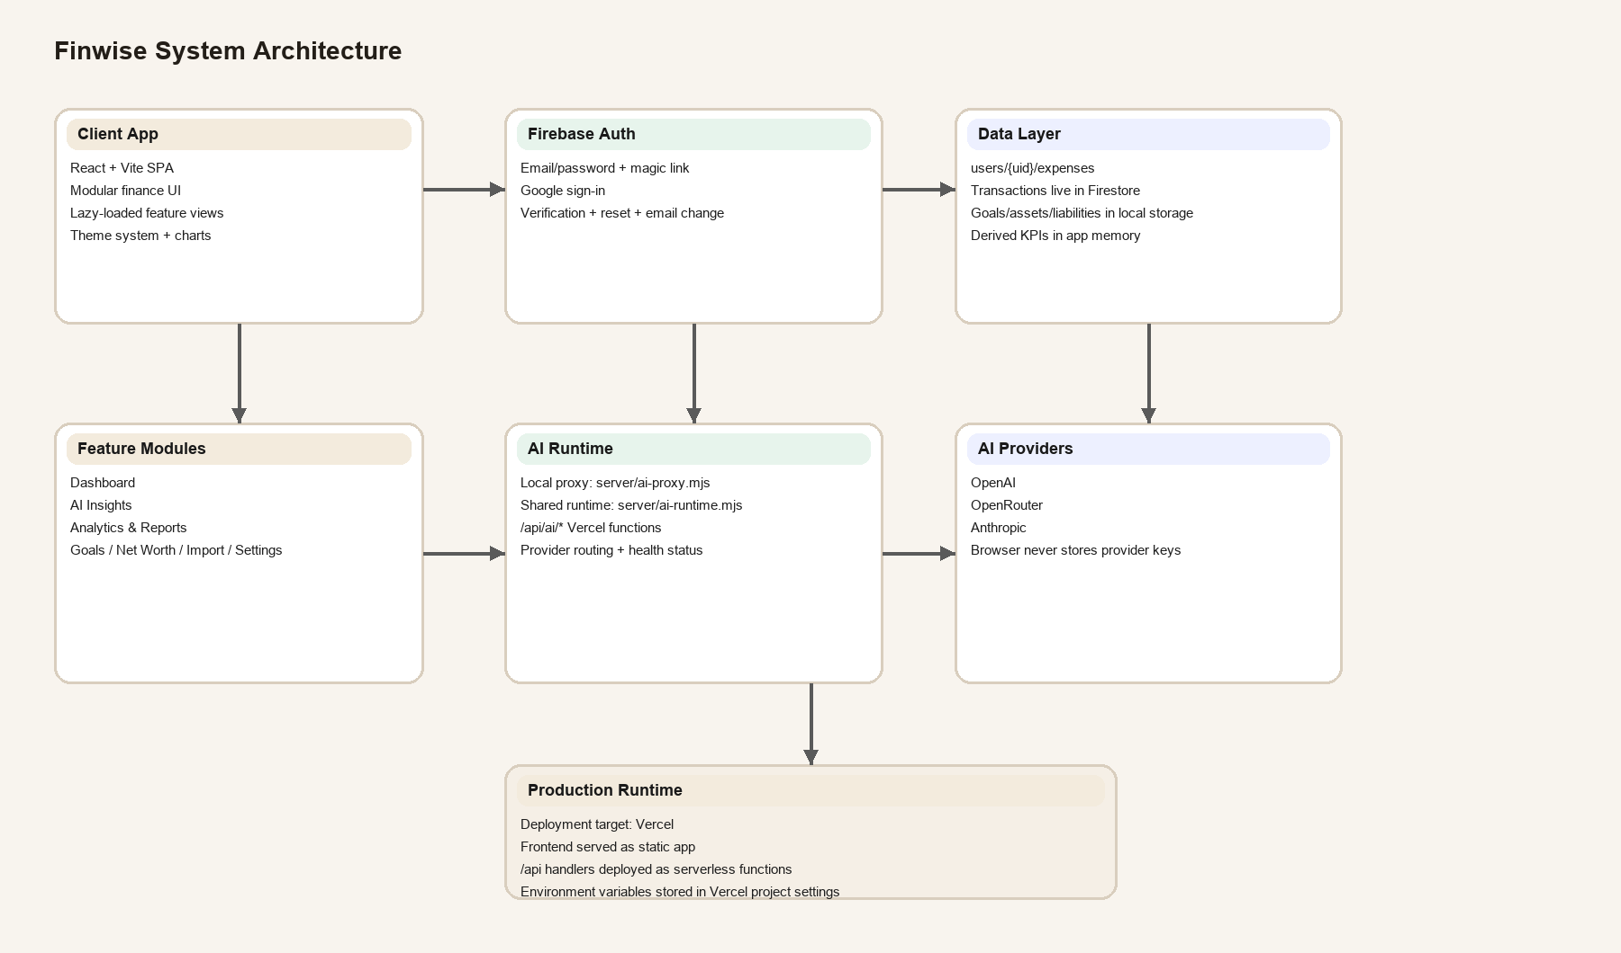
Figure 1. Finwise system architecture

5. Frontend Application Design
The main stateful shell lives in `src/App.jsx`. It owns authentication state, transaction subscription, derived metrics, tab routing, AI request orchestration, budget settings, goals, assets, liabilities, and notification toasts. Feature screens are modular React components loaded on demand through lazy loading and a `Suspense` boundary.
- The app uses one navigation model for desktop sidebar and one for mobile bottom navigation, both driven by the same `activeTab` state.
- Feature modules include Dashboard, AIInsights, AnalyticsReports, GoalsTargets, NetWorthTracker, AddForm, History, ImportPage, and Settings.
- Shared logic lives in `src/lib/utils.js`, `src/lib/constants.js`, and `src/lib/ai.js`.
- The CSS is centralized in `src/styles/appStyles.js`, giving the product a consistent visual system across cards, charts, forms, empty states, and premium onboarding surfaces.

6. Data Model and Core Calculations
Transactions are stored in Firestore under `users/{uid}/expenses`. Each record contains amount, type, category, note, date, recurring, and recurringFrequency. Local storage is used for user-specific non-transaction settings and planning data like goals, assets, liabilities, AI preferences, budget, and notification toggles.
Metric | How it is calculated
Balance | income - expense - investment - insurance for the selected period
Savings Rate | ((income - expense) / income) * 100
Tracked Cash | allTimeIncome - allTimeExpense - allTimeInvestment - allTimeInsurance
Tracked Net Worth | trackedCash + trackedInvestments + manualAssetTotal - liabilityTotal
Recurring Outflow | sum of selected-period recurring non-income transactions
Budget Progress | selected-period expense / budget
Unusual Transaction | expense above 1.8x its category historical average when enough history exists

7. Authentication System
Authentication began as a broader experiment with email/password, Google, Apple, and phone OTP. In practice, the stable and user-friendly production mix became email/password, Google sign-in, and email-link magic-link authentication. Apple sign-in and phone OTP were removed from the experience because they added setup and deliverability complexity without improving reliability for this product.
- Email/password supports account creation and sign-in.
- Google OAuth supports quick sign-in with popup or redirect depending on screen size.
- Email link sign-in acts as a passwordless fallback and is completed with `isSignInWithEmailLink` and `signInWithEmailLink`.
- Settings exposes email verification, password reset, and verified email change via Firebase APIs.
Important implementation note: the app stores the pending email-link address in local storage, sends the link with `sendSignInLinkToEmail`, and on return completes the flow by checking the current URL for a sign-in link. If the saved email is missing, the user is prompted to re-enter the same email address for completion.

8. AI Insights Platform
The AI layer was designed in two tiers. Tier one is a local heuristic analysis engine inside `src/lib/ai.js`, which can always generate structured advice even when no provider key is available. Tier two is the provider-backed AI runtime, which sends structured financial context to OpenAI, OpenRouter, or Anthropic through the backend proxy.
Part | Responsibility
`src/lib/ai.js` | Build heuristic report, ask-answer fallback logic, backend health fetch, API client requests
`server/ai-runtime.mjs` | Load local `.env`, report backend health, build prompts, route provider calls, format JSON responses
`server/ai-proxy.mjs` | Local Node HTTP server for development on port 8787
`api/ai/*.js` | Vercel production handlers for health, insights, and chat query endpoints
The browser never stores provider keys. The frontend only chooses provider and model name. Secret keys live in the proxy environment, both locally and in Vercel.

9. Local Development Workflow
Local development ended up with two execution modes: frontend-only via Vite, and combined app-plus-proxy via a helper script. The combined workflow is preferred because AI routes depend on the local proxy.
Command | Purpose
`npm run dev` | Start the Vite frontend only
`npm run proxy` | Start the local AI proxy at 127.0.0.1:8787
`npm run dev:full` | Start both Vite and the AI proxy together
`npm run build` | Create a production build and validate bundling
The Vite dev server proxies `/api/*` to the local AI proxy, so local AI failures often come down to whether port 8787 is listening. Once that was understood, the stable local workflow became running both services together rather than starting them separately and accidentally losing the proxy.

10. Production Deployment on Vercel
The frontend deploys to Vercel as a static React application. The backend AI runtime deploys to Vercel by placing handlers in the `/api/ai` directory. This is critical: the local Node proxy used in development is not available automatically in production.
- The app frontend is built by Vite and served by Vercel.
- The `/api/ai/health`, `/api/ai/insights`, and `/api/ai/query` routes are deployed as Vercel functions.
- The Vercel project stores runtime secrets as environment variables, then the app is redeployed so the new variables are visible to the functions.
- Production AI failures were solved by converting handlers to Node-style `export default async function handler(req, res)` functions and redeploying.
Deployment also required standard Git hygiene. Secrets accidentally committed to `.env` triggered GitHub push protection. The durable fix was to add `.env` to `.gitignore`, remove it from Git tracking, amend the offending commit, and rotate exposed provider keys.

11. Environment Variables and Secrets
Variable | Used for | Where set
AI_PROXY_HOST | Local proxy host | Local `.env`
AI_PROXY_PORT | Local proxy port | Local `.env`
OPENAI_API_KEY | OpenAI provider access | Local `.env` and Vercel env
OPENAI_MODEL | OpenAI model selection | Local `.env` and Vercel env
OPENROUTER_API_KEY | OpenRouter provider access | Local `.env` and Vercel env
OPENROUTER_MODEL | OpenRouter model selection | Local `.env` and Vercel env
ANTHROPIC_API_KEY | Anthropic provider access | Local `.env` and Vercel env
ANTHROPIC_MODEL | Anthropic model selection | Local `.env` and Vercel env
A useful guardrail was added to backend health reporting: if an OpenAI-style key appears to be stored under `OPENROUTER_API_KEY`, the health payload warns about it. This helped catch a provider mismatch during setup.

12. Security and Reliability Decisions
- Provider keys were moved out of the browser and into backend env vars.
- Email-link auth replaced more fragile phone and Apple experiments for this product context.
- Git tracking of `.env` was removed to satisfy push protection and reduce accidental exposure.
- The app falls back to local heuristics when provider-backed AI is unavailable, so users still receive useful financial guidance.
- The account area includes verification, password reset, and email change to make identity management feel complete rather than bolted on.

13. Performance Optimization and Code Splitting
Once the live app was stable, the next improvement was performance. The app had grown large enough that a single big production bundle was no longer ideal. The final step was to lazy-load feature screens and split vendor chunks by responsibility.
Optimization | Effect
Lazy-loaded tab components | Users only download analytics, AI, goals, import, or net-worth code when those areas are opened
Manual vendor chunking in Vite | React, Firebase, and chart libraries are split into separate chunks
Small tab loading state | Transitions feel intentional while a deferred screen chunk loads
After optimization, the main app shell bundle dropped into a much healthier range, with charting and Firebase each living in their own chunks instead of being paid on first paint.

14. Implementation Journey and Major Decisions
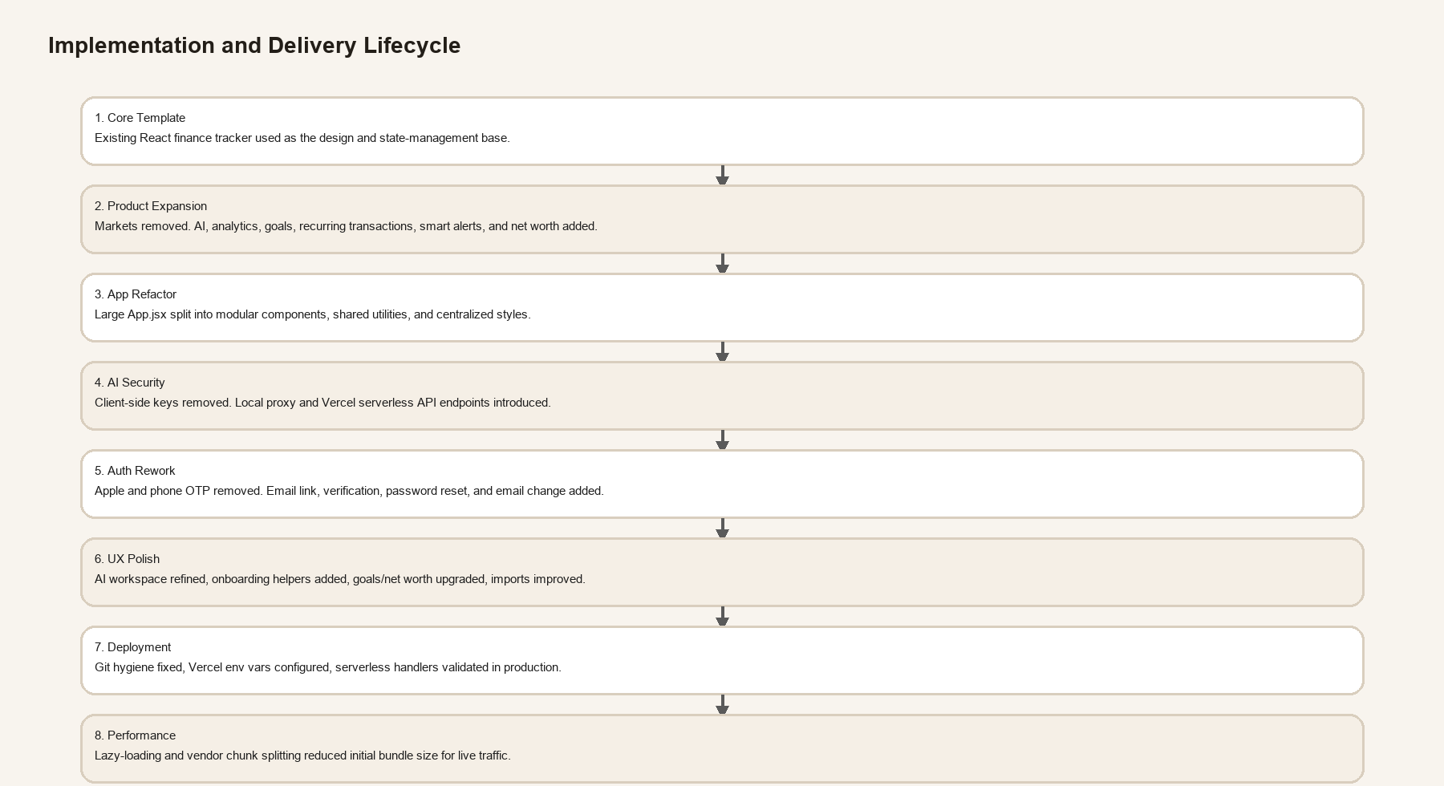
Figure 2. Implementation and delivery lifecycle
The project evolved in layers rather than one rewrite. First the finance surface area expanded. Then the giant root component was split into modular screens. Then AI security moved server-side. Then the auth model was simplified. Finally, the UX and performance passes tightened the product for real-world use.

15. Testing and Validation Checklist
- Build verification with `npm run build` after each meaningful implementation phase
- Health checks against local AI proxy and Vite-proxied `/api/ai/health`
- End-to-end AI query checks against configured providers
- Authentication checks for email/password, Google, magic-link completion, password reset, and verification flows
- Visual refinement of AI layouts, dashboard diagnostics, and settings/account flows
- Production validation on Vercel after env changes and handler updates

16. Troubleshooting Reference
Symptom | Likely cause | Recommended fix
`ECONNREFUSED 127.0.0.1:8787` in local AI requests | Local proxy not running | Use `npm run dev:full` or start `npm run proxy` separately
AI falls back to local reasoning in Vercel | No deployed `/api` runtime, missing env vars, or no redeploy | Ensure `api/ai/*` exists, env vars are set in Vercel, and trigger a new deployment
Magic link shows success but email appears missing | Delivery landed in Promotions or Spam | Check inbox tabs and spam folder, then brand templates later if needed
Phone test numbers work but real OTP fails | Firebase production SMS constraints and billing/setup complexity | Remove or deprioritize phone OTP for this product
GitHub push rejected | Secret detected in commit history | Remove `.env` from tracking, amend commit, rotate keys, push again
OpenRouter or OpenAI requests fail | Wrong key placement, quota problem, or unsupported model | Verify provider key name, billing/quota, and model selection

17. File and Folder Reference
Path | Role
`src/App.jsx` | Stateful app shell, routing by tab, derived metrics, auth orchestration
`src/components/*` | Feature modules: dashboard, AI, analytics, goals, net worth, import, history, settings, login
`src/lib/utils.js` | Formatting helpers, date logic, pie aggregation, storage keys
`src/lib/ai.js` | Heuristic report generation and frontend AI request helpers
`src/styles/appStyles.js` | Global visual system
`src/firebase.js` | Firebase bootstrapping
`server/ai-runtime.mjs` | Shared provider runtime and health logic
`server/ai-proxy.mjs` | Local development AI proxy
`api/ai/*.js` | Production serverless AI handlers for Vercel
`vite.config.js` | Dev proxy rules plus vendor chunk splitting

18. Recommended Next Steps
- Brand the Firebase email templates so inbox trust is stronger and magic-link delivery feels more polished.
- Introduce optional recurring automation or reminders based on budgets and goal pace.
- Add richer onboarding data seeding for first-time users importing from bank statements.
- Track release metrics such as AI usage, import completion rate, and goal creation rate after launch.
- Consider a dedicated backend persistence layer for goals, assets, and settings if cross-device state consistency becomes a higher priority.

Appendix: Deployment Runbook
- 1. Confirm Firebase Authentication methods are enabled: Email/Password, Google, and Email Link.
- 2. Confirm Firestore rules and project configuration are correct.
- 3. Add provider keys in Vercel Project Settings -> Environment Variables.
- 4. Redeploy after env changes.
- 5. Validate `/api/ai/health` in production.
- 6. Test sign-in, AI query, transaction add, import, analytics, goals, and net worth flows.
- 7. Check browser console and Vercel function logs for any last-mile failures.

