HOSPITAL MANAGEMENT SYSTEM
Project Documentation & System Design
Modules: User Management • Patient • Doctor • Appointment • Billing • Pharmacy • Reports • Dashboard
User Roles: Admin • Doctor • Normal User (Patient)
Prepared by: Mahe
Full Stack Developer — Angular & ASP.NET Core

1. Project Overview
The Hospital Management System (HMS) is a web-based application that digitizes the day-to-day operations of a hospital or clinic. It brings patient records, doctor scheduling, appointments, billing, and pharmacy inventory into a single platform, replacing manual registers with a searchable, auditable, role-based system.
The system is designed as a multi-role application with three login types — Admin, Doctor, and Normal User (Patient) — each seeing a dashboard and permissions scoped to their responsibilities.

1.1 Objectives
- Provide a single source of truth for patient demographic and medical visit data.
- Let patients self-register and book appointments with the right doctor and time slot.
- Give doctors a clear daily queue, patient history, and a way to record diagnoses and prescriptions.
- Automate billing from consultations, pharmacy items, and other charges, with clear payment tracking.
- Track pharmacy stock in real time and flag items nearing expiry or reorder level.
- Provide the admin with system-wide visibility through dashboards and operational reports.

1.2 Technology Stack
Layer | Technology
Frontend | Angular 17 (standalone components, reactive forms, route guards, signals)
Backend | ASP.NET Core Web API — Clean Architecture (Domain, Application, Infrastructure, API)
Database | SQL Server with Entity Framework Core (Code First)
Authentication | JWT-based authentication with role claims; BCrypt password hashing
Real-time (optional) | SignalR for live appointment/queue notifications
Reporting | SQL views / stored procedures feeding chart-based dashboards

2. Modules & User Roles

2.1 Modules Overview
Module | Description | Primary Access
User Management | Registration, login, role assignment (Admin / Doctor / Normal User), profile & password management. | Admin
Patient | Patient profile, medical history, blood group, emergency contact, visit history. | Admin, Doctor, Patient
Doctor | Doctor profile, specialization, department, consultation fee, weekly availability. | Admin, Doctor
Appointment | Search doctor, check slot availability, book / reschedule / cancel, status tracking. | Admin, Doctor, Patient
Billing | Generate bills from consultation & pharmacy charges, track payment status, receipts. | Admin, Patient
Pharmacy | Medicine catalog, stock levels, prescription-linked dispensing, expiry & reorder alerts. | Admin, Pharmacist/Doctor
Reports | Appointment volume, revenue, doctor-wise load, pharmacy stock and expiry reports. | Admin
Dashboard | Role-specific landing page with key metrics, quick actions and notifications. | Admin, Doctor, Patient

2.2 Role-based Permissions
Role | Permissions
Admin | Full access: manage users/roles, doctors, departments, view/edit all patients, appointments, billing, pharmacy stock, and all reports.
Doctor | View own appointment queue, patient history for own patients, record diagnosis & prescriptions, update availability, view own performance report.
Normal User (Patient) | Manage own profile, search doctors, book/cancel own appointments, view own prescriptions and bills, make payments.

3. System Architecture
The application follows a layered Clean Architecture on the backend, with an Angular single-page application on the frontend communicating over a REST API secured with JWT.
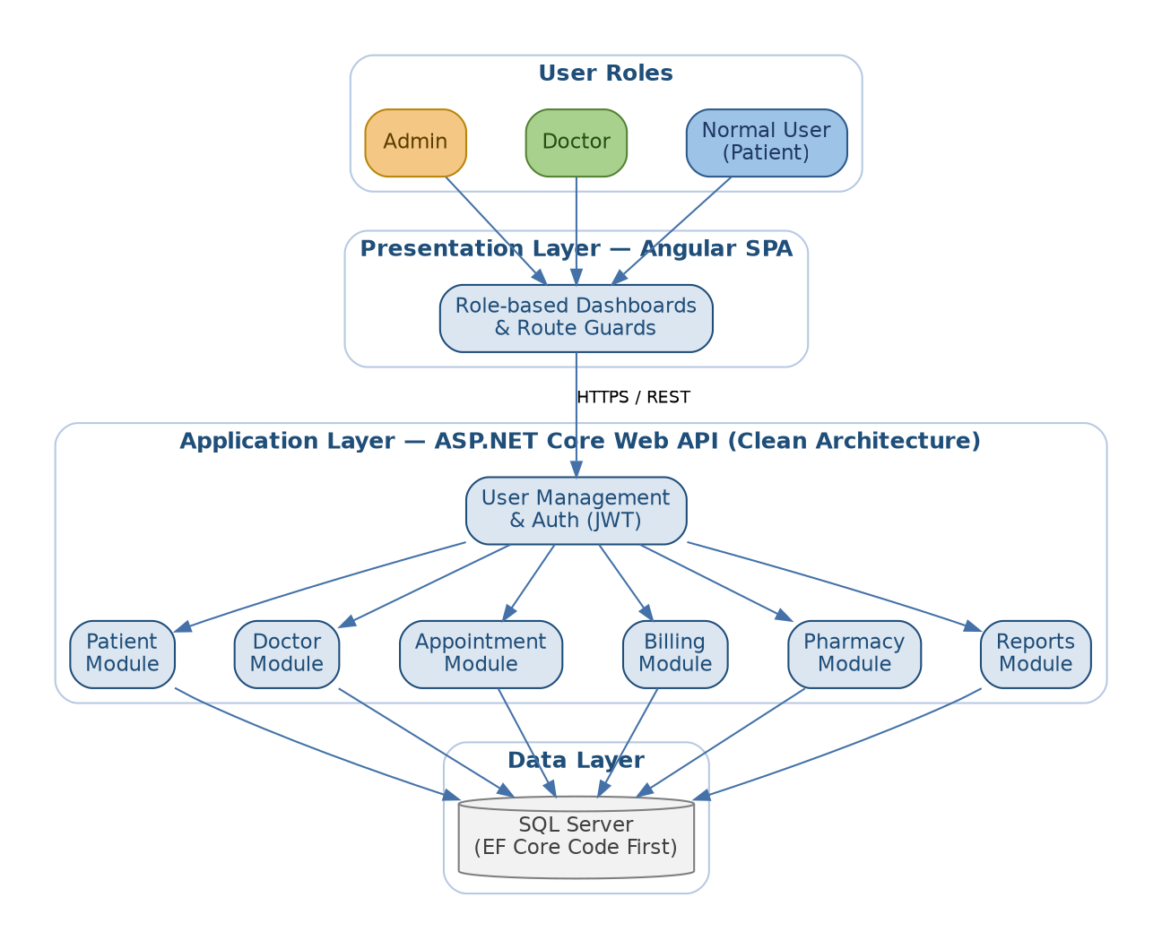
Figure 1: High-level module & layer architecture

4. Process Flow Diagrams

4.1 Login & Role-based Access Flow
A single login screen serves all three roles; after authentication the JWT's role claim decides which dashboard the user is routed to.
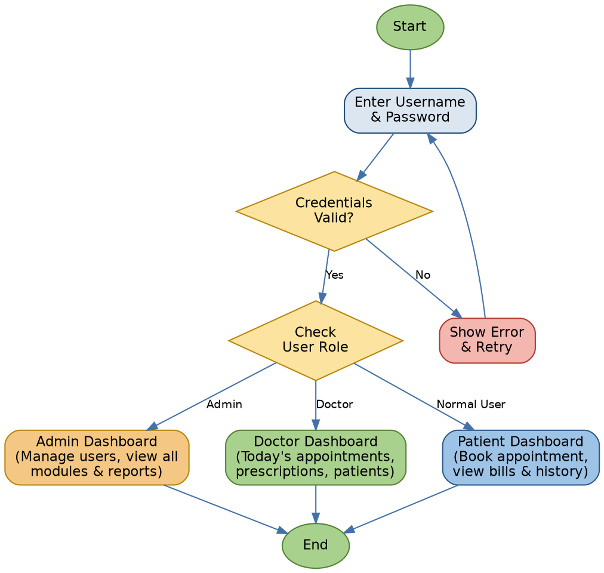
Figure 2: Login and role-based routing flow

4.2 Appointment Booking Flow
Covers a patient registering, searching for a doctor, and booking an available slot.
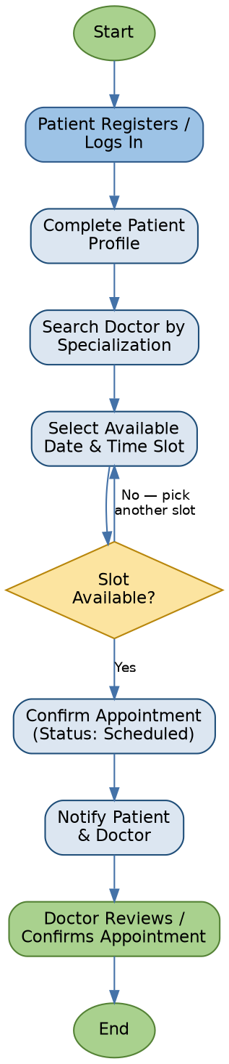
Figure 3: Patient registration & appointment booking flow

4.3 Doctor Consultation & Prescription Flow
Covers the doctor's side of an appointment, from reviewing the queue to closing the visit.
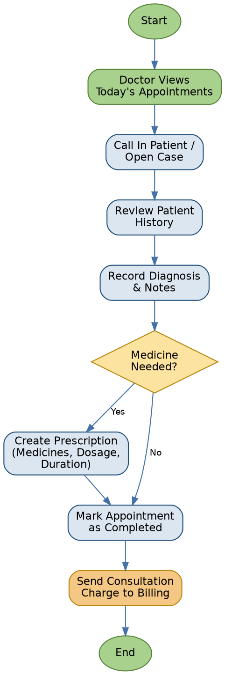
Figure 4: Doctor consultation & prescription flow

4.4 Billing & Payment Flow
Consultation and pharmacy charges roll up into a single bill per visit, with optional insurance handling before patient payment.
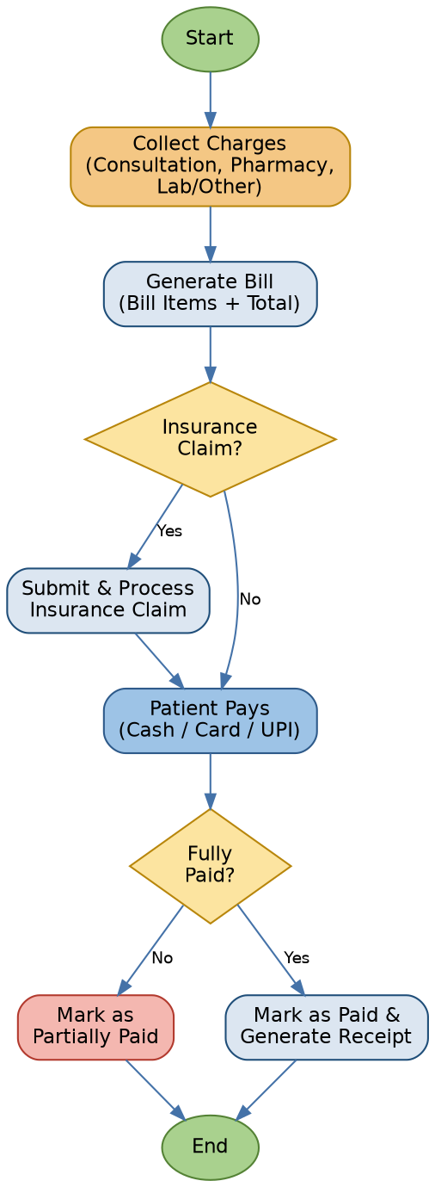
Figure 5: Billing and payment flow

4.5 Pharmacy Dispensing Flow
Triggered by a prescription; checks stock, dispenses, and pushes the item cost to the patient's bill.
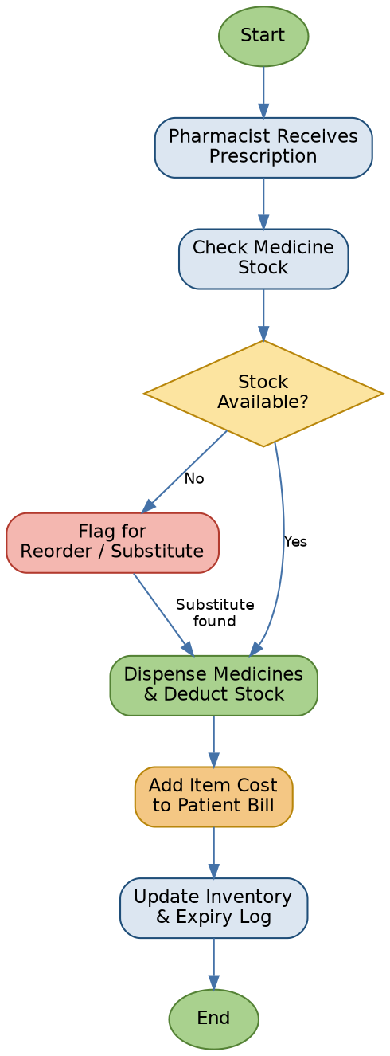
Figure 6: Pharmacy dispensing flow

5. Database Design
The schema is normalized around Users (with a Role), with Patients and Doctors as 1:1 extensions of a User. Appointments link a Patient and a Doctor, and fan out into Prescriptions and Bills.
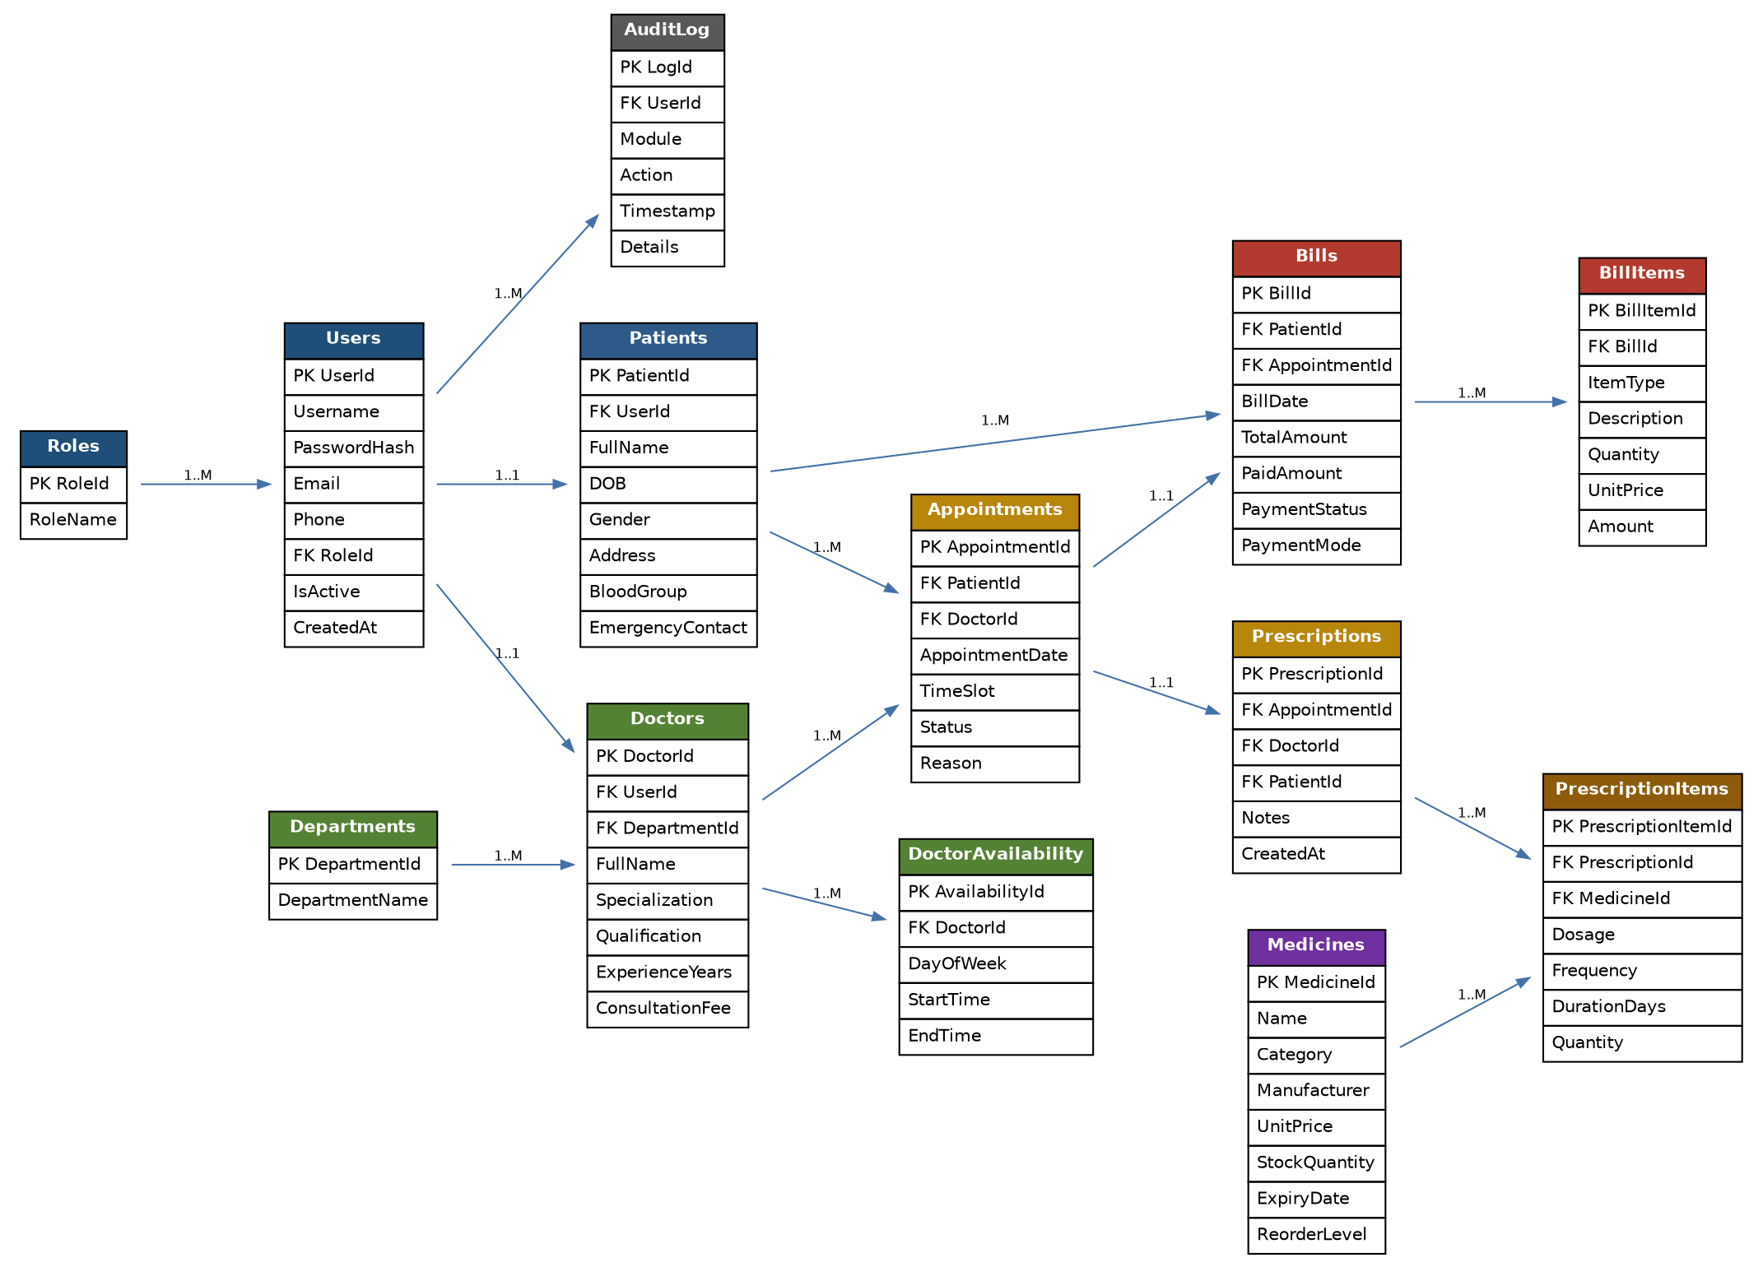
Figure 7: Entity-Relationship diagram

6. Database Tables

6.1 Roles
Lookup table for the three login types.
Column | Data Type | Constraints | Description
RoleId | int | PK, Identity | Unique role identifier
RoleName | nvarchar(30) | Not Null, Unique | Admin / Doctor / Patient

6.2 Users
Central authentication table for every login (User Management module).
Column | Data Type | Constraints | Description
UserId | int | PK, Identity | Unique user identifier
Username | nvarchar(50) | Not Null, Unique | Login username
PasswordHash | nvarchar(256) | Not Null | BCrypt-hashed password
Email | nvarchar(100) | Not Null, Unique | Contact email
Phone | nvarchar(15) | Null | Contact phone number
RoleId | int | FK → Roles.RoleId | Assigned role
IsActive | bit | Not Null, Default 1 | Account enabled/disabled
CreatedAt | datetime2 | Not Null, Default now | Account creation timestamp

6.3 Patients
Extends a Patient-role User with demographic and medical-contact details.
Column | Data Type | Constraints | Description
PatientId | int | PK, Identity | Unique patient identifier
UserId | int | FK → Users.UserId, Unique | Linked login account
FullName | nvarchar(100) | Not Null | Patient's full name
DOB | date | Not Null | Date of birth
Gender | nvarchar(10) | Not Null | Male / Female / Other
Address | nvarchar(250) | Null | Residential address
BloodGroup | nvarchar(5) | Null | e.g. O+, AB-
EmergencyContactName | nvarchar(100) | Null | Emergency contact person
EmergencyContactPhone | nvarchar(15) | Null | Emergency contact number
CreatedAt | datetime2 | Not Null, Default now | Profile creation timestamp

6.4 Departments
Hospital departments used to group doctors (supports the Doctor module).
Column | Data Type | Constraints | Description
DepartmentId | int | PK, Identity | Unique department identifier
DepartmentName | nvarchar(100) | Not Null, Unique | e.g. Cardiology, Orthopedics

6.5 Doctors
Extends a Doctor-role User with professional details.
Column | Data Type | Constraints | Description
DoctorId | int | PK, Identity | Unique doctor identifier
UserId | int | FK → Users.UserId, Unique | Linked login account
DepartmentId | int | FK → Departments.DepartmentId | Department the doctor belongs to
FullName | nvarchar(100) | Not Null | Doctor's full name
Specialization | nvarchar(100) | Not Null | e.g. Cardiologist
Qualification | nvarchar(100) | Null | e.g. MBBS, MD
ExperienceYears | int | Null | Years of practice
ConsultationFee | decimal(10,2) | Not Null | Standard consultation charge

6.6 DoctorAvailability
Weekly recurring time windows a doctor is bookable in (feeds Appointment slot search).
Column | Data Type | Constraints | Description
AvailabilityId | int | PK, Identity | Unique availability row identifier
DoctorId | int | FK → Doctors.DoctorId | Doctor this slot belongs to
DayOfWeek | nvarchar(10) | Not Null | Monday .. Sunday
StartTime | time | Not Null | Availability start time
EndTime | time | Not Null | Availability end time

6.7 Appointments
Core booking record linking a Patient and a Doctor.
Column | Data Type | Constraints | Description
AppointmentId | int | PK, Identity | Unique appointment identifier
PatientId | int | FK → Patients.PatientId | Patient who booked
DoctorId | int | FK → Doctors.DoctorId | Doctor booked with
AppointmentDate | date | Not Null | Scheduled date
TimeSlot | nvarchar(20) | Not Null | e.g. 10:30 AM – 10:45 AM
Status | nvarchar(20) | Not Null, Default 'Scheduled' | Scheduled / Completed / Cancelled / No-show
Reason | nvarchar(250) | Null | Patient-provided reason for visit
CreatedAt | datetime2 | Not Null, Default now | Booking timestamp

6.8 Prescriptions
One per appointment where the doctor prescribes medicine.
Column | Data Type | Constraints | Description
PrescriptionId | int | PK, Identity | Unique prescription identifier
AppointmentId | int | FK → Appointments.AppointmentId, Unique | Related appointment
DoctorId | int | FK → Doctors.DoctorId | Prescribing doctor
PatientId | int | FK → Patients.PatientId | Patient prescribed to
Notes | nvarchar(500) | Null | Diagnosis / doctor's notes
CreatedAt | datetime2 | Not Null, Default now | Prescription timestamp

6.9 PrescriptionItems
Individual medicines within a prescription (feeds Pharmacy dispensing).
Column | Data Type | Constraints | Description
PrescriptionItemId | int | PK, Identity | Unique line item identifier
PrescriptionId | int | FK → Prescriptions.PrescriptionId | Parent prescription
MedicineId | int | FK → Medicines.MedicineId | Medicine prescribed
Dosage | nvarchar(50) | Not Null | e.g. 500mg
Frequency | nvarchar(50) | Not Null | e.g. Twice daily
DurationDays | int | Not Null | Number of days to take
Quantity | int | Not Null | Total units to dispense

6.10 Medicines
Pharmacy catalog and stock ledger.
Column | Data Type | Constraints | Description
MedicineId | int | PK, Identity | Unique medicine identifier
Name | nvarchar(100) | Not Null | Medicine name
Category | nvarchar(50) | Null | e.g. Antibiotic, Painkiller
Manufacturer | nvarchar(100) | Null | Manufacturer name
UnitPrice | decimal(10,2) | Not Null | Price per unit
StockQuantity | int | Not Null, Default 0 | Current stock on hand
ExpiryDate | date | Not Null | Batch expiry date
ReorderLevel | int | Not Null, Default 10 | Threshold to trigger reorder alert

6.11 Bills
One per appointment; rolls up consultation and pharmacy charges (Billing module).
Column | Data Type | Constraints | Description
BillId | int | PK, Identity | Unique bill identifier
PatientId | int | FK → Patients.PatientId | Billed patient
AppointmentId | int | FK → Appointments.AppointmentId, Unique | Related appointment
BillDate | datetime2 | Not Null, Default now | Date bill was generated
TotalAmount | decimal(10,2) | Not Null | Sum of all bill items
PaidAmount | decimal(10,2) | Not Null, Default 0 | Amount paid so far
PaymentStatus | nvarchar(20) | Not Null, Default 'Pending' | Pending / Partially Paid / Paid
PaymentMode | nvarchar(20) | Null | Cash / Card / UPI / Insurance

6.12 BillItems
Individual charge lines making up a Bill.
Column | Data Type | Constraints | Description
BillItemId | int | PK, Identity | Unique line item identifier
BillId | int | FK → Bills.BillId | Parent bill
ItemType | nvarchar(30) | Not Null | Consultation / Medicine / Lab / Other
Description | nvarchar(200) | Not Null | Line item description
Quantity | int | Not Null, Default 1 | Quantity billed
UnitPrice | decimal(10,2) | Not Null | Price per unit
Amount | decimal(10,2) | Not Null | Quantity × UnitPrice

6.13 AuditLog
System-wide activity log feeding the Reports module and supporting traceability.
Column | Data Type | Constraints | Description
LogId | bigint | PK, Identity | Unique log entry identifier
UserId | int | FK → Users.UserId | User who performed the action
Module | nvarchar(30) | Not Null | Module the action occurred in
Action | nvarchar(100) | Not Null | e.g. Created Appointment, Updated Stock
Timestamp | datetime2 | Not Null, Default now | When the action occurred
Details | nvarchar(500) | Null | Additional context / changed values

7. Reports & Dashboard

7.1 Reports Module
- Appointment report: daily/monthly volume, by doctor, by status (completed/cancelled/no-show).
- Revenue report: billing collections by date range, payment mode, and department.
- Doctor workload report: appointments per doctor, average consultation time.
- Pharmacy report: current stock levels, items below reorder level, items nearing expiry.
- Patient visit history report: full timeline of a patient's appointments, prescriptions, and bills.

7.2 Dashboard (per role)
Role | Key Widgets
Admin | Total patients, doctors, today's appointments, revenue this month, low-stock medicine alerts.
Doctor | Today's appointment queue, pending prescriptions, weekly patient count.
Normal User (Patient) | Upcoming appointment, last prescription, outstanding bill amount, quick "Book Appointment" action.

8. Conclusion
This document lays out the module structure, role-based access model, process flows, and normalized database schema for the Hospital Management System. It is intended as both a design reference during development and supporting material for project presentations or interview discussions.

