FAKE NEWS DETECTION:-

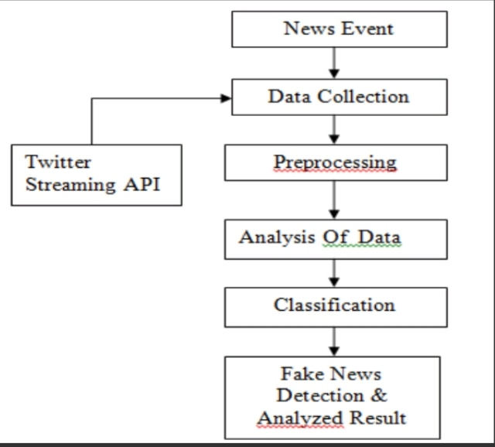

1.News Event:-

This is the event or incident that you want to gather information about. It could be a current news story, a trending topic, or any event of interest. ultimate goal in fake news detection within a news event is to ensure that accurate and trustworthy information is promoted while identifying and addressing the spread of false or misleading content. It’s an important aspect of combating the dissemination of misinformation and maintaining the integrity of news reporting.

2.Data Collection:-

In this step, you gather data related to the news event. This data can come from various sources such as social media, news websites, or databases. The goal is to accumulate relevant information about the event.

3.Twitter Streaming API:-

The Twitter Streaming API is a service provided by Twitter that allows you to access real-time tweets on specific topics or keywords. It's commonly used to collect data from Twitter related to a news event. Twitter Streaming API is a valuable tool for monitoring and analysing discussions on social media platforms like Twitter, which are often sources of news and information. When used in conjunction with pre-processing, analysis, and classification techniques, it aids in the detection of fake news, helping to maintain the integrity of news reporting and public awareness.

4.Preprocessing:-

Before analysis, the collected data needs to be cleaned and prepared. This includes tasks like removing irrelevant information, handling duplicates, and converting data into a suitable format for analysis.

5. Analysis of Data:-

Once the data is pre-processed, you can perform various analyses. This can include quantitative analysis (e.g., counting the number of tweets or sentiment analysis) and qualitative analysis (e.g., identifying key themes or trends in the data).Analysing data in fake news detection is a multi-faceted process that combines text analysis, sentiment analysis, machine learning, and domain expertise to distinguish between trustworthy and potentially deceptive information.

6. Classification:-

This step involves categorizing the data. For example, you might classify tweets as "relevant" or "irrelevant" to the news event. Machine learning techniques can be used for this purpose Classification in fake news detection is a critical step in differentiating between genuine and potentially deceptive information within the Twitter data stream. It allows for timely intervention to prevent the spread of false news and misinformation.

7.Fake News Detection & Analyzed Result:-

Fake news detection involves identifying and flagging misleading or false information related to the news event. This can be done using natural language processing and machine learning algorithms. The analysed result will show which information is trustworthy and which is potentially false.

**Conclusion**:-

In this process outlines how to collect and analyse data from social media (in this case, Twitter) related to a news event, classify it, and then identify fake news within the collected information. It's an essential process for staying informed and ensuring the credibility of the information you receive during important events.

TEAM LEADER:

*M.VASANTH:vasanthmoses12@gmail.com

TEAM MEMBERS:

*K.SETHUAKASH:Sethuakash941@gmail.com

*R.SUBASH:subashmenaka123@gmail.com

*M.VEL MURUGAN:vm4333333@gmail.com

*K.NAVEEN: Kumarnaveen72562@gmail.com