Documentation for the Creation of Custom Anatomical Models
High Level Design
Robin Hu (Oct. 1, 2007)
Contents
Section 1
1. Problem statement
2. How is a custom model handled?
3. Special user interface classes
4. How to find class information
Section 2
- How the C++ files are created
- Scanning and parsing
- Creating C++ classes
Section 3
- What we are doing now
- Graphing Library
- Current issues/Stuff to do

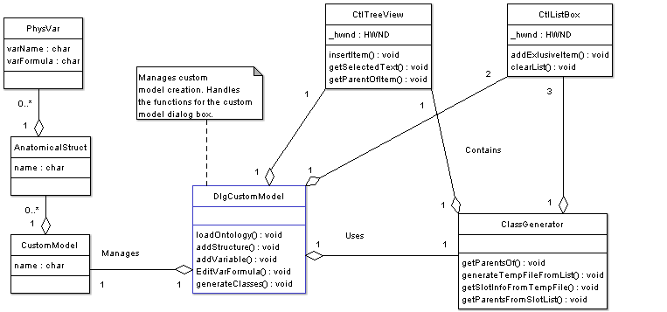
(Figure 1: A UML diagram describing the relationships between classes involved in custom model creation.)
1.1
Problem
Find a way to allow the user to create a custom model in our program. The user’s model should have anatomical structures and physiological variables. The user should be able to select an anatomical structure from a list. The program can determine the selected anatomical structure’s parents and slot information. The program should also be able to generate the required C++ program files based on what the user selected.
1.2
How is a custom model handled?
The class called DlgCustomModel manages custom model creation through a user interface. The user interface has tools allowing the user to add/remove anatomical structures, add/remove physiological variables and edit physiological variable formulas. Those are managed through special methods in DlgCustomModel.
The custom model that the user creates is stored in memory. A classed called CustomModel stores this data. Each instance of CustomModel has a list of AnatomicalStruct objects. Each AnatomicalStruct instance has a list of PhysVar objects. Lists are handled using the ListContainer class.
DlgCustomModel has a method called loadOntology(). This method looks at something called a Protégé Ontology File and loads the data from that file into the tree list. The Protégé Ontology File only contains class/parent relationships; no slot information. Note that the Protégé Ontology File is used no where else.
1.3
Special User Interface Classes
There are two special classes that help manage the user interface: CtlListBox and CtlTreeView. You would use these classes if you wanted to handle list boxes and tree lists (the classes hide the underlying Win32 function calls). For example, CtlListBox has methods that allow the programmer to insert and remove items from a list box. These two classes are used by DlgCustomModel.
1.4
How to Find Class Information
So the user selected an anatomical structure from the tree list. How does the program figure out its super-classes? What about its slots? The programmer would use the ClassGenerator class. ClassGenerator has a method that allows the programmer to find all the superclasses of a certain class. In order for that to work, the tree list window handle must be passed into the ClassGenerator instance. That’s because ClassGenerator actually uses the tree list to find information about superclasses. The superclasses are all inserted into a list box. In that sense, ClassGenerator actually uses Win32 windows to process data!
Suppose you now have a list box filled with class names (like all the superclasses of the anatomical structure “Lung”). You need to figure out all the aggregations and slot information for these classes. That information is stored in a Protégé Instance File. This file is so big, I had to break it up into about 30 smaller files. The classes in this file are stored alphabetically.
What I do when I need information about a certain class is, traverse the Protégé Instance File until I find the class I am looking for. I then copy the class information over to a temporary file (called tempClasses.dat). I do this for every single class I need. The temporary file can have dozens upon dozens of different classes.
When I am done creating the temporary file, I can call a method from ClassBuilder to process the data in the temporary file. ClassBuilder can then generate the actual C++ files using a combination of parsing routines.
2.1
How the C++ Files (.h and .cpp) are created
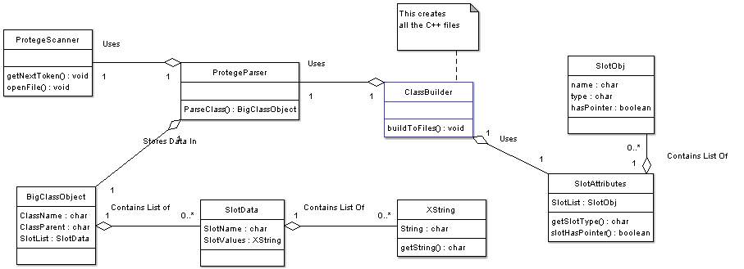
(Figure 2: A UML diagram showing relationships between classes used in C++ file creation.)
To create the required C++ files for the project, the ClassBuilder class must be used. ClassBuilder contains a method called buildToFiles() that takes a Protégé Instance file as an argument. It creates the C++ files based on what’s contained in the Protégé Instance File. To aid in the process, ClassBuilder uses two other classes: SlotAttributes and ProtegeParser.

2.2
Scanning and Parsing
The scanner (class ProtegeScanner) is the lowest level of the C++ file generation process. The scanner looks at a raw Protégé Instance File and breaks it up into tokens. A token is usually a single word or a parenthesis. To retrieve the next token, you call the method getNextToken(). To turn the scanned tokens into useful data, you need to use the parser.
ProtegeParser is a class that looks at scanned tokens and turns it into something meaningful. The parser organizes the data and places it into an instance of BigClassObject (sorry, I could not think of a better name).
Here is one way you can visualize BigClassObject:
BigClassObject
className, FMAID
classParent
Slot1 → Slot2 → Slot3 …
Note that each slot can have multiple values, which is stored in an instance of SlotData. Xstring is simply a container class to hold a single character string.
Each instance of BigClassObject can hold only enough information for a single anatomical structure. Once an instance of BigClassObject is filled with data, it can be passed onto the ClassBuilder which will interpret the data.
2.3
Creating C++ Classes
Once you have an instance of BigClassObject, you have enough information to create the header and source files for that anatomical structure. There is some extra information needed to properly create the C++ files. That extra information can be found in the class SlotAttributes. It basically tells you if a slot should be a character string or if it needs a pointer.
ClassBuilder has methods that write the class header file (.h) with the proper macros, inheritance, public and private attributes, and methods. There are methods that will write the constructor and function implementations.
Of course, the programmer doesn’t need to worry about all these details. You only need to call one method, buildToFiles() in order to create all the necessary C++ files. You also need to specify the location of the temporary Protégé Instance file.

3.1
Update 4-14-08. READ THIS.
The program no longer generates C++ files. The functions to make the C++ files are still in place, but they are not used.
I used my program to create the files located in the directory called “classheader”. Those are the header files you need to include if you want to generate an instance of an anatomical structure. In other words, if you want to create an instance of “Anatomical_entity()”, include “anatomical_entity.h”.
There is a brand new class that handles creation of such instances. It’s called, InstanceCreator. In particular, it has a method called makeInstance().
Here is what makeInstance() does, step by step:
- The user selects a structure S, which is passed into makeInstance(S).
- Call cgen.generateTempFileSingle(S, “path.txt”), which will copy information about S into path.txt. The information about S is stored in files located in the directory called “classdefs”.
- Call parser.parseProtegeFile() to parse the file “path.txt”. This will return BigClassObject B containing all the parsed info about S, stuff like name, parent, and ID.
- Get the first slot from B. Let’s call it slot1.
- Get the first slot VALUE of slot1. We are now in the inner while loop. Call it slotValue1.
- Call cgen.getFMAIDof(slotValue1). This will return the FMAID of slotValue1. Save this value in B.
- Repeat step 5 and 6 until there are no more slot values left for slot1.
- Go back to step 4 and get the next slot in the list. Repeat until there are no more slots.
- B should now have more information stored in it. All slots of S, the values of each slot, and the FMAID of each value.
- Create a new instance of Anatomical_entity(), AE.
- Pass B into AE, by calling AE->setAttributes(B).
- Now you have an anatomical entity with all its attributes set. Do what you want with that.
Classes used in InstanceCreator:
ClassGenerator (to manipulate Protégé files)
ProtegeParser (to parse Protégé files)
SlotAttributes (to determine the type of a slot)
BigClassObject (to store data about a structure)
SlotData (to store data about a slot, like it’s name and values)
XString (to store data about a slot value, like it’s name and ID)
Anatomical_entity (the object we want to create)

  - Graphing Library
The library I am using to graph things is called Chart Director and its website is www.advsofteng.com. To use it you need to include a few things:
- The headers in the folder “graph/include”. If you want to use the graphing capabilities, include the header “chartdir.h” in every piece of code.
- Place the file chartdir41.dll in the Debug directory where the .exe file is.
- In the project goto: Project Properties -> Linker -> Additional Dependencies. Add the path to the file chartdir41.lib. I placed chartdir41.lib in the “graph” folder.
- If all those settings are in place the program should compile.

To show the image to the user, you can create a dialog box and display the image in the dialog box.

  - Current Bugs/Issues (4-23-2008), Stuff to do.
There is a minor issue with Win32 and the graph display. Currently, Chart Director creates a *.bmp file in the current directory. To display the image, I need to use a Win32 resource file. However, the resource file cannot be overwritten while the program is running. The program must restart in order to see the changes in the graph image. A possible solution would be to NOT use a resource file to display the graph. I’m not sure how to do this.
There is a bug in the parsing algorithm. It’s something I didn’t notice before. Basically, in the ClassDefs folder with all the fmapins text files, some of the structures have a name that looks like this:
([Inferior+temporal+gyrus%2C+posterior+division+%28T3p%29]
Notice the “%2C” characters in the name? The parser I wrote removes those when it copies the name over into BigClassObject. So in BigClassObject, that name looks like this:
Inferior temporal gyrus posterior division T3p
That’s fine, except I use the new string to search the fmapins files for structures. In other words, if the structure name originally had “%2C” in it, it is impossible to do simple string matching because I don’t retain the percent signs when I copy the name over into memory.
The issue arises in my InstanceCreator class. When you run the makeInstance() function, it searches the fmapins text files for the FMAID’s of structures. It uses string matching. Well, if the original structure name has a “%2C” in it, then the string matching will fail. Thus, those structures won’t have FMAID’s.

It would be nice if the Custom Model Dialog Box was transformed into an actual window. Right now it’s a modeless dialog box, which is kind of annoying. It should be an MDI window instead, like the Circulatory System Window.
Also, double clicking the structure name in the Tree View Control should add it to the listbox in the Custom Model window.
The Anatomical_entity class has a member variable that holds a pointer to BigClassObject, containing all the information about that particular anatomical structure. However, there is no good way to access that information. Access methods (get/set methods) need to somehow be created to efficiently access the slot values from BCO.

If you are having problems, email this guy: rfh10@case.edu.

