# Evaluating the Success of a Local Election Campaign

* Robert Sinclair, Campaign Lab

Local campaigns are complicated. Strategy is often based on tradition or anecdotal evidence. Meaningful testing is impossible. Can we systematically assess what works, and what doesn’t?

A national election campaign will affect every part of the country differently. We want to separate its influence from a constituency’s result, so we can assess only that local campaign’s success.

We can do this by looking at constituencies with similar voters and comparing their results. Similar constituencies, based on some key demographic markers, can be expected to vote similarly. If a constituency consistently performed better than similar constituencies, we can assume its campaign strategy was a good one, or at least played a part in its success. Once we know which constituencies did well, we can then look at their strategies and learn what worked, and what didn’t. We can also learn where best to apply these strategies for future elections.A screenshot of a cell phone

## Methodology

We use the swing to/from Labour from the 2017 general election to the 2019 general election to initially score a constituency. This gives us a very basic idea of which constituencies did well, the top performing seats are shown in this table.

## Characterise constituencies

We use the publicly available 2011 census data, broken down by constituency, to characterise the electorate by its demographic makeup. We chose a simple set of features to get a view of the demographics of a constituency.

A basic assumption of this approach is that all voters with the same demographic information will vote the same way; this also implies no geographic or historical voting dependence.

* Population density
* % House ownership
* % Car ownership
* % White ethnicity
* % unemployed
* % retired
* % Not deprived

We can now see the spread of constituencies based on their demographics.

In the graph below every point represents a constituency. It shows constituencies close to similar constituencies based on their demographics. Here they are coloured by their Labour vote share.

For example, my home constituency of Bethnal green and Bow is similar in demographic makeup to Hackney south and Shoreditch, and therefore they are shown close together. It is not trivial that the vote share should be so conveniently separated. Clearly just by looking at a few demographic features we can make a good guess at the outcome of the 2019 general election.

In this second graph, the constituencies are laid out in the same way but instead coloured by the swing to/from Labour in the 2019 Election. The average swing was -7.9%. But we can clearly see there are patterns of similar constituencies which are consistently different to the national average swing.

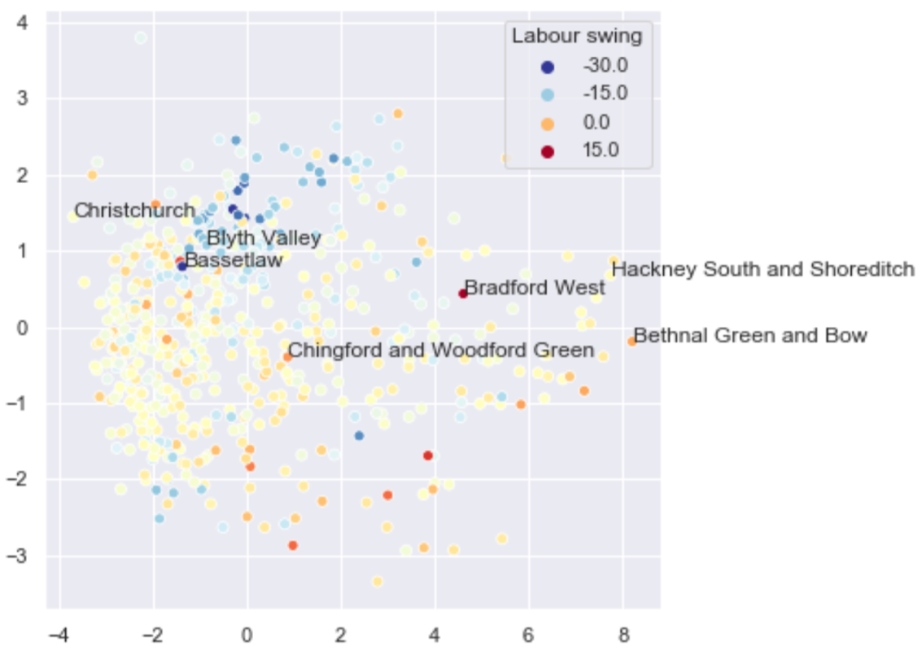

We can use this information to highlight outliers, where we can assume the local election campaign made a difference to the result.

We compare every constituency with all other constituencies. The difference in their swings is divided by the demographic distance between them. The sum of all these comparisons gives us an idea of how much it out performed (or underperformed) what we might expect.

For example, consider two constituencies, A and B, with very similar demographics which performed very differently in the election. A had a swing from Labour of -3%, B had a swing of -15%. Because they are very similar, we know that the national campaign should have appealed to them similarly. We divide the difference in swing (12%) by the difference in all their demographic features to obtain a score. A will receive a positive score, B a negative one. If the constituencies were very different in character, it would not have told us much information, dividing the swing by a large distance reflects this. To get our overall score for A, we compare it with every other constituency in a similar way and add up each contribution. (For a technical explanation of the methodology, see the end of this report).

This, in effect, gives us a measure of confidence in how well a constituency did, see the graph and table below.

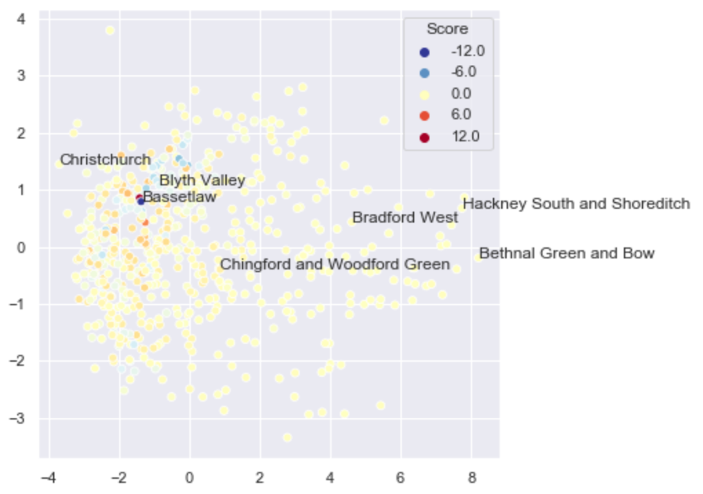

If a constituency is quite unusual - there are not many constituencies with similar demographics, like some points on the right of this graph) -we don’t know a lot about it, so it can never get a high score.

We can account for how unusual a constituency is by looking at how many constituencies are similar to it, or the ‘density’ of constituencies with that demographic makeup. We can normalize for the density of constituencies in a particular demographic space. Doing this we calculate an absolute score for that constituency, and the ‘density’ of similar constituencies indicates the confidence in that result.

For a full methodology see the technical description at the end.

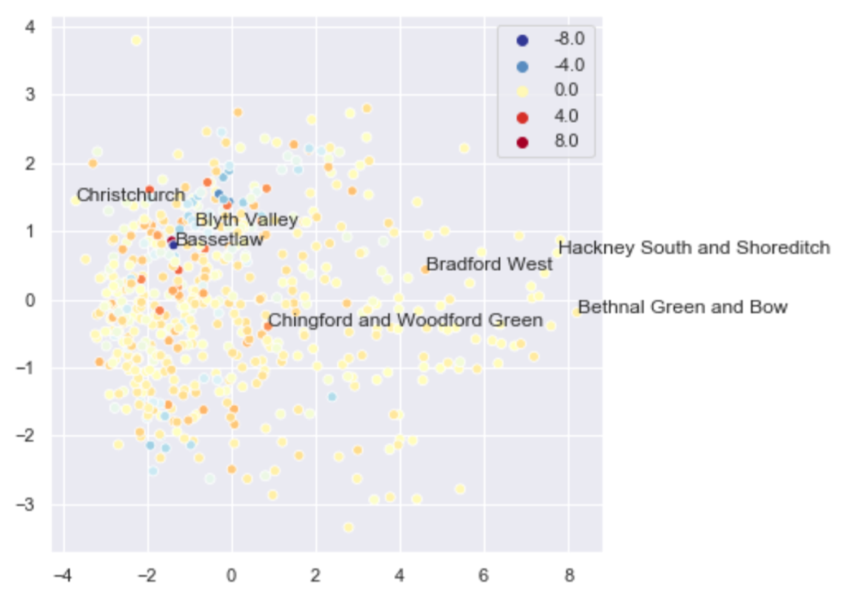

### Investigate a constituency’s score

Now we have to try to determine why some constituencies did well. There are obviously many reasons that could contribute to an anomalously good campaign. The highest score goes to Southport, investigating this result we can see that unlike other similar constituencies it had a large Lib Dem presence which fell and contributed to a large Labour swing in this election. Bradford west had the largest swing to Labour, but this can mostly be attributed to Salma Yaqoob’s successful independent campaign in the 2017 election, and Labour picking up their votes this time around. There will be many exceptional circumstances, especially at the very top and bottom of our rankings, but in general this can be used to assess a constituencies campaign.

Investigating the next constituency on the ranking, the Vale of Glamorgan, we can see which constituencies contributed to its high score:

This table gives an explanation for the Vale’s large score. The Vale of Glamorgan had only a slight negative swing away from Labour in this election, unlike many similar constituencies. Brigend and Tamworth are the most similar constituencies to the Vale of Glamorgan, they swung away from Labour by a large 18%, contributing positive scores to the Vale of Glamorgan. Bassetlaw is less similar to the Vale than Brigend, but its huge -34% swing means it contributes more to the final score we get for the Vale. We arrive at the our final score for the Vale by adding up all the values in the ‘score contribution’ column for every constituency.

We can apply anything we learn from the Vale of Glamorgan’s campaign strategy to these constituencies for next election.

We can also look at the election results for the constituencies mentioned individually, see below (UKIP and BXP have been combined into one bar).

## Technical methodology

All constituencies are compared with each other. For every pair of constituencies *i* and *j,* we calculate a ‘distance’, , according to their demographics. Similar constituencies, based on the features chosen above, will have a small distance between them. This distance is the sum of the absolute difference of all *k* features chosen above.

We need to focus on local effects Using the absolute Euclidean difference does not differentiate local effects, so we use the exponential of the distance:

The base of this exponential can be chosen depending on how close you want the local effects to be. We use a value of 10.

The total score for constituency *j* can be calculated from the sum:

## Sensitivity Analysis

We can test the robustness of our method by varying the input.

First, we drop features from the demographic inputs. Dropping one feature the r2 score is never below 0.95. Dropping two features the r2 is never below 0.93. This correlation means we have a good overview of the demographic character.

Next, we add a gaussian distributed noise equal to 10% of the input’s standard deviation, to `shake` the input and we can check if we still get similar results. Adding the noise to the demographic input the r2 = 0.99, to the election results r2 = 0.98.

The correlation when noise is applied is so good that you may ask if the analysis is doing anything. But comparing the score we calculate to the election swing we see a large spread in the scatter and get an r2 of 0.69.

